

Fast Food Density in Wales

Report prepared by:
Claire Beynon Specialty Registrar in Public Health, Public Health Wales
and
Linda Bailey, Consultant in Public Health, Public Health Wales.

With acknowledgement to
Anna Childs and Rhys Powell, Public Health Wales.

February 2019

Contents

 | Page number
Introduction | 2
Food Standards Agency Food Hygiene Ratings | 2
Methodology | 4
Results | 6
Discussion | 8
Further Research | 8
Use of Data | 8

Tables and Figures
 | Page number
Table 1: Inclusion and Exclusion Criteria Based on Food Standards Agency Categories | 4
Table 2: Fast Food Outlets per 100,000 Population by Local Authority for Wales, November 2018 | 6
Figure 1: Map of Fast Food Density for Wales by Local Authority Area | 7

1.0 Introduction
As part of a wider study examining population level risk factors for childhood obesity there was a need to examine the food environment in Wales and therefore to calculate fast food density by local authority area for Wales.

The term 'fast food' does not have one agreed definition in the literature. We attempted to delineated food outlets that sell energy dense savoury food that could provide a substitute meal prepared outside the home that is available quickly. This definition therefore covers a range of outlets that include, but are not limited to, burger bars, kebab and chicken shops, chip shops, Indian takeaways, Chinese takeaways and pizza outlets.

Public Health England reported fast food density by local authority area in 2018. See https://assets.publishing.service.gov.uk/government/uploads/system/uploads/attachment_data/file/741555/Fast_Food_map.pdf. The Public Health England methodology used by Public Health England was examined. This methodology used the Food Standards Agency data on hygiene ratings as the basis for the analysis. A review of potential data sources for Wales was undertaken and similarly the Food Standards Agency Hygiene Ratings data was considered the best source of routine data for the analysis in Wales.

1.1 Food Standards Agency Food Hygiene Ratings
The Food Hygiene Ratings allows potential patrons to find out if a restaurant, takeaway or food shop has good food hygiene standards. Ratings are typically given to places where food is supplied, sold or consumed, such as:
- restaurants, pubs and cafes
- takeaways, food vans and stalls
- canteens and hotels
- supermarkets and other food shops
- schools, hospitals and care homes
Each business receives a rating when inspected by a local authority Food Safety Officer. The rating is based on the standards of compliance with food hygiene law. There are two groups of exempt businesses which are inspected by the local authority food safety officer but are not given a food hygiene rating:
- businesses that are low-risk to public health, for example, newsagents, chemist shops or visitor centres selling pre-wrapped goods that do not require refrigeration
- childminders and businesses that offer caring services at home
The rating scheme is set out in law in Wales and Northern Ireland but display of the rating sticker is voluntary in England.

Each local authority plans a programme of inspections every year. The frequency of inspections depends on the potential risk to public health. Businesses that pose a higher risk are inspected more often than businesses that pose a lower risk. The assessment takes account of the following factors:
- type of food that is handled
- the number and type of customers, for example vulnerable groups
- types of processes carried out before the food is sold or served
- hygiene standards seen on the day of the last inspection
The data contained within the Food Standards Agency food hygiene rating system was identified as a source of readily accessible data useful in identifying counts of fast food outlets in Wales.

2.0 Methodology
The food hygiene rating data table for each of the twenty two local authorities in Wales was downloaded from the Food Standards Agency in November 2018.

2.1 Inclusion and Exclusion Criteria
All food outlets defined under the existing heading of ‘Takeaway and sandwich shop’ were included in the count of outlets. In addition, to overcome the fact that some food outlets classified as restaurants also sell food to take away, a review of the restaurants was undertaken using key words to identify them. Table 1 shows which outlets were included or excluded.
Table 1: Inclusion and Exclusion Criteria Based on Food Standards Agency Categories
Business Type | Inclusion/Exclusion criteria
Takeaway/sandwich shop | Include fully
Restaurant/Cafe/Canteen | Include via key search terms
Distributors/Transporters | Exclude fully
Farmers/growers | Exclude fully
Hospitals/Childcare/Caring Premises | Exclude fully
Hotel/bed and breakfast/guest house | Exclude fully
Importers/Exporters | Exclude fully
Manufacturers/packers | Exclude fully
Mobile caterer | Exclude fully
Other catering premises | Exclude fully
Pub/bar/nightclub | Exclude fully
Retailers – other | Exclude fully
Retailers - supermarkets/hypermarkets | Exclude fully
School/college/university | Exclude fully

The key search terms used were:
• “fish” to identify fish and chip shops. Note: Fisheries and place names with fish e.g. Fishguard were excluded.
• “India” and “Tand” to identify Indian restaurants which often also sell food to take away.
• “chin” to identify Chinese restaurants which often also sell food to take away. Tea Rooms which referred to china in the title were excluded.
• "pizza" to identify pizza restaurants which often also sell food to take away.
• "burger"
• "chicken"
• "kebab"
In addition well some known chains which were classified as sandwich and takeaways by certain local authorities and restaurants by other local authorities but sell food to take away were searched for to rectify any misclassification. This included burger, chicken and sandwich shops. The terms used were
• "Dona" to identify McDonalds (and account for misspelling)
• “Wimpy”
• "KFC"
• “Greggs”
• "Subway"

Once the number of outlets had been counted, this total was divided by the latest mid-year estimates of population for each local authority as produced by the Office of National Statistics (2017 data) and then a figure per 100,000 population was produced.

3.0 Results
Table 2 shows the number of fast food outlets per 100,000 population by local authority area to two decimal places. The mean for Wales is 100.65 fast food outlets per 100,000 population. With the highest value found in Conwy at 132.58 fast food outlets per 100,000 population and the lowest in Monmouthshire at 73.72 per 100,000 population.

Table 2: Fast Food Outlets per 100,000 Population by Local Authority for Wales, November 2018
Local Authority | Fast food outlets per 100 000 head of population
Blaenau Gwent | 125.00
Bridgend | 108.80
Caerphilly | 99.00
Cardiff | 93.99
Carmarthenshire | 89.01
Ceredigion | 99.86
Conwy | 132.59
Denbighshire | 107.14
Flintshire | 99.23
Gwynedd | 132.58
Isle of Anglesey | 107.45
Merthyr Tydfil | 118.33
Monmouthshire | 73.72
Neath Port Talbot | 104.86
Newport | 89.77
Pembrokeshire | 76.98
Powys | 80.00
Rhondda Cynon Taf | 107.49
Swansea | 101.83
Torfaen | 97.51
Vale of Glamorgan | 88.75
Wrexham | 80.38
Wales | 100.65
Calculated using Food Standards Agency Food Hygiene Ratings from November 2018 and the Office of National Statistics Mid-year Population Estimates for 2017
This data is presented in Figure 1 as a map of Wales, using five categories. The darker the shading, the greater the density of fast food outlet per 100,000 population in that Local Authority area.

Figure 1: Map of Fast Food Density for Wales by Local Authority Area
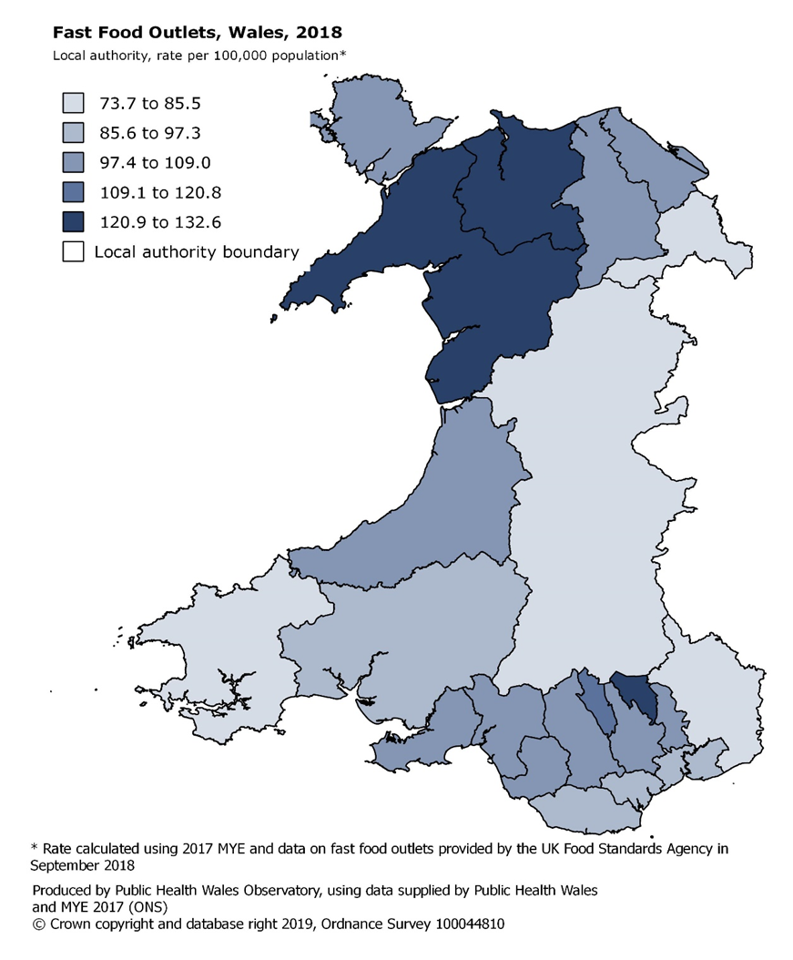

4.0 Discussion
This is the first time that fast food density has been calculated for Wales, and this provides a different insight into existing data which may have an impact on the health of the population of Wales. The major limitation of the use of this dataset is the fact that the data is updated by each local authority regularly and is therefore continuously changing.

The methodology used was different from that used by Public Health England and as such data is not directly comparable. Public Health England were not able to disclose their full methodology i.e. the names of the eight major chains used in their searches and a pragmatic decision was therefore taken to develop the methodology in Wales independently. The methodology used by Public Health England included searches of categories such as mobile caterers, other catering premises, retailers-other, retailers- supermarkets and schools, colleges and universities for the eight major chains and using key words set out here: https://www.gov.uk/government/publications/fast-food-outlets-density-by-local-authority-in-england. As the methodology in Wales only searched using the key words and major chains in the category ‘Restaurant/Café/Canteen’ it is possible that if any comparison were made between the countries this would underestimate the levels of fast food outlets in Wales in comparison to England due to this difference in methodology.

4.1 Further Research
The data presented represents a snap shot in time at November 2018. As the data changes it will be interesting to recalculate this to assess the future levels and trends over time in any local authority area. It was not possible to explore if retrospective data is held by the Food Standards Agency over time, but a retrospective study of fast food density over time would be another interesting research project if resources were available and the data is accessible.

4.2 Use of the Data
This data may be useful for Local Authorities and Local Public Health Teams when discussing fast food density in the local area. It may also help Local Authorities and Local Public Health Teams when considering planning applications for additional fast food outlets.

