Shingles immunisation uptake

Data source: Audit+

Current cumulative shingles immunisation uptake in each age cohort is available here: https://public.tableau.com/app/profile/public.health.wales.vpd.and.respiratory.surveillance.group/viz/NationalandHBlevelShinglesdashboard-ENGLISH/DBShinglesuptake-ENGLISH

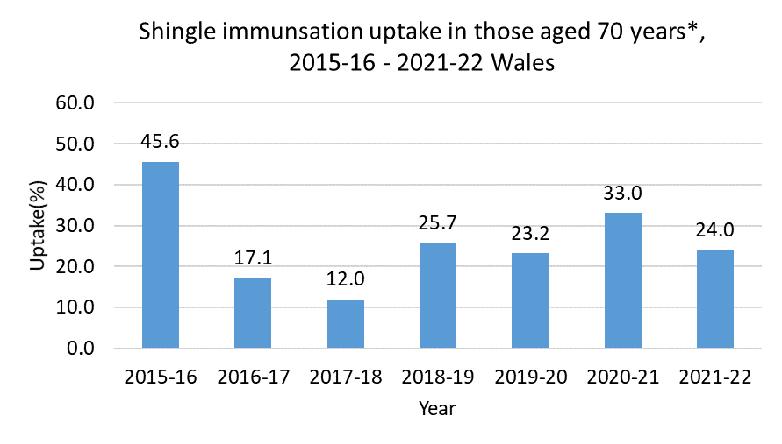
*age as at 1st September and uptake as at 31st August in the following year. Data for the equivalent time period prior to 2015-16 is unavailable.
Please note: This includes only those who became 70 years of age and were newly eligible for shingles vaccination each year. This chart does not include catch up doses given to those who remain eligible in subsequent years. There was a staggered rollout of the shingles vaccination programme between 2015-16 and 2017-18 and the number of individuals eligible for shingles vaccination increased over this time; this may have had an effect on uptake in each cohort. Although vaccination uptake in the first year of eligibility for 70 year olds is low, the cumulative uptake dashboard shows that uptake does increase over time.

Shingles GP consultations

Data source: Audit+

Three week rolling GP consultation rate for shingles per 100,000 practice population: Wales, 2012-2022.
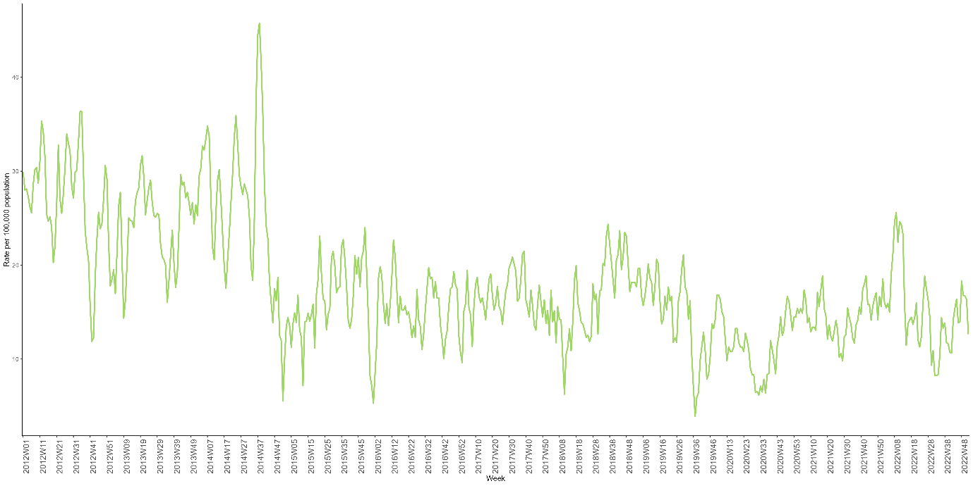
Three week rolling GP consultation rate for shingles per 100,000 practice population, by age group: Wales, 2012-2022.
