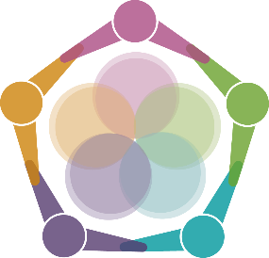
Taking Care Giving Care Circles

Description:

The COVID 19 pandemic has tested everybody’s ability to manage their wellbeing but for those in healthcare, this has presented some unique challenges. Many of us have taken on a variety of roles out of our comfort zone and part of the coping with this shared experience is shared reflection, allowing individuals time to recognise how they can support each other and tools they can use themselves.
In order to further support your wellbeing in this shared way, we are looking to offer the opportunity for you to attend a 20 minute care space session.
This 20 minute session is an opportunity for you to think (in pairs and as a group) about how things are going for you and whether and how you are/might be kind to yourself. We know that looking after our wellbeing is always important but right now that is perhaps even more crucial.
The session is highly structured to ensure everyone has the opportunity to think about their own needs. This safe space enables you to only share what is comfortable for you and is of course completely voluntary.

Aimed at:

All staff

Session duration:

Twenty minutes

Minimum/Maximum numbers:

6/8

How to book onto a course:

- search under class from your learner homepage in ESR
- search for 028 PHW Taking Care
- click on go
- this will bring up the available sessions running
- click on enrol for the session you want to attend

