

All Wales COVID-19

Workforce Risk Assessment Tool


All Wales COVID-19 Workforce Risk Assessment Tool

Introduction

This Risk Assessment Tool has been developed to help people working in the NHS and Social Care in Wales to see if they are at higher risk of developing more serious symptoms if they come into contact with the COVID-19 virus.
We want to help you understand whether you may be at greater risk and to help you and your line
manager to choose the right actions for you based on your level of risk.
Your employer has a duty of care to protect your health and safety at work and this includes understanding if you are at extra risk from COVID-19. This duty of care includes ensuring an equitable approach for all staff regardless of ethnicity or any other protected characteristics.
The next page sets out an overview of the risk assessment process. It has links to the latest guidance and information on the basic things that everyone can do to reduce their risk of COVID-19 infection, as well as the things that employers must do to support people who work for them.
Please use the resources as well as the Risk Assessment Tool to get the best results.

COVID-19 Understand your risk: Act to stay safe

What you need to do

Step 1 Check your risk – complete the Risk Assessment

Step 2 Understand your risk
A score of 0-3 | Low Risk
A score of 4-6 | High Risk
A score of 7 or more | Very High-Risk

Observe Social distance
Deployment to a
different area

Practice Good Hand Hygiene

Step 3 Identify the right actions for you

Step 4 Act now – Take the right actions

Setting and
PPE review

Rigorous Infection prevention
Focus on your health and wellbeing

Control
Workplace adaptation or

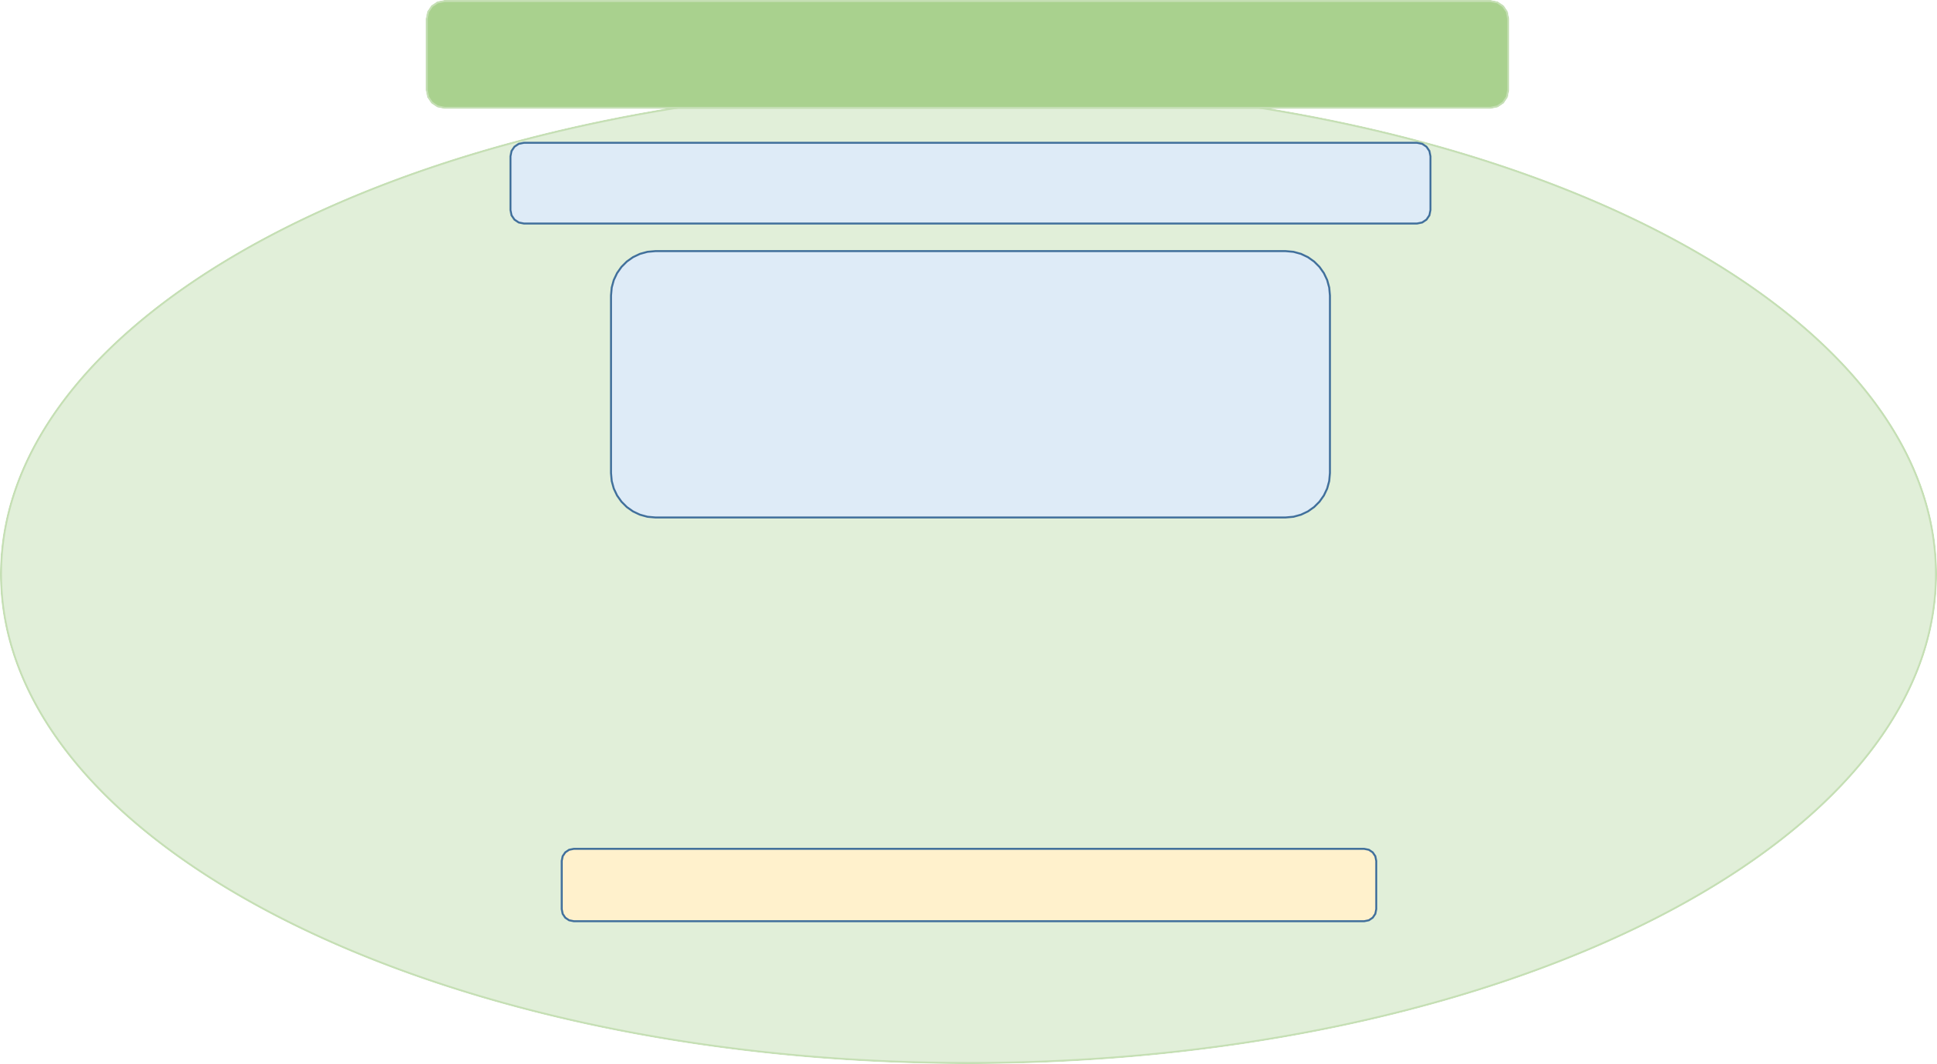and control
existing health conditions
Take Vitamin D
supplement
Manage your
weight
Boost your
wellbeing
Role redesign

All Wales COVID-19 Workforce Risk Assessment Tool

Who needs to use this tool?
This Tool is for everyone working or volunteering in health and social care in Wales.
The Chief Medical Officer for Wales, Dr Frank Atherton has now paused ‘Shielding‘. However, it remains vital that we protect our workforce defined on medical grounds as clinically extremely vulnerable from COVID-19. Adults with Down’s syndrome were added to this group in November. If you are included in the clinically extremely vulnerable group you will automatically score 7 on this Risk Assessment Tool putting you at Very High Risk, indicating that you should continue to work from home or go to work only if you can work in a COVID secure workplace with stringent 2m social distancing at all times.
If you are in the clinically vulnerable ‘people at risk’ group, and have been working from home or on modified duties, you
should continue to do so.
We recognise that the clinically vulnerable ‘people at risk’ group includes a wide spectrum of disease severity. You may wish to discuss with your Line Manager, Occupational Health or GP about your health conditions to discuss whether it is safe for you to return to work.
Pregnant women may be particularly vulnerable and beyond 28 weeks should work from home or in non-patient facing roles in a COVID secure workplace where 2m physical distancing can be stringently maintained at all times. Black, Asian, and Minority Ethnic (BAME) women under 28 weeks pregnant are at considerably increased risk throughout their pregnancy and so should avoid face-to-face contact with COVID-19 cases.

All Wales COVID-19 Workforce Risk Assessment Tool – confidential once completed

How to use this Tool
The Tool asks a number of questions about you that are designed to identify whether you are at a higher risk from COVID-19. It asks some questions about your age, health, weight and ethnicity which may increase your risk of serious illness following an infection with COVID-19.
You may know the answers to the questions yourself, but if not you can discuss this with your line manager, workforce
team, union representative, Occupational Health or advocate.
You may also want to consult your GP about the health conditions.

Please complete the questions and add up your score.

If you were shielding prior to 16 August 2020 or you are in the clinically vulnerable ‘people at risk’ group, and have been working from home or on modified duties, you should continue to do so. You should now arrange a time to discuss with your line manager. This may include a discussion with Occupational Health.

COVID-19 Understand your risk: Act to stay safe
We will continue to develop and improve the All Wales COVID-19 Workforce Risk Assessment Tool. If you have any comments or queries on the use or to improve the tool please email HSS.Covid19.WorkplaceAssessmentSubGroup@gov.wales


All Wales COVID-19 Workforce Risk Assessment Tool – confidential once completed
Step 1
Check
your risk

Consider each risk factor that applies to you and total your score
Risk factor | Score
Age – COVID-19 seems to have a bigger impact on people who are older.
- If you are aged 50-59 | 1
- If you are aged 60-69 | 2
- If you are aged 70-79 | 4
Sex at birth – COVID-19 seems to have a bigger impact on males than females
- Male | 1
Ethnicity – COVID-19 seems to have a bigger impact on people from some ethnicities
- Do you identify as one of the BAME or Mixed race groups as set out in this link | 1
Existing Health conditions (Comorbidity) – COVID-19 seems to have a bigger impact if you already have other pre-existing health conditions.
You may want to speak to your GP if you are not sure about these questions.
- Cardiovascular disease  Are you on any treatment for Hypertension (high blood pressure), Atrial Fibrillation (Irregular heart rate), Heart Failure,  Previous MI (had a heart attack), had a stroke, or Transient Ischemic Attack (mini stroke) | 1
- Diabetes Mellitus Type 1 or 2 | 1
- Chronic lung disease (including asthma, COPD, interstitial lung disease) | 1
- Chronic kidney disease (any stage 1-5) | 1
- Sickle cell trait, Thalassaemia trait or other haemoglobinopathy | 1
Obesity – COVID-19 seems to have a bigger impact if you are overweight
This link will help you work out your BMI – if your BMI is more than 30 OR If your waist circumference is:  - South Asian Female more than 33 inches (84cm); Other BAME or white Female more than 34.5 inches (88cm)  - South Asian Male more than 35 inches (89cm); Other BAME or white Male more than 40 inches (102cm) | 1
Family history – COVID-19 seems to have a family susceptibility for some people, especially twins
- Has a member of your immediate family (parent, sibling, child) been in ITU or died with COVID-19 | 1
Total score

All Wales COVID-19 Workforce Risk Assessment Tool – confidential once completed

Step 2 Understand your risk – what your score means in your workplace setting

 | Score
Workplace setting | Low Risk 0-3 | High Risk 4-6 | Very High Risk 7 or more
Community care | Continue to work following all recommended hygiene and social distancing measures | Consider modified duties and PPE Review* following all recommended hygiene and social distancing measures | Only return to work to a COVID secure workplace with stringent 2m social distancing at all times.  Consider work from home; or non- patient facing where possible
Primary care
Secondary care
Non AGP
Secondary care with AGP | PPE Review* | PPE Review* and/or  Modified duties
*PPE Review – This should consider the work setting, review all Transmission Based Precautions and ensure the selection and correct use of PPE including training and fit testing

Now arrange a time to discuss with your line manager to agree a plan and ensure you are appropriately protected. This may include a discussion with Occupational Health.

All Wales COVID-19 Workforce Risk Assessment Tool – confidential once completed

Step 3 Identify the right actions for you
Now you have completed your COVID-19 Risk Assessment score please discuss with your line manager, occupational health, workforce team, union representative or advocate to ensure you are appropriately protected.
Use the hierarchy of controls to mitigate risks: work from home where possible; reduce daily number of face to face contacts; stay 2m away from others; consider face coverings in enclosed workplaces or where social distancing is unreliable; ensure frequent hand and surface hygiene; stay at home and arrange testing if symptoms emerge.

Things I can do myself
Do the important things to maintain your safety in the workplace
- Observe good hand hygiene, with frequent use of soap and water or alcohol-containing gel.
- Maintaining a distance of 2 metres is an important aspect of the measures we must all take to minimise the risks of the spread of COVID-19. It is something we should aim to do in all aspects of our daily lives, in informal workplace activity as well as patient contact.
- Use appropriate personal protective equipment identified for your role and know how to use it properly.
- Observe isolation requirements for known or suspected COVID-19
cases.
- Ensure your infection control training is up to date.

Things my employer can help with
- Your line manager or union rep will help you use the tools and
identify the right actions for you.
- Making adjustments
  - Can some or all of your duties be undertaken or completed in
a different way
  - Can adjustments be made to enable you to work safely,
  - Can face-to-face contact with the public and home visits be
limited or avoided
  - Ensure appropriate physical distancing within the workplace
- Will adjustments enable you to work from home
- If no adjustments can be made to mitigate your risk, then temporary Medical Exclusion may be considered.

All Wales COVID-19 Workforce Risk Assessment Tool – confidential once completed

Step 4 Act now – take the right actions

Following your discussions with your line manager record the agreed plan and ensure you set a time for review.

What reasonable adjustments have been identified and taken to mitigate your identified risks?

………………………………………………………………………. Date adjustments were introduced*

……………………………………………………………………….

Date for review

…………………………………………………………………..

This may be time based or instigated by an event that impacts on your circumstances

* This should be signed and dated by both employee and line manager

All Wales COVID-19 Workforce Risk Assessment Tool – confidential once completed

Welsh Government are committed to ensuring that we learn quickly so that we can best protect you from harm due to COVID-19.
Your help and support in consenting to us gathering the evidence from your risk assessment is vital to inform further analysis so that we can better understand the disproportionate impact that COVID-19 is having on some individuals. This information will be used for this sole purpose in relation to COVID-19 and to continue to improve our risk assessment. It will only ever be your anonymised information that will be shared.

Information provided in confidence will only be used for the purposes advised and consented to by yourself

COVID-19 Understand your risk: Act to stay safe
We will continue to develop and improve the All Wales COVID-19 Workforce Risk Assessment Tool. If you have any comments or queries on the use or to improve the tool please email HSS.Covid19.WorkplaceAssessmentSubGroup@gov.wales

