Easy Read

Coronavirus support - looking after your mental health

A guide for people with a learning disability

 | Do activities that help you feel calm
 | Do them everyday. Not just when you are upset. For example:
 | - Be kind to yourself. This means do not judge yourself because you are not perfect. Do not compare yourself to other people.
 | - Try relaxation exercises. You can watch some good videos to help you with this here: www.moodcafe.co.uk/download-relaxation-exercises.
 | - Try Mindfulness. You can find out more by watching this video: www.youtube.com/watch?v=v1fl7gqKYRQ.
 | - Talk to someone you trust about how you feel.
 | Look after yourself
 | Looking after your body can help you feel better.
 | - Plan what you will do each day.
 | - Sleep well.
 | - Exercise.
 | - Eat and drink healthily
 | Check your thoughts
 | Try not to worry as this can make you feel worse.
 | - Do not watch the news too much.
 | - Find information that is helpful to you
 | - Think about the things you can do. Do not focus on what you cannot do.
 | - Keep yourself busy
 | Do things that help you feel good
 | It is ok to laugh and enjoy ourselves.
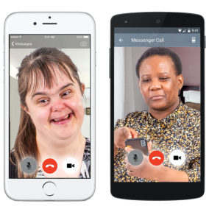 | - Talk to someone who makes you feel good. You can use Zoom to do this. Watch this video to find out how to use Zoom: https://www.youtube.com/watch?v=zhBd30l1prg
 | - Everyday, try to think about 3 things that have gone well. They can be small things too.
 | - Think about the things that make you happy. Try to do more of them where you can. Here are some calendars that can help you think of things you can do everyday: https://www.actionforhappiness.org/calendars
 | Speak to someone
 | If you would like to talk to someone in private about your mental health here are some helplines:
The C.A.L.L. helpline:
Phone: 0800 132 737
Text: text the word ‘help’ to 81066
Mind Cymru Infoline:
Phone: 0300 123 3393
Text: 86463
Email: info@mind.org.uk

Mencap support people with a learning disability, their families and carers.
Phone: 02074540454
Email: information@mencap.org.uk
Website: www.mencap.org.uk

 | Find advice and information on the internet
 | You can find good information about coronavirus on these websites.
 | Learning Disability Wales: https://www.ldw.org.uk/project/coronavirus/
Mencap Cymru:
https://wales.mencap.org.uk/information-and-support/information-about-coronavirus
All Wales People First:
http://allwalespeople1st.co.uk/latest-news/
 | This advice was made into Easy Read by Easy Read Wales using Photosymbols

