IMPORTANT NOTICE – PLEASE READ
Changes to the Routine Childhood Immunisation Schedule (Wales)
Effective from Tuesday 1 July 2025
From 1 July 2025, there will be significant changes to the routine childhood immunisation schedule in Wales. You can read the Welsh Government policy here: Changes to routine childhood and selective neonatal hepatitis B vaccinations (WHC/2025/019) | GOV.WALES

IMPORTANT: Due to an unavoidable delay, the NHS IT system (CYPrIS) used to schedule routine childhood immunisations will not be fully updated in time for the 1 July 2025 changes.

This delay is likely to be ongoing for a few months. You will be notified as soon as the IT system has been updated.

This means:

- CYPrIS invitation letters to parents will contain outdated information

- CYPrIS scheduled forms sent to GP practices will also contain outdated information i.e. appointing PCV at 12 weeks instead of MenB (see scenarios below)

- CYPrIS will not reflect that after 1 July 2025 any child born before 1 July 2024 attending a 12-month immunisation appointment should receive the 6-in-1 vaccine instead of Hib/MenC.

It is therefore vital that all vaccinators are fully aware of the new schedule and follow it manually until the system is updated.

What do I need to do as a vaccinator?

No | Scenario | Action
1 | Child attending 12-week immunisations before 1 July 2025 | No change - continue with the existing schedule.  At 12 weeks: Give 6-in-1, PCV, and Rotavirus  At 16 weeks: Give 6-in-1 and MenB
2 | Child attending 12-week immunisations on or after 1 July 2025 | Follow new schedule.  At 12 weeks: Give 6-in-1, MenB*, and Rotavirus  At 16 weeks: Give 6-in-1 and PCV
3 | From 1 July 2025, any child born before 1 July 2024 attending a 12-month immunisation appointment | Hib/MenC vaccine no longer available, give 6-in-1 instead** (alongside PCV, MMR and MenB scheduled at one year of age). In EMIS this should be coded as a 3rd 6-in-1 dose (EMISNQTH31) and in VISION this should be coded as a 3rd dose of Diphtheria/Tet/Pert/Polio/Hib/HepB. Record as second 3rd dose in child’s record.

*Once MenB (at 12 weeks) is entered into CYPrIS, this will automatically correct the schedule to appoint PCV at 16 weeks
**The 6-in-1 vaccine includes protection against Hib and will replace the Hib/MenC when it is no longer available. For further information see: Immunisation and Vaccines - Public Health Wales

- Check the red book and previous vaccine history prior to vaccination.
- As always, please ensure that all administered vaccines are clearly recorded on either the scheduled or unscheduled immunisation forms and return promptly to child health.

Documentation checklist
☐ | - Amend the CYPrIS scheduled form or complete an unscheduled form as required
☐ | - Amend the child’s Red Book as required
☐ | - Enter onto the GP system

We appreciate your understanding and support during this transition. Please ensure this information is shared with all relevant colleagues. Thank you
Visual summary of changes.

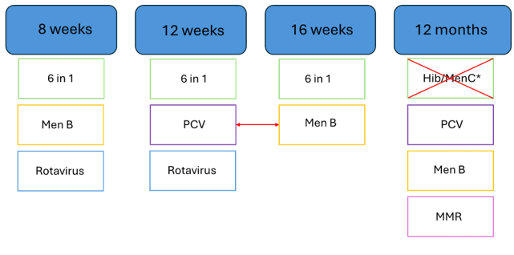
* See table below:
 | Born before 01/07/2024 |  | Born on or after 01/07/2024
Appointment Date | Before 1st July 2025 | From 1st July 2025 | From 1st July 2025
12-month appointment | Hib/MenC  PCV  MMR  MenB | 6-in-1  PCV  MMR  MenB | PCV  MMR  MenB

Where can I find more information about the changes to the routine childhood immunisation schedule in 2025 and 2026?

If you want more information visit the Public Health Wales website at: Changes to the childhood immunisation schedule - Information for health professionals - Public Health Wales or scan the QR code below.

If you have further questions, in the first instance contact your local Health Board at:
Scan me
to go to the Public Health Wales website
Insert local contact details here.

You can contact Public Health Wales at phw.vaccines@wales.nhs.uk

