Log into your ESR account and click into ‘My Learning’

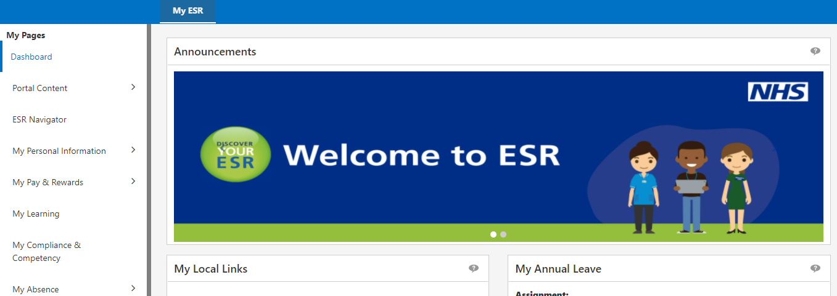

Change the drop down on the right to ‘All’ and in the empty box to the right type in 000 COVID-19 Vaccine Pfizer-BioNTech (Comirnaty 10 micrograms/dose)
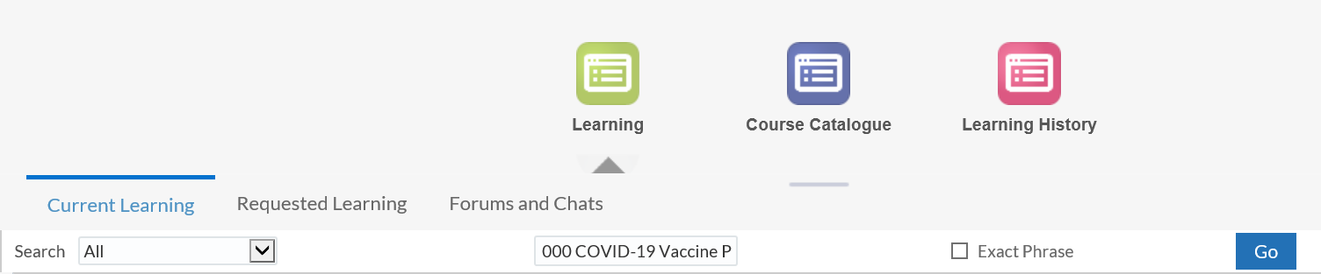

Note: This course is available separately as with all other vaccine modules and has been grouped with the other COVID-19 vaccine programmes under a learning path - 000 NHS WALES - COVID - 19 Vaccination Programme 2021/22
The course will be listed:
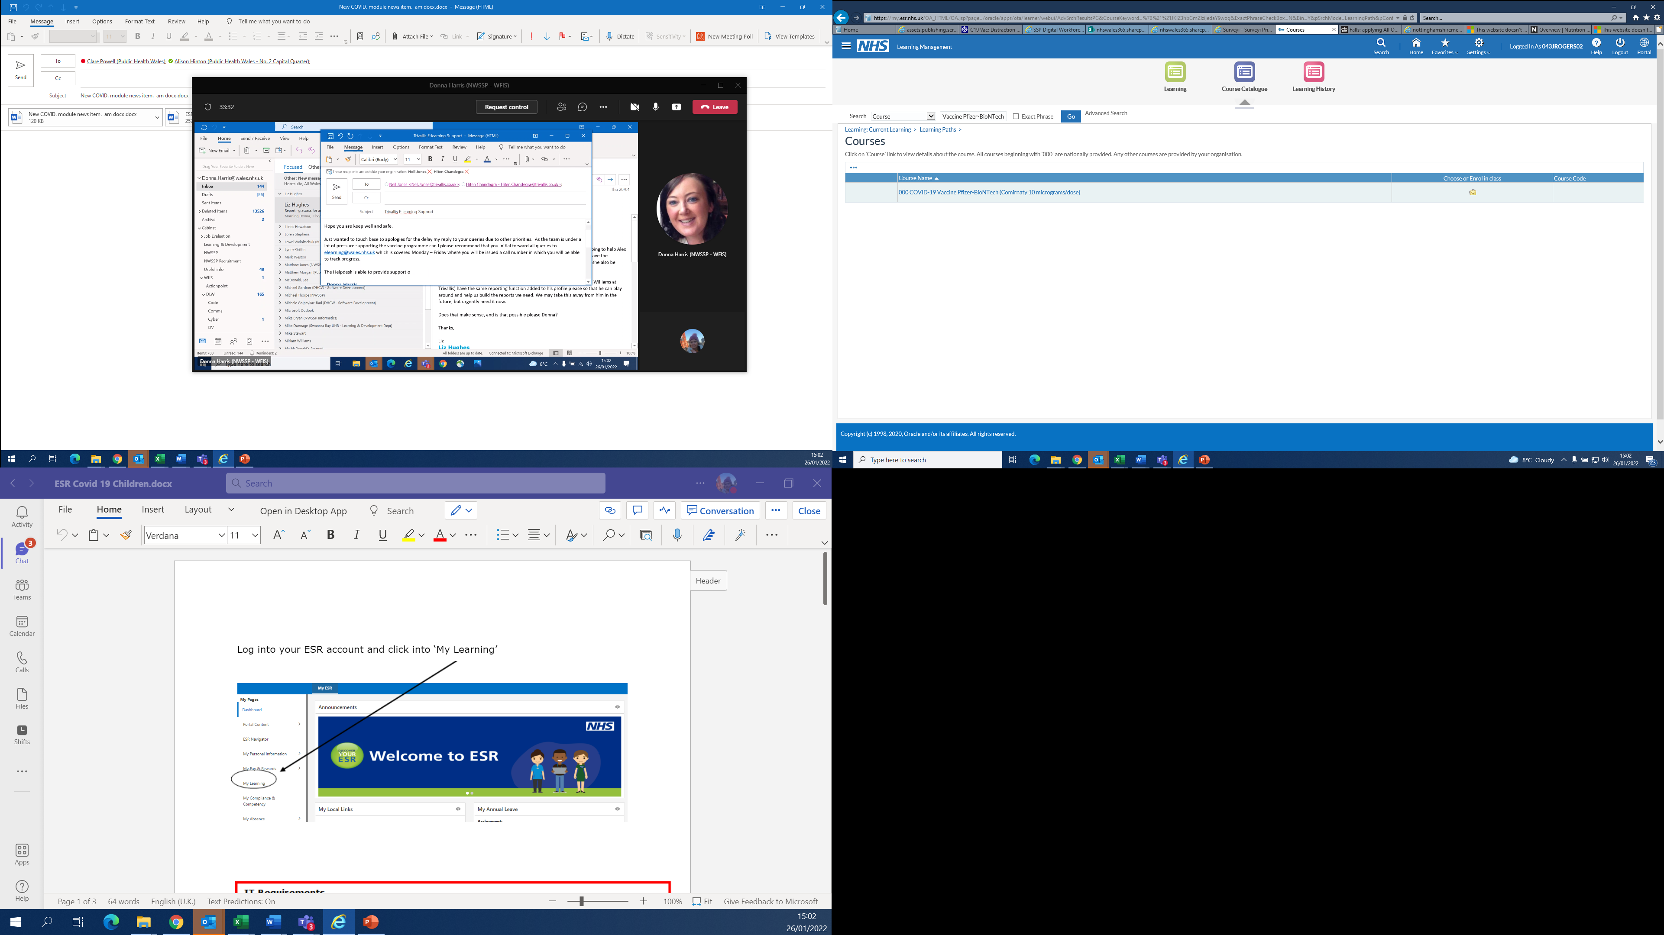

To access the course please select enrol
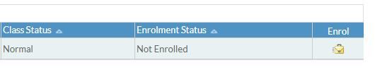

After you have enrolled onto the course you will need to select Apply
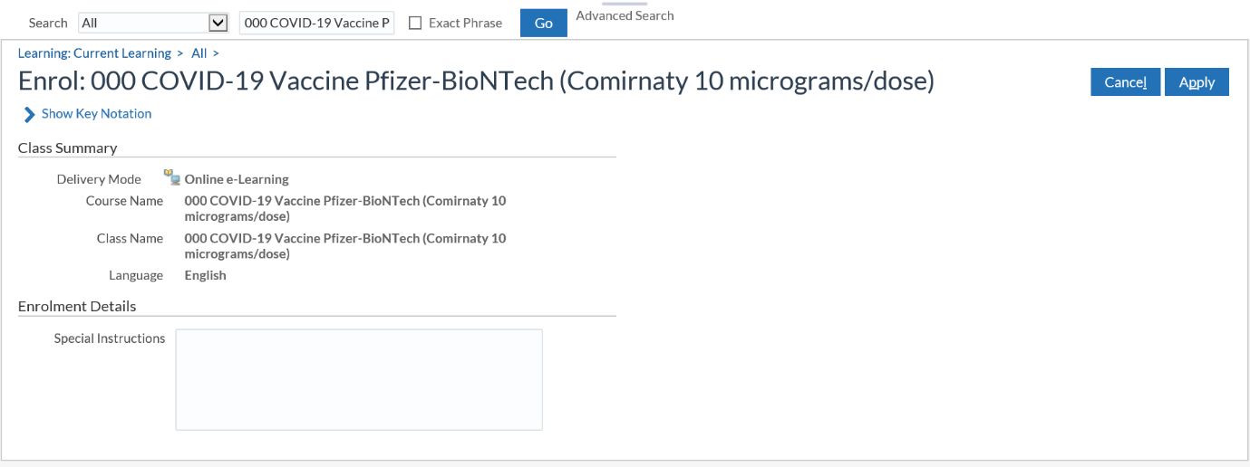

Once you have applied you will now be enrolled onto the course

You will find the course listed in E-Learning Enrolments. Once you have found the course please select play

