Cardiff and Vale Health Board: Childhood Immunisation Uptake

Childhood immunisation summary chart
The chart below summarises uptake rates for Health Board resident children for selected routine childhood immunisations. Please see All Wales Chart below for comparison. The statistics for these charts are taken from the latest Vaccine Uptake in Children in Wales (COVER) Report.

These results are for children living in the Health Board area in September 2023 and who reached their first, second, fifth, 15th and 16th birthdays during the quarter July – September 2023.
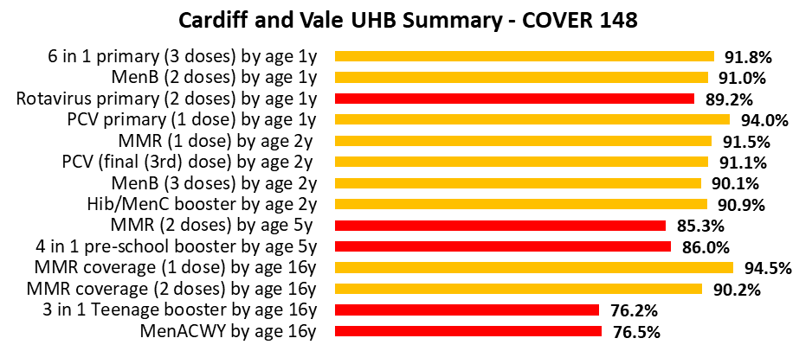

All Wales: Childhood immunisation summary chart
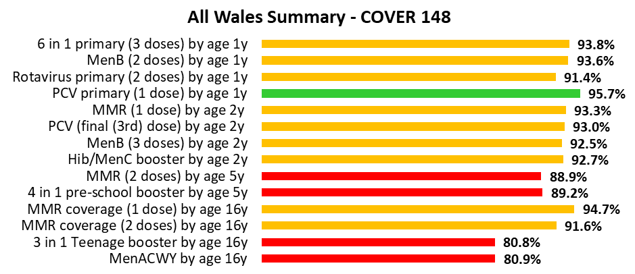

Childhood immunisation uptake trend
The chart below shows trends in the uptake of selected routine immunisations for Health Board resident children. Please see All Wales Chart below for comparison. The chart uses data from the Public Health Wales quarterly COVER reports, from 2004 to the latest report.

All Wales: Childhood immunisation uptake trend

