

All Wales Health Visitor good practice guidelines for the follow up of preschool children who are outstanding routine immunisations
Author: Anne McGowan, Clare Powell and Dr Richard Roberts Vaccine Preventable Disease Programme Public Health Wales.
Date: July 2016 | Version: v1
Publication/ Distribution:
- All Wales Health Visitor Forum
- Health Boards
- NHS Wales (Intranet)

Review Date: July 2018
Purpose and Summary of Document:
All Wales guidance to support health visitor follow up of children who have missed routine immunisation appointments

Contents page
1 Introduction 3
2 Aim 4
3 Scope 4
4 The Health Visitor’s role in immunisations. 4
5 Health Visitor responsibilities 9
6 Conclusion 13

Acknowledgements

This all Wales Health Visitor good practice guidelines for the follow up of preschool children who are outstanding routine immunisations has been developed following consultation with the all Wales Health Visitor forum and the Immunisation Coordinators. The authors particularly acknowledge the Aneurin Bevan Health Board Public Health Nursing Standard for the Management of Persistent Non Attendances, No access Visits and Service Refusal documents.

Introduction

After clean water, immunisation is the most effective public health intervention available. Immunisation is a core component of the proposed Healthy Child Wales Programme (HCWP) and promoting immunisation is a key part of health visitors’ work. ¹ Parents consider health visitors to be an important and trusted source of advice and information about immunisation.² Every contact with families provides an opportunity for health visitors to review the immunisation status of children and advise and arrange for immunisations outstanding or for those due in the future.

Aim
This guidance aims to ensure that all children have every opportunity to ensure they are up to date with age appropriate immunisations and reduce inequalities in immunisation uptake related to deprivation.

Scope
The guidance applies to all health visitors (HV), family support nurses (FSN), community nursery nurses (CNN) and administrative staff within the public health nursing services in Wales.

The Health Visitor’s role in immunisations
Welsh Government policy gives the HV service a key role in immunisation programmes in Wales.

Welsh Government Policy

The Healthy Child Wales Programme (HCWP) sets the strategic direction for health boards in Wales for the delivery of early intervention health services that are designed to ensure that children achieve optimum health.¹ Immunisation is a core component of the HCWP and health visitors are required to take opportunities to deliver on the Welsh Government (WG) Tier 1 target to increase immunisation rates at four years of age. Health visitors are required to build upon the universal and enhanced core programme to the intensive element for children who have repeatedly failed to attend for routine immunisation appointments as shown in figure1.

Figure 1: Welsh Government. Healthy Child Wales Programme 0 – 7 years
Childhood Immunisations
Universal | Health Visitors will continue to promote all recommended immunisations.
Enhanced | The Health Visitor will promote and reinforce those immunisations that may have been missed or are overdue for some children.
Intensive | The Health Visitor will ensure alternative venue immunisations are offered for children who have repeatedly failed to attend.
Ref Healthy Child Wales document scheduled to be launched October 2016

The Welsh Government Flying Start (FS) Programme recognises immunisation as a major contributor to public health and has an important role to play in reducing health inequalities. ³ The Tier 1 target for 95% of FS children to be fully vaccinated by 4 years is a population indicator for the programme. FSHV services are required to:

- Ensure they keep up to date with the latest guidance on the schedule of immunisations
- Check the child health records to ensure Flying Start children are fully immunised
- Follow-up those children who have not been fully immunised
- Work with primary care colleagues to ensure any children who have missed immunisations are brought up to date with any outstanding vaccines at the earliest possible opportunity
- Monitor and report to their manager the uptakes of immunisation of the children in their caseload so proactive action can be taken in a timely manner
- Achieve the Tier 1 target, which is to have completed all routine immunisations by the age of 4 years of age

Welsh Health Circular (2005) 081 announced changes to the Measles Mumps Rubella (MMR) catch up programme and also made changes to the routine follow up by HVs of children who miss MMR.⁴ This policy requires HV services to:

- Check, correct and return to child health regular lists of children who have missed scheduled vaccination
- Receive a quarterly list of all children reaching 18 months who have missed their MMR vaccine and take action, including contacting the parents, and return this information to child health departments

Training

The UK childhood immunisation programme is constantly developing with the addition of new vaccines and changes to recommendations. Keeping up to date on an annual basis is vital if health visitors are to advise parents appropriately and confidently.⁵ National training standards require;

“Anyone who immunises or advises on immunisation should receive specific training in immunisation and should attend annual updates”. ⁶

References and information on training events for keeping up-to-date on immunisation are available from the Public Health Wales vaccination webpage’s.
Key documents include;
- The routine childhood schedule in Wales
- Vaccination of individuals with uncertain or incomplete immunisation status ⁷

Immunisation uptake

In Wales generally preschool immunisation rates are high, but there is a considerable range in uptake with pockets of low immunisation uptake particularly in some of the most deprived areas of Wales. Lower uptake is mainly due to difficulties accessing services as reported by NICE 2009, health visitors should bear this in mind when considering a flexible provision of immunisation services.⁸ Health visitors should be familiar with their practice / GP cluster local immunisation uptake ⁹ and aware of any groups needing additional support in accessing services or who have particular information requirements on their caseloads.

Figure 1: Inequalities in immunisation uptake (%) in Wales, 2011 (received all vaccines at 1,2 and 5 years, received Td/IPV at 16 years).

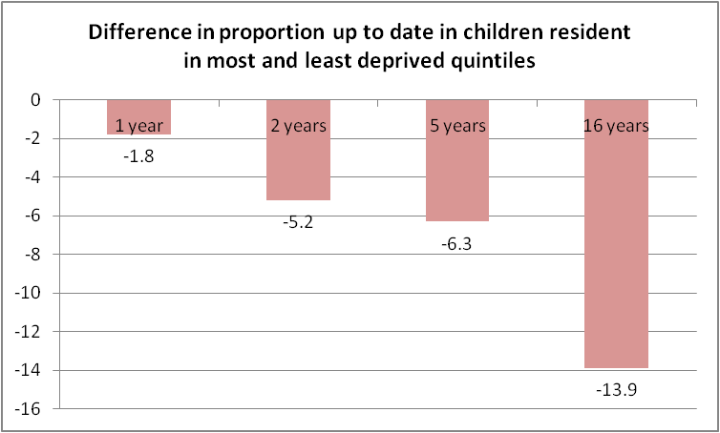

Inequality between the most deprived and least deprived areas in the proportion of children completing all recommended immunisations by one year of age in 2011 was small at around 2%, increasing to 5% at two years and 6% at five years (Figure 1). The most deprived areas correspond with those areas likely to be designated for FS services. There was a difference of 5% in immunisation uptake at the fourth birthday by LA between Flying Start (78%) and non-Flying Start (83%) areas in Wales for 2012/13 and again in 2013/14 (Figure 2).

Figure 2: Percentage of children in Flying Start and non –Flying Start areas that are fully immunised* at 4th birthday, Wales, 2011-12 to 2013- 14

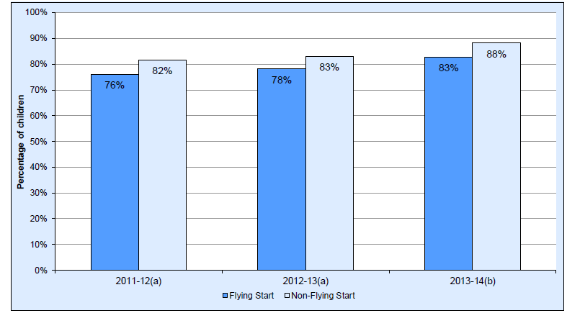
Source: Public Health Wales COVER report 2011-2012,2012-13,2013-14, National Community Child Health Database (NCCCHD) 2011-12,2012-13,2013-14 (denominator)
- Pre-expansion areas as at 31 March 2012
- Programme areas as at 31 March 2014
*Fully immunised defined as completed “4 in 1” preschool booster, the Hib/MenC booster and second MMR dose by four years of age.

Communication

Many parents have questions and concerns about immunisation which can lead to hesitancy in their decision making. These need to be addressed fully and sympathetically. If a HV requires additional information and advice, they should be aware of where specialist information, advice and support can be obtained. This can be obtained from the health board immunisation coordinator or local health protection team.¹⁰ If parents or carers require more detailed information or in-depth discussion, health visitors should be aware of local referral pathways to other appropriate health professionals’ e.g. community paediatricians within their health board.

A small minority of parents actively reject individual vaccines or immunisation as whole. These parents still require the offer of information and a discussion about immunisation at the time and at future contacts with the health visiting service, as appropriate. It is known that some families, who initially decide against immunisation, later go on to have their children immunised with some or all vaccines.

Health Visitor responsibilities

The health visitor is responsible for the follow up of non-attenders and for arranging immunisations for all children with consent on their caseload.

It is the responsibility of the caseload holder to assess and prioritise the follow up of non-attendance, no access to a child, or service refusal. In all instances the HV must be able to evidence that they have undertaken an investigation and assessment process to support decision making.

The follow up of missed appointments can be delegated to others but remains the responsibility of the HV, who should ensure that the person to whom she has delegated the task is fully aware of the expectations of their role.

Definition of No Access or Non-Attendance

No access is where access to see children has been denied or avoided by the parent or carer on two separate consecutive occasions following either a verbal prearranged home visit or written appointment sent to the home address.

Non-attendance is when the parent or carer has not brought the child for a clinic appointment and no explanation has been given on two consecutive occasions.

Following a failure to attend an appointment generated by the Child Health (CHC 2000) System for immunisations:

Health visiting staff should re-appoint the child for a further appointment using the scheduled documentation. This is to ensure that information is accurately recorded and a repeat appointment is generated.

Failure to attend scheduled appointments with no reason on two occasions (preschool children) will result in the health visitor receiving a green “missed two appointments” notification form from the Child Health Computer.

On receipt of the missed two appointments report the health visitor should:

Check for inaccurate child health records (reporting the child is unvaccinated when GP records show they have received the vaccination) and update CH departments as appropriate.

Check that the child’s details are correct, i.e. name and address, check these details with the GP practice as the child may have moved. Update CH department as appropriate. Document in the appropriate section of the health visiting record.

Contact should be made with the family to investigate the reason for non attendance. Document in the child’s health visiting record any action taken around the missed appointments i.e. home visits or reappoint.

Support the family to make alternative arrangements to ensure the child is vaccinated.

Return the ‘missed two appointment form’ to the appropriate child health office within 7 working days with instructions to reappoint/do not reappoint (CHIPS 2014) ¹¹.

For hard to reach families domiciliary immunisations should be considered by the immunisation provider. A template immunisation domiciliary guidance ¹² is available for health boards to adapt locally. NICE guidance recommends domiciliary immunisation as part of a range of interventions to increase uptake. The NICE guidance states in the context of preventing measles using MMR vaccine: ‘modelling suggested that home visits (likely to be the most expensive means of increasing coverage by one percentage point) would be a cost effective use of NHS resources. The implication is that almost any method of increasing MMR coverage would be cost effective.⁸ The NICE assessment modelled only measles, therefore the cost effectiveness of catching up a number of missing vaccines at the same time would be greater.

If after discussion with the parent or guardian it is clear that they do not wish their child to receive the immunisations at this time, document this conversation in the health visiting records and complete a Refusal of Consent for Childhood Immunisations Form. A copy of this form must be sent to the child health office, the GP and in the HV records.

Examples

Abertawe Bro Morgannwg University Health Board (ABMUHB) ratified a governance framework for domiciliary or alternative venue delivery of Tier 1 immunisations to families who are hard to reach and required an enhanced approach to ensure that children are fully vaccinated. Following three failures to attend for immunisation services and a risk assessment conducted by the health visiting service, outstanding immunisations will be delivered in domiciliary or alternative pre-school setting by health visiting staff. Local feedback on this approach acknowledged the challenge of the cultural change but reported in the first eight months of operation 19 children had been vaccinated under the policy, predominantly in FS areas.

- In Betsi Cadwaladr University Health Board (BCUHB) a vulnerable groups team is in place with a health visitor as a member. The health visitor vaccinates on Gypsies and Travellers’ sites. The vulnerable groups team report they have achieved high immunisation coverage on sites in the health board area. In Blaenau Gwent Local Authority (LA) the majority of FS HVs routinely vaccinate as core work. Blaenau Gwent had the highest percentage (86%) of children in FS areas that are fully immunised at 4th birthday by local authority in 2012-13. In Torfaen LA 80% of FS HVs actively immunise, offering routine immunisations in Integrated Children’s Centres, sending manual updates of vaccines given to the GPs.

- The Immunisation Coordinator and Public Health team in Powys have developed a system that strengthens the HV role in immunisations. Powys requires very small absolute numbers to achieve targets. For example the 95% uptake Tier 1 target would have been achieved for the period 01/07/14 and 30/09/14 in children reaching their 4th birthday if 20 additional children had been brought up to date with outstanding MMR, Hib/MenC or DTaP/Polio vaccines

- Home immunisation is recommended only for those who have repeatedly failed to attend on multiple occasions, for example after three missed invitations. If HVs have maintained competence in immunisation they may administer missing vaccines themselves. An ‘immunisation team’ of nurses that can be called on for domiciliary immunisation may be a practical alternative as is being proposed by ABHB.

- Cardiff and Vale FS are conducting a postcard pilot in a number of languages.

- Cwm Taf Health Board is piloting direct HV caseload immunisation uptake feedback to HV’s and managers.

Conclusion
Health visitors are in a unique position to identify and follow up children who fail to attend invitations for routine immunisation. There is a professional consensus that HVs have a key role in ensuring hard to reach children are immunised. Around 2-3% of children have existing consent for immunisation but repeatedly fail to attend when invited.
All children have a named health visitor with caseloads ranging from 110 children in Flying Start areas but higher in other areas. The good work and best practice by some HV and FS services to improve immunisation uptakes illustrates the success of HV led interventions for hard to reach children.
This best practice guidance aims to ensure consistent, effective and universal follow up of children in Wales who have failed to attend two immunisation appointments with no reason so that children in Wales are fully immunised and inequalities are reduced.

References

- Welsh Government 2016, Healthy Child Wales (0-7 years) http://gov.wales/about/cabinet/decisions/previous-administration/2014/julsep/health/900684md1878/?lang=en Accessed 26 June 2016
- Department of Health 2010, COI Research Management, Parents tracking research. Summary of waves 21 – 33 available at http://webarchive.nationalarchives.gov.uk/+/www.dh.gov.uk/en/Publichealth/Immunisation/Marketresearch/index.htm. Accessed 17 September 2015
- Welsh Government 2015, Flying Start –Annex. Health Support Services Guidance. Available at http://gov.wales/topics/people-and-communities/people/children-and-young-people/parenting-support-guidance/help/flyingstart/?lang=en Accessed 5 November 2015.
- Welsh Health Circular 2005, MMR Immunisation catch up programme (2005)081. Available at http://nww.immunisation.wales.nhs.uk/policy-letters-j-to-z#MMR
Accessed 5 November 2015
- Green Book Immunisation against infectious disease chapter 11 UK Immunisation schedule. Available at http://nww.immunisation.wales.nhs.uk/schedules-uk-other-countries Accessed 5 November 2015
- Health Protection Agency 2005, National Minimum Standards for Immunisation Training. Available at http://nww.immunisation.wales.nhs.uk/national-training-standards
Accessed 5 November 2015
- Public Health England 2016 Vaccination for individuals with uncertain or incomplete immunisation status. Available at http://nww.immunisation.wales.nhs.uk/schedules-uk-other-countries.Accessed 4 July 2016
- NICE 2009. Reducing differences in the uptake of immunisations (including targeted vaccines) among children and young people aged under 19 years. NICE public health guidance 21. Available at http://www.nice.org.uk/PH21 Accessed 17 September 2015
- COVER 2016. Childhood immunisation. Available at: http://nww.immunisation.wales.nhs.uk/cover Accessed 4 July 2016
- Health Board Immunisation Coordinators 2015, contact list. Available at http://nww.immunisation.wales.nhs.uk/contacts. Accessed 4 July 2016
- Child Health Immunisation Process Standards 2014. Child Health Immunisation Process Standards - National Minimum Standards for Childhood Immunisation Administrative and Data v2 Public Health Wales. Available at http://nww.immunisation.wales.nhs.uk/child-health-system#Guidance. Accessed 4 July 2016.
- Public Health Wales 2016. Template domiciliary guidance. Available at: http://nww.immunisation.wales.nhs.uk/guidelines-and-templates#General Guidelines and Advice. Accessed 4 July 2016.

