



Welsh Cancer Intelligence and Surveillance Unit
Cancer incidence in Wales, 2002 - 2020: Final release
Pathology samples indicating new cases of cancer in Wales, January 2018 - May 2023
Note:
‘All cancers’ refer to ‘All malignancies excluding non-melanoma skin cancer (NMSC)’
‘Pre-pandemic average’ refers to the average count from the years 2018 and 2019.

Key Messages
- New detected cases of all cancers decreased by 14.2% in 2020 from 20,340 cases in 2019 to 17,461 cases in 2020.
- Between 2002 and 2019, the number of new diagnoses of all cancers increased by nearly 27%. Due to the reduction of detected cases during the pandemic, the increase between 2002 and 2020 was 8.8% (Fig 1).
- This release includes a new experimental analysis which identifies new cases of cancer detected through pathology tests, providing rapid and timely statistics. The analysis shows that in 2022 there were still 0.4% fewer detected cancers than in 2019 (Fig 2).
- Analysis of pathology tests shows variation in the recovery of detected cancers between cancer sites. For example, the number of tests indicating prostate cancer was 19.5% lower in 2022 than 2019 whereas the number of tests indicating breast cancer was 5.2% higher in 2022 than 2019.
- Age-standardised incidence rates of all cancers between 2002 and 2019 increased by 3.4% in the most deprived areas and decreased by 1.7% in the least deprived, widening the deprivation gap in Wales (Fig 3).
- Between 2019 and 2020, age standardised incidence rates fell more in the least deprived areas than the most deprived areas (reduction of 16.3% in the least deprived compared to 10.5% in the most deprived areas, Fig 3).

Additional Information
Monthly cancer incidence from pathology tests, January 2018 to May 2023
- Examining monthly pathology samples allows a more rapid and timely analysis of cancer cases in Wales. These new, experimental statistics give an insight into cancer detection following the Covid-19 pandemic. We welcome feedback about this new analysis.
- Cancer registration data provides the most comprehensive picture of cancer incidence in Wales. Pathology samples underestimate the incidence of cancer, but the overall trends are comparable. Not all cancers are confirmed with a pathology test, either because the patient declines a test, is too unwell or the cancer is identified via a different route. For more information about comparability, see Figure 4 and Table 2.
- The number of pathology samples indicating prostate cancer are persistently lower than 2019 pre-pandemic levels. Pathology samples for lung cancer show a similar picture (Table 1).
- For bowel and breast cancer, diagnoses are returning to pre-pandemic levels (Table 1).
Table 1: Percentage difference of pathology samples counted in the years 2020-2022 compared to 2019, for the most common cancer sites in Wales.
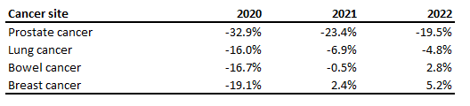
Impact of the Covid-19 pandemic
- There were 3,089 fewer cases of all cancers diagnosed between April and December 2020 compared to the pre-pandemic average.
- Cancer incidence rates differ between the sexes, with men having a 26% higher age-standardised rate of all cancers than women in 2019. The gap between age-standardised rates of men and women reduced in 2020 to 21%.
- Due to the drop in prostate cancer diagnoses in 2020, following measures introduced to control the spread of Covid-19, female breast became the most detected cancer followed by lung, prostate and then bowel.
- The shift in detection of different cancer types may have influenced the gap in cancer incidence between men and women.
- In 2020, the crude incidence rate of all cancers was 12.6% higher in the least deprived areas in Wales than in the most deprived (571 cases per 100,000 population vs. 507 cases per 100,000 population). This represents a smaller gap than previous years, due to the larger fall in incidence rates in the least deprived areas of Wales.
- In 2020, age-standardised rates were nearly 19% higher in the most deprived areas than in the least deprived areas of Wales. This is an increase in the gap compared to previous years.
Underlying trends
- Between 2002 and 2019, the crude incidence rate of all cancers increased more quickly in the least deprived areas than in the most deprived areas (24.9% increase vs. 9% increase). This is due to the relatively older populations in the least deprived areas.
- Age-standardised incidence rates are consistently higher in the more deprived areas, suggesting an underlying difference in the populations other than increasing age or a difference in age structure.
- Each year, including 2020, nearly 80% of cancer diagnoses occurred in people aged 60 and over in Wales.

Appendix A
Figure 1: Number of new cases of ‘All malignancies excluding NMSC’ for persons and all ages in Wales, between 2002 and 2020.
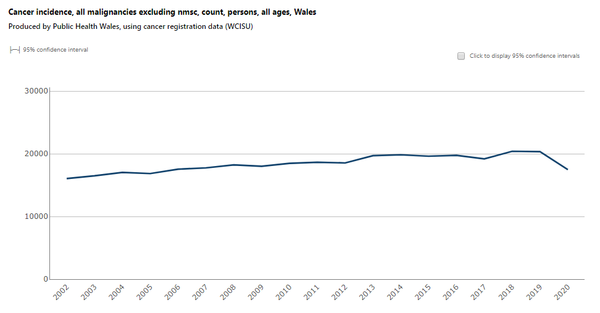

Figure 2: Number of pathology samples indicating ‘All cancers excluding NMSC’ for persons and all ages in Wales, between January 2018 and May 2023.
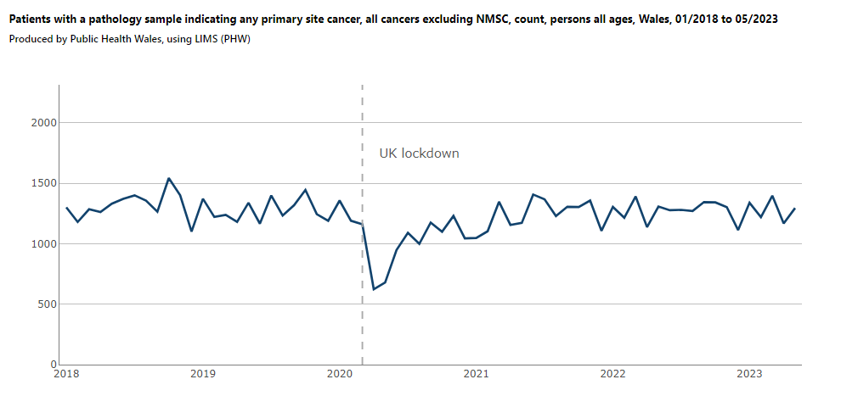
Figure 3: Incidence of ‘All malignancies excluding NMSC’ by European age-standardised incidence rate, for persons and all ages, for the least and most deprived deprivation fifths in Wales.
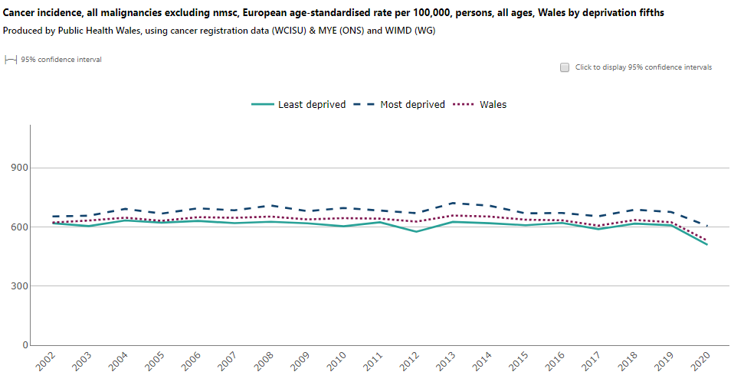
Figure 4: Number of monthly pathology samples and cancer registrations of ‘All malignancies excluding NMSC’ for persons and all ages in Wales, between January 2018 and December 2020.
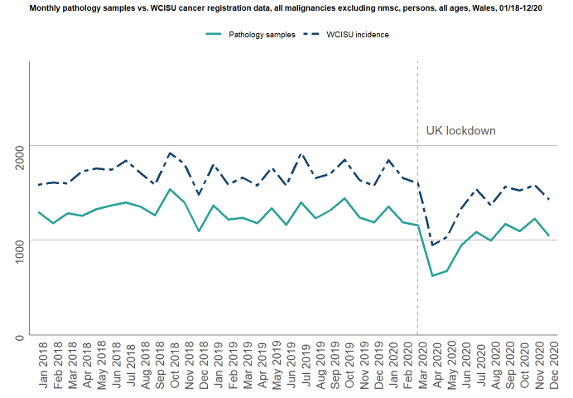
Table 2: Summary comparison of pathology samples and cancer registrations between January 2018 and May 2023, showing pathology samples as a percentage of the total cancer registrations by cancer type.

