Main messages
Survival estimates during the pandemic period are difficult to interpret due to the variation in background mortality, please see the technical guide for further information.

Headlines
- The latest net cancer survival estimate for Wales shows that for people diagnosed from 2017 to 2021, 63.1% survived cancer five years from diagnosis, on average.

- Long-term historic improvement in five-year net cancer survival has stagnated since the 2014-2018 diagnosis period. This stalling in improvement started before the Covid-19 pandemic (Chart 1) and has continued beyond it.

- One-year net cancer survival stopped improving appreciably each year of diagnosis from 2014 to 2019, then dipped to 71.9% in 2020, the first full year of the pandemic. This improved significantly to 75.2% in 2021 but only returned survival to the pre-pandemic level (Chart 2).

- Cancer survival worsens with increasing levels of area deprivation (Chart 3). For the 2017-2021 diagnosis period, 70.1% of people from the least deprived areas survived to five years, compared to 51.8% of people from the most deprived areas. This wide deprivation gap has not widened since diagnoses between 2002-2006.

Other key findings
Specific cancer sites
- Since the pandemic, one-year lung cancer net survival has not recovered as well as for other major cancers (Chart 4).

- For men with breast cancer, five-year net survival (unstandardised) has increased rapidly from 64.3% to 94.5% since the 2009–2013 diagnosis period to 2017 to 2021 (Chart 5). In comparison, survival from the much more common female breast cancer increased from 86.3% to 91.2%.

- For men aged 15-54 diagnosed with colorectal cancer, five-year net survival declined sharply, falling from 66.9% in 2008-2012 to 53.3% in 2017-2021 (Chart 6). A similar but smaller decline trend can be seen in England and Scotland, although these are not directly comparable due to differences in age groups and periods.

- Since the 2013-2017 diagnosis periods, one-year net survival for liver cancer has declined from 50.7% to 31.8% in those aged 15-54, falling below outcomes for 55–74-year-olds (Chart 7). A similar but smaller decline trend can be seen in England and Scotland, although these are not directly comparable due to differences in age groups and periods.

Area deprivation (unstandardised net survival)
- For five-year net cancer survival, the deprivation inequality gap remains wider in men (21.5% percentage points difference) than women (14.9% percentage points difference) in the 2017-2021 period.

- For people diagnosed with colorectal cancer, five-year net survival was 49.1% for those living in the most deprived areas compared to 66.0% for those living in the least deprived areas. This inequality gap in net survival is wider than it was for the previous period (Chart 8).

- Between the diagnosis periods 2009-2013 and 2013-2017, ten-year net survival for lung cancer greatly improved in the least deprived areas (from 8.3% to 14.7%), but much less so for the most deprived (from 6.8% to 8.5%), widening existing deprivation inequalities (Chart 9).

Stage at diagnosis (unstandardised net survival)
- Five-year net survival continued to increase for female breast cancer diagnoses at stage 4 (Chart 10).

- One-year net survival for stage 4 cervical cancer diagnoses has increased from 35.0% in the 2014-2018 diagnosis period to 41.3% in the 2017-2021 diagnosis period (Chart 11).

Note: Where all cancers is mentioned, this refers to all cancers excluding non-melanoma skin cancer (NMSC). Breakdowns are age-standardised unless otherwise specified. Any percentage point differences are absolute and not relative differences.

Charts

Chart 1
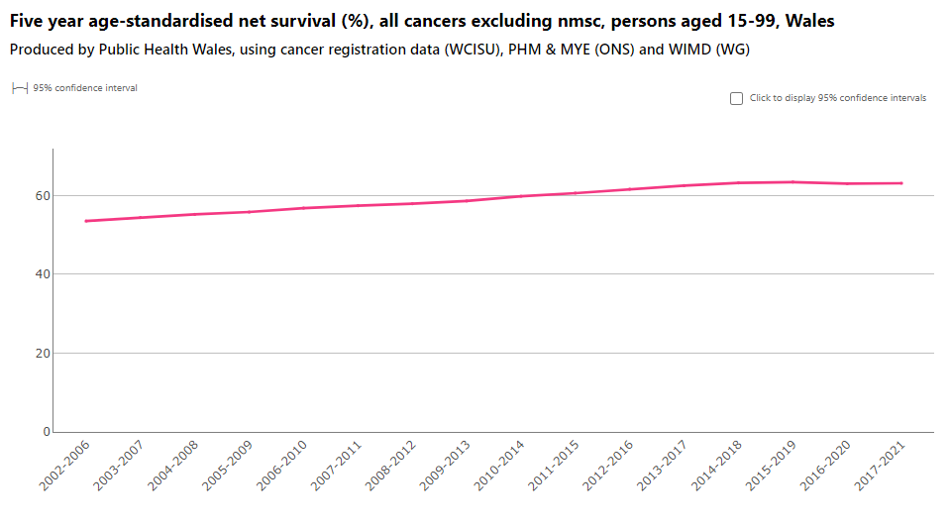

Chart 2
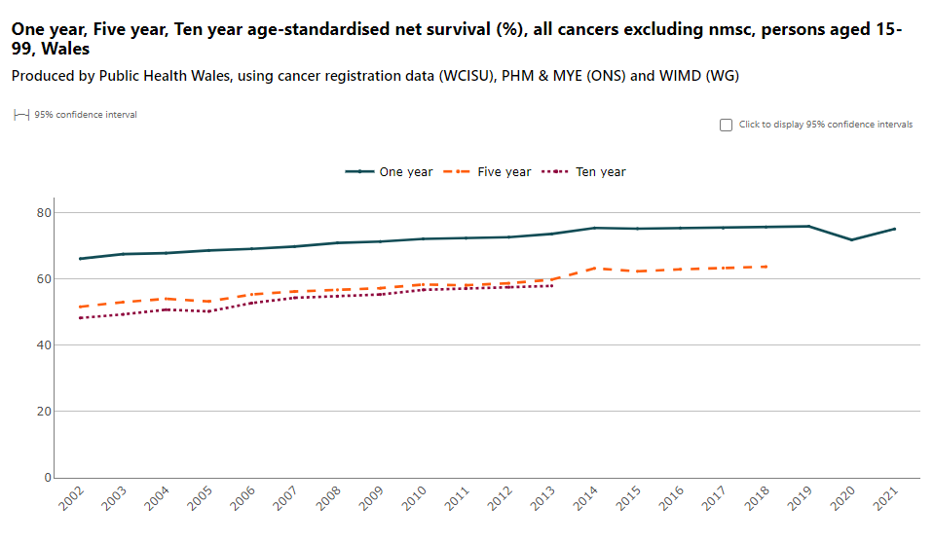
Chart 3
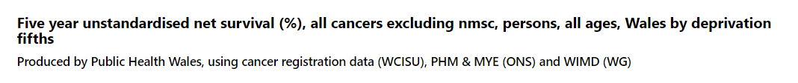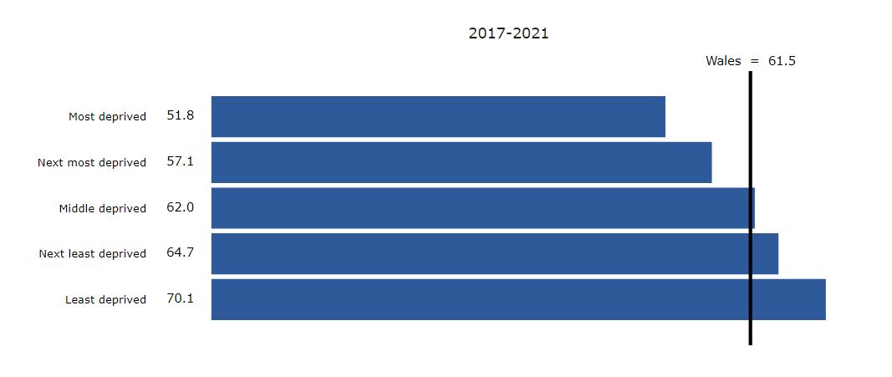

Chart 4
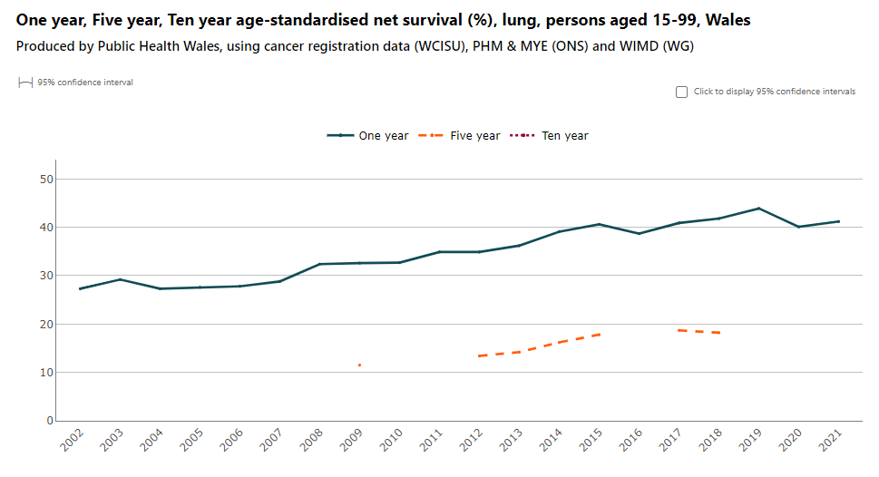

Chart 5
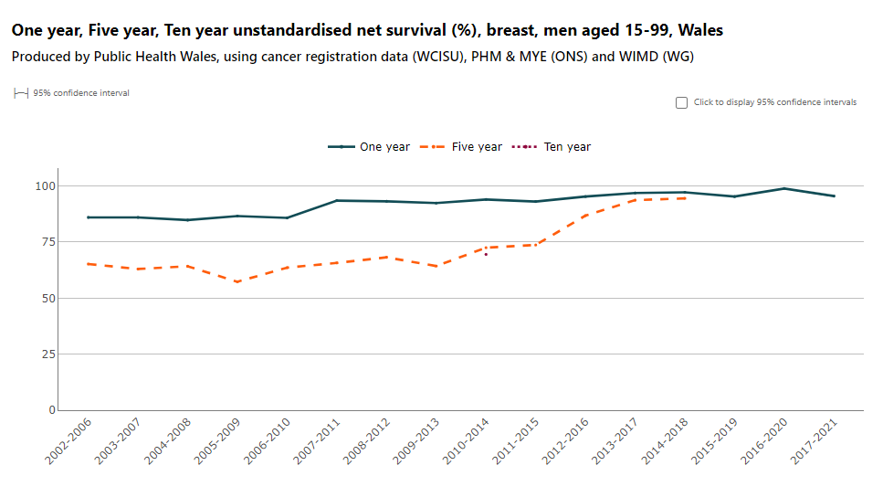

Chart 6
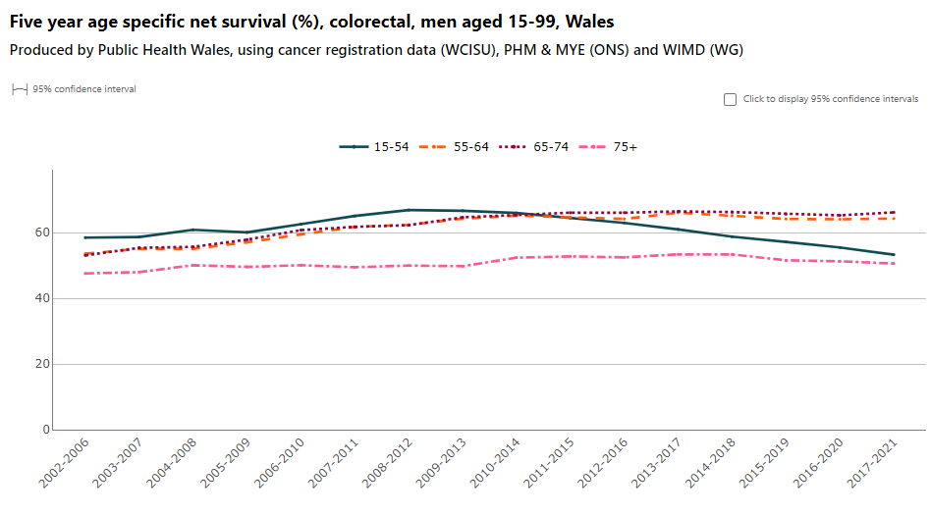

Chart 7
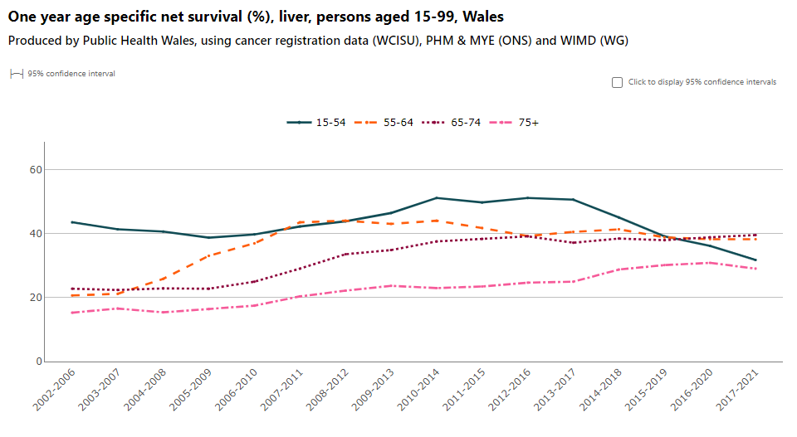

Chart 8
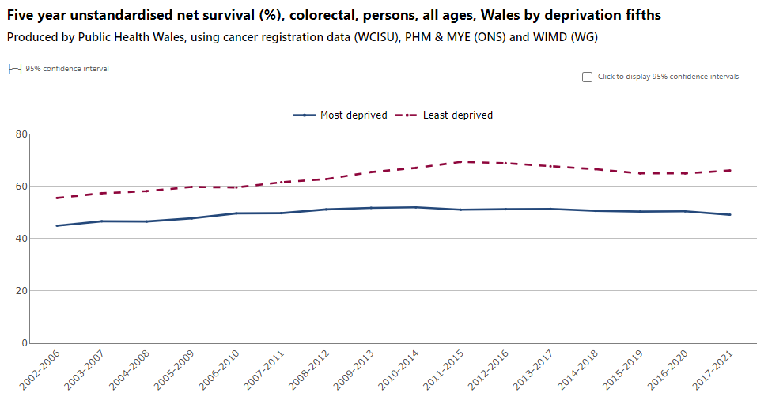
Chart 9
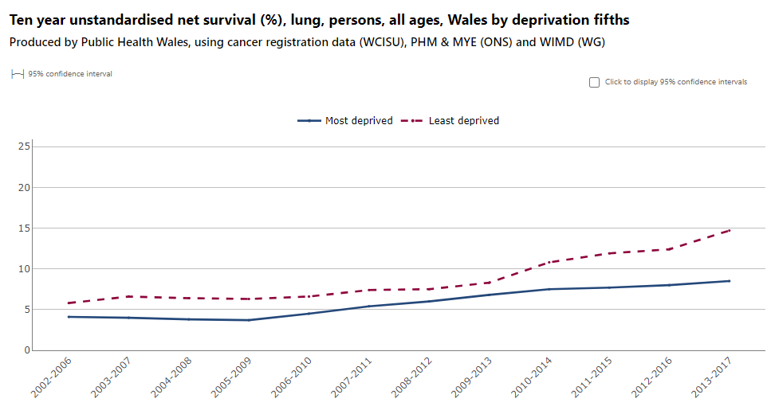

Chart 10
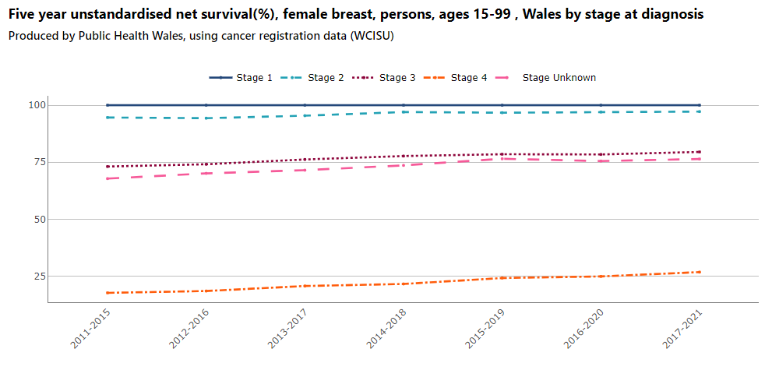
Chart 11
