
Welsh Cancer Intelligence and Surveillance Unit
Official Statistics: Cancer mortality in Wales, 2002 – 2024
Note:
- ‘All cancers combined’ refers to ‘All cancers excluding non-melanoma skin cancer (NMSC)’
- ‘Mortality rate’ refers to ‘Age-adjusted mortality rate’ unless stated otherwise
- ‘Post-pandemic’ refers to 2022 onwards
- ‘Pre-pandemic’ refers to pre-2020
* 2022 populations were used for 2023 and 2024 rate calculations as the latest years were unavailable. Therefore, please interpret rates for 2023 and 2024 with caution.
Headlines
Cancer remains the leading cause of mortality in Wales, accounting for a quarter of all deaths in 2024. There were 9,123 new cancer deaths in 2024.
Lung, bowel (colorectal), prostate and female breast cancers accounted for 4 in 10 cancer deaths in Wales in 2024, with lung cancer alone accounting for 2 in 10 cancer deaths.
Over half of all cancer deaths in Wales are in people aged 75 and over (Figure 1). This has been steadily rising from 48% in 2002 to 57% in 2024, as the population in Wales becomes more elderly.
Cancer mortality rates remain higher in the most deprived areas compared to the least deprived areas in Wales (Figure 2), with no real improvements over the reported period. The rate was 52% higher in the most deprived areas in 2024.
The picture of cancer mortality post-pandemic is still unclear. The lasting effects of the pandemic - especially among those now presenting with more advanced disease — may continue to influence mortality trends in the coming years, which we will keep monitoring and reporting on.
Please find our cancer mortality statistics on our Cancer Reporting Tool here: Cancer Reporting Tool - Official Statistics - Public Health Wales. The document is also available in Welsh here.
Other key findings
Pre-pandemic, the number of deaths from cancer in Wales gradually increased between 2002 and 2019. However, this is primarily driven by the ageing population with the mortality rate decreasing during this period (Figure 3).
Post-pandemic, the number of annual cancer deaths has plateaued, with the numbers now slightly less than the pre-pandemic level in 2019. The cancer mortality rate has also plateaued* (Figure 3). This is true for both men and women.
Men continue to have more deaths from cancer than women in Wales (4,895 deaths vs. 4,228 deaths in 2024), although the gap in the mortality rate is narrowing (Figure 3).
Lung cancer is responsible for around a fifth of all cancer deaths in Wales, making it the leading cause of cancer mortality. Half of all lung cancer deaths occur in people aged 75 and over, highlighting the disease’s association with age and long-term exposure to risk factors such as smoking.
There has been a long-term decline in lung cancer mortality, driven largely by falling rates in men (Figure 4). Between 2002 and 2024, the mortality rate in men decreased by 38%. For women, mortality rates remained relatively static over the same period. This reflects a complex picture — while incidence in women increased between 2002 and 2016, survival also improved, offsetting the potential rise in deaths.
Lung cancer shows the widest socioeconomic inequalities in mortality of the four most common cancers (Figure 5). In 2024, mortality rates were 2.5 times higher in the most deprived areas compared to the least deprived. This mirrors smoking rates, which are 3 times higher in the most deprived areas than in the least deprived (National Survey for Wales).
In 2024, bowel cancer had the second highest number of cancer deaths after lung cancer. However, it had the fourth highest mortality rate in Wales after lung, prostate and female breast cancers once adjusted for age. In 2024, 59% of bowel cancer deaths occurred in people aged 75 and over.
Female breast cancer also shows a plateauing of mortality rates in the post-pandemic years compared to a general decrease pre-pandemic, although fluctuations are seen year-on-year* (Figure 6). A slight increase can be seen in 2024. However, it is too early to say whether this is the start of an increasing trend.
In 2024, prostate cancers accounted for 7% of all cancer deaths (13% of male cancers), making it the 3rd leading cause of cancer mortality overall and 2nd leading cause for men. Prostate cancer mortality has an older age profile, with 77% of deaths occurring in people aged 75 and over.

Appendix

Figure 1: Cancer mortality by age group, all cancers excluding NMSC, count, persons, Wales, 2002-2024
Produced by Public Health Wales, using Public Health Mortality (PHM) from the Office for National Statistics (ONS)
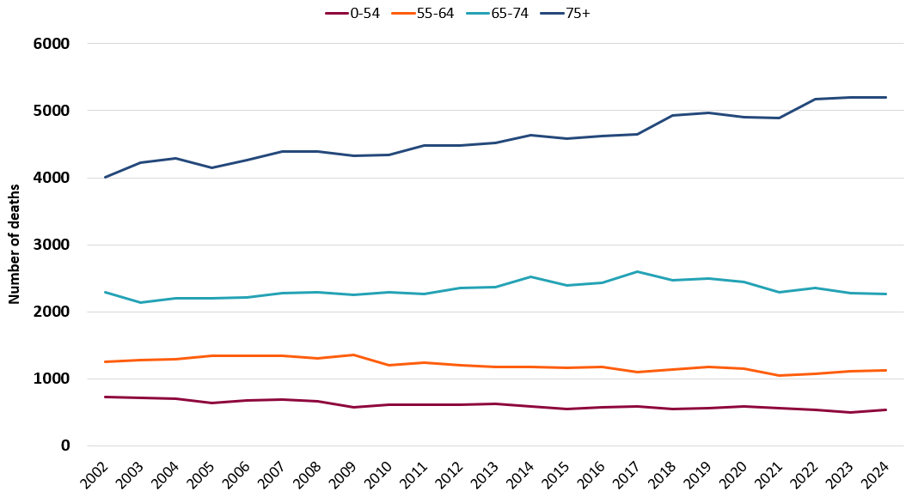

Figure 2: Cancer mortality by deprivation fifth, all cancers excluding NMSC, European age-standardised rate, persons, all ages, Wales, 2002-2024
Produced by Public Health Wales, using PHM and Mid-Year Estimates (MYE) from ONS
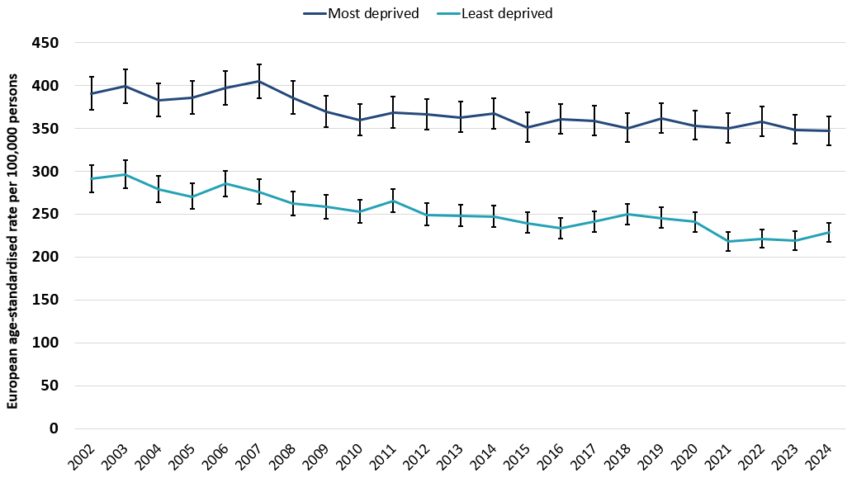

Figure 3: Cancer mortality by sex, all cancers excluding NMSC, European age-standardised rate, all ages, Wales, 2002-2024
Produced by Public Health Wales, using PHM and MYE from ONS
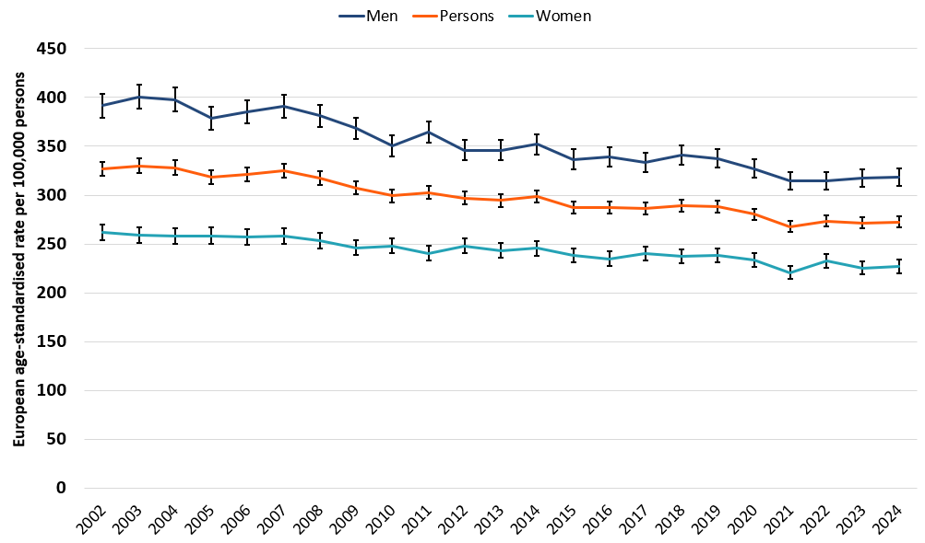

Figure 4: Cancer mortality by sex, lung cancer, European age-standardised rate, all ages, Wales, 2002-2024
Produced by Public Health Wales, using PHM and MYE from ONS
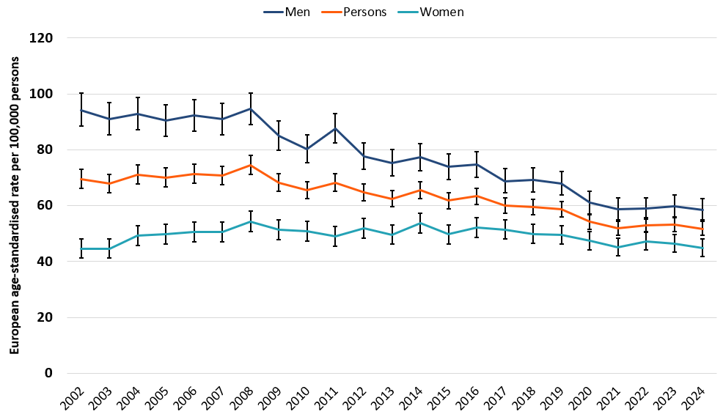

Figure 5: Cancer mortality by deprivation fifth, lung cancer, European age-standardised rate, persons, all ages, Wales, 2002-2024
Produced by Public Health Wales, using PHM and MYE from ONS
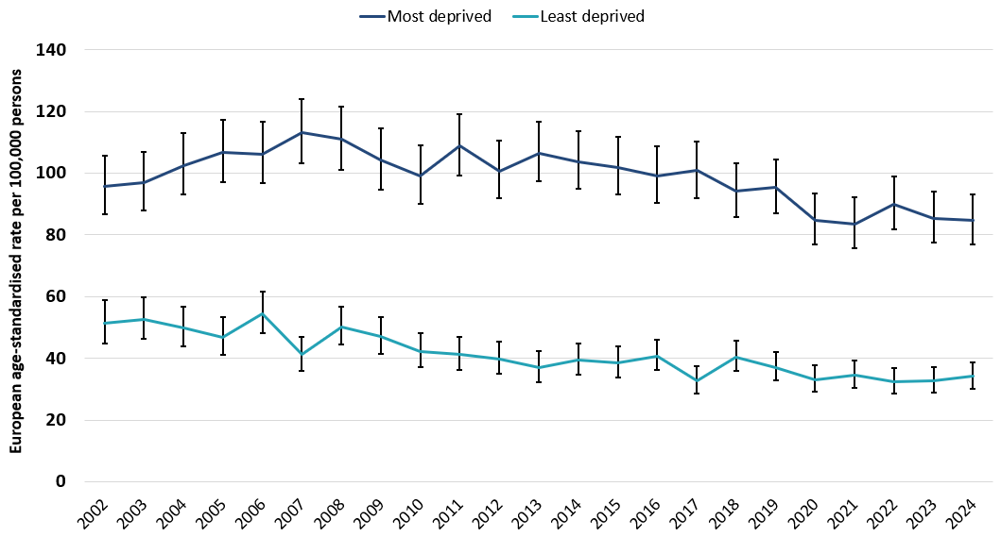

Figure 6: Cancer mortality, female breast cancer, European age-standardised rate, all ages, Wales, 2002-2024
Produced by Public Health Wales, using PHM and MYE from ONS
