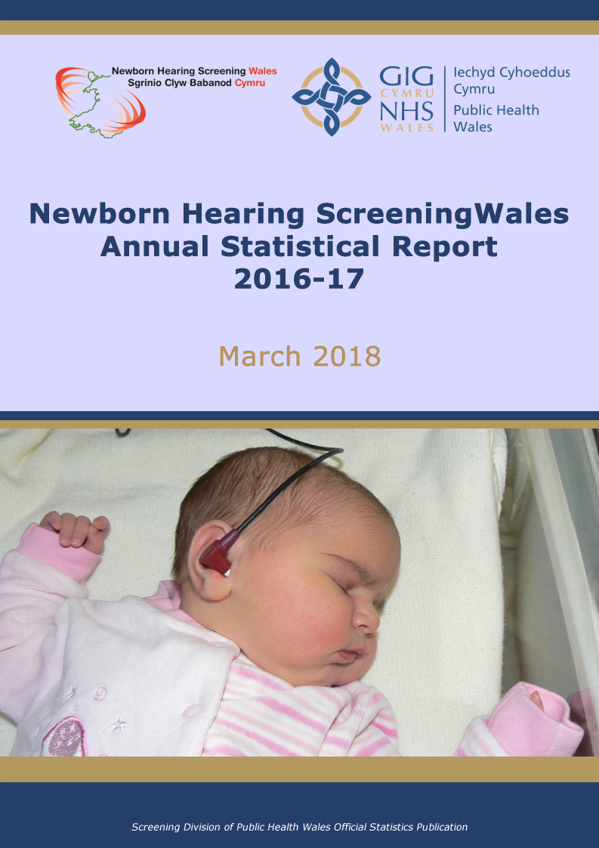

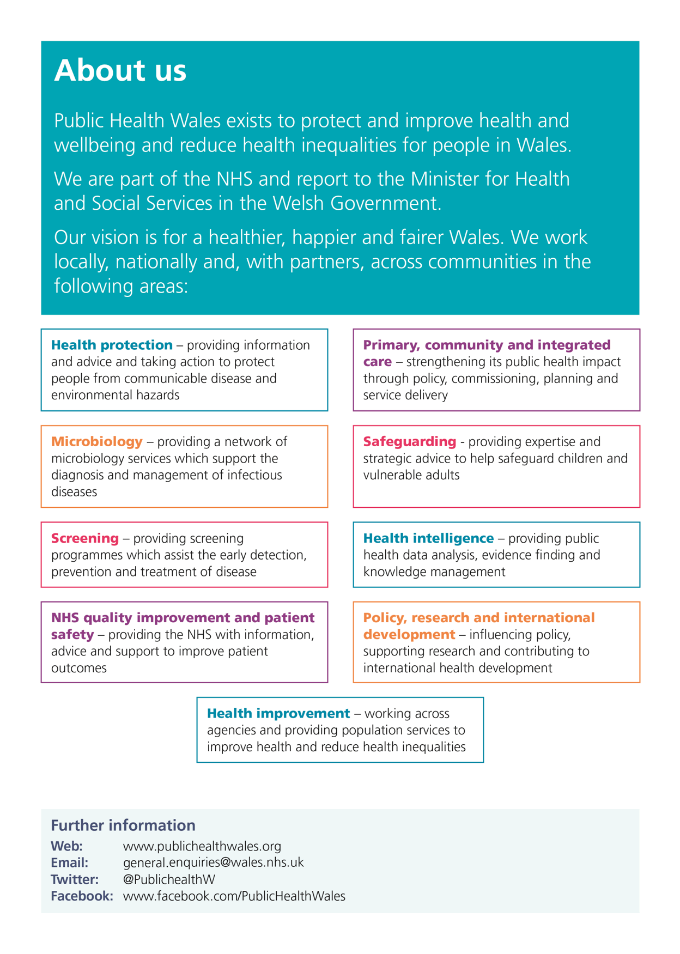

This report is a detailed summary of information on work undertaken by Newborn Hearing Screening Wales for the financial year from April 2016 to the end of March 2017. Results are reported by Health Board and are broken down to show the hospital location where screening or assessment has been carried out in some cases. Further details are available on request.

**Publication Details:**

**Title:** Newborn Hearing Screening Wales Annual Statistical Report 2016-17

**Date:** This report published 15 March 2018

**ISBN:** 978-1-910768-50-1

**For more information about this report contact:**

Helen Clayton, Lead Informatics and Data Services Manager,

Informatics Division, Floor 6, Public Health Wales, Number 2 Capital Quarter, Tyndall Street, Cardiff, CF10 4BZ

Tel: 029 2010 4405

Email: [Screening.Information@wales.nhs.uk](mailto:Screening.Information@wales.nhs.uk)

**Quality Assurance Statement**

Screening data records are constantly changing. The databases used by Public Health Wales Screening Division are updated on a daily basis when records are added, changed or removed (archived). This might relate to when a person has been identified as needing screening; has had screening results that need to be recorded, or  has a change of status and no longer needs screening respectively. Data is received from a large number of different sources with varying levels of accuracy and completeness. The Screening Division checks data for accuracy by comparing datasets – for example GP practice data – and corrects the coding data where possible. It should be noted that there are sometimes delays in data collection – for example a person might not immediately register with their GP. These delays will therefore affect the completeness of the data depending on individual circumstances. In addition, the reader should be aware that data is constantly updated and there might be slight readjustments in the numbers cited in this document year on year because of data refreshing.

© 2018 Public Health Wales NHS Trust

Material contained in this document may be reproduced without prior permission provided it is done so accurately and is not used in a misleading context.

Acknowledgement to Public Health Wales NHS Trust to be stated.

Copyright in the typographical arrangement, design and layout belongs to Public Health Wales NHS Trust.

Contents

1 Introduction 6

1.1 ‘Key messages’ for parents 6

1.2 Programme delivery 6

1.3 Screening pathway 7

2 Headline statistics 8

3 Data 10

3.1 Standards 10

3.2 Coverage 14

3.3 Timeliness of testing 15

3.4 Attendance at screening appointments for well babies 17

3.5 High risk babies completing screening 18

3.6 Screening Outcomes 19

3.7 Referrals for assessment 21

3.8 Attendance at assessment appointments - well and high risk babies 22

3.9 Time taken to start and complete assessments 23

3.10 Confirmation of hearing loss 25

3.11 Hearing aid fitting 26

3.12 Yield, Sensitivity, Specificity and Predictive Values 27

4 Definitions 28

5 Editorial Team and Pre-Release List 30

**Tables and Graphs**

Table 1: Programme performance standards 10

Table 2: Total number of live births by Health Board, babies eligible and suitable, number and proportion consented and tested 14

Graph 1: Well babies receiving first test in hospital within seven days of birth 15

Graph 2: Well babies receiving first test in the community within seven days of birth 15

Graph 3: Well babies completing screening within four weeks 16

Table 3.i: All Wales well baby attendance at screening appointments 17

Table 3.ii: Well baby attendance at screening appointments by Health Board 17

Graph 4: High risk babies completing screening 18

Table 4: Screening outcomes for well babies 19

Table 5: Screening outcomes for high risk babies 20

Table 6: Referrals for assessment 21

Table 7.i: All Wales attendance at assessment appointments (includes community clinic and hospital outside Wales) 22

Table 7.ii: Attendance at assessment appointments by Health Board 22

Table 8: Time taken to start assessment 23

Table 9.i: All Wales time taken to complete assessment (includes community clinic and hospital outside Wales) 24

Table 9.ii: Time taken to complete assessment by Hospital 24

Table 10: Number of babies with confirmed hearing loss born between 1st April 2016 and 31st March 2017 by Region 25

Table 11: Age of confirmation of hearing loss 25

Table 12: Age at hearing aid fitting 26

Graph 5: Hearing aid fitting within four weeks of identification of hearing loss by Health Board for 2016 – 2017 27

# Introduction

This is the thirteenth annual statistical report published by Newborn Hearing Screening Wales (NBHSW). This report covers data for babies born between 1st April 2016 and 31st March 2017.

One or two babies in every 1000 are born with a hearing loss that may affect their speech and language development. NBHSW was launched in 2003 and aims to identify these babies as early as possible, as evidence shows that introducing an early support programme before six months of age leads to better outcomes for speech and language development.

## 1.1 ‘Key messages’ for parents

* Newborn hearing screening identifies if your baby has a hearing loss that could affect their speech and language development without early support
* All babies born to women who live in Wales are offered newborn hearing screening soon after birth
* Screening is offered either while you are still in hospital after your baby’s birth, or a week or two later, usually in a local clinic
* Babies who have needed special care usually have their hearing screen before they go home
* The screening tests do not hurt or harm your baby
* Screening does not identify all hearing loss or prevent it at a later date
* Having your baby’s hearing screened is your choice. The newborn hearing screener and the leaflet “Your Baby’s Hearing Screening Test” will give you more information

## 1.2 Programme delivery

The Screening Division of Public Health Wales is responsible for managing, delivering and quality assuring the Newborn Hearing Screening programme. It is one of three programmes within Maternal and Child Screening, with an overall programme Lead. The programme is administered and delivered in three Regions across Wales and employs Programme and Regional Coordinators, Screening Managers, Screeners and administrative staff. The North Wales Region covers Betsi Cadwaladr University Health Board. The Mid and West Wales Region covers Abertawe Bro Morgannwg University Health Board, Hywel Dda University Health Board and Powys Teaching Health Board. The South East Wales Region covers Aneurin Bevan University Health Board, Cardiff and Vale University Health Board and Cwm Taf University Health Board. Screening of babies in Powys is shared across the 3 Regions factoring in geographical proximity and the most effective deployment of staff and resources. The programme also has an external Quality Assurance Advisor. Diagnostic assessment and early support is provided by a clinical network of audiologists and medical leads in each Health Board.

## 1.3 Screening pathway

Babies who are eligible for screening are identified in each Health Board from midwife birth notifications. Newborn Hearing Screeners offer screening tests to babies who are in hospital, and in community clinics when it has not been possible to perform the screen in hospital. The majority of babies in neonatal intensive care or special baby care units are screened before discharge.

Babies who have a clear response in both ears on screening are discharged from the programme. Those who do not show a clear response in both ears at the end of the screening process are referred for diagnostic assessment. Babies who miss or do not complete screening or assessment are offered a hearing test at nine months of age by their local Health Board.

Parents of babies who have a clear response in one ear are offered the opportunity to make arrangements for a further hearing test.

Diagnostic assessments are undertaken by audiologists within Health Boards. Babies identified with a hearing loss are fitted with hearing aids if appropriate and are supported by a multi-disciplinary early years team. The team includes a specialist doctor, teacher of the deaf, audiologist and speech and language specialist.

More information is available at [www.newbornhearingscreening.wales.nhs.uk](http://www.newbornhearingscreening.wales.nhs.uk)

# Headline statistics

**Screening**

* The coverage rates show that screening is offered to 100% of eligible babies with 99.5% tested, with very few parents declining the screen
* Across Wales, 75.1% of well babies are screened within seven days of birth
* 100% of high risk babies complete the screening programme and 98.7% of well babies complete screening within four weeks

**Assessment**

* 1.3% of babies screened are referred for assessment
* 91.9% of babies referred for assessment complete the assessment process within three months
* The time taken to start the assessment process is within the allocated time for 97.3% of well babies (within four weeks of final screening test) and 98.4% of high risk babies (within eight weeks of final screening test)
* 95.4% of babies referred receive an assessment

**In April 2016 to March 2017**

* The number of births across Wales was 33,884
* The number of babies eligible and suitable for screening was 32,998
* The number of babies whose parents consented to screening and were tested was 32,845
* For well babies 93.3% of screening appointments were attended. 6.6% of screening appointments were not attended or were cancelled and 0.1% declined
* 78.4% of assessment appointments were attended
* 4.6% of babies referred for assessment were not seen due to non-attendance

**Outcomes**

* In babies born between 1st April 2016 and 31st March 2017, the prevalence of diagnosed permanent hearing loss greater than 40 dBHL is 0.9 per 1000 of those babies screened. This is consistent with the prevalence since the start of the programme.
* The mean age of confirmation of hearing loss was 10.0 weeks
* The mean age of hearing aid fitting was 14.7 weeks
* 92.6% of babies were fitted with hearing aids within four weeks of confirmation of hearing loss
* Since the introduction of universal newborn hearing screening in 2003, the prevalence of permanent significant bilateral hearing loss (defined as greater than 40 dBHL) in children under 5 years is 1.4 per 1000.

# Data

## Standards

This table outlines the standards set by the screening programme to monitor performance.

Table 1: Programme performance standards

|  |  |  |  |  |  |  |  |
| --- | --- | --- | --- | --- | --- | --- | --- |
| **NBHSW Standards – Screening Programme** | | | | | | | |
|  | **Objective** | | **Criteria** | **Minimum Standard** | **Actual Value** | **Met** | **Variance From 2015/16** |
| 1 | To maximise the number of babies who are offered screening | | The percentage of eligible babies who are offered screening | >= 99% of all babies | **100%** | **Yes** | **=**  **None** |
| 2 | To maximise the number of babies who enter the screening programme | | The percentage of eligible babies who enter the screening programme | >=95% of all babies | **99.5%** | **Yes** | **=**  **None** |
| 3 | To screen most babies within the first week of life | | The percentage of babies receiving the first screening test within the first week of life | >70% of those well babies screened | **75.1%** | **Yes** | **+1.6%** |
| 4 | To maximise the number of babies who complete the screening programme within the allocated time periods | | Well babies - the percentage of babies who complete the screening programme within 4 weeks | >=90% of all babies entering the screening programme | **98.7%** | **Yes** | **=**  **None** |
| High risk babies in SCBU > 48 hours - the percentage of babies who complete the screening programme | >=95% of all high risk babies entering the screening programme | **100%** | **Yes** | **=**  **None** |
| All babies - the percentage of babies who complete the screening programme | >=95% of all babies entering the screening programme | **100%** | **Yes** | **=**  **None** |
|  | | **Objective** | **Criteria** | **Minimum Standard** | **Actual Value** | **Met** | **Variance From 2015/16** |
| 5 | | To minimise the number of babies requiring a diagnostic ABR who have normal hearing | Those babies who are referred for diagnostic ABR with normal hearing | <3% of all those who complete assessment and are found to have normal hearing as a proportion of all babies screened | **0.8%** | **Yes** | **+0.2%** |
| 6 | | To start the assessment procedure (diagnostic ABR) in appropriate cases within the allocated time | Referred well babies that start assessment procedure (Diagnostic ABR) in appropriate cases within 4 weeks | >=90% of those referred | **97.3%** | **Yes** | **+0.1%** |
| Referred high risk babies that start assessment procedure (Diagnostic ABR) in appropriate cases within 8 weeks | >=90% of those referred | **98.4%** | **Yes** | **+1.9%** |
| 7 | | To complete the assessment procedure within the allocated time | Those babies that complete the assessment procedure within 3 months (in appropriate cases) | >=85% of those requiring assessment | **91.9%** | **Yes** | **-1.3%** |
| 8 | | To minimise the number of babies who do not receive screening | The percentage of offered screening appointments which are not attended (well babies) | <=3% (includes DNA appointments only) | **2.3%** | **Yes** | **=**  **None** |

|  |  |  |  |  |  |  |
| --- | --- | --- | --- | --- | --- | --- |
|  | **Objective** | **Criteria** | **Minimum Standard** | **Actual Value** | **Met** | **Variance From 2015/16** |
| 9 | To minimise the number of babies who do not receive screening | The percentage of offered screening appointments which are declined (well babies) | < 1% of well babies | **0.1%** | **Yes** | **=**  **None** |
| 10 | To refer an appropriate number of babies for assessment | The percentage of screened babies referred for assessment | Between 1-2% | **1.3%** | **Yes** | **+0.2%** |
| 11 | To minimise the number of babies who do not receive an assessment | The percentage of offered assessment appointments which are not attended | < 10% (DNA appointments only) | **11.1%** | **No** | **+0.4%** |
| 12 | To minimise the number of babies who do not receive an assessment | The percentage of babies who are referred for assessment and not seen | < 5% | **4.6%** | **Yes** | **+1.6%** |
| 13 | To refer an appropriate number of babies for a repeat screen from audiology (one ear clear response, well babies) | The percentage of screened babies referred | < 1% | **0.96%** | **Yes** | **+0.16%** |

|  |  |  |  |  |  |  |
| --- | --- | --- | --- | --- | --- | --- |
|  | **Objective** | **Criteria** | **Minimum Standard** | **Actual Value** | **Met** | **Variance From 2015/16** |
| 16 | To provide information to promote informed choice. | The percentage of mothers who provide positive responses on the information subscale of a user survey. The criteria for inclusion in the survey may be selected to compare the experiences of families | >90% positive responses from mothers completing the user survey | **99%** | **Yes** | **N/A**  No survey completed |
| 17 | To evaluate mothers’ satisfaction with the screening programme | The percentage of mothers who provide positive responses on a general satisfaction subscale of a user survey. The criteria for inclusion in the survey may be selected to compare the experiences of families. | >= 95% of mothers completing user survey questionnaire. | **95%** | **Yes** | **N/A**  No Survey  completed |

## Coverage

*Standard 1: ≥ 99% of eligible babies are offered screening*

*Standard 2: ≥ 95% of eligible babies enter the screening programme*

Table 2: Total number of live births by Health Board, babies eligible and suitable, number and proportion consented and tested

|  |  |  |  |  |  |  |
| --- | --- | --- | --- | --- | --- | --- |
| **Health Board** | **Births** | **Eligible**  **& Suitable** | **Consented**  **&**  **Tested** | **% Tested of Eligible & Suitable** | **Total Offered** | **% Offered of Eligible and Suitable** |
| Abertawe Bro Morgannwg University Health Board | 5556 | 5454 | 5430 | 99.6 | 5454 | 100.0% |
| Aneurin Bevan University Health Board | 6602 | 6410 | 6395 | 99.8 | 6410 | 100.0% |
| Betsi Cadwaladr University Health Board | 7459 | 7244 | 7210 | 99.5 | 7244 | 100.0% |
| Cardiff and Vale University Health Board | 5914 | 5693 | 5652 | 99.3 | 5692 | 99.98% |
| Cwm Taf University Health Board | 3403 | 3348 | 3334 | 99.6 | 3348 | 100.0% |
| Hywel Dda University Health Board | 3693 | 3635 | 3617 | 99.5 | 3635 | 100.0% |
| Powys Teaching Health Board | 1257 | 1214 | 1207 | 99.4 | 1214 | 100.0% |
| **All Wales** | **33884** | **32998** | **32845** | **99.5** | **32997** | **100.0%** |

This standard is met for babies across all of Wales.

## 3.3 Timeliness of testing

*Standard 3: >70% of well babies screened receive the first screening test within the first week of life*

Graph 1: Well babies receiving first test in hospital within seven days of

birth



Graph 2: Well babies receiving first test in the community within seven days of birth



The all Wales average for well babies having an initial test within seven days of birth is 75.1% which is an increase of 1.6% on the previous year.

In some areas it is not possible to perform an initial screen in hospital. Home births, early discharges from hospital and the limited hospital screening at weekends affect this figure as there is no hospital screening opportunity.

*Standard 4: ≥90% of well babies entering the screening programme complete screening within four weeks*

**Graph** **3:** Well babies completing screening within four weeks



Twenty seven babies were over six weeks old before their initial test. The figure is similar to the previous year. The service continues to encourage attendance by reviewing clinic locations and timings in relation to convenience for parents and agreeing appointments by telephone.

Across Wales, 98.7% of well babies completed screening within four weeks which is the same as the previous year. For the majority of Powys resident babies there is no hospital screening opportunity however following a review of frequency of clinics, the standard for the percentage of babies completing screening within four weeks has been comfortably achieved at 96.7% which continues to increase year on year with a further increase of 1.3% from the last report. This increase also shows the impact of changing to a hospital screening model in Shropshire which has resulted in more Powys babies being screened in Telford.

## 3.4 Attendance at screening appointments for well babies

*Standard 8: ≤ 3% of offered screening appointments not attended (DNA appointments only)*

*Standard 9: < 1% of offered screening appointments declined*

Table 3.i: All Wales well baby attendance at screening appointments

|  |  |  |  |  |  |
| --- | --- | --- | --- | --- | --- |
| **Screening Location** | **Attended (%)** | **DNA (%)** | **Cancelled (%)** | **Parent Declined (%)** | **Total** |
| All Wales | 33713  (93.3%) | 816  (2.3%) | 1569  (4.3%) | 46  (0.1%) | 36144 |

The standard for DNA appointments has been achieved this year at 2.3%. Cancelled appointments have increased slightly at 4.3% despite efforts to agree convenient appointments with the parents at the point of making them and ensure maximum convenience with clinic locations and timings.

Table 3.ii: Well baby attendance at screening appointments by Health

Board

|  |  |  |  |  |
| --- | --- | --- | --- | --- |
| **Screening Location** | **Attended (%)** | **DNA or Cancelled (%)** | **Parent Declined (%)** | **Total** |
| Abertawe Bro Morgannwg University Health Board | 92.5% | 7.4% | 0.1% | 6276 |
| Aneurin Bevan University Health Board | 93.2% | 6.7% | 0.1% | 6613 |
| Betsi Cadwaladr University Health Board | 95.9% | 4.0% | 0.1% | 7879 |
| Cardiff and Vale University Health Board | 92.7% | 7.3% | 0.1% | 6667 |
| Cwm Taf University Health Board | 93.8% | 6.1% | 0.1% | 4103 |
| Hywel Dda University Health Board | 90.7% | 9.0% | 0.3% | 3746 |
| Powys Teaching Health Board | 88.6% | 10.8% | 0.6% | 860 |

## 3.5 High risk babies completing screening

*Standard 4: ≥ 95% of all high risk babies entering the screening programme complete screening*

Graph 4: High risk babies completing screening



100% of high risk babies completed screening.

## 3.6 Screening Outcomes

*Standard 10: Between 1 and 2 % of screened babies referred for assessment*

*Standard 13: <1 % of screened babies referred to audiology for repeat screen (well babies with a one ear clear response)*

**Table 4:** Screening outcomes for well babies

|  |  |  |  |  |
| --- | --- | --- | --- | --- |
| **Screening Location** | **Discharged** | **Referred for Assessment** | **Referred to Audiology** | **Referred for Behavioural Test** |
| Outside Wales | 99.6 | 0.2 | 0.1 | 0.1 |
| Abertawe Bro Morgannwg University Health Board | 98.4 | 0.6 | 0.6 | 0.4 |
| Aneurin Bevan University Health Board | 96.6 | 1.1 | 1.5 | 0.9 |
| Betsi Cadwaladr University Health Board | 97.9 | 0.7 | 0.8 | 0.7 |
| Cardiff and Vale University Health Board | 97.0 | 1.1 | 1.5 | 0.4 |
| Cwm Taf University Health Board | 97.6 | 1.1 | 0.8 | 0.5 |
| Hywel Dda University Health Board | 98.3 | 0.7 | 0.6 | 0.4 |
| Powys Teaching Health Board | 96.8 | 0.9 | 0.5 | 1.8 |
| **All Wales Total** | **97.6** | **0.8** | **0.96** | **0.6** |

The above table excludes high risk babies and therefore shows that 0.8% of well babies are referred for Assessment following bilateral no clear response. The standard for referrals to audiology is being met overall.

Table 5: Screening outcomes for high risk babies

|  |  |  |  |
| --- | --- | --- | --- |
| **Screening Location** | **Discharged** | **Referred for Assessment** | **Referred for Behavioural Test** |
| Outside Wales | 94.5 | 3.9 | 1.6 |
| Abertawe Bro Morgannwg University Health Board | 89.3 | 9.9 | 0.7 |
| Aneurin Bevan University Health Board | 89.8 | 8.2 | 2.0 |
| Betsi Cadwaladr University Health Board | 89.8 | 7.9 | 2.4 |
| Cardiff and Vale University Health Board | 88.1 | 11.2 | 0.7 |
| Cwm Taf University Health Board | 94.6 | 4.5 | 0.9 |
| Hywel Dda University Health Board | 92.4 | 6.1 | 1.5 |
| Powys Teaching Health Board | 83.3 | 0.0 | 16.7 |
| **All Wales Total** | **90.7** | **7.8** | **1.5** |

Although the overall referrals for assessment meet the expected standard of 1-2% of babies screened, a higher percentage of high risk babies than well babies are referred for assessment. Referrals for assessment for high risk babies include those with no clear response in one ear as well as those with bilateral no clear response.

## 3.7 Referrals for assessment

*Standard 10: Between 1 and 2% of screened babies referred for assessment*

Table 6: Referrals for assessment

|  |  |  |  |
| --- | --- | --- | --- |
| **Location** | **Total Screened** | **Referred for assessment** | **% of Babies Referred** |
| Abertawe Bro Morgannwg University Health Board | 5430 | 70 | 1.3% |
| Aneurin Bevan University Health Board | 6395 | 93 | 1.5% |
| Betsi Cadwaladr University Health Board | 7210 | 77 | 1.1% |
| Cardiff and Vale University Health Board | 5652 | 84 | 1.5% |
| Cwm Taf University Health Board | 3334 | 49 | 1.5% |
| Hywel Dda University Health Board | 3617 | 42 | 1.2% |
| Powys Teaching Health Board | 1207 | 11 | 0.9% |
| **All Wales** | **32845** | **426** | **1.3%** |

The above breakdown is based on screening location rather than assessment location, it should be noted that some babies will be assessed in a different Health Board area from where they were screened. There were an additional 28 babies referred directly for assessment as a result of a medical decision without first completing screening.

## 3.8 Attendance at assessment appointments - well and high risk babies

*Standard 11: <10% offered assessment appointments not attended (DNA appointments only)*

Table 7.i: All Wales attendance at assessment appointments (includes community clinic and hospital outside Wales)

|  |  |  |  |  |  |
| --- | --- | --- | --- | --- | --- |
| **Health Board** | **Attended** | **Cancelled** | **Parent Declined** | **DNA** | **Total** |
| All Wales Total | 558  (78.4%) | 69  (9.7%) | 6  (0.8%) | 79  (11.1%) | 712 |

Table 7.ii: Attendance at assessment appointments by Health Board

|  |  |  |
| --- | --- | --- |
| **Health Board** | **Attended** | **% DNA** |
| Abertawe Bro Morgannwg University Health Board | 85 | **11.5%** |
| Aneurin Bevan University Health Board | 126 | **10.8%** |
| Betsi Cadwaladr University Health Board | 100 | **9.1%** |
| Cardiff and Vale University Health Board | 123 | **13.0%** |
| Cwm Taf University Health Board | 71 | **14.3%** |
| Hywel Dda University Health Board | 47 | **6.9%** |

This standard is not being met and there was an increase in DNAs of 0.4% from the previous year. Work is continuing to reduce the percentage of DNAs to the assessment appointments.

## 3.9 Time taken to start and complete assessments

*Standard 6: ≥ 90% well babies start assessment within four weeks*

*Standard 6: ≥ 90% of high risk babies start assessment within eight weeks*

Table 8: Time taken to start assessment

|  |  |  |
| --- | --- | --- |
|  | **% Starting within Set Timescales** | |
| **Assessment Location** | **Well** | **High Risk** |
| Glan Clwyd Hospital | 100.0% | 100.0% |
| Gwynedd Hospital | 88.9% | 91.7% |
| Hospital Outside Wales | 100.0% | 100.0% |
| Mountain Ash Hospital | 100.0% | 100.0% |
| Neath Port Talbot Hospital | 100.0% | 100.0% |
| Nevill Hall Hospital | 100.0% | 100.0% |
| Princess of Wales Hospital | 100.0% | 92.9% |
| Royal Glamorgan Hospital | 94.4% | 100.0% |
| Royal Gwent Hospital | 95.9% | 100.0% |
| Singleton Hospital | 95.5% | 94.7% |
| UHW | 98.4% | 100.0% |
| West Wales General Hospital | 100.0% | 100.0% |
| Wrexham Maelor Hospital | 95.8% | 100.0% |
| Ysbyty Cwm Cynon Outpatients Dept | 100.0% | 100.0% |
| **All Wales Total** | **97.3%** | **98.4%** |

All Wales figures show a slight improvement on last year in both the well baby and high risk groups which were 97.2% and 96.5% respectively in the last report.

*Standard 7: ≥ 85% babies complete assessment within three months (if appropriate)*

*Standard 12: < 5% of babies referred for assessment are not seen*

Table 9.i: All Wales time taken to complete assessment (includes community clinic and hospital outside Wales)

|  |  |  |  |  |  |
| --- | --- | --- | --- | --- | --- |
| **Assessment Location** | **Never Attended** | **Attended then DNA'd final test** | **Not Yet Complete** | **Completed < 3 Months** | **Completed 3+ Months** |
| All Wales Total | 4.6% | 1.5% | 0.0% | 91.9% | 2.0% |

Both standards continue to be met but with a further slight decrease of 1.6% compared with last year’s figures for babies completing assessment within three months but an increase of 1.6% in the number of babies referred but never seen.

Table 9.ii: Time taken to complete assessment by Hospital

|  |  |  |  |  |  |
| --- | --- | --- | --- | --- | --- |
| **Assessment Location** | **Never Attended** | **Attended then DNA'd final test** | **Not Yet Complete** | **Completed < 3 Months** | **Completed 3+ Months** |
| Glan Clwyd Hospital | 0.0 | 0.0 | 0.0 | 100.0 | 0.0 |
| Gwynedd Hospital | 9.5 | 4.8 | 0.0 | 76.2 | 9.5 |
| Hospital Outside Wales | 0.0 | 0.0 | 0.0 | 100.0 | 0.0 |
| Mountain Ash Hospital | 0.0 | 3.6 | 0.0 | 96.4 | 0.0 |
| Neath Port Talbot Hospital | 10.0 | 10.0 | 0.0 | 80.0 | 0.0 |
| Nevill Hall Hospital | 0.0 | 0.0 | 0.0 | 100.0 | 0.0 |
| Princess of Wales Hospital | 0.0 | 0.0 | 0.0 | 89.5 | 10.5 |
| Royal Glamorgan Hospital | 11.1 | 3.7 | 0.0 | 85.2 | 0.0 |
| Royal Gwent Hospital | 2.5 | 0.0 | 0.0 | 93.8 | 3.7 |
| Singleton Hospital | 2.4 | 0.0 | 0.0 | 97.6 | 0.0 |
| UHW | 10.1 | 2.0 | 0.0 | 85.9 | 2.0 |
| West Wales General Hospital | 0.0 | 2.4 | 0.0 | 97.6 | 0.0 |
| Wrexham Maelor Hospital | 2.9 | 0.0 | 0.0 | 97.1 | 0.0 |
| Ysbyty Cwm Cynon Outpatients Dept | 50.0 | 0.0 | 0.0 | 50.0 | 0.0 |

## 3.10 Confirmation of hearing loss

The total number of babies identified with a bilateral moderate or greater permanent hearing loss in Wales born between 1st April 2016 and 31st March 2017 is 32.

Table 10: Number of babies with confirmed hearing loss born between 1st April 2016 and 31st March 2017 by Region

|  |  |
| --- | --- |
| **Division** | **Total** |
| North Wales | 5 |
| Mid & West Wales | 8 |
| South Wales | 19 |
| **All Wales Total** | **32** |

Table 11 shows average and median age of confirmation of hearing loss in babies born between 1st April 2016 and 31st March 2017.

Table 11: Age of confirmation of hearing loss

|  |  |  |
| --- | --- | --- |
| **Health Board** | **Average (weeks)** | **Median (weeks)** |
| Abertawe Bro Morgannwg University Health Board | 11.0 | 8.9 |
| Aneurin Bevan University Health Board | 8.0 | 6.7 |
| Betsi Cadwaladr University Health Board | 7.5 | 7.4 |
| Cardiff and Vale University Health Board | 15.7 | 11.3 |
| Cwm Taf University Health Board | 6.9 | 7.1 |
| Hywel Dda University Health Board | 8.5 | 8.5 |
| **All Wales Total** | **10.0** | **7.9** |

## 3.11 Hearing aid fitting

**Average and median age of hearing aid fitting by Health Board**

Table 12 shows average and median age of hearing aid fitting of babies born between 1st April 2016 and 31st March 2017. These figures allow for prematurity.

Table 12: Age at hearing aid fitting

|  |  |  |
| --- | --- | --- |
| **Health Board** | **Average (weeks)** | **Median (weeks)** |
| Abertawe Bro Morgannwg University Health Board | 11.1 | 8.4 |
| Aneurin Bevan University Health Board | 15.3 | 9.1 |
| Betsi Cadwaladr University Health Board | 10.0 | 9.6 |
| Cardiff and Vale University Health Board | 21.6 | 16.1 |
| Cwm Taf University Health Board | 8.0 | 8.0 |
| Hywel Dda University Health Board | 10.1 | 10.1 |
| **All Wales Total** | **14.7** | **9.6** |

The figures in both Tables 11 and 12 are affected by small numbers of identified babies in each Health Board. Clinical and social factors can influence timing of both confirmation of hearing loss and hearing aid fitting.

Graph 5: Hearing aid fitting within four weeks of identification of hearing loss by Health Board for 2016 – 2017

92.6% of babies in Wales are fitted within four weeks of identification.



Timely hearing aid fitting for babies identified with a hearing loss can be influenced by clinical and social factors and does not always reflect issues with service delivery.

## 3.12 Yield, Sensitivity, Specificity and Predictive Values

The yield from the programme indicates that the number of cases detected related to the number of babies screened is 1:784. The sensitivity of the programme is 92.0% with a specificity of 98.8%. The positive predictive value of the screen is 9.7%.

# Definitions

This section provides further detail on the calculations used in this report.

**Health Board**

Screening data is taken from the All Wales New Born Hearing system.  Babies are allocated to Health Boards based on residence, unless stated that the location is based on where the screening took place. We do not hold data on place of birth.

**Eligible babies**

Babies born to mothers who are temporarily or permanently resident in Wales at the time of birth and babies that move into Wales under the age of 6 weeks.

**Suitable for testing**

Babies are suitable for testing when they and their mother are well. Babies born prematurely are suitable for testing when the baby’s gestational age is more than 36 weeks.

**Uptake**

The proportion of eligible and suitable babies who are tested.

**High risk babies**

Babies who have spent more than 48 hours in a Special Care Baby Unit/Neonatal Intensive Care Unit.

**Referral for re-screen in Audiology**

Parental request for re-screen following a one ear clear response result for a well baby on completion of screening.

**Targeted Behavioural Test**

A hearing assessment for babies undertaken by audiologists at a developmental age of 9 months. This is offered to babies who do not complete screening or assessment, babies whose parents request follow up for a well baby with a one ear clear response, and babies who have identified risk factors for hearing loss.

**Yield**

The number of babies with a follow-up outcome that meets the definition of the target case, per 1000 babies screened. The target case for NBHSW is bilateral permanent hearing loss of a level greater than 40 dBHL across the frequency range of 500Hz, 1KHz, 2kHz and 4KHz.

**Sensitivity**

The number with confirmed hearing loss that were correctly identified as positive on screening.

**Specificity**

The number confirmed with no hearing loss that were correctly identified as negative on screening.

**Predictive Value**

The proportion of referred cases following a positive screening test which are found to have confirmed hearing loss.

# Editorial Team and Pre-Release List

**Editorial Team:**

Jacqui Evans Newborn Screening Manager, North Wales

Meg Shepherd Programme Co-ordinator, North Wales

Amanda Roberts Programme Co-ordinator, South Wales

Jackie Harding Regional Co-ordinator, Mid and West Wales

Ruth Lawler Head of Programme, Maternal and Child Screening

Dr Sikha de Souza Consultant in Public Health

Dr Sharon Hillier Acting Director of Screening Division

Helen Clayton Lead Informatics and Data Services Manager

Kate Lilly Senior Information Officer

Christie Redman Information Officer

**Pre-Release List:**

These Official Statistics were sent to the people on this pre-release list five working days prior to publication in accordance with the Pre-publication Official Statistics Order Access (Wales) 2009.

**Public Health Wales**

Jan Williams Chair

Dr Tracey Cooper Chief Executive

Dr Quentin Sandifer Executive Director of Public Health Services and Medical Director

Anna Ashman Communications Manager, Public Health Wales

**Welsh Government**

Dr Frank Atherton Chief Medical Officer

Dr Andrew Goodall Director General - Health and Social Services

Irfon Rees Deputy Director - Public Health Division

Rebekah Tune Head of Strategic Communications and Marketing

Prof Chris Jones Deputy Chief Medical Officer / Medical Director NHS Wales

Dr Heather Payne Senior Medical Officer for Maternal & Child Health

Helen Tutt Senior Executive Manager – Health Protection Services

Stephen Thomas Head of Health Protection Branch

Sarah O’Sullivan-Adams Head of Sensory Health