Position Statement: PRID/S/001
Date of Publication: 29/11/2016
Date of Review: November 2017


Public Health Wales supports the Introduction of Graduated Driving Licencing (GDL) For New Drivers in Great Britain

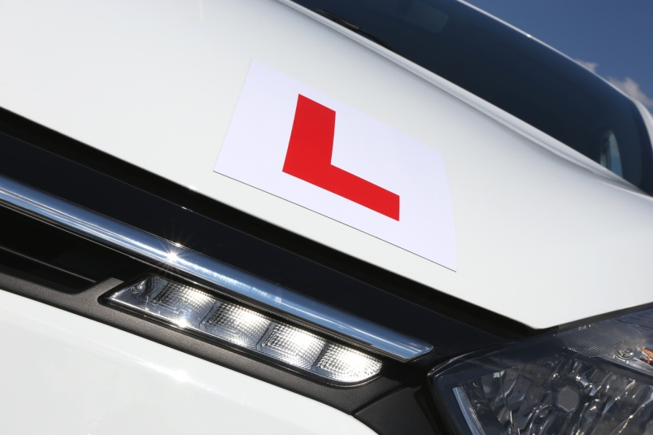

Key Points
- In Great Britain, around 12% of crashes involve new young drivers aged 17 to 19 years, but this group only holds around 2% of driving licences.
- In Great Britain, each year, Graduated Driver Licensing (GDL) could prevent 433 deaths and serious injuries, 4478 casualties and save the economy £200M.
- In Wales, each year, GDL could prevent 27 deaths and serious injuries, 296 casualties and save the economy £13M.

Our Position
Public Health Wales believes that the introduction of Graduated Driving Licensing in Great Britain would save lives, reduce injuries and improve safety, for everyone. We believe that the evidence base is consistent and compelling.

We believe that the UK Government should consider the introduction of a Graduated Driving Licence in Great Britain, and that any scheme should cover all novice drivers and should include a passenger restriction (for new young drivers), a night time driving restriction and a drink drive limit of 20mg per 100ml of blood.

What is Graduated Driver Licensing?

Graduated Driver Licensing (GDL) enables new drivers to build driving experience in low risk conditions. High risk conditions are driving at night, with similar aged passengers (for new young drivers) and having consumed any alcohol. GDL reduces risk by reducing exposure to these conditions. It does this by introducing a minimum length learner period and adding an intermediate phase between learner and full licence. The intermediate phase can last for up to 4 years.

What are the current concerns with Road Safety?
We know that, in Great Britain, around one in five newly qualified drivers crash within six months of passing their driving test. In addition, around four people are killed or seriously injured each day in young driver crashes, and an 18 year old driver has a crash risk around six times higher than their parents and three times higher than a newly qualified driver aged 35.

In Wales, a greater proportion of crashes involve young drivers than the rest of Great Britain. In Dyfed Powys, 18.2% of crashes involve young drivers, the highest of any police force in Great Britain.

What Impact can Graduated Driver Licensing Have?
A single estimate of impact of GDL is impossible, but effects from different schemes in different settings range from a 4% to 60% reduction in casualties following the implementation of GDL.

Evidence from areas with GDL in place has highlighted that, in Ontario, there was a 62% decrease in crashes between midnight and 5am, and in California there was a 40% decrease in teen passenger deaths and injuries.

What is the current situation with regards to Graduated Driver Licensing in the UK?
In Northern Ireland, the Road Traffic (Amendment) Bill gained Royal Assent on 26th March 2016. This will see the introduction of a six month minimum learning period, a compulsory programme of training and intermediate drivers restricted to no more than one 14 to 20 year old passenger between 11pm and 6am for all drivers under the age of 24 during the first six months post test. In addition, learner and intermediate drivers will have a drink drive limit of 20mg/100ml. The date for implementation has not yet been agreed.

On the Isle of Man, new proposals, including a passenger and night time driving restriction for new drivers, have been put forward to ‘promote a safer environment while new drivers build up their experience and competence’

Scotland does not have legislative power to introduce GDL, and permission to draw down this power has been refused. However, Scotland has introduced a reduction in the drink drive limit to 50mg per 100ml of blood.

Wales also does not have legislative power to introduce GDL at present.

Glboally, where is Graduated Driver Licensing in Place?

GDL is in place in Australia, Canada, the USA and in New Zealand, where the first scheme was introduced in 1987. Similar schemes are also in place in Hong Kong and sixteen European countries.

Are there alternative options for improving Road Safety?

Aside from GDL, other options to improve road safety and reduce injuries could include:
- Increasing the learner driver age
- Reducing the current “drink drive” limit
- Introducing 20mph as the default national speed limit.
These options are considered in greater detail in this statement’s background paper.

For more information, please contact: publichealth.policy@wales.nhs.uk.
Full references and a detailed evidence review are available in a background paper, available on our website.

