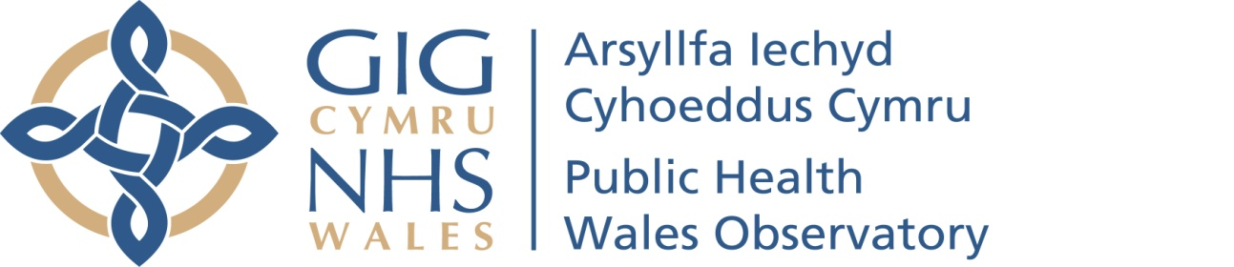

Welsh Index of Multiple Deprivation 2014 revised: Health board maps
Author: Public Health Wales Observatory
Date: 19 October 2015 | Version: 1
Publication/ Distribution:
- Public (Internet)
- Public Health Wales Observatory (Intranet)
Purpose and Summary of Document:
The purpose of this document is to present maps showing areas of deprivation using the Welsh Index of Multiple Deprivation (WIMD) 2014 (WG) within Wales and its health boards.

The maps in this document have been updated to include revised WIMD 2014 data (see Introduction section for further details).

Contents
1 Introduction 3
2 How to copy and paste maps 4
3 Maps 6
3.1 Wales 6
3.2 Betsi Cadwaladr University Health Board 7
3.3 Powys teaching Health Board 8
3.4 Hywel Dda University Health Board 9
3.5 Abertawe Bro Morgannwg University Health Board 10
3.6 Cardiff and Vale University Health Board 11
3.7 Cwm Taf University Health Board 12
3.8 Aneurin Bevan University Health Board 13

Introduction
The Public Health Wales Observatory has produced lower super output area (LSOA) maps of the Welsh Index of Multiple Deprivation (WIMD) 2014 for Wales and each health board. All maps within this document are based on national fifths of deprivation.

WIMD is the official measure for deprivation for small areas in Wales. It is used to give an overall deprivation rank for each of the 1,909 LSOAs in Wales from 1 (most deprived) to 1,909 (least deprived). WIMD 2014 was published on the 26th November 2014 by the Welsh Government. However, following publication the Department for Work and Pensions discovered an error in the income indicator data they had provided. The data had been included in the income domain of WIMD 2014. This error has since been corrected and a revised WIMD 2014 dataset was published on 12th August 2015. The maps included in this document use the revised WIMD 2014 data.
The index is based on eight domains consisting of income, employment, health, education, access to services, community safety, physical environment and housing. Each of the eight domains are based on a range of different indicators, these are weighted and combined into an overall index of multiple deprivation. The weighting is the adjustment of the contribution of the domain indexes make to the overall index when they are combined. Income and employment are classed as the most important domains and are given the biggest weighting in the overall index.
WIMD is a relative comparator and therefore should not be used for comparing ranks over time i.e. if an area has ranked lower in the index in 2014, this does not necessarily mean that this area has become more deprived, but provides a measure of whether the area is more or less deprived relative to all other areas. WIMD cannot tell you how much more deprived one LSOA is than another. If one area is ranked as the 100th most deprived and another area as the 300th most deprived, you cannot say that one area is three times more deprived than the other.
It is important to note that low deprivation does not equate to affluence and that not everyone living in a deprived area is deprived and not all deprived people live in deprived areas. An area itself is not deprived it is the circumstances of people who are living there that affect its deprivation ranks.
The WIMD scores cannot be compared with those from deprivation indices of other UK countries.
More information regarding WIMD 2014 can be found on the Observatory and Welsh Government websites.
This document consists of:
- a Wales map,
- seven health board maps.

How to copy and paste maps
The standard {Cut}, {Copy} and {Paste} options can be used in Microsoft Word to export tables, charts and maps to other documents as well as resize the image.

Copying and pasting tables, charts and maps (Figure 1)

Select the image you want to copy by left clicking on it once so that the surrounding points are displayed.

Either on the ‘Home’ tab or through the right click menu select either ‘Cut’ or ‘Copy’.

In the document you want to insert the copy select ‘Paste’ either through the ‘Home’ tab or the right click menu.
Figure 1
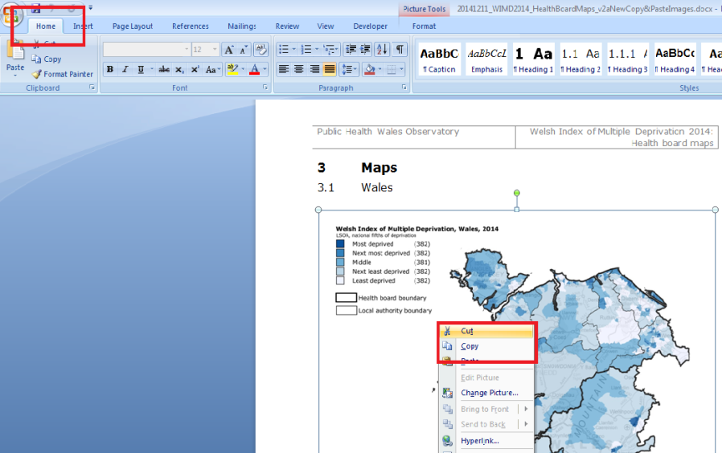

Figure 2
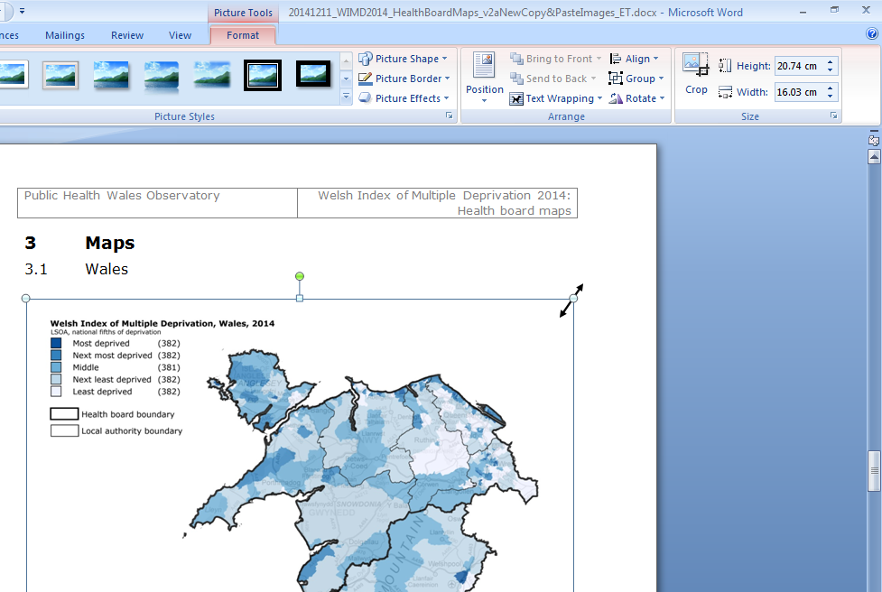

Resizing images (Figure 2)

To adjust the size left click on the image once so that the surrounding points are displayed.

You can either adjust the length and width manually through the ‘Format’ tab or use the points to resize the image by clicking and dragging.

When resizing an image it is best to use the corner points dragging method as this will keep the perspective, resizing just horizontally or vertically leads to the pixels distorting and leads to a reduction in image quality.

Maps

Wales
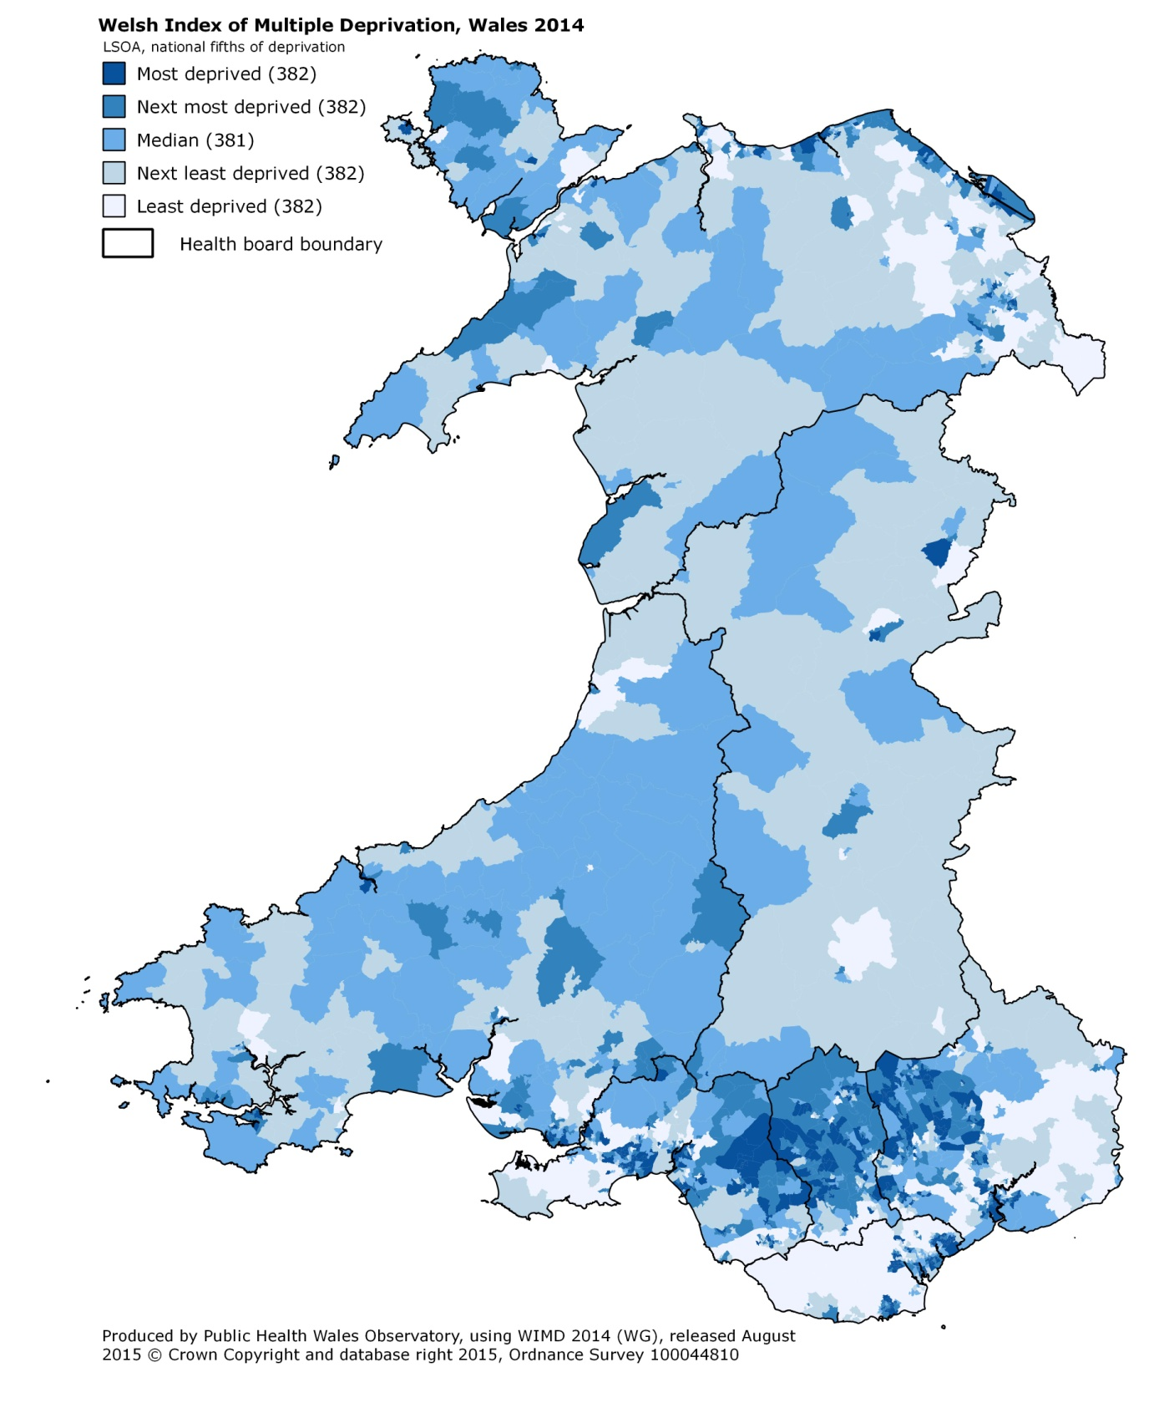

Betsi Cadwaladr University Health Board
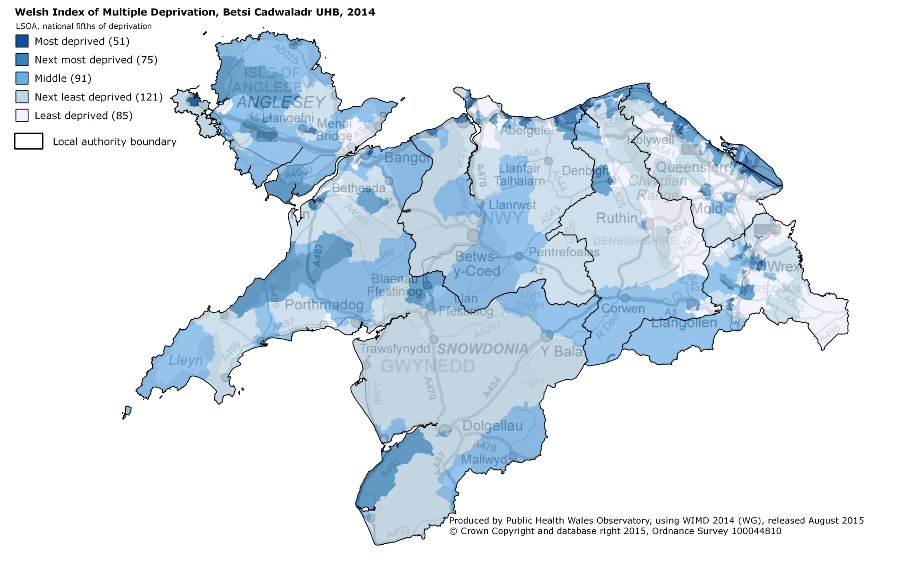

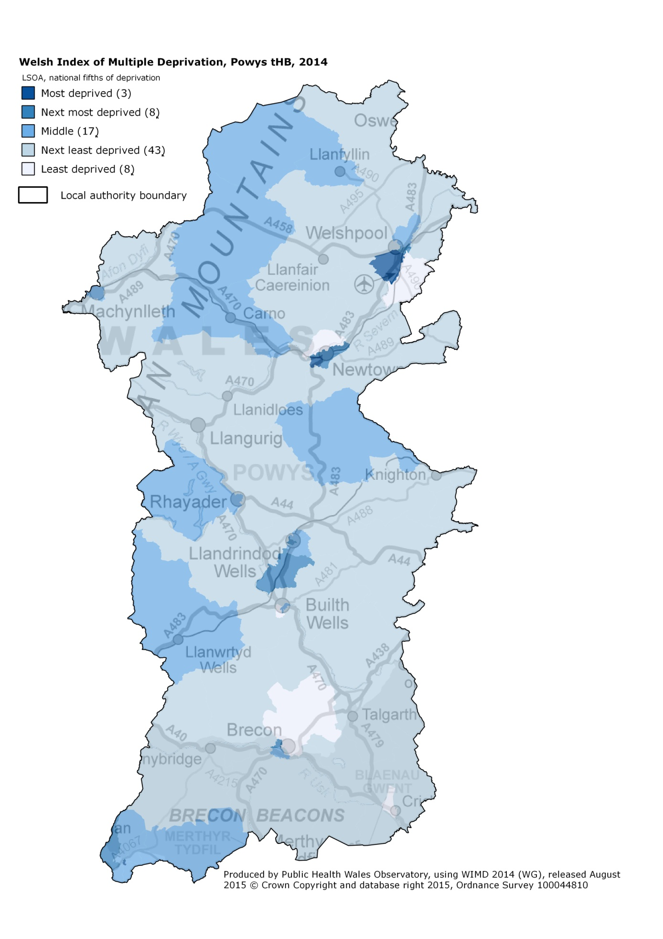
Powys teaching Health Board

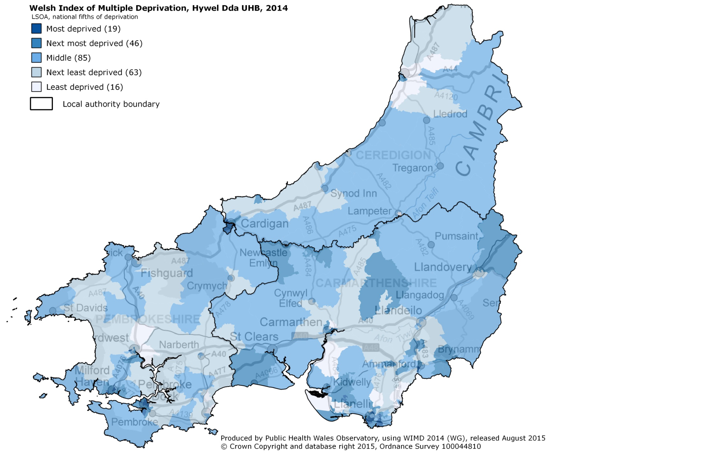
Hywel Dda University Health Board

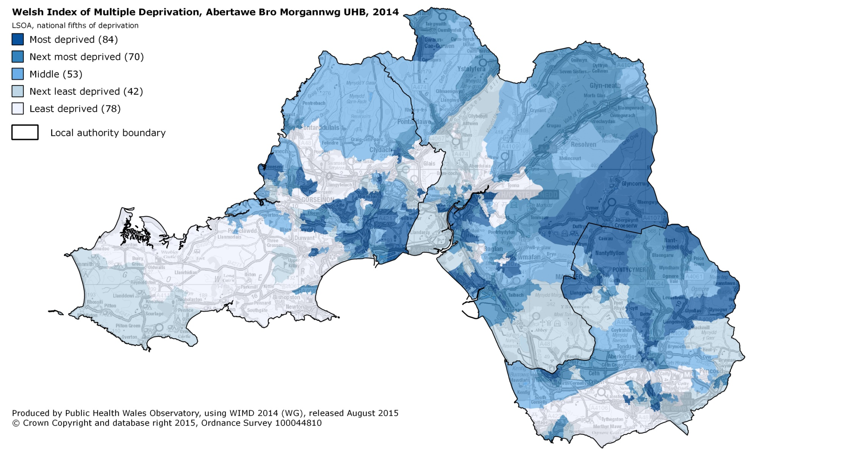
Abertawe Bro Morgannwg University Health Board

Cardiff and Vale University Health Board
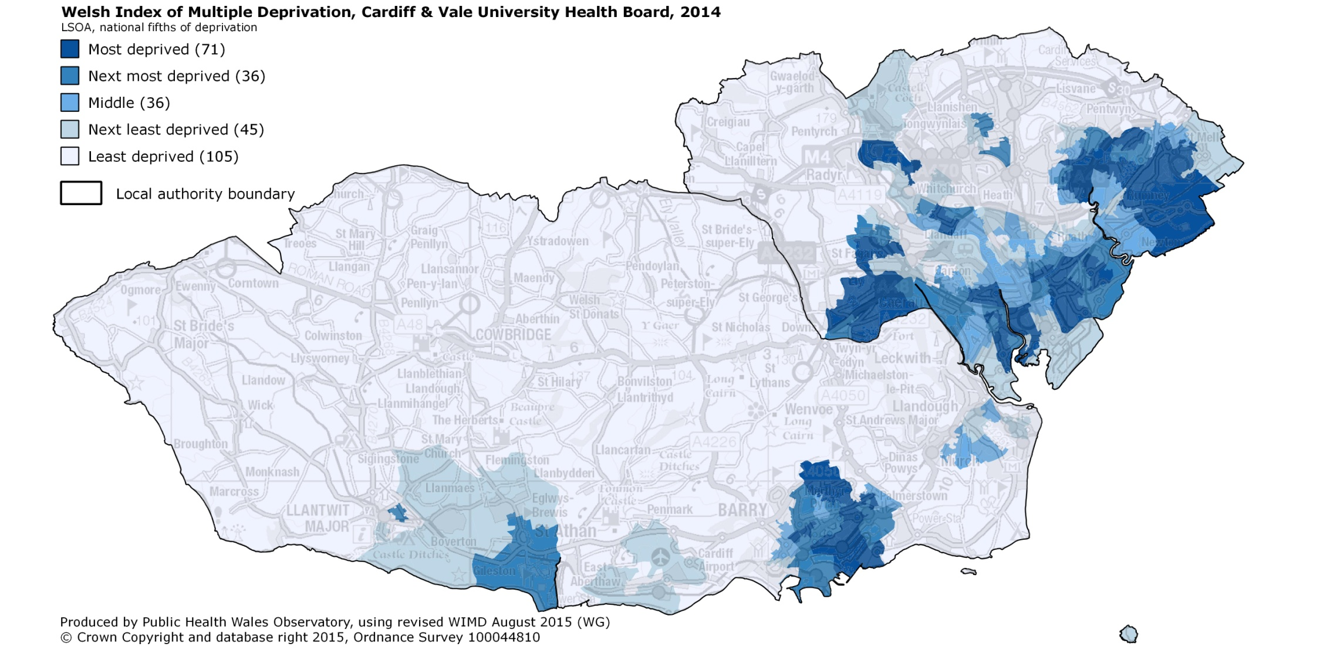

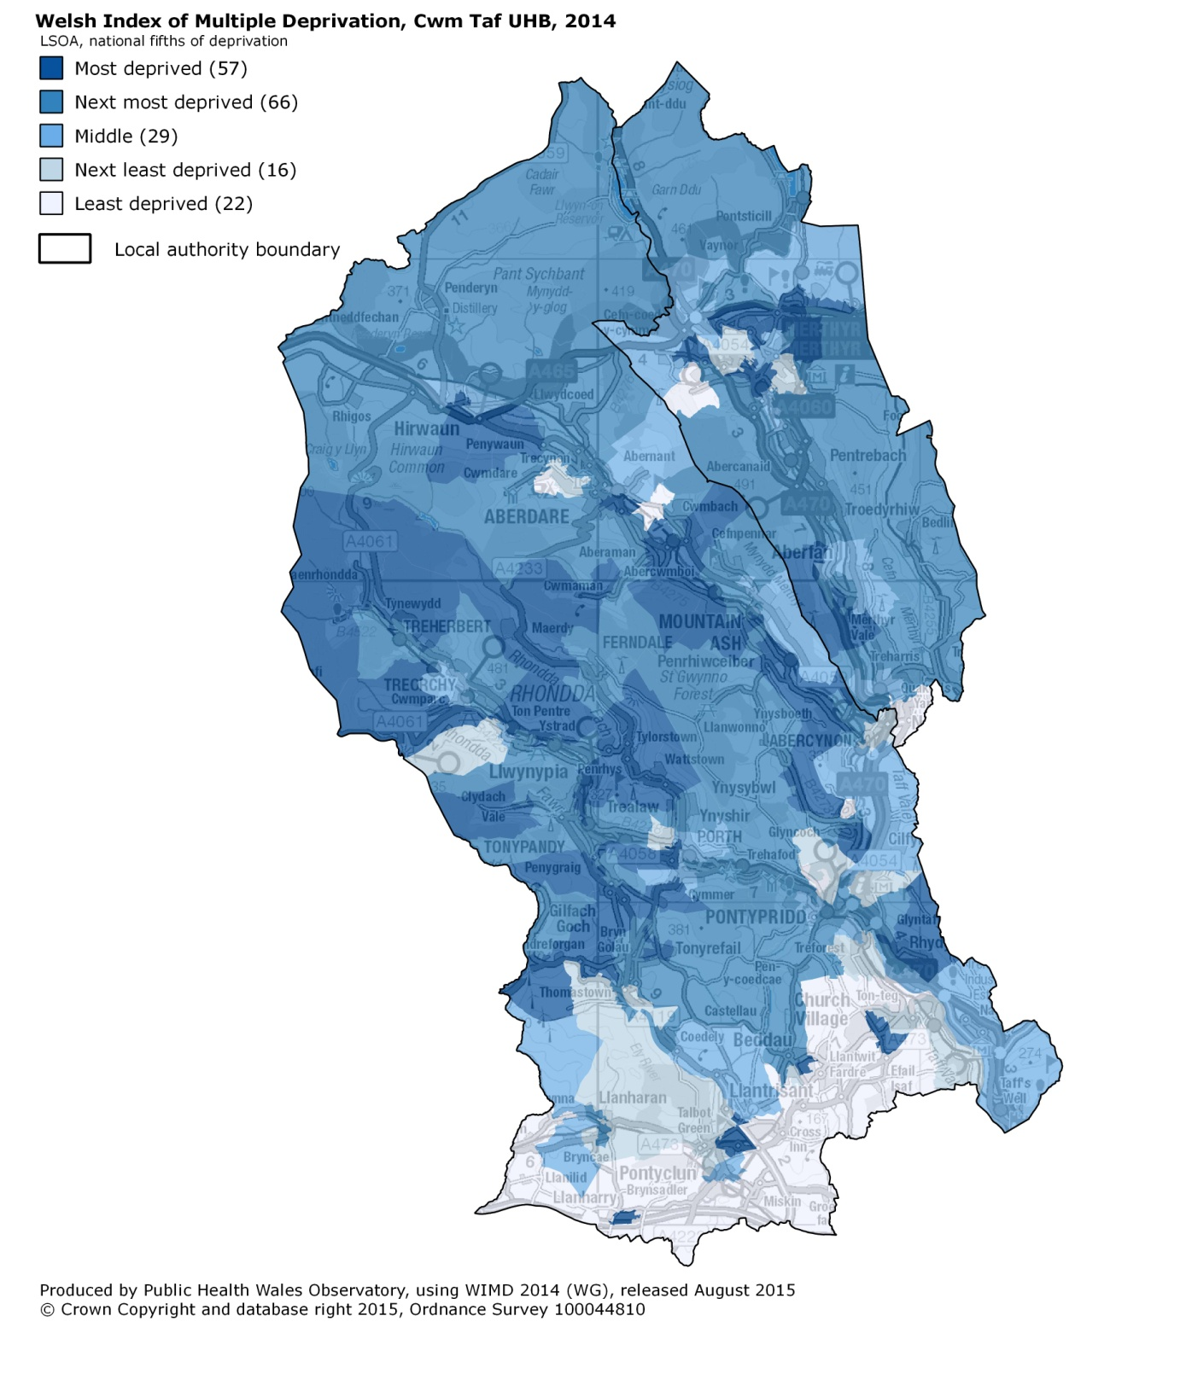
Cwm Taf University Health Board

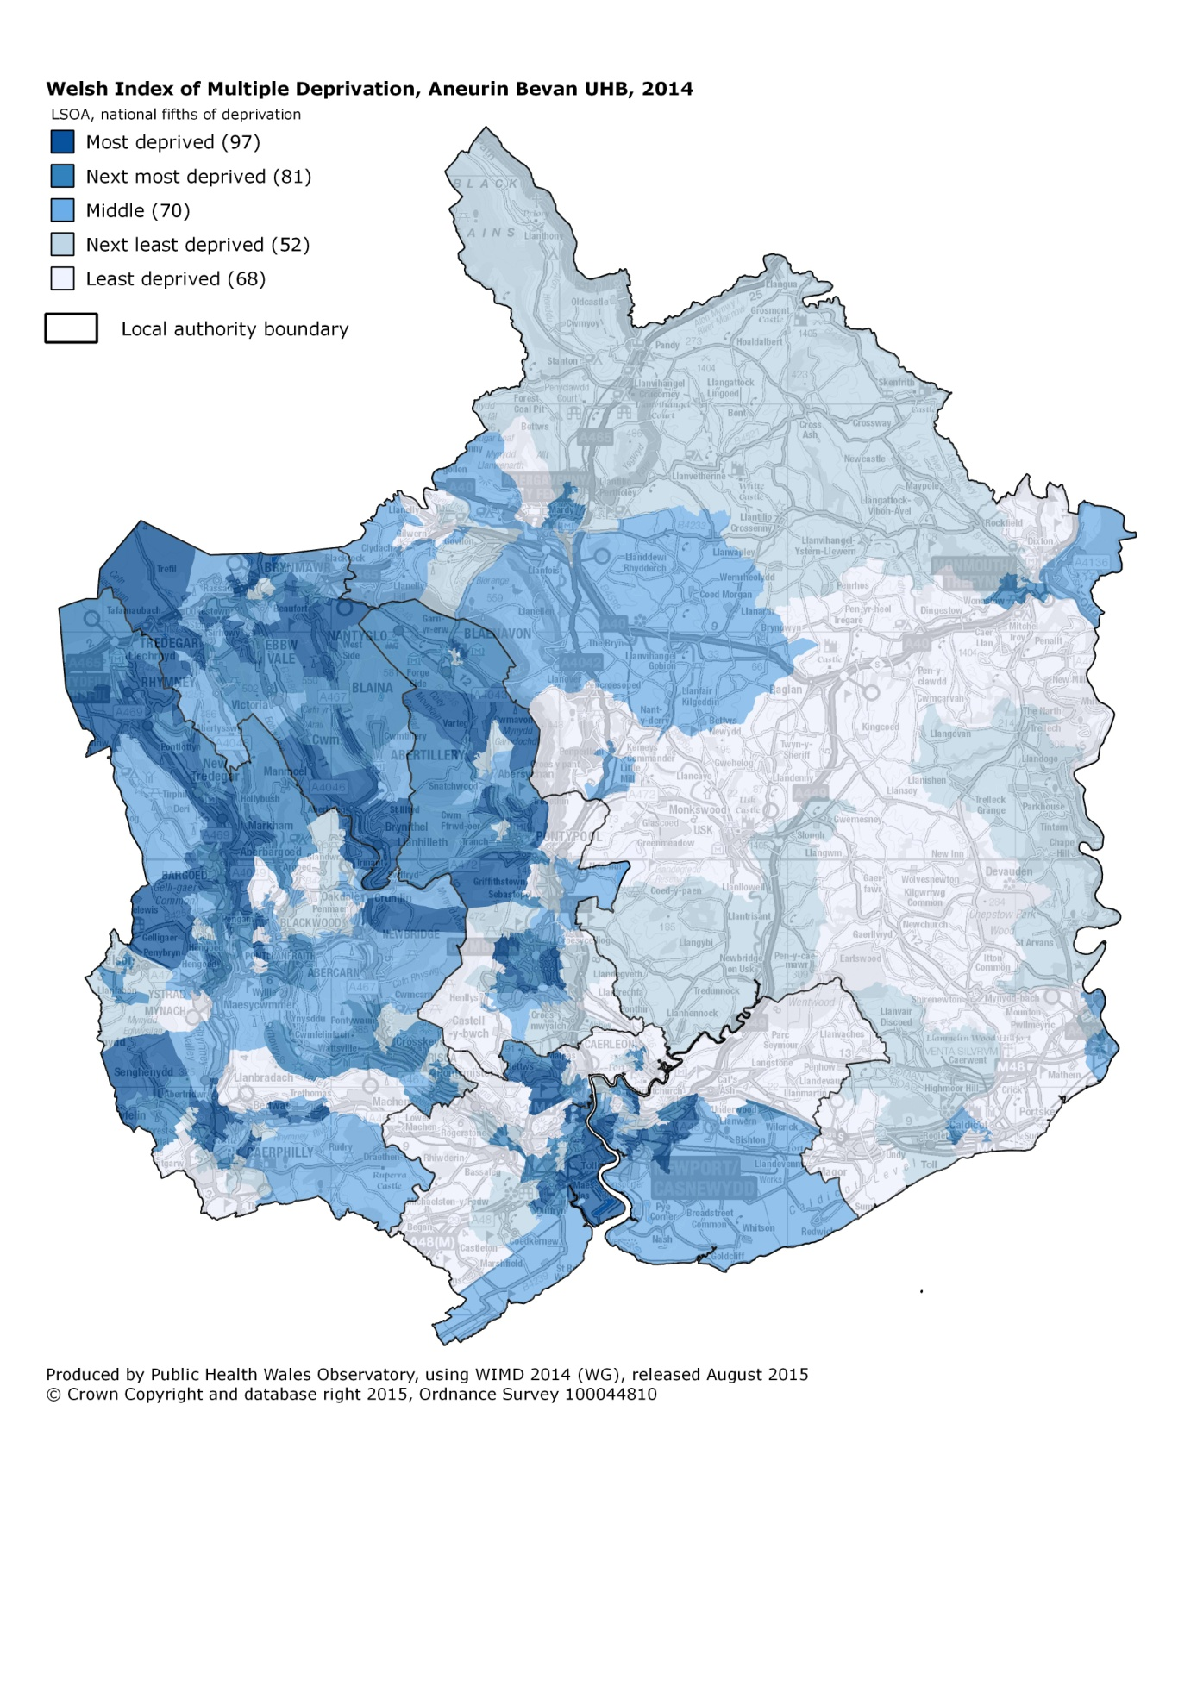
Aneurin Bevan University Health Board

