

Sub-local authority analysis of the Welsh Health Survey
Are you currently being treated for diabetes?
In general, would you say your health is...
How much do you weigh?

Sub-local authority analysis of the Welsh Health Survey

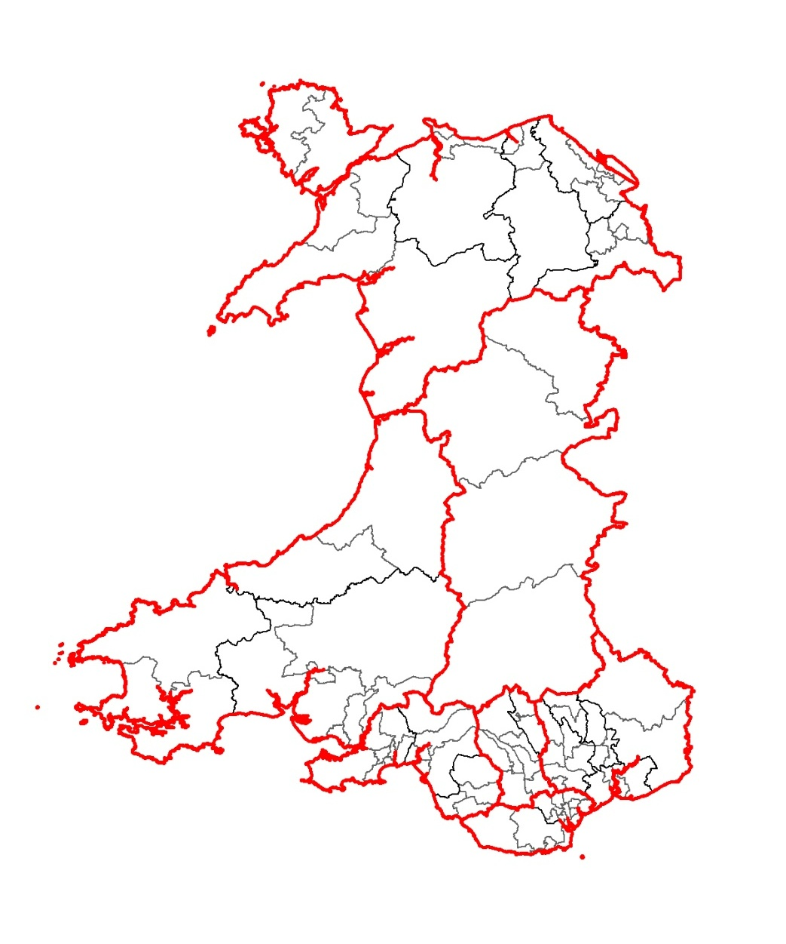

March 2012

March 2012



Acknowledgements
This report was prepared by the Public Health Wales Observatory in collaboration with the Welsh Government.

Author:
Claire Tiffany (Public Health Wales Observatory)

Contributors included:
Joanna Arthur, Ioan Francis, Rhys Gibbon, Ciaran Humphreys, Deirdre Hickey, Claire Jones, Nathan Lester, Bethan Patterson (Public Health Wales Observatory)
Elinor Griffiths, Cath Roberts (Welsh Government).

Contact
The report, accompanying data files and indicator guide can be downloaded from the Observatory website:
www.publichealthwalesobservatory.wales.nhs.uk

For further information please contact:
publichealthwalesobservatory@wales.nhs.uk

Material contained in this document may be reproduced without prior permission provided it is done so accurately and is not used in a misleading context. Acknowledgement to Public Health Wales NHS Trust to be stated. Copyright in the typographical arrangement, design and layout belongs to Public Health Wales NHS Trust.
© 2012 Public Health Wales NHS Trust

Contents

1 Key messages 5
2 Introduction 6
3 Methodology and definitions 7
3.1 Background to the Welsh Health Survey 7
3.2 Background to Upper Super Output Area geographies 8
3.3 Using six years of survey data for USOA estimates 9
3.4 Age-standardisation 9
3.5 Sampling errors and confidence intervals 10
4 Analysis 11
4.1 High blood pressure 12
4.2 Heart conditions 13
4.3 Respiratory illness 14
4.4 Mental illness 15
4.5 Arthritis 16
4.6 Diabetes 17
4.7 Chronic illness 18
4.8 Limiting long term illness 19
4.9 General health status 20
4.10 SF-36 Physical component summary score 21
4.11 SF-36 Mental component summary score 22
4.12 Smoking 23
4.13 Physical activity 24
4.14 Overweight or obese 25
4.15 Obese 26
4.16 Contact with General Practitioner 27
4.17 Hospital attendance from accidents injury and poisoning 28
Appendices 29
Appendix A: Map showing USOAs in Wales 29
Appendix B: USOAs by local authority and health board 30
Appendix C: Abbreviations 31

Key messages

- Using six years of data from the Welsh Health Survey at geographies below local authority level has allowed more detailed analysis of the health of people living in Wales, the way they use health services and their health related lifestyle than previously. This report and accompanying online data file highlights the differences in people’s health at a more local level.
- There are substantial variations in the proportion of people with key illnesses among Upper Super Output Areas (USOAs) in Wales. For example, the percentages of people reporting being treated for diabetes, mental illness and arthritis are over three times higher in some USOAs compared to others. The highest percentages of people reporting key illnesses are generally in USOAs in the South Wales Valleys and parts of the major towns and cities.
- The percentage of adults reporting their general health status as fair or poor varies considerably across USOAs in Wales, from 14 to 34 per cent. People living in the South Wales Valleys and parts of the major towns and cities are more likely to report a poorer health status and have lower SF-36 physical and mental component summary scores than those in Mid and North Wales.
- Health related lifestyles vary across USOAs in Wales. The percentage of smokers is two and a half times higher in some (where one in three adults smoke) compared to others (where one in seven smoke). Considerable variations are seen within health board areas. For example, smoking prevalence at USOA level ranges from 18 to 36 per cent in Cardiff and Vale and from 14 to 31 per cent in Abertawe Bro Morgannwg.
- Adults are generally more physically active and less overweight or obese in USOAs in North and Mid Wales compared to those living in the South Wales Valleys and parts of the major towns and cities. The percentage of obese people varies from 11 to 26 per cent and, patterns are similar to the overweight and obese measure.
- The use of selected health services varies among USOAs, although there is no clear pattern across Wales.
- The patterns exhibited for many of the indicators show associations between poor outcomes and area deprivation. For example, outcomes in the South Wales Valleys and more deprived parts of Cardiff, Newport, Swansea, Barry and Rhyl tend to be worse than the Welsh average.

Introduction
There is currently a lack of high-quality information about the health of people living in Wales, the way they use health services and their health related lifestyle at a level below local authority. In order to address this, the Public Health Wales Observatory in collaboration with the Welsh Government have produced and presented a selection of indicators from the Welsh Health Survey at sub-local authority level. It is hoped this report, and accompanying online data file, will be useful for directors of public health, their teams and partner organisations. It will be particularly valuable in informing action to improve health and service delivery at a local level.
This report presents analysis of a dataset containing six years of Welsh Health Survey results (from 2003/04 to 2009). It contains a brief background to the Welsh Health Survey, the selection of USOAs as the sub-local authority geography and the methodology used. The analysis is presented as a series of maps with accompanying commentary. An online data file and indicator guide are available from: http://www.wales.nhs.uk/sitesplus/922/page/60135.
The seventeen indicators chosen from the Welsh Health Survey are listed in Table 1. They cover key illnesses, health status, health related lifestyles and use of selected health services. All indicators chosen were measured using the same question each year. Alcohol use and fruit and vegetable intake were not included in this report as changes in the survey questions in 2008 mean it is not possible to amalgamate multiple years’ data.
The maps in this report present the USOA level data, with local authority and health board boundaries provided for context. A map detailing the 94 USOAs, 22 local authority and 7 health boards in Wales is given in Appendix A. Appendix B shows the number of USOAs in each local authority and health board area.

Table 1: Welsh Health Survey indicators used in this report

Key illnesses  High blood pressure  Heart conditions  Respiratory illness  Mental illness  Arthritis  Diabetes  Chronic illness  Limiting long term illness | Health Status  General health status  Physical component summary score  Mental component summary score  Health related lifestyle  Smoking  Physical activity  Overweight or obese  Obese
Use of health services
Contact with GP
Hospital attendance due to accidents injury and poisoning

Methodology and definitions
This section provides a guide to the methodology and definitions used in the report. It provides background to the Welsh Health Survey, USOA geographies and some of the statistical methods used.

Background to the Welsh Health Survey
The table below provides a brief background to the Welsh Heath Survey, including data collection, sample size, interpretation of the data and accessing the results.

A guide to the Welsh Health Survey

Data Collection | - The Welsh Health Survey provides information about the health of people living in Wales, the way they use health services and their health related lifestyle.  - It is based on a representative sample of people living in private households in Wales, selected using a random sample from the Post Office’s Postcode Address File.  - The survey was established in its current form in 2003 and runs all year round.  - An achieved sample of around 15,000 adults and 3,000 children is aimed for per year, to include a minimum of 600 adults from each local authority area. Data from six years of the survey are used in this report, covering around 90,000 adults.  - The sample is stratified by local authority. The smaller authorities are oversampled to allow the production of survey estimates at this level following the collection of two years’ data.  - The survey collects information on households (through a short interview) and on individuals (through a self-completion questionnaire).  - At each household, all adults and a maximum of two children are eligible for inclusion in the survey.  - The findings presented within this report are based on the results from the individual self completion questionnaire.
Accuracy and Completeness | - The Welsh Health Survey was designed to be representative of the general adult population in Wales.  - Survey data is usually presented at a Wales level. Combining data from more than one year can allow results to be presented at a lower level by improving the precision of the estimates due to the larger sample size used. For this report, results have been published at USOA level using data combined for six years from 2003/04 to 2009.  - For the 2009 survey, a household interview was obtained with 78 per cent of eligible households in the sample, and self-completion questionnaires were obtained for 82 per cent of adults in participating households.  - The Postcode Address File covers more than 99 per cent of private households in Wales; the small proportion of people not covered by the Postcode Address File, for example those living in institutions, were not covered by the Welsh Health Survey.  - The Welsh Health Survey therefore does not include adults living in institutional settings such as care homes or nursing homes etc.  - It should be noted that people living in institutions are likely to be on average, in poorer health than those in private households. This should be kept in mind when considering results from this survey.
Interpretation of the data | - As the survey relies on a self-completion questionnaire, the results of the survey reflect people’s own understanding of their health rather than a clinical assessment of their medical condition, and their own interpretation of the health services they have used.  - Interpretation of the results should take account of the questionnaire design, as the mode of collection and the questions themselves affect the information collected.  - The adult self-completion questionnaire is available in the appendix of the Annual Report¹ and on the survey theme page.
Data weighting | - The survey results are weighted² to take account of unequal selection probabilities and for differential non-response i.e. to ensure that the age and sex distribution of the responding sample matches that of the population of Wales.
Who manages the data? | - The National Centre for Social Research (NatCen) carries out the survey on behalf of the Welsh Government.
Accessing the results | - ¹Welsh Health Survey reports are available on the survey theme pages at:  www.wales.gov.uk/statistics  - ²NatCenWelsh Health Survey Technical Report: www.wales.gov.uk/statistics

Background to Upper Super Output Area geographies
This report presents data from the Welsh Health Survey at Wales USOA level, which is a statistical geography produced for Wales by the Data Unit Wales, based on a set of Super Output Areas produced by the Office for National Statistics (ONS).
Following the 2001 Census, the ONS derived a set of statistical geographies for England and Wales called Super Output Areas. The smallest of these, the Lower Super Output Areas (LSOAs), contain around 1,500 people and are used in the Welsh Index of Multiple Deprivation.
However, whilst producing estimates at low levels such as LSOAs is desirable, it is not always possible to produce accurate lower level statistics due to insufficient data. Middle Super Output Areas (MSOAs), each containing around 7,200 people, allow a greater range of statistics to be produced. However, even these are often too small to be able to use certain data sources, particularly survey data.
USOAs have been designed to provide a geography of a similar population size that is more detailed than local authority but still large enough to allow a wide range of statistics to be produced, with each of the 94 USOAs in Wales having an average population of 32,000 people.

Using six years of survey data for USOA estimates
This report uses six years of Welsh Health Survey data (from 2003/04 to 2009 combined) to present results at USOA level. Combining six years of survey data improves the precision of the estimates at small geographies due to the larger sample size used, and ensures that the data is sufficiently robust for general use.
The sample size for USOAs after combining six years of data ranges from just under 500 to over 2,000. Combining several years of data can be problematic if a variable of interest is changing rapidly, however change in health and lifestyle is generally gradual.

Impact of survey design on USOA estimates
The Welsh Health Survey sample is stratified by local authority, allowing estimates to be produced both at a national and local authority level. The weighting process is also designed to produce national and local authority estimates. Therefore it should be considered that the survey was not specifically designed for analysis at USOA level, for instance the sample is not distributed to reflect the clustering of USOAs within local authorities which has implications for the precision of results. There may be other limitations in survey estimates at USOA level, although these are likely to be less problematic for age-standardised results such as these.

Age-standardisation
Age-standardisation has been used in order to enable USOAs to be compared after adjusting for the effects of any differences in their age distributions. When different USOAs are compared in respect of a variable on which age has an important influence e.g. limiting long term illness, any differences in age distributions between these areas are likely to affect the observed differences in the proportions of interest. For example, a USOA with a high number of older people may have a higher observed proportion of limiting long term illness. Age-standardisation was carried out using the direct standardisation method. The standard population to which the age distribution of USOAs was adjusted was the mid-year 2007 population estimates for Wales. Standardising to the 2007 population for Wales has two advantages. Firstly, it means this analysis is broadly comparable to other Welsh Health Survey results reported in this way. Secondly, the Wales age standardised rate is essentially a crude rate.

Sampling errors and confidence intervals

Sampling Errors
As with any survey, results are subject to various sources of error. An important component of this is sampling error, which arises because the estimates are based on a sample rather than a full count of the population. The results obtained for any single sample are likely to vary slightly from the true population values, and the difference between the estimates derived from the sample and the population value is referred to as the sampling error. In general, the larger the sample size the smaller the sampling error.
It is possible to estimate the size of sampling error by calculating the standard error of survey estimates. The standard error (se) of a percentage (p) based on a simple random sample of size n is calculated as:
se(p)=(p(100-p)/n)

Confidence Intervals
A confidence interval can be calculated around a survey estimate and gives a range of values within which the true value is likely to fall. In this report we use 95 per cent confidence intervals. There is a 95 per cent chance that that a 95 per cent confidence interval includes the true value. In other words, a 95 per cent confidence interval gives an indication of the range of variation expected in the survey estimate due to chance (random variation). In general, the larger the sample size the narrower the confidence interval.
The standard error (se) measures the precision with which the estimates from the sample approximate to the true population values and is used to construct the confidence interval for a survey estimate. The 95 per cent confidence interval for a percentage (p) is calculated as:
p ± 1.96 se(p)

Statistical significance
Linked to confidence intervals is the concept of statistical significance. As well as showing rates for every USOA, this report also comments on USOAs that have rates which are statistically significantly higher or lower than the average for Wales.
A difference is called statistically significant if it is unlikely to have occurred by chance. It should be noted that statistical significance is not intended to imply substantive importance; rather that a difference is probably not due to chance. Unless otherwise stated, commentary in the report highlights differences that are statistically significant at the 95 per cent level, in other words differences that are only five per cent likely to have occurred by chance.
As a rough guide to interpretation, when comparing data about two groups (such as the proportion reporting high blood pressure living in two different areas), if their confidence intervals overlap, it can be assumed that the scores are not statistically significantly different. This approach is not as rigorous as doing a formal statistical test, but is straightforward, widely used and reasonably robust.

Analysis
Maps were produced using USOA, local authority and health board boundaries and show data by fifths of equal range within Wales. For reference, a map showing USOAs, local authorities and health boards in Wales is given in Appendix A. In addition an online data file (Excel spreadsheet) is available with interactive charts presenting data for USOAs by health board. The data behind all the maps and charts can be accessed via the online data file at http://www.wales.nhs.uk/sitesplus/922/page/60135.

Interpreting maps
The maps show data by fifths of equal range within Wales. This is achieved by taking the data at USOA level and splitting it into five equally-sized subsets (fifths). For example, if the rate ranged from 10 to 20, the fifths would be as follows: 10 to <12; 12 to <14; 14 to <16; 16 to <18; and 18 to 20. Maps are created by shading each USOA according to which fifth it fell into. This method aims to put areas with similar values within the same fifth; however, where there is little variation across Wales, the groups may be quite similar and the use of dark and light colours could make the variation seem greater than it really is.

Interpreting charts (online data file)
A sample chart, from the online data file, is shown below. USOA data is displayed by health board (Cardiff and Vale University Health Board in this instance), for each indicator. USOAs within the health board are compared against each other and the rate for Wales.
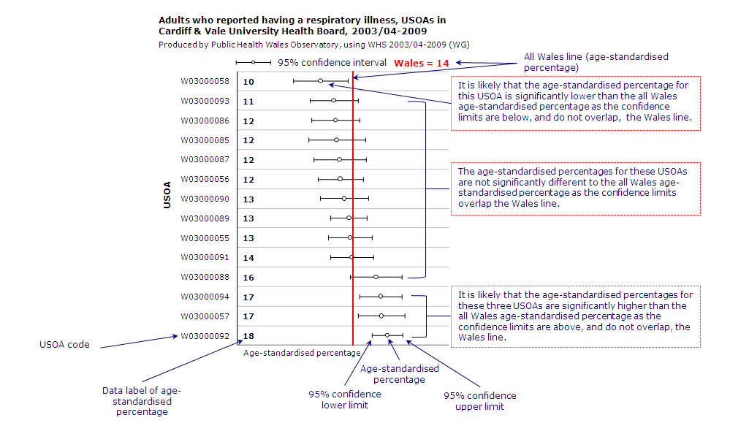

4.1 High blood pressure

Definition
Percentage of adults (age-standardised) who reported currently being treated for high blood pressure.
About high blood pressure
High blood pressure (hypertension) can put strain on arteries and the heart, which increases the risk of having a heart attack, stroke or kidney disease. Factors that can increase the risk of high blood pressure include increasing age, family history of high blood pressure, high salt intake, physical inactivity, being overweight, smoking and high alcohol intake.

Pattern of high blood pressure
The percentage of adults who report being treated for high blood pressure in Wales ranges from 15 to 25 per cent at USOA level. The majority of USOAs have values very similar to the Welsh average of 19 per cent. Aneurin Bevan and Cwm Taf in the south east have the highest proportion of USOAs with a percentage statistically significantly higher than the average for Wales, whilst Betsi Cadwaladr (North Wales) and Powys in Mid Wales have the highest proportion of USOAs significantly below the Welsh average.
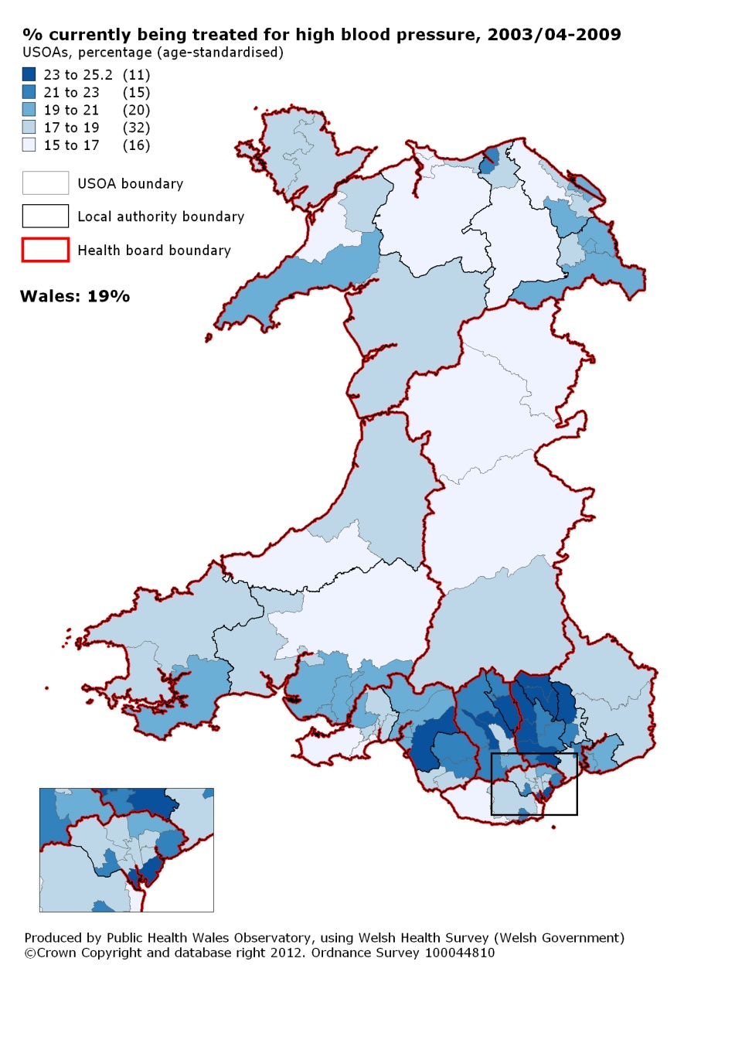

4.2 Heart conditions
Definition
Percentage of adults (age-standardised) who reported currently being treated for a heart condition (excluding high blood pressure). Includes adults who have ever been treated for a heart attack or currently being treated for angina, heart failure or ‘another heart condition’.
About heart conditions
Risk factors for heart conditions can be intrinsic, such as increasing age, sex, family history and ethnicity or modifiable factors such as smoking, poor diet, being overweight or obese, being physically less active and high alcohol intake.
Pattern of heart conditions
At USOA level between seven and 12 per cent of adults reported currently being treated for heart conditions. The majority of USOAs have values very similar to the Welsh average of nine per cent. Higher percentages occur in USOAs in the south, particularly in parts of Carmarthenshire, and the health boards of Abertawe Bro Morgannwg, Cwm Taf and Aneurin Bevan. Higher percentages are also seen in areas of the Isle of Anglesey, Denbighshire and Wrexham in North Wales.

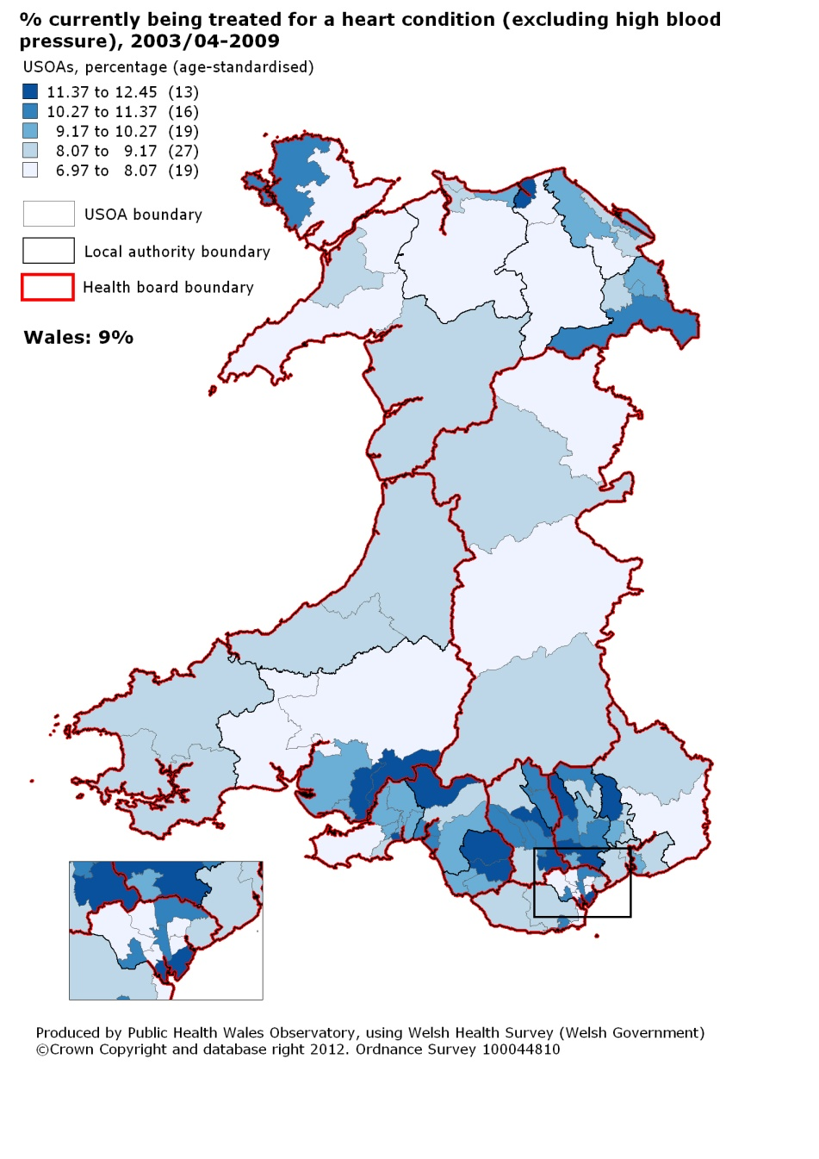

4.3 Respiratory illness
Definition
Percentage of adults (age-standardised) who reported currently being treated for a respiratory illness, including asthma, pleurisy, bronchitis, or 'another respiratory illness'.
About respiratory illness
Respiratory illnesses are a common cause of ill health, emergency hospital admissions and death. Chronic respiratory illnesses can have a significant impact on an individual’s quality of life and ability to undertake daily activities. Risk factors for respiratory illness include smoking and passive smoking, air pollutants and occupational exposures.
Pattern of respiratory illness
Across Wales, the percentage of adults who reported being treated for respiratory illnesses ranges from eight to 20 per cent. The USOAs with the highest percentages occur in South Wales, particularly in Swansea, Neath Port Talbot and Carmarthenshire. All nine USOAs in Cwm Taf Health Board (covering Rhondda Cynon Taff and Merthyr Tydfil) in the south east, are higher than for Wales overall (14 per cent), with three statistically significantly higher.

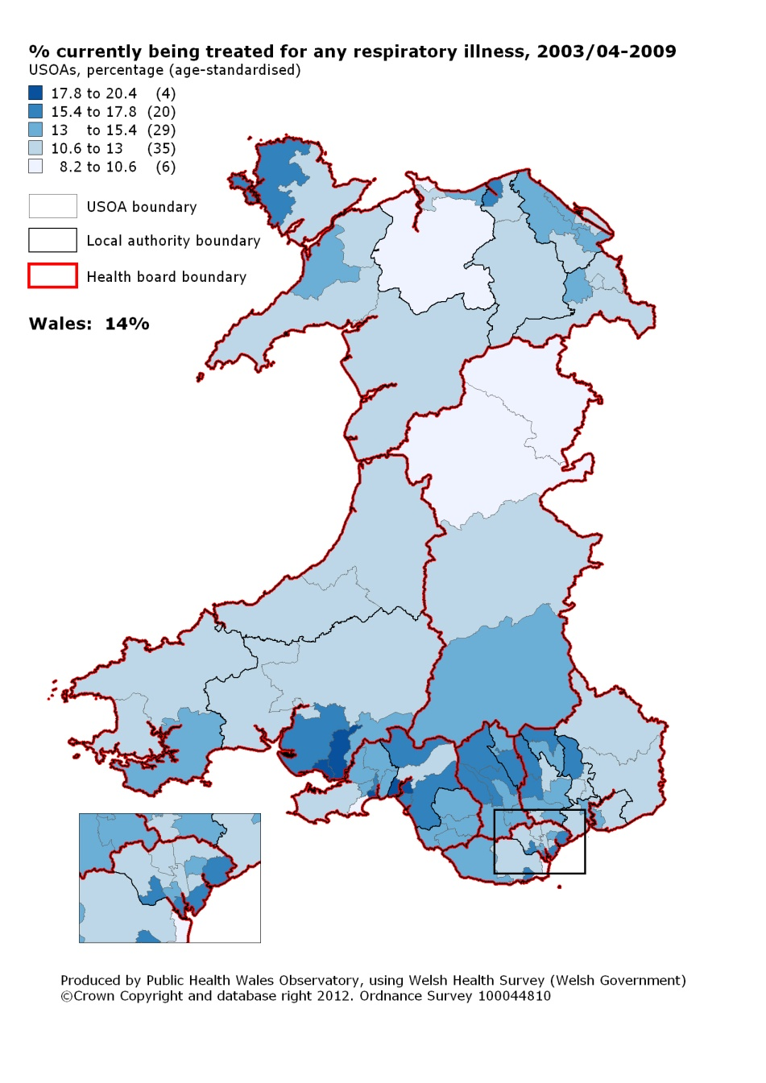

4.4 Mental illness
Definition
Percentage of adults (age-standardised) who reported currently being treated for a mental illness, including depression, anxiety, or ‘another mental illness’.
About mental illness
There are a wide range of factors that can have a positive or negative impact on mental health. Risks to mental health include life events, such as bereavement or exposure to abuse, and individual and family factors such as physical disability and poor health in childhood. Protective factors which positively affect mental health include good health and a secure family life. Mental illness often goes undiagnosed and untreated, and can come and go over the life course. This means life time prevalence will be substantially higher than the percentage of adults who report currently being treated.
Pattern of mental illness
There is a higher concentration of adults who report being treated for mental illness in USOAs in the south east region. Across Wales, percentages range from four to 14 per cent, with an average of 10 per cent. Six USOAs in Wales have rates of around 14 per cent, and of these five are from either Aneurin Bevan or Cwm Taf health boards in the south east.

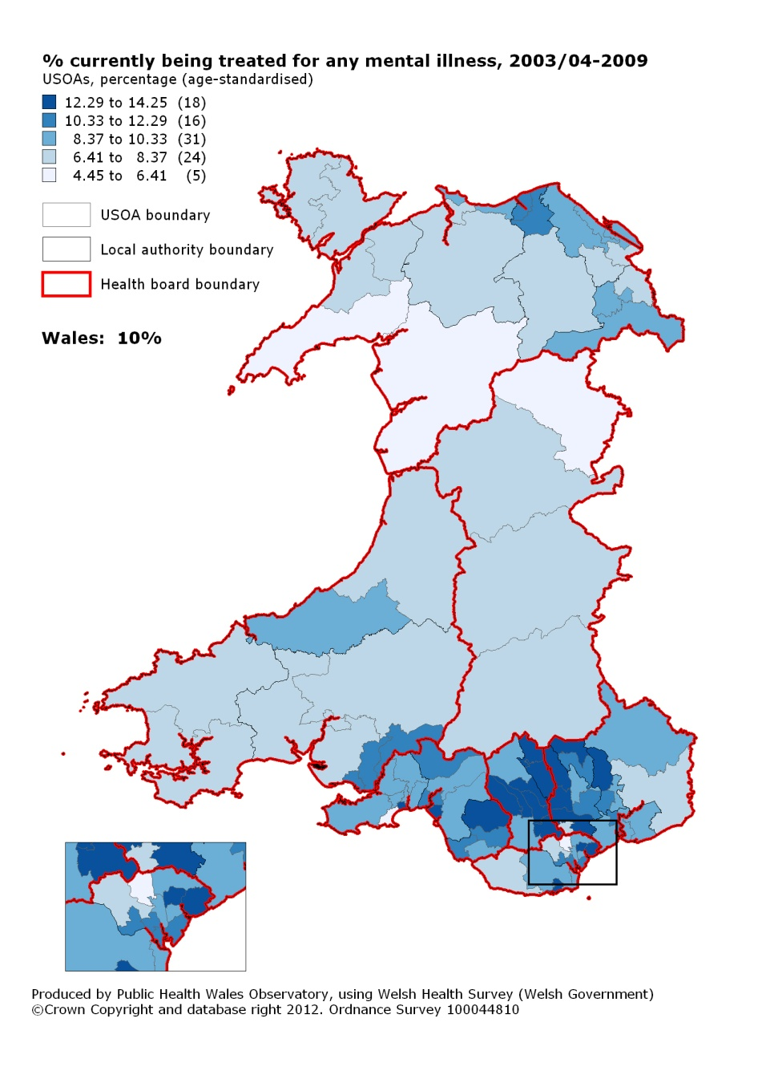

4.5 Arthritis
Definition
Percentage of adults (age-standardised) who reported currently being treated for arthritis.
About arthritis
Arthritis is a common condition that causes pain and inflammation of the joints and bones. Most types of arthritis are caused by many factors acting together. Arthritis can be hereditary or lifestyle behaviours, such as smoking, can increase the risk further if an individual is already susceptible to the condition. Osteoarthritis is the most common type of arthritis, and risk factors include age, sex (more common in females), being overweight, repetitive joint stress from certain occupations or sports, as well as genetic susceptibility. Not all adults with arthritis will be diagnosed or on treatment.
Pattern of arthritis
The percentage of adults who report currently being treated for arthritis ranges from seven to 21 per cent, with the overall rate in Wales at 14 per cent. USOAs in South Wales, particularly in the south of Carmarthenshire and Cwm Taf and Aneurin Bevan health boards, have the highest percentages.
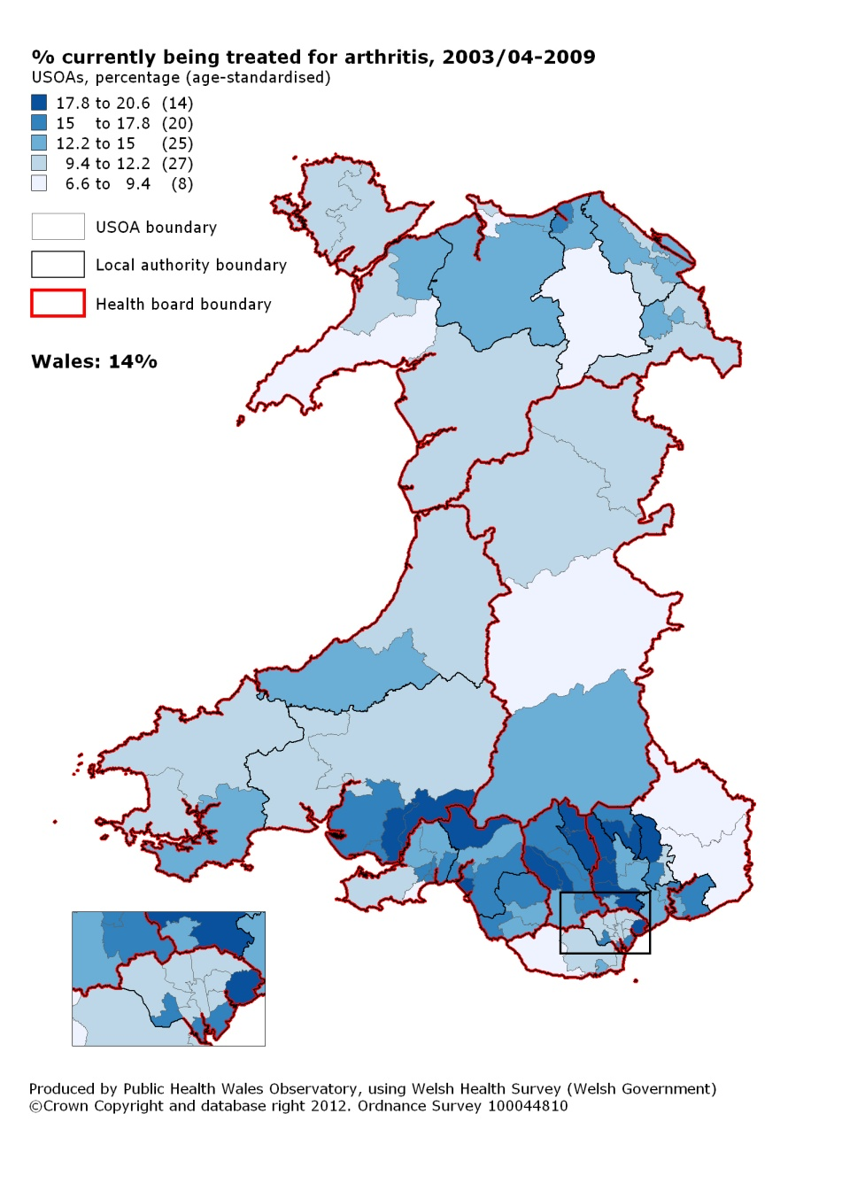

4.6 Diabetes
Definition
Percentage of adults (age-standardised) who reported currently being treated for diabetes. No distinction is made between type 1 and type 2 diabetes.
About diabetes
Diabetes is caused by having too much glucose in the blood. There are two main types of diabetes; type 1 and type 2. Type 1 diabetes usually develops before the age of 40 and is the less common form of the condition, accounting for five to 15 percent of all people with diabetes. Type 2 diabetes usually appears in people over the age of 40, although it is becoming increasingly common in children and young people. Type 2 diabetes is often associated with obesity. Healthy lifestyle behaviours such as healthy eating and increased physical activity can help prevent developing diabetes. Ethnicity is also a risk factor with higher prevalence found in Black and Asian populations. Many cases of diabetes are undiagnosed. Recent modelled estimates place prevalence across Wales at nine per cent¹; a third higher than the Welsh Health Survey’s estimated six per cent of adults who report being treated for diabetes.
Pattern of diabetes
The percentage of adults in Wales who report being treated for diabetes is six per cent, ranging from three to 10 per cent at USOA level. The widest variation among USOAs (from four to 10 per cent) is seen in Cardiff and Vale health board and the highest rates are generally seen in USOAs in South Wales.
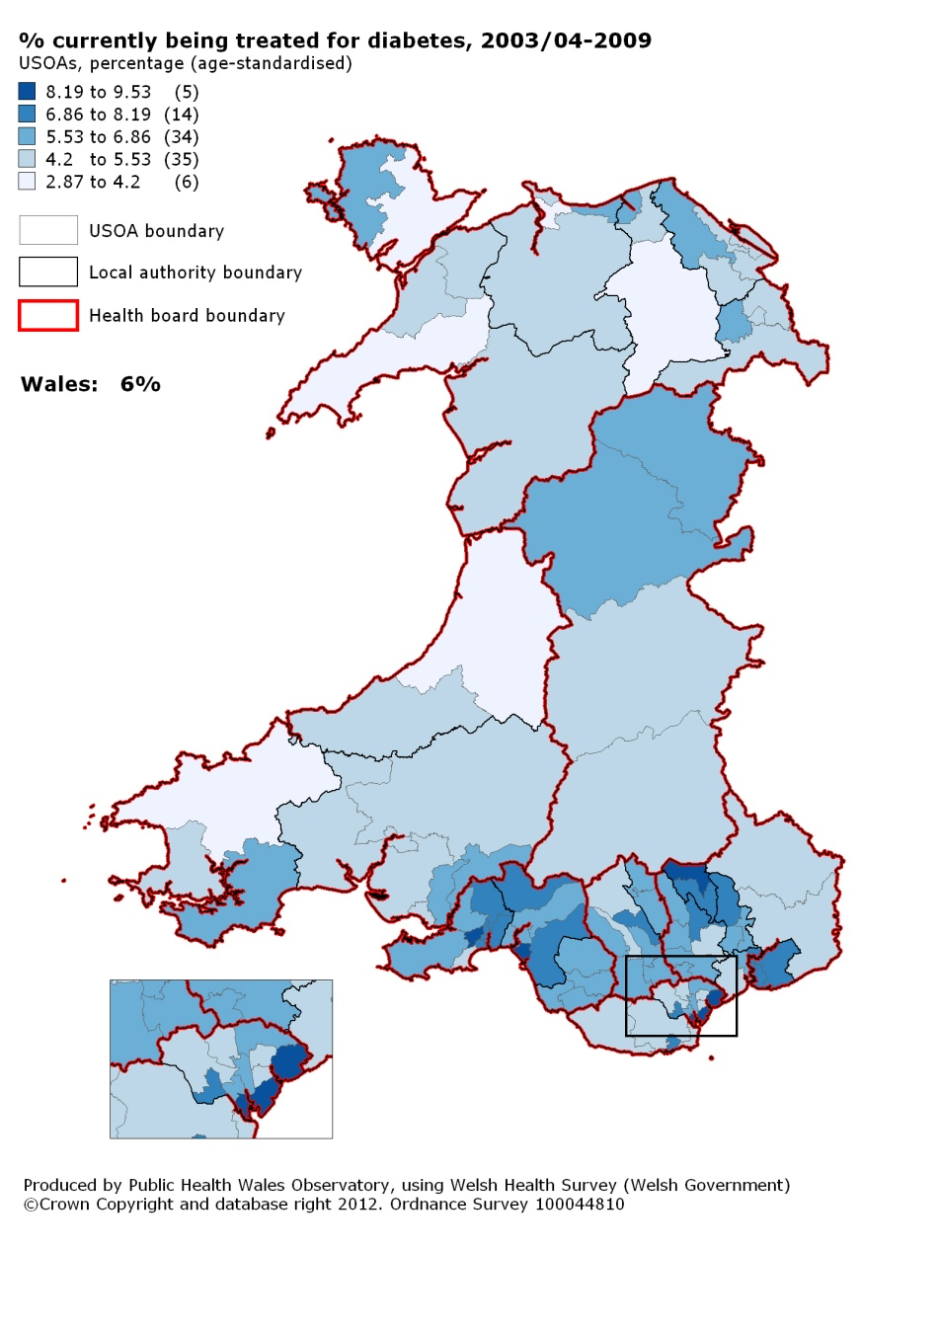

¹ Association of Public Health Observatories, available at: http://www.apho.org.uk/DISEASEPREVALENCEMODELS

4.7 Chronic illness
Definition
Percentage of adults (age-standardised) who reported currently being treated for any of the illnesses covered by the survey or another chronic or long-term illness.
About chronic illnesses
Chronic illnesses include heart disease, respiratory disease, cancer and diabetes. They are often life-long and can have significant impacts for the individual and family members and on the demand for health care services. Lifestyle factors such as smoking, unhealthy diets and being physically less active, and an ageing population are likely to increase the burden of ill health from chronic illnesses.
Pattern of chronic illnesses
Just under half of adults in Wales reported receiving treatment for a chronic illness, with percentages ranging from 40 to 56 per cent at USOA level. The highest percentages are in USOAs in South Wales, specifically the health boards of Abertawe Bro Morgannwg, Cwm Taf and parts of Aneurin Bevan.
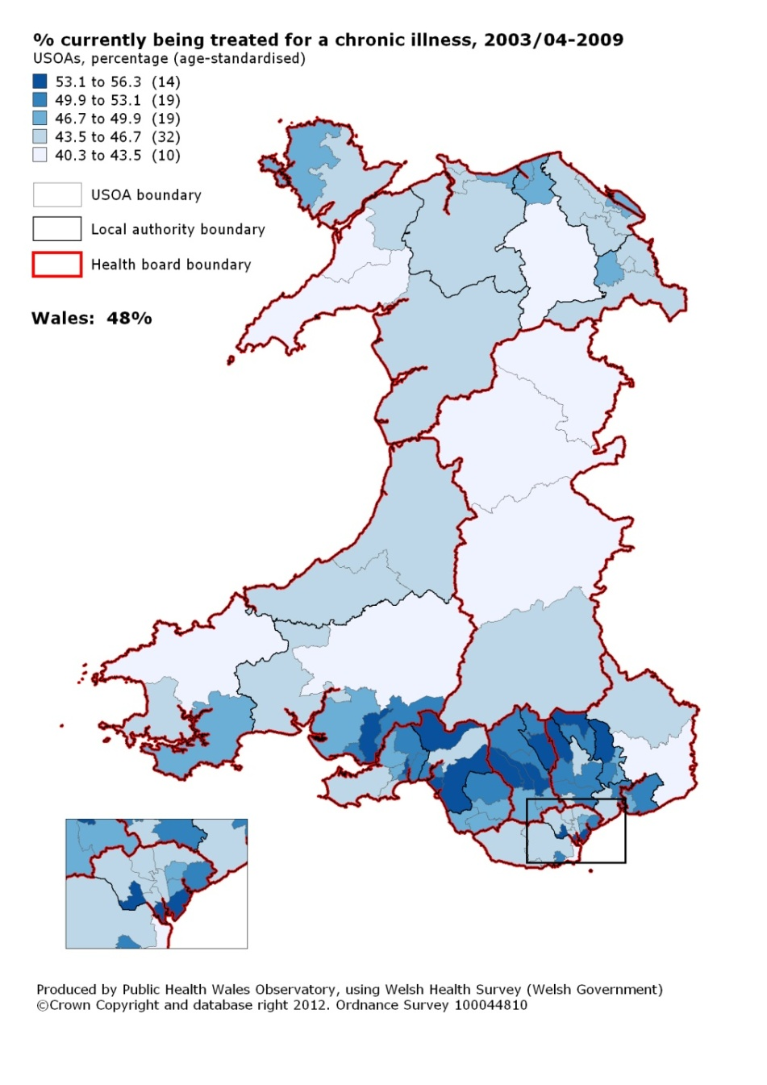

4.8 Limiting long term illness
Definition
Percentage of adults (age-standardised) who reported having any limiting long term illness, health problem or disability which limits their daily activities or the work they can do, including problems due to old age.
About Limiting Long Term Illness
Limiting long-term illness is widely used as a measure of health status. Having a limiting long term illness can impact on an individual’s quality of life and their ability to undertake daily activities, including work and being an active member of their community.
Pattern of Limiting Long Term Illness
In Wales, 28 per cent of adults reported having a limiting long term illness. At USOA level percentages range from 22 to 37 per cent. Generally health boards in the south have higher proportions of USOAs with percentages statistically significantly higher than Wales.
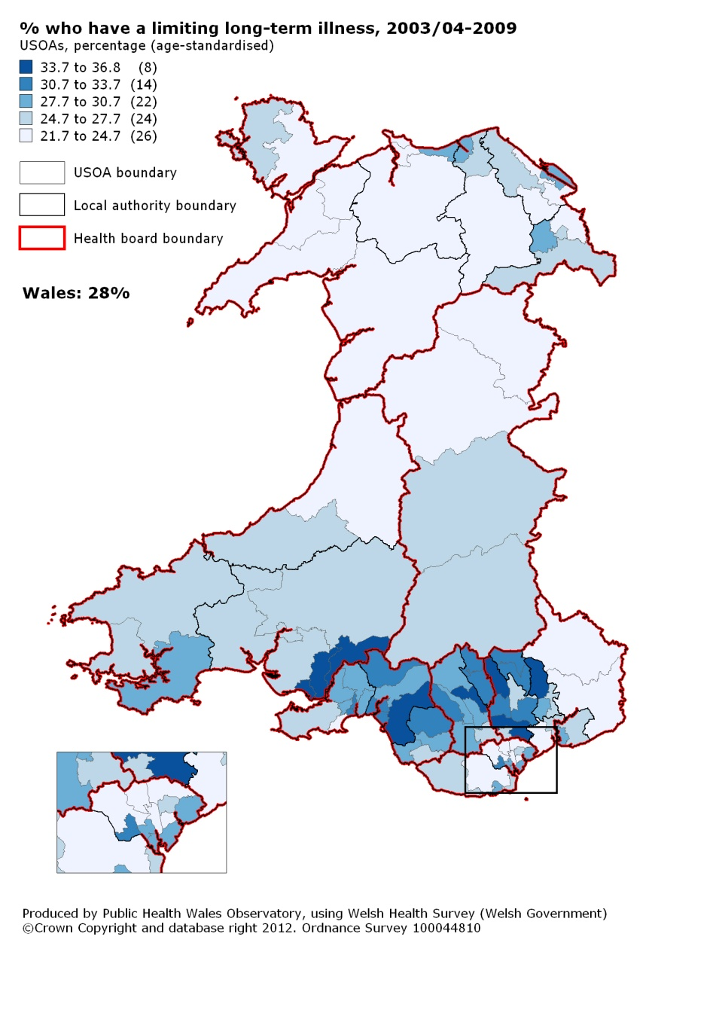

4.9 General health status
Definition
Percentage of adults (age-standardised) who reported their general health status as fair or poor.
About health status
Health status can be influenced by a range of factors such as age, sex, ethnic group and level of income as well as lifestyle factors such as smoking, diet and physical activity levels. The Welsh Health Survey includes a question asking respondents to rate their own general health, ranging from excellent to poor.
Pattern of health status
In Wales, 21 per cent of adults reported that their general health status was fair or poor, ranging from 14 to 34 per cent across USOAs. In North Wales, 12 out of 22 USOAs have percentages statistically significantly below the average for Wales. Poorer health status was more commonly reported in USOAs in South East Wales, with the exception of Monmouthshire.
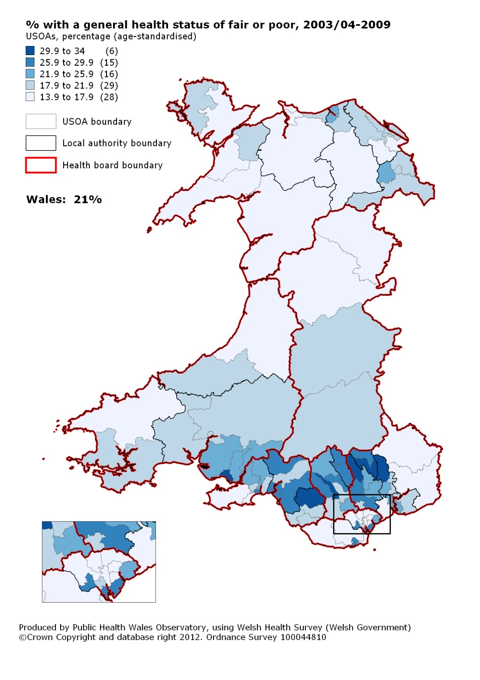

4.10 SF-36 Physical component summary score
Definition
Mean SF-36 physical component summary score (age-standardised). A higher score indicates better health.
About SF-36 Physical Component Summary Score
Physical health is an important aspect of health and well being. The Welsh Health Survey includes a standard set of questions about respondents’ perception of their physical and mental health and the impact it has on their daily lives. Responses are combined to produce two summary measures of physical and mental health. A higher score indicates better health. Further details regarding the creation of the score are given in the indicator guide.
Pattern of SF-36 Physical component summary score
The mean physical component summary score for Wales is 49. At USOA level, scores ranged between 45 and 51; a higher score indicates better health. Lower scores are reported in the South Wales Valleys, indicating poorer physical health.
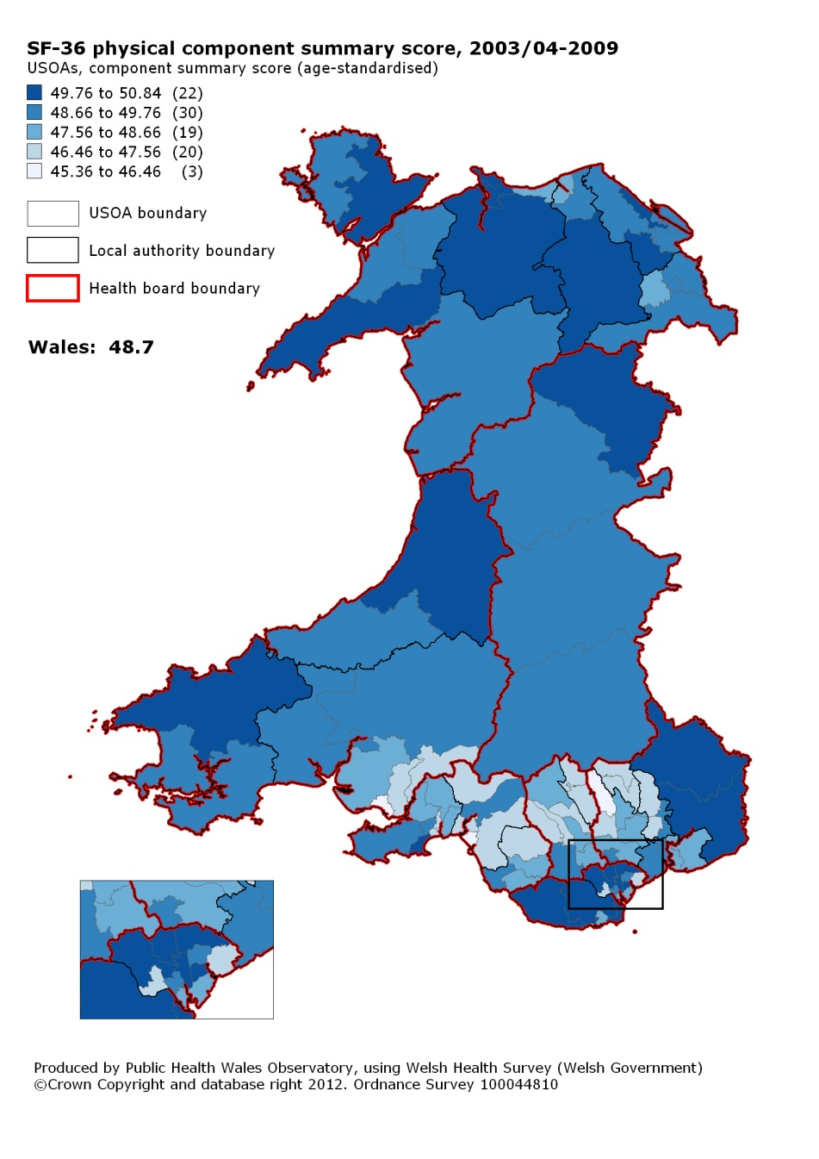

4.11 SF-36 Mental component summary score
Definition
Mean SF-36 mental component summary score (age-standardised). A higher score indicates better health.
About SF-36 Mental component summary score
Mental health is an important aspect of health and well being. The Welsh Health Survey includes standard set of questions about respondents’ perception of their physical and mental health and the impact it has on their daily lives. Responses are combined to produce two summary measures of physical and mental health. A higher score indicates better health. Further details regarding the creation of the score are given in the indicator guide.
Pattern of SF-36 Mental Component Summary Score
The mean mental component summary score for Wales is 50. At USOA level, scores ranged between 47 and 52. A higher score indicates better health. Lower scores in USOAs in the south, particularly south east Carmarthenshire, Rhondda Cynon Taff, Merthyr Tydfil, Caerphilly, Blaenau Gwent and Torfaen suggest poorer mental health.
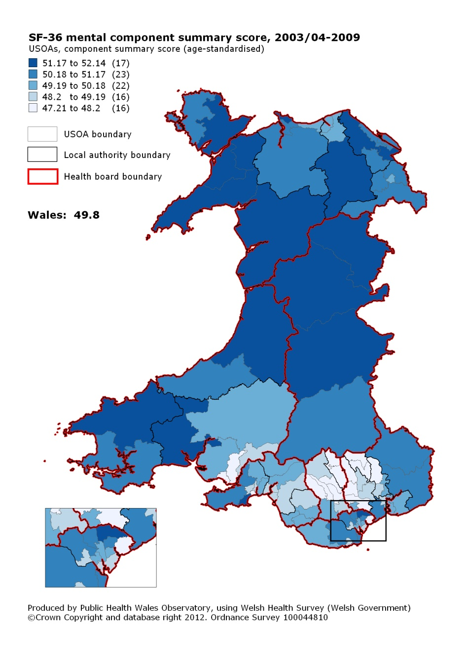

4.12 Smoking
Definition
Percentage of adults (age-standardised) who reported being a current smoker (daily or occasionally).
About smoking
Smoking is the largest single cause of avoidable ill health and early death in Wales. Smoking and passive smoking have been linked to a range of serious illnesses including cancers and heart disease. Smoking is generally more common in younger people and people living in the most deprived areas are more likely to smoke than people living in the least deprived areas.
Pattern of smoking
In Wales, 25 per cent of adults reported smoking ranging from 14 to 36 per cent at USOA level. The map highlights the variation across Wales, particularly in the south of the country. For example, within health boards, smoking prevalence at USOA level ranges from 18 to 36 per cent in Cardiff and Vale and from 14 to 31 per cent in Abertawe Bro Morgannwg.
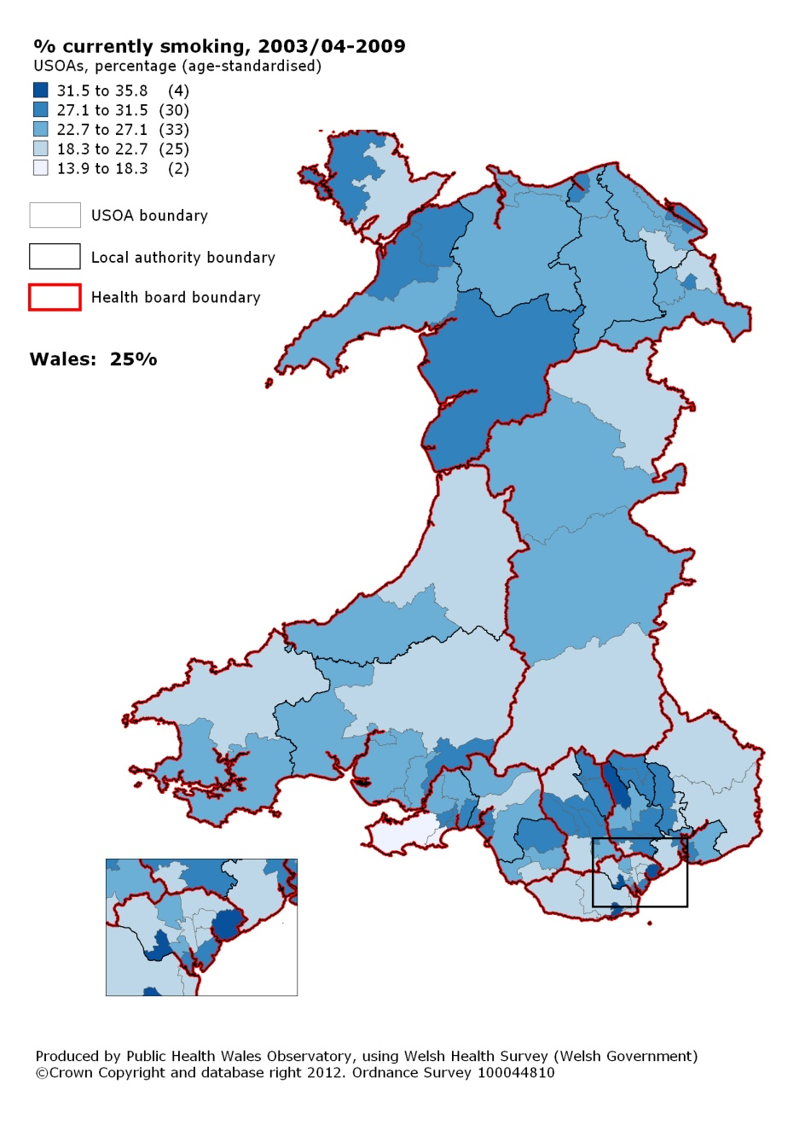

4.13 Physical activity
Definition
Percentage of adults (age-standardised) who reported physical activity meeting guidelines in the past week.
About physical activity
Current guidelines, introduced in 2011, recommend that an adult undertakes at least 30 minutes of physical activity, of moderate intensity, on five or more days each week. Previous guidelines were slightly less flexible and as such slightly harder to meet. People who are physically less active are at increased risk of developing conditions such as coronary heart disease, stroke and type 2 diabetes.
Pattern of physical activity
In Wales, only 30 per cent of adults report physical activity meeting recommended guidelines. Percentages range from 22 to 38 per cent at USOA level. The map shows generally higher levels of physical level activity in North and Mid Wales with lower levels in the south and a largely rural urban split.
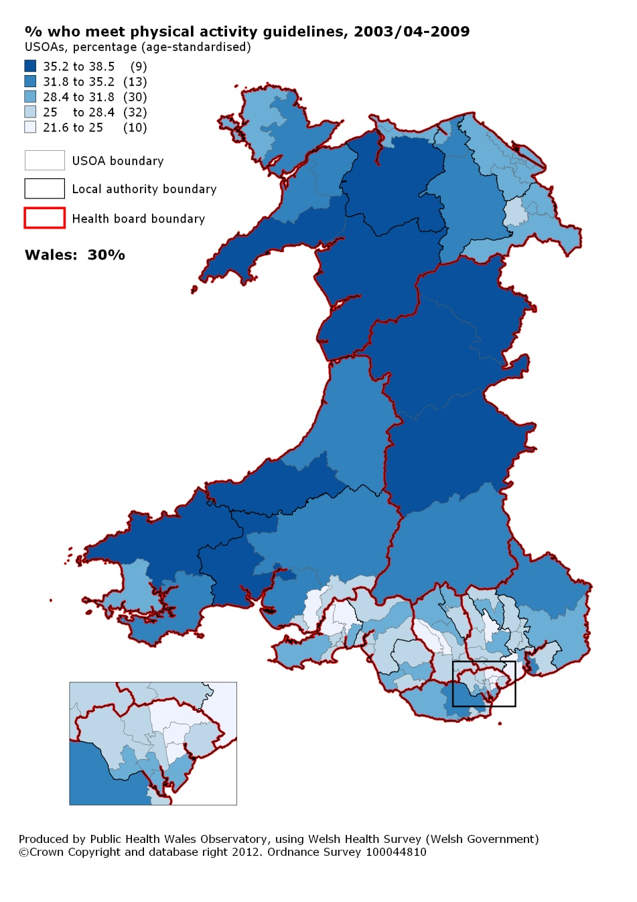

4.14 Overweight or obese
Definition
Percentage of adults (age-standardised) who reported a weight and height classed as overweight or obese (BMI of 25 or over)
About overweight or obese
Adults with a Body Mass Index (BMI) of 25 or over are defined as overweight or obese. Obesity is an important determinant of cardiovascular disease, type 2 diabetes, some cancers and physical and psychological well-being. People living in the most deprived areas are less likely to eat a healthy, balanced diet. However, the evidence from the Survey on the association between deprivation and meeting physical activity guidelines is weak.
Pattern of overweight or obese
In Wales, 56 per cent of adults reported a weight and height classed as being overweight or obese ranging from 48 per cent in areas of North Wales and Cardiff & Vale to 63 per cent in areas of Aneurin Bevan and Cardiff and Vale. In Cwm Taf, five of the nine USOAs have percentages statistically significantly above the average for Wales.

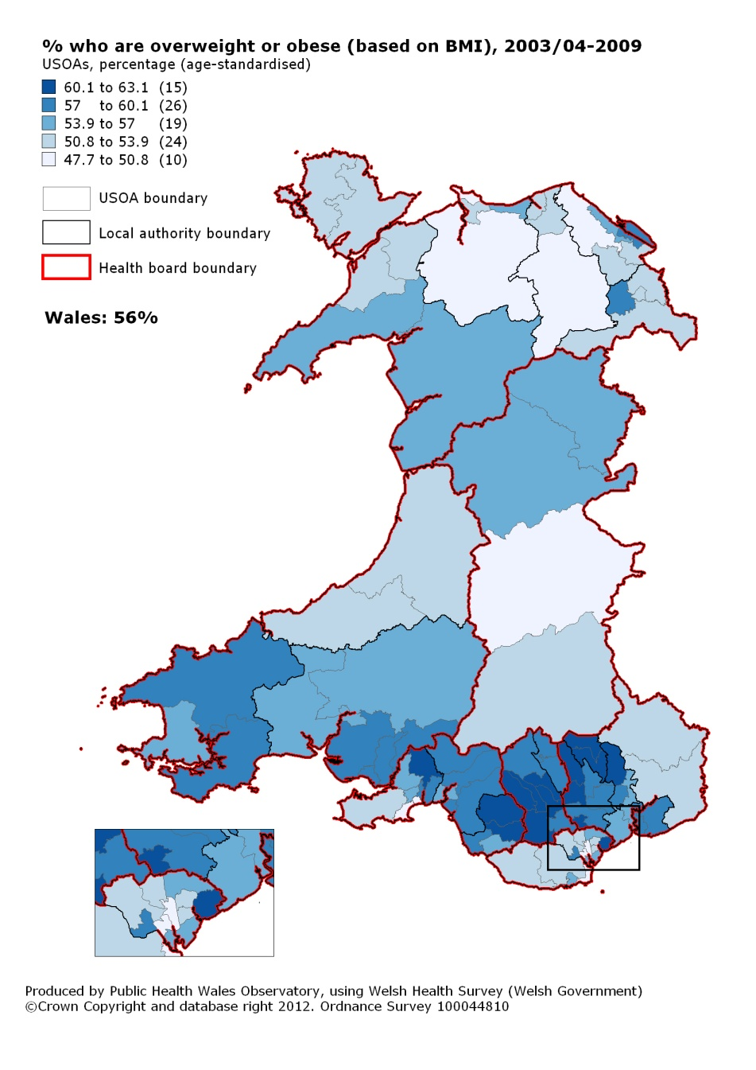

4.15 Obese
Definition
Percentage of adults (age-standardised) who reported a weight and height classed as obese (BMI of 30 or over).
About obesity
Adults with a Body Mass Index (BMI) of 30 or over are classed as obese. Obesity is an important determinant of cardiovascular disease, type 2 diabetes, some cancers and physical and psychological well-being. People living in the most deprived areas are less likely to eat a healthy, balanced diet. However, the evidence from the Survey on the association between deprivation and meeting physical activity guidelines is weak.
Pattern of obesity
In Wales, the percentage of adults who reported a weight and height classed as obese ranged from 11 per cent to 26 per cent. In Cwm Taf, four out of nine USOAs have percentages statistically significantly above the average for Wales (20 per cent). With the exception of Cwm Taf the largest variations within health boards are seen in South Wales. Abertawe Bro Morgannwg has the largest variation among USOAs with percentages ranging from 11 to 25 per cent.
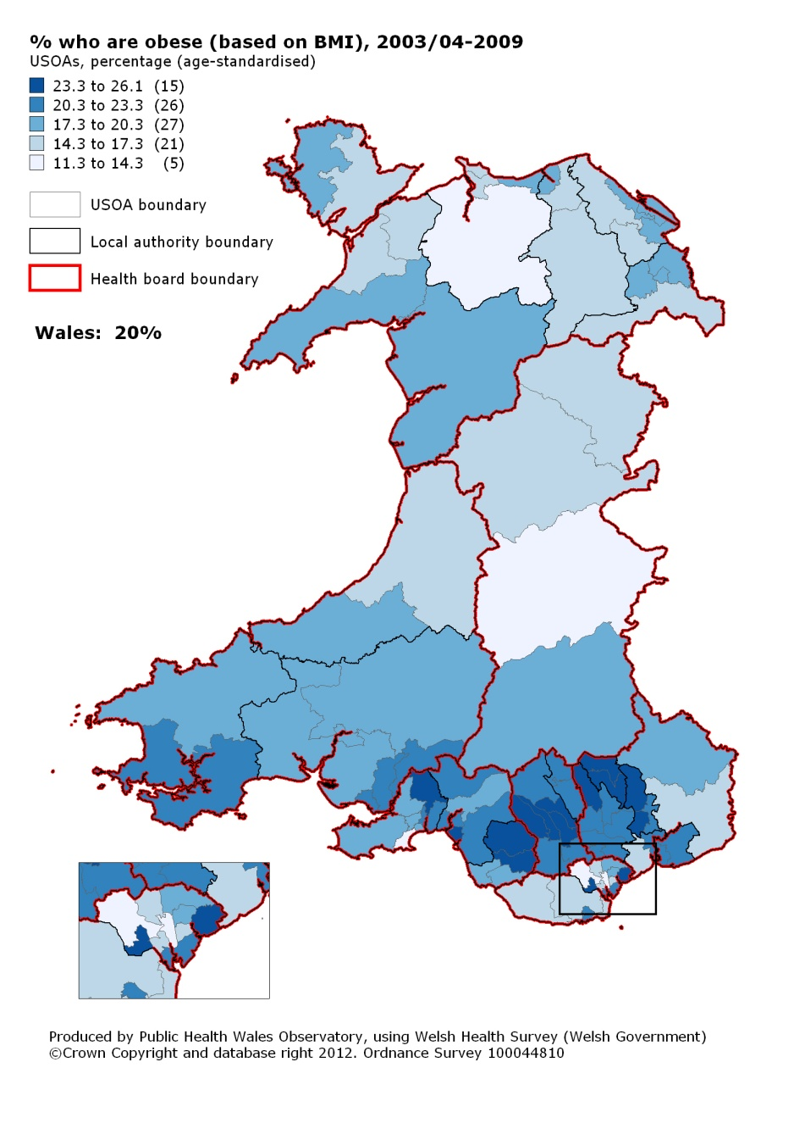

4.16 Contact with General Practitioner
Definition
Percentage of adults (age-standardised) who reported speaking to a General Practitioner (GP) about their own health in the past two weeks (either in person or by telephone).
About contact with GP
General practices provide a wide range of services including health advice, diagnosis, treatment, referral to other services, immunisation and screening programmes. Measuring the number of people who contact their GP can help determine the level of morbidity in the population and the demand for primary care services.
Pattern of contact with GP
In Wales, 17 per cent of adults reported having contact with a GP in the past two weeks, ranging from 13 to 23 per cent at USOA level. There appears to be no clear pattern across Wales.
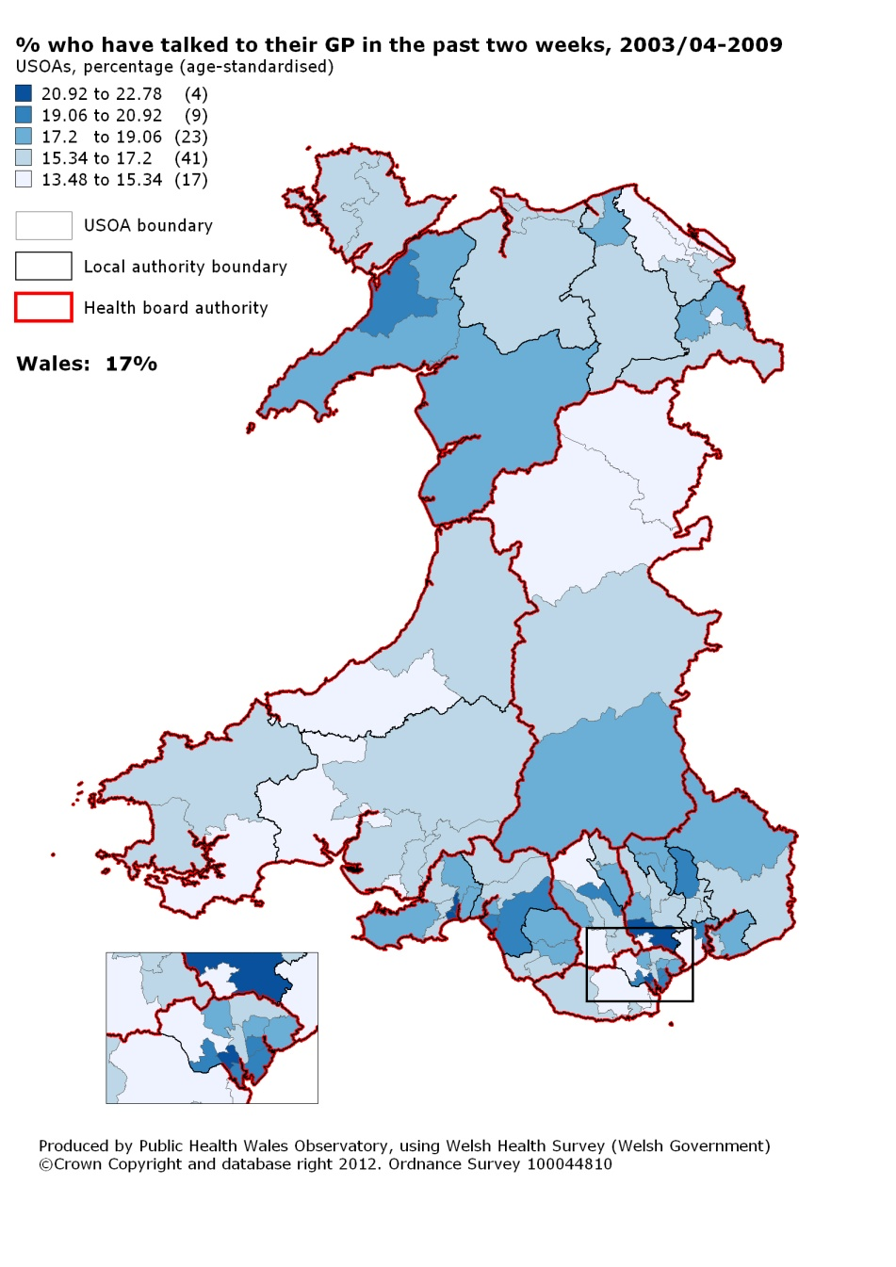

4.17 Hospital attendance from accidents injury and poisoning
Definition
Percentage of adults (age-standardised) who reported having an accident, injury or poisoning needing hospital treatment or a visit to casualty in the past three months. This includes a small number of injuries and poisonings that may be deliberate, for example through assault or self harm, as well as accidents.
About hospital attendance from accidents injury or poisoning
Injuries can have consequences for the individual, families, health services and society as a whole. People living in the most deprived areas are more likely to sustain an injury than people in the least deprived areas. Accident and Emergency (A&E) data has shown a strong link between distance to hospital and attendance rates; people living close to A&E departments are more likely to attend with a minor injury than people living further away.
Pattern of hospital attendance from accidents injury or poisoning
Overall, five per cent of adults in Wales reported attending hospital because of an accident in the last three months, with percentages ranging from two to seven per cent at USOA level. There appears to be no clear pattern across Wales.

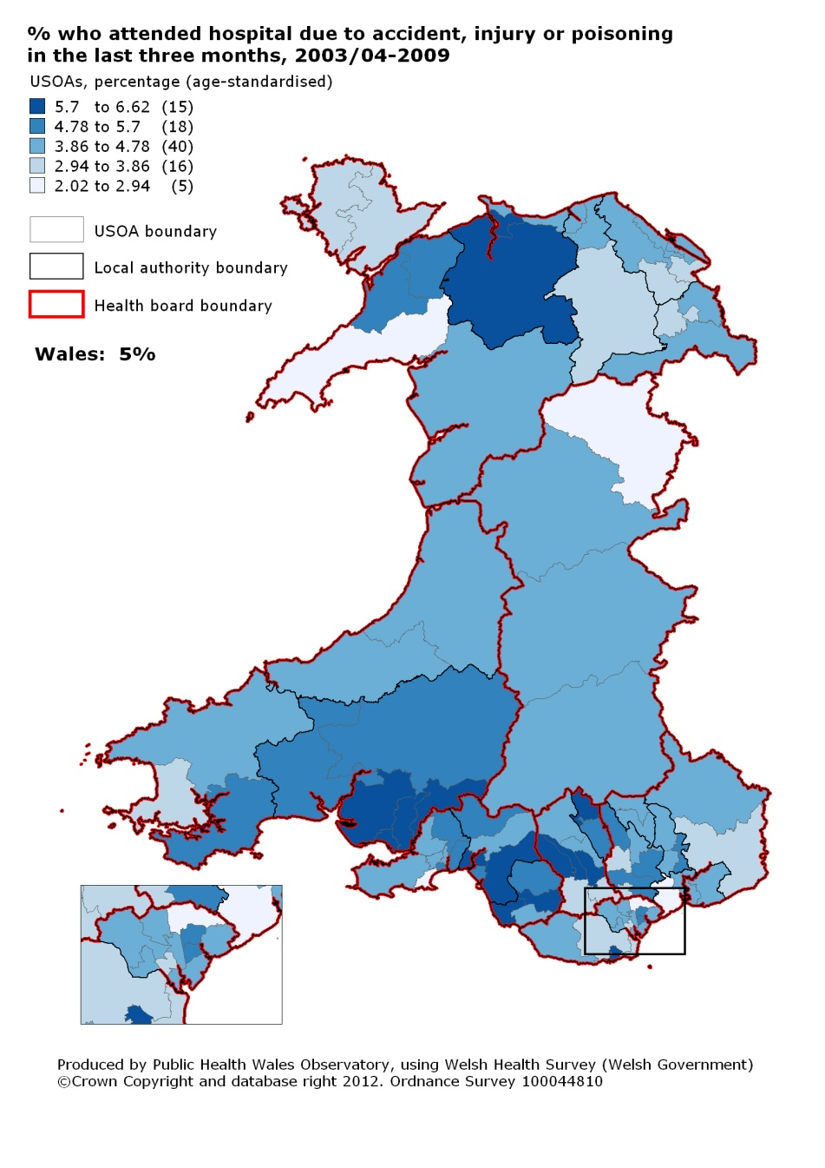

Appendices

Appendix A: Map showing USOAs in Wales

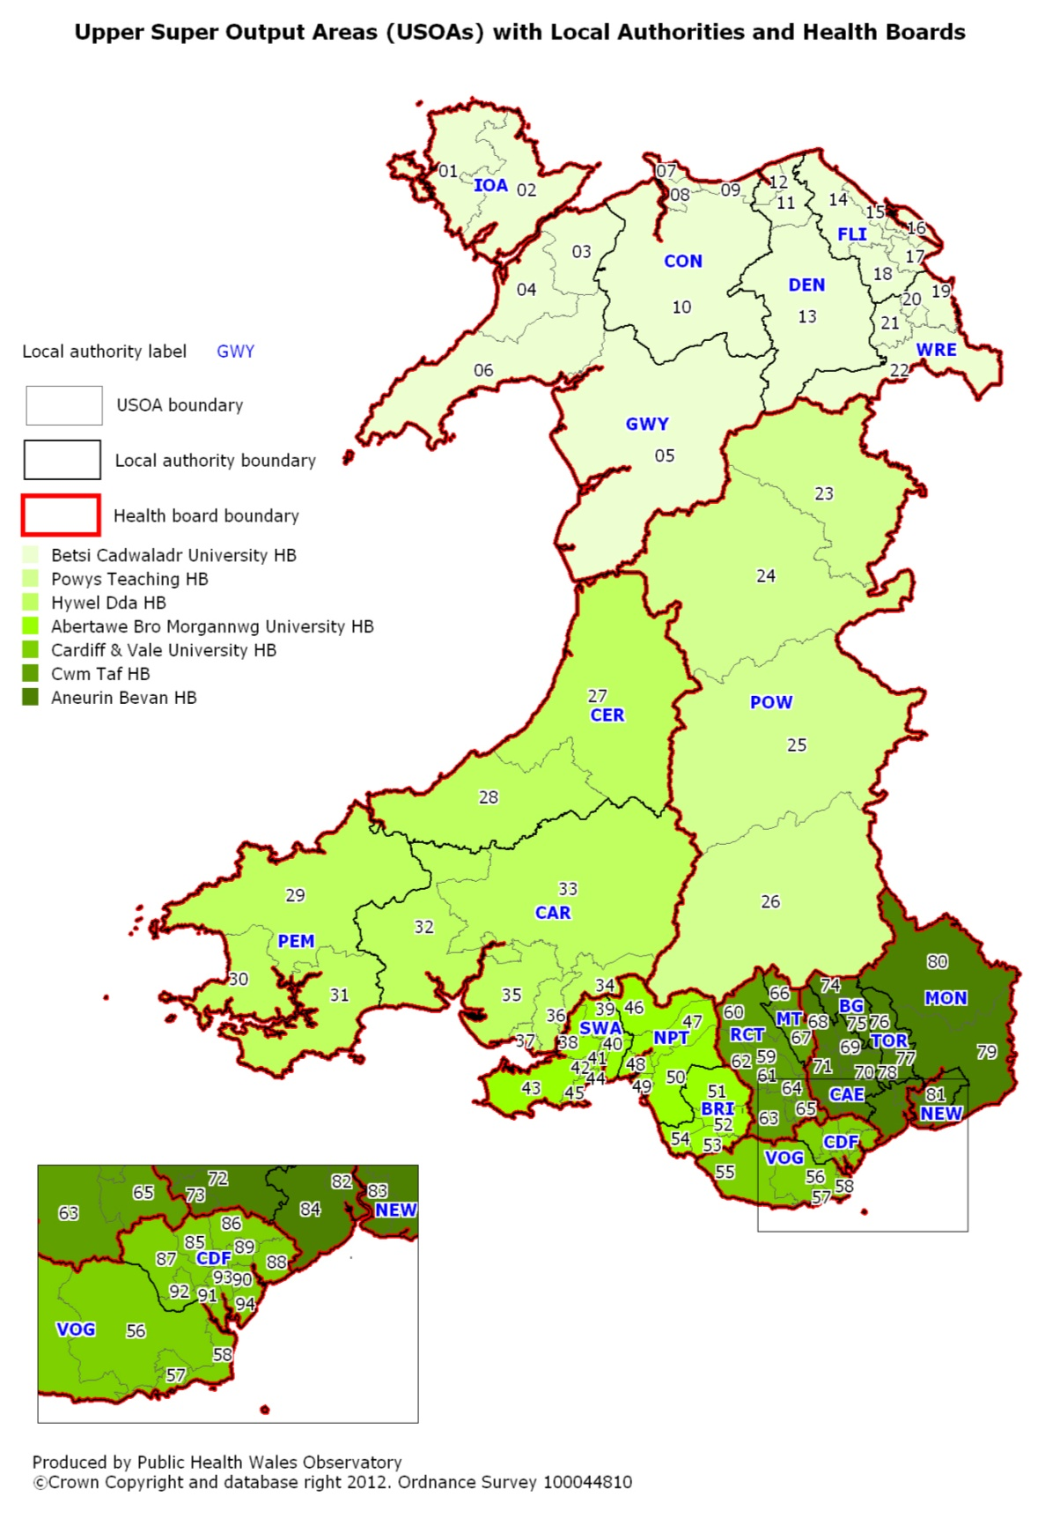

Appendix B: USOAs by local authority and health board

Appendix C: Abbreviations
A&E Accident and Emergency
BMI Body Mass Index
GP General Practitioner
HB Health board
LA Local authority
LSOA Lower Super Output Area
MSOA Middle Super Output Area
NatCen National Centre for Social Research
ONS Office for National Statistics
SF-36 Short Form (36) Health Survey
USOA Upper Super Output Area
WHS Welsh Health Survey
WG Welsh Government

