

Small area analysis of the Cwm Taf University Health Board maternity database
Author: Beth Patterson, Senior Public Health Intelligence Analyst; Hugo Cosh, Advanced Public Health Intelligence Analyst
Date: 17 January 2014 | Version: 2d
Publication/ Distribution:
Purpose and Summary of Document:
The purpose of this document is to present small area analysis of the Cwm Taf University Health Board maternity database to provide further insight into local patterns regarding maternal health.

Work Plan reference:

Contents

1 Introduction 3
2 Methods 3
2.1 Unit of analysis 3
2.2 Time period 3
2.3 Geography 4
2.4 Data collection 4
2.5 Data completeness 4
3 Results 5
3.1 Local authority summary of BMI of mother 5
3.2 Maternities where the mother had BMI of 25+ (overweight or obese) 6
3.3 Maternities where the mother had BMI of 30+ (obese) 7
3.4 Maternities where the mother reported smoking 8

Introduction
Following the Observatory’s report on the Potential for small area analysis on the Cwm Taf University Health Board maternity database and subsequent discussions with the Cwm Taf Public Health Team, this document presents the agreed small area analysis of the Cwm Taf University Health Board maternity database. The following indicators are included:
- maternities where, at the 12 week assessment, the mother had a body mass index (BMI) of:
  - 25+ (overweight or obese);
  - 30+ (obese)
  - 40+ (morbidly obese) (local authority / health board only)
- maternities where the mother reported smoking.

Methods
The data was obtained from Cwm Taf University Health Board by the Public Health Wales Informatics team. Access to the data, which is held in the Microsoft SQL server (provided by the NHS Wales Informatics Service), was then granted to members of the Observatory in order to be able to perform the analysis.
The extract of data obtained was analysed against the current All Wales Maternity Record form and the former Pontypridd and Rhondda booking form.

Unit of analysis
As the analyses presented in this document focus on lifestyle characteristics relating to the mother, the chosen unit used for counting was maternities i.e. individual pregnancies that start with “booking in” and end with birth (of one or more babies). This means that where the pregnancy resulted in more than one baby e.g. twins, the mother will be counted once. If an individual mother had two pregnancies within the time period, both would be counted as lifestyle characteristics may vary from one pregnancy to another e.g. a mother may smoke during one pregnancy but not during another.
Counting maternities in the v_CT_Maternity database is based on the PregnancyID field.

Time period
The analyses cover deliveries from 1st January 2012 to 31st March 2013 due to:
- Data completeness issues of the smoking status field up to 2011.
- Data quality issues of the coding of lower super output area (LSOA) and middle super output area (MSOA) of residence to 2010, particularly for Merthyr Tydfil residents.
Therefore, the data are taken exclusively from the MITS database which is the current maternity system and covers deliveries between March 2011 and March 2013.
Delivery date is the preferred measure of time since the data were extracted according to delivery dates and booking date is more incomplete and shows some instability.

Geography
The analyses in sections 3.1, 3.2 and 3.4 are mapped by MSOA of residence as the numbers were too small, and consequently, unstable for mapping at LSOA level. All analyses presented here are based on residents of Cwm Taf University Health Board only.

Data collection
Both smoking status and BMI were taken at the “booking in” assessment which usually (but not always) takes place at around 12 weeks. This should be kept in mind when interpreting the results as:
- some mothers may have stopped smoking part-way through their pregnancy;
- although likely to be minimal, BMI may be affected by some small weight gain during the first trimester.
Assessments which took place later than 12 weeks of gestation may capture further pregnancy-related weight gain as part of the BMI measure.

Data completeness
Data completeness of the smoking status and BMI fields was of overall good quality for the period analysed: January 2012 to March 2013; however, some NULL and zero entries remain and are quantified as:
- 9.9% of maternities for the BMI field (with a higher proportion of NULLs recorded in Merthyr Tydfil residents (18.7%) than RCT residents (7.5%))
- 8.0% of maternities for the smoking status field
Incomplete or invalid entries were excluded from the analysis; therefore some caution should be taken with the interpretation of the results.

Results

Local authority summary of BMI of mother

Maternities where the mother had BMI of 25+ (overweight or obese)
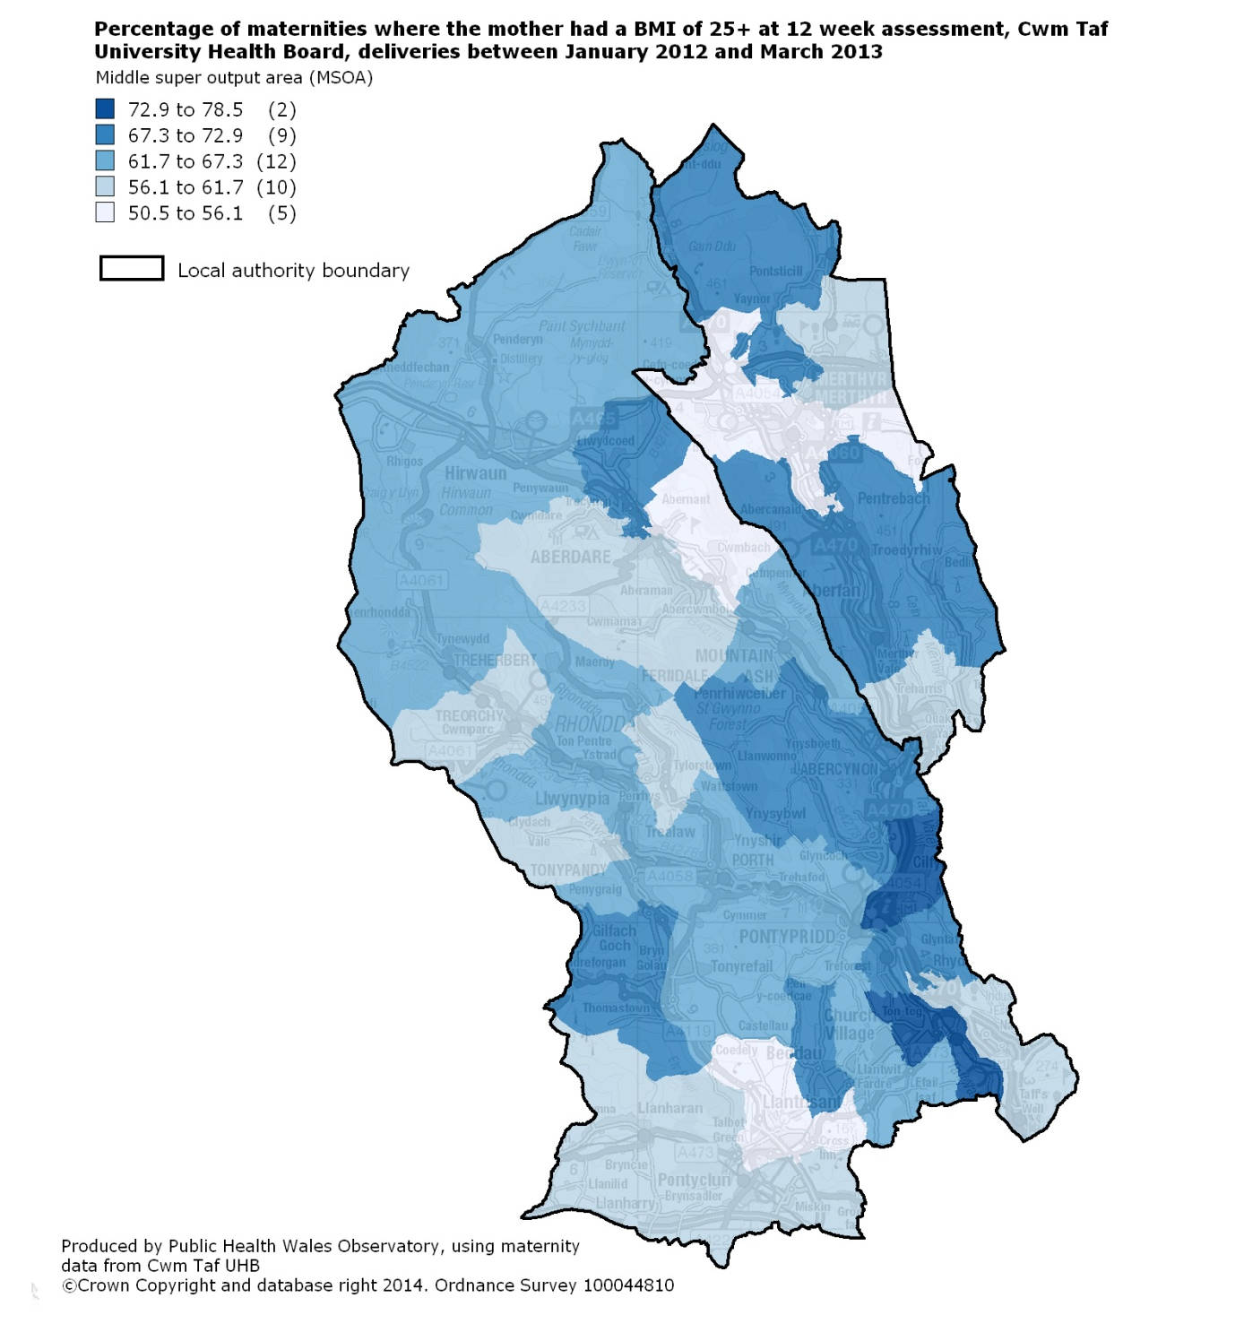

Maternities where the mother had BMI of 30+ (obese)
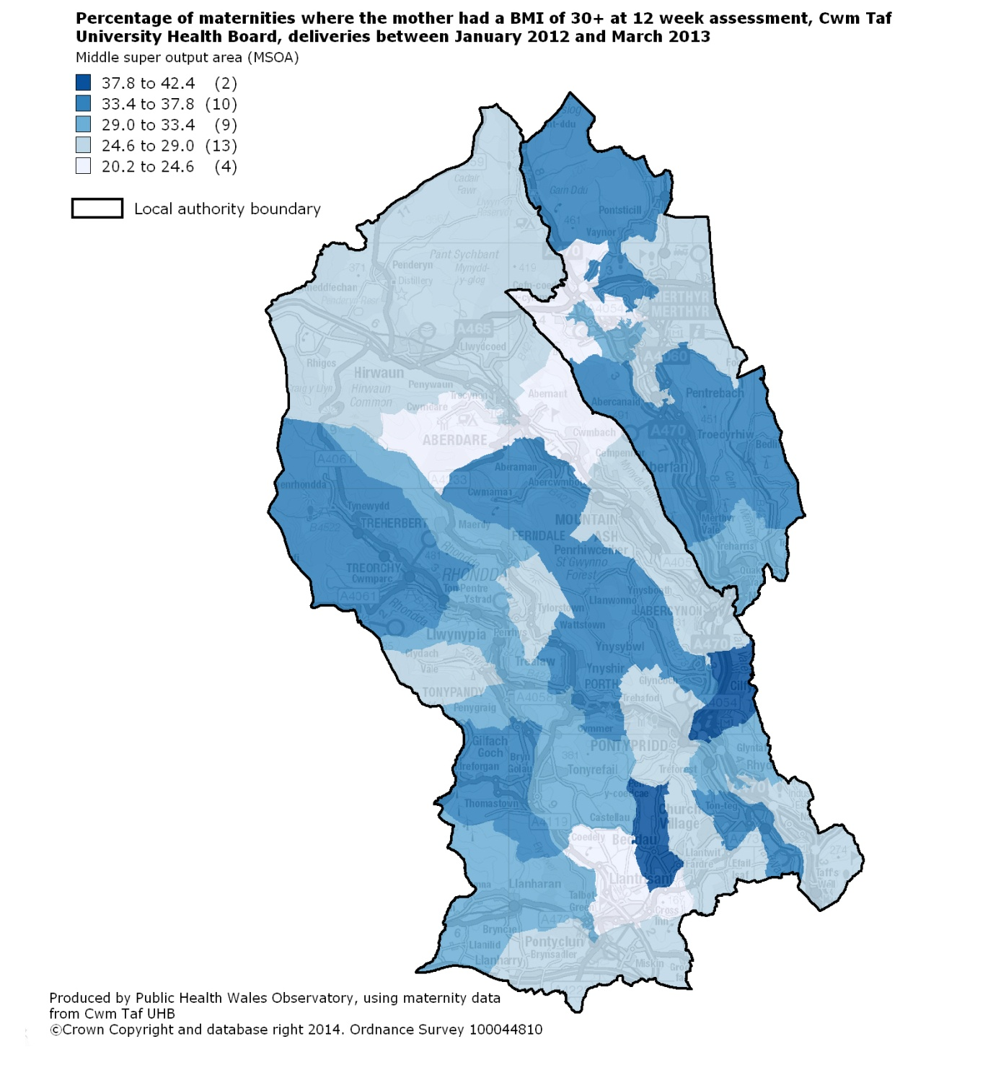

Maternities where the mother reported smoking
