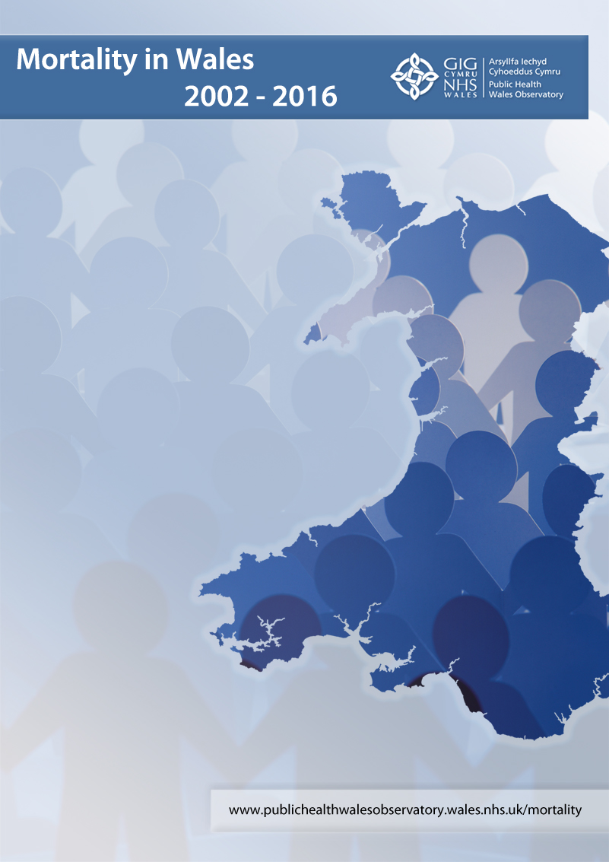

<insert title here>

Authors: Anna Childs, Andrew Dring, Nathan Lester, Dr Kirsty Little

Contact

Public Health Wales Observatory
5th Floor Number 2 Capital Quarter
Tyndall Street,
Cardiff CF10 4BZ

Email: publichealthwalesobservatory@wales.nhs.uk
Website: www.publichealthwalesobservatory.wales.nhs.uk

© 2018 Public Health Wales NHS Trust.
Material contained in this document may be reproduced under the terms of the Open Government Licence (OGL)
www.nationalarchives.gov.uk/doc/open-government-licence/version/3/
provided it is done so accurately and is not used in a misleading context.
Acknowledgement to Public Health Wales NHS Trust to be stated.
Copyright in the typographical arrangement, design and layout belongs to Public Health Wales NHS Trust.

Contents

Key Messages 4
1. Introduction 5
2. Mortality 2002-2016 5
2.1 Age-specific mortality 2002-2016 7
2.2 What happened to mortality in 2015? 8
2.3 What has happened since 2015? 11
3. Conclusion 12
4. References 13
5. Appendix 15

Key Messages

- The mortality rate in Wales has been declining since the Second World War; however since around 2011 this decline has faltered and rates have shown little change.
- A plateau in life expectancy in Wales is also visible since around 2011.
- This phenomenon has been repeated across much of Western Europe, but in Wales the effect occurred earlier and only Scotland now has lower life expectancy.
- The faltering of the decline in the overall mortality rate has been driven by increased deaths in the 85-89 and 90+ age groups. However, mortality rates among 55-84 year olds are also no longer in decline.
- Mortality rates rose significantly in 2015, attributed at least in part to increases in deaths from flu and pneumonia, and dementia and Alzheimer’s disease among those aged 75+.
- The levelling off of mortality rates in Wales, in conjunction with a growing vulnerable elderly population, may mean that increases in mortality such as that seen in 2015 will be more likely in the future.
- The slowing of the improvement in mortality in Wales is a cause for concern. Public Health Wales will remain in close communication with the Office for National Statistics (ONS) and Public Health England (PHE) and other organisations studying the changes to mortality trends both to monitor the ongoing pattern of mortality and to explore the underlying factors.

Introduction

Since the Second World War mortality rates in England and Wales have generally been falling¹, due to medical advances in diagnosis and treatment and improved lifestyles, in particular a reduction in smoking.
In 2015, ONS reported a 5.6% increase in the number of deaths in England and Wales, the largest year on year percentage increase since the change from 1967 to 1968². There was also a significant increase in the age-standardised death rate compared to 2014.
The increase in deaths in 2015 generated widespread public health, media and academic interest providing the impetus for this report³⁻¹¹. However, it is important to consider any annual change in mortality in the context of wider mortality trends.
Therefore, the aim of this report is to provide a brief analysis of mortality trends in Wales over the last fifteen years and to investigate the causes behind the increase in mortality in 2015.

Mortality 2002-2016

Number of deaths
The number of deaths in Wales has generally been increasing since 2011 such that there were around 33,000 deaths in 2016 compared with 30,500 in 2011. However, this might be expected given changes in the population of Wales which was at its largest ever at 3.1 million in 2016. Improvements in healthcare and lifestyle mean that people are living longer and therefore our population is getting older.

Given that the population of Wales is growing and aging, the most meaningful way of monitoring trends in deaths is by using age-standardised rates. Rates take into account changes in the size of the population and age standardisation means we are also accounting for any changes in the age structure of the population. The next section looks at trends in the age-standardised death rate.
Mortality rate
Since 2011, mortality rates in Wales have remained stable although year on year fluctuations are evident as shown in figure 1. This marks an important change in trend as mortality rates have generally been falling since the Second World War¹.

The levelling off of mortality rates in Wales is similar to the trend exhibited in the other UK nations. Rates in Wales broadly follow the same trend as the combined rate for England and Wales, but are consistently higher than the rates for England and Wales over the period shown.

Life expectancy is another way of looking at mortality. There is a close link between the two measures, so that a decrease in mortality rates will generally be associated with an increase in life expectancy and vice versa. We would therefore expect any change in mortality rates to be reflected in the trend in life expectancy.

Life expectancy
Life expectancy at birth in Wales has increased far more slowly since 2011, marking a distinct change in trend. Figure 2 shows a plateau in life expectancy has occurred in the other UK nations as well. This is also visible for Sweden and Iceland which are shown as they are among highest ranked nations (ranked 1st and 3rd out of 188 countries) for the 33 UN Sustainable Development Goal health indicators and share similar demographic characteristics to the UK (ranked 5th). The data used here are sourced from the Global Burden of Disease study as they allow comparison between UK constituent countries and European nation states. Please note that the data is modelled based on national mortality data where available.
Wales appears to have experienced this change earlier than most other Western European countries¹² (see table 1, appendix). Despite life expectancy being at its highest level, the relative position of Wales has worsened such that of the 25 European nations shown in table 1 (see appendix), Wales has slipped from a rank of 16th to 24th with only Scotland now exhibiting lower life expectancy.

Age-specific mortality 2002-2016
Whilst the European age-standardised mortality rate provides a good measure of all age mortality, age-specific rates allow us to assess whether trends are consistent across age groups.

There is a recurring theme across the majority of the age groups pictured in figure 3; as with the overall mortality rate, the age specific rates show a period of decline, followed by a period of little change. In most cases the change occurs around 2011.

As illustrated in figure 3, the levelling off in mortality rates is not confined to the very elderly population; the 55-59 to 80-84 age groups show a clear levelling off of mortality rates since around 2011. In the 85-89 age group rates have been stable since 2006. In the 90+ age group the rate declined between 2002 and 2011 since when it has begun to rise, although more fluctuation is evident in these older age groups. Age specific rates in age groups under 50 years are subject to considerable fluctuation over time due to relatively small numbers of deaths. This is also apparent to a certain extent in the 50-54 age group.

What happened to mortality in 2015?
The 2015 increase in mortality in England and Wales has been widely reported³⁻¹¹. Similar increases in the number of deaths have also been reported elsewhere in Europe including France, Spain, Denmark and Switzerland¹⁰.

There were 1,572 more deaths registered in the first three months of 2015 compared with the same period in 2014 in Wales. In 2015, the European age-standardised mortality rate in Wales rose to 1,064 deaths per 100,000 population, from 1,017 deaths per 100,000 in 2014. It is important to understand this increase in the context of the wider mortality trend, for example the rate fluctuated from 1,060 deaths per 100,000 population in 2013, down to 1,017 per 100,000 in 2014 and up again to 1,064 per 100,000 population in 2015.

Much of the increase in 2015 occurred in those aged 85 years and over with a significant increase in those aged 90+ (figure 4). This is consistent with what has been reported for England and Wales as a whole².

The increase in mortality in 2015 can be largely attributed to increases in mortality from flu and pneumonia, or other respiratory diseases, and dementia and Alzheimer’s disease (see figure 5). This is consistent with the causes reported by ONS for England and Wales¹¹.

Influenza

Of the 1,572 extra deaths registered in the first three months of 2015, 758 were registered in January coinciding with the peak in flu activity for the 2014/15 winter season.

The Welsh GP weekly consultation rate for influenza-like illness (ILI) was not unusually high (see figure 6). However, the predominant strain of influenza circulating at this time, A(H3N2), is associated with illness in older people, for whom¹⁴ the 2014/15 ILI consultation rates were at their highest since the 2010-11 influenza season in Wales¹³. Influenza activity in hospitals and outbreaks in nursing and residential homes and care facilities was also notably high¹³. Lower vaccine efficacy was also reported during 2014/15 for the UK, 34% compared with 50% during the 2010/11 season, with little difference in take-up rates¹⁴.

There was a more significantly increased incidence of flu during the 2010/11 winter season (figure 6 above). However, the predominant strain circulating during the 2010/11 flu season presented more of a problem for younger people who have greater resilience, resulting in the high consultation rates shown in figure 6¹⁴, but less of an impact on mortality.

Figure 5 shows that there was also an increase in deaths in older people from other respiratory diseases followed by a decrease in 2016. The death rate due to dementia and Alzheimer’s also increased and went up again in 2016. This is consistent with findings for England and Wales as a whole^{11,15}.

Alzheimer’s and dementia
The increase in deaths from dementia and Alzheimer’s disease may be influenced by a number of factors. More people are surviving to older ages both as a result of improvements in healthcare and also because of demographic events in the twentieth century such as the post war baby booms and subsequent improved chances of surviving infancy and early childhood¹⁶.

In more recent years there has also been a general improvement in the recognition of both disease and mortality from age related degenerative conditions including dementia and Alzheimer’s disease¹⁶.

Changes to the coding of underlying cause of death can have an impact on the number of deaths recorded with a specific underlying cause. Two major coding changes occurred in 2011 and 2014. For example, the implementation of IRIS software for the coding of underlying cause of death in 2014 is associated with 7.1% increase in deaths attributed to an underlying cause of dementia¹⁷.

More than a third of deaths with an underlying cause of dementia or Alzheimer’s disease also have a respiratory disease (such as flu) mentioned on the death certificate¹⁵. This may suggest that people with degenerative conditions such as dementia and Alzheimer’s disease have more vulnerability to the effects of flu and other respiratory conditions.

What has happened since 2015?
Following a large increase in 2015, the age-standardised mortality rate decreased slightly to a rate of 1,046 per 100,000 population in 2016. This is more consistent with the period since 2011.

The provisional European age-standardised mortality rate for 2017 of 1,037 per 100,000 population is again lower than the rate reported for 2015, and more consistent with both the 2016 rate and the period since 2011.

Provisional data for the first seven weeks of 2018 suggests that the number of deaths registered was higher than the previous 5-year average^{18,19}. Analysis by colleagues in the Public Health Wales Communicable Disease Surveillance Centre has indicated that flu is again implicated in the increased level of mortality during this period in Wales.

The previous ongoing decline in overall mortality rates may have masked similar peaks and troughs in the past; however, the levelling off of mortality rates in Wales, in conjunction with a growing vulnerable elderly population, may indicate that that fluctuations in mortality such as that seen in 2015 may be more likely in the future.

Conclusion

The mortality rate in Wales has been falling steadily since the Second World War¹. The increase in mortality in Wales between 2014 and 2015 was the largest since 1968². Analysis of cause of death in older people has shown that increases in deaths from flu and pneumonia, other respiratory disease, and Alzheimer’s and dementia had a major impact on the overall rate.

However, the key finding of this report is that the increase in deaths in 2015 did not occur in isolation. The improvement in mortality rates has slowed markedly since 2011 and this is also reflected in a plateauing of life expectancy. Although happening at slightly different times and to differing extents, this phenomenon is exhibited in other parts of the UK and Europe.

Overall mortality rates are most strongly influenced by age specific rates among older people (aged 85+) due to the relatively large number of deaths occurring in this subgroup. Our analysis has shown that the faltering in the decline of mortality rates in Wales is also being driven by changes in mortality among older people. However, it is clear that the levelling off in mortality is occurring at younger ages too.

The slowing of the decline of mortality in Wales is clearly a matter of public health concern. This is part of a broader picture of changes in mortality and life expectancy across the UK and in other developed countries. Work is ongoing among a number of agencies to further explore the reasons behind this. Public Health Wales will continue to work alongside partners both to monitor the ongoing mortality trends and to further explore the factors that may be driving the changes we have highlighted, particularly in relation to factors specific to Wales.

References

- Griffiths C, Brock A. Twentieth century mortality trends in England and Wales. Health Stat Q 2003;18:5-16
- Office for National Statistics. Provisional analysis of death registrations: 2015. [Online]. Available at: https://www.ons.gov.uk/peoplepopulationandcommunity/birthsdeathsandmarriages/deaths/articles/provisionalanalysisofdeathregistrations/2015. [Accessed: 27th March 2018]
- Green M. Sharp rise in UK mortality rate may be due to austerity measures. [Online]. The Conversation 2017 February 17th. Available at http://theconversation.com/sharp-rise-in-uk-mortality-rate-may-be-due-to-austerity-measures-72984 [Accessed 5th March 2018]
- Public Health Matters Blog. What’s happening with mortality rates in England? Blog 2017 20th July. Available at: https://publichealthmatters.blog.gov.uk/2017/07/20/whats-happening-with-mortality-rates-in-england/ [Accessed: 5th March 2018]
- Why has mortality in England and Wales been increasing? An iterative demographic analysis. J R Soc Med 2017; 110: https://doi.org/10.1177/0141076817693599 Available at: https://www.ncbi.nlm.nih.gov/pubmed/28208027 [Accessed: 5th March 2018]
- Hiam L, Dorling D, Harrison DK, McKee M. What caused the spike in mortality in England and Wales in January 2015? J R Soc Med 2017; 110: 131-7
- Number of deaths in England and Wales hits 12-year high. The Guardian. 2016 7th April. Available at: https://www.theguardian.com/uk-news/2016/apr/07/number-deaths-england-wales-12-year-high-life-expectancy [Accessed: 5th March 2018]
- Biggest annual rise in deaths for almost fifty years prompts warnings of crisis in elderly care. The Telegraph. 2016 16th Feb. Available at: http://www.telegraph.co.uk/news/health/12158930/Biggest-annual-rise-in-deaths-for-almost-fifty-years-prompts-warnings-of-crisis-in-elderly-care.html [Accessed: 5th March 2018]
- Sharp spike in deaths in England and Wales needs investigating says Public Health expert. BMJ 2016;252i1981 Available at: http://www.bmj.com/content/352/bmj.i981 [Accessed: 5th March 2018]
- Office for National Statistics. Deaths registered in England and Wales: 2015 Annual data on death registrations contains death rates, cause of death data by sex and age and death registrations by area of residence and single year of age. [Online] Statistical Bulletin Available at: https://www.ons.gov.uk/peoplepopulationandcommunity/birthsdeathsandmarriages/deaths/bulletins/deathsregistrationsummarytables/2015 [Accessed: 5 March 2018]
- Office for National Statistics. Spike in number of deaths in 2015 driven by increased mortality in over 75s. News release 2016 7th April. Available at: https://www.ons.gov.uk/news/news/spikeinnumberofdeathsin2015drivenbyincreasedmortalityinover75s [Accessed: 5th March 2018]
- Public Health Wales. Health and its determinants in Wales. Informing strategic planning. 2018. [Online]. Available at: http://www2.nphs.wales.nhs.uk:8080/PubHObservatoryProjDocs.nsf/85c50756737f79ac80256f2700534ea3/99a9490d2e6d05268025820b005851de/$FILE/Health&determinantsinWales_Report_Eng.pdf [Accessed: 5th March 2018]
- Public Health Wales Vaccine Preventable Disease Programme and Communicable Disease Surveillance Centre. Seasonal influenza in Wales - 2014/15, August 2015. [Online]. Cardiff: Public Health Wales. Available at: http://www2.nphs.wales.nhs.uk:8080/VaccinationsImmunisationProgsDocs.nsf/($All)/AECFDA367EA8E8F580257EC8002EE440/$File/Seasonal%20influenza%20vaccine%20uptake%20in%20Wales%20201415_v1a.pdf [Accessed: 5th March 2018]
- Office for National Statistics. Excess Winter Mortality in England and Wales: 2014/15 (Provisional) and 2013/14 (Final). [Online] Statistical Bulletin. Available at: https://www.ons.gov.uk/peoplepopulationandcommunity/birthsdeathsandmarriages/deaths/bulletins/excesswintermortalityinenglandandwales/201415provisionaland201314final [Accessed: 5th March 2018]
- Office for National Statistics. Dementia/alzheimers and respiratory disease behind the biggest annual increase in deaths since the 1960s. [Online]. Available at: https://www.ons.gov.uk/peoplepopulationandcommunity/birthsdeathsandmarriages/deaths/articles/dementiaandrespiratorydiseasebehindbiggestannualdeathsincreasesincethe1960s/2016-04-07 [Accessed: 5th March 2018]
- Institute of Health Equity. Marmot indicators briefing. 2017. [Online]. Available at: http://www.instituteofhealthequity.org/resources-reports/marmot-indicators-2017-institute-of-health-equity-briefing/marmot-indicators-briefing-2017-updated.pdf [Accessed: 5th March 2018]
- Office for National Statistics. Impact of the implementation of IRIS software for ICD-10 cause of death coding on mortality statistics, England and Wales. 2014. [Online] Statistical Bulletin: Available at: https://www.ons.gov.uk/peoplepopulationandcommunity/birthsdeathsandmarriages/deaths/bulletins/impactoftheimplementationofirissoftwareforicd10causeofdeathcodingonmortalitystatisticsenglandandwales/2014-08-08 [Accessed:5th March 2018]
- Office for National Statistics. Weekly provisional figures on deaths registered in England and Wales. 2018: up to week ending 30 March 2018. [Online]. Available at: https://www.ons.gov.uk/peoplepopulationandcommunity/birthsdeathsandmarriages/deaths/datasets/weeklyprovisionalfiguresondeathsregisteredinenglandandwales [Accessed: 27th March 2018]
- Hiam L, Dorling D. Rise in mortality in England and Wales in first seven weeks of 2018. 2018. BMJ. 2018; 360:k1090 doi: 10.1136/bmj.k1090 (Published 14 March 2018) Available at: http://www.bmj.com/content/360/bmj.k1090?utm_medium=email&utm_campaign_name=20180376&utm_source=etoc_weekly [Accessed: 5th March 2018]

Appendix

