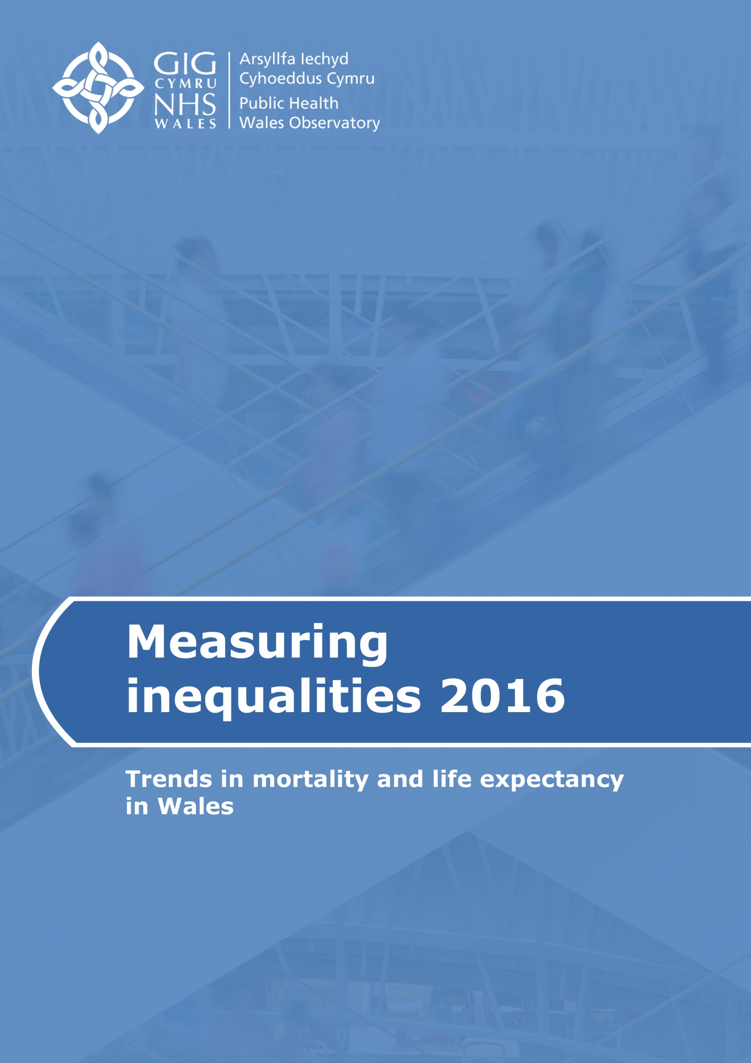

This report is part of the Measuring Inequalities 2016 publication, which also includes:
- a summary document for each of the seven health boards
- interactive data files showing the main indicators
- a technical guide describing the methods, data sources and caveats
These are available from www.publichealthwalesobservatory.wales.nhs.uk/inequalities

We would welcome feedback on this report and examples of how it has been used. To provide feedback, or to request further information, please contact us:

Public Health Wales Observatory
14 Cathedral Road
Cardiff
CF11 9LJ

email: publichealthwalesobservatory@wales.nhs.uk
web: www.publichealthwalesobservatory.wales.nhs.uk

Main project team (analysis and writing)
James Allen, Hugo Cosh, Arthur Duncan-Jones, Andrea Gartner, Leon May, Beth Patterson

Additional analytical support
Grace Jefferies, Dr Gareth Davies

Project directors
Nathan Lester, Kirsty Little

Acknowledgements
Our thanks go to Charlotte Fellows (Public Health England) for providing advice on the analysis by cause of death presented in section 4.

© 2016 Public Health Wales NHS Trust

All tables, charts and maps were produced by the Public Health Wales Observatory and the data sources are shown under each graphic. Material contained in this profile may be reproduced without prior permission provided it is done so accurately and is not used in a misleading context. Acknowledgement to Public Health Wales NHS Trust to be stated. Typographical copyright lies with Public Health Wales NHS Trust.

Contents

Figures and tables 2
Abbreviations 2
Key Messages 3
1 Introduction 5
2 Guide to interpretation 6
2.1 Does deprivation relate to individuals or areas? 6
2.2 Has the inequality gap or the social gradient in health been measured? 6
2.3 How has the inequality gap been measured? 7
2.4 How should life expectancy figures be interpreted? 7
2.5 How were the deprivation ‘fifths’ created? 7
3 Measuring inequalities in life expectancy 8
3.1 Within the United Kingdom 8
3.2 Within Wales as a whole 9
3.2.1 Across deprivation fifths 9
3.2.2 Across local authorities and health boards 11
3.2.3 Across small geographical areas 13
3.3 Within health boards and local authorities 15
4 Effects of reducing mortality from specific causes of death 17
5 Measuring inequalities in mortality rates 18
5.1 All-cause mortality 18
5.2 Preventable mortality 20
6 Supplementary analysis 22
6.1 Welsh Index of Multiple Deprivation (WIMD) 2014: national map 22
6.2 Welsh Health Survey respondents reporting good health, by age group 23
6.3 Census 2011 respondents reporting good health, by small area 24
7 Discussion 26
8 References 27

Figures and tables

Figure 1 | Life expectancy, healthy life expectancy and disability-free life expectancy at birth, UK nations, 2009-11 | 8
Figure 2 | Comparison of life expectancy and healthy life expectancy at birth, with Slope Index of Inequality, Wales, 2005-09 and 2010-14 | 9
Figure 3 | Percentage of life expectancy in good health by deprivation fifth, Wales, 2005-09 and 2010-14 | 10
Figure 4 | Life expectancy at birth, males, Wales, 2010-14 | 13
Figure 5 | Life expectancy at birth, females, Wales, 2010-14 | 14
Figure 6 | Years of life expectancy gained or lost if the most deprived fifth had the same mortality rates as the least deprived fifth, by broad cause of death, Wales, 2012-14 | 17
Figure 7 | All-cause mortality, European age-standardised rate per 100,000, Wales, 2005-14 | 19
Figure 8 | Preventable mortality, European age-standardised rate per 100,000, all ages, Wales, 2005-14 | 20
Figure 9 | Preventable and non-preventable mortality by deprivation fifth, European age-standardised rate per 100,000, Wales, 2012-14 | 21
Figure 10 | Welsh Index of Multiple Deprivation 2014 | 22
Figure 11 | Percentage of survey respondents who reported good health, by age group, least and most deprived fifth, Wales, 2010-14 | 23
Figure 12 | Percentage of males assessing their general health status as good or very good, Wales, 2011 | 24
Figure 13 | Percentage of females assessing their general health status as good or very good, Wales, 2011 | 25
Table 1 | Life expectancy and healthy life expectancy at birth, males, Wales health boards and local authorities, 2010-14 | 11
Table 2 | Life expectancy and healthy life expectancy at birth, females, Wales health boards and local authorities, 2010-14 | 12
Table 3 | Inequality gap in life expectancy and healthy life expectancy at birth (Slope Index of Inequality, in years), Wales health boards and local authorities, 2010-14 | 16

Abbreviations
The following abbreviations are used within this report to describe which data sources were used for each table, chart and map. For further information about these data sources, see the technical guide, available at www.publichealthwalesobservatory.wales.nhs.uk/inequalities
ONS Office for National Statistics
PHM Public Health Mortality
WIMD Welsh Index of Multiple Deprivation
WHS Welsh Health Survey
MYE Mid-Year Population Estimates
Health board names have also been abbreviated to UHB (University Health Board) and THB (Teaching Health Board). Abertawe Bro Morgannwg UHB has been abbreviated to ABM UHB.

Key Messages
Measuring inequalities in life expectancy
- People in Wales are living longer, and are spending more of their lives in good health. In males, life expectancy has increased from 77.0 years in 2005-09 to 78.3 years in 2010-14, with healthy life expectancy increasing from 63.5 to 65.3 over the same period. In females, life expectancy has risen from 81.4 to 82.3, with a rise in healthy life expectancy from 65.3 to 66.7 years.
- There are small differences in life expectancy across the UK nations. For both males and females, life expectancy in Wales is higher than in Scotland and Northern Ireland, but lower than in England.
- There is more than a five-year difference in healthy life expectancy between males living in Northern Ireland and England (58.6 vs 64.7 years). In Wales, healthy life expectancy is higher than in Northern Ireland, but slightly lower than the UK average.
- The difference in life expectancy between the least and most deprived areas in Wales shows no clear sign of reducing. In males, there remains a gap in life expectancy of around 9 years between the least and most deprived and an even larger gap in healthy life expectancy of approximately 19 years. In females, the gaps are similarly persistent, at around 7 years for life expectancy and approximately 18 years for healthy life expectancy.
- Males living in the most deprived fifth of Wales not only have a shorter lifespan, but also spend less of it in good health (77%) compared to those living in the least deprived fifth (89%). The same is true of females (74% vs 86%).
- Females are living longer than males (82.3 vs 78.3 years in 2010-14) but are spending a slightly lower proportion of their lives in good health (81% vs 83%). Since 2005-09, life expectancy (and healthy life expectancy) in males has increased slightly more, proportionally, than in females.
- There is substantial variation in life expectancy across local authorities in Wales, and even greater variation in healthy life expectancy; for example, around twelve years separates the highest and lowest healthy life expectancies in females (71.1 years in Gwynedd compared to 59.3 in Blaenau Gwent).
- The percentage of life expectancy in good health also varies widely across local authorities, from 74% in females living in Blaenau Gwent to 86% in the Isle of Anglesey.
- There is wide variation in life expectancy across the 410 Middle Super Output Areas in Wales. In males, there is a difference of 14 years between the lowest and highest area, and in females, the difference is 15 years.
- In the Thornhill area of North Cardiff, life expectancy in males is nearly 85 years, compared to less than 71 years in Rhyl, North Denbighshire.
- In the Rhiwbina area of North Cardiff, life expectancy in females is nearly 90 years, compared to less than 75 years in Pillgwenlly in central Newport.
- There is up to an 11-year gap in male life expectancy between the least and most deprived areas within some local authorities (e.g. Denbighshire, Cardiff, Swansea). The gap is generally larger in males than in females.
- There is more than a 20-year difference in healthy life expectancy between the least and most deprived areas of Cardiff and the Vale of Glamorgan, for both sexes.
- There is a wider range of deprivation in some areas than others. This should be noted when interpreting the gaps in life expectancy and mortality rates shown within this report. For example, Cardiff includes some of the least deprived areas of Wales (e.g. in Cyncoed) and some of the most deprived (e.g. in Splott), which partly explains the large gap in healthy life expectancy in males (24.4 years) within the local authority. Other local authorities have narrower ranges of deprivation, which is likely to lead to narrower inequality gaps. To aid interpretation, the range of deprivation within each local authority is shown within the health board summary documents, which are available on the Observatory website.
Effects of reducing mortality from specific causes of death
- Reducing overall mortality from circulatory disease to levels seen in the least deprived areas of Wales would increase life expectancy in the most deprived areas by 1.5 years in males and 1.3 years in females. Similar gains could be made if cancer mortality rates were reduced (1.3 years in males, 1.2 in females).
- Reducing excess deaths from external causes (e.g. accidents, suicide) could have a particularly large effect on males living in the most deprived areas, potentially adding nearly a year to their life expectancy.
Measuring inequalities in mortality rates
- Overall mortality rates are lower than they were ten years ago, but the gap between the least and most deprived fifth shows no sign of reducing. For deaths occurring at under 75 years of age, mortality rates have remained more than twice as high in the most deprived.
- Overall rates of preventable mortality have reduced over the last ten years, but the gap between the least and most deprived fifth shows no sign of reducing. The rate in the most deprived has remained over twice as high as in the least deprived.
- In the most deprived fifth of Wales, preventable mortality accounts for 25% of the overall mortality rate in males, and 20% of the overall mortality rate in females. These figures are considerably lower in the least deprived fifth, at 18% and 14% respectively.
Welsh Health Survey respondents reporting good health, by age group
- The difference in prevalence of good health between people living in the least and most deprived areas is already apparent at age 0-15. This gap then grows as age increases, peaking in males at age 65-74 (79% in least deprived vs 52% in most deprived) and in females at age 55-64 (84% vs 56%).

Introduction
The drive to monitor and address health inequalities has a long and important history within the UK.
Pioneering epidemiologist William Farr analysed mortality rates in broad occupational groups as far back as the mid-19th Century¹. The first formal measure of occupation-based social class (the Registrar General’s social class schema) was created in 1911 and used throughout the 20th Century to show the social gradient in health².
The Black report³ and the Acheson inquiry⁴ demonstrated persistent health inequalities within the UK, in the context of improvements in overall population health. The more recent Marmot Review⁵ confirmed the continuing social gradient in health in England, citing social inequalities as the driver of health inequalities, and calling for action to equalise the social determinants of health (e.g. employment, education, environment).
In Wales, our 2011 profile⁶ demonstrated similar findings: people living longer, and longer in good health, but with large and persistent inequalities between the least and most deprived areas.
Achieving a reduction of health inequalities has been a priority in Wales since devolution, and is one of the six strategic themes within the Welsh Government’s public health framework Our Healthy Future⁷. Reflecting the key messages of the Marmot Review, this framework states that where health inequalities can be avoided, they constitute inequities which are in opposition to the Welsh Government’s ambition to create a fair and just society. Addressing such inequities is the focus of the strategic action plan Fairer Health Outcomes For All⁸, which recommends action across the life course and across the social determinants of health and wellbeing. These aspirations have also been carried through into the Well-being of Future Generations (Wales) Act⁹, which includes ‘A more equal Wales’ and ‘A healthier Wales’ amongst its seven well-being goals.
With the aim of continuing to support the national government and local Public Service Boards in their efforts to develop appropriate approaches to tackling health inequalities across Wales, and to implement and monitor the effectiveness of such action, the 2011 profile is now updated by this publication. Section 3 provides an analysis of life expectancy using the latest-available data, including estimates of healthy life expectancy. This is followed by a new analysis of how reducing mortality rates from specific causes of death could improve life expectancy in the most deprived parts of Wales. Section 5 then provides the latest picture of the trends in mortality rates across deprivation fifths within Wales.

Guide to interpretation
This section provides key information on how to interpret the figures within this report, given the methods and data sources used to produce them. Further details can be found within the technical guide, available at www.publichealthwalesobservatory.wales.nhs.uk/inequalities
A particular caveat to be aware of concerns the use of population estimates supplied by the Office for National Statistics (ONS). During the preparation of this report, it was discovered that the population aged 85+ has been underestimated in some areas by the ONS estimates. In most parts of Wales, the impact of this issue on life expectancy and mortality rates will be small, and the effect on national figures is likely to be negligible. Further details are available from the webpage linked above.

Does deprivation relate to individuals or areas?
The most accurate way to monitor health inequalities would be to measure individual people’s socio-economic characteristics, for example their income and occupation. However, in the absence of suitable socio-economic data at the individual level, an area-based deprivation measure has been used: the Welsh Index of Multiple Deprivation 2014 (WIMD). This index combines data from eight domains, including income and employment, to provide a deprivation rank for each of the 1,909 Lower Super Output Areas (LSOAs) in Wales. The average population of these LSOAs is around 1,600 people.
It should be noted that not everyone living in a deprived area is living in deprived circumstances and, equally, some people living in an area classed as least deprived may experience deprivation. For example, around 4 in 5 people in households claiming income benefit live outside the most deprived 10 per cent of LSOAs in Wales¹⁰.
Therefore, even though the measures in this report are based on areas, this does not mean the focus for action should be area based.

Has the inequality gap or the social gradient in health been measured?
This report provides information on i) the difference in health between people living in the least and most deprived areas (‘inequality gap’), and ii) the difference in health across people living in areas at increasing levels of deprivation (the ‘social gradient’ in health).
For example, figure 2 uses the Slope Index of Inequality (SII, see section 2.3) to estimate the inequality gap in life expectancy within Wales, whilst the social gradient in preventable mortality across deprivation fifths is shown in figure 9.
The inequality gap is a commonly-used method of monitoring health inequalities. However, it should be noted that a sole focus on reducing this gap would ignore people living in areas between the extremes of deprivation. According to Marmot’s proportionate universalism⁵, and as outlined in Fairer Health Outcomes for All⁸, in order to make the social gradient in health less steep, resources for improving health should be targeted across the whole population, with a scale and intensity that is proportionate to the level of deprivation.

How has the inequality gap been measured?
The main measure of the inequality gap in life expectancy used in this report is the Slope Index of Inequality (SII). The SII is a measure of the difference in life expectancy between the most and least deprived, whilst taking into account the distribution across the whole population. As such, it is a measure that takes account of the social gradient, but summarises this as an absolute gap between life expectancy at the two extremes of the deprivation spectrum.
To measure the inequality gap in mortality rates, this report uses the rate ratio. This is calculated by dividing the rate in the most deprived fifth by the rate in the least deprived fifth. If this rate is greater than one, then the rate is higher in the most deprived fifth. A rate ratio of two means that the rate is twice as high in the most deprived fifth as in the least deprived fifth.

How should life expectancy figures be interpreted?
Life expectancy (LE) is a widely used statistical measure of the average expected years of life for a newborn based on recently-observed mortality rates. As such, LE at birth is also a measure of mortality across all ages. It should be noted, however, that mortality rates are likely to change in the future, and therefore whilst LE figures are our “best guess” at this point in time, they cannot provide a precise estimate of the lifespan of an individual.
In addition to general LE, it is important to consider healthy life expectancy (HLE). This represents the number of years a person might expect to live in good or very good health. HLE incorporates survey data on health in Wales and hence its estimation may be affected by any survey sampling error. Further information is available in the technical guide.
This report includes estimates of disability-free life expectancy for the UK nations (fig.1), which is the number of years a person might expect to live without a disability or limiting long-term illness. It has not been possible to produce updated estimates of disability-free life expectancy for areas within Wales. These were included in our 2011 profile⁶, but due to subsequent changes in survey questions regarding limiting long-term illness, sufficient data is not available at the time of writing.

How were the deprivation ‘fifths’ created?
For the Wales-level analysis, all 1,909 Lower Super Output Areas (LSOAs) in Wales were grouped into fifths according to their WIMD published rank. These deprivation fifths are commonly used. For the health board and local authority level analysis, however, specific deprivation fifths within each area have been produced, as some areas do not have sufficient numbers of LSOAs in each national fifth. In Blaenau Gwent for example, there are no LSOAs that are nationally classed as least deprived. This approach is consistent with those used elsewhere in the UK, including in the development of Marmot indicators⁵ at a local level in England.
There is a wider range of deprivation in some areas than others. This should be noted when interpreting the gaps in life expectancy and mortality rates shown within this report. For example, Cardiff includes some of the least deprived areas of Wales (e.g. in Cyncoed) and some of the most deprived (e.g. in Splott), which partly explains the large gap in healthy life expectancy in males (24.4 years) within the local authority. Other local authorities have narrower ranges of deprivation, which is likely to lead to narrower inequality gaps. To aid interpretation, the range of deprivation within each local authority is shown within the health board summary documents, which are available on the Observatory website.

Measuring inequalities in life expectancy

Within the United Kingdom
Key messages
- There are small differences in life expectancy across the UK nations (fig.1). For both males and females, life expectancy in Wales is higher than in Scotland and Northern Ireland, but lower than in England.
- There is more than a five-year difference in healthy life expectancy between males living in Northern Ireland and England (58.6 vs 64.7 years). In Wales, healthy life expectancy is higher than in Northern Ireland, but slightly lower than the UK average.
- In Wales, disability-free life expectancy is estimated at 61.7 years in males and 62.9 years in females, both of which are slightly lower than the UK average.

Figure 1

Within Wales as a whole

Across deprivation fifths
Key messages
- People in Wales are living longer, and are spending more of their lives in good health (fig. 2). In males, life expectancy has increased from 77.0 years in 2005-09 to 78.3 years in 2010-14, with healthy life expectancy increasing from 63.5 to 65.3 over the same period. In females, life expectancy has risen from 81.4 to 82.3, with a rise in healthy life expectancy from 65.3 to 66.7 years.
- The difference in life expectancy between the least and most deprived areas in Wales shows no clear sign of reducing (fig. 2). In males, there remains a gap in life expectancy of around 9 years between the least and most deprived and an even larger gap in healthy life expectancy of approximately 19 years. In females, the gaps are similarly persistent, at around 7 years for life expectancy and approximately 18 years for healthy life expectancy.
- As shown in figure 3, males living in the most deprived fifth of Wales not only have a shorter lifespan, but also spend less of it in good health (77%) compared to those living in the least deprived fifth (89%). The same is true of females (74% vs 86%).
- Females are living longer than males (82.3 vs 78.3 years in 2010-14) but are spending a slightly lower proportion of their lives in good health (81% vs 83%). Since 2005-09, life expectancy (and healthy life expectancy) in males has increased slightly more, proportionally, than in females.
Figure 2

Example interpretation: based on deaths registered in 2010-14, the difference in life expectancy between males living in the least deprived and most deprived areas in Wales is 8.8 years.

Further information
- Due to differences in data and methods (detailed below), the following comparisons with England should be interpreted with caution:
- The inequality gap in life expectancy in Wales (fig.2) is similar to that in England¹¹ (8.8 years in Wales vs 9.1 in England for males, and 7.2 vs 6.9 for females).
- The gaps in healthy life expectancy are slightly smaller in Wales than in England¹¹ (18.7 vs 19.2 in males, 18.2 vs 19.5 in females) but these differences are not statistically significant.
- The latest-available figures for England are based on data from 2011-13, rather than 2010-14, and inequality was measured across ten deprivation groups, as opposed to five in Wales. Also, a different survey was used to measure good health in England.
- Examining the linearity of the distribution of the estimates across the deprivation fifths can help with the interpretation of the Slope Index of Inequality and its confidence interval. Charts showing this distribution are available for every health board and local authority area on our website, and further guidance on interpretation can be found in the technical guide.
- The life expectancy and healthy life expectancy figures presented in this report are not comparable to those shown in the original Measuring Inequalities profile⁶. This is due to the 2014 version of the Welsh Index of Multiple Deprivation being used in this report, as opposed to the 2011 version, and the revisions to population estimates carried out in light of the 2011 Census.

Figure 3

Across local authorities and health boards
Key messages
- There is substantial variation in life expectancy across local authorities in Wales, and even greater variation in healthy life expectancy (table 1); for example, around twelve years separates the highest and lowest healthy life expectancies in females (71.1 years in Gwynedd compared to 59.3 in Blaenau Gwent).
- The percentage of life expectancy in good health also varies widely across local authorities, from 74% in females living in Blaenau Gwent to 86% in the Isle of Anglesey.
Table 1

Further information
- Due to differences in data and methods (detailed below), the following comparisons with England should be interpreted with caution:
- Male life expectancy at birth in England¹² ranges from 74.0 (Blackpool) to 82.1 years (Harrow), and healthy life expectancy¹³ ranges from 55.8 (Manchester) to 70.0 (Wokingham). These ranges are wider than those found in Wales, which is likely to reflect the wider range of deprivation found in England. The picture is similar for females, with life expectancy ranging from 79.6 (Manchester) to 86.2 (Kensington and Chelsea), and healthy life expectancy ranging from 56.0 (Tower Hamlets) to 71.0 (Richmond upon Thames).
- The latest-available figures for England are based on data from 2009-13. Also, a different survey was used to measure good health in England.
Table 2

Across small geographical areas
Key messages
- There is wide variation in life expectancy across the 410 Middle Super Output Areas (MSOAs) in Wales. In males, there is a difference of 14 years between the lowest and highest area (fig. 4), and in females, the difference is 15 years (fig. 5).
- In the Thornhill area of North Cardiff, life expectancy in males is nearly 85 years, compared to less than 71 years in Rhyl, North Denbighshire.
- In the Rhiwbina area of North Cardiff, life expectancy in females is nearly 90 years, compared to less than 75 years in Pillgwenlly in central Newport.
Further information
- It is not possible to calculate healthy life expectancy for MSOAs in Wales, due to the small sample size of Welsh Health Survey data at this geographical level.
- In Wales, according to 2014 mid-year population estimates, MSOAs have an average population of around 7,500.

Figure 4
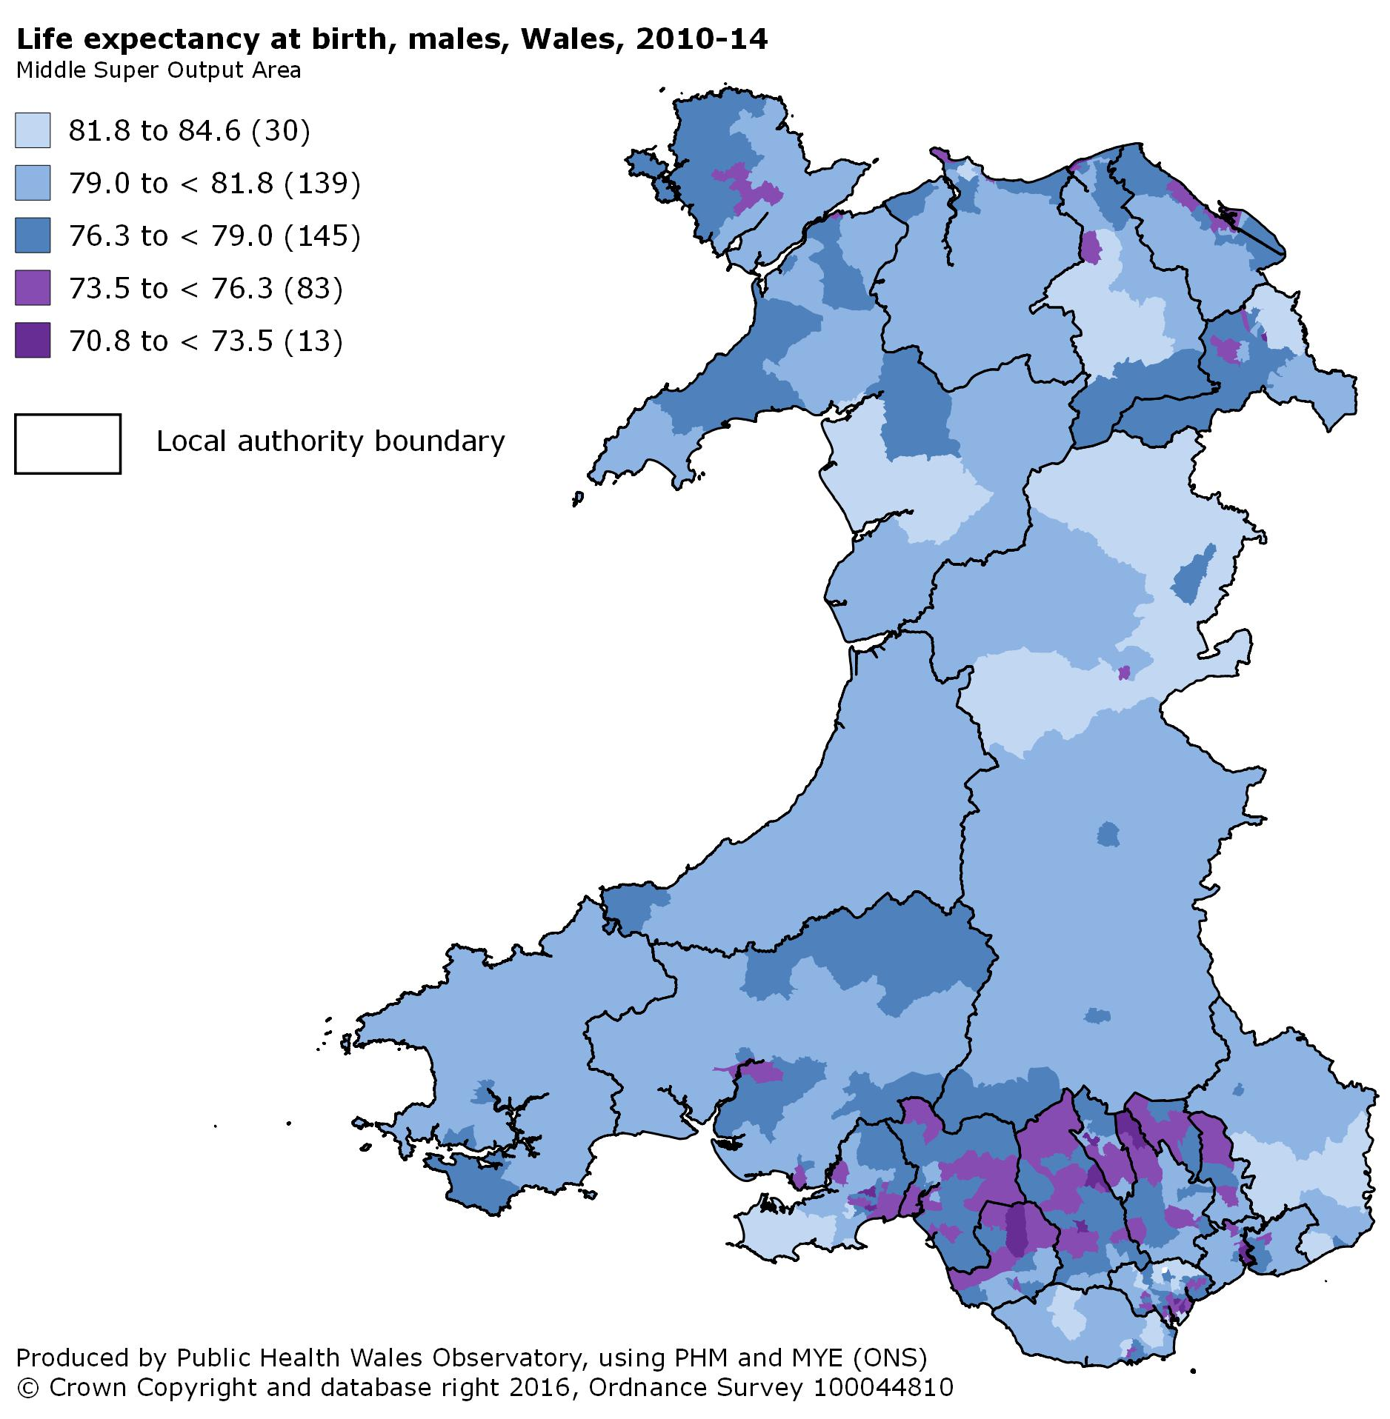

Figure 5
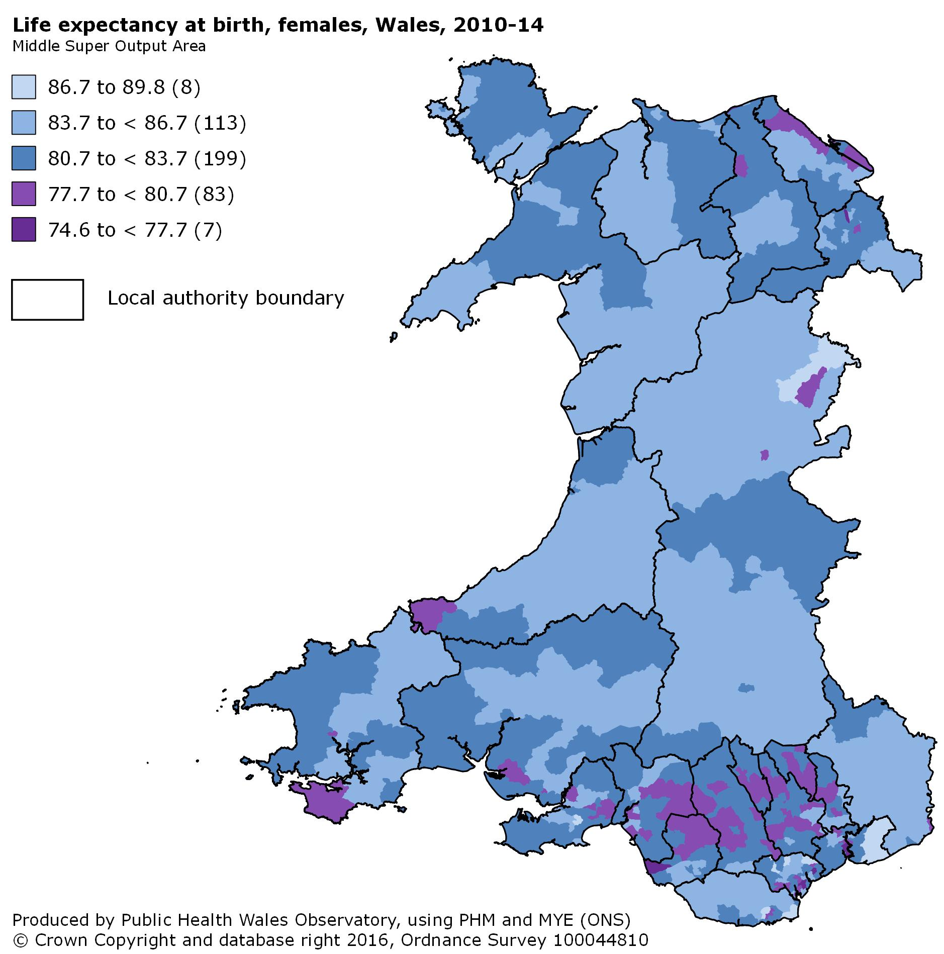

Within health boards and local authorities
Key messages
- There is up to an 11-year gap in male life expectancy between the least and most deprived areas within some local authorities (e.g. Denbighshire, Cardiff, Swansea). The gap is generally larger in males than in females (table 3).
- There is more than a 20-year difference in healthy life expectancy between the least and most deprived areas of Cardiff and the Vale of Glamorgan, for both sexes (table 3).
- There is a wider range of deprivation in some areas than others. This should be noted when interpreting the gaps in life expectancy and mortality rates shown within this report. For example, Cardiff includes some of the least deprived areas of Wales (e.g. in Cyncoed) and some of the most deprived (e.g. in Splott), which partly explains the large gap in healthy life expectancy in males (24.4 years) within the local authority. Other local authorities have narrower ranges of deprivation, which is likely to lead to narrower inequality gaps. To aid interpretation, the range of deprivation within each local authority is shown within the health board summary documents, which are available on the Observatory website.
Further information
- Due to differences in data and methods (detailed below), the following comparisons with England should be interpreted with caution:
- The largest inequality gaps in life expectancy in England¹² are 12.6 years in males (Stockton-on-Tees) and 10.0 in females (Middlesborough), which are not dissimilar to the largest gaps in Wales as shown in table 3.
- For healthy life expectancy, the largest inequality gaps in England¹³ are 24.6 years in males (Kensington and Chelsea) and 22.1 years in females (Bradford), which once again are not dissimilar to the largest gaps in Wales (fig. 7).
- The latest-available figures for England are based on data from 2009-13, rather than 2010-14, and inequality was measured across the Middle Super Output Areas within each local authority, as opposed to the deprivation fifths used in our analysis for Wales. Also, a different survey was used to measure good health in England.
- Examining the linearity of the distribution of the estimates across the deprivation fifths can help with the interpretation of the SII and its confidence interval. Charts showing this distribution are available for every health board and local authority area on our website, and further guidance on interpretation can be found in the technical guide.

Table 3

Effects of reducing mortality from specific causes of death
Key messages
- Reducing overall mortality from circulatory disease to levels seen in the least deprived areas of Wales would increase life expectancy in the most deprived areas by 1.5 years in males and 1.3 years in females (fig. 6). Similar gains could be made if cancer mor tality rates were reduced (1.3 years in males, 1.2 in females).
- Reducing excess deaths from external causes (e.g. accidents, suicide) could have a particularly large effect on males living in the most deprived areas, potentially adding nearly a year to their life expectancy (fig. 6).
Further information
- To calculate these figures, life expectancy in the most deprived fifth was re-calculated after applying mortality rates from the least deprived fifth. For example, there may have been 1,000 circulatory disease deaths in the most deprived fifth; this might fall to 800 deaths when that population is given the same circulatory disease mortality rate as the least deprived fifth. This would lead to increased life expectancy in the most deprived fifth.
Figure 6

- Due to differences in data and methods (detailed below), the following comparisons with England should be interpreted with caution:
- Males living in the most deprived areas of England¹⁴ could gain slightly more life expectancy from reducing excess deaths from circulatory diseases than in Wales (1.8 vs 1.5 years), whilst in Wales greater gains could be made by reducing excess deaths from external causes (0.9 vs 0.6 years).
- It should be noted that the latest-available figures for England are based on data from 2011-13, rather than 2012-14.
- Overall, addressing specific causes of death would have a similar impact on the most deprived areas of Wales as on the most deprived areas of England.
- This analysis is available for local areas (health boards and local authorities) via www.publichealthwalesobservatory.wales.nhs.uk/inequalities. For some local areas, the chart shown in figure 6 will include negative values, appearing in the left half of the chart area. This means that mortality rates for the particular cause of death are higher in the least deprived than in the most deprived areas. This could happen in the case of the ‘mental’ category for example, which includes deaths with an underlying cause of dementia. Such deaths may be more common in the least deprived areas than in the most deprived, because people are likely to live longer in those areas, and dementia becomes more prevalent as age increases. Such a pattern may also exist for other causes of death, but the effect may not be visible in the chart (fig. 6) due to being grouped with other similar diseases; for example, prostate cancer and female breast cancer, which are known generally to be more common in the least deprived than the most deprived areas, are grouped in ‘all cancers’ with other types of cancer (e.g. lung) which are known to be more common in the most deprived areas.

Measuring inequalities in mortality rates

All-cause mortality
Key messages
- Overall mortality rates are lower than they were ten years ago, but the gap between the least and most deprived fifth shows no sign of reducing (fig. 7). For deaths occurring at under 75 years of age, mortality rates have remained more than twice as high in the most deprived.
Further information
- Mortality rates are statistically significantly higher in males than in females. This is likely to be due to a combination of biological and social factors; for example, smoking prevalence has historically been higher in males than in females.
- For deaths at all ages, in both males and females, mortality rates in the most deprived fifth do not appear to have fallen since 2009-11. Furthermore, the overall all-age mortality rate has not fallen appreciably in more recent years, in both males and females. Data for subsequent years will help to determine whether this is a temporary plateau or a sign that mortality rates are beginning to fall more slowly they have been in recent years.
- The mortality rates shown in figure 9 are not comparable to those shown in the original Measuring Inequalities profile⁶. This is due to the adoption of the 2013 European Standard Population for the calculation of age-standardised rates in this report.

Figure 7

Preventable mortality
Key messages
- Overall rates of preventable mortality (defined below) have reduced over the last ten years, but the gap between the least and most deprived fifth shows no sign of reducing (fig. 8). The rate in the most deprived has remained over twice as high as in the least deprived.
- In the most deprived fifth of Wales, preventable mortality accounts for 25% of the overall mortality rate in males, and 20% of the overall mortality rate in females (fig. 9). These figures are considerably lower in the least deprived fifth, at 18% and 14% respectively.
Further information
- According to the Office for National Statistics¹⁵, a death is classified as preventable if “in the light of understanding of the determinants of health at the time of death, all or most deaths from that cause (subject to age limits if appropriate) could be avoided by public health interventions in the broadest sense.” Examples of preventable deaths would be those caused by chronic heart disease and lung cancer. Further details are available in the technical guide.

Figure 8

Figure 9

Supplementary analysis

Welsh Index of Multiple Deprivation (WIMD) 2014: national map
Key messages
- The highest concentrations of areas in the most deprived fifth of Wales are found in the South Wales Valleys, on the North Wales coast and within the urban areas of Cardiff, Newport and Swansea (fig. 10).
Further information
- To generate deprivation fifths, the 1,909 Lower Super Output Areas (LSOAs) in Wales were ordered from highest to lowest by WIMD rank, and then split into five equal groups, ranging from least deprived to most deprived.
- In Wales, according to 2014 mid-year population estimates, LSOAs have an average population of around 1,600.

Figure 10
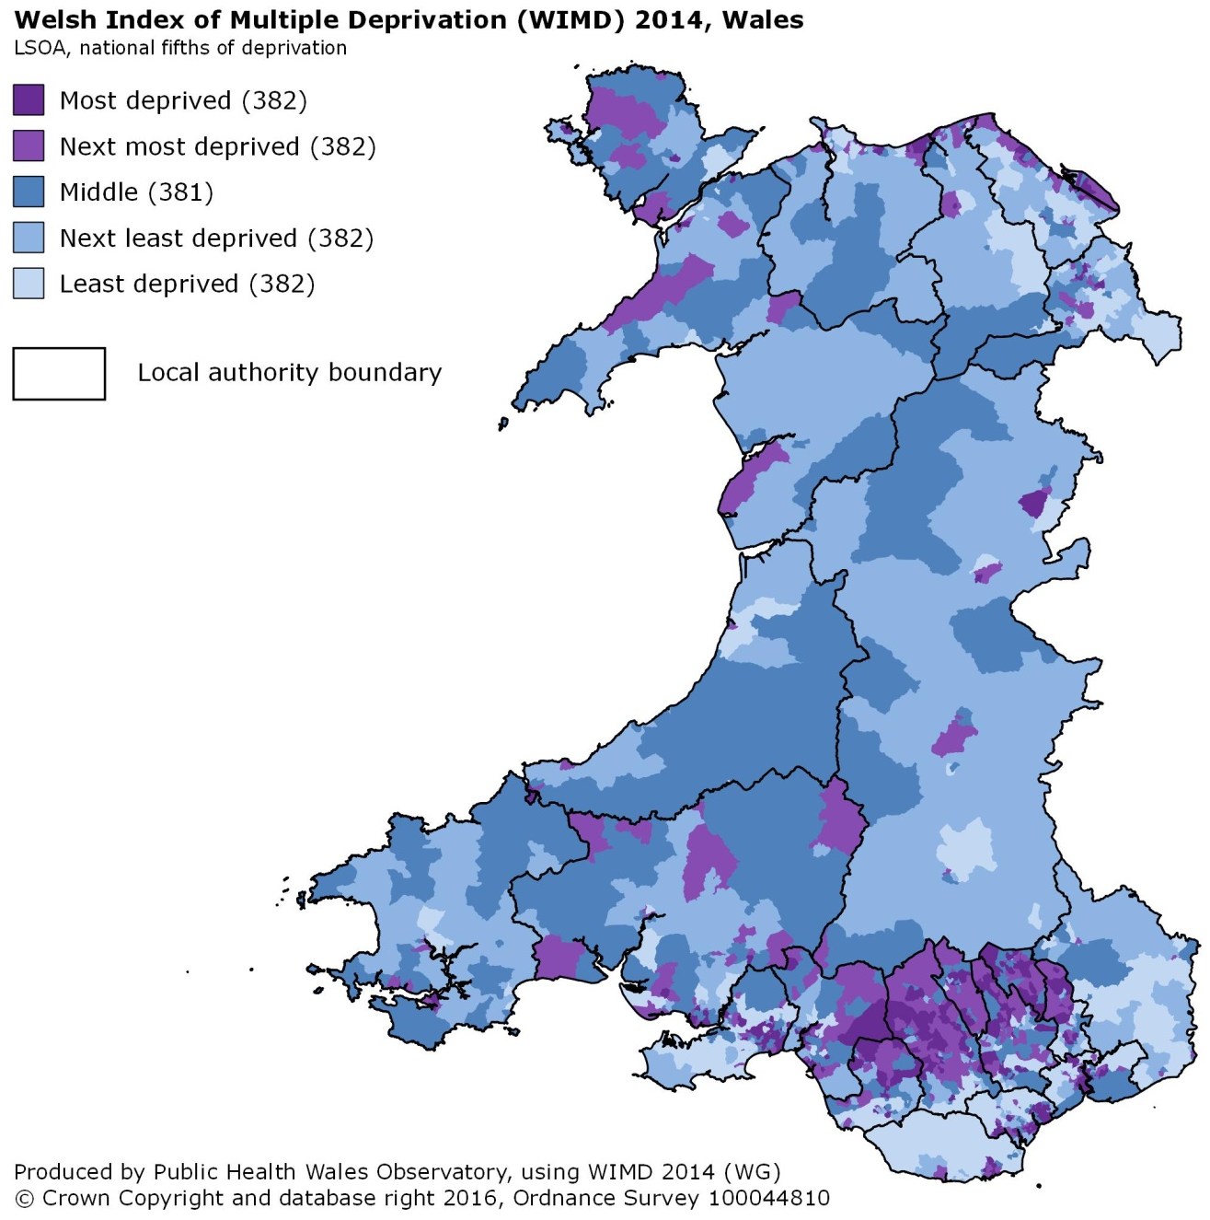

Welsh Health Survey respondents reporting good health, by age group
Key messages
- The difference in prevalence of good health between least and most deprived fifth is already apparent at age 0-15 (fig. 11). This gap then grows as age increases, peaking in males at age 65-74 (79% in least deprived vs 52% in most deprived) and in females at age 55-64 (84% vs 56%).
Further information
- The percentage of survey respondents reporting good health was used to produce the healthy life expectancy figures within this report (section 3).

Figure 11

Census 2011 respondents reporting good health, by small area
Key messages
- There is wide variation across Wales in the percentage of Census respondents reporting good health, ranging from under 60% to around 90% in both males (fig. 12) and females (fig. 13).
- In the South Wales Valleys, where levels of deprivation are high (fig. 10), there are high concentrations of areas with less than 70% of respondents reporting good health.
Further information
- By using data from Census 2011, the maps in figures 12 and 13 provide a greater level of geographical detail regarding good health than is possible using the Welsh Health Survey, which has a much smaller sample size.
- The maps show data for Lower Super Output Areas (LSOAs), which is the same statistical geography as that used by the Welsh Index of Multiple Deprivation (fig. 10). According to 2014 mid-year population estimates, LSOAs in Wales have an average population of around 1,600.
Figure 12
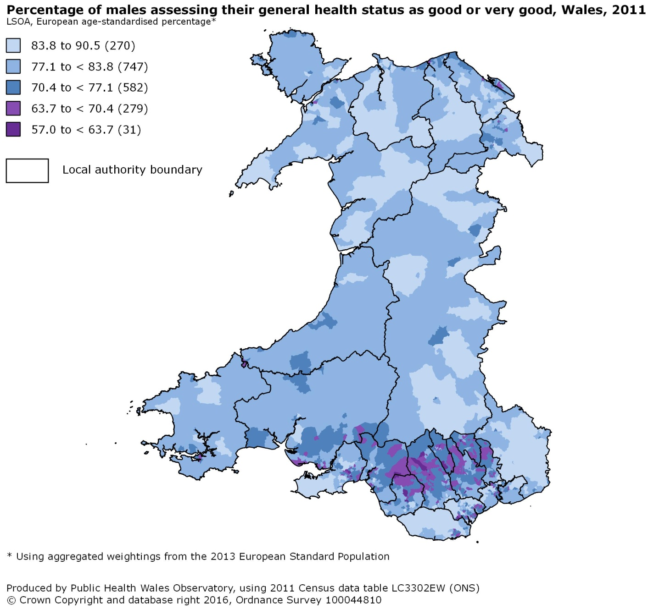

Figure 13
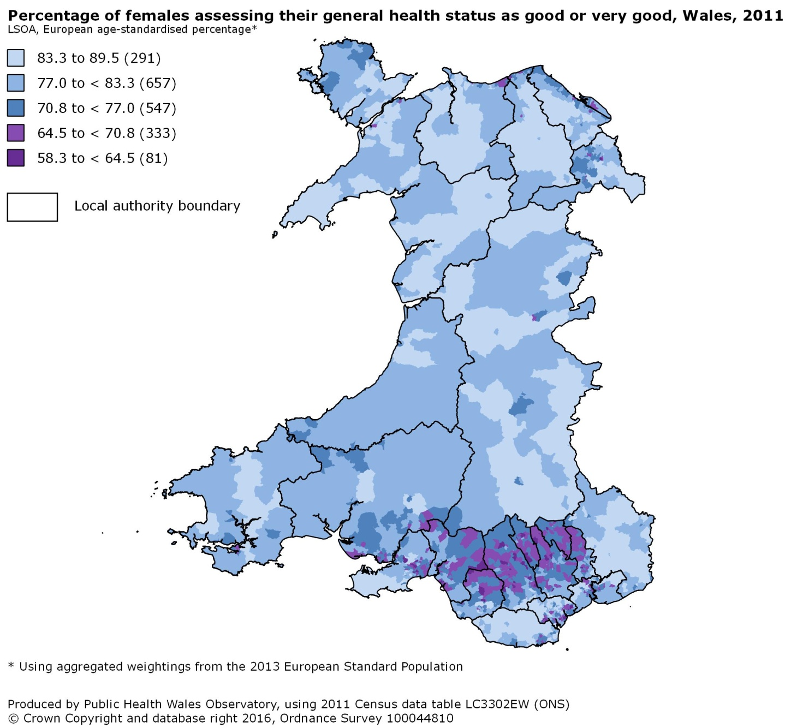

Discussion
Life expectancy in Wales has never been higher. People can also expect to remain in good health for longer. This is good news for the people of Wales.
However, this report also shows that health inequalities are proving to be persistent. People in the least deprived areas of Wales not only live longer than those in the most deprived areas; they also spend more of their lives in good health. More than 20 years separates the highest and lowest healthy life expectancies within Cardiff, the capital city.
These findings echo those of our 2011 profile⁶, and those of the Marmot Review⁵ carried out in England. Our results show no sign of positive changes over time: the inequality gaps in life expectancy, and healthy life expectancy, show no clear narrowing in 2010-14 compared to 2005-09.
Behavioural and lifestyle factors, such as smoking and obesity, play an important role in the generation of these health inequalities. In the most deprived areas of Wales, 29% of the population currently smoke and 29% are obese, compared to 11% smoking and 17% obese in the least deprived areas¹⁶. To reduce health inequalities, we must direct efforts towards reducing the prevalence of smoking and obesity in Wales, especially in people living in deprived circumstances.
The NHS also has a small but significant part to play in reducing health inequalities, by ensuring front-line services deliver effective and evidence-based interventions to all those who can benefit, in dialogue with patients and communities¹⁷.
However, to make a lasting and significant inroad into health inequalities, we have to look to ‘the causes of the causes’, those upstream drivers such as education, employment and working conditions, which shape our social and community networks, and henceforth our individual choices to smoke or to eat unhealthily. The Marmot Review⁵ argues that the most effective way to tackle health inequalities is to address inequalities in these social determinants.
Many organisations outside of the NHS have an important influence on these determinants, including government, non-health public bodies, the third sector and the commercial sector. The new Public Services Boards that have been established under the Well-being of Future Generations (Wales) Act⁹ are a major vehicle to exert such influence.
There is already a great deal of work underway in Wales to address these concerns. Action across the social gradient, and action across the social determinants, represent two of the four underpinning principles in the Welsh Government’s strategic action plan Fairer Health Outcomes for All⁸. The further two principles are evidence-based interventions, and action across the life course. Together these principles echo the recommendations of the Marmot Review⁵.
However, given the patterns displayed within this report, the challenges that remain cannot be underestimated. Whilst many European countries are experiencing similar difficulties¹⁸, this does not permit anything other than a continued and even increased focus on action across the social gradient in health. Section 5 of this report demonstrates that with increasing deprivation comes increasing rates of both overall mortality and preventable mortality. This confirms that social inequalities are interwoven with health inequalities in Wales, as reported by Marmot⁵ in England.
In light of such patterns, many social epidemiologists and public health professionals assert that a redistribution of income and power will be required to make a significant impact upon existing health inequalities^{5,19}. Further devolution of the tax system may provide opportunities for the Welsh Government to effect such change and thereby pursue the aspirations of Fairer Health Outcomes for All. These aspirations can only be achieved through interagency working to tackle social inequalities, alongside a commitment to equity-based services as one the key principles of prudent healthcare.
The sustainable development principle of the Well-being of Future Generations (Wales) Act⁹ compels public bodies to think more long-term, and to act now to prevent problems getting worse, in order to create a Wales that is healthier and more equal in the future. It may take years, or even decades, to see action on social inequalities result in reduced inequalities in life expectancy and mortality rates, but this is a worthy goal for agencies in Wales to pursue together.

References

All hyperlinks to online sources were functional as at 16th June 2016.
- Goldblatt P, Whitehead M. Inequalities in health - development and change. Population Trends [online] 2000; 100:14-19. Available at http://www.ons.gov.uk/ons/rel/population-trends-rd/population-trends/no--100--summer-2000/index.html
- Donkin A et al. Implications of changes in the UK social and occupational classifications in 2001 for vital statistics. Population Trends [online] 2002; 107:23-29. Available at http://www.ons.gov.uk/ons/rel/population-trends-rd/population-trends/no--107--spring-2002/index.html
- Department of Health and Social Security. Inequalities in health: report of a research working group. London: DHSS, 1980.
- Acheson D. Inequalities in health: report of an independent inquiry. London: TSO; 1998. Available at http://www.archive.official-documents.co.uk/document/doh/ih/ih.htm
- Marmot Review Team. Fair society, healthy lives: strategic review of health inequalities in England post-2010. The Marmot review. London: TSO; 2010. Available at http://www.marmotreview.org/
- Public Health Wales Observatory. Measuring inequalities: Trends in mortality and life expectancy in Wales. Public Health Wales NHS Trust; 2011. Available at http://www.wales.nhs.uk/sitesplus/922/page/58379
- Welsh Government. Our healthy future - technical working paper. Cardiff: WAG; 2009. Available at http://gov.wales/topics/health/cmo/healthy/?lang=en
- Welsh Government. Fairer health outcomes for all: reducing inequities in health strategic action plan. Cardiff: WAG; 2011. Available at http://gov.wales/topics/health/cmo/healthy/?lang=en
- Welsh Government. Well-being of Future Generations (Wales) Act 2015 [online]. 2015. Available at http://thewaleswewant.co.uk/about/well-being-future-generations-wales-act-2015
- Welsh Government. Welsh Index of Multiple Deprivation 2014: Guidance on use. 2015. Available at http://gov.wales/statistics-and-research/welsh-index-multiple-deprivation/?lang=en
- Office for National Statistics. Inequality in healthy life expectancy at birth by national deciles of area deprivation: England, 2011 to 2013 [online]. 2015. Available at http://www.ons.gov.uk/ons/rel/disability-and-health-measurement/inequality-in-healthy-life-expectancy-at-birth-by-national-deciles-of-area-deprivation--england/2011-13/index.html

- Office for National Statistics. Slope index of inequality (SII) in life expectancy (LE) at birth by sex for Upper Tier Local Authorities (UTLAs) in England, 2009 to 2013 [online]. 2015. Available at https://www.ons.gov.uk/peoplepopulationandcommunity/healthandsocialcare/healthandlifeexpectancies/datasets/slopeindexofinequalitysiiinlifeexpectancyleatbirthbysexforuppertierlocalauthoritiesutlasinengland
- Office for National Statistics. Slope index of inequality (SII) in healthy life expectancy (HLE) at birth by sex for Upper Tier Local Authorities (UTLAs) in England, 2009 to 2013 [online]. 2015. Available at https://www.ons.gov.uk/peoplepopulationandcommunity/healthandsocialcare/healthandlifeexpectancies/datasets/slopeindexofinequalitysiiinhealthylifeexpectancyhleatbirthbysexforuppertierlocalauthoritiesutlasinengland
- Public Health England. The Segment Tool 2015 - Segmenting life expectancy gaps by cause of death: Key results for England [online]. 2015. Available at http://www.lho.org.uk/LHO_Topics/Analytic_Tools/Segment/TheSegmentTool.aspx
- Office for National Statistics. Definition of avoidable mortality [online]. 2012. Available at http://www.ons.gov.uk/ons/about-ons/get-involved/consultations/archived-consultations/2011/definitions-of-avoidable-mortality/index.html
- Welsh Government. Welsh Health Survey: Tables – Health-related lifestyle trends, 2003/04-2015 [online]. 2016. Available at http://gov.wales/statistics-and-research/welsh-health-survey/?lang=en
- Bentley C. Systematically addressing health inequalities. Department of Health; 2008. Available at http://www.institute.nhs.uk/commissioning/general/health_inequalities_national_support_team_resources.html
- European Union. Health inequalities in the EU: Final report of a consortium. 2013. Available at http://ec.europa.eu/health/social_determinants/docs/healthinequalitiesineu_2013_en.pdf
- Mackenbach JP. Can we reduce health inequalities? An analysis of the English strategy (1997-2010). Journal of Epidemiology and Community Health [online] 2011; 65:568-575. Available at http://jech.bmj.com/content/65/7/568.full.pdf+html

