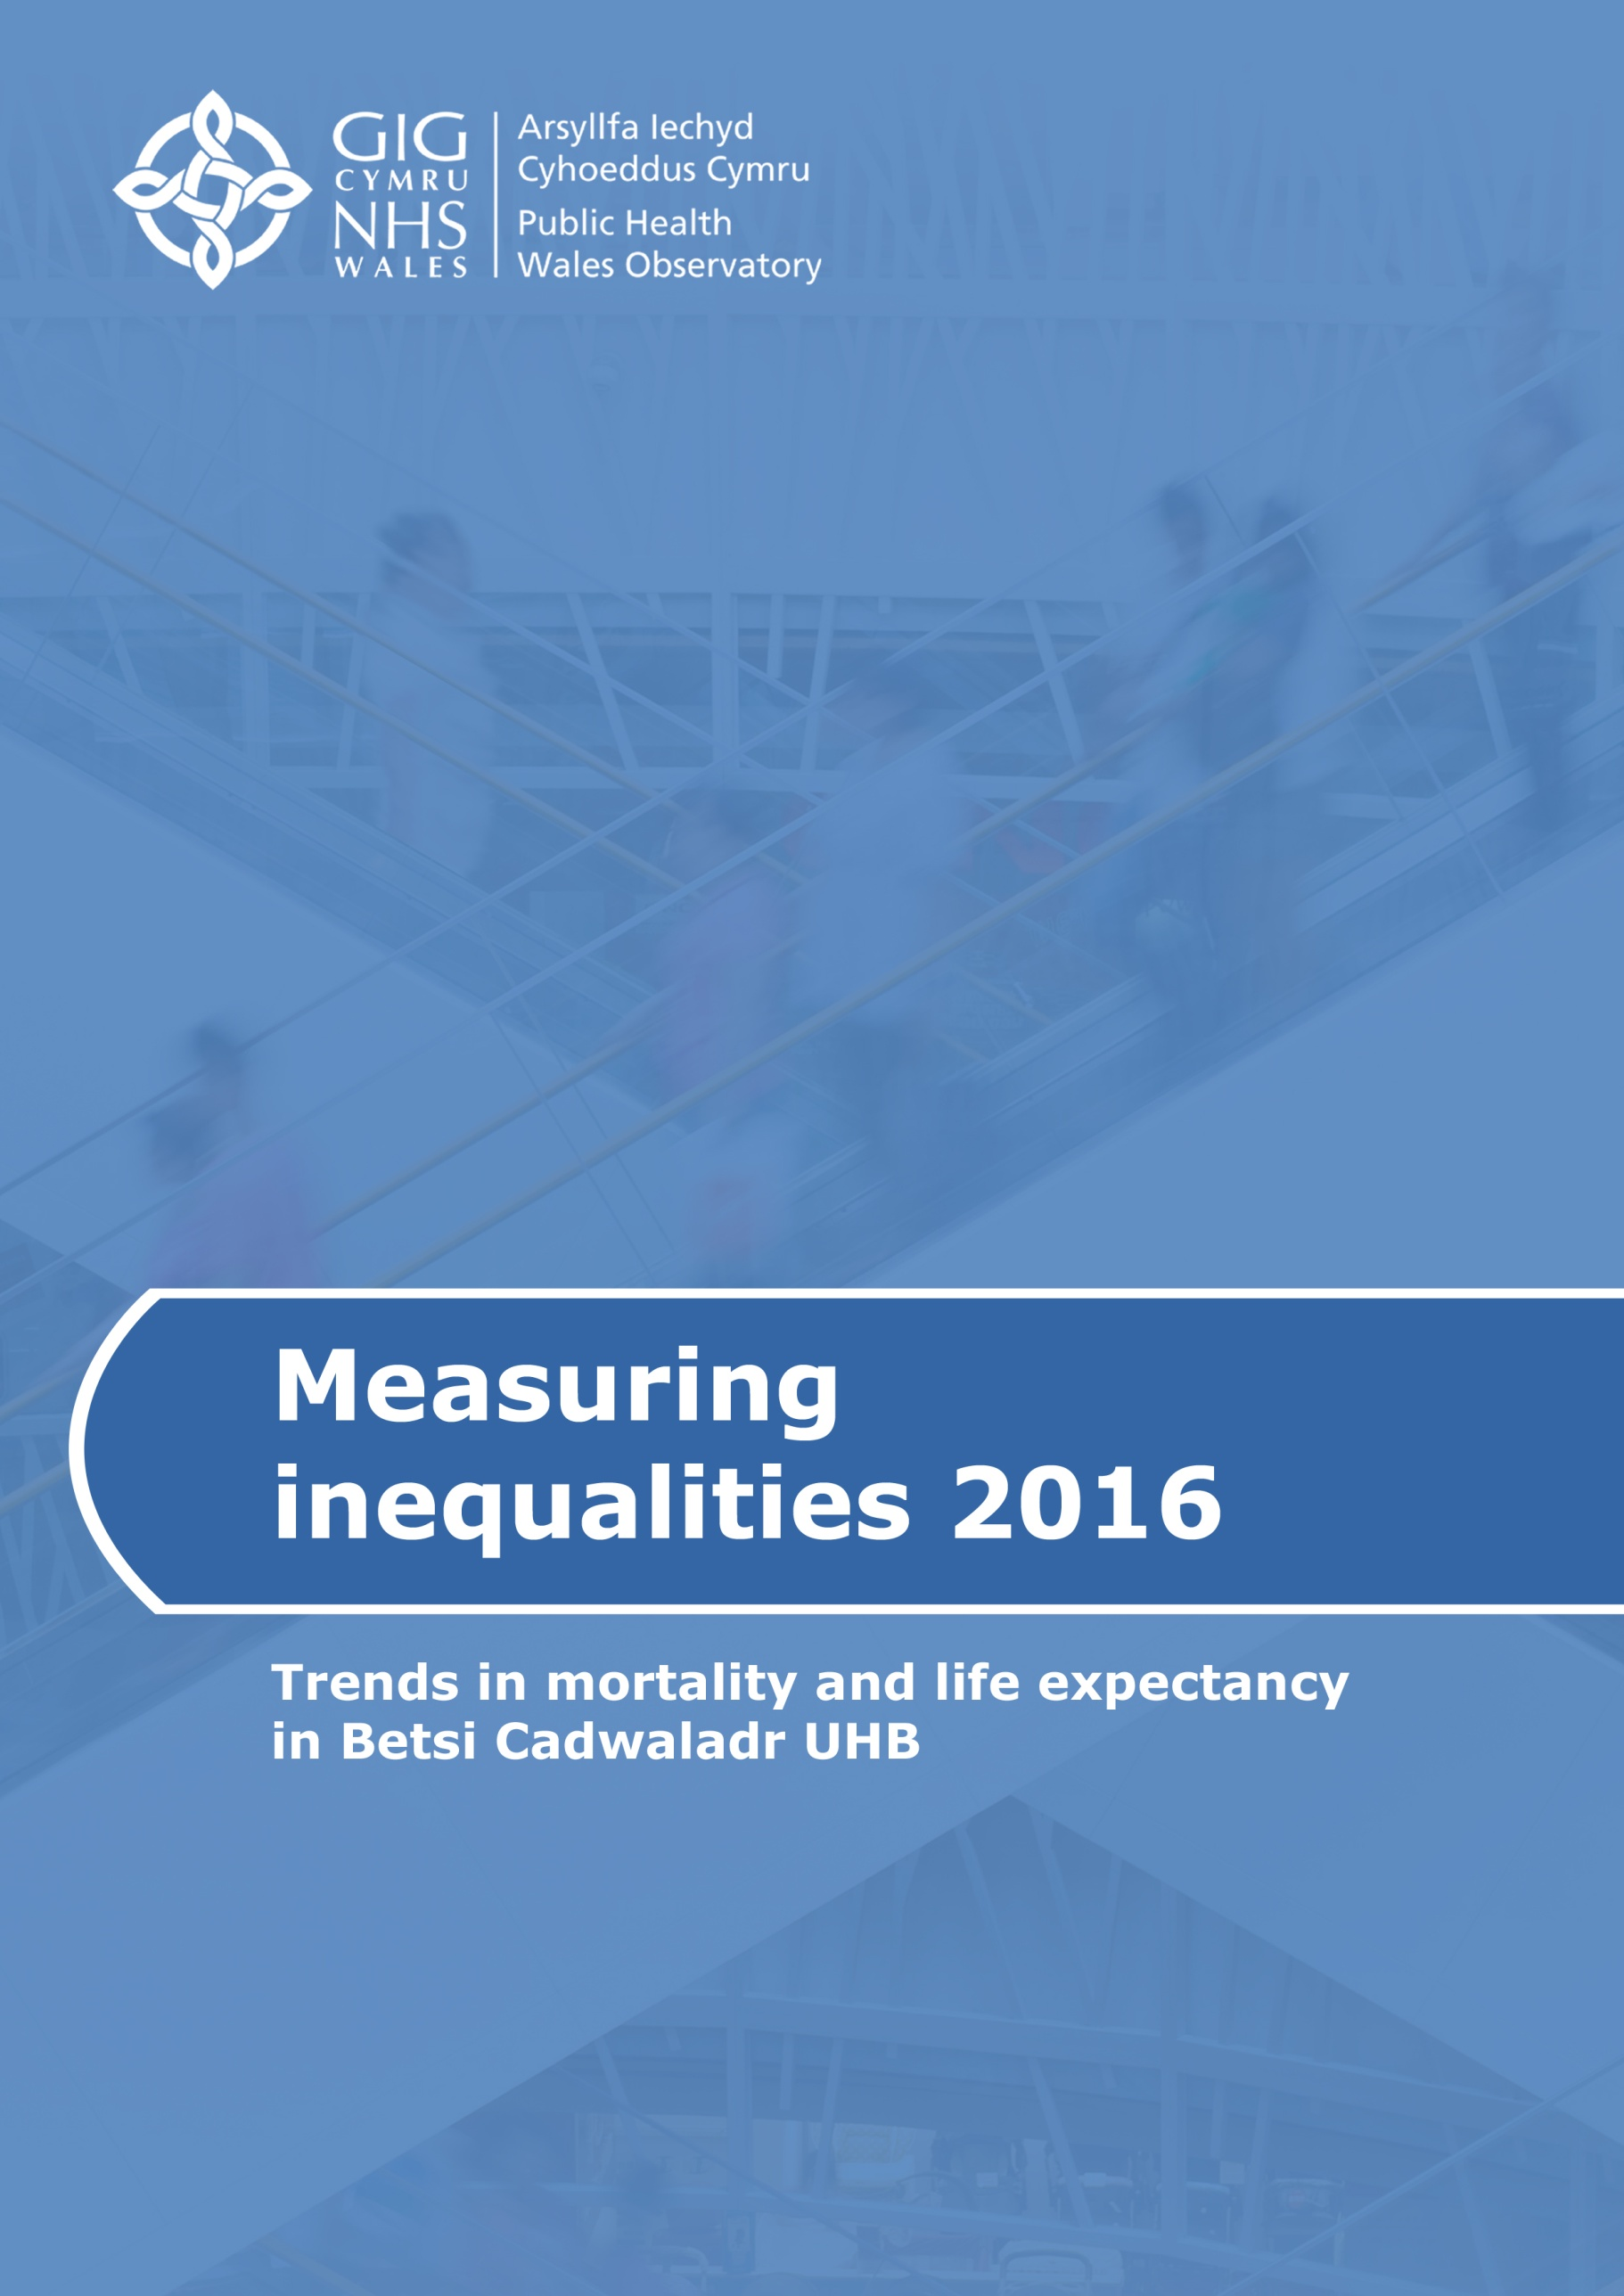

Contents

1 Introduction 2
2 Deprivation 3
Betsi Cadwaladr UHB 4
Isle of Anglesey 5
Gwynedd 6
Conwy 7
Denbighshire 8
Flintshire 9
Wrexham 10
3 Measuring inequalities in life expectancy 11
3.1 Life expectancy, healthy life expectancy, percentage of life expectancy in good health, and effects of reducing mortality from specific causes of death 11
Betsi Cadwaladr UHB 11
Isle of Anglesey 15
Gwynedd 18
Conwy 21
Denbighshire 24
Flintshire 27
Wrexham 30
3.2 Life expectancy at birth at Middle Super Output Area (MSOA) level 33
Males 33
Females 34
4 Measuring inequalities in mortality rates 35
Betsi Cadwaladr UHB 35
Isle of Anglesey 36
Gwynedd 36
Conwy 37
Denbighshire 37
Flintshire 38
Wrexham 38
5 Census 2011 respondents reporting good health 39
Males 39
Females 40

Introduction

This document provides local information on the indicators contained in Measuring Inequalities 2016: Trends in mortality and life expectancy in Wales. It includes selected charts and maps for the health board area. This summary document is designed to complement the Wales report and give a local perspective.
The publication Measuring inequalities 2016 consists of:
- A Wales report including commentary
- A summary document for each of the seven health boards
- Interactive data files providing the main indicator data (charts, tables and maps)
- A technical guide describing the methods, data sources and caveats
- Infographics
These resources are available at www.publichealthwalesobservatory.wales.nhs.uk/inequalities

It has recently come to light that the population aged 85+ has been underestimated in some areas by the Office for National Statistics population estimates. In most parts of Wales, the impact of this issue on Measuring inequalities 2016 will be very small; further details are provided in a brief paper available via the link above.

Deprivation

To aid interpretation of the information in sections 3 and 4, this section shows the range of deprivation within Betsi Cadwaladr UHB and the local authorities it covers, and how this range compares to Wales as a whole.
There is a wider range of deprivation in some areas of Wales than others. This should be noted when interpreting the gaps in life expectancy and mortality rates shown within this report. For example, Cardiff includes some of the least deprived areas of Wales (e.g. in Cyncoed) and some of the most deprived (e.g. in Splott), which partly explains the large gap in healthy life expectancy in males (24.4 years) within the local authority. Other local authorities in Wales have narrower ranges of deprivation, which is likely to lead to narrower inequality gaps.
The 2014 version of the Welsh Index of Multiple Deprivation (WIMD 2014) measures deprivation across eight domains, including income and employment. The index provides an overall deprivation rank for each of the 1,909 Wales Lower Super Output Areas (LSOAs). Within each area shown below, LSOAs have been ranked by deprivation and split into five equal groups (“fifths”) ranging from least deprived to most deprived. Full details can be found in the technical guide accompanying this publication.

Betsi Cadwaladr UHB

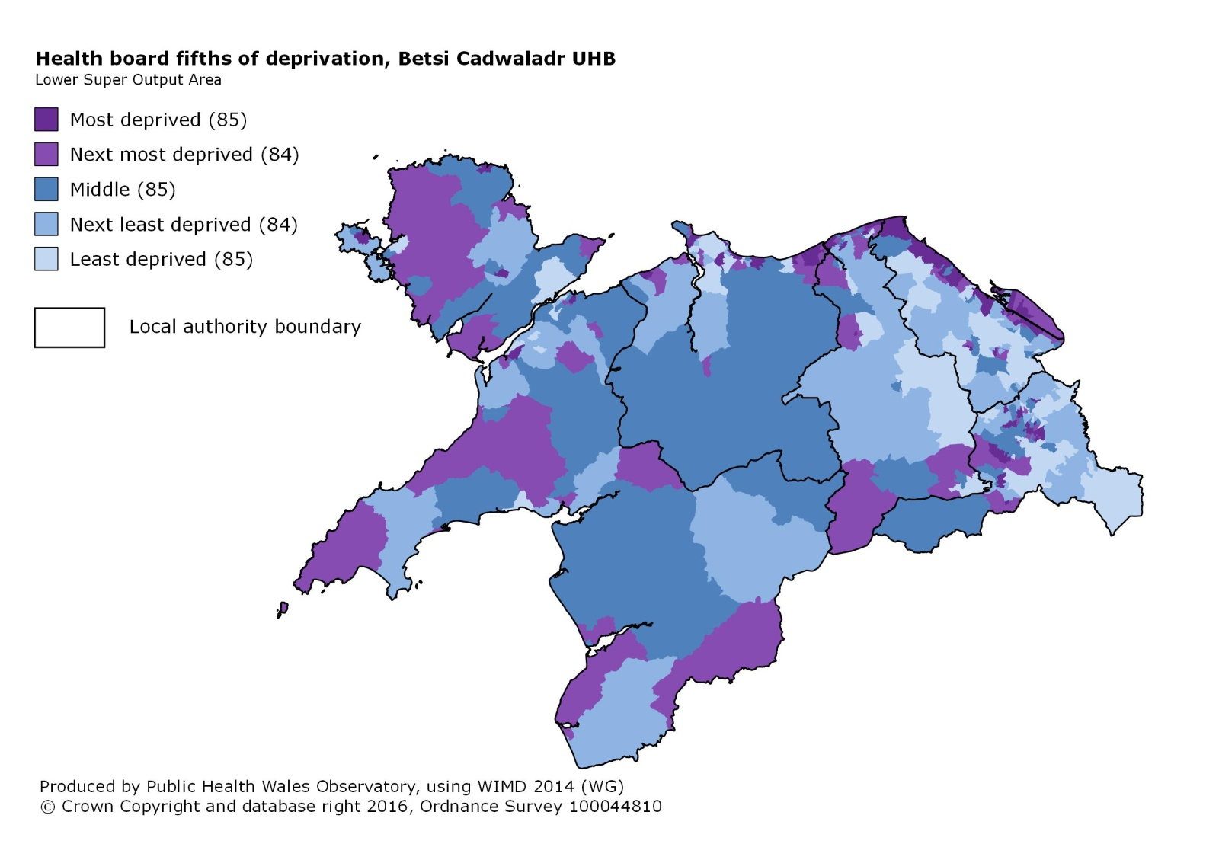

Isle of Anglesey

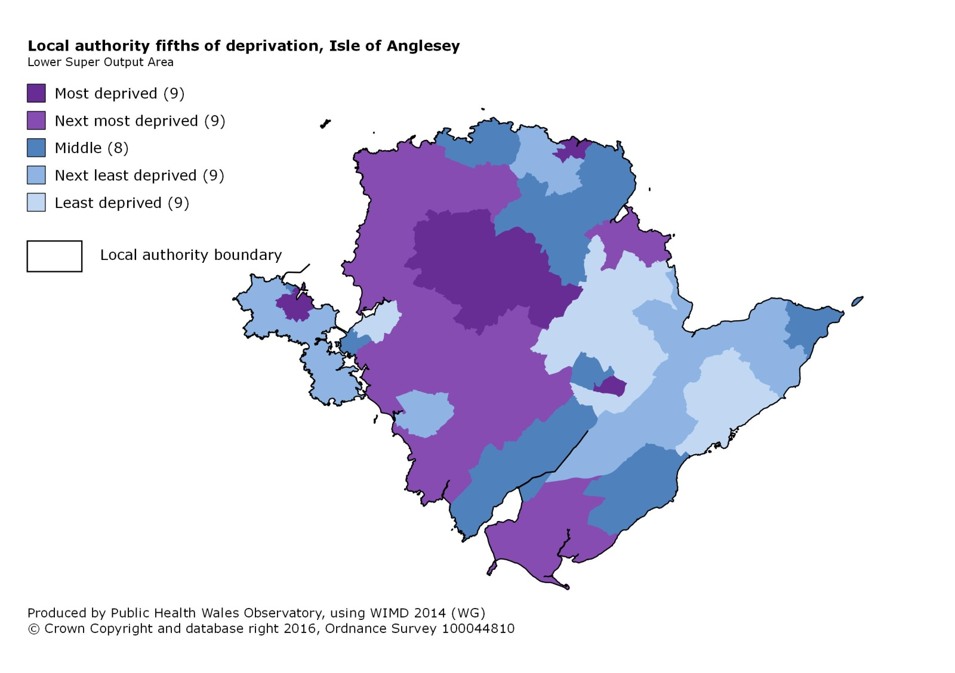

Gwynedd

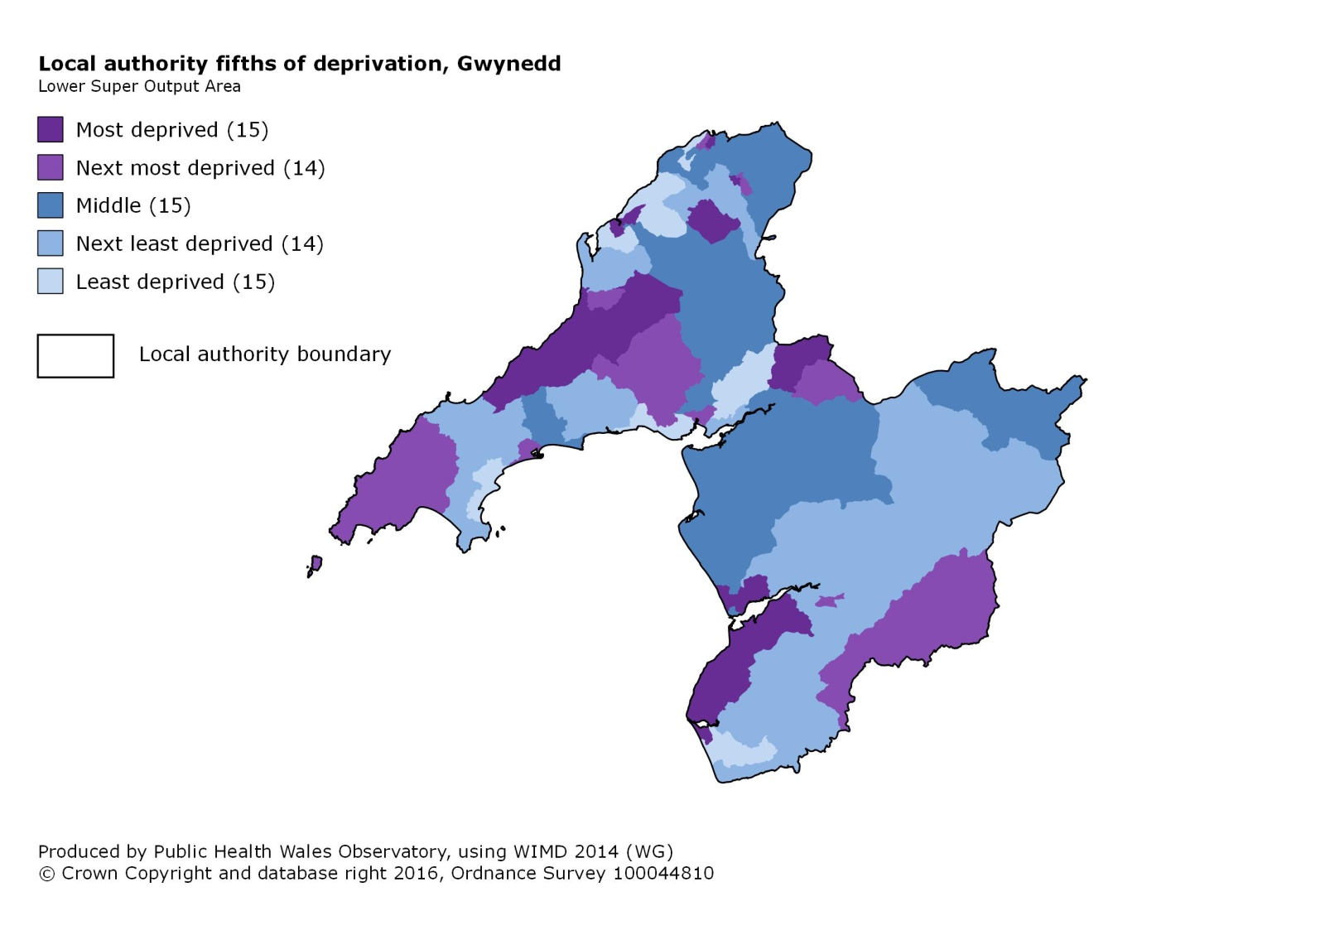

Conwy

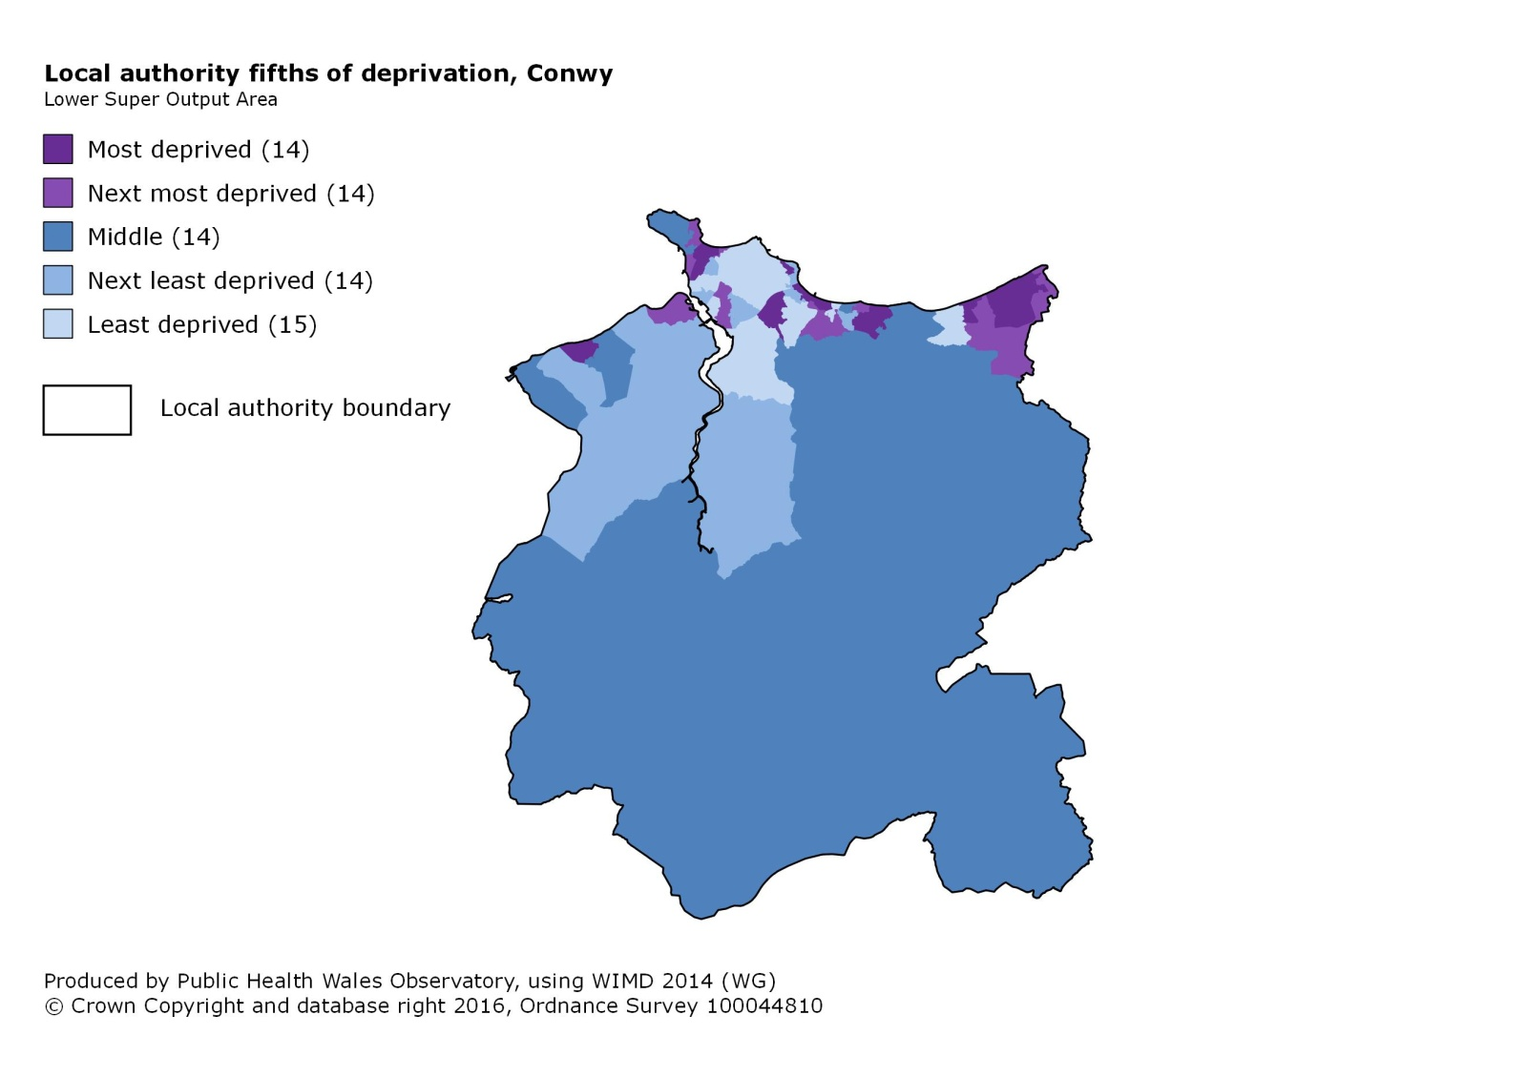

Denbighshire

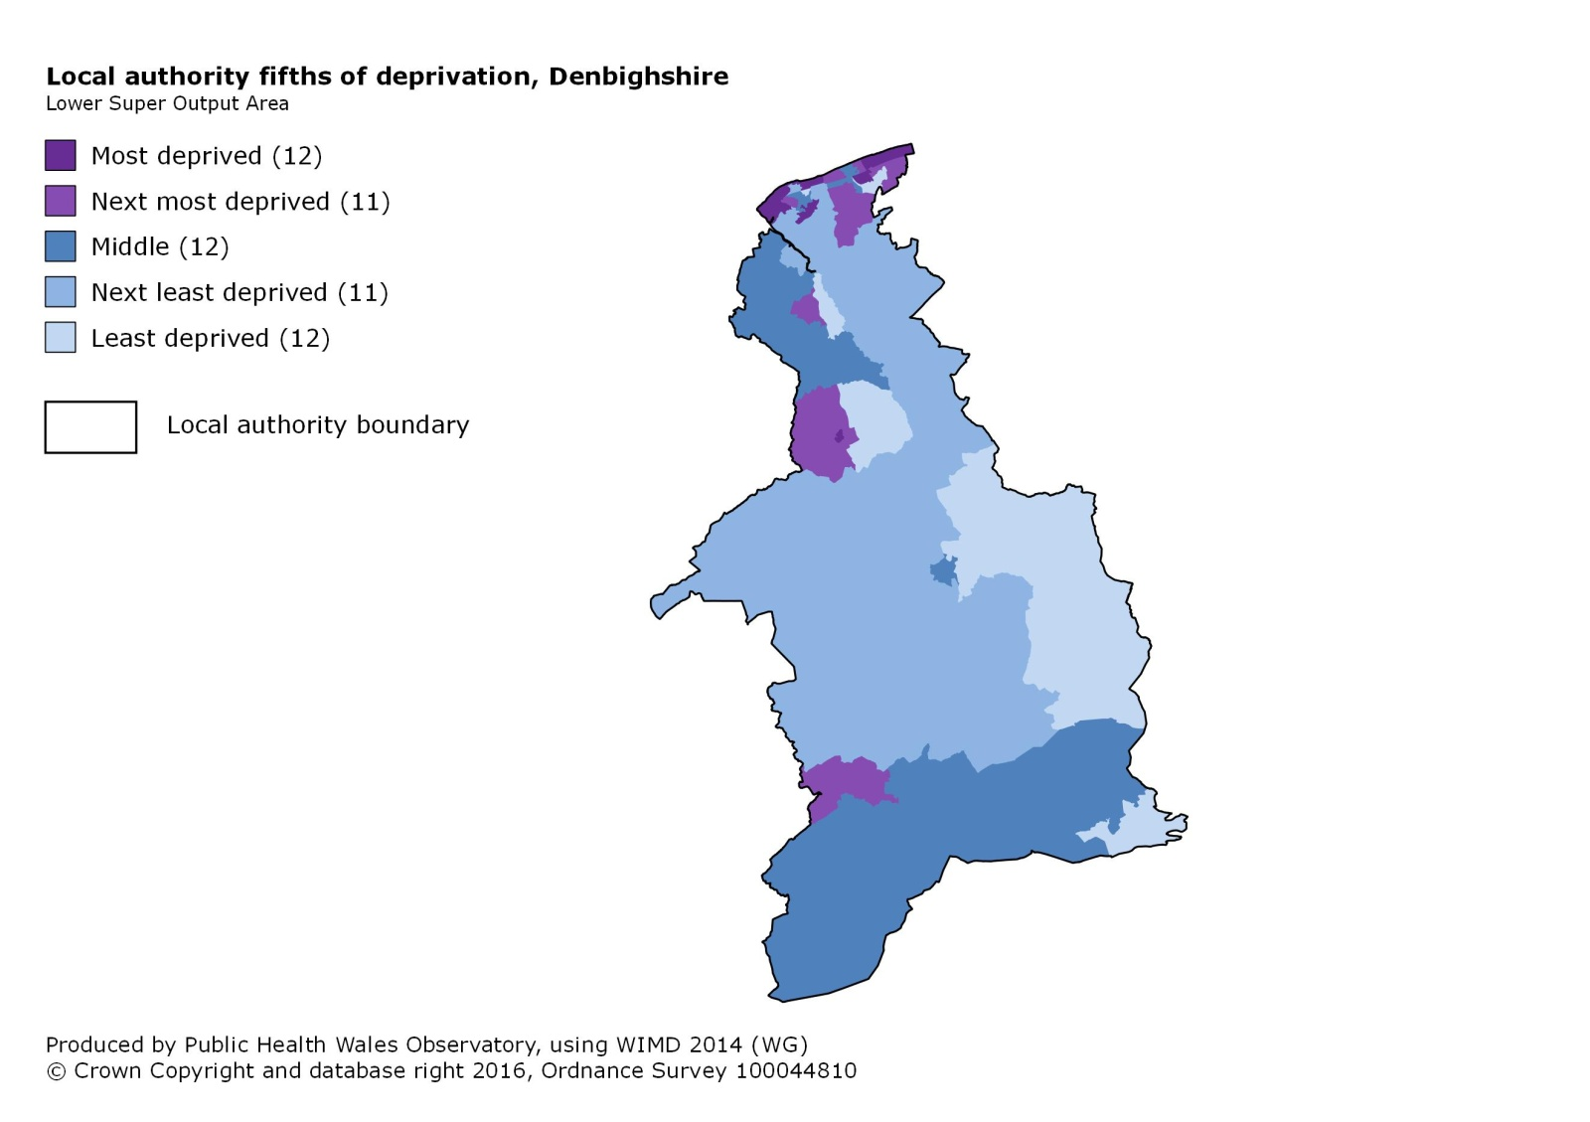

Flintshire

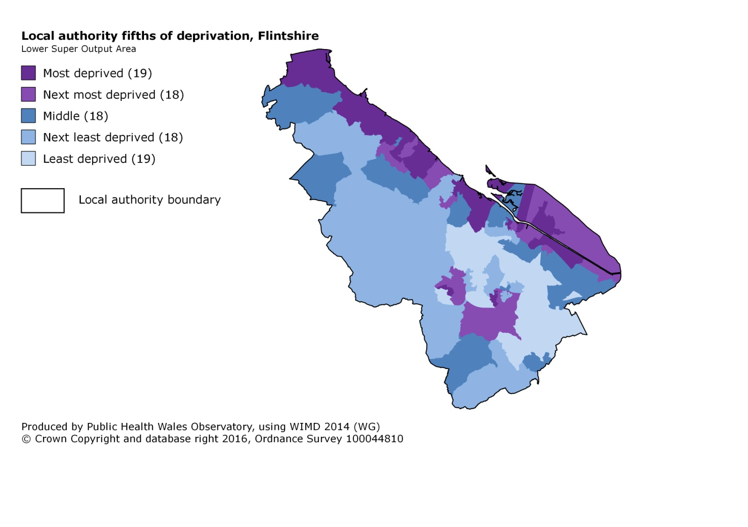

Wrexham

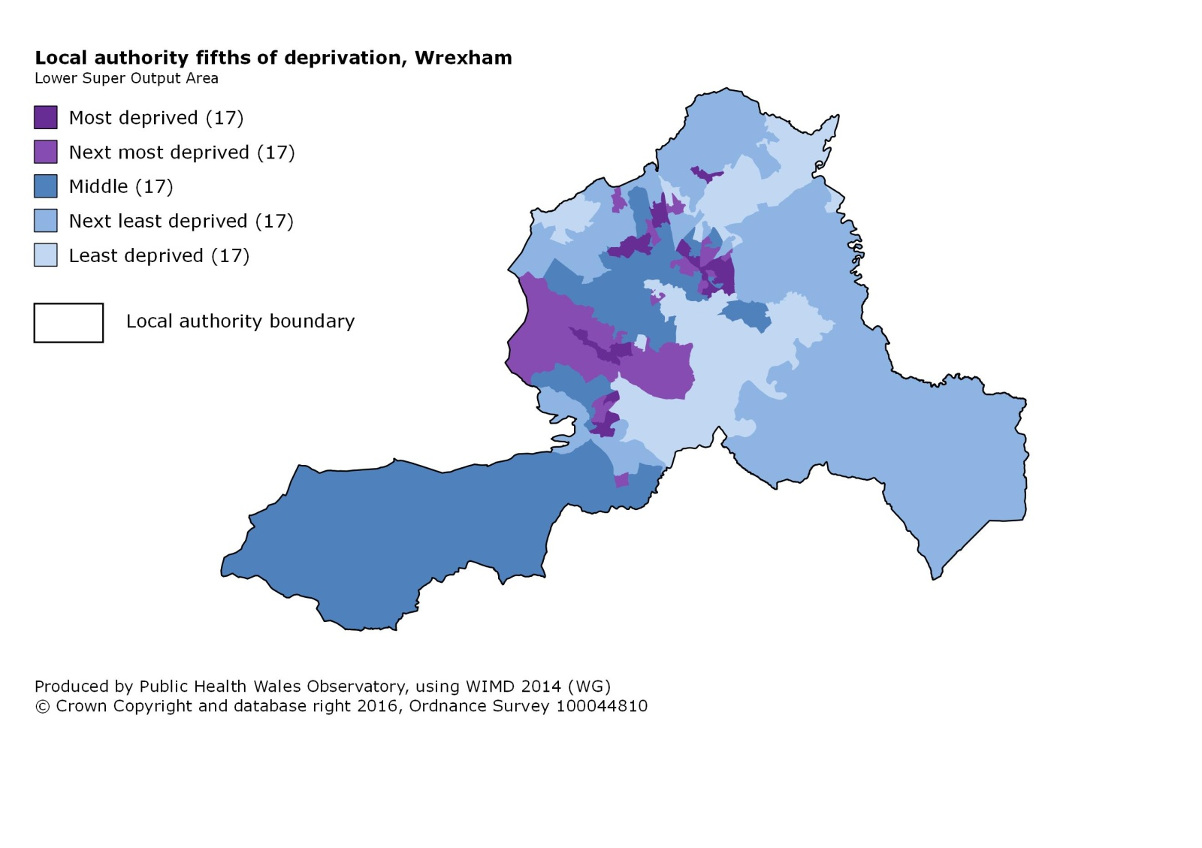

Measuring inequalities in life expectancy

Life expectancy, healthy life expectancy, percentage of life expectancy in good health, and effects of reducing mortality from specific causes of death

Betsi Cadwaladr UHB

Isle of Anglesey

Gwynedd

Conwy

Denbighshire

Flintshire

Wrexham

Life expectancy at birth at Middle Super Output Area (MSOA) level

Males
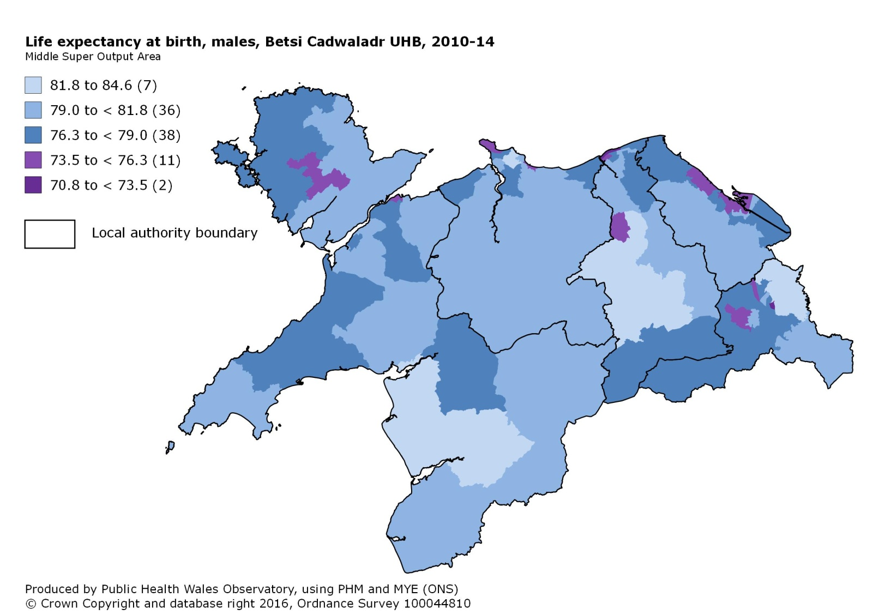

Females
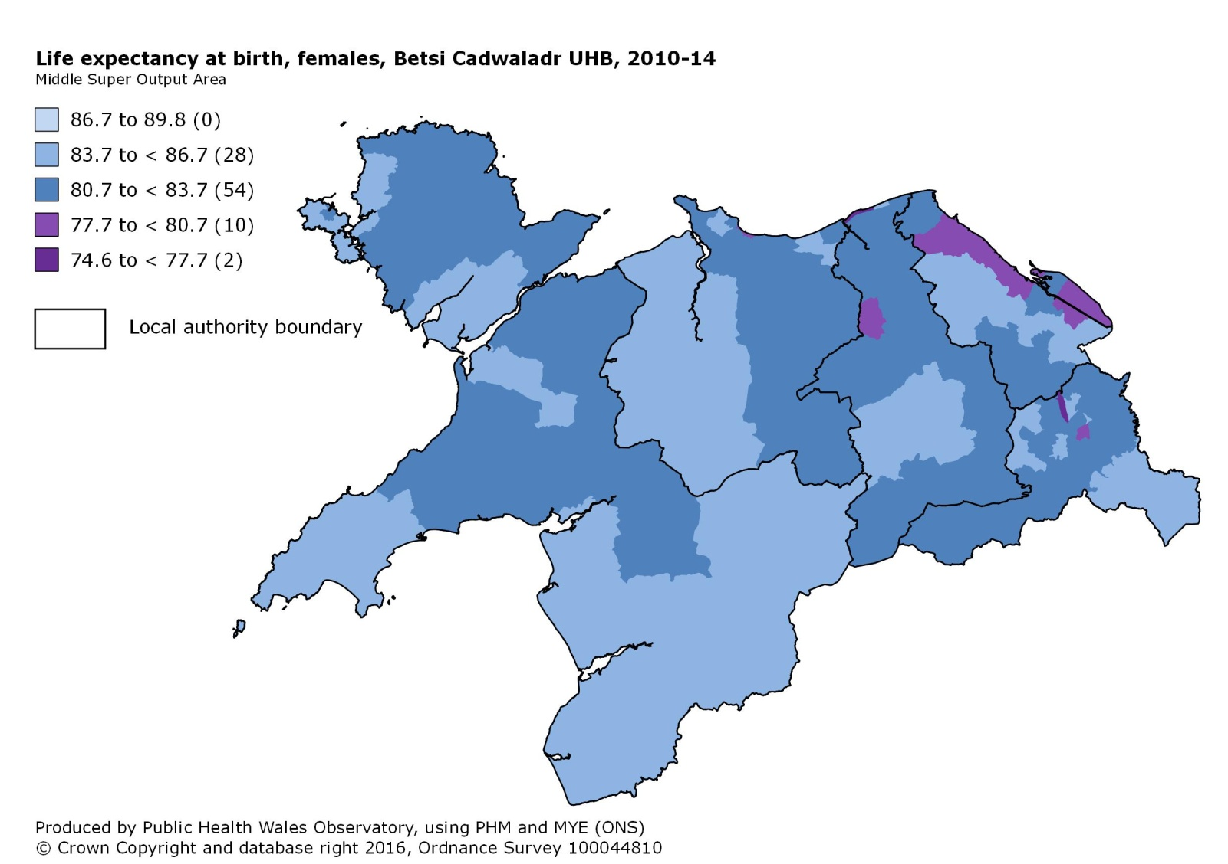

Measuring inequalities in mortality rates

Betsi Cadwaladr UHB

Isle of Anglesey

Gwynedd

Conwy

Denbighshire

Flintshire

Wrexham

Census 2011 respondents reporting good health

Males
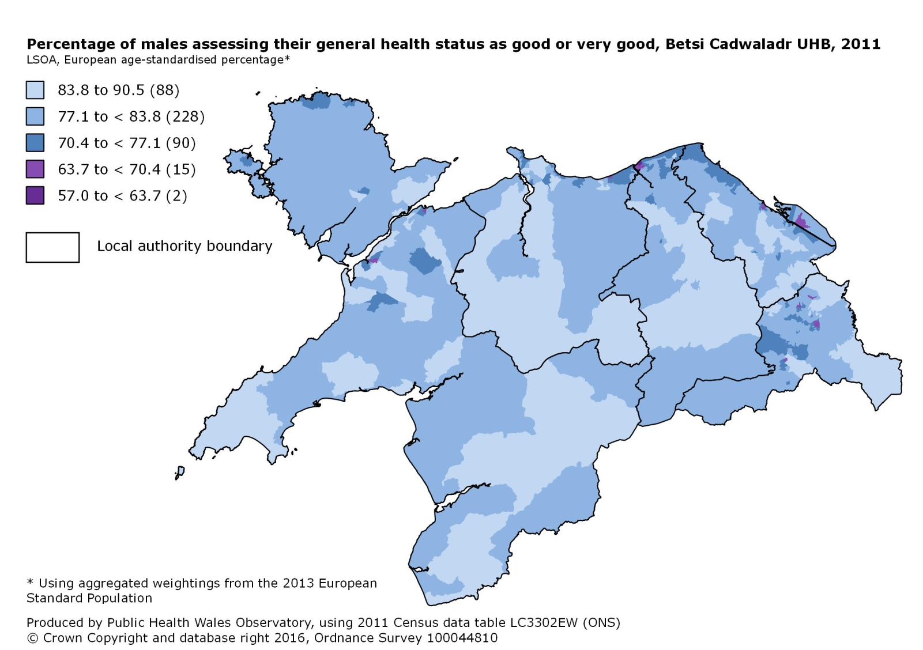

Females
