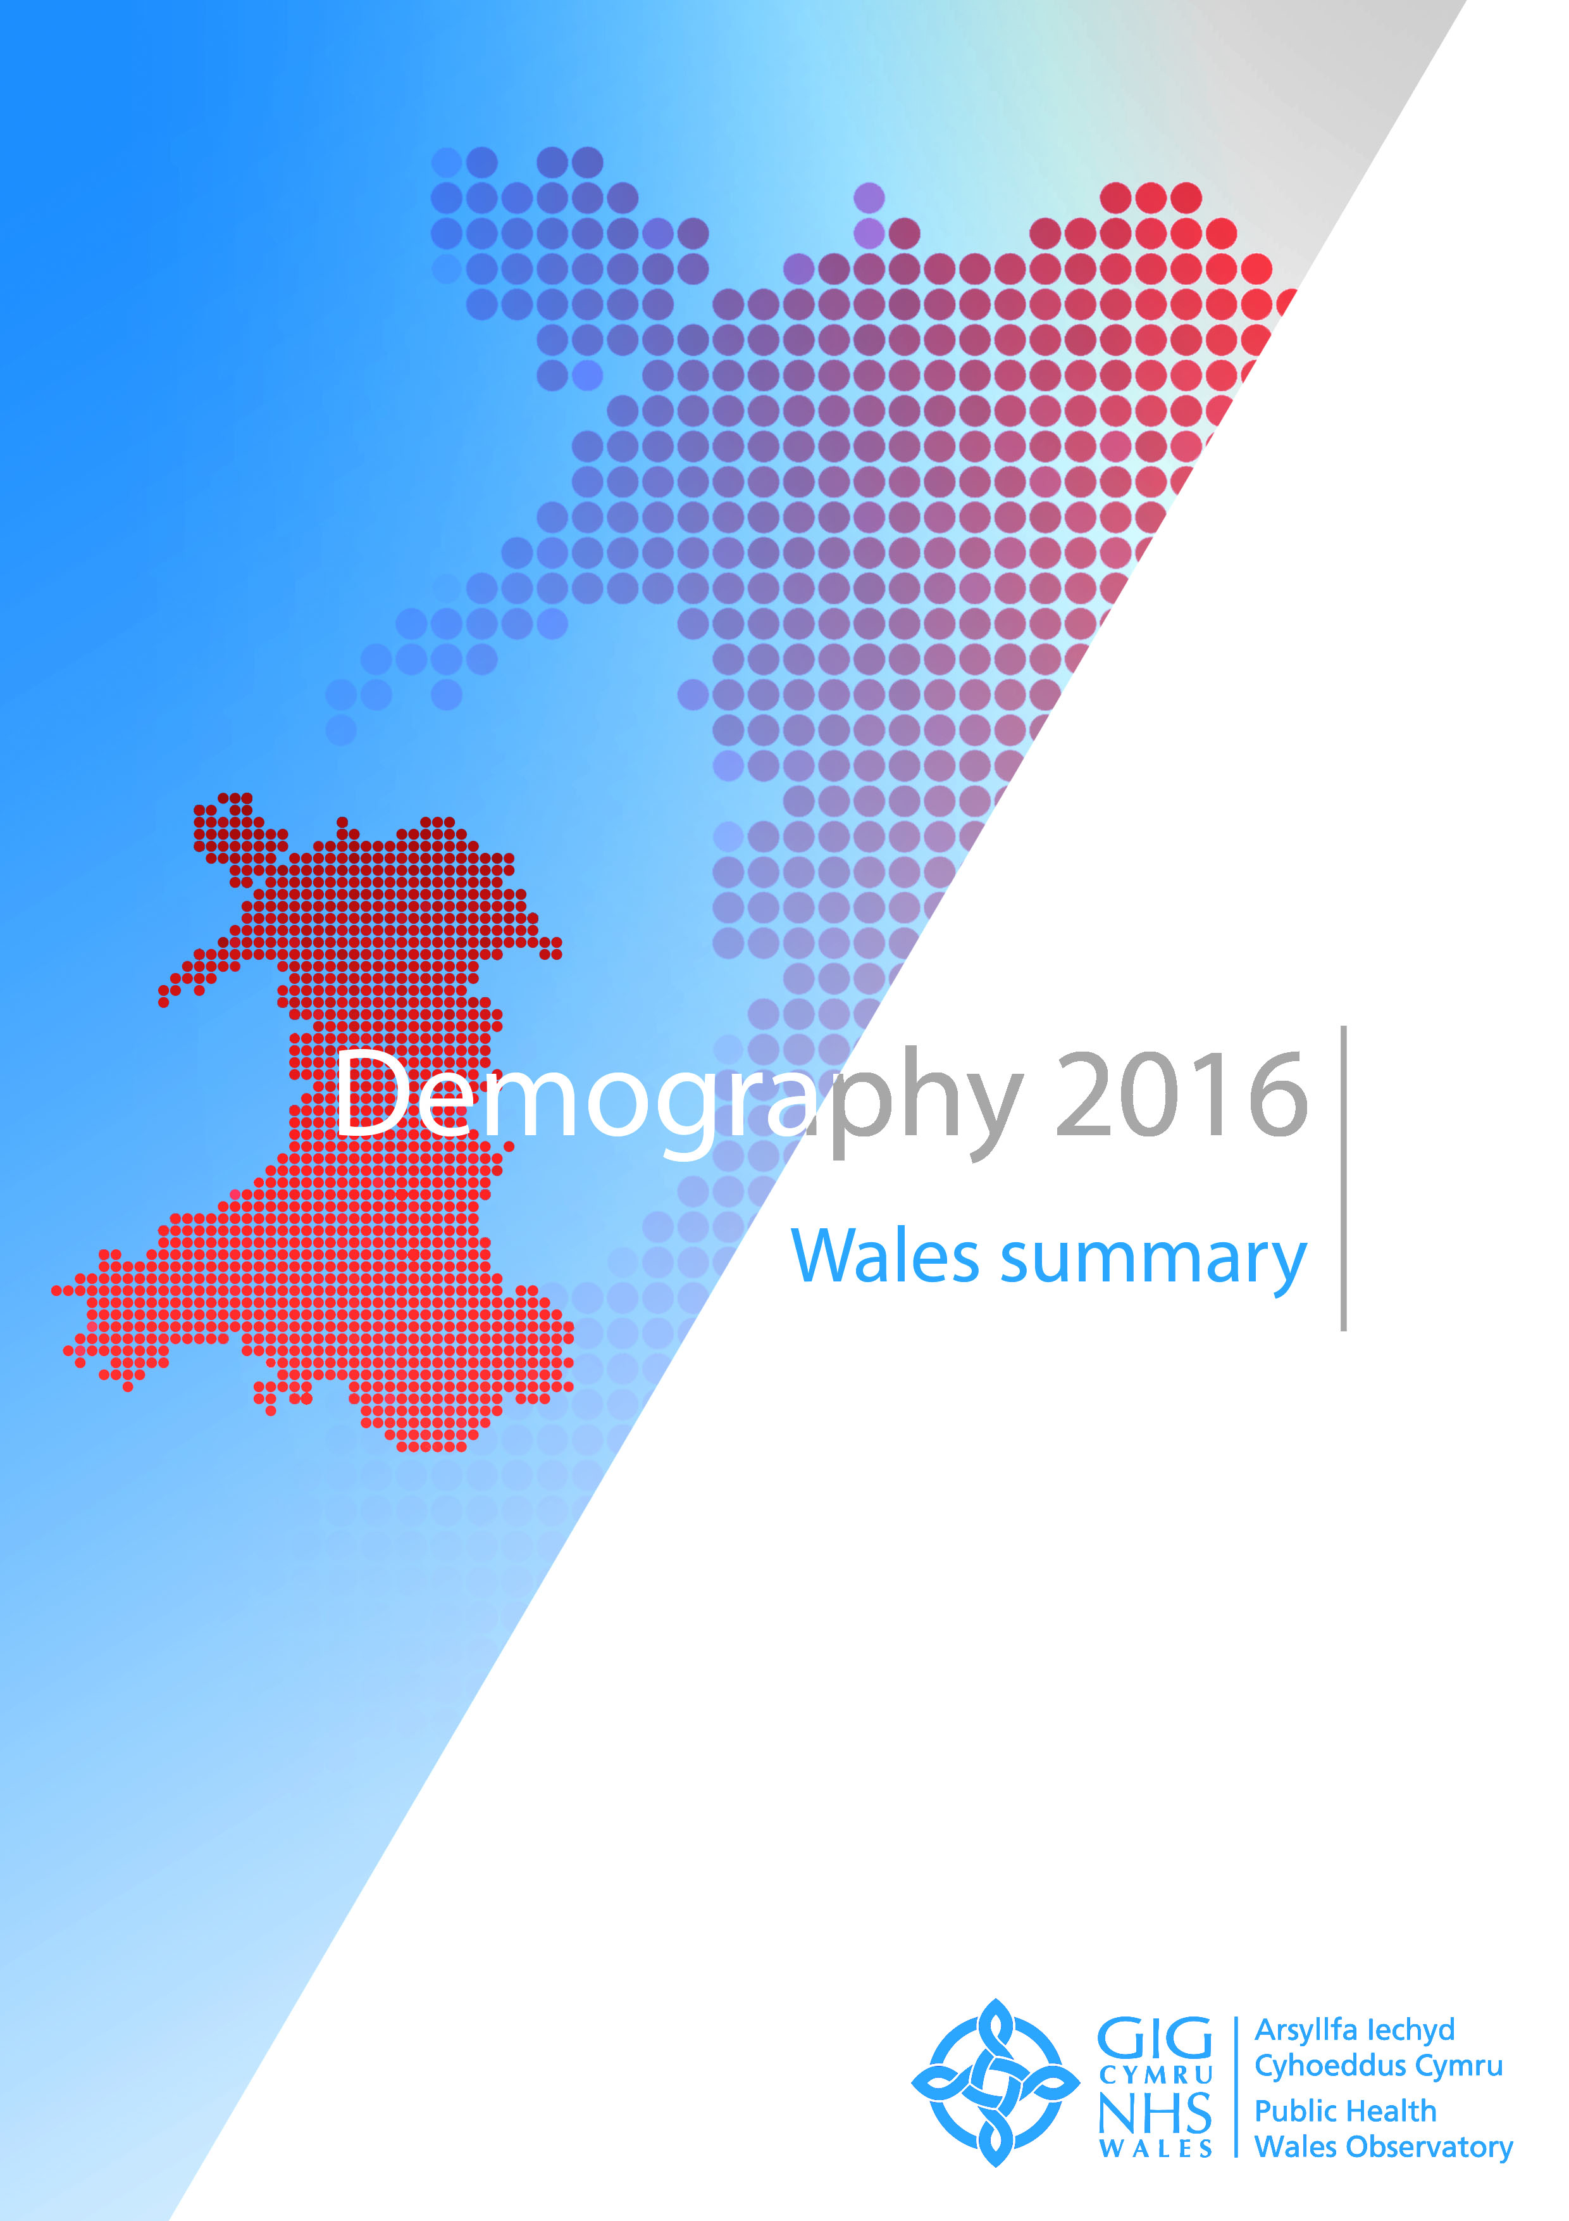

The publication Demography 2016 consists of:
- Wales summary document and key messages
- Seven health board summary documents
- Four interactive data files showing the main indicators and key messages
- Three map interactive files
- Infographics of selected key messages
- Technical guides describing the indicators, data sources and caveats

These resources are available at
https://phw.nhs.wales/services-and-teams/observatory/data-and-analysis/demography-2016/

For further information, or to provide feedback on Demography 2016, please contact us:

Public Health Wales Observatory
14 Cathedral Road
Cardiff
CF11 9LJ

email: publichealthwalesobservatory@wales.nhs.uk
web: www.publichealthwalesobservatory.wales.nhs.uk

Main project team
Ioan Francis, Rhian Hughes, Grace Jefferies, Victoria Middleton

Additional support
James Allen, Anna Childs, Andrew Dring, Dee Hickey, Leon May, Rhys Powell

Project director
Nathan Lester

Acknowledgements
Thanks to the following people for their help with this publication:
Hugo Cosh, Andrea Gartner, Rhys Gibbon, Tracy Price

© 2016 Public Health Wales NHS Trust

All tables, charts and maps were produced by the Public Health Wales Observatory and the data sources are shown within each graphic. Material contained in this profile may be reproduced without prior permission provided it is done so accurately and is not used in a misleading context. Acknowledgement to Public Health Wales NHS Trust to be stated. Typographical copyright lies with Public Health Wales NHS Trust.

Contents

How to copy charts and maps
1 Introduction 3
2 Population estimates 4
2.1 Key messages 4
2.2 Population trends 5
2.3 Population trends by age 5
2.4 Population pyramid 2005 and 2014 comparison 6
2.5 Population estimates by Lower Super Output Area 7
3 Population projections 11
3.1 Key messages 11
3.2 Projection trends by age 12
3.3 Past trends and projections 12
4 Mortality 13
4.1 Key messages 13
4.2 All-cause mortality trends 14
4.3 All-cause mortality 2012-14 16
4.4 All-cause mortality by Middle Super Output Area 18
5 General fertility rate 19
5.1 Key messages 19
5.2 General fertility rate trends 20
5.3 General fertility rate 2014 21
5.4 General fertility rate by Lower Super Output Area 22

How to copy charts and maps into other documents
The standard {Cut}, {Copy} and {Paste} options can be used in Microsoft Word to export tables, charts and maps to other documents. Images can also be resized as required.
Copying and pasting charts and maps (Figure 1)
- Select the image you want to copy by left clicking on it once so that the surrounding points are displayed.
- Either on the ‘Home’ tab or through the right click menu select either ‘Cut’ or ‘Copy’.
- In the document where you want to insert the image, select ‘Paste’ either through the ‘Home’ tab or the right-click menu.
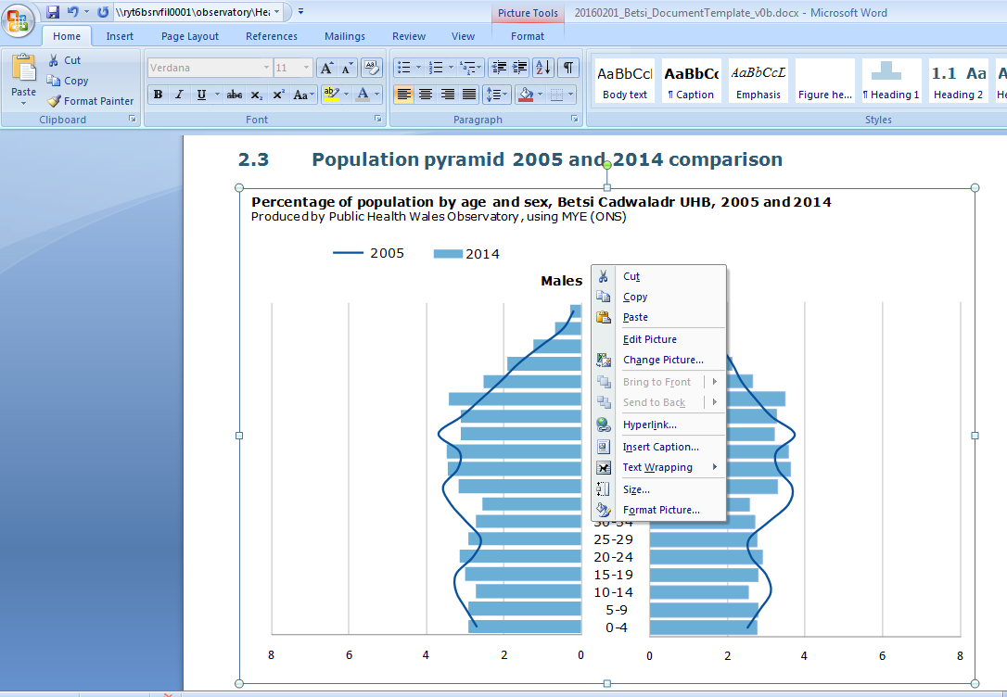
Figure 1

EXAMPLE

Resizing images (Figure 2)
- To adjust the size, left-click the image once so that the surrounding points are displayed.
- You can either adjust the length and width manually through the ‘Format’ tab or use the points to resize the image by clicking and dragging.
- When resizing an image it is best to use the corner points dragging method, as this will retain the proportions of the original image. Re-sizing just horizontally or vertically leads to distortion of the perspective and a reduction in image quality.
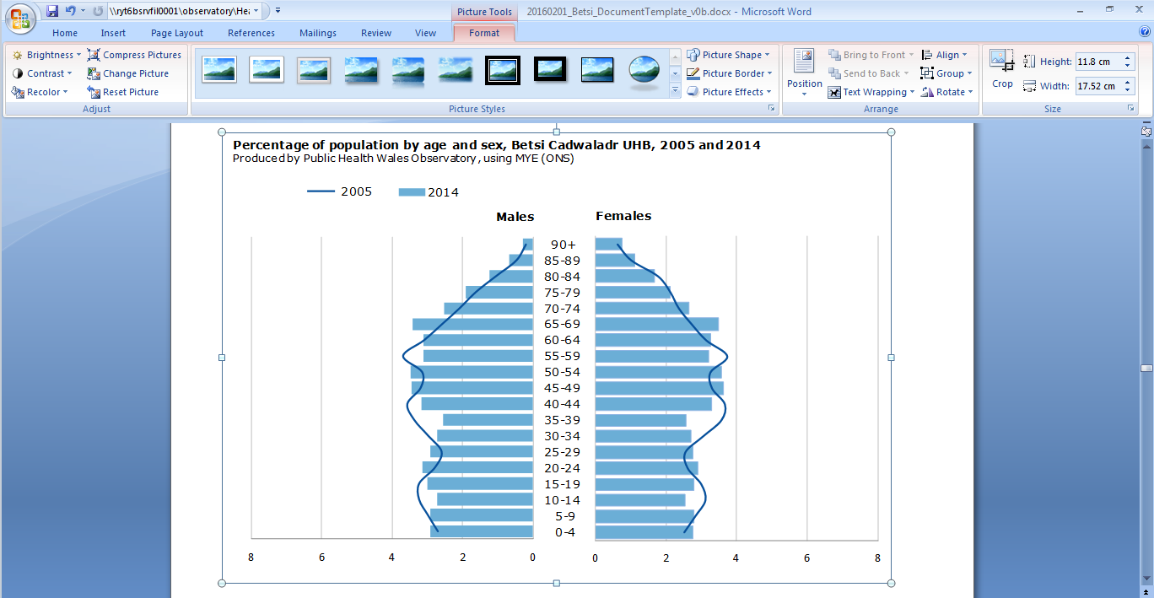
Figure 2

EXAMPLE

Introduction

This Wales summary document provides national level information on the indicators contained in the publication Demography 2016. It includes selected charts, tables and small area maps for Wales and is designed to complement the health board summary documents.
The publication Demography 2016 consists of:
- A Wales summary document and key messages
- Seven health board summary documents
- Four interactive data files showing the main indicators and key messages
- Three map interactive files
- Infographics of selected key messages
- Technical guides describing the indicators, data sources and caveats

These resources are available at https://phw.nhs.wales/services-and-teams/observatory/data-and-analysis/demography-2016/

Note
It has recently come to light that the population aged 85+ has been underestimated in some areas by the Office for National Statistics population estimates. In most parts of Wales the impact of this issue will be small. Further details are available from the Demography 2016 webpage

Population estimates

Population estimates are produced annually by the Office for National Statistics. The estimates are based on the most recent Census (2011) from which births are added, deaths are subtracted and an estimate is made of net migration.

Key messages

- Over the last 10 years (2005 to 2014), the population of Wales has increased by over 4% from around 2.97 million to 3.09 million (5.1% and 3.2% increase for males and females, respectively)

- In 2014, an estimated 49% of the population were male and 51% female in Wales

- The largest increase (10.4%) in population was seen in Cardiff which increased from around 320,000 in 2005 to 350,000 in 2014

- Ceredigion saw the only decrease (-0.1%) in population from 2005 to 2014

- In 2014, 1 in 5 Welsh residents were aged over 65 years (20%), 6 in every 10 (62%) were of working age (16 to 64 years) and nearly 1 in 5 (18%) were aged under 16

- The population aged under 16 in Wales has decreased by over 2% between 2005 and 2014, from around 568,000 to 555,000

- The population in Wales aged 85+ has increased by over a quarter (27%) between 2005 and 2014, from an estimated 62,000 to 79,000

Population trends

Population trends by age

Population pyramid 2005 and 2014 comparison

Population estimates by Lower Super Output Area

Under 16
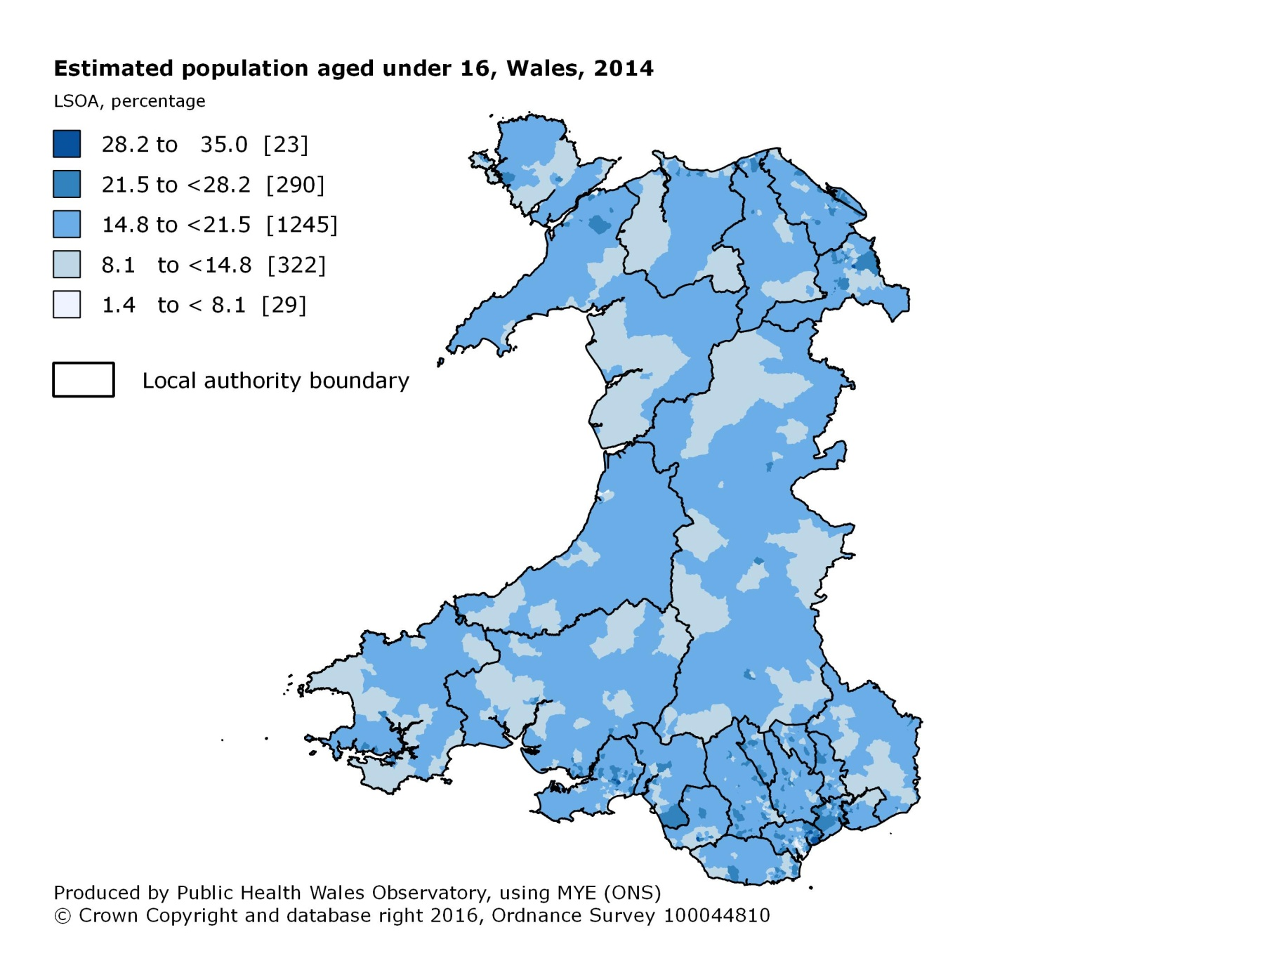

16 – 64 years
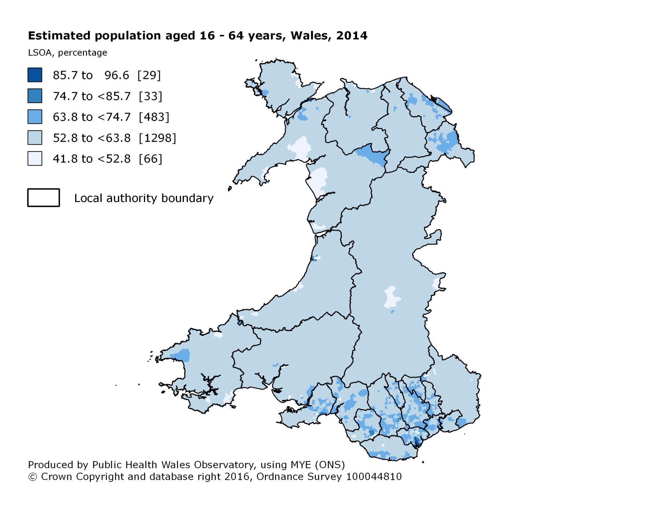

65 – 84 years
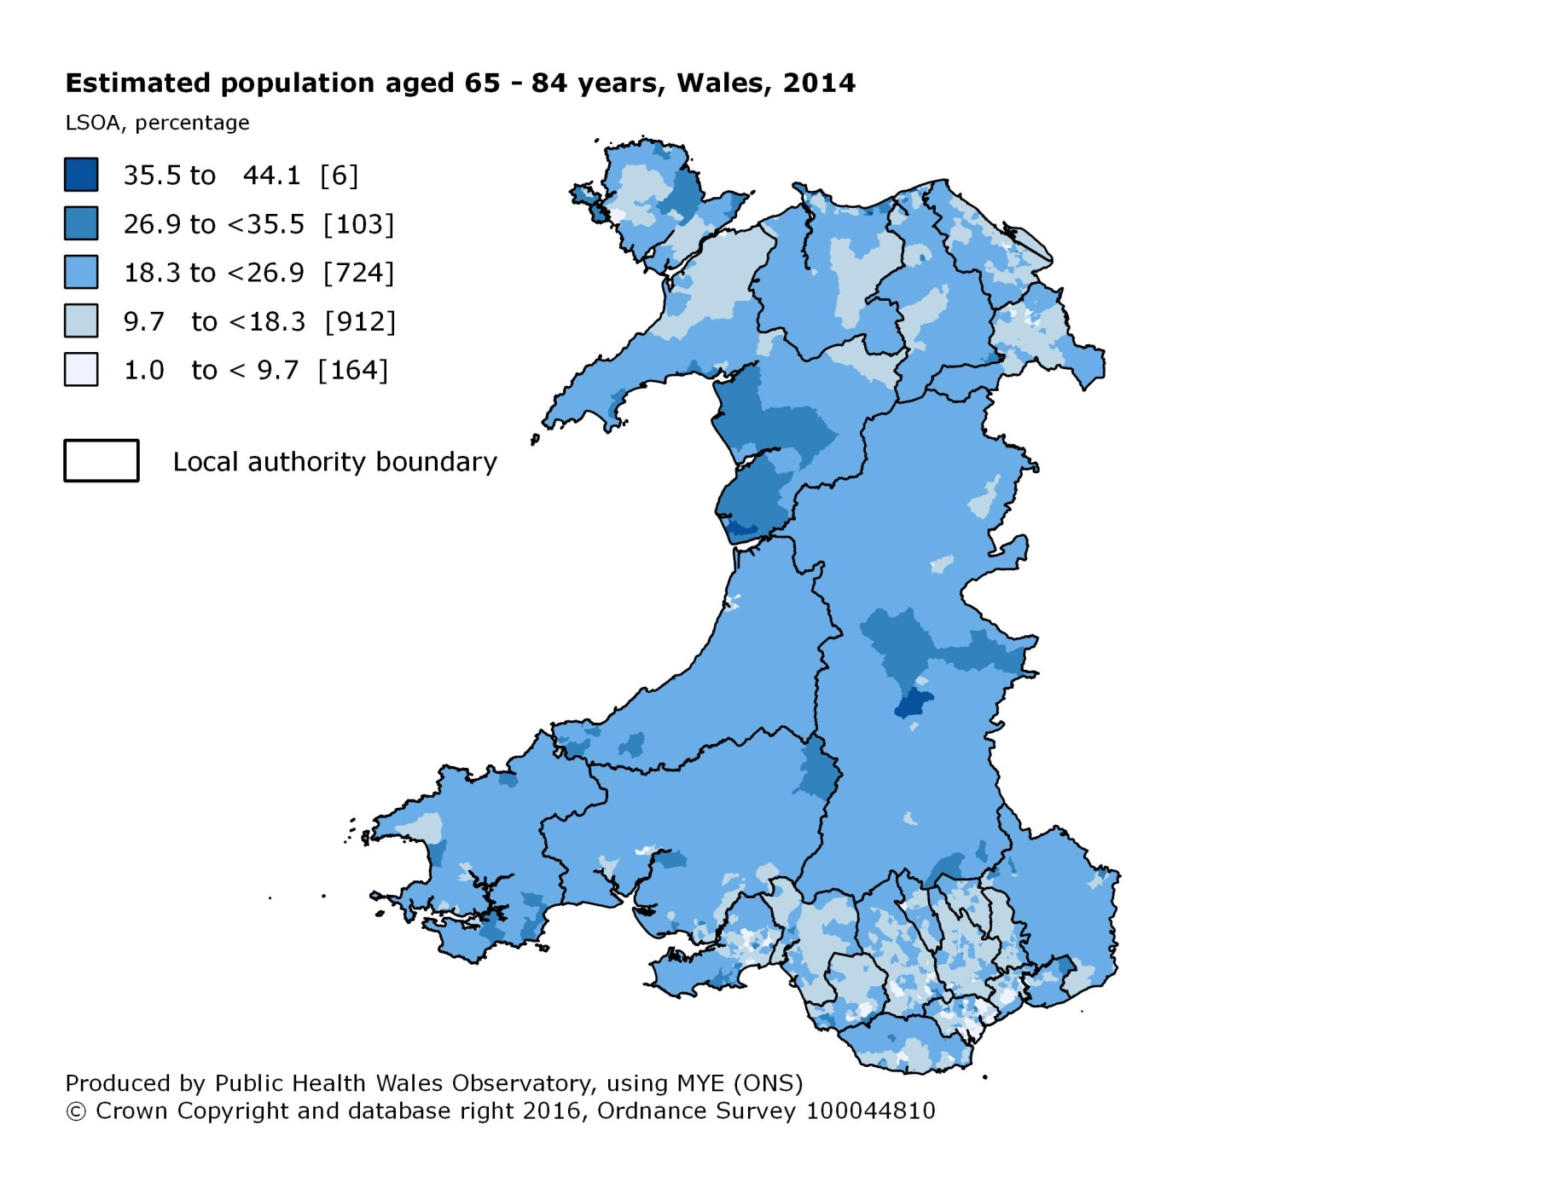

85+ years
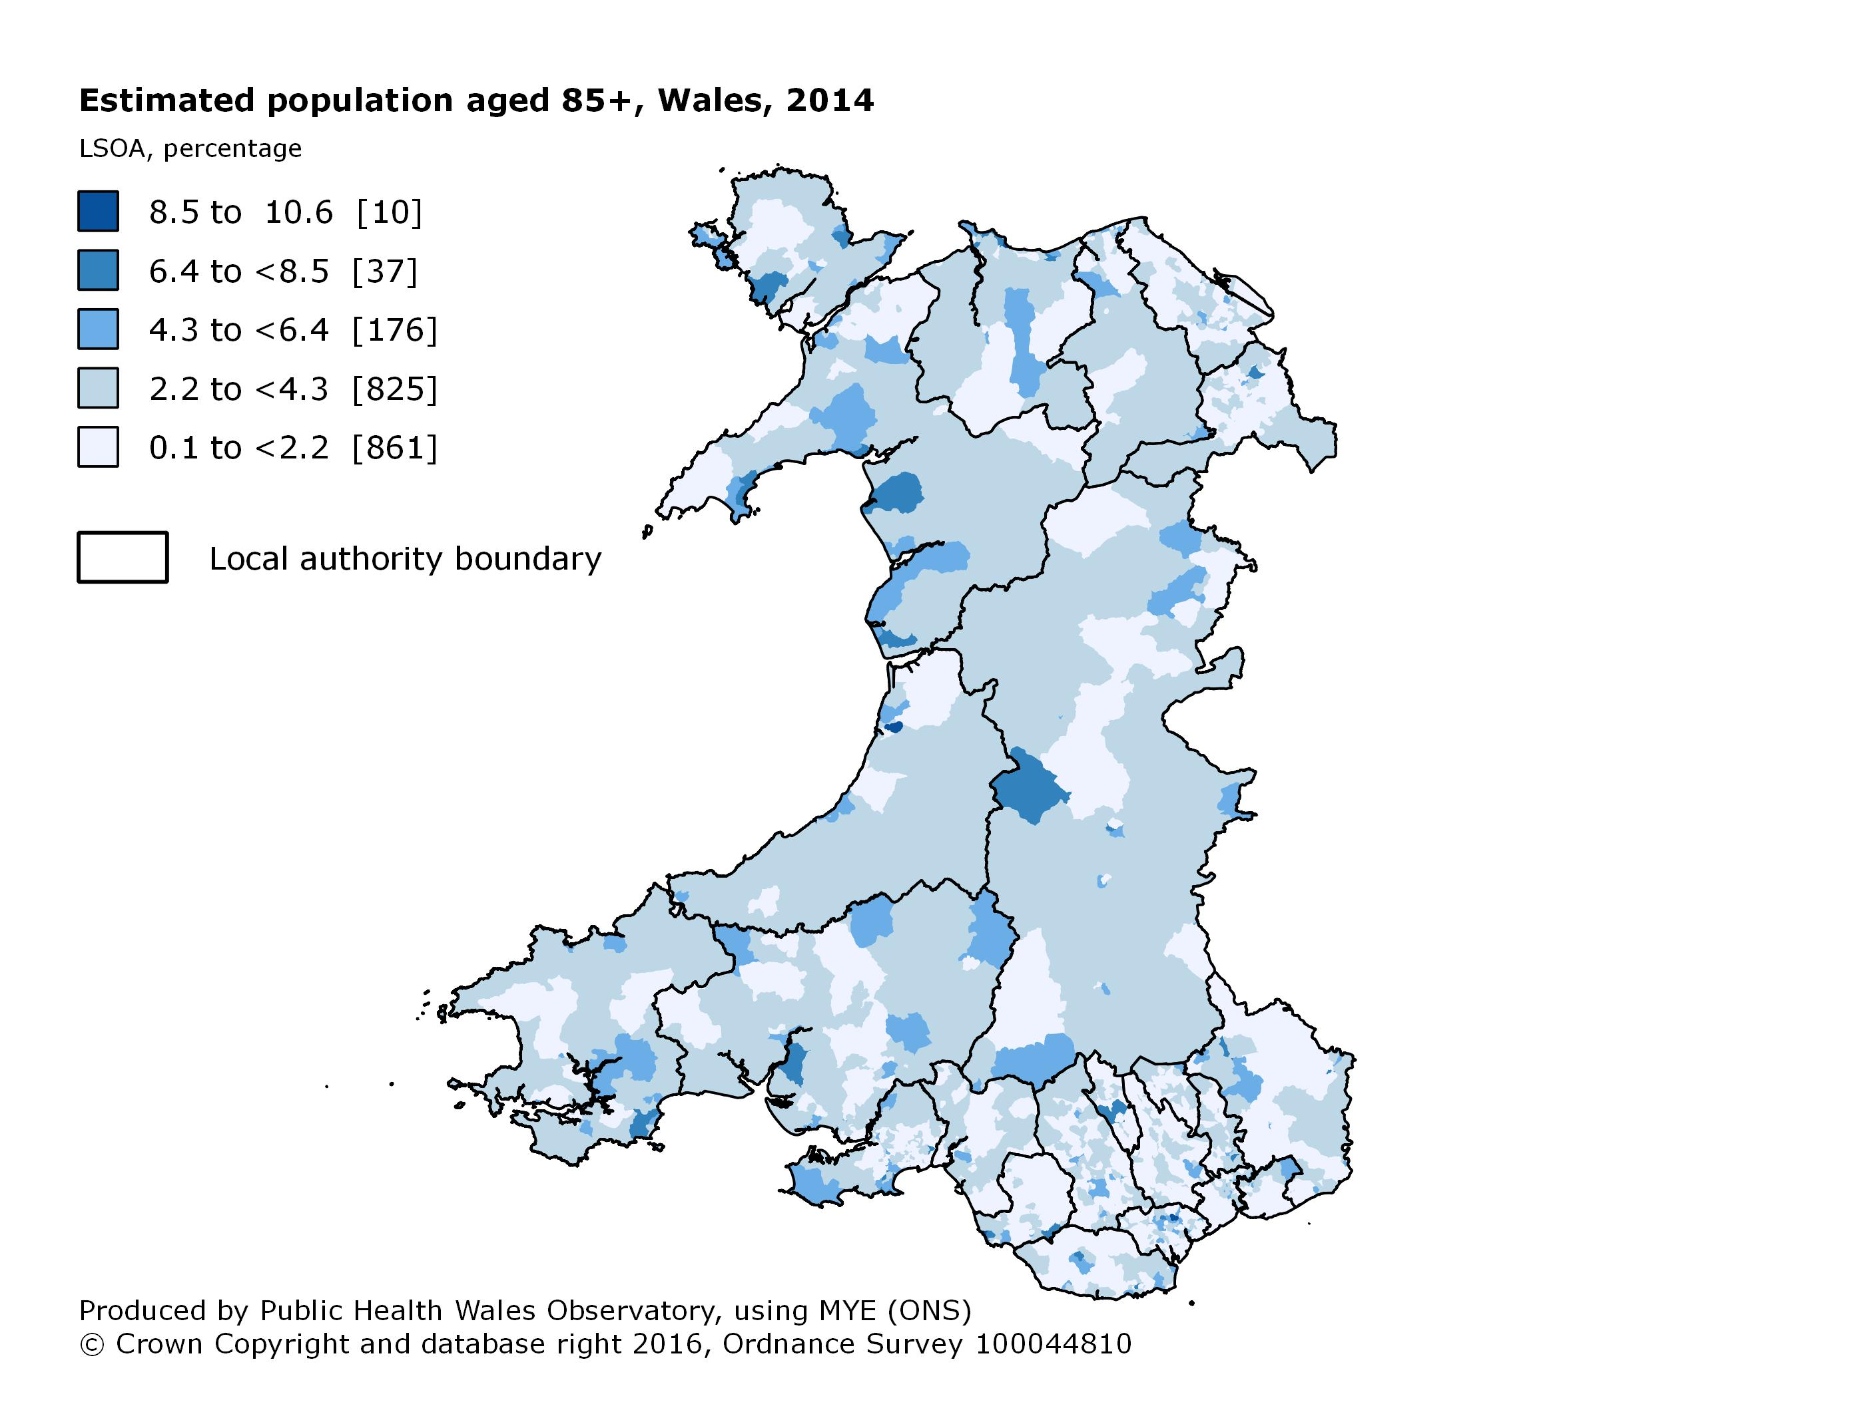

Population projections

Population projections provide estimates of the size of the future population and are based on assumptions about births, deaths and migration which are based on past trends.

Key messages

- The population of Wales is projected to increase by almost 9%, from around 3.1 million in 2011 to over 3.3 million in 2036

- The 65 to 84 and 85+ age groups are projected to have the largest increase by 2036, when an estimated 1 in 4 people in Wales will be aged 65 and over

- By 2036, it is estimated that the number of people aged 85 and over in Wales will increase by nearly 145% (from around 75,000 in 2011 to over 184,000 in 2036), with the largest increase seen in Flintshire (approximately 220%)

- It is estimated that there will be a small decline of just over 1% in the number of people aged under 65 living in Wales by 2036, with the largest decrease seen in Powys (approximately 17%)

- The largest projected population increase at the local authority level is in Cardiff which is projected to increase by around a third, from an estimated 345,000 in 2011 to over 455,000 in 2036

- Three local authority areas are projected to have a decrease in the population in 2036 (Isle of Anglesey, Blaenau Gwent and Monmouthshire), with the largest decline of nearly 7% seen in Blaenau Gwent (from around 70,000 in 2011 to 65,000 in 2036)

Projection trends by age

Past trends and projections

Mortality

The main measure of mortality used in this profile is the European age-standardised rate which accounts for differences in the population age structure between areas and over time.

Key messages

- All-cause mortality rates for under 75s and all ages have generally decreased in Wales between 2004-06 and 2012-14

- Over the last 10 years in Wales, there has been a 16.5% decrease in all-cause mortality rates in males aged under 75 and nearly 14% decrease in females aged under 75

- In 2012-2014 the all-cause mortality rate for under 75s in Wales was 34% higher in males than females

- There has been a 12.4% decrease in all-cause mortality rates for persons of all ages between 2004-06 and 2012-14 in Wales (13.5% and 11.9% decrease for males and females, respectively)

- In 2012-14, Blaenau Gwent had the highest all-cause mortality rate for persons aged under 75 and all ages whilst Monmouthshire had the lowest all-cause mortality rate for persons aged under 75 and all ages

- Wales had a higher all-cause mortality rate compared to England for both persons aged under 75 (10.4%) and all ages (7%) in 2012-14

All-cause mortality trends
Under 75

All ages

All-cause mortality 2012-14
Under 75

All ages

All-cause mortality by Middle Super Output Area
Under 75
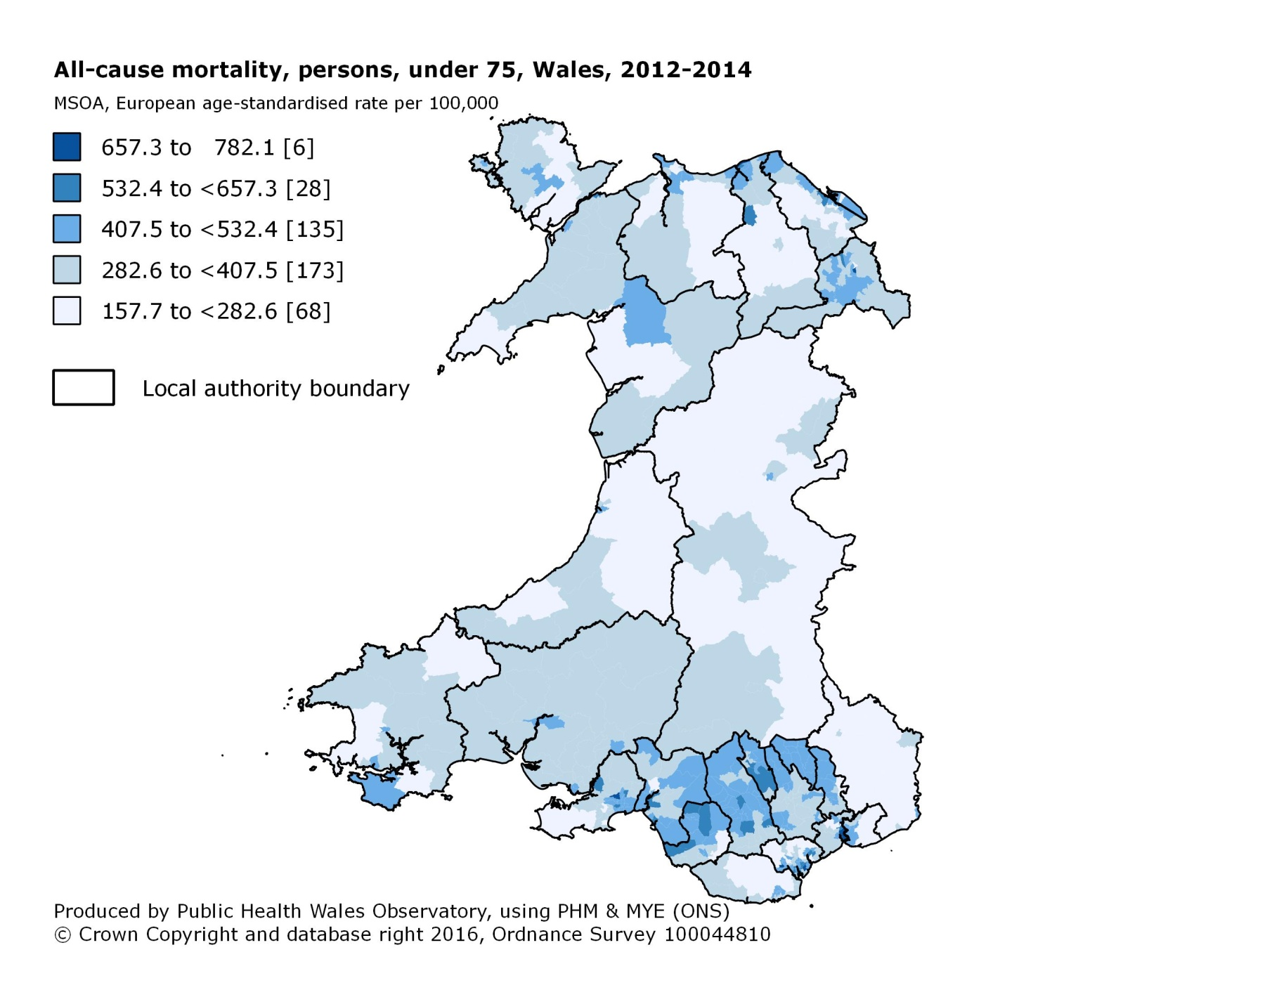

General fertility rate

The general fertility rate is the number of live births per 1,000 females aged 15-44.

Key messages

- There were just over 33,500 live births in Wales in 2014

- Over the past 10 years, the fertility rate in Wales has shown little variation with a small increase seen between 2005 and 2014 (56 and 59 live births per 1,000 females aged 15-44, respectively)

- In 2014, the highest fertility rate was in Denbighshire and the lowest in Ceredigion (72 and 44 live births per 1,000 females aged 15-44, respectively)

- The presence of a large student population within a local authority tends to reduce the fertility rate in that area, as students in higher education tend to have below average fertility

- Denbighshire had the largest increase in fertility rate, from 59 per 1,000 females aged 15-44 in 2005 to 72 per 1,000 females aged 15-44 in 2014

- Gwynedd, Rhondda Cynon Taf and Torfaen local authorities showed a small decrease in fertility rate between 2005 and 2014

General fertility rate trends

General fertility rate 2014

General fertility rate by Lower Super Output Area

