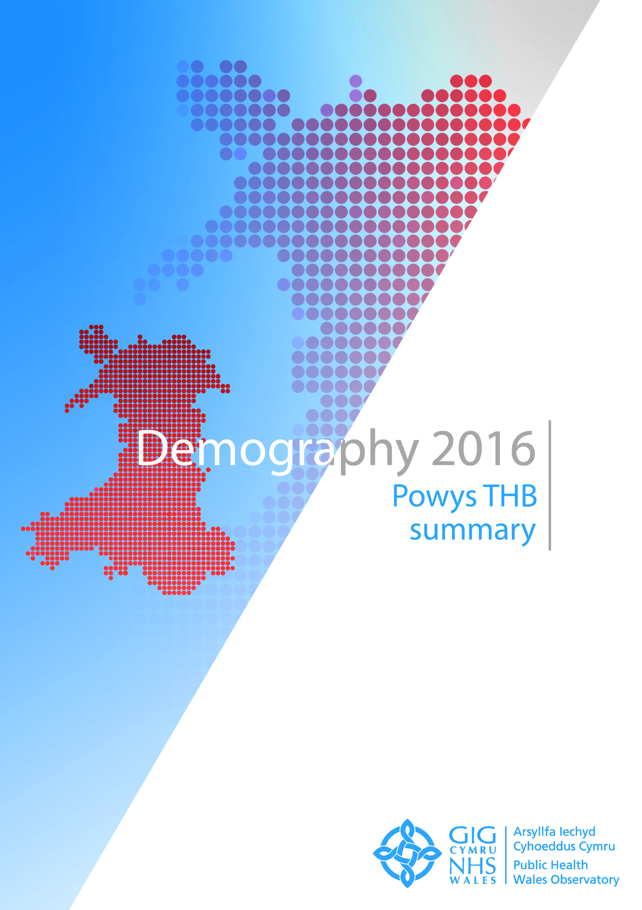

The publication Demography 2016 consists of:
- Wales summary document and key messages
- Seven health board summary documents
- Four interactive data files showing the main indicators and key messages
- Three map interactive files
- Infographics of selected key messages
- Technical guides describing the indicators, data sources and caveats

These resources are available at
https://phw.nhs.wales/services-and-teams/observatory/data-and-analysis/demography-2016/

For further information, or to provide feedback on Demography 2016, please contact us:

Public Health Wales Observatory
14 Cathedral Road
Cardiff
CF11 9LJ

email: publichealthwalesobservatory@wales.nhs.uk
web: www.publichealthwalesobservatory.wales.nhs.uk

Main project team
Ioan Francis, Rhian Hughes, Grace Jefferies, Victoria Middleton

Additional support
James Allen, Anna Childs, Andrew Dring, Dee Hickey, Leon May, Rhys Powell

Project director
Nathan Lester

Acknowledgements
Thanks to the following people for their help with this publication:
Hugo Cosh, Andrea Gartner, Rhys Gibbon, Tracy Price

© 2016 Public Health Wales NHS Trust

All tables, charts and maps were produced by the Public Health Wales Observatory and the data sources are shown within each graphic. Material contained in this profile may be reproduced without prior permission provided it is done so accurately and is not used in a misleading context. Acknowledgement to Public Health Wales NHS Trust to be stated. Typographical copyright lies with Public Health Wales NHS Trust.

Contents

How to copy charts and maps
1 Introduction 3
2 Population estimates 4
2.1 Population trends 4
2.2 Population trends by age 4
2.3 Population pyramid 2005 and 2014 comparison 5
2.4 Population pyramid 2014 comparison 5
2.5 Population estimates by Lower Super Output Area 6
3 Population projections 10
3.1 Projection trends by age 10
3.2 Past trends and projections 10
4 Mortality 11
4.1 All-cause mortality trends 11
4.2 All-cause mortality 2012-14 12
4.3 All-cause mortality by Middle Super Output Area 14
5 General fertility rate 15
5.1 General fertility rate trends 15
5.2 General fertility rate 2014 16
5.3 General fertility rate by Lower Super Output Area 17

How to copy charts and maps into other documents
The standard {Cut}, {Copy} and {Paste} options can be used in Microsoft Word to export tables, charts and maps to other documents. Images can also be resized as required.
Copying and pasting charts and maps (Figure 1)
- Select the image you want to copy by left clicking on it once so that the surrounding points are displayed.
- Either on the ‘Home’ tab or through the right click menu select either ‘Cut’ or ‘Copy’.
- In the document where you want to insert the image, select ‘Paste’ either through the ‘Home’ tab or the right-click menu.
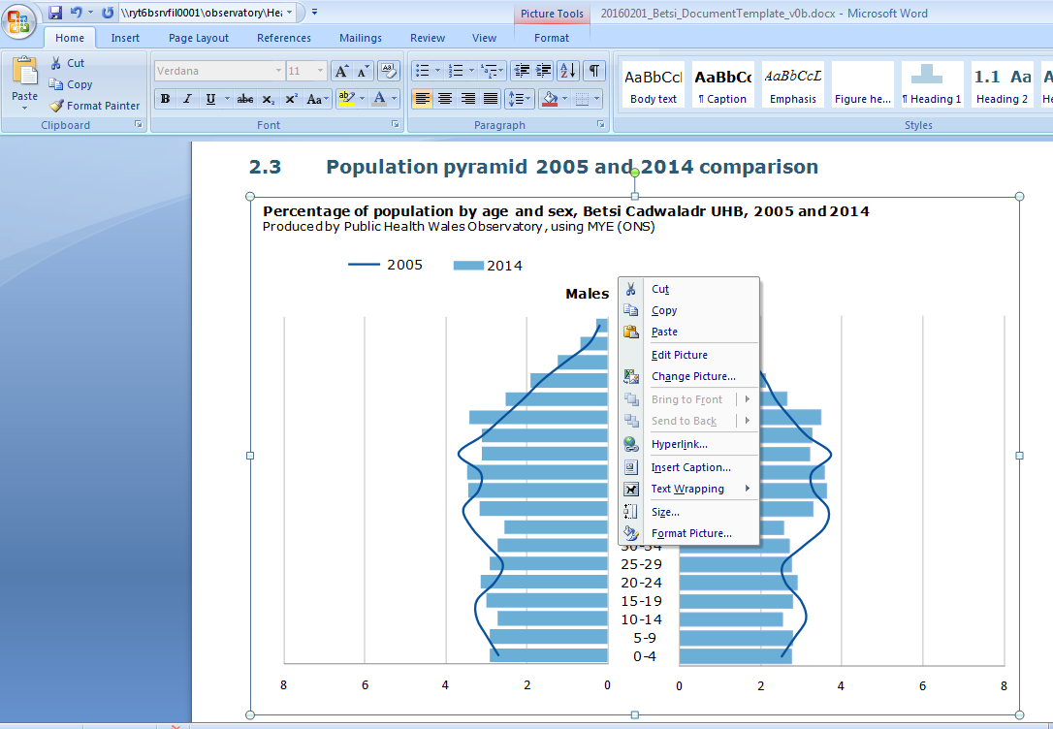
Figure 1

EXAMPLE

Resizing images (Figure 2)
- To adjust the size, left-click the image once so that the surrounding points are displayed.
- You can either adjust the length and width manually through the ‘Format’ tab or use the points to resize the image by clicking and dragging.
- When resizing an image it is best to use the corner points dragging method, as this will retain the proportions of the original image. Re-sizing just horizontally or vertically leads to distortion of the perspective and a reduction in image quality.
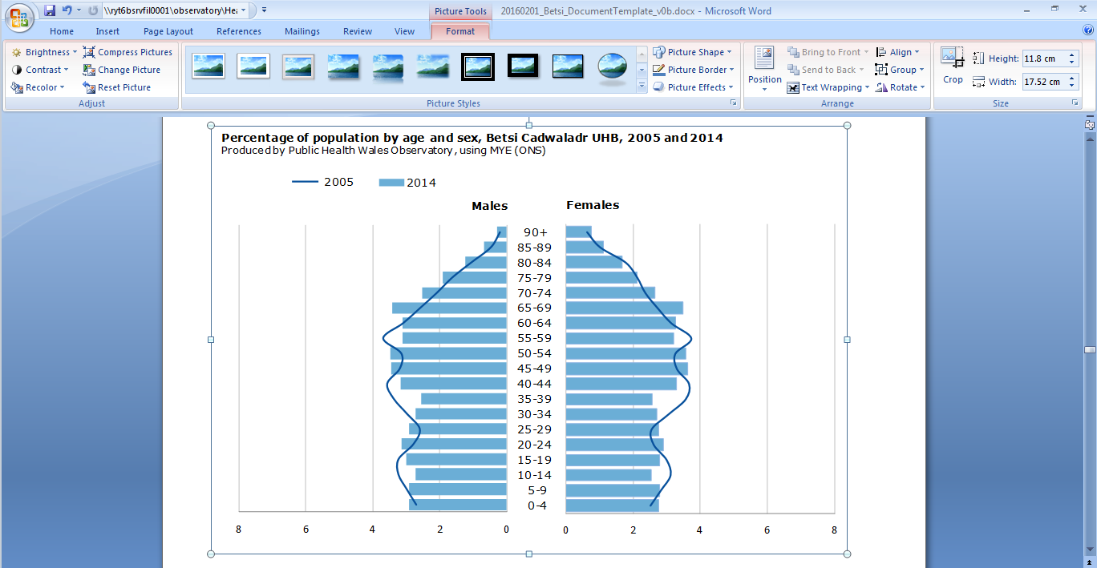
Figure 2

EXAMPLE

Introduction

This health board summary document provides local level information on the indicators contained in the publication Demography 2016. It includes selected charts and small area maps for the health board area and is designed to complement the Wales summary document.
The publication Demography 2016 consists of:
- A Wales summary document and key messages
- Seven health board summary documents
- Four interactive data files showing the main indicators and key messages
- Three map interactive files
- Infographics of selected key messages
- Technical guides describing the indicators, data sources and caveats
These resources are available at https://phw.nhs.wales/services-and-teams/observatory/data-and-analysis/demography-2016/

Note:
It has recently come to light that the population aged 85+ has been underestimated in some areas by the Office for National Statistics population estimates. In most parts of Wales the impact of this issue will be small. Further details are available from the Demography 2016 webpage

Population estimates

Population trends

Population trends by age

Population pyramid 2005 and 2014 comparison

Population pyramid 2014 comparison

Population estimates by Lower Super Output Area

Under 16
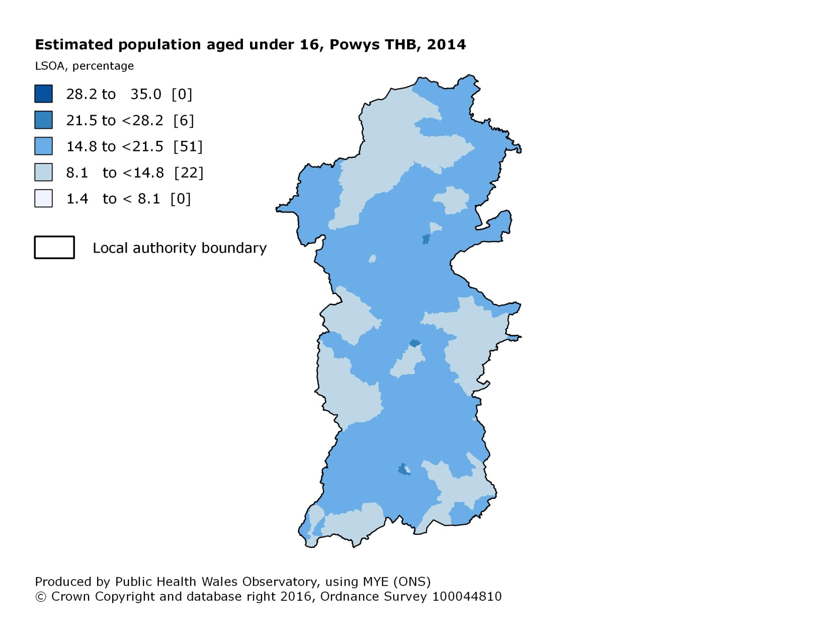

16 – 64 years
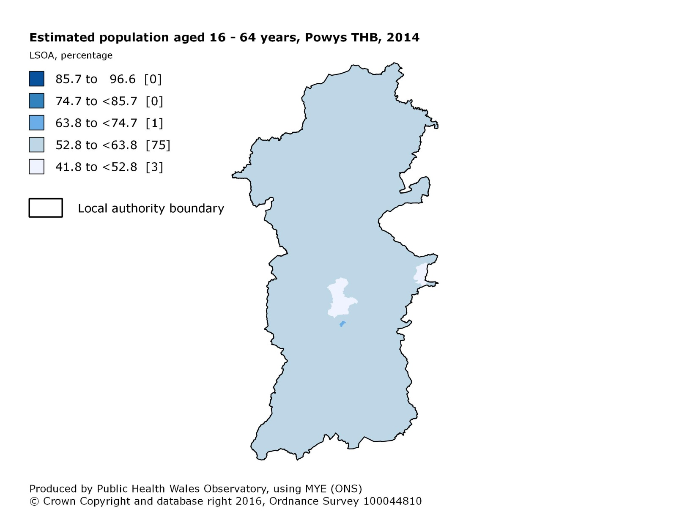

65 – 84 years
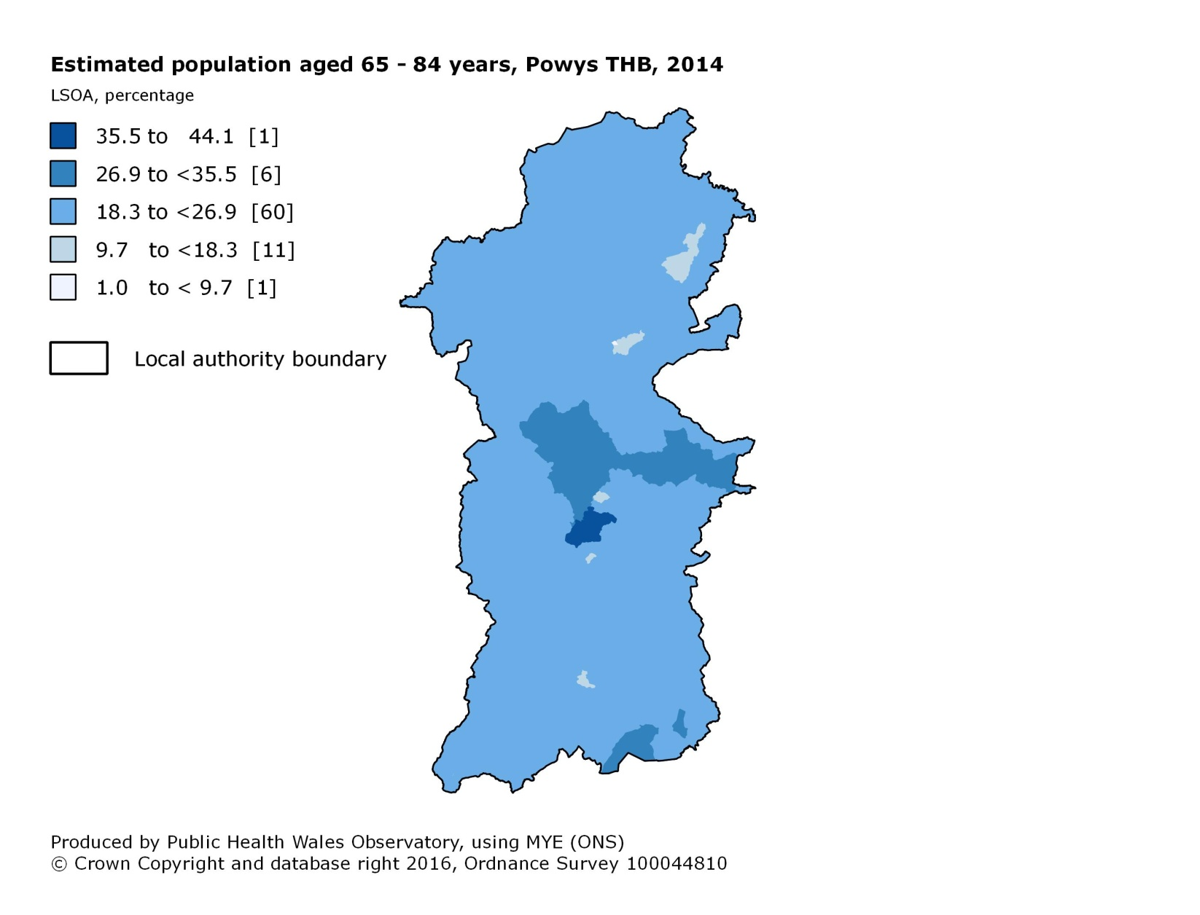

85+ years
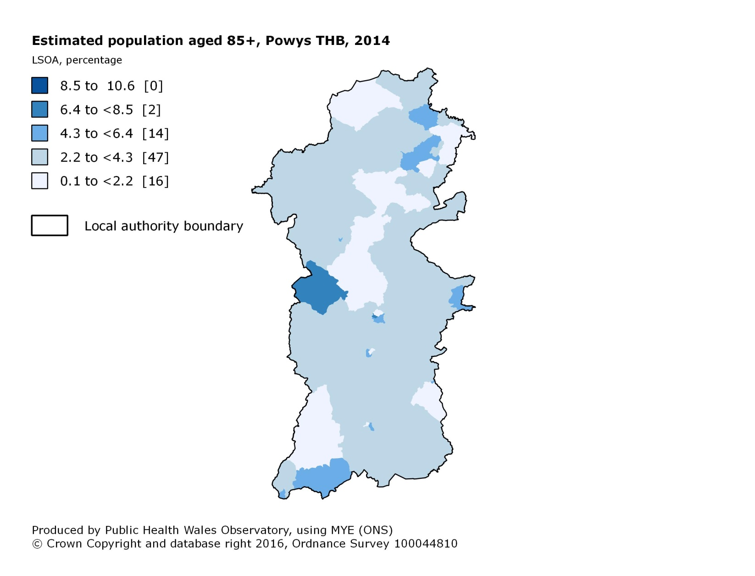

Population projections

Projection trends by age

Past trends and projections

Mortality

All-cause mortality trends
Under 75
All ages

All-cause mortality 2012-14

Under 75

All ages

All-cause mortality by Middle Super Output Area
Under 75
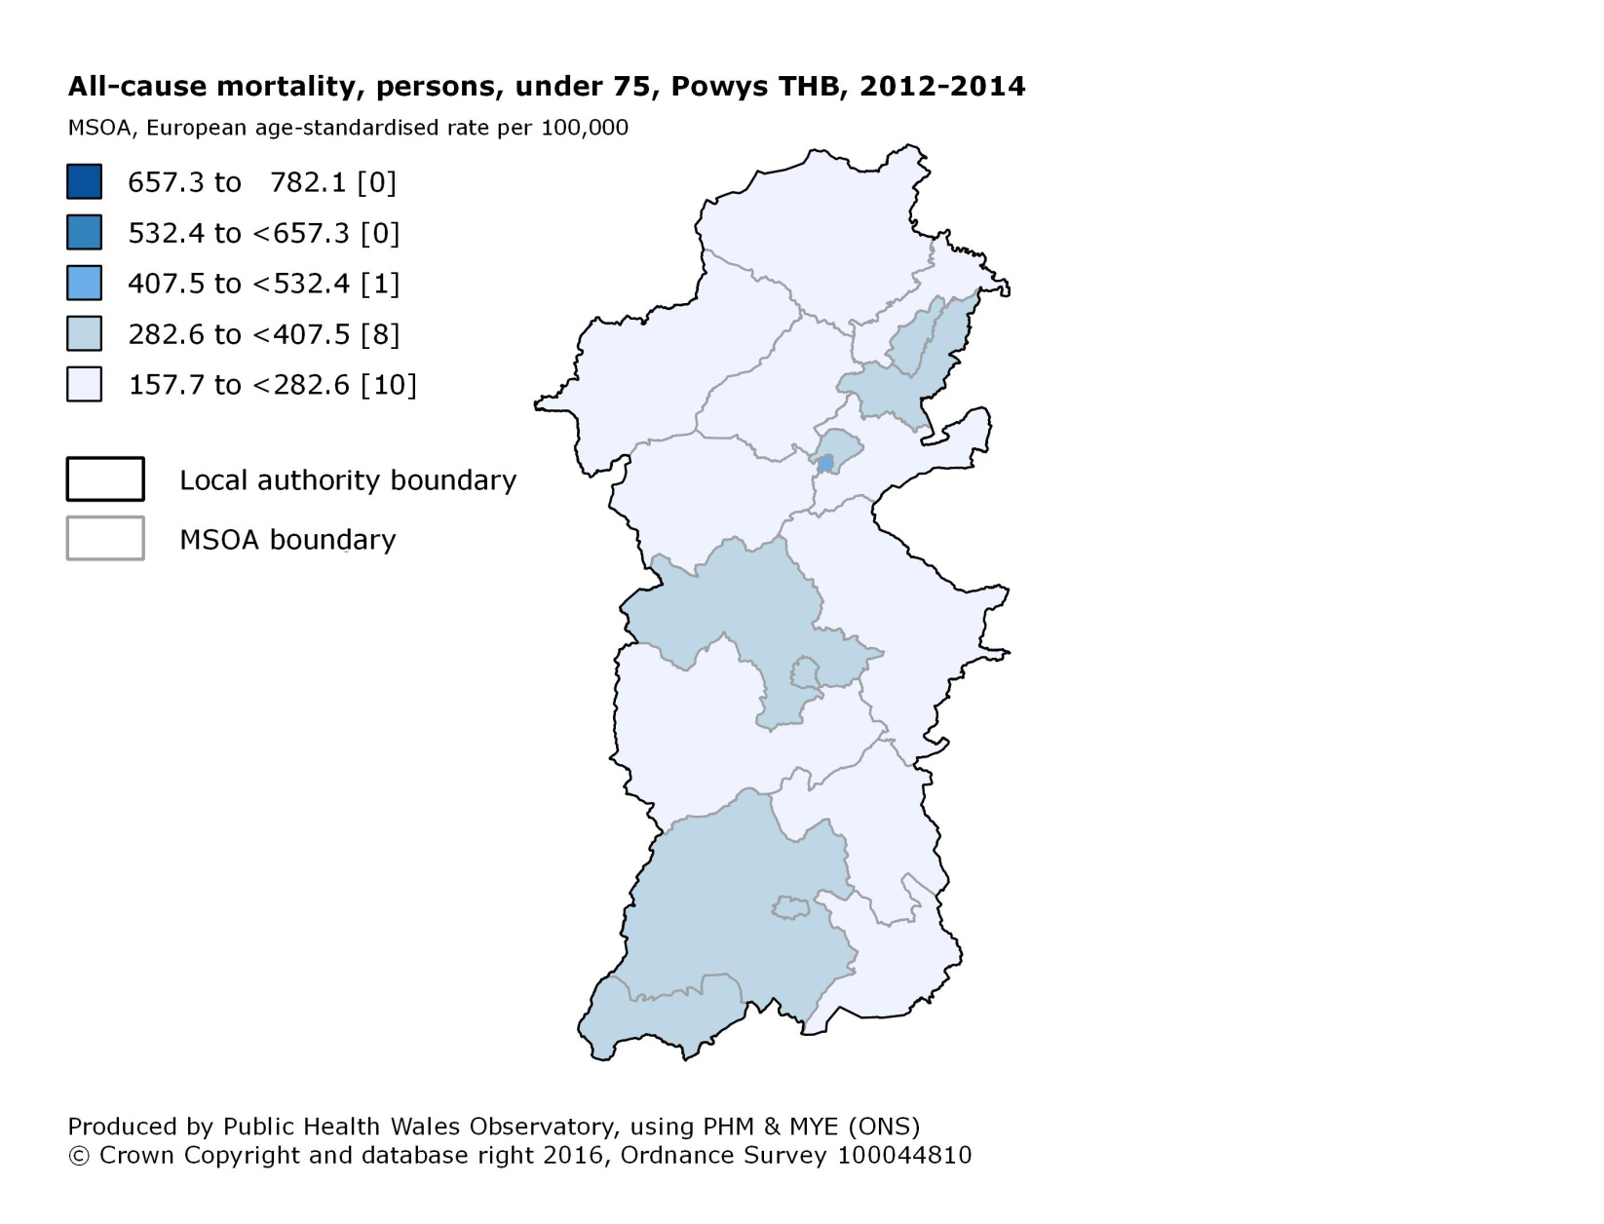

General fertility rate

General fertility rate trends

General fertility rate 2014

General fertility rate by Lower Super Output Area

