

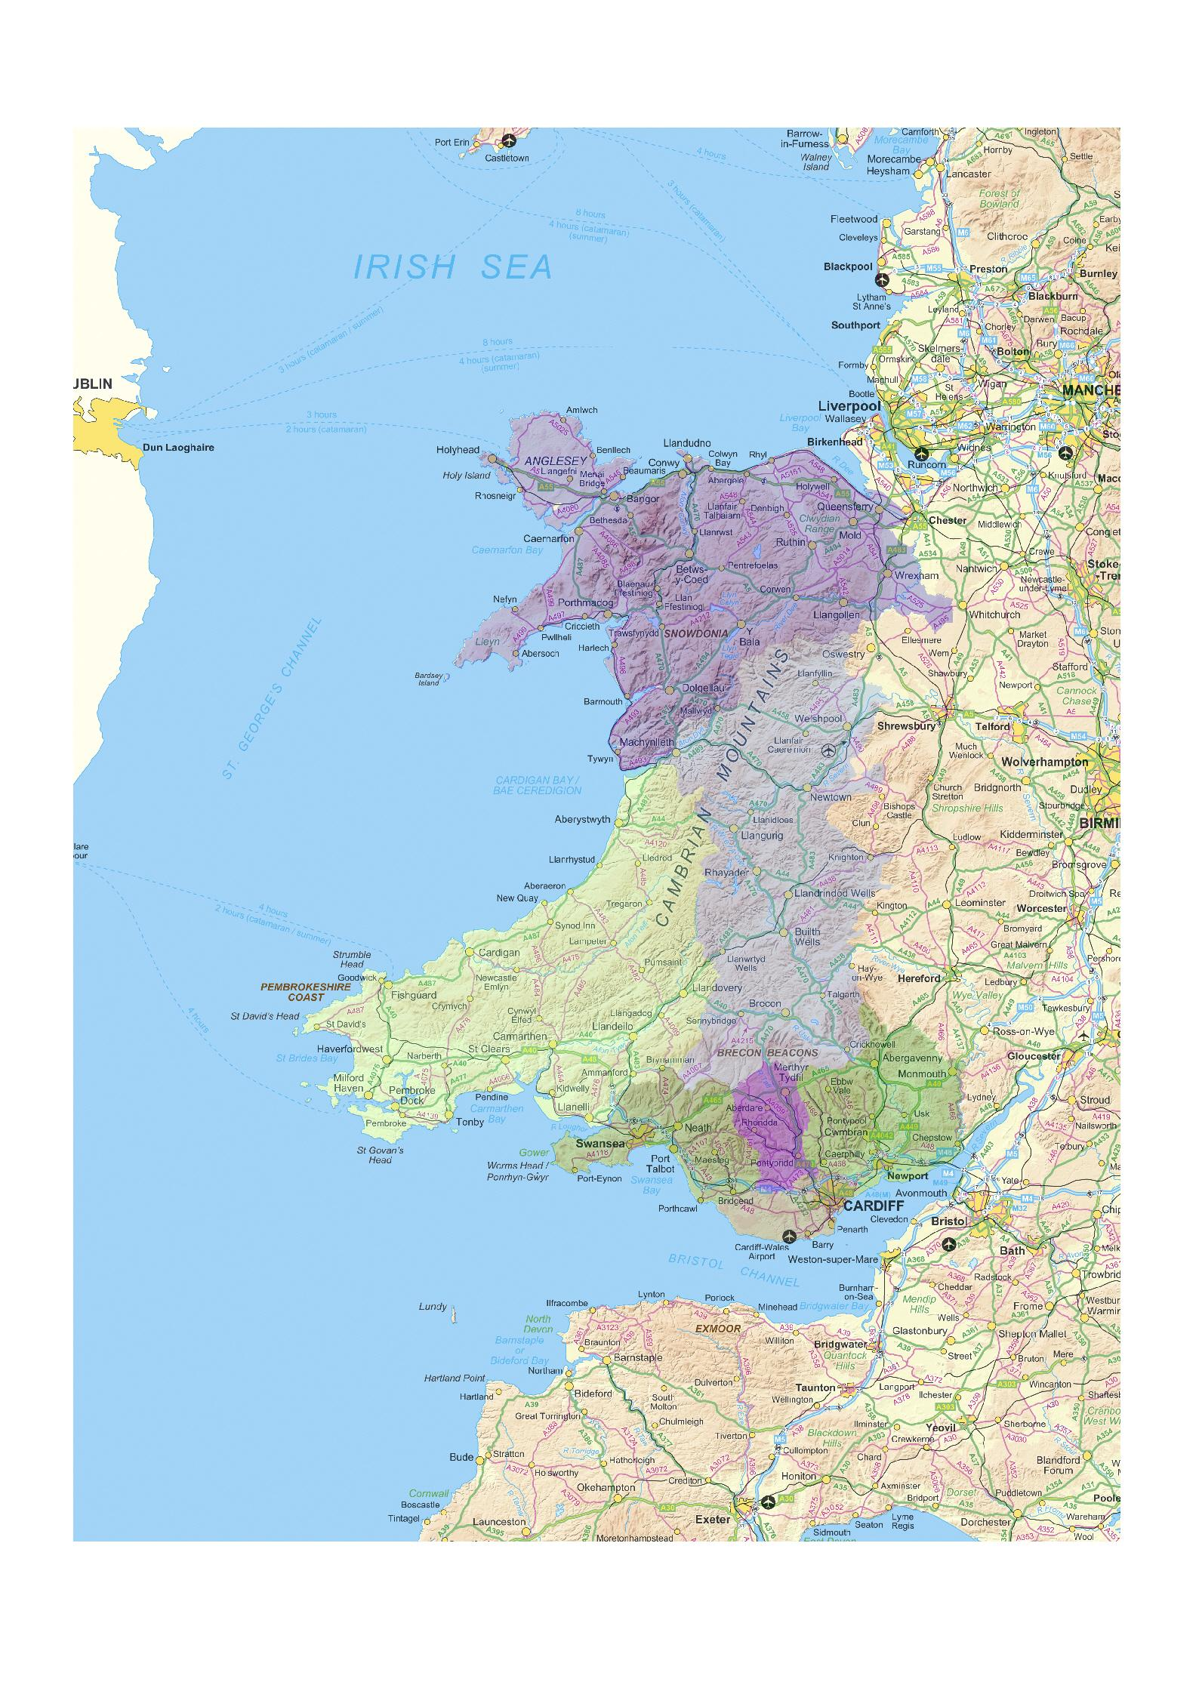
Chronic obstructive pulmonary disease in the Abertawe Bro Morgannwg area: report 1

Acknowledgements

This report was prepared by the Public Health Wales Observatory. Contributors included Tracy Price, Rhys Gibbon, Dr Ciarán Humphreys, Nathan Lester, Bethan Patterson, Isabel Puscas, Martin Holloway and Hugo Cosh.

The team is grateful to the following for their advice and support:
- Caroline Brooks, Martin Heaven, Steven Macey, Prof Ronan Lyons, Dr David Ford and the Technical Team from the Health Information Research Unit (HIRU) at Swansea University;
- The Abertawe Bro Morgannwg SAIL and Community Network group, especially Dr Stephen Monaghan, Dr Annie Delahunty and Ian Phillips.
- Dr Chris Johns and Dr Sean Young, clinical leads within the Abertawe Bro Morgannwg area.

This report can be downloaded from the Observatory website:
http://www.publichealthwalesobseravtory.wales.nhs.uk

For further information please contact:
publichealthwalesobseravtory@wales.nhs.uk

© 2011 Public Health Wales NHS Trust

Material contained in this document may be reproduced without prior permission
provided it is done so accurately and is not used in a misleading context.

Acknowledgement to Public Health Wales NHS Trust to be stated

ISBN 978-0-9565398-8-5

Key messages
This report has been produced by the Public Health Wales Observatory to support the activities of community networks within ABM UHB. It describes the patterns of COPD among patients registered with the community network practices using the SAIL databank at Swansea University. Use of SAIL data for public health purposes is in early stages of development and this work should be considered experimental.

COPD in Abertawe Bro Morgannwg UHB
- Smoking is a major risk factor for COPD. The proportion of smokers in ABM UHB is comparable to Wales.
- Based on practices contributing data to SAIL, diagnosed COPD prevalence is around 1.5 per cent for ABM UHB. Community network rates are highest in Cityhealth, Swansea; Afan, Neath Port Talbot; and North Bridgend. Rates are lowest in Bayhealth and Llwchwr both within Swansea local authority area. The highest community network prevalence (Cityhealth 2.0 per cent) is twice that of the lowest (Bayhealth 1.0 per cent)
- The COPD admission rate for ABM UHB is lower than the Wales rate. The highest community network rates are in Penderi and Cityhealth, Swansea; North, Bridgend; and Afan, Neath Port Talbot. The lowest are in Bay health and Llwchwr in Swansea.
- The COPD death rate is lower in ABM UHB than that for Wales. Within the health board area rates are highest in Cityhealth and Penderi in Swansea; Afan, Neath Port Talbot and Bridgend North. Rates are lowest in Bridgend West and Bay health (Swansea).

SAIL
The SAIL databank has tremendous potential for public health intelligence through data linkage, access to GP data and outcome measurement through longitudinal analyses. It is anticipated that this work proves useful to community networks, assists in developing further work utilising SAIL and will help demonstrate how the NHS may benefit from SAIL derived analysis to encourage other GP practices across ABM UHB and elsewhere in Wales to participate.

Table of contents
1 Introduction 6
1.1 The scope of the report 8
1.2 Aim 8
1.3 Objectives 8
2 What is Chronic Obstructive Pulmonary Disease? 9
2.1 Clinical coding for COPD 10
3 Important considerations 11
3.1 Data sources used and their caveats 11
3.1.1 GP data 11
3.1.2 Welsh Demographic Service data 12
3.1.3 Hospital data 12
3.1.4 Death data 13
3.2 Statistical concepts and methodology 14
3.2.1 Age-standardisation 14
3.2.2 Confidence intervals 14
3.2.3 Defining community network populations 15
3.2.4 Data linkage 15
4 Results 16
4.1 Demography 16
4.2 Estimated Prevalence of COPD 17
4.3 Admissions for COPD 18
4.4 Deaths due to COPD 20
5 Discussion 21
5.1 Additional COPD analyses 22
5.2 Practical issues with the use of SAIL 23
6 Conclusions 24
7 References 26
8 Supporting information 27
8.1 GP practices within Abertawe Bro Morgannwg University Health Board submitting data to the SAIL databank at time of analysis 27
8.2 READ codes 29
8.3 ICD10 codes 30
8.4 Practices signed up and supplying data to SAIL (March 2011) 31
8.5 Counts of persons and patients with diagnosed COPD by community network area 32
8.6 COPD admissions by community network area 33
8.7 COPD deaths by community network area 34

Introduction
This report has been produced to support the activities of community networks within Abertawe Bro Morgannwg University Health Board (ABM UHB). It describes the pattern of chronic obstructive pulmonary disease (COPD) among patients registered with community network GP practices in the ABM UHB area.

The Secure Anonymised Information Linkage (SAIL) databank was used for this work. SAIL is a research tool developed and hosted by Swansea University and made available for public health use. Use of SAIL data for public health purposes is in early stages of development and this work should be considered experimental. The SAIL databank has tremendous potential for public health intelligence using data linkage, access to GP data and outcome measures through longitudinal analyses. The Public Health Wales Observatory agreed a project specification with ABM UHB to examine COPD prevalence, hospital admissions and deaths for GP community networks in the ABM UHB area. The map shown in Fig 1 outlines all GP practices by community network. A list of GP practices submitting data to SAIL for 2008 can be found in section 8.1.

This work has been undertaken whilst being overseen by the multi agency ABM UHB SAIL and Community Network Group.

Figure 1: Map of GP community networks in the Abertawe Bro Morgannwg University Health Board area
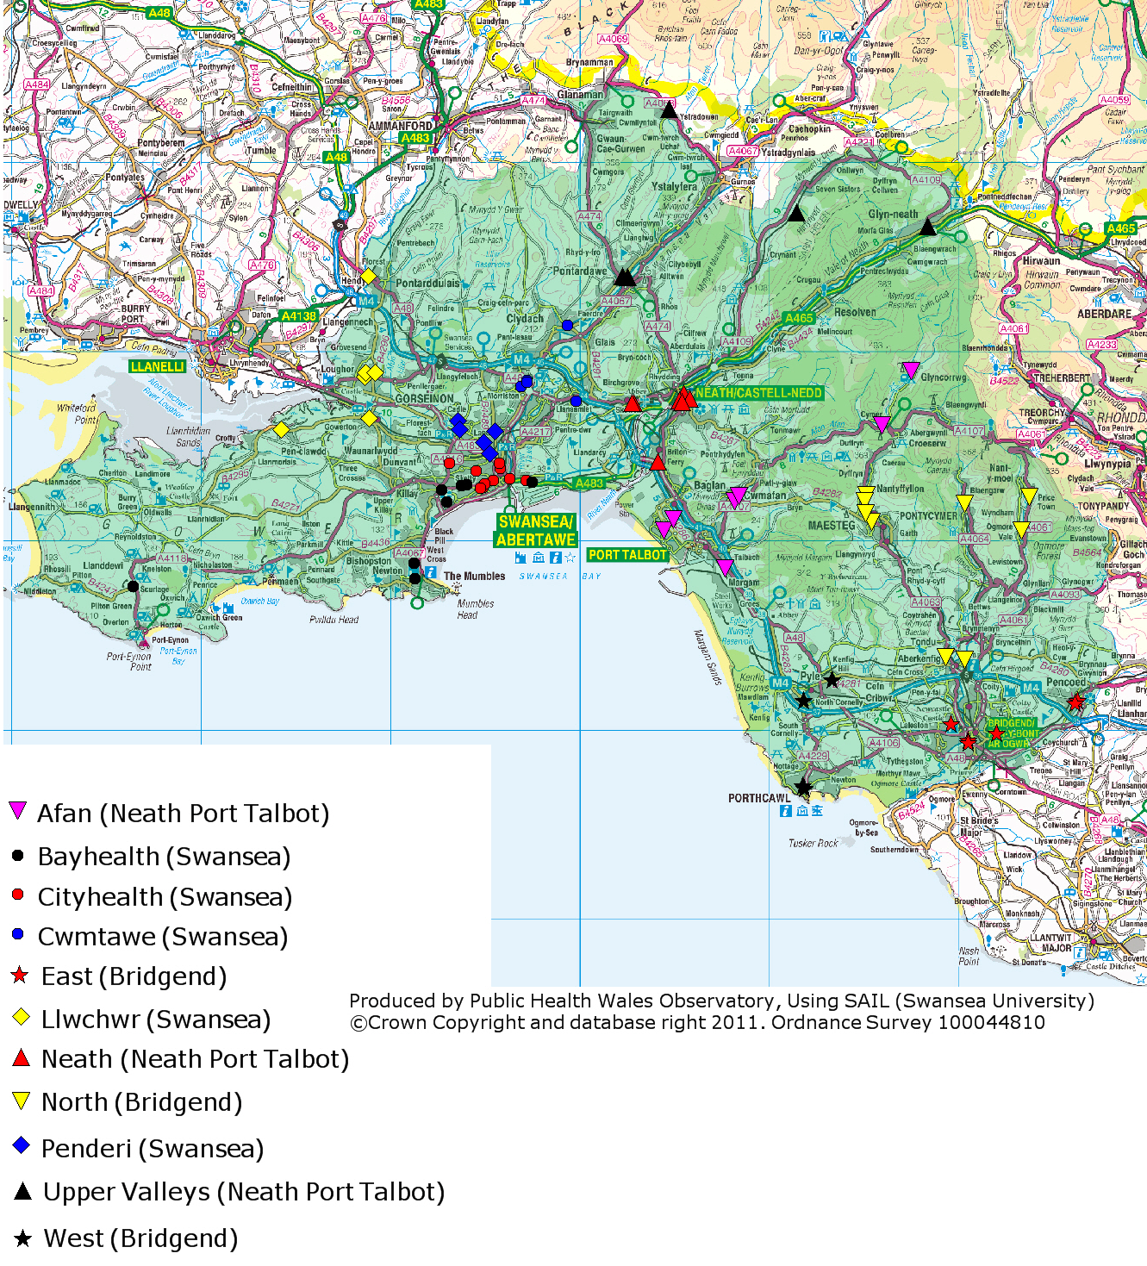

The scope of the report
The report provides:
- A summary of the methods and results
- Estimates of COPD prevalence using data from GP practices by community network for the ABM UHB area
- Hospital admission rates for COPD by community network for the ABM UHB area
- Death rates by community network for the ABM UHB area

Aim
To produce estimates for COPD prevalence, hospital admissions and mortality by GP community network for the ABM UHB area

Objectives
- Provide useful information on COPD to the community networks, their GP practices and other interested groups in the ABM UHB area
- Demonstrate how information can be derived from SAIL for public health purposes
- Develop skills of Observatory staff in using the SAIL databank
- Hopefully assist in the advocacy for participation of GP practices within SAIL

What is Chronic Obstructive Pulmonary Disease?
Chronic obstructive pulmonary disease is characterised by airflow obstruction that is usually progressive, not fully reversible and does not change markedly over several months.¹ COPD is now the preferred term for the conditions in patients with airflow obstruction who were previously diagnosed as having chronic bronchitis or emphysema.¹

Chronic obstructive pulmonary disease is predominantly caused by smoking. The Welsh Health Survey is a rich source of information on lifestyle. It is a self-reported survey randomly sampling around 15,000 adults (aged 16+) per year in Wales. The sample is constructed to allow reporting at local authority level. The chart uses data from the Welsh Health Survey and gives the proportion of adults who reported being a smoker.

Almost 1 in 4 people in Wales smoke, with ABM UHB having the same rate as Wales. Within the health board, Neath Port Talbot is seen to have a slightly higher rate than Wales.

Other risk factors for COPD include air pollution, occupational exposure, childhood respiratory illness, unhealthy diet and exposure to respiratory allergens.²

COPD is the second largest cause of emergency admissions in the UK.¹ The risk of lung cancer and heart disease is increased for COPD patients i.e. all 3 being chronic diseases with smoking as a risk factor.¹

Approximately 1.4 per cent (42,000) of Wales residents have COPD.³

Clinical coding for COPD
In the primary care setting, READ coding is used. These codes provide a thesaurus of clinical terms which are used by GPs to record information on a patient record⁴ e.g. diagnosis, procedure, drugs prescribed. The READ codes used to identify patients with a COPD diagnosis are those from the nationally agreed Quality and Outcomes Framework (QOF) and can be found in section 8.2.

For hospital admissions and death data, International Statistical Classification of Diseases and Related Health Problems 10th Revision (ICD-10) was used. This is an international standard classification for diagnoses provided by the World Health Organisation (WHO).⁵ The ICD-10 codes used for COPD admissions and deaths can be found in section 8.3.

Important considerations
This section includes information on the different datasets, statistics and methods used through the SAIL databank during the work.

Data sources used and their caveats

GP data
GP practices supply anonymised data to the SAIL databank. The particular fields used in this analysis are GP practice (to determine community network), age and diagnosis.

It is not yet clear how analysis of this data for a secondary purpose approximates to the true prevalence of COPD. The findings should therefore be viewed with caution. Further to this, the absence of data from particular practices will affect the comparative elements of the analysis. The significance of this effect on local authority level analyses is dependent on the size and composition of the missing practice and its COPD prevalence. GP data are currently being submitted to the SAIL databank for only 65 per cent of practices in ABM UHB. Further details can be found in section 8.4.

The patient’s journey through primary care consists of a number of stages and at each stage data may or may not be recorded. The volume and quality of data is dependent on it being fully and accurately recorded at each stage.³ If it is not, then the data captured by the electronic systems at GP practices may not reflect the real position. Figure 2 below demonstrates this.

Figure 2: Recording of data in the community
Prevalence of condition in the population dependent on age deprivation and other factors
Pass the clinician’s threshold for diagnosis
Recording to an electronic system in line with reporting specification
Patient contacts health services
Patient recorded with condition & captured by report

Welsh Demographic Service data
Welsh Demographic Service (WDS) data have been used to produce the population chart and as the denominator for rate calculations. The WDS, previously known as the NHS administrative register (NHSAR), is a record of all patients registered with a General Practitioner in Wales. Its advantage is that it represents a count of actual people rather than an estimate of the population. However, it is vulnerable to error, such as a delay in the updating of records following death or change of address. For example, patients may either fail to register with a GP during a temporary period of residence, or neglect to inform the GP when leaving the area. These issues are known to affect data particularly in areas with a large proportion of students in higher education, or where the population is more transient for other reasons.

Hospital data
The Patient Episode Database for Wales (PEDW) includes records of inpatients and day cases treated in NHS Wales hospitals and Welsh residents treated in hospitals in England.⁶ Planned (elective), emergency and transfer admissions are all included in PEDW.⁶ The data are collected and coded at each hospital and are then transferred electronically to the NHS Wales Informatics Service (NWIS) where they are validated and merged into the main database. An anonymised subset of PEDW is then provided to University of Swansea for use through the SAIL databank.

The hospital data analysis included in this report is rate of persons admitted to hospital with a primary diagnosis of COPD i.e. irrespective of the number of COPD admissions a person had in any one year, each person was only counted once per year.

The data held in PEDW is of interest to public health services since it can provide information regarding both health service utilisation and also the incidence and prevalence of disease. However, it is important to bear in mind that PEDW was created to track hospital activity from the point of view of payments for services, rather than epidemiological analysis.⁶

Further information on PEDW and its caveats can be found on the Public Health Wales Observatory website at: http://www.wales.nhs.uk/sitesplus/922/page/50308

Death data
The annual district death extract (ADDE) contains individual records for death registrations in England and Wales. The Office for National Statistics (ONS) collates and validates the data. As it is a legal requirement to register a death, the ADDE provides a reliable and complete data source.⁷

ADDE data are based on underlying cause of death e.g. if an individual dies from pneumonia but had been made vulnerable due to end-stage cancer, then cancer is recorded as the underlying cause of death. It is important to note that older people are more likely to have many underlying health conditions (COPD being one of them), making it more difficult to determine the underlying cause of death.

Further information on the ADDE and its caveats can be found on the Public Health Wales Observatory website: http://howis.wales.nhs.uk/sitesplus/922/page/37247. (under Reference Guide)

Statistical concepts and methodology

Age-standardisation
The actual recorded prevalence of a condition is the ‘crude’ prevalence. Whilst this figure is very useful, it can be misleading when comparing different populations. In particular, disease and mortality rates vary with age. Age-standardisation allows comparison of rates across different populations by taking account of the different age structures of those populations.

This report uses the direct standardisation method, which produces the prevalence you would get if the population had the same age-structure as a particular standard population. In order to calculate this, we apply the rates which occur in each age band to the new (standard) population structure. The measure only allows for comparison between rates which have been standardised, it is not a proportion or risk of an event occurring.

The European standard population (ESP) is often used for direct standardisation. This is a hypothetical population structure which does not change and is the same for both genders. The advantage of using such a hypothetical population is one of greater comparability, for example, between different countries, across time periods, and between genders. The calculation does not, of itself, involve a comparison with rates across Europe.

Direct European age standardisation is used to analyse COPD prevalence, admissions and deaths. This is the standard method used by the Public Health Wales Observatory. The rates are calculated using GP practice registered populations.

Confidence intervals
Confidence intervals (CIs) are indications of the natural variation that would be expected around the prevalence and they should be considered when assessing or interpreting the prevalence. The size of the CI is dependent on the number of events occurring and the size of the population from which the events came. Generally speaking, rates based on small numbers of events and small populations are likely to have wider CI i.e. an indication of susceptibility to random variation. Conversely, rates based on large populations are likely to have narrower CIs. The upper limit of the CI is known as the upper confidence limit (UCL) and the lower the lower confidence limit (LCL). CIs are presented at 95% which suggests that one can be certain that 95% of the time the true value falls within the UCL and LCL.

As COPD is relatively common, CIs are narrow at local authority and health board level. CIs only consider variation due to ‘random’ factors, systematic differences between areas or practices (e.g. due to deprivation) are not accounted for by confidence intervals.

Defining community network populations
Registered populations have been used for this work i.e. numbers of persons registered with GP practices within each of the community networks. Defining the population of a community network for a given year can be complex because a person could be registered with one or more practice during that year. It is common practice in health intelligence to use a census point in a given year and using the practice populations for the community networks on that day as a proxy for the year. For the purpose of this analysis the census point was set as 30th June for each year (2006 to 2008).

Early analyses of the SAIL databank revealed that there were some duplicate IDs (<0.03%) and following a discussion with a SAIL analyst it was agreed to omit these.

Different methods were needed for defining the population for calculating prevalence (diagnosis) rates compared to admission and death rates. The admissions (PEDW) and deaths (ADDE) data are submitted for all practices via NWIS, who append GP details as well as anonymised person and household ID codes. The prevalence data (QOF) is submitted from only the participating GP practices into SAIL, with anonymised person ID codes and household codes for these data being derived and supplied to SAIL by NWIS. Therefore for the prevalence rate calculations only practices submitting data were included but all were included for the admission and death rate calculations.

Data linkage
One of the advantages to using the SAIL databank is that the dataset have been anonymised and linked. Although the full potential of this may not have been achieved by this experimental piece of work, some elements of the data linkage have been, they are:
- The WDS data was used to define community network populations, the result of which was linked to the GP data to determine which practices were submitting data to SAIL.
- WDS was linked to PEDW to allocate community networks.
- WDS was also linked to the ADDE to again allocate community networks.

Results
This section includes analyses on community network populations, estimated COPD prevalence using GP data, COPD admission and death rates by community network for the ABM UHB area.

A summary table containing the numbers of persons registered with a GP, persons with a COPD diagnosis, persons admitted with a primary diagnosis of COPD and numbers of deaths with an underlying cause of COPD can be found in section 8.5.

Demography
The chart shows the proportion of the ABM UHB registered population by age. Figures are included for the total ABM UHB registered population and for those persons registered with a GP practice that is submitting data to the SAIL databank.

The overall pattern of the two populations is broadly similar. The GP practices submitting data to SAIL account for 61 per cent of the total ABM UHB registered population.

Estimated Prevalence of COPD
As with most chronic conditions, the large majority of COPD cases are successfully managed in primary care (by GP practices). Therefore, GP practice data is likely to give the best available picture as to the levels of diagnosed COPD in an area.

The chart provides European age-standardised percentages of diagnosed COPD by community network area, local authority and ABM UHB. A percentage for Wales has not been calculated because the proportion of practices outside of the ABM UHB area submitting data to the SAIL databank is considerably lower than that for ABM UHB.

The diagnosed COPD prevalence percentage for ABM UHB is around 1.5 per cent. Within the health board and local authority area level there is not much variation, with the lowest diagnosed prevalence seen in Swansea (1.4 per cent) and highest in Neath Port Talbot (1.6 per cent). There is more variation at the community network level with the highest rates seen for Cityhealth (2.0 per cent), Afan (1.8 per cent) and Bridgend North (1.7 per cent). The lowest rates are in Bayhealth and Llwchwr (both 1.0 per cent).

Admissions for COPD
As previously mentioned in section 2, COPD is the second largest cause of emergency admissions in the UK and therefore puts considerable demand on secondary care services.

The chart below gives European age standardised hospital admission rates for persons with a primary diagnosis of COPD by community network area. It is important to note that irrespective of the number of admissions a person had in any one year, each person was only counted once per year. This method of counting an individual provides a proxy for numbers of persons requiring inpatient hospital care for COPD and secondary care COPD prevalence; whereas counting all admissions is would be used when trying to measure service demand on secondary care for COPD inpatients.

The person-based COPD admission rate for persons is seen to be slightly below that for Wales as a whole. At the local authority level the rate for Swansea is below the Wales rate, Bridgend is comparable and Neath Port Talbot is above. There is more variation at the community network level with rates trebling between the lowest and the highest. Higher rates are seen for Penderi (189 per 100,00), Bridgend North (181 per 100,000) and Cityhealth (180 per 100,000). The lowest rates are seen in Bayhealth (62 per 100,000) and Llwchwr (87 per 100,000).

Deaths due to COPD
Around 1,500 people in Wales die from COPD each year. This equates to approximately 1 in 20 deaths (5 per cent).

The chart below gives European age-standardised death rates by community network area for persons with an underlying cause of death from COPD.

The COPD death rate for ABM UHB is seen to be below that for Wales. However, within the health board area there is considerable variation with Cityhealth (33 per 100,000) and Penderi (33 per 100,000) in Swansea, and Afan (32 per 100,000) in Neath Port Talbot having rates noticeably higher than the Wales rate. The wide CI’s for these areas indicate smaller numbers of events and so the rate could change more markedly with just one or two more or fewer deaths than would be the case for other areas. Therefore, caution should be taken when interpreting these rates.

Discussion
This is the first published analysis that derives community network level information from the SAIL databank. This demonstrates the ability to access GP data to inform planning at a local level. It also illustrates the utility of data linkage; community network level mortality rates could not be derived in any other way.

Prevalence data depends on the availability of GP practice data within SAIL. The proportion of practices not participating in SAIL varies from 53 per cent (Bridgend) to 23 per cent (Swansea). This means the reliability of these estimates will be different across the different areas and community networks.

Hospital activity and deaths data in this report are independent of GP practice participation in SAIL. Hospital activity will relate not only to the underlying burden of disease, but may also relate to co-morbidities, community services for COPD as well as hospital factors such as admission thresholds and variations in coding practice.

Similarly deaths from COPD may reflect a wide array of factors including underlying burden of disease, self care and NHS management of the condition and co-morbidities.

A consistent pattern is seen across community networks in terms of prevalence, hospital admissions and deaths from COPD. It is expected that such patterns would be heavily affected by the deprivation and smoking profiles of their registered populations. Penderi appears to rank higher in its admission and death rates compared to its recorded prevalence rates, the reasons for this are unclear.

Admission rates show the wider variation across areas than either prevalence rates or death rates. These rates do not double count admissions for one individual in a year, so variation counting numbers of admissions may be greater.

Although overall prevalence for COPD in ABM UHB is similar to that from QOF, this work did not examine whether participation in SAIL provided different estimates to QOF at a community network level.

Additional COPD analyses
There are additional analyses that could be undertaken to further investigate the levels of COPD in ABM UHB. Examples include:
- When the number of practices across Wales participating in SAIL increases, it would be interesting to compare the diagnosed COPD prevalence rate for participating practices within Wales against those presented in this report for ABM UHB and its community networks
- Exploring the difference between data from GP practices participating and not participating in SAIL e.g. difference in demographic make-up, difference in participation across community networks
- Investigate the reported smoking habits of COPD patients
- Exploring other data linkages e.g.:
  - link the GP data to PEDW to determine:
    - the proportion of patients with a COPD diagnosis that have been admitted for COPD
    - the proportion of those admitted to hospital for COPD, who don’t have a COPD diagnosis with the GP practice
    - proportion of patients visiting their GP prior to a COPD emergency admission
  - similarly link GP data to deaths to determine:
    - the proportion of patients with a COPD diagnosis that died as a result of their condition
    - the proportion of those who died with an underlying cause of COPD, but didn’t have a COPD diagnosis with the GP practice
  - other analyses on these data sets e.g.:
    - emergency admissions only, counting number of admissions rather than persons to determine service pressures
    - look at secondary and other diagnoses for hospital admissions
    - take account of the proximity of the GP practice to the hospital
    - determine if home visits are coded in the GP data and if so analyse home visits from e.g. community resource team, district nurse
  - link to the Welsh Index of Multiple Deprivation to adjust for deprivation
  - prescribing data

Practical issues with the use of SAIL
This work was undertaken as experimental work using the SAIL databank. As well as familiarising themselves with the SAIL databank, its tables, fields and structure, the Observatory analysts were faced with various challenges, some of which are documented below.
- The Observatory analysts needed to learn and use a different version of SQL (programming language) to that routinely used by the Observatory.
- For any work to be undertaken on the SAIL databank, approval is needed from their Information Governance Review Panel (IGRP).
- All analysis on the SAIL databank had to be undertaken onsite at Swansea University.
- For data security reasons, only anonymised and aggregated data can be taken from the SAIL gateway, with approval needed for each individual file.
- SAIL data are not as ‘cleansed’ as data usually used by the Observatory e.g. duplicate IDs. These issues needed to be investigated and adjusted for.
- Defining a method for community network populations was time consuming but this work will be useful for future work of this type.

Conclusions
COPD
Diagnosed COPD prevalence from SAIL data is around 1.5 per cent which is comparable to rates published from QOF data.³ COPD admission and death rates are generally lower for ABM UHB than those for Wales as a whole.

A consistent pattern is seen across community networks in terms of prevalence, hospital admissions and deaths from COPD.

Higher rates are seen in:
- Cityhealth, Swansea
- Afan, Neath Port Talbot
- North, Bridgend
- Penderi, Swansea

Lower rates are consistently seen in
- Bayhealth
- Llwchwr

Penderi appears to rank higher in rate of persons admitted and deaths compared to its recorded prevalence rates; the reasons for this are unclear. It is expected that such patterns would be heavily affected by the deprivation and smoking profiles of their registered populations.

This work is a starting point for the provision of information from SAIL to support the work of community networks. It is expected that further questions and analyses may arise from this initial piece of work and these should be explored to inform future work.

Lessons learnt and moving forward
- The method for deriving community network populations for rate calculations has now been defined and can be used for future work.
- It would be useful to train additional Observatory analysts on the SAIL databank to ensure cover for analysis and QA during periods of annual leave and other work pressures. Discussions are already underway at the Observatory to address this issue. This would progress as part of taking forward future work on utilising the SAIL databank.
- Enough time should be allowed for gaining IGRP approval required for the use of the SAIL databank.
- The SAIL databank holds a wealth of information, of great value to public health intelligence. Although much of the wealth of information can be derived from general practice data, much can still be done at the network level from linking national datasets to the Welsh Demographic Service.
- This work could be rolled out to other areas across Wales if numbers of GP practices within the area submitting data to the SAIL databank are sufficient.

References
- National Clinical Guideline Centre. Chronic obstructive pulmonary disease: management of chronic obstructive pulmonary disease in adults in primary and secondary care. CG101. 2010. [Online]. Available at:
http://www.nice.org.uk/nicemedia/live/13029/49425/49425.pdf
[Accessed 21st Jun 2011]

- Detels R, Holland W, Knox G eds. Oxford textbook of public health. Vol 3. Applications in public health. Oxford: OUP; 1991.

- Public Health Wales Observatory. Prevalence of chronic conditions in Wales from the Quality and Outcomes Framework. Carmarthen: Public Health Wales; 2011.

- Connecting for Health. Read codes. 2011. [Online]. Available at:
www.connectingforhealth.nhs.uk/systemandservices/data/uktc/readcodes
[Accessed 21st Jun 2011]

- World Health Organisation. International classification of diseases. 2011. [Online]. Available at: www.who.int/classifications/icd/en/ [Accessed 21st Jun 2011]

- Public Health Wales Observatory. Patient Episode Database for Wales. 2011. [Online]. Available at: http://www.wales.nhs.uk/sitesplus/922/page/50308 [Accessed 21st Jun 2011]

- Public Health Wales Observatory. Profiles of lifestyle and health. Indicator guide and glossary. 2011. [Online]. Available at:
http://www2.nphs.wales.nhs.uk:8080/PubHObservatoryProjDocs.nsf/85c50756737f79ac80256f2700534ea3/b504e918aeb1394e802576f500596966/$FILE/LifestyleAndHealth_IndicatorGuideAndGlossary.pdf [Accessed 21st Jun 2011]

Supporting information

GP practices within Abertawe Bro Morgannwg University Health Board submitting data to the SAIL databank at time of analysis
Bridgend
- East
  - New Surgery
  - The Medical Centre
  - Newcastle Surgery
  - Ashfield Surgery
- North
  - Llynfi Surgery
  - Tynycoed Surgery
  - Nantyffyllon Surgery
  - Bron y Garn Surgery
  - Nantymoel Surgery
- West
  - The Surgery
  - The Portway Surgery

Neath Port Talbot
- Upper Valleys
  - Pontardawe Primary Care Centre
  - Vale of Neath Practice
  - Cwmllynfell Surgery
  - St James Medical Centre
- Neath
  - Dyfed Road Health Centre
  - Briton Ferry Health Centre
- Afan
  - Afan Valley Group Practice
  - Cwmavon Health Centre
  - Mount Surgery
  - King's Surgery
  - Morrison Road Surgery
  - Llysmeddyg Surgery
  - Cwmavon Health Centre

Swansea
- BayHealth
  - St. Thomas Surgery
  - Grove Medical Centre
  - Gower Medical Practice
  - Uplands and Mumbles Surgery
  - University Health Centre
  - Kings Road Surgery
- CityHealth
  - Mayhill Surgery
  - St. Helen's Medical Centre
  - Nicholl Street Medical Centre
  - Kingsway Surgery
  - Tawe Medical Centre
  - Port Tennant Surgery
  - High Street Surgery
  - Cockett Surgery
- Cwmtawe
  - Llansamlet Surgery
  - New Cross Surgery
  - Strawberry Place Surgery
- Llwchwr
  - Gowerton Medical Centre
  - Ty'r Felin Surgery
  - Penybryn Surgery
- Penderi
  - Cwmfelin Medical Centre
  - Brynhyfryd Surgery
  - Fforestfach Medical Group
  - Manselton Surgery
  - Cheriton Medical Centre

READ codes
Codes used
- H3...
- H31..% (excluding H3101, H31y0, H3122)
- H32..%
- H36.. - H3z..

Descriptions
H3 : Chronic obstructive pulmonary disease
H31 : Chronic bronchitis
H310 : Simple chronic bronchitis
H3100 : Chronic catarrhal bronchitis
H310z : Simple chronic bronchitis NOS
H311 : Mucopurulent chronic bronchitis
H3110 : Purulent chronic bronchitis
H3111 : Fetid chronic bronchitis
H311z : Mucopurulent chronic bronchitis NOS
H312 : Obstructive chronic bronchitis
H3120 : Chronic asthmatic bronchitis
H3121 : Emphysematous bronchitis
H3123 : Bronchiolitis obliterans
H312z : Obstructive chronic bronchitis NOS
H313 : Mixed simple and mucopurulent chronic bronchitis
H31y : Other chronic bronchitis
H31y1 : Chronic tracheobronchitis
H31yz : Other chronic bronchitis NOS
H31z : Chronic bronchitis NOS
H32 : Emphysema
H320 : Chronic bullous emphysema
H3200 : Segmental bullous emphysema
H3201 : Zonal bullous emphysema
H3202 : Giant bullous emphysema
H3203 : Bullous emphysema with collapse
H320z : Chronic bullous emphysema NOS
H321 : Panlobular emphysema
H322 : Centrilobular emphysema
H32y : Other emphysema
H32y0 : Acute vesicular emphysema
H32y1 : Atrophic (senile) emphysema
H32y2 : MacLeod's unilateral emphysema
H32yz : Other emphysema NOS
H32z : Emphysema NOS
H36 : Mild chronic obstructive pulmonary disease
H37 : Moderate chronic obstructive pulmonary disease
H38 : Severe chronic obstructive pulmonary disease
H39 : Very severe chronic obstructive pulmonary disease
H3y : Other specified chronic obstructive airways disease
H3y0 : Chronic obstruct pulmonary dis with acute lower resp infectn
H3y1 : Chron obstruct pulmonary dis wth acute exacerbation, unspec
H3z : Chronic obstructive airways disease NOS

ICD10 codes
Codes used
- J40-J44

Descriptions
- J40 – Bronchitis, not specified as acute or chronic
- J41 – Simple and mucopurulent chronic bronchitis
- J42 - Unspecified chronic bronchitis
- J43 - Emphysema
- J44 – Other chronic obstructive pulmonary disease

Practices signed up and supplying data to SAIL (March 2011)
AREA | Number of practices | Signed up to SAIL | Data flowing
Bridgend | 19 | 12 (63%) | 9 (47%)
Neath Port Talbot | 23 | 14 (61%) | 14 (61%)
Swansea | 35 | 33 (94%) | 27 (77%)
ABM UHB | 77 | 59 (77%) | 50 (65%)
Source: provided by HIRU, Swansea University

Counts of persons and patients with diagnosed COPD by community network area
 | Persons⁺ registered with GP practices in the area that are submitting data to SAIL¹ | Persons⁺ with diagnosed COPD² | Proportion (crude rate) with diagnosed COPD (%)² | European age-standardised percentage (%)²
Bridgend | 83,110 | 1,738 | 2.1 | 1.5
East | 32,268 | 581 | 1.8 | 1.4
North | 26,495 | 629 | 2.4 | 1.7
West | 24,347 | 528 | 2.2 | 1.3
Neath Port Talbot | 78,493 | 1,729 | 2.2 | 1.6
Upper Valleys | 24,855 | 570 | 2.3 | 1.5
Neath | 22,897 | 441 | 1.9 | 1.3
Afan | 30,741 | 718 | 2.3 | 1.8
Swansea | 164,371 | 2,926 | 1.8 | 1.4
BayHealth | 43,142 | 571 | 1.3 | 1.0
CityHealth | 41,365 | 945 | 2.3 | 2.0
Cwmtawe | 23,225 | 401 | 1.7 | 1.3
Llwchwr | 26,399 | 365 | 1.4 | 1.0
Penderi | 30,240 | 644 | 2.1 | 1.6
Abertawe Bro Morgannwg UHB | 325,974 | 6,393 | 2.0 | 1.5

+ data only included for those GP practices submitting data to SAIL, 2008

Data sources
1. Welsh Demographic Service (WDS) 2008 via the SAIL databank; 2. GP data 2008, via the SAIL databank;

COPD admissions by community network area
 | Persons* admitted with primary diagnosis of COPD³ | Proportion / crude rate (%)^{1, 3} | European age-standardised percentage (%)^{1, 3}
Bridgend | 332 | 217.3 | 139.9
East | 114 | 170.4 | 118.1
North | 141 | 273.7 | 181.0
West | 77 | 224.2 | 124.3
Neath Port Talbot | 344 | 246.8 | 146.6
Upper Valleys | 76 | 247.5 | 150.3
Neath | 129 | 224.8 | 128.8
Afan | 139 | 270.7 | 165.4
Swansea | 431 | 174.9 | 117.0
BayHealth | 81 | 115.2 | 61.5
CityHealth | 120 | 230.5 | 179.8
Cwmtawe | 73 | 172.9 | 114.2
Llwchwr | 57 | 128.9 | 87.3
Penderi | 100 | 266.6 | 189.0
Abertawe Bro Morgannwg UHB | 1,107 | 205.5 | 131.2
Wales | 6,513 | 207.2 | 137.5

* all GP practices, annual average for 2006-2008
Data sources
1. Welsh Demographic Service (WDS) 2008 via the SAIL databank; 3. Patient Episode Database for Wales (PEDW) via the SAIL databank;

COPD deaths by community network area
 | Deaths* with underlying cause of COPD⁴ | Proportion / crude rate (%)^{1, 4} | European age-standardised percentage (%)^{1, 4}
Bridgend | 62 | 40.8 | 22.6
East | 21 | 31.8 | 19.9
North | 26 | 49.7 | 29.1
West | 15 | 44.8 | 18.6
Neath Port Talbot | 82 | 58.6 | 27.9
Upper Valleys | 18 | 57.3 | 27.6
Neath | 31 | 53.6 | 25.0
Afan | 33 | 64.9 | 31.6
Swansea | 111 | 45.1 | 24.6
BayHealth | 30 | 42.5 | 18.1
CityHealth | 26 | 49.9 | 33.3
Cwmtawe | 18 | 42.6 | 24.0
Llwchwr | 16 | 36.4 | 19.6
Penderi | 21 | 56.2 | 33.1
Abertawe Bro Morgannwg UHB | 255 | 47.3 | 24.9
Wales | 1,538 | 48.9 | 27.5

* all GP practices, annual average for 2006-2008
Data sources
1. Welsh Demographic Service (WDS) 2008 via the SAIL databank; 4. Annual District Death Extract (ADDE), via the SAIL databank

