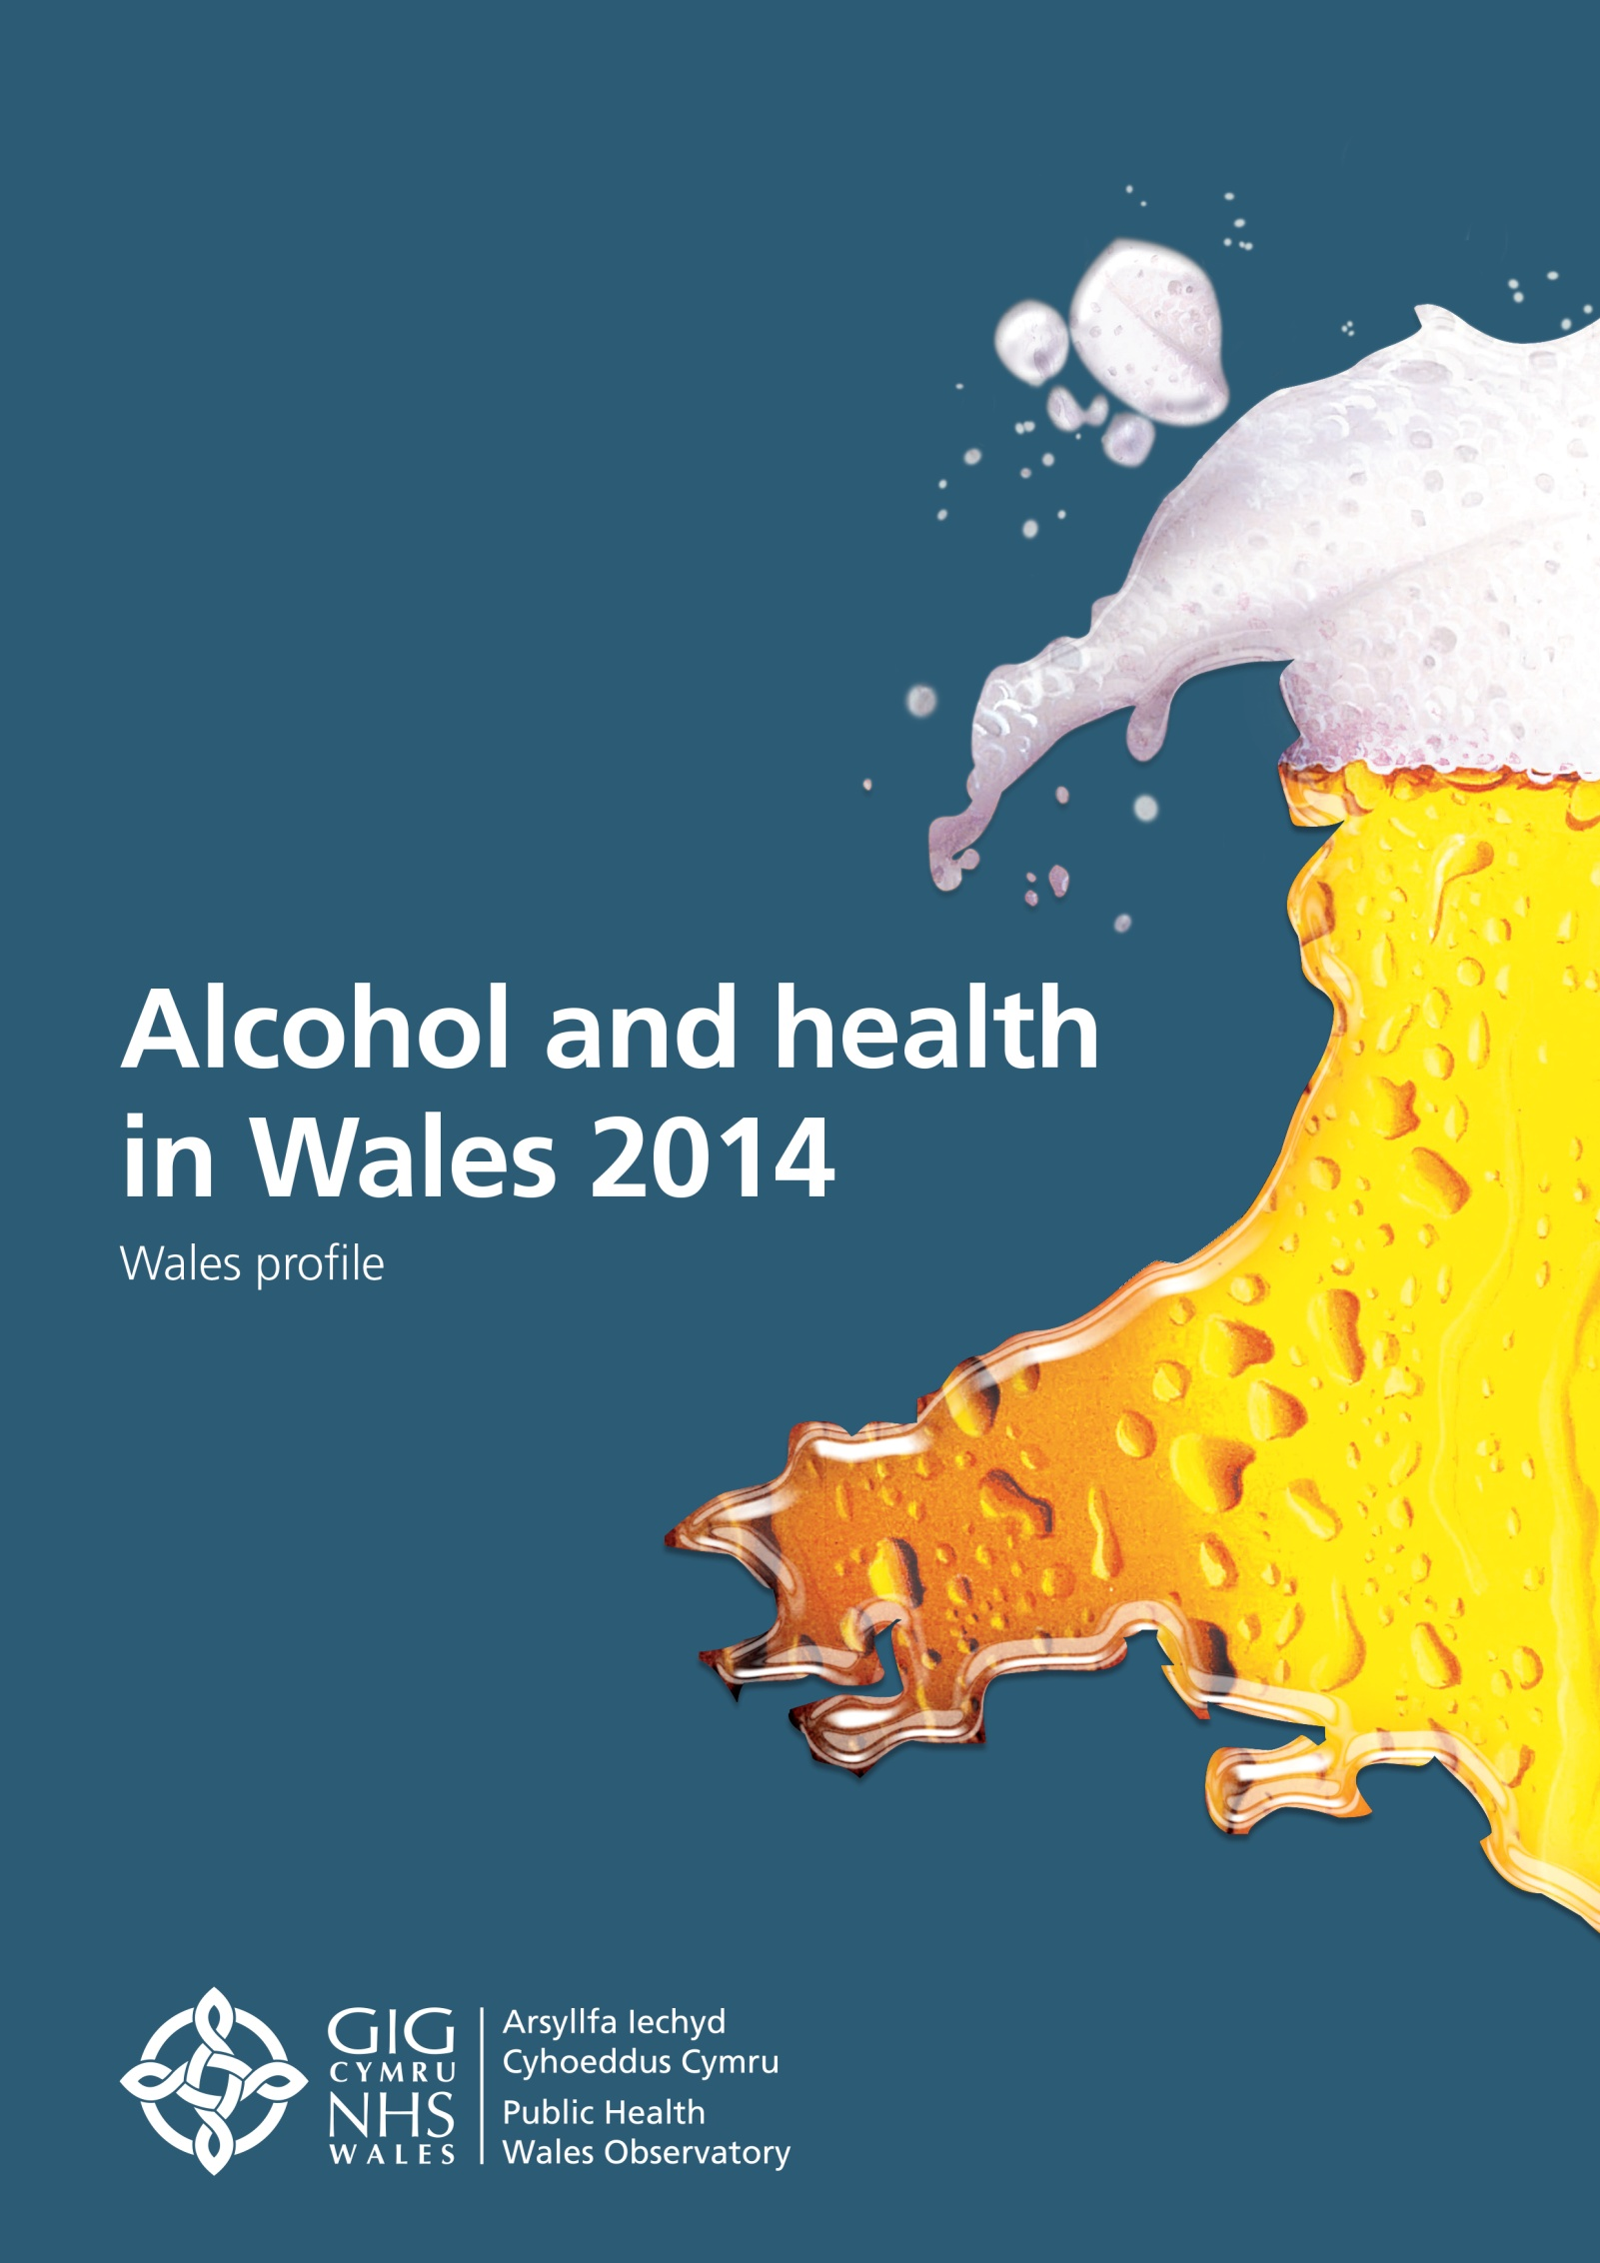

The publication Alcohol and health in Wales 2014 consists of:
- a Wales profile
- seven health board summary documents
- interactive data files with the main indicators
- a technical guide describing the methods, data sources and caveats
These are available on www.publichealthwalesobservatory.wales.nhs.uk/alcohol

Main project team (analysis and writing): Andrea Gartner, Ioan Francis, Dee Hickey, Rhian Hughes, Leon May

Additional analysis work: James Allen, Hugo Cosh, Arthur Duncan-Jones, Rhys Powell, Holly Walsh, Mari Ann Jones

Project manager: Andrea Gartner

Project director: Nathan Lester

Acknowledgements:
Thanks to the following people for their help with this publication: Professor Mark Bellis, Helen Crowther, Dr Gareth Davies, Ruth Davies, Andrew Dring, Cath Roberts (WG), Isabel Puscas, Mark Robinson (PHE), Sacha Wyke (PHE)

Contact:

Public Health Wales Observatory
14 Cathedral Road
Cardiff CF11 9LJ

Email: publichealthwalesobservatory@wales.nhs.uk
Website: www.publichealthwalesobservatory.wales.nhs.uk

© 2014 Public Health Wales NHS Trust

All tables, charts and maps were produced by the Public Health Wales Observatory and the data sources are shown under each graphic. Material contained in this profile may be reproduced without prior permission provided it is done so accurately and is not used in a misleading context. Acknowledgement to Public Health Wales NHS Trust to be stated. Typographical copyright lies with Public Health Wales NHS Trust.

Table of contents

Figures & Tables 2
Key Messages 5
1 Introduction 6
2 Definition of units and drinking patterns 7
3 Patterns of drinking 9
3.1 Drinking in children and young people 9
3.2 Consumption in adults in Wales 10
3.2.1 Frequency of alcohol consumption in Wales 11
3.2.2 Alcohol consumption trend in Wales 11
3.2.3 Abstainers 12
3.2.4 Drinking patterns by age group and over time 13
3.2.5 Geographical variation in very heavy drinking 16
3.3 Drinking patterns and trends in Great Britain 18
3.4 Comparison of survey results and sales data 18
3.5 International comparison of consumption 20
4 Hospital admissions 21
4.1 The scale and breakdown by condition 22
4.2 Hospital admission trends over time 24
4.3 Geographical variation in hospital admissions 26
4.4 Comparison to England and English regions 28
5 Mortality 32
5.1 Alcohol-specific and alcohol-attributable mortality 32
5.2 Chronic liver disease and cirrhosis 34
5.3 Months of life lost 35
5.4 Geographical variation in mortality 37
5.5 Comparison to England and English regions 38
6 Socio-economic patterns 41
7 References 47

Figures & Tables

Table 1 | Number of units in common alcoholic drinks | 7
Table 2 | Overview of definitions used | 8
Figure 1 | Percentage of respondents who reported drinking alcohol at least once a week, boys and girls aged 11-16, 2009/10 | 10
Figure 2 | Reported average frequency of drinking alcohol, percentages, males and females aged 16+, Wales, 2012 | 11
Figure 3 | Percentage of adults who reported drinking on the heaviest day in the past week, age-standardised percentage, males and females aged 16+, Wales, 2008 -2013 | 12
Figure 4 | Percentage of adults who reported abstaining from alcohol, males and females aged 16+, Wales, 2008-09 and 2011-12 | 13
Figure 5 | Percentage of adults who reported drinking above guidelines, males and females aged 16+, Wales, 2008-09 and 2011-12 | 14
Figure 6 | Percentage of adults who reported heavy (binge) drinking, males and females aged 16+, Wales, 2008-09 and 2011-12 | 15
Figure 7 | Percentage of adults who reported very heavy drinking, males and females aged 16+, Wales, 2008-09 and 2011-12 | 15
Figure 8 | Percentage of adults reporting very heavy drinking (males over 12 units, females over 9 units) on the heaviest drinking day in the past week, age-standardised percentage, persons, Wales health boards, 2011-2012 | 16
Figure 9 | Percentage of adults reporting very heavy drinking (males, over 12 units, females over 9 units) on the heaviest drinking day in the past week, Wales, 2008-12 | 17
Figure 10 | Percentage of adults who reported drinking alcohol on the heaviest drinking day in the past week, persons aged 16+, Great Britain, 2012 | 18
Figure 11 | Comparison of sales and survey consumption data, weekly alcohol units per person, 1996-2012 | 19
Figure 12 | International alcohol consumption for selected countries, litres of pure alcohol per person aged 15+, 2010 | 20
Table 3 | Overview of definitions for person-based hospital admission indicators | 21
Figure 13 | Alcohol-specific hospital admissions by condition, 2012/13 | 22
Figure 14 | Alcohol-attributable hospital admissions (narrow) by condition, 2012/13 | 23
Figure 15 | Alcohol-attributable hospital admissions (broad) by condition, 2012/13 | 24
Figure 16 | Hospital admissions (person based), European age-standardised rate (EASR) per 100,000, males and females, all ages, Wales, financial years 2003/04-2012/13 | 25
Figure 17 | Alcohol-specific hospital admissions, 3-year rolling crude rate per 100,000, males and females aged under 18, Wales, financial years 2003/04-2012/13 | 26
Figure 18 | Alcohol-specific hospital admissions (person-based), European age-standardised rate per 100,000, males, all ages, Wales health boards, financial year 2012/13 | 27
Figure 19 | Alcohol-specific hospital admissions (person-based), European age-standardised rate per 100,000, females, all ages, Wales health boards, financial year 2012/13 | 27
Figure 20 | Alcohol-specific hospital admissions (person-based), persons, all ages, Wales, 2010/11-2012/13 | 28
Figure 21 | Alcohol-specific hospital admissions, European age-standardised rate (EASR) per 100,000, all ages, Wales, England & English regions, financial year 2012/13 | 29
Figure 22 | Alcohol-specific hospital admissions, 3-year rolling crude rate per 100,000, persons aged under 18, Wales & England, financial years 2003/04-2012/13 | 30
Figure 23 | Alcohol-attributable hospital admissions (person-based narrow), European age standardised rate (EASR) per 100,000, all ages, Wales, England & English regions, financial year 2012/13 | 30
Figure 24 | Alcohol-attributable hospital admissions (person-based, broad), European age-standardised rate (EASR) per 100,000, all age, Wales, England and English regions, financial year 2012/13 | 31
Table 4 | Overview of definitions for mortality indicators | 32
Figure 25 | Alcohol-specific and alcohol-attributable mortality by condition, 2010-12 | 33
Figure 26 | Mortality, European age-standardised rate (EASR) per 100,000, males and females, all ages, Wales, 2003-05 to 2010-12 | 34
Figure 27 | Mortality from chronic liver disease and cirrhosis, European age-standardised rate (EASR) per 100,000, males and females, all ages, Wales, 2003-05 to 2010-12 | 35
Figure 28 | Months of life lost due to alcohol, males aged under 75, Wales health boards, 2010-2012 | 36
Figure 29 | Months of life lost due to alcohol, females aged under 75, Wales health boards, 2010-2012 | 36
Figure 30 | Alcohol-specific mortality, European age-standardised rate per 100,000, males, all ages, Wales health boards, 2010-2012 | 37
Figure 31 | Alcohol-specific mortality, European age-standardised rate per 100,000, females, all ages, Wales health boards, 2010-2012 | 37
Figure 32 | Alcohol-specific mortality, persons, all ages, Wales, 2003-12 | 38
Figure 33 | Alcohol-specific mortality, European age-standardised rate (EASR) per 100,000, all ages, Wales, England & English regions, 2010-2012 | 39
Figure 34 | Alcohol-attributable mortality, European age-standardised rate (EASR) per 100,000, all ages, Wales, England & English regions, 2012 | 40
Figure 35 | Self-reported alcohol consumption, age-standardised percentage by deprivation fifth, males aged 16+, Wales, 2011-12 | 42
Figure 36 | Self-reported alcohol consumption, age-standardised percentage by deprivation fifth, females aged 16+, Wales, 2011-12 | 42
Figure 37 | Mortality by deprivation fifth, European age-standardised rate (EASR) per 100,000*, all ages, Wales, 2003-05 to 2010-12 | 44
Figure 38 | Hospital admissions by deprivation fifth (person-based), European age-standardised rate (EASR) per 100,000, all ages, Wales, financial years 2003/04-2012/13 | 46
Foreword
Every week in Wales alcohol results in 29 deaths; around 1 in 20 of all deaths. These are not just bar brawls and overdoses resulting from binge drinking. In fact, most result from long-term drinking and its role in increasing risks of diseases such as cancer and cardiovascular disease. Tragically, many of those affected by alcohol are unaware of how it is harming their health until the disease process is well established.
The impact of alcohol on health also creates enormous pressures on our health systems. Every week our hospitals handle as many as 1,000 admissions related to alcohol, increasing strains on already stretched services. Such admissions are only the tip of an iceberg which includes many more presentations at emergency departments, ambulance requests and GP appointments all resulting from alcohol. The cost of alcohol to Wales extends even further through alcohol related crime, domestic violence, abuse and neglect where individuals’ well-being, property and sometimes families are harmed through the misuse of alcohol by others. Alcohol related long-term disability and lost productivity at work mean that it is not just individuals but also the economy that suffers from an unhealthy relationship with alcohol.
Our problems with alcohol in Wales must be tackled early in life. A greater proportion of children drink alcohol in Wales than in England, Scotland or the Republic of Ireland. The normalisation of drinking at a young age, particularly when associated with binge drinking, is especially harmful and is linked with poor educational performance, sexual health problems in early life and sets the pattern for harmful drinking behaviour in adulthood. Alcohol also hurts the poorest the most. While this report shows that no parts of Wales are untouched by alcohol, its impact is greatest in our most deprived communities which suffer substantially higher levels of both alcohol related disease and deaths.

We can change our relationship with alcohol. The Welsh Government is taking forward a Minimum Unit Price for alcohol; a targeted measure intended to reduce alcohol consumption in the heaviest drinkers who favour very cheap alcohol but leave the moderate drinker with little or no changes to what they pay for their drinks. Such measures have successfully improved health elsewhere and can do the same in Wales. However, we also need to empower individuals in Wales to make the right choices about their own drinking. Too many drinkers fail to recognise how even moderate drinking can increase their risks of developing diseases such as cancer. Public health professionals must rise to the challenge of informing the public about these risks in an environment dominated by advertising intent on increasing consumption of their products. Our experience with tobacco suggests that sustained and population wide messages about harms were only possible once legislation stipulated prominent health information on all advertisements and products. The risks related to alcohol use are now clear - what is needed is the policy to allow them to be communicated at scale to the public.
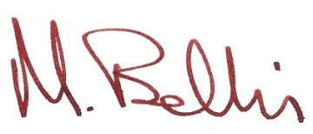
The Welsh Government’s 10 year substance misuse strategy, Working Together to Reduce Harm (2008-18), is clear that a multi-pronged approach involving individuals, the health service, the alcohol industry and government is required if we are to make significant progress in tackling this public health challenge. I congratulate my colleagues at the Public Health Wales Observatory for producing this comprehensive report which sets out the scale of the challenges we face if we are to prevent the harms related to alcohol consumption across Wales. It provides a clear indication that while we are making progress much more is still to be done if we want to reduce the avoidable harms that alcohol causes to families, business and communities across Wales.
Professor Mark Bellis
Director of Policy,
Research and Development
Public Health Wales

Key Messages

- Alcohol remains a major cause of death and illness in Wales. Around 1,500 deaths in Wales are attributable to alcohol each year (4.9% of all deaths).
- Drinking in children and young people remains a concern with 17% of males and 14% of females aged 11-16 in Wales drinking alcohol at least once a week. This is higher than in Scotland, Ireland, England and the survey average.
- Adult consumption has fallen slightly in Wales since 2008 for all three measures: drinking above guidelines, heavy (binge) drinking and very heavy drinking. This mirrors UK sales data which has fallen since its peak in 2004.
- Adults under 45 now drink less. Drinking above guidelines, heavy and very heavy drinking have decreased in adults aged under 45, particularly in males and the youngest females, and increased or stayed the same for adults aged 45 and over. Whilst a reduction in average drinking is good news, it is not uniform across the age groups and masks persistent or increased drinking in over 45 year olds.
- More young males aged 16-24 and more older females aged 75+ have abstained from alcohol in the past year, whilst the percentage in the other age groups has largely remained the same.
- The comparison with UK alcohol sales data suggests that surveys including the Welsh Health Survey underestimate alcohol consumption, and may still only represent 60% of the alcohol sold.
- The hospital admission rate in children and young people under 18 for alcohol-specific conditions has been decreasing steadily for several years, but around 410 young people were still admitted per year in the most recent period.
- The rate of individuals admitted to hospital for alcohol-specific conditions has remained static since 2006/07. The rate of alcohol-attributable admissions (narrow) has decreased slowly since 2006/07, but in contrast, the rate for the broad measure has increased steadily over time.
- Both the alcohol-specific hospital admission rates and alcohol-attributable admission rates are lower in Wales than in England for males, but more similar for females.
- The months of life lost in Wales with 13.5 months for males and 6.5 months for females was higher than in England with 11.5 months for males and 5.4 months for females.
- There were around 250 alcohol-specific deaths in males and 140 in females per year in Wales, based on the period 2010-12, and alcoholic liver disease accounts for the majority of these. Mortality rates are higher in Wales than in England.
- Mortality and hospital admissions are strongly related to deprivation, where rates in the most deprived areas are much higher than in least deprived areas. In contrast self-reported heavy and very heavy drinking is very similar between the deprivation fifths.
- There is no sign of improvement in the gap in mortality between the most deprived and the least deprived areas over time.
- Inequalities in alcohol-specific and alcohol-attributable (narrow) hospital admissions have slightly narrowed over time, but slightly widened for the alcohol-attributable (broad) admissions.

Introduction

Alcohol is deeply engrained in the culture of Wales, the UK and many other countries. Many people enjoy alcoholic drinks in moderation but alcohol use can lead to significant harm to the individual, their families and society. The harmful use of alcohol ranks among the top five risk factors for disease, disability and death throughout the world. Alcohol is a causal factor in more than 200 disease and injury conditions and accounts for an estimated 5.9% of all deaths worldwide¹. Alcohol use and its consequences remain a major public challenge in Wales, the UK and elsewhere.
The Welsh Government’s substance misuse strategy Working together to reduce harm was published in 2008 and in its 10 year plan sets out a national programme for tackling and reducing the harms associated with alcohol, drugs and other substances². The Welsh Government publishes annual reports on progress made to implement the strategy² and data from our publication has been provided for the forthcoming 2014 annual update.
This new publication provides the latest update to our report A profile of alcohol and health in Wales published five years ago³. Public Health England have recently published revised methods for mortality and hospital admission indicators⁴ following a review of alcohol-attributable fractions⁵ for each condition linked to alcohol. We have implemented these methods using Wales data, providing a comprehensive and extended set of indicators for Wales, allowing a comparison to England.
This Wales report provides further analysis with interpretation on alcohol consumption patterns, hospital admissions, mortality and socio-economic inequalities. The publication contains an extensive local component to support local action with seven health board summary documents, each with data provided at the lowest geographical level possible. The main indicator data is published in interactive data files and details of definitions, methods and caveats as well as guidance on interpretation can be found in the technical guide.

Definition of units and drinking patterns

Alcohol units
In the UK alcoholic drinks are measured in units where one unit corresponds to approximately 8 grams (g) or 10 millilitres (ml) of pure alcohol. The number of units in a drink depends on the size of the drink and its alcohol strength (Table 1).
The number of units in a drink is calculated by multiplying the amount in millilitres (ml) by its strength (Alcohol by Volume, ABV which is measured as a percentage) and dividing the result by 1,000. For example, to work out the number of units in a pint (568ml) of strong lager (ABV 5.2%):
5.2 (%) x 568 (ml) ÷ 1,000 = 2.95 units
Further information and a unit calculator can be found on the NHS choices website on alcohol units⁶.

Table 1 Number of units in common alcoholic drinks
Drink (and unit strength (ABV)) | Quantity | Units
Small glass red/white/rosé wine (12%) | 125 ml | 1.5 units
Standard glass red/white/rosé wine (12%) | 175 ml | 2.1 units
Large glass red/white/rosé wine (12%) | 250 ml | 3 units
Pint of lower-strength lager/beer/cider (3.6%) | Pint (568 ml) | 2 units
Pint of higher-strength lager/beer/cider (5.2%) | Pint (568 ml) | 3 units
Bottle of lager/beer/cider (5%) | 330 ml | 1.7 units
Can of lager/beer/cider (4.5%) | 440 ml | 2 units
Alco pop (5.5%) | 275 ml | 1.5 units
Single small shot of spirits (Gin, rum, vodka, whisky, tequila, sambuca) (40%) | 25 ml | 1 unit
Source: NHS Live Well website⁶
Drinking guidelines
Current NHS guidelines state that men should not regularly drink more than 3 to 4 units per day and women not more than 2 to 3 units per day⁶. ‘Regularly’ is defined as drinking this amount every day or most days of the week. It also recommends taking a break from alcohol for 48 hours after a heavy drinking session⁶.

Data on drinking patterns comes from surveys which tend to collect information on the amount drunk on the heaviest drinking day in the past week rather than the usual consumption. This may be very different and so has implications for the interpretation of survey data.
Drinking above guidelines
Drinking above guidelines from surveys is usually measured as men drinking more than 4 units and women drinking more than 3 units on their heaviest drinking day in the previous week.
Heavy (binge) drinking
The term ‘binge drinking’ usually refers to drinking lots of alcohol in a short period of time or drinking to get drunk⁶. In surveys, it is usually measured as drinking more than twice the daily guidelines, which for men is more than 8 units and women more than 6 units on their heaviest drinking day in the previous week. In Welsh Health Survey (WHS) publications this measure has been referred to as either ‘heavy drinking’ or ‘binge drinking’. To avoid any confusion with the new ‘very heavy drinking’ category, both terms ‘heavy (binge) drinking’ are used throughout this report for Wales or Great Britain data (see Table 2).
Very heavy drinking
The new measure ‘very heavy drinking’ has no formal definition, but has recently been used in Office for National Statistics (ONS) publications and referred to as men drinking more than 12 units and women drinking more than 9 units on their heaviest drinking day in the previous week. This definition, listed in Table 2, is used throughout this report where survey results are reported for Wales and Great Britain.
Abstainers
Abstainers in this report refer to WHS respondents who report not having drunk alcohol in the past 12 months (Table 2). It includes those abstainers who have not consumed alcohol during this fixed period of time regardless of whether they have drunk alcohol before this 12 month period.

Table 2 Overview of definitions used
Category | Men | Women
Abstainer | Not drinking at all in the previous 12 months | Not drinking at all in the previous 12 months
Drinking above guidelines | Drinking more than 3-4 units on the heaviest drinking day in the previous week | Drinking more than 2-3 units on the heaviest drinking day in the previous week
Heavy (binge) drinking | Drinking more than 8 units on the heaviest drinking day in the previous week | Drinking more than 6 units on the heaviest drinking day in the previous week
Very heavy drinking | Drinking more than 12 units on the heaviest drinking day in the previous week | Drinking more than 9 units on the heaviest drinking day in the previous week

Patterns of drinking

Drinking patterns in this report come from surveys which ask a sample of the population about their drinking habits. These results are then used as an estimate of the drinking patterns of the population. The main source is the annual Welsh Health Survey, which asks around 15,000 residents in Wales about their health and lifestyle choices.
Another survey is the Opinions and Lifestyle Survey (OPN), run by the ONS (formerly called the General Household Survey), which covers adults in England, Scotland and Wales, and allows comparisons across Great Britain.

Further information on these surveys can be found in the technical guide that accompanies this publication (see inside cover). Additionally, socio-economic patterns of alcohol consumption are discussed in Section 6.

Drinking in children and young people

Drinking alcohol can damage a child’s health. It is recommended that children do not drink alcohol, however if children do drink alcohol, they should not do so until they are at least 15 years old⁷.

…Drinking in children and young people remains a concern with 17% of males and 14% of females aged 11-16 in Wales drinking alcohol at least once a week. This is higher than in Scotland, Ireland and England and the survey average ...”

Drinking in children and young people remains of concern with 17% of males and 14% of females aged 11-16 in Wales drinking alcohol at least once a week in 2009/10, the most recent data available (Figure 1). The Health Behaviour in School-aged Children survey (HBSC) is conducted in 40 countries, including Wales, England and Scotland. The percentages of young people drinking alcohol at least once a week are higher in Wales than in Scotland, Ireland, England and the survey average for both males and females. The percentage in Wales is twice that of Ireland. At the health board level, the higher percentages of 11-16 year olds are in Cwm Taf UHB (males and females both 18%) and Aneurin Bevan UHB (males 21% and females 20%). The largest difference between males and females is in Powys with twice the percentage of males (20%) reporting drinking than females (10%), although this may be the result of bias associated with small numbers of survey respondents.

Figure 1

Consumption in adults in Wales

Survey results are essential to identify characteristics of those drinking, and patterns are reported by sex and age-group. WHS respondents were asked questions on their drinking habits including how often they drank, if they are a non-drinker and, if they are a drinker, how much of each type of alcohol they drank on the heaviest day in the last week. The questions changed from 2008 onwards and the data is not comparable to earlier results. Trends or comparisons over time are shown wherever possible.

Please note that surveys are known to underestimate drinking in the population, as shown in comparisons to alcohol sales data, see section 3.4. They are, however, useful measures for comparing areas or groups of people.

Frequency of alcohol consumption in Wales
Males drink more frequently than females. Around 46% of males reported either drinking once or twice a week or 3 to 4 days a week on average for the past 12 months compared to 35% for females. The percentage of adults who have not drunk alcohol in the past 12 months is higher for females than males (Figure 2), also measured as abstainers (section 3.2.3).
Figure 2

…Adult consumption has fallen slightly across Wales since 2008 for all three measures. This mirrors UK sales data which has fallen since its peak in 2004 ...”

Alcohol consumption trend in Wales
More males than females report drinking above guidelines, heavy (binge) drinking or very heavy drinking (see Table 2 for definitions). The percentages of adults have slightly decreased over time for all three measures although the differences between the earliest and most recent period are unlikely to be statistically significant (Figure 3).

Figure 3

Abstainers

… More young males aged 16-24 and more older females aged 75+ have abstained from alcohol in the past year, whilst percentage in the other groups has largely remained the same ... ”

The percentage of adults who report not having drunk alcohol in the past 12 months differs between age groups (Figure 4). The percentage of abstainers is generally higher in females compared to males and is lowest in the 25-64 age range. The percentages have largely remained the same or increased slightly across the age groups between 2008-09 and 2011-12. The greatest increases are in females aged 75+ years, and males aged 16-24 years where the percentage has increased from 11% in 2008-09 to 14% in 2011-12 (Figure 4).

Figure 4

Drinking patterns by age group and over time

… Adults under 45 now drink less. Drinking above guidelines, heavy and very heavy drinking have decreased in adults aged under 45, particularly in males and the youngest females, and increased or stayed the same for adults aged 45 or over ... ”

Drinking patterns and the change over time vary by age group and measure (Figure 5, 6, 7).

Drinking above guidelines

Drinking above guidelines has decreased substantially in the younger age groups (16-24, 25-34 and 35-44), most notably in males (Figure 5), however, there was no change for females aged 25-34. For example, the percentage in young males aged 16-24 has fallen from 51% to 42% and in young females from 46% to 39%. In those aged 45 and above the percentages have either remained the same or have slightly increased between the time periods, with the 45-54 year old age group having the highest percentages (Figure 5).

Figure 5

Heavy (binge) drinking

The pattern of change in heavy (binge) drinking is similar to that of drinking above guidelines. Percentages have significantly decreased in males aged under 45 and females aged 16-24, and increased or stayed the same for those aged 45 and over (Figure 6). Most notably, the percentage in females aged 55-64 has increased from 14% to 18% and in males aged 65-74 from 18% to 21%.
Very heavy drinking

The decrease in very heavy drinking for males aged under 45 and females aged 16-24 is very similar to heavy (binge) drinking. Very heavy drinking has slightly increased or stayed the same for males and females aged 45 and over (Figure 7). Males aged 25-34 and females aged 16-24 still report the highest percentages but the differences between the age groups are becoming smaller. Whilst the reduction in average drinking in Wales is good news, it is not uniform across the age groups and masks persistent or increased drinking in males and females over 45.

Figure 6

Figure 7

Geographical variation in very heavy drinking
The percentage of adults aged 16 and over who report very heavy drinking varies between health boards. The percentage for persons in Powys tHB (12.6%) and Hywel Dda UHB (13.3%) is statistically significantly lower than Wales, whilst Cwm Taf UHB (17.6%) is statistically significantly higher (Figure 8).
Figure 8

The percentages vary considerably at sub-local authority level (upper super output areas) ranging from 8.4 to 21.8 (see map) (Figure 9). The map for each health board separately is included in the Health Board summary document (see inside cover). The highest percentages of adults reporting very heavy drinking are in USOAs within Rhondda Cynon Taf, Caerphilly, Bridgend and Blaenau Gwent.

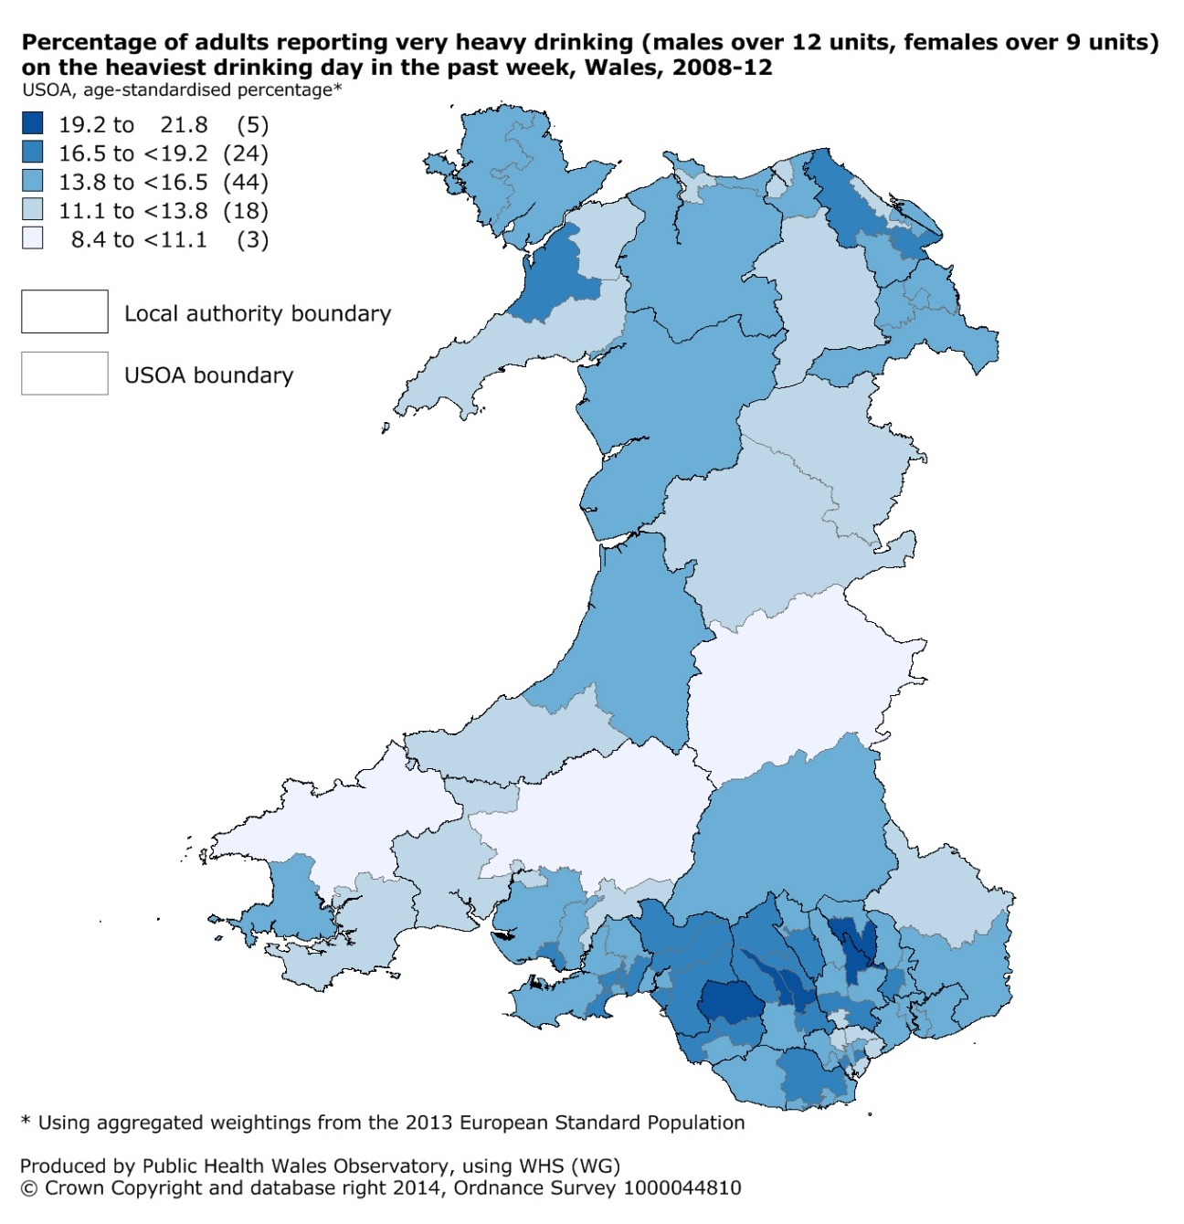
Figure 9

Drinking patterns and trends in Great Britain
The percentages of drinking for the three definitions in Wales are higher than in England, but lower than in Scotland (Figure 10). According to the Opinions and Lifestyle Survey (OPN), 27% of adults in Wales reported heavy (binge) drinking on the heaviest drinking day in the past week, higher than in England with 25% and lower than in Scotland with 33%. In Wales, 16% reported very heavy drinking compared to 13% in England and 19% in Scotland.
The data can differ between surveys. The OPN reports that 55% of adults drink above guidelines in Wales whereas the WHS reports 42% for 2012. This is likely to be due to a relatively small sample size for Wales in the OPN (unweighted sample of 370 adults) and a different survey design. The WHS percentages of those reporting heavy (binge) drinking (26%) or very heavy drinking (14%) are much closer.
Figure 10

Comparison of survey results and sales data

… The comparison with UK alcohol sales data suggests that surveys including the Welsh Health Survey underestimate alcohol consumption, and may still only represent 60% of the alcohol sold ... ”

The average sale of alcohol per week per person in the UK has fallen from 22.3 units of alcohol at its peak in 2004 to 18.6 units in 2012 (Figure 11). Sales data are derived from HM Revenue and Customs duty charged on alcohol produced or processed in the UK, or brought into the UK for consumption but not necessarily consumed. Sales figures are not available for Wales separately as it is not possible to identify where in the UK the product was manufactured or released for consumption.
Survey data is known to underestimate consumption in the population and only capture around 60% of the true figures^{8,9}. In 2010, the average weekly alcohol consumption per adult in Great Britain (General Lifestyle Survey (GLF) survey data) was 11.5 units, much lower than UK sales data of 19.6 units in 2010.
The estimated weekly consumption for adults in Wales from the WHS was 10.7 units in 2007 showing a similar gap to sales data (21.5 units). More recent figures for Wales cannot be produced robustly because of question changes in 2008. Additionally, the estimates since 2008 are higher as they take into account the increasing strength of drinks. The WHS sales data gap is therefore now expected to be more similar to the GLF.
The GLF survey data does not include Northern Ireland and includes persons aged 16+ whereas the sales figures are for persons aged 15+ and it is unclear how accurate sales figures are as an estimate of consumption. People tend to understate the amount they drink, partly unintentionally, as they genuinely forget some of the drinking or because it is difficult to estimate units due to different strengths and serving sizes⁸. Some may deliberately understate the amount drunk, because they feel that it is not socially acceptable, and very heavy drinkers are underrepresented in surveys⁸. Drinking reported for the previous week may also not represent usual drinking patterns or include special events. While there may be underestimation in the survey results, survey data is still essential to identify characteristics of those drinking, for example comparisons between age groups, males and females, or frequency of drinking which sales data cannot provide.

Figure 11

International comparison of consumption
Drinking patterns can vary considerably from country to country. The recent report by the World Health Organisation¹ shows that globally people aged 15 and over drink on average 6.2 litres of pure alcohol per year. In the UK the consumption per person aged 15 and over was an estimated 11.6 litres of pure alcohol in 2010¹ (Figure 12). This was compared to other selected Western countries and is lower in the UK than in Australia or France with 12.2 litres, but higher than the Netherlands with 9.9 litres or Italy with 6.7 litres of alcohol (Figure 12). The sources for the data shown differ between countries but mostly use official data sources such as tax or sales rather than survey data¹. These have been adjusted to exclude tourists and also include an estimate of unrecorded consumption.

Figure 12

Hospital admissions
Hospital admission relating to alcohol is an important indicator of morbidity and the effect of alcohol misuse on the health of the population. In this report we focus on indicators measuring individuals admitted to hospital at least once a year (person-based) for three different definitions, following revised methods used in England⁵. These are very briefly explained in table 3, but for further details please see the technical guide.

Table 3 Overview of definitions for person-based hospital admission indicators
Admissions indicator | Brief definition
Alcohol-specific hospital admissions | Measures individuals admitted with alcohol-specific (wholly attributable) conditions, either in the primary diagnosis (main reason) or in secondary diagnoses. This list of conditions has been revised.
Alcohol-attributable hospital admissions (person-based, narrow) | Measures individuals admitted with alcohol-attributable conditions (either wholly or partly attributable to alcohol) at least once a year, either as the primary diagnosis (main reason) or an external cause (e.g. injuries) as a secondary diagnosis, whichever is most linked to alcohol (highest fraction). This is a new measure.
Alcohol-attributable hospital admissions (person-based, broad) | Measures individuals admitted with alcohol-attributable conditions (either wholly or in part attributable to alcohol) at least once a year, either as the primary diagnosis (main reason) or a secondary diagnosis, whichever is most linked to alcohol (highest fraction). This measure has been revised.
The alcohol-attributable admissions use attributable fractions for each condition, which is based on evidence in academic literature for a relationship between alcohol and the condition well as the prevalence of drinking. We use the same fractions produced for England in our calculation of the indicator data and assumptions are made that these equally apply to Wales and, for example, each local authority in Wales. They are therefore considered estimates and need to be interpreted with care.
Episode-based alcohol-attributable indicators have also been produced and are published in interactive data files (see inside cover), but not included in this report. They measure admitting episodes where each individual could be counted more than once a year. These relate more to the burden on the health service whilst this report focusses on the effect of alcohol on the population and therefore on person-based analyses.
Socio-economic patterns in hospital admissions are examined in section 6. Further details on the indicators and methods are contained in the technical guide (see inside cover).

The scale and breakdown by condition
Alcohol-specific hospital admissions
Around 6,700 males and 3,500 females have been admitted to hospital with an alcohol-specific condition (Figure 13). Each individual is only counted once in this definition for one alcohol-specific condition (Figure 13) but this may not be the only alcohol-specific condition noted or the main reason for admission. Nevertheless, it gives an indication of the contribution of each condition to the measure. Over half of females and over two thirds of males had a diagnosis of mental and behavioural disorder, including for example acute intoxication. Just over 1 in 5 females had a diagnosis of ethanol poisoning, twice the proportion in males. This measure underestimates admissions due to alcohol as only those entirely down to alcohol are included.
Figure 13
Alcohol-attributable hospital admissions (narrow)
An estimated 8,100 males and 4,600 females were admitted to hospital with an alcohol-attributable condition using the narrow definition (Figure 14). This includes individuals with an alcohol-attributable condition as the main reason for admission (primary diagnosis) or an external cause (e.g. injury) as a secondary diagnosis. This measure may also understimate admissions due to alcohol as it is not considering all secondary diagnoses, but it is likely to be more comparable over time.
Around a third of these hospital admissions were for conditions that are wholly attributable to alcohol (32.1% in males and 38.7% in females) and the main reason (primary diagnosis) for admission. These therefore include some of the individuals in the other definition of alcohol-specific admissions but not all, as those with only an alcohol-specific secondary diagnosis are not included in this narrow definition. Almost a third of males and 1 in 5 females were admitted for unintentional injuries. Please note that cardiovascular disease accounted for 9.6% of narrow hospital admissions in males (8.5% of females).

Figure 14
Alcohol-attributable hospital admissions (broad)
An estimated 21,700 males and 12,300 females were admitted to hospital with an alcohol-attributable condition using the broad definition (Figure 15). This includes individuals with at least one diagnosis that relates to an alcohol-attributable condition, but not necessarily the main reason for attendance. It considers the admission with the condition with the strongest link to alcohol i.e. the largest fraction. Coding of secondary diagnoses may vary locally and so this measure may vary in its ability of picking up all individuals with an admission related to alcohol.
Almost half of the admissions had a diagnosis of cardiovascular disease, where a relatively high proportion are linked to alcohol and which is a common diagnosis. Any change to hospital admissions for cardiovascular disease with a link to alcohol is therefore strongly reflected in the pattern of alcohol-attributable hospital admissions using the broad definition. Please note that these groups only contain certain conditions that are linked to alcohol, for example, only some cardiovascular diseases. For a list of these please see the technical guide. Risk factors for cardiovascular disease are wide ranging, and any pattern in cardiovascular disease could be the result of risk factors other than alcohol consumption. For these reasons this measure needs to be interpreted with caution, particularly when considering a trend (see Section 4.2). Please also see the technical guide for further details. Just under a third of individuals were admitted with conditions that are wholly attributable to alcohol consumption. This measure contains all the individuals in the definition of alcohol-specific hospital admission.

Figure 15

Hospital admission trends over time
The rate of individuals admitted to hospital for alcohol-specific (wholly attributable) conditions increased during the early years of the period shown but has remained stable since 2006/07. In our previous publication A profile of alcohol and health in Wales³ we recommended that the alcohol-attributable trend (now called broad) should be considered alongside the alcohol-specific measure to ensure that a trend over time is not merely reflecting a change in trend in one of the attributable conditions, rather than the impact of alcohol in general over time. This is more complex with two alcohol-attributable definitions showing different trends. The rate of alcohol-attributable admissions (narrow) has slowly decreased since 2006/07. This is in contrast to the broad measure which has steadily increased over time (Figure 16).

… The rate of individuals admitted to hospital for alcohol specific -conditions has remained static since 2006/07, but in contrast the rate for the broad measure has increased steadily over time ... ”

The broad admission indicator is heavily influenced by patterns in cardiovascular disease linked to alcohol (Section 4.3) with half of the individuals counted with cardiovascular disease in either the primary or secondary diagnosis. Although not shown here, the trend in admissions with cardiovascular disease linked to alcohol has been rising over time and so this is reflected in the trend in the broad alcohol-attributable admissions. It may not, however, reflect the impact of alcohol on cardiovascular disease as there are many risk factors other than alcohol and treatment may change over time. Also, coding of secondary diagnosis may vary over time as well as between areas which needs to be taken into account when interpreting the broad alcohol-attributable admission measure. The narrow admissions measure is not affected in the same way and is therefore a more suitable measure for tracking trends over time instead of the broad admission indicator. It is still advisable, however, to consider the alcohol-specific trend alongside the narrow measure.
The rate in males is consistently higher than the female rate, for all measures.

Figure 16
Hospital admissions aged under 18

…The hospital admission rate in children and young people under 18 for alcohol- specific conditions has been decreasing steadily for several years, but around 410 young people are still admitted per year in the most recent period... ”

The rate for children and young people aged under 18 admitted for alcohol-specific (wholly attributable) conditions has statistically significantly decreased since the period 2005-07 in both males and females (Figure 17). This downward trend is good news, but around 410 young people were still admitted per year in the most recent period. People aged under 18 are the only group with a higher rate in females than in males. This rate in all young people under 18 in Wales is consistently higher than in England although the difference is slightly narrowing over time (Figure 22 in Section 4.4).

Figure 17

Geographical variation in hospital admissions
Alcohol-specific hospital admission rates vary locally, amongst health board areas and upper super output areas. The rate for males in Powys tHB and Hywel Dda UHB is statistically significantly lower than for Wales, and statistically significantly higher in Aneurin Bevan UHB and Cwm Taf UHB (Figure 18). The rates for females are statistically significantly lower in Powys tHB and in Cardiff and Vale UHB than for Wales, and statistically significantly higher in Betsi Cadwaladr UHB and Aneurin Bevan UHB (Figure 19). Other indicators, although not shown here, are included in the health board summary documents (see inside cover).

Figure 18

Figure 19

Rates for alcohol-specific hospital admissions vary considerably in smaller areas of Wales (upper super output areas) and range from 165 to 613, see map (Figure 20). A separate map for each health board is included in the health board summary document (see inside cover).
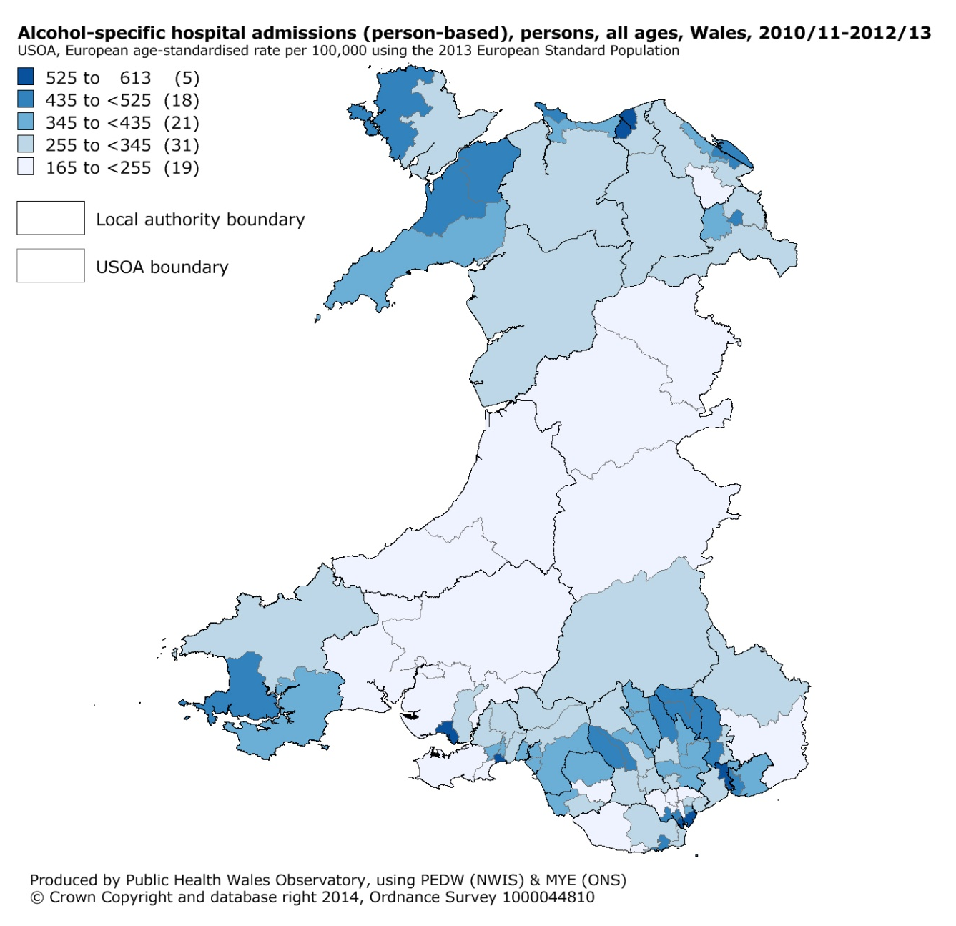
Figure 20

Comparison to England and English regions
Both the alcohol-specific hospital admission rates and alcohol-attributable admission rates for all ages in males are lower in Wales than in England but more similar for females (Figure 21, 23 and 24). However, rates amongst the English regions vary considerably.
Alcohol-specific admission rates range from 344 per 100,000 in the East of England to 740 in the North West for males (from 172 to 364 respectively for females). The range is narrower for Wales health board areas, where rates vary from 297 to 526 for males and 188 to 258 for females (Figure 18 and Figure 19 in Section 4.3).
The patterns are similar for alcohol-attributable admissions although the Wales rate for alcohol-attributable admissions (narrow) is only slightly lower than England. There are small differences in the method or data between the England and Wales rates. For example, English rates only consider patients in English hospitals, whereas the Wales rates include patients resident in Wales but treated in English hospitals. Also, there are some coding issues where around 2% of hospital spells in Wales in the most recent year do not have a diagnosis coded. It is not clear how this affects the person-based analysis but it is unlikely to affect the interpretation of the differences greatly. Please see the technical guide for further details of the methods.
In contrast to rates for all ages, rates in young people aged under 18 in Wales are consistently higher than in England (Figure 22), although all are decreasing. The differences between them have been narrowing but are still substantial in the most recent period of 2010-12 with a crude rate of 65 per 100,000 in Wales compared to 45 per 100,000 in England.

Figure 21
Figure 22

Figure 23
Figure 24

Mortality

Alcohol-specific and alcohol-attributable mortality
Mortality linked to alcohol can be measured using different definitions. In this report we show alcohol-specific mortality and alcohol-attributable mortality. These are very briefly explained in table 4, but for further details please see the technical guide.

Table 4 Overview of definitions for mortality indicators
Mortality indicator | Brief definition
Alcohol-specific mortality | Includes deaths with an underlying cause of death that is wholly attributable to alcohol e.g. alcoholic liver disease. Additional causes of death were added in the revision of methods.
Alcohol-attributable mortality | Includes deaths with an underlying cause of death that is either wholly or partly attributable to alcohol. Revised attributable fractions for each cause of death are applied in the calculation. This wider definition is an estimate based on fractions assuming they apply equally to Wales.
Public Health England have recently published revised methods for these⁴. Data using the revised method is not comparable to previously published data. Alcohol-specific mortality has been produced instead of alcohol-related mortality (ONS definition) in this updated report as it is easily comparable to England and English regions. Socio-economic inequalities in mortality are examined in Section 6.
Around 250 males and 140 females die from an alcohol-specific condition per year in Wales, based on the period 2010-12 (Figure 25). Alcoholic liver disease accounts for the majority of these deaths (82% for males, 86% for females) (Figure 25). Alcohol-specific mortality only includes deaths entirely caused by alcohol, which underestimates the impact of alcohol on mortality in the population.

Figure 25
Using the wider definition of alcohol-attributable mortality there were around four times as many deaths as for alcohol-specific mortality, with 990 male and 530 female deaths per year in Wales, based on the period 2010-12 (Figure 25). These avoidable deaths are a sizeable proportion of overall deaths in Wales accounting for 6.6% of all male deaths, and 3.3% of all female deaths.
Wholly attributable causes account for around one in four of these deaths (26%) in both males and females. Cancer accounts for 31% of the alcohol-attributable deaths in males and 38% for females shown in the purple colour on the chart. Cardiovascular disease (shown in darker blue) accounts for over 7% of male and 13% of female deaths.

Trends over time
Rates vary slightly over time (Figure 26). Alcohol-specific mortality rates for males were rising slowly with the peak in 2007-09. The rates have since declined but overall are still higher in the most recent period of 2010-12 compared to the earliest in 2003-05. The trend for females shows rates having risen slightly over time. Alcohol-attributable rates also vary a little over time with a slight decrease in recent years. The alcohol-attributable rates in 2010-12 are slightly lower than in 2003-05 but this small difference is not statistically significant. Mortality rates for males are around twice those for females (Figure 26).
Figure 26

Chronic liver disease and cirrhosis
Around 260 males and 170 females die from chronic liver disease in Wales per year (based on 2010-12). The majority of these, just over 200 males and 120 females, died from alcoholic liver disease. The remainder have a cause of death of chronic hepatitis (not elsewhere specified) or fibrosis and cirrhosis of the liver which in the large part of cases is due to alcohol but can also have other causes. There is only slight variation in rates over time and differences are not statistically significant (Figure 27).

Figure 27

Months of life lost
The months of life lost due to alcohol is an estimate of the increase in life expectancy at birth that would be expected if all alcohol-attributable deaths among persons aged under 75 years were prevented. It was produced using the English method and unfortunately does not include confidence intervals. This measure is related to alcohol-attributable mortality including the use of the same fractions, but includes only the alcohol-attributable deaths in those aged under 75. As with the alcohol-attributable mortality this indicator needs to be interpreted with care. For further details please see the technical guide.

…The months of life lost in Wales with 13.5 months for males and 6.5 months for females was higher than in England with 11.5 months for males and 5.4 months for females... ”

The number of months of life lost due to alcohol in Wales was 13.5 months for males and 6.5 months for females in 2010-12 (Figures 28 and 29). The months of life lost in Wales was higher than in England with 11.5 months for males and 5.4 months for females.
The months of life lost due to alcohol in males was lowest in Powys tHB and Hywel Dda UHB with nearly 12 months and highest in Cwm Taf UHB with just over 18 months (Figure 28). For females this ranged from around 6 months in Hywel Dda UHB and Cardiff and Vale UHB to just over 8 months in Cwm Taf UHB.

Figure 28

Figure 29

Geographical variation in mortality
Alcohol-specific mortality rates vary locally, amongst health boards and small areas. The rate for males in Powys tHB is statistically significantly lower than Wales with 11 per 100,000, and statistically significantly higher in Cardiff and Vale UHB and Cwm Taf UHB with around 22 per 100,000. The rate for females is statistically significantly higher than Wales in Cwm Taf UHB.
Figure 30

Figure 31

Rates for alcohol-specific mortality vary considerably at upper super output area level ranging from 5 to nearly 30 per 100,000, see map (Figure 32). A separate map for each health board is included in the health board summary document (see inside cover).
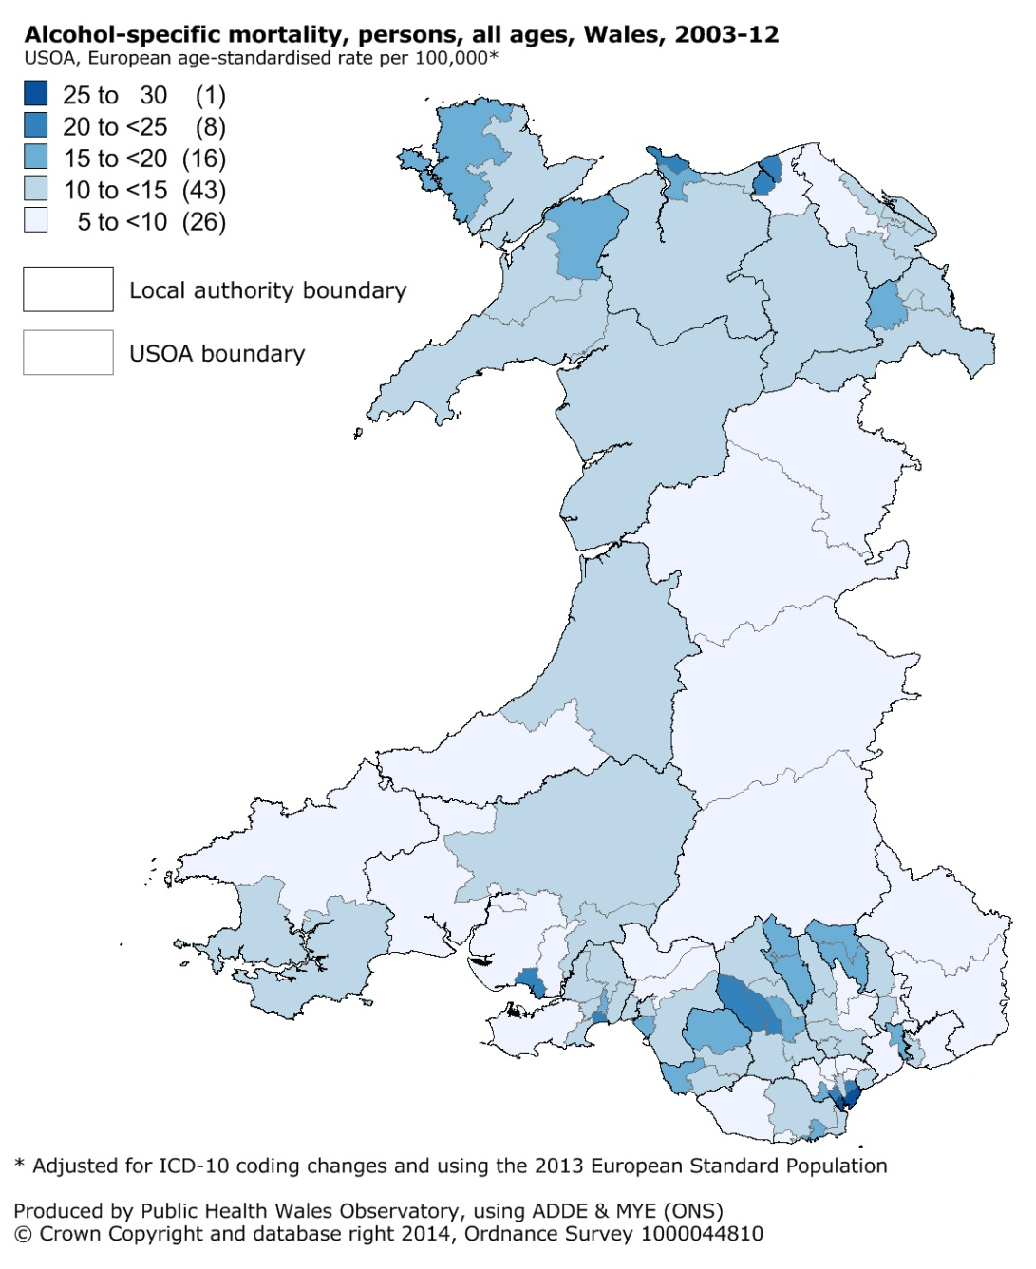
Figure 32

Comparison to England and English regions
Mortality rates for both definitions are higher in Wales than in England (Figures 33 and 34) but mortality rates amongst the English regions vary considerably. Alcohol-specific mortality rates range from 10.3 per 100,000 in the East of England to 20.2 in the North West for males (from 4.4 in London to 10.6 in the East of England for females). The range amongst English regions is similar for Wales health board areas, where rates vary from 11 to 22 for males and 7 to 13 for females (Figures 30 and 31). The Wales rate at 17.3 is most similar to the rate for the West Midlands at 17.7.
The patterns are similar for alcohol-attributable mortality and the Wales rate appears most similar to the North East of England. There are minor method differences between the England and Wales rates but these are unlikely to affect the interpretation of the differences much. Please see the technical guide for more details.
Figure 33
3

Figure 34

Socio-economic patterns
Alcohol is a source of socio-economic inequalities in health as shown in our previous publication on inequalities¹⁰. This section looks at some key alcohol indicators and their relationship to area deprivation in the absence of suitable individual level socio-economic data. We use the Welsh Index of Multiple Deprivation 2011 (WIMD) to identify ‘fifths’ of deprivation. The most deprived fifth contains the most deprived 20% of areas and the least deprived fifth the least deprived 20% of areas. As with all area-based deprivation measures, not everyone living in a deprived area is necessarily living in deprived circumstances and equally, some people living in an area classed as least deprived may experience deprivation.
Generally, we found little difference in alcohol consumption between the deprivation fifths for heavy (more than 8 units for males, 6 units for females) and very heavy drinking (more than 12 units for males, 9 units for females) (Figures 35 and 36). The exception is heavy drinking in females which is slightly higher in the least deprived areas (25%) compared to all other deprivation fifths (20%-21%), although this is unlikely to be statistically significant. For heavy drinking and very heavy drinking we therefore found no apparent relationship to deprivation.
There is an inverse relationship for drinking above guidelines (more than 4 units for males, 3 units for females) where the proportion is higher in the least deprived areas (52% in males) than in the most deprived areas (45% in males). This is slightly stronger in females with 44% in the least deprived areas compared to 32% in the most deprived.
A recent academic study using WHS data (2003/04-2007) found that deprivation acted differently on the risk of binge drinking between males and females at different age groups¹¹. The proportion of respondents drinking above guidelines showed the same inverse relationship as in our analysis shown in Figures 35 and 36. In contrast to our results, the study found that binge drinking increased with increasing deprivation¹¹. Our broad analysis looks at all WHS respondents aged 16 and over combined for 2011-2012 and so may mask different relationships for some age groups, but also covers newer WHS data after the question change and adjustment for strength of drinks from 2008 onwards. The deprivation measure may also have changed between the WIMD 2005 and the WIMD 2011. These patterns should therefore be interpreted with caution and further analysis would be needed to investigate the differing results.

Figure 35

Figure 36

The pattern in alcohol consumption is in stark contrast to outcomes in both mortality and hospital admissions which show a strong relationship to deprivation where rates in the most deprived areas are much higher than in least deprived areas.

…Mortality and hospital admissions are strongly related to deprivation. In contrast self-reported heavy and very heavy drinking is similar between the deprivation fifths ...”

This report focuses on the rate ratio, a measure of relative inequality, as it can be compared between causes and between males and females independent of scale. It is produced by dividing the rate for the most deprived areas by the rate in the least deprived areas. For comparisons over time the absolute difference between the rates was also considered to ensure consistent interpretation of patterns.
Alcohol-specific indicators are more strongly related to deprivation than alcohol-attributable indicators. Alcohol-specific mortality and hospital admissions have the largest rate ratios, with the rates in the most deprived areas for males between 3.3 and 4.6 times higher than the rates in the least deprived areas (between 2.5 and 3.1 times higher for females) (Figures 37 and 38).
The rate ratios were lower for alcohol-attributable mortality where the rates for males in the most deprived areas were around twice those in least deprived areas (around 1.7 times higher for females) (Figure 37). The rate ratio is also higher for males than for females, and mortality for both definitions is more strongly related to deprivation for males than females.
Inequalities in mortality have not changed significantly since 2003/05. Although there is variation in rates over time, mortality rates have increased overall with only a slight drop in rates for males in the most recent years (Figure 37). They have increased more in the most deprived compared to the least deprived. The gap has therefore slightly widened, although due to relatively small numbers of deaths and large confidence intervals this difference is not statistically significant. Changes in the gap for alcohol-attributable mortality are much smaller and similarly not statistically significant.

Figure 37
Interpreting inequalities trends in hospital admissions is more complex due to the nature of the three different definitions used. Please see Section 4.1 for a discussion on the definitions or the technical guide for further details. Our analysis covers the financial years 2003/04 to 2012/13.

… There is no sign of improvement in the gap in mortality between the most deprived and the least deprived areas over time... ”

The rates of individuals being admitted to hospital with alcohol-specific conditions varies over time, but rates have overall been rising in both the most and the least deprived areas (Figure 38). The rates had increased relatively more in the most deprived in the first few years and so the absolute rate difference had been rising. This difference narrowed again in the most recent years to a similar level to the first year. The rate ratio, the relative measure of inequalities, also fluctuated over time, but has dropped in the more recent years. The rate in the most deprived areas for males has dropped from 4.4 times in the first period to 3.4 times the rate in the least deprived in the most recent period (3.4 to 2.8 in females). Relative inequalities have therefore narrowed over time, although due to large confidence intervals this difference is not statistically significant in females. This suggests that a decrease in the most deprived areas in recent years may have contributed to a slight narrowing of inequalities in alcohol-specific hospital admissions.

The pattern for individuals admitted with alcohol-attributable conditions using the narrow definition appears similar but far less pronounced with only a very slight narrowing in inequalities that is not statistically significant (Figure 38). The absolute rate difference and the rate ratio have slightly decreased over time, again due to a larger decrease in rates in the most deprived areas than in the least deprived most recently.

…Inequalities in alcohol-specific and alcohol-attributable (narrow) hospital admissions have slightly narrowed over time, but slightly widened for the alcohol-attributable (broad) admissions... ”

Some conditions are more linked to deprivation than others and are more prevalent and therefore contribute differently to inequalities. Although the data is not shown here, wholly attributable conditions made the biggest contribution to inequalities in the narrow admissions, with mental and behavioural disorders making up the majority of these. Cancer, cardiovascular disease and unintentional injuries had the opposite effect, where the proportions of individuals admitted with these conditions were higher in least deprived areas and so were causing the inequalities to narrow. Please note that these condition groups only contain certain conditions that are linked to alcohol, for example, only some cardiovascular diseases. For a list of these please see the technical guide.
The pattern of inequalities is slightly different for individuals admitted with alcohol-attributable conditions using the broad definition. The rates in most deprived and least deprived areas have consistently risen over time with only slight variation. The rate ratios have fallen slightly from 2.2 to 1.9 for males and females, but the difference in females is not statistically significant. The absolute rate difference has widened slightly over time, and the reduction in rate ratio is largely down to the rise in rates and the relatively larger rise in the least deprived areas.
As with the narrow definition discussed earlier, the conditions have different effects on inequalities. Although the data is not shown here, wholly attributable conditions also make the biggest contribution to inequalities in the broad admissions, with mental and behavioural disorders making up the majority of these. As discussed in Section 4 admissions with cardiovascular disease as a diagnosis (primary or secondary) make up a large proportion of these admissions, but have a narrowing effect on inequalities. The proportion of individuals admitted with a cardiovascular disease linked to alcohol is actually higher in the least deprived areas than the most deprived. Please note that the diagnosis may not be the main reason for admission in this definition.
The reasons why the outcomes measures are strongly related to deprivation but not to consumption indicators are unclear. There may be differences in individuals’ drinking patterns in the least and most deprived areas, for example there may be differences in the regularity of heavy drinking episodes or the actual units consumed above the limit. It may also be that underestimation of consumption in surveys is proportionally greater in deprived areas, or heavier drinkers are underrepresented in the survey. As discussed earlier our broad analysis may also mask relationships to deprivation by age groups. In addition the pattern in outcomes due to alcohol may be influenced by other factors such as poorer general health and differences in individuals seeking treatment or help.

Figure 38

References

- World Health Organisation. Global status report on alcohol and health 2014. Geneva: WHO; 2014. Available at: http://www.who.int/substance_abuse/publications/global_alcohol_report/en/ [Accessed: 23rd Sep 2014]
- Welsh Assembly Government. Working together to reduce harm. The substance misuse strategy for Wales 2008-2018. Cardiff: WAG; 2008. Available at: http://wales.gov.uk/topics/people-and-communities/safety/substancemisuse/publications/strategy0818/?skip=1&lang=en [Accessed: 23rd Sep 2014)
- Gartner A et al. A profile of alcohol and health in Wales. Cardiff: Wales Centre for Health; 2009. Available at: http://www.wales.nhs.uk/sites3/Documents/749/Alcohol%20Profile%20for%20Wales%20(E).pdf [Accessed: 23rd Sep 2014]
- Public Health England. User guide: Local alcohol profiles for England. [Online]. 2014. Available at: http://www.lape.org.uk/downloads/LAPE%20User%20Guide_Final.pdf [Accessed: 23rd Sep 2014)
- Jones L, Bellis MA, Updating England-specific alcohol-attributable fractions. Liverpool: John Moores University; 2014. Available at: http://www.cph.org.uk/wp-content/uploads/2014/03/24892-ALCOHOL-FRACTIONS-REPORT-A4-singles-24.3.14.pdf [Accessed: 23rd Sep 2014)
- NHS Choices. Alcohol units. [Online]. 2013. Available at: http://www.nhs.uk/Livewell/alcohol/Pages/alcohol-units.aspx [Accessed: 23 Sep 2014]
- NHS Choices. Should my child drink alcohol? [Online]. 2013. Available at: http://www.nhs.uk/chq/pages/2595.aspx?categoryid=62 [Accessed: 23rd Sept 2014)
- Goddard E. Obtaining information about drinking through surveys of the general population. National Statistics Methodology Series No. 24. [Online]. 2001. http://www.ons.gov.uk/ons/guide-method/method-quality/specific/gss-methodology-series/gss-methodology-series--24--obtaining-information-about-drinking-through-surveys-of-the-general-population.pdf. [Accessed: 23rd Sep 2014]
- Catto S, Gibbs D. How much are people in Scotland really drinking? Edinburgh: NHS Health Scotland, ScotPHO; 2008. Available at: http://www.scotpho.org.uk/publications/reports-and-papers/491-how-much-are-people-in-scotland-really-drinking-a-review-of-data-from-scotlands-routine-national-surveys- [Accessed: 23rd Sep 2014]
- Public Health Wales Observatory, 2011, Measuring inequalities 2011. Trends in mortality and life expectancy in Wales. Public Health Wales NHS Trust; 2011. Available at: http://www.wales.nhs.uk/sitesplus/922/page/58379 [Accessed: 1st Oct 2014]
- Fone D et al. Socioeconomic patterning of excess alcohol consumption and binge drinking: a cross-sectional study of multilevel associations with neighbourhood deprivation. BMJ Open 2013:3:e002337. doi:10.1136/bmjopen-2012-002337. Available at: http://bmjopen.bmj.com/content/3/4/e002337.full.pdf+html [Accessed: 23rd Sep 2014]

