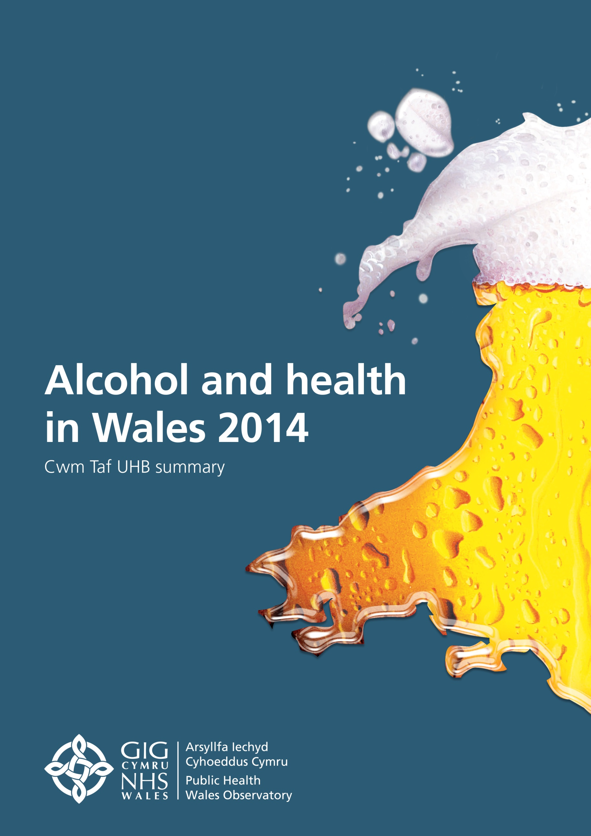

Table of contents

1 Introduction 2
2 Alcohol Consumption 3
2.1 Drinking above guidelines 3
2.2 Heavy (binge) drinking 5
2.3 Very heavy drinking 7
3 Hospital admissions 9
3.1 Alcohol-specific hospital admissions (all ages) 9
3.2 Alcohol-specific hospital admissions (under 18) 12
3.3 Alcohol-attributable admissions (broad) 13
3.4 Alcohol-attributable admissions (narrow) 14
4 Mortality 16
4.1 Alcohol-specific mortality 16
4.2 Alcohol-attributable mortality 19
4.3 Mortality from chronic liver disease and cirrhosis 20
4.4 Months of life lost 21

© 2014 Public Health Wales NHS Trust

All charts and maps were produced by the Public Health Wales Observatory and the data sources are shown under each graphic. Material contained in this summary may be reproduced without prior permission provided it is done so accurately and is not used in a misleading context. Acknowledgement to Public Health Wales NHS Trust to be stated. Typographical copyright lies with Public Health Wales NHS Trust.

1 Introduction

This health board summary document provides local information on the indicators contained in the publication Alcohol and health in Wales 2014. It contains selected charts for the health board area for persons. Please note that the charts and data tables for most of the indicators are also available by sex and local authority in the interactive data file (see link below), as well as additional episode-based hospital admission indicators. This summary document is designed to complement the Wales profile and give a local perspective.
The publication Alcohol and health in Wales 2014 consists of:
- a Wales profile
- seven health board summary documents
- interactive data files with the main indicator data (charts and tables)
- a technical guide describing the methods, data sources and caveats
These are available on www.publichealthwalesobservatory.wales.nhs.uk/alcohol

Alcohol consumption

Drinking above guidelines

Heavy (binge) drinking

Very heavy drinking

Hospital admissions

Alcohol-specific hospital admissions (all ages)

Alcohol-specific hospital admissions (under 18)

Alcohol-attributable admissions (broad)

Alcohol-attributable admissions (narrow)

Mortality

Alcohol-specific mortality

Alcohol-attributable mortality

Mortality from chronic liver disease and cirrhosis

Months of life lost

