

Respiratory Disease Delivery Plan Indicators 2015
Date: 21st July 2015 | Version: 1 FINAL
Publication/ Distribution:
- Health boards and local public health teams
- Public Health Wales Observatory (Intranet)
Purpose and Summary of Document:
The purpose of this document is to bring together a series of indicators to assist health board colleagues with the development of their Respiratory Disease Delivery Plan. This is not designed as a stand-alone document but as a resource to hold indicators for re-use elsewhere.

© 2015 Public Health Wales NHS Trust
Material contained in this document may be reproduced without prior permission provided it is done so accurately and is not used in a misleading context.
Acknowledgement to Public Health Wales NHS Trust to be stated.
Typographical copyright lies with Public Health Wales NHS Trust.

Contents
1 Introduction 4
2 How to copy and paste tables, charts and maps 5
2.1 Copying and pasting tables, charts and maps (Figure 1) 5
2.2 Resizing images (Figure 2) 6
3 Hospital activity 7
3.1 Person-based hospital admissions: Chronic Obstructive Pulmonary Disease 7
3.2 Emergency hospital admissions: Asthma 11
3.3 Emergency hospital admissions: Chronic Obstructive Pulmonary Disease 15
4 Mortality indicators 19
4.1 Respiratory Disease 19
4.2 Asthma 23
4.3 Chronic Obstructive Pulmonary Disease 25
4.4 Interstitial Lung Disease 29
4.5 Obstructive Sleep Apnoea-Hypopnoea Syndrome 32
5 GP practice registers 33
5.1 Patients on GP practice registers with asthma 33
5.2 Patients on GP practice registers with chronic obstructive pulmonary disease 33
6 Smoking prevalence 34

Introduction
This document has been produced by the Public Health Wales Observatory, following discussion with the Welsh Government, in order to support health boards with their development of a Respiratory Disease Delivery Plan. The document contains a series of indicators to assist health boards in measuring how their area is performing in accordance to Population Outcome Indicators outlined in the Together for Health – A Respiratory Health Delivery Plan (Welsh Government 2014)¹.
This document includes indicators from a variety of data sources which include:
- Public Health Mortality (PHM), Office for National Statistics (ONS)
- Patient Episode Database for Wales (PEDW), NHS Wales Informatics Service (NWIS)
- Audit+, NHS Wales Informatics Service (NWIS)
- Welsh Health Survey (WHS), Welsh Government (WG)
The following ICD-10 codes have been used when extracting data from both the Public Health Mortality file (PHM) and the Patient Episode Database for Wales (PEDW), in accordance with those used in The NHS Atlas of Variation in HealthCare for Respiratory Disease (RightCare 2012)²:
- Respiratory Disease: J00-J99
- Chronic Obstructive Pulmonary Disease: J40-J44
- Asthma: J45-J46
In addition, following advice from Clinical Coding and Classification (NWIS), the following have been defined according to ICD-10 as:
- Interstitial Lung Disease: J60-J70; J80-J84; D86.0
- Obstructive Sleep Apnoea-Hypopnoea Syndrome: G47.1; G47.3; G47.4
Hospital activity indicators are subject to known variation in both the practice and accuracy of clinical coding across Wales.
All hospital activity and mortality indicators by deprivation fifths have been calculated using the Welsh Index of Multiple Deprivation 2014 (WIMD 2014). Further information regarding WIMD can be found on the Observatory website: http://howis.wales.nhs.uk/sitesplus/922/page/43919
95% confidence intervals presented for hospital activity and mortality indicators are calculated using a method proposed by Dobson et al (1991)³.
Additional notes on indicators are provided in their individual chapters.
¹ Welsh Government. (2014). Together for Health – A Respiratory Health Delivery Plan. Available at: http://gov.wales/docs/dhss/publications/140429respiratoryen.pdf [Accessed: 21st July 2015]
² RightCare. (2012). The NHS Atlas of Variation in HealthCare for Respiratory Disease. Available at: http://www.sepho.org.uk/extras/maps/NHSatlasRespiratory/atlas.html [Accessed: 21st July 2015]
³ Dobson A.J. et al (1991) Confidence intervals for weighted sums of Poisson parameters. Stat Med 10(3):457-462.

How to copy and paste tables, charts and maps
The standard {Cut}, {Copy} and {Paste} options can be used in Microsoft Word to export tables, charts and maps to other documents as well as resize the image.

Copying and pasting tables, charts and maps (Figure 1)

- Select the image you want to copy by left clicking on it once so that the surrounding points are displayed.
- Either on the ‘Home’ tab or through the right click menu select either ‘Cut’ or ‘Copy’.
- In the document you want to insert the copy select ‘Paste’ either through the ‘Home’ tab or the right click menu.

Figure 1
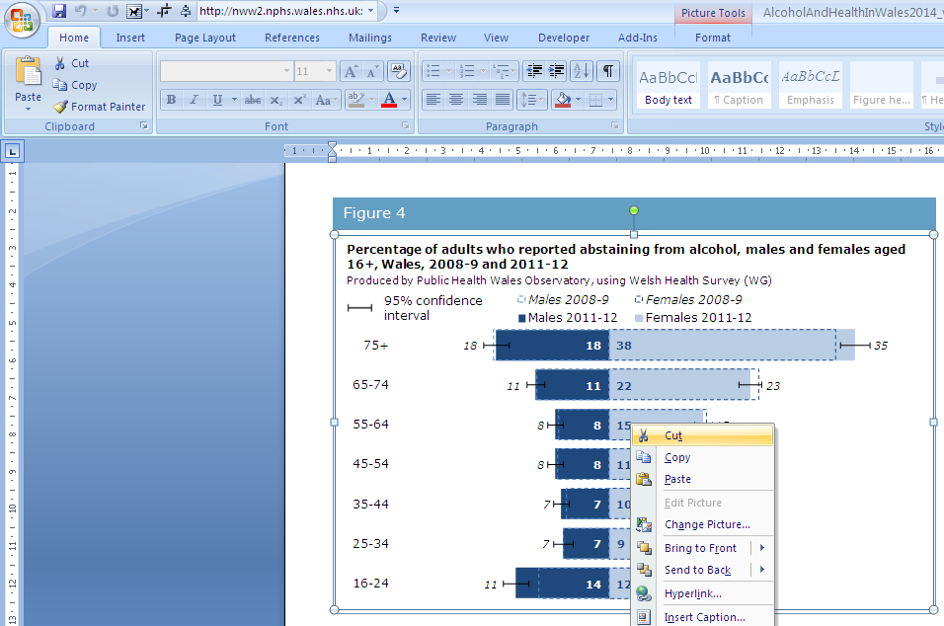

Figure 2
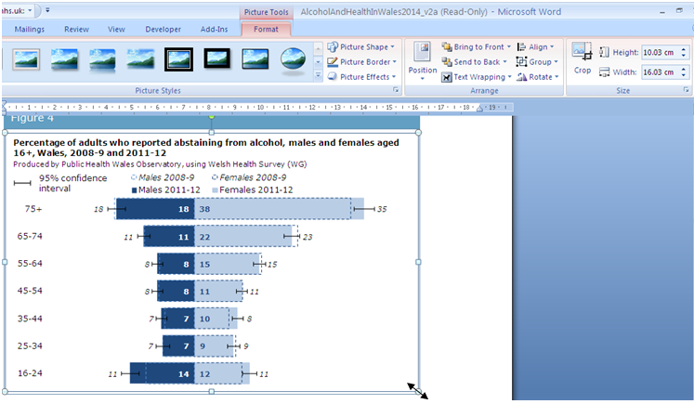

Resizing images (Figure 2)
- To adjust the size left click on the image once so that the surrounding points are displayed.
- You can either adjust the length and width manually through the ‘Format’ tab or use the points to resize the image by clicking and dragging.
- When resizing an image it is best to use the corner points dragging method as this will keep the perspective, resizing just horizontally or vertically leads to the pixels distorting and leads to a reduction in image quality.

Hospital activity

Person-based hospital admissions: Chronic Obstructive Pulmonary Disease

This analysis counts the number of individuals admitted to hospital where the primary diagnosis in the admitting episode was an ICD-10 code between J40-J44. Individuals were only counted once regardless of the number of times they were admitted with a primary diagnosis between J40-J44 during the same financial year.

Emergency hospital admissions: Asthma

Asthma admissions were counted where the primary diagnosis was an ICD-10 code between J45-J46 and the admission method was an emergency (admission method between 21 and 28). This analysis is spell based meaning multiple spells are counted when an individual is admitted more than once during the financial year.

Emergency hospital admissions: Chronic Obstructive Pulmonary Disease

Chronic obstructive pulmonary disease admissions were counted where the primary diagnosis was an ICD-10 code between J40-J44 and the admission method was an emergency (admission method between 21 and 28). This analysis is spell based meaning multiple spells are counted when an individual is admitted more than once during the financial year.

Mortality indicators

Respiratory Disease

Please note that all deaths by cause analyses exclude neonates.

Asthma

Please note that all deaths by cause analyses exclude neonates.

Mortality by local authorities is not presented for asthma since the number of deaths in each local authority is too small to produce a stable rate.

Chronic Obstructive Pulmonary Disease

Please note that all deaths by cause analyses exclude neonates.

Interstitial Lung Disease

Please note that all deaths by cause analyses exclude neonates.

Obstructive Sleep Apnoea-Hypopnoea Syndrome
There were 18 deaths from Obstructive Sleep Apnoea-Hypopnoea Syndrome (ICD-10 codes: G47.1; G47.3; G47.4) in Wales between 2004 and 2013.

GP practice registers

Patients on GP practice registers with asthma

Patients on GP practice registers with chronic obstructive pulmonary disease
European age-standardised rate per 100 (using aggregated 2013 ESP) with 95% confidence intervals (intervals calculated using a method proposed by Dobson et al (1991)).
An update to the GP cluster level chronic condition analyses is available on the Public Health Wales Observatory intranet only at: http://howis.wales.nhs.uk/sitesplus/922/page/63747.
The analyses present information on the disease burden and age adjusted variation for the following seven conditions, which have a high impact on services:
- chronic obstructive pulmonary disease;
- asthma;
- coronary heart disease;
- heart failure;
- hypertension;
- epilepsy; and
- diabetes.
Please note that only practices that submitted data to Audit+ on 31/03/2014 are included in their clusters in this update. Further details can be found in the Readme sheet in the interactive data file.

Smoking prevalence

The Observatory has produced trend analysis on smoking prevalence up to 2014 by health boards and local authorities using data from the Welsh Health Survey. This is available on the Observatory website:
http://howis.wales.nhs.uk/sitesplus/922/page/64616
Further information on the Welsh Health Survey can be accessed on the Observatory website at:
http://howis.wales.nhs.uk/sitesplus/922/page/37257

