

Heart Disease Delivery Plan Indicators 2015:
Powys teaching Health Board

Date: 19th June 2015 | Version: Final
Publication/ Distribution:
- Health boards and local public health teams
- Public Health Wales Observatory (Intranet)
Purpose and Summary of Document:
In April 2015 Powys Local Public Health Team requested a series of indicators showing comparative information across Wales for use in their Heart Disease Delivery Plan Annual Report (2015). Since analysis was produced on an all Wales basis and may have wider utility, the Observatory has packaged this information producing a document for each health board. This is not designed as a stand-alone document but as a resource to hold indicators for re-use elsewhere.

© 2015 Public Health Wales NHS Trust
Material contained in this document may be reproduced without prior permission provided it is done so accurately and is not used in a misleading context.
Acknowledgment to Public Health Wales NHS Trust to be stated.
Typographical copyright lies with Public Health Wales NHS Trust.

Contents
1 Introduction 4
2 How to copy and paste tables, charts and maps 4
Copying and pasting tables, charts and maps (Figure 1) 4
Resizing images (Figure 2) 5
3 Mortality: CVD 6
Mortality from cardiovascular disease, European age-standardised rate (EASR) per 100,000, males and females aged under 75, Wales by deprivation fifth, 2011-13 6
Mortality from cardiovascular disease, European age-standardised rate (EASR) per 100,000, all persons aged under 75, Powys tHB Middle Super Output Areas (MSOAs), 2009-2013 7
Mortality from cardiovascular disease, European age-standardised rate (EASR) per 100,000, all persons aged under 75, Powys tHB Middle Super Output Areas (MSOAs), 2009-2013 (MAP) 8
Cardiovascular disease mortality, European age-standardised rate per 100,000, persons aged under 75, Wales health boards, 2011-2013 9
Cardiovascular disease mortality, European age-standardised rate per 100,000 persons, all ages, Powys tHB, Wales & England, 2004 -2013 10
4 Mortality: CHD 11
Mortality from coronary heart disease, European age-standardised rate (EASR) per 100,000, males and females aged under 75, Wales by deprivation fifth, 2011-13 11
Mortality from coronary heart disease, European age-standardised rate (EASR) per 100,000, all persons, all ages, Powys tHB Middle Super Output Areas (MSOAs), 2009-2013 12
Coronary heart disease mortality, European age-standardised rate (EASR) per 100,000, all persons, all ages, Powys tHB Middle Super Output Areas (MSOAs), 2009-2013 (MAP) 13
Coronary heart disease mortality, European age-standardised rate per 100,000, persons aged under 75, Wales health boards, 2011-2013 14
5 Emergency admissions (PEDW) 15
Cardiovascular disease emergency hospital admissions, EASR per 100,000, persons, all ages, Wales local authorities, financial year 2013/14 15
Cardiovascular disease emergency hospital admissions, EASR per 100,000, persons, all ages, Wales health boards, financial year 2013/14 16
6 QOF Audit+ 16
Patients on GP practice registers with coronary heart disease, age-standardised percentage, Wales health boards, 2013-14 16
7 Welsh Health Survey 17
Age-standardised percentage of adults reporting to be obese (BMI 30+), persons aged 16 and over, Wales health boards, 2012-13 17
8 Additional notes 18

Introduction
This paper is one of a set of seven i.e. one for each of the health boards in Wales. They have been produced by the Public Health Wales Observatory following a request from a member of the Powys Local Public Health Team for a series of indicators to support the development of the Heart Disease Delivery Plan in their area.
This document includes indicators from a variety of data sources which include:
- Public Health Mortality (PHM)
- Patient Episode Database for Wales (PEDW)
- QOF Audit+
- Welsh Health Survey (WHS).

How to copy and paste tables, charts and maps
The standard {Cut}, {Copy} and {Paste} options can be used in Microsoft Word to export tables, charts and maps to other documents as well as resize the image.

Copying and pasting tables, charts and maps (Figure 1)
- Select the image you want to copy by left clicking on it once so that the surrounding points are displayed.
- Either on the ‘Home’ tab or through the right click menu select either ‘Cut’ or ‘Copy’.
- In the document you want to insert the copy select ‘Paste’ either through the ‘Home’ tab or the right click menu.
Figure 1
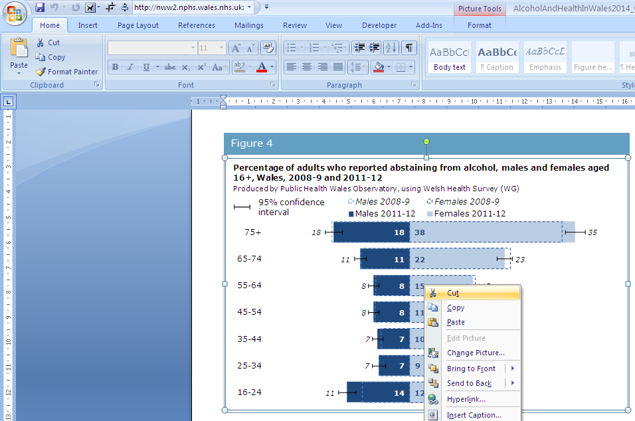

Figure 2
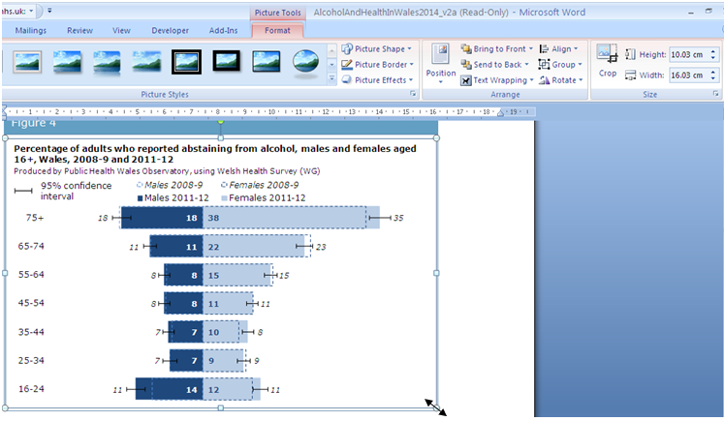

Resizing images (Figure 2)
- To adjust the size left click on the image once so that the surrounding points are displayed.
- You can either adjust the length and width manually through the ‘Format’ tab or use the points to resize the image by clicking and dragging.
- When resizing an image it is best to use the corner points dragging method as this will keep the perspective, resizing just horizontally or vertically leads to the pixels distorting and leads to a reduction in image quality.

Mortality: CVD

Mortality from cardiovascular disease, European age-standardised rate (EASR) per 100,000, males and females aged under 75, Wales by deprivation fifth, 2011-13

Further information regarding WIMD can be found on the Observatory website: http://howis.wales.nhs.uk/sitesplus/922/page/43919

Mortality from cardiovascular disease, European age-standardised rate (EASR) per 100,000, all persons aged under 75, Powys tHB Middle Super Output Areas (MSOAs), 2009-2013

Mortality from cardiovascular disease, European age-standardised rate (EASR) per 100,000, all persons aged under 75, Powys tHB Middle Super Output Areas (MSOAs), 2009-2013 (MAP)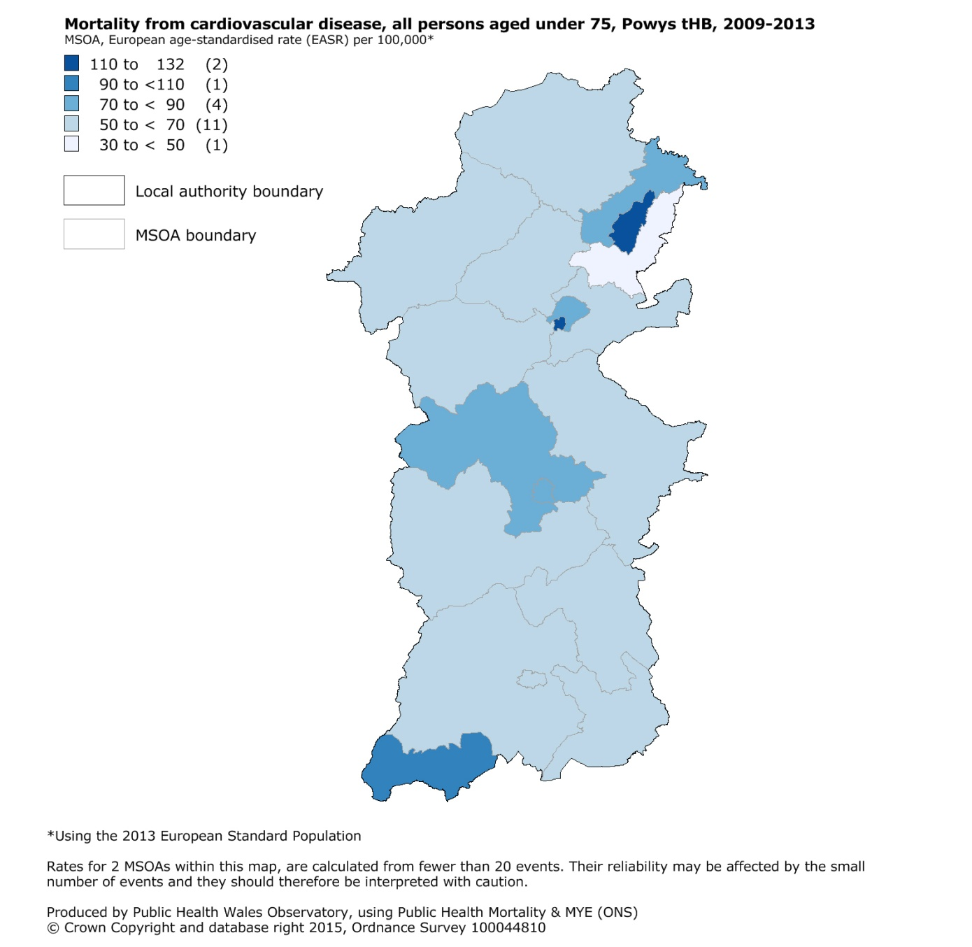

Deaths were assigned to a valid MSOA using the postcode field within the Public Health Mortality (PHM) file extract.

Cardiovascular disease mortality, European age-standardised rate per 100,000, persons aged under 75, Wales health boards, 2011-2013

The rates presented here differ to those published on our cardiovascular disease topic page for the following reasons:
- CVD topic page uses 2001 based MYEs, this analysis uses 2011 based MYEs
- CVD topic page has adjusted the EASRs to account for coding changes, this analysis has not (affects data from 2011 onwards)
- CVD topic page uses the 1976 European Standard Population (ESP), this analysis uses the 2013 ESP

Cardiovascular disease mortality, European age-standardised rate per 100,000 persons, all ages, Powys tHB, Wales & England, 2004 -2013

Please note that all deaths by cause analyses exclude neonates.

Mortality: CHD

Mortality from coronary heart disease, European age-standardised rate (EASR) per 100,000, males and females aged under 75, Wales by deprivation fifth, 2011-13

Further information regarding WIMD can be found on the Observatory website.

Mortality from coronary heart disease, European age-standardised rate (EASR) per 100,000, all persons, all ages, Powys tHB Middle Super Output Areas (MSOAs), 2009-2013

Coronary heart disease mortality, European age-standardised rate (EASR) per 100,000, all persons, all ages, Powys tHB Middle Super Output Areas (MSOAs), 2009-2013 (MAP) 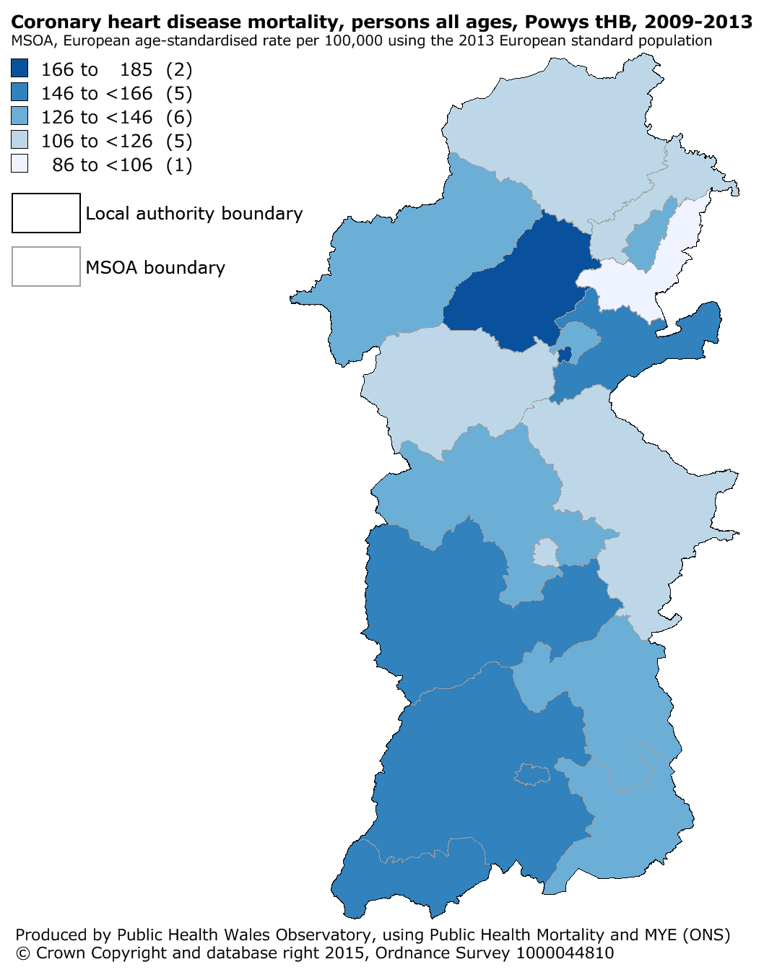

Deaths were assigned to a valid MSOA using the postcode field within the Public Health Mortality (PHM) file extract.

Coronary heart disease mortality, European age-standardised rate per 100,000, persons aged under 75, Wales health boards, 2011-2013

Please note that all deaths by cause analyses exclude neonates.

Emergency admissions (PEDW)

Cardiovascular disease emergency hospital admissions, EASR per 100,000, persons, all ages, Wales local authorities, financial year 2013/14

Cardiovascular disease emergency hospital admissions, EASR per 100,000, persons, all ages, Wales health boards, financial year 2013/14
There is known to be variation in practices of clinical coding across Wales. The accuracy of clinical coding also varies across Wales.

QOF Audit+

Patients on GP practice registers with coronary heart disease, age-standardised percentage, Wales health boards, 2013-14
European age-standardised rate per 100 (using aggregated 2013 ESP) with 95% confidence intervals (intervals calculated using a method proposed by Dobson et al (1991)).
An update to the GP cluster level chronic condition analyses is available on the Public Health Wales Observatory intranet only at: http://howis.wales.nhs.uk/sitesplus/922/page/63747.
The analyses present information on the disease burden and age adjusted variation for the following seven conditions, which have a high impact on services:
- chronic obstructive pulmonary disease;
- asthma;
- coronary heart disease;
- heart failure;
- hypertension;
- epilepsy; and
- diabetes.
Please note that only practices that submitted data to Audit+ on 31/03/2014 are included in their clusters in this update. Further details can be found in the Readme sheet in the interactive data file.

Welsh Health Survey

Age-standardised percentage of adults reporting to be obese (BMI 30+), persons aged 16 and over, Wales health boards, 2012-13
Further information on the Welsh Health Survey can be accessed on the Observatory website at: http://howis.wales.nhs.uk/sitesplus/922/page/37257

Additional notes
- Where we say cardiovascular disease in relation to mortality and hospital admissions, we mean the ICD-10 chapter on diseases of the circulatory system (ICD-10 I00-I99). Cardiovascular disease (CVD) and circulatory disease is often used interchangeably but they are not exactly the same.
- 95% confidence intervals presented for mortality and emergency admissions indicators are calculated using a method proposed by Dobson et al (1991) ¹.
- Welsh Index of Multiple Deprivation 2014 (WIMD 2014) has been used for mortality indicators by deprivation fifth.

- QOF indicators use data submitted to Audit+ on 31/03/2014.

¹ Dobson A.J. et al (1991) Confidence intervals for weighted sums of Poisson parameters. Stat Med 10(3):457-462.

