
Data to support the Liver Disease Plan 2015
Author: Public Health Wales Observatory
Date: 27 July 2015 | Version: 1 FINAL
Publication/ Distribution:
- Health boards and local public health teams
- Public Health Wales Observatory (Intranet)
Review Date: 27 July 2016
Purpose and Summary of Document:
This document contains data to assist Health Boards with compiling their Liver Disease Plans. This is not designed as a stand-alone document but as a resource to hold indicators for re-use elsewhere.
Work Plan reference:

© 2015 Public Health Wales NHS Trust
Material contained in this document may be reproduced without prior permission provided it is done so accurately and is not used in a misleading context.
Acknowledgement to Public Health Wales NHS Trust to be stated.
Typographical copyright lies with Public Health Wales NHS Trust.

Contents
1 INTRODUCTION 4
1.1 Purpose of document 4
1.2 Content 4
1.3 Notes 4
2 How to copy and paste charts 5
2.1 Copying and pasting tables, charts and maps (Figure 1) 5
2.2 Resizing images (Figure 2) 6
3 Lifestyle indicators 7
3.1 Adult obesity 7
3.2 Child obesity 8
3.3 Months of life lost due to alcohol 9
4 Hospital activity 10
4.1 Non-alcoholic fatty liver disease (NAFLD) 10
4.2 Alcoholic liver disease 11
4.3 Alcohol-specific hospital admissions (Count) 12
4.4 Alcohol-specific hospital admissions, aged under 18 (Crude rate) 13
4.5 Alcohol-specific hospital admissions (European age-standardised rate) 14
4.6 Cholecystectomy procedures 15
4.7 Liver transplants procedures 16
4.8 Endoscopic retrograde cholangiopancreatography (ERC) procedures 17
4.9 Paracetamol overdose hospital admissions 18
4.10 Liver disease hospital admissions 19
4.11 Hepatitis B related end-stage liver disease/ hepatocellular carcinoma hospital admissions 20
4.12 Hepatitis C related end-stage liver disease/ hepatocellular carcinoma hospital admissions 21
5 Mortality indicators 22
5.1 Pancreatic cancer 22
5.2 Paracetamol poisoning 23
5.3 Chronic liver disease including cirrhosis by age group 24
5.4 Chronic liver disease including cirrhosis, all ages 27
5.5 Chronic liver disease including cirrhosis, aged under 75 years 28
5.6 Chronic liver disease including cirrhosis (trend) 30
5.7 Chronic liver disease including cirrhosis (trend by age group) 32
5.8 All cause liver disease, aged under 75 years 34
5.9 Liver cancer, aged under 75 years 35

INTRODUCTION

Purpose of document
This document provides information about liver disease to Health Boards in order that they can respond to the national Liver Disease Delivery Plan.

Content
Data is presented as indicators in three groups; Lifestyle, Hospital activity, and Mortality. Where indicator data is already publically available and published online a link is provided to the data and a metadata description is given. Indicators which have been produced by the Public Health Wales Observatory for inclusion in this document are presented as a chart with each of the seven health boards and a Wales comparator line. Metadata is included above the chart.
Data already held by the Health Protection division, such as information on blood borne viruses or alcohol and substance misuse treatment is not included.

Notes
The document predominantly uses crude or European age-standardised rates (EASR). Where EASRs are used, rates for some health boards have been suppressed. This is because there are fewer than twenty events over the period and therefore not enough to calculate a stable rate. Where possible this has been avoided by including more years of data.
Indicators are presented at health board level to avoid issues with small numbers associated with presenting indicators at local authority level.

How to copy and paste charts
The standard {Cut}, {Copy} and {Paste} options can be used in Microsoft Word to export tables, charts and maps to other documents as well as resize the image.

Copying and pasting tables, charts and maps (Figure 1)
- Select the image you want to copy by left clicking on it once so that the surrounding points are displayed.
- Either on the ‘Home’ tab or through the right click menu select either ‘Cut’ or ‘Copy’.
- In the document you want to insert the copy select ‘Paste’ either through the ‘Home’ tab or the right click menu.
Figure 1
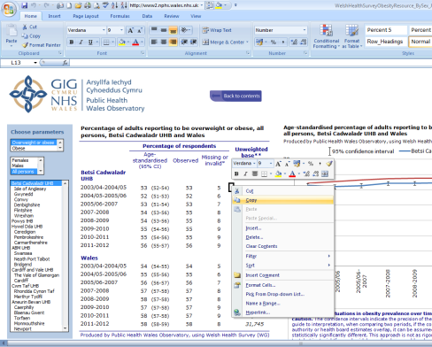

Figure 2
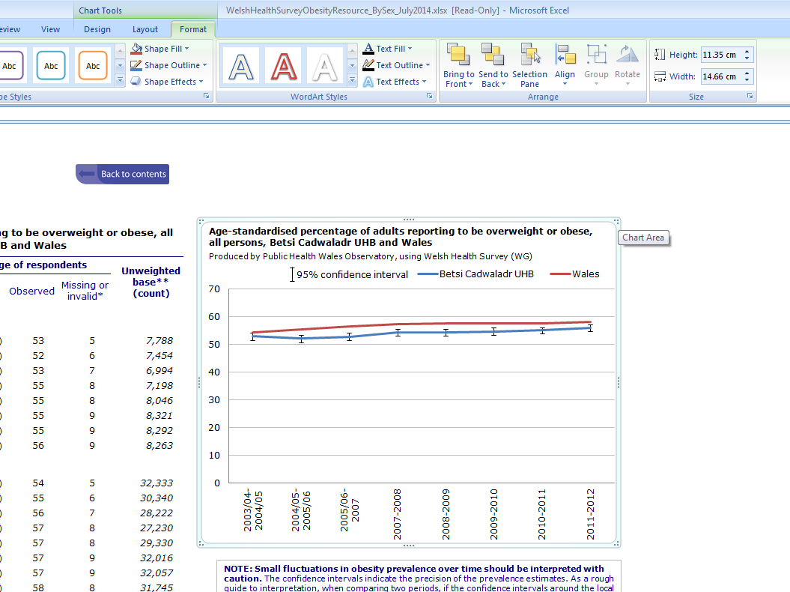

Resizing images (Figure 2)
- To adjust the size left click on the image once so that the surrounding points are displayed.
- You can either adjust the length and width manually through the ‘Format’ tab or use the points to resize the image by clicking and dragging.
- When resizing an image it is best to use the corner points dragging method as this will keep the perspective, resizing just horizontally or vertically leads to the pixels distorting and leads to a reduction in image quality.

Lifestyle indicators

Adult obesity
The percentage of adults responding to the Welsh Health Survey (WHS) who report height and weight equivalent to a Body Mass Index (BMI) of 30+ ("obese").
Demography: All persons aged 16 and over, by sex.
Geography: Wales, health boards and local authorities.
Time period: 2013-14 for most recent year, trend data from 2003-04 to 2013-14.
Source: Produced by Public Health Wales Observatory using Welsh Health Survey (Welsh Government).
Notes: A BMI of 30+ has been used to classify adults as obese. The indicator includes two measures, obese (BMI 30+) and overweight or obese (BMI 25+).
Link:
http://www2.nphs.wales.nhs.uk:8080/PubHObservatoryProjDocs.nsf/85c50756737f79ac80256f2700534ea3/474d273f2c7b6e7a80257e88004e33c8/$FILE/WHSLifestyleTrends_2015_v2a_Web.xlsx
[Accessed 27 July 2015]

Child obesity
The percentage of children aged 4 to 5 years who are overweight or obese.
Demography: Children aged 4 to 5 years, by sex.
Geography: Wales, health boards and local authorities.
Time period: 2013-14.
Source: Produced by Public Health Wales Observatory, using CMP (NWIS).
Notes: British 1990 growth reference (UK90) was the selected reference scale used to determine which category each child was assigned to i.e. ‘underweight’, ‘healthy weight’, ‘overweight but not obese’ and ‘obese’. Children were categorised as overweight or obese if they were in the 85th centile and above. The report includes a number of different indicators. Indicators relating to overweight or obese children can be found in section 4.4 (page 22).

Link:
http://www2.nphs.wales.nhs.uk:8080/ChildMeasurementDocs.nsf/85c50756737f79ac80256f2700534ea3/692fe9649b4fc8be80257e49002a4bcb/$FILE/ATT0SH7G.pdf#page=53 [Accessed 03 July 2015]

Months of life lost due to alcohol
An estimate of the increase in life expectancy at birth that would be expected if all alcohol-attributable deaths among persons aged under 75 years were prevented.
Demography: All persons aged under 75, by sex.
Geography: Wales health boards.
Time period: 2010-2012.
Source: Produced by Public Health Wales Observatory, using ADDE, Life Tables for Wales and MYE (ONS).
Notes: This measure is related to alcohol-attributable mortality including the use of the same fractions, but only includes alcohol-attributable deaths in those aged under 75. The report includes a number of indicators. Indicators relating to months of life lost due to alcohol can be found on page 36 (Figures 28 and 29).
Link: http://www2.nphs.wales.nhs.uk:8080/PubHObservatoryProjDocs.nsf/85c50756737f79ac80256f2700534ea3/d7ead329fc08591480257d7200326f03/$FILE/AlcoholAndHealthInWales2014_v2a.pdf#page=38 [Accessed 03 July 2015]

Hospital activity

Non-alcoholic fatty liver disease (NAFLD)
European age-standardised rate of non-alcoholic fatty liver disease, per 100,000.
Demography: All persons, all ages.
Geography: Wales health boards.
Time period: 2009/10 - 2013/14.
Source: Produced by Public Health Wales Observatory using PEDW (NWIS) and MYE (ONS).
Notes: NAFLD admissions are identified when ICD-10 code K76.0 appears as the principal diagnosis on the admitting episode. Excludes admissions from regular day/night attendees.

Alcoholic liver disease
European age-standardised rate of hospital admissions due to alcohol specific liver disease, per 100,000.
Demography: All persons, all ages.
Geography: Wales health boards.
Time period: 2011/12 - 2013/14.
Source: Produced by Public Health Wales Observatory, using PEDW (NWIS) & MYE (ONS).
Notes: Alcoholic liver disease admissions are identified when ICD-10 code K70 appears as the principal diagnosis on the admitting episode. Excludes admissions from regular day/night attendees.

Alcohol-specific hospital admissions (Count)
The number of alcohol-specific hospital admissions broken down by alcohol-specific condition.
Demography: All persons, all ages, by sex.
Geography: Wales.
Time period: 2012/13.
Source: Produced by Public Health Wales Observatory, using PEDW (NWIS) & MYE (ONS).
Notes: Each individual is only counted once in this definition for one alcohol-specific condition, but this may not be the only alcohol-specific condition noted or the main reason for admission. This measure can be found on page 22 (figure 13) from the link below.
Link: http://www2.nphs.wales.nhs.uk:8080/PubHObservatoryProjDocs.nsf/85c50756737f79ac80256f2700534ea3/d7ead329fc08591480257d7200326f03/$FILE/AlcoholAndHealthInWales2014_v2a.pdf#page=24 [Accessed 03 July 2015]

Alcohol-specific hospital admissions, aged under 18 (Crude rate)
Hospital admission rate due to alcohol-specific causes, 3-year rolling crude rate per 100,000.
Demography: All persons, aged under 18, by sex.
Geography: Wales and health boards (separate link).
Time period: 2003/04 - 2012/13.
Source: Produced by Public Health Wales Observatory, using PEDW (NWIS) & MYE (ONS).
Notes: The rate of children and young people aged under 18 admitted for alcohol-specific (wholly attributable) conditions. This measure can be found on page 26 (figure 17) in the Wales report and section 3.2 in the health board reports.
Link:
Wales report: http://www2.nphs.wales.nhs.uk:8080/PubHObservatoryProjDocs.nsf/85c50756737f79ac80256f2700534ea3/d7ead329fc08591480257d7200326f03/$FILE/AlcoholAndHealthInWales2014_v2a.pdf#page=28 [Accessed 03 July 2015]
Health board reports: http://www.wales.nhs.uk/sitesplus/922/page/75230 [Accessed 03 July 2015]

Alcohol-specific hospital admissions (European age-standardised rate)
Hospital admissions (person based), European age-standardised rate per 100,000 in males and females due to alcohol-specific causes.
Demography: All persons, all ages, by sex.
Geography: Wales.
Time period: 2003/04 - 2012/13.
Source: Produced by Public Health Wales Observatory, using PEDW (NWIS) & MYE (ONS).
Notes: The rate of individuals admitted to hospital for alcohol-specific (wholly attributable) conditions. The chart includes two additional measures, details of which can be found in the report (see table 3, page 21). The chart can be found on page 25 (figure 16) from the link below.
Link: http://www2.nphs.wales.nhs.uk:8080/PubHObservatoryProjDocs.nsf/85c50756737f79ac80256f2700534ea3/d7ead329fc08591480257d7200326f03/$FILE/AlcoholAndHealthInWales2014_v2a.pdf#page=27 [Accessed 03 July 2015]

Cholecystectomy procedures
European age-standardised rate of elective cholecystectomy procedures per 100,000.
Demography: All persons, all ages.
Geography: Wales local authorities.
Time period: 2008/09 - 2012/13.
Source: Produced by Public Health Wales Observatory, using PEDW (NWIS) & MYE (ONS).
Notes: Cholecystectomy procedures are identified when there is any mention of OPCS codes J18.1, J18.2, J18.3, J18.4, J18.5, J18.8 and J18.9 in a patient’s record. Admission methods codes 11, 12, 13, 14 and 15 were used to define elective procedures. This measure is available through instant atlas which includes a number of indicators. To view elective cholecystectomy procedures use the “select data” tab.
Link: http://www2.nphs.wales.nhs.uk/InstantAtlas/VESP2014/Atlas.html [Accessed 03 July 2015]

Liver transplants procedures
European age-standardised rate of liver transplant procedures per 100,000.
Demography: All persons, all ages.
Geography: Wales health boards.
Time period: 2004/05 - 2013/14.
Source: Produced by Public Health Wales Observatory, using PEDW (NWIS) & MYE (ONS).
Notes: Liver transplant procedures are identified when there is any mention of OPCS code J01 in a patient’s record. This indicator counts occurrences of procedures, rather than the number of spells or episodes where at least procedure was carried out. Some spells may have more than one recorded procedure.

Endoscopic retrograde cholangiopancreatography (ERC) procedures
European age-standardised rate of Endoscopic retrograde cholangiopancreatography (ERC) procedures per 100,000.
Demography: All persons, all ages.
Geography: Wales health boards.
Time period: 2013/14.
Source: Produced by Public Health Wales Observatory, using PEDW (NWIS) & MYE (ONS).
Notes: ERC procedures are identified when there is any mention of OPCS code J43 in a patients record. This indicator counts occurrences of procedures, rather than the number of spells or episodes where at least one procedure was carried out. Some spells may have more than one recorded procedure. All patient classes have been included for this indicator.

Paracetamol overdose hospital admissions
European age-standardised rate of paracetamol overdose hospital admissions per 100,000.
Demography: All persons, all ages.
Geography: Wales health boards.
Time period: 2013/14.
Source: Produced by Public Health Wales Observatory, using PEDW (NWIS) & MYE (ONS).
Notes: Paracetamol overdose hospital admissions are identified when ICD-10 codes T39.1 and either X40 (accidental poisoning) or X60 (intentional poisoning) occur on the admitting episode of care, in any diagnosis position.

Liver disease hospital admissions
European age-standardised rate of liver disease hospital admissions per 100,000.
Demography: All persons, all ages.
Geography: Wales health boards.
Time period: 2013/14.
Source: Produced by Public Health Wales Observatory, using PEDW (NWIS) & MYE (ONS).
Notes: Liver disease hospital admissions are identified when ICD-10 codes B15-B19, C22, I81, I85, K70-K77 or T86.4 appear as the principal diagnosis on the admitting episode. Excludes admissions from regular day/night attendees.

Hepatitis B related end-stage liver disease/ hepatocellular carcinoma hospital admissions
European age-standardised rate of Hepatitis B related end-stage liver disease/hepatocellular carcinoma hospital admissions per 100,000.
Demography: All persons, all ages.
Geography: Wales health boards.
Time period: 2004/05 - 2013/14.
Source: Produced by Public Health Wales Observatory, using PEDW (NWIS) & MYE (ONS).
Notes: Hepatitis B related end-stage liver disease/hepatocellular carcinoma hospital admissions are identified when ICD-10 codes B18.0-B18.1 or B16 appear as the principal diagnosis on the admitting episode. Excludes admissions from regular day/night attendees.
Rates for some health boards have been suppressed due to the low number of events.

Hepatitis C related end-stage liver disease/ hepatocellular carcinoma hospital admissions
European age-standardised rate of Hepatitis C related end-stage liver disease/hepatocellular carcinoma hospital admissions per 100,000.
Demography: All persons, all ages.
Geography: Wales health boards.
Time period: 2004/05 - 2013/14.
Source: Produced by Public Health Wales Observatory, using PEDW (NWIS) & MYE (ONS).
Notes: Hepatitis C related end-stage liver disease/hepatocellular carcinoma hospital admissions are identified when ICD-10 codes B18.2 or B17.1 appear as the principal diagnosis on the admitting episode. Excludes admissions from regular day/night attendees.

Mortality indicators

Pancreatic cancer
European age-standardised rate of mortality from pancreatic cancer per 100,000.
Demography: All persons, aged under 75.
Geography: Wales health boards.
Time period: 2011-13.
Source: Produced by Public Health Wales Observatory, using PHM & MYE (ONS).
Notes: Mortality from pancreatic cancer is identified when ICD-10 code C25 appears as the underlying cause of death.

Paracetamol poisoning
European age-standardised rate of mortality from paracetamol poisoning per 100,000.
Demography: All persons, all ages.
Geography: Wales health boards.
Time period: 2004-13
Source: Produced by Public Health Wales Observatory, using PHM & MYE (ONS).
Notes: Mortality from paracetamol poisoning is identified when ICD-10 codes T39.1 and either X40 (accidental poisoning) or X60 (intentional poisoning) appear in any cause position.
Rates for some health boards have been suppressed due to the low number of events.

Chronic liver disease including cirrhosis by age group
Crude rate of mortality from chronic liver disease and cirrhosis per 100,000.
Demography: All persons, aged 20-74 and 75 and over.
Geography: Wales health boards.
Time period: 2004-06 - 2011-13, rolling 3 year periods.
Source: Produced by Public Health Wales Observatory, using PHM & MYE (ONS).
Notes: Mortality from chronic liver disease including cirrhosis is identified when ICD-10 codes K70, K73 or K74 appear as the underlying cause of death.

Aged 20-74

Aged 75 and over

Chronic liver disease including cirrhosis, all ages
European age-standardised rate of mortality from chronic liver disease and cirrhosis per 100,000.
Demography: All persons, all ages, by sex.
Geography: Wales and Wales health boards.
Time period: 2011-13.
Source: Produced by Public Health Wales Observatory, using PHM & MYE (ONS).
Notes: Mortality from chronic liver disease including cirrhosis is identified when ICD-10 codes K70, K73 or K74 appear as the underlying cause of death.

Chronic liver disease including cirrhosis, aged under 75 years
European age-standardised rate of mortality from chronic liver disease including cirrhosis, per 100,000.
Demography: All persons, aged under 75 years, by sex.
Geography: Wales health boards.
Time period: 2009-13.
Source: Produced by Public Health Wales Observatory, using PHM & MYE (ONS).
Notes: Mortality from chronic liver disease including cirrhosis is identified when ICD-10 codes K70, K73 or K74 appear as the underlying cause of death.

Chronic liver disease including cirrhosis (trend)
European age-standardised rate of mortality from chronic liver disease including cirrhosis, per 100,000.
Demography: Persons, all ages.
Geography: Wales health boards.
Time period: 2004-06 to 2011-13, rolling 3 year periods.
Source: Produced by Public Health Wales Observatory, using PHM & MYE (ONS).
Notes: Mortality from chronic liver disease including cirrhosis is identified when ICD-10 codes K70, K73 or K74 appear as the underlying cause of death.

Chronic liver disease including cirrhosis (trend by age group)
Annual average number of deaths from chronic liver disease including cirrhosis, per 100,000.
Demography: All persons, aged 20-74 and 75 and over.
Geography: Wales health boards.
Time period: 2004-06 to 2011-13, rolling 3 year periods.
Source: Produced by Public Health Wales Observatory, using PHM (ONS).
Notes: Mortality from chronic liver disease including cirrhosis is identified when ICD-10 codes K70, K73 or K74 appear as the underlying cause of death.

All cause liver disease, aged under 75 years
European age-standardised rate of mortality from all cause liver disease per 100,000.
Demography: All persons, aged under 75 years, by sex.
Geography: Wales health boards.
Time period: 2011-13.
Source: Produced by Public Health Wales Observatory, using PHM & MYE (ONS).
Notes: Mortality from all liver disease is identified when ICD-10 codes B15-B19, C22, I81, I85, K70-K77 or T86.4 appear as the underlying cause of death.

Liver cancer, aged under 75 years
European age-standardised rate of mortality from liver cancer per 100,000.
Demography: All persons, aged under 75 years.
Geography: Wales health boards.
Time period: 2009-13.
Source: Produced by Public Health Wales Observatory, using PHM & MYE (ONS).
Notes: Mortality from liver cancer is identified when ICD-10 code C22 appears as the underlying cause of death.

