|  |  |  |
| --- | --- | --- |
| PHW Observatory RGB | | |
| Indicators to support the Betsi Cadwaladr University Health Board Local Public Health Strategic Framework | |
| **Author:** Nathan Lester, Head of Analytical Team | |
| **Date:** 7th October 2011 | **Version:** 2a |
| **Status:** | |
| **Purpose and Summary of Document:**  A number of indicators (charts and tables) have been requested by Public Health Wales colleagues on behalf of Betsi Cadwaladr University Health Board. The purpose of the indicators is to support the health board’s local public health strategic framework.  Indicators are supplied for the six constituent local authorities of BCU HB and most are trend data. | |

Table of Contents

1. % low birth weight (singleton live) by middle super output area 3

2. % low birth weight (singleton live), local authority trend 5

3. Infant mortality rate (under 1 year), local authority trend 6

4. Emergency hospital admission rates due to injury, persons aged 18 years and under by middle super output area 7

5. Emergency hospital admission rates due to injury, persons aged 18 years and under, local authority trend 9

6. Teenage conception rate, females under 16 years, local authority trend 10

7. Teenage conception rate, females under 18 years, local authority trend 11

8. Young people (aged 16 and 18 years) who are not in education, employment or training, by local authority 12

9. Circulatory disease mortality, persons under 75 years by middle super output area 13

10. Circulatory disease mortality, persons under 75 years, local authority trend 15

11. Overweight and obese, persons aged 16 and over, local authority trend 16

12. Obese, persons aged 16 and over, local authority trend 17

13. Limiting long term illness in working age population, persons aged 16 years and over, local authority trend 18

Appendix: metadata 19

% low birth weight (singleton live) by middle super output area 19

% low birth weight (singleton live), local authority trend 20

Infant mortality rate (under 1 year), local authority trend 21

Emergency hospital admission rates due to injury, persons aged 18 years and under by middle super output area 22

Emergency hospital admission rates due to injury, persons aged 18 years and under, local authority trend 23

Teenage conception rate, females under 16 years, local authority trend 24

Teenage conception rate, females under 18 years, local authority trend 25

Young people (aged 16 and 18 years) who are not in education, employment or training, by local authority 26

Circulatory disease mortality, persons under 75 years by middle super output area 27

Circulatory disease mortality, persons under 75 years, local authority trend 28

Overweight and obese, persons aged 16 and over, local authority trend 29

Obese, persons aged 16 and over, local authority trend 30

Limiting long term illness in working age population, persons aged 16 years and over, local authority trend 31

## % low birth weight (singleton live) by middle super output area

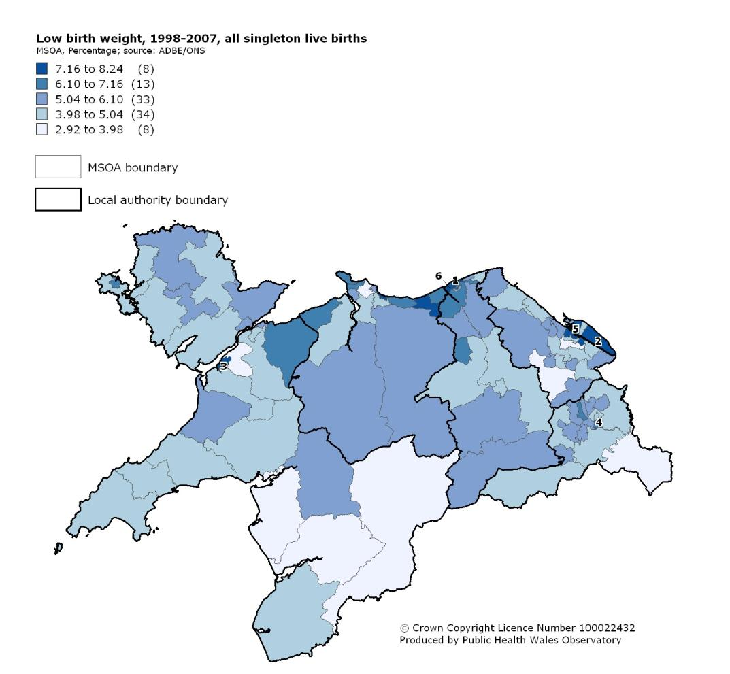

Numbers on map indicate MSOAs with a rate statistically significantly higher than the all Wales rate.

**Low birth weight in Betsi Cadwaladr University Health Board area, percentage of singleton live births, 1998-2007**

Produced by Public Health Wales Observatory, using data from ONS (ADBE, MYE)****

## % low birth weight (singleton live), local authority trend



## Infant mortality rate (under 1 year), local authority trend



## Emergency hospital admission rates due to injury, persons aged 18 years and under by middle super output area

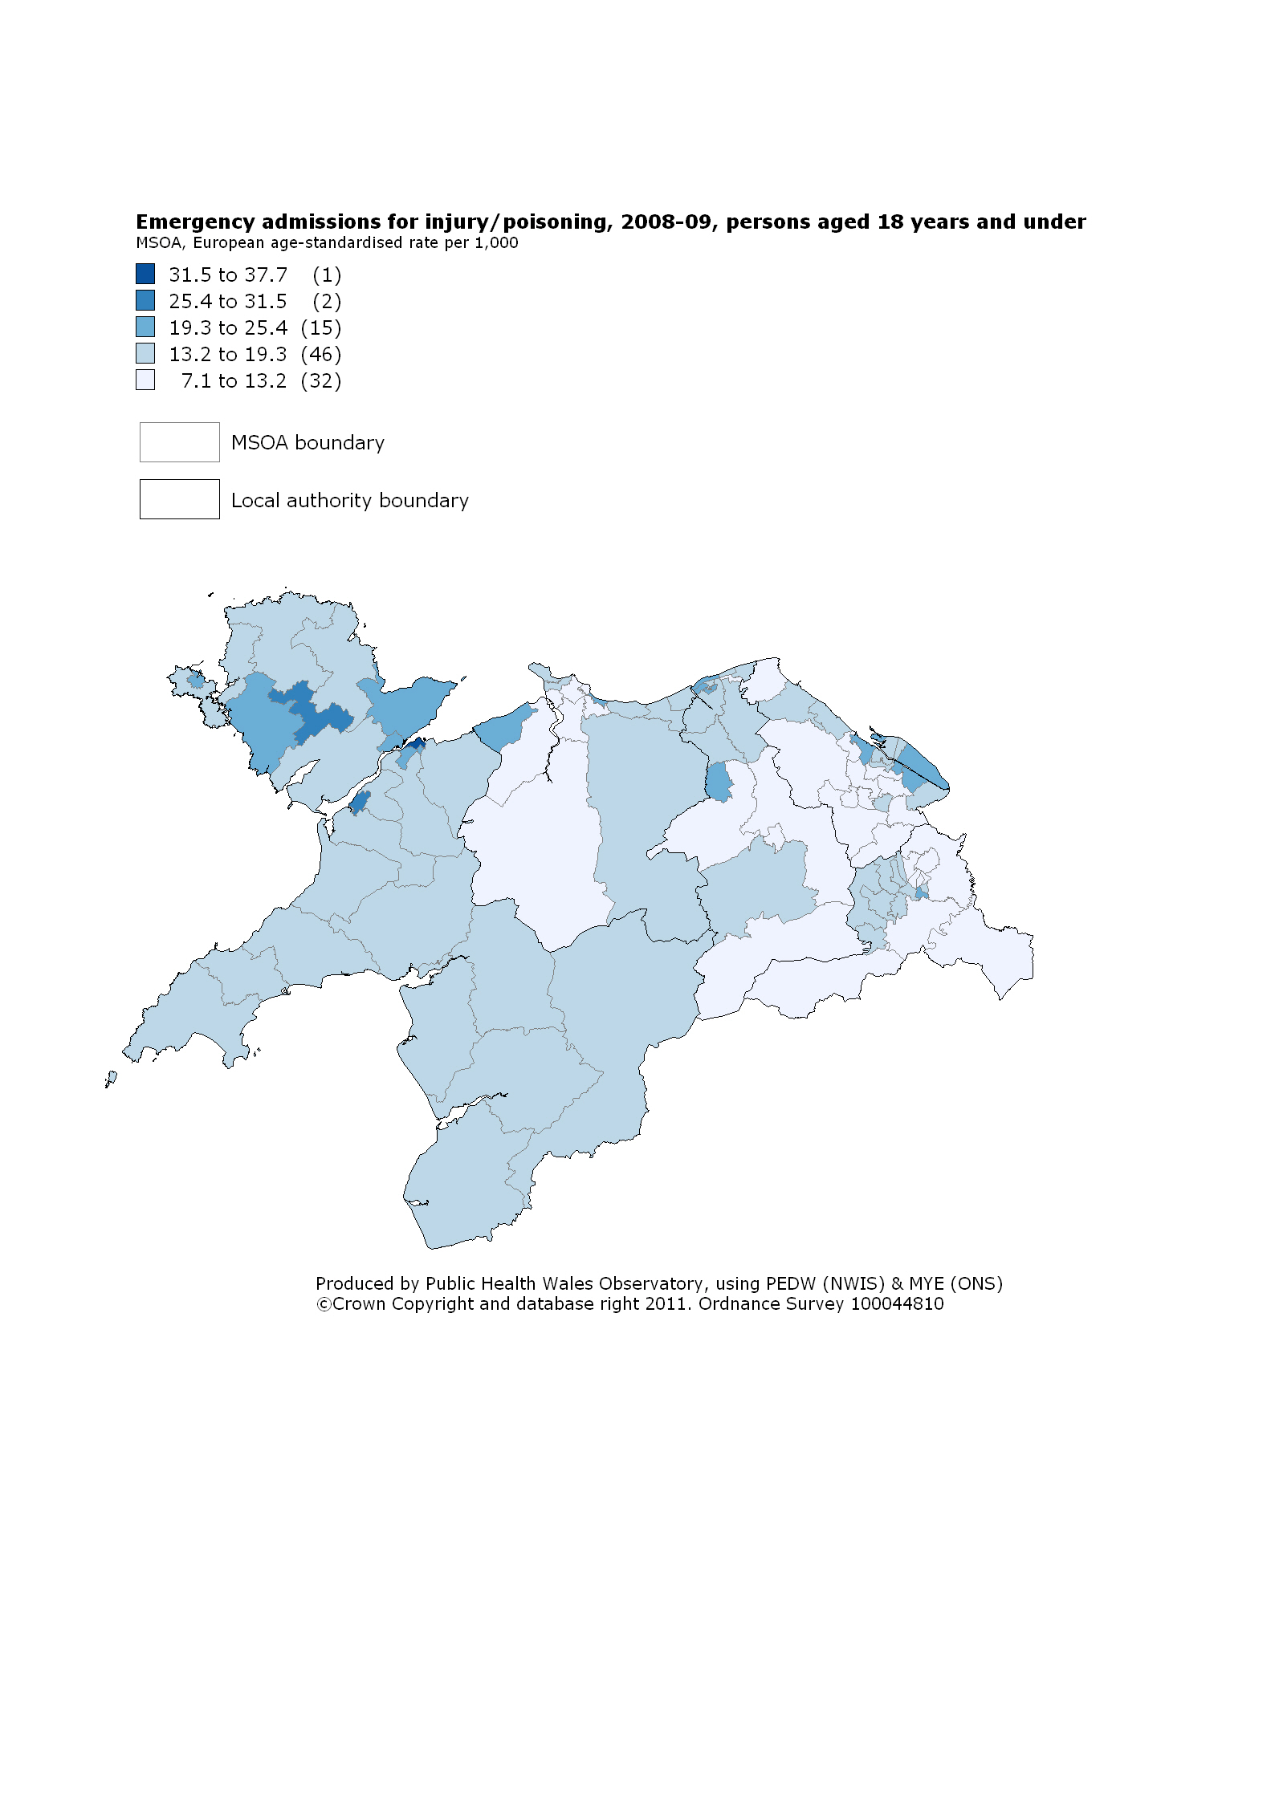

**Emergency hospital admission rates due to injury, European age-standardised rate per 1,000 persons aged 18 years and under, 2008-2009** 

## Emergency hospital admission rates due to injury, persons aged 18 years and under, local authority trend



## Teenage conception rate, females under 16 years, local authority trend



## Teenage conception rate, females under 18 years, local authority trend



## Young people (aged 16 and 18 years) who are not in education, employment or training, by local authority



## Circulatory disease mortality, persons under 75 years by middle super output area

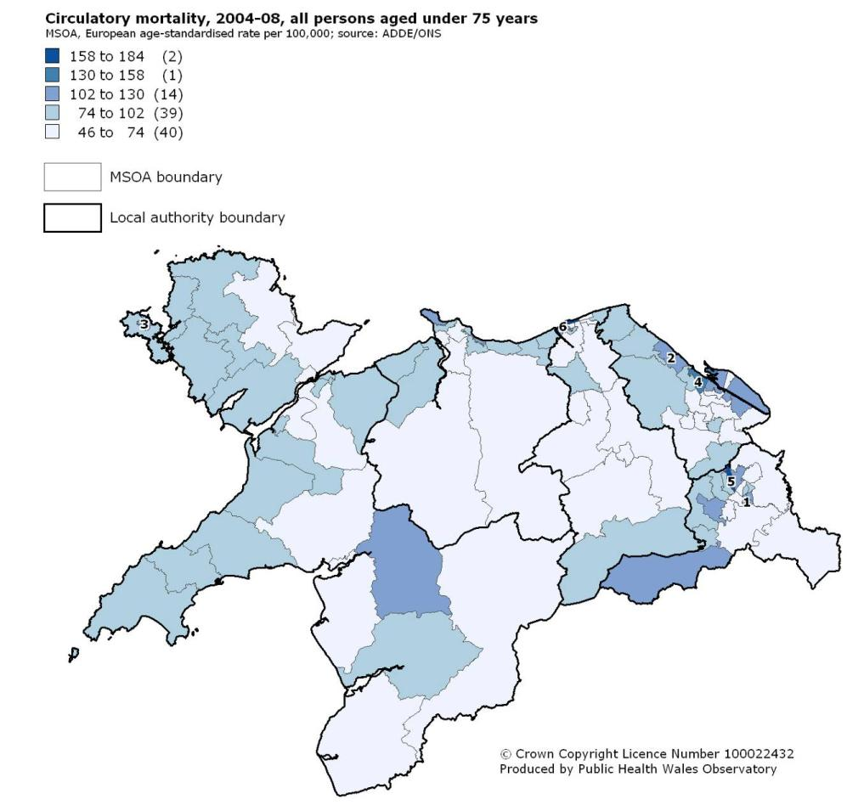

Numbers on map indicate MSOAs with a rate statistically significantly higher than the all Wales rate.

**Mortality from circulatory disease in Betsi Cadwaladr University Health Board area, all persons aged under 75, 2004-08, European age-standardised rates per 100,000**

Produced by Public Health Wales Observatory, using data from ONS (ADDE, MYE)



## Circulatory disease mortality, persons under 75 years, local authority trend



## Overweight and obese, persons aged 16 and over, local authority trend



## Obese, persons aged 16 and over, local authority trend



## Limiting long term illness in working age population, persons aged 16 years and over, local authority trend



# Appendix: metadata

This appendix describes the indicators, and data sources used in this document. Relevant notes and caveats are included.

## % low birth weight (singleton live) by middle super output area

|  |  |
| --- | --- |
| **What is being measured?** | **The percentage of singleton live-born babies weight less than 2500 grams at birth.** |
| **How is this indicator defined?** | Singleton live births <2500g x100  All singleton live births   * Data in the charts also show 95 per cent confidence intervals. |
| **Where does the data actually come from?** | Annual District Births Extract (ADBE), Office for National Statistics (ONS) |
| **Who does it measure?** | All singleton live births by place of residence |
| **When does it measure it?** | 1998-2007 |
| **What geographical area does it cover?** | Middle super output areas (MSOA) within BCUHB. Local authority and Wales data are shown for comparative purposes |
| **How accurate and complete will the data be for this indicator? Are there any problems, notes for interpretation or warnings with the data in relation to this indicator?** | * The registration of birth is mandatory in the UK, so the dataset should be a complete record of births. * Since low birth weight is a fairly rare event, ten years’ data are required in order to provide robust estimates at MSOA level * The 95 per cent confidence intervals are indications of the random variation that would be expected around the percentage these must be considered when assessing or interpreting the data. The 95 per cent confidence interval represents a range which has a 95 per cent probability of including the underlying population rate. The range of the confidence interval is dependent on the size of the population from which the events came. Rates based on small populations are likely to have wider confidence intervals and rates based on large populations are likely to have narrower confidence intervals. |

## % low birth weight (singleton live), local authority trend

|  |  |
| --- | --- |
| **What is being measured?** | **The percentage of singleton live-born babies weight less than 2500 grams at birth.** |
| **How is this indicator defined?** | Singleton live births <2500g x100  All singleton live births   * Data in the charts also show 95 per cent confidence intervals. |
| **Where does the data actually come from?** | Annual District Births Extract (ADBE), Office for National Statistics (ONS) |
| **Who does it measure?** | All singleton live births by place of residence |
| **When does it measure it?** | 2001-03 to 2007-09 (three year rolling trend) |
| **What geographical area does it cover?** | Local authority areas within BCUHB. Wales data are shown for comparative purposes. |
| **How accurate and complete will the data be for this indicator? Are there any problems, notes for interpretation or warnings with the data in relation to this indicator?** | * The registration of birth is mandatory in the UK, so the dataset should be a complete record of births. * Since low birth weight is a fairly rare event, three year rolling averages are required in order to provide robust trend data at LA level * The 95 per cent confidence intervals are indications of the random variation that would be expected around the percentage these must be considered when assessing or interpreting the data. The 95 per cent confidence interval represents a range which has a 95 per cent probability of including the underlying population rate. The range of the confidence interval is dependent on the size of the population from which the events came. Rates based on small populations are likely to have wider confidence intervals and rates based on large populations are likely to have narrower confidence intervals. |

## Infant mortality rate (under 1 year), local authority trend

|  |  |
| --- | --- |
| **What is being measured?** | **The number of deaths in live born infants aged less than one year per 1,000 live born infants.** |
| **How is this indicator defined?** | Deaths in live born infants <1 year x1000  All live born infants   * Data in the charts also show 95 per cent confidence intervals. |
| **Where does the data actually come from?** | Annual District Births Extract (ADBE) and Annual District Deaths Extract (ADDE), Office for National Statistics (ONS) |
| **Who does it measure?** | All infant (<1) deaths by place of residence |
| **When does it measure it?** | 2001-05 to 2005-09 (five year rolling trend) |
| **What geographical area does it cover?** | Local authority areas within BCUHB. Wales data are shown for comparative purposes. |
| **How accurate and complete will the data be for this indicator? Are there any problems, notes for interpretation or warnings with the data in relation to this indicator?** | * The registration of births and deaths is mandatory in the UK, so the datasets should be a complete record of births and infant deaths. * Since infant deaths are rare events (about 150 per year in Wales), five year rolling averages are required in order to provide robust trend data at LA level * The 95 per cent confidence intervals are indications of the random variation that would be expected around the rate. These must be considered when assessing or interpreting the data. The 95 per cent confidence interval represents a range which has a 95 per cent probability of including the underlying population rate. The range of the confidence interval is dependent on the size of the population from which the events came. Rates based on small populations are likely to have wider confidence intervals and rates based on large populations are likely to have narrower confidence intervals. |

## Emergency hospital admission rates due to injury, persons aged 18 years and under by middle super output area

|  |  |
| --- | --- |
| **What is being measured?** | **The number of emergency admissions to hospital in persons aged 18 years and under where the primary diagnosis is injury, per 1,000 population** |
| **How is this indicator defined?** | **Numerator**   * All hospital admissions in persons aged 18 years or less where:   + Admission method is emergency   + Primary diagnosis is injury (ICD-10 S00 to T98)   **Denominator**   * Population aged <19 years * Rates were directly age-standardised using the European standard population and presented per 1,000 population. * Data in the charts also show 95 per cent confidence intervals. |
| **Where does the data actually come from?** | Patient Episode Database for Wales (PEDW), NHS Wales Informatics Service; Mid-Year Population Estimates (ONS) |
| **Who does it measure?** | All emergency admissions for injury <19 years by place of residence |
| **When does it measure it?** | 2008-09 (two year rate) |
| **What geographical area does it cover?** | Middle super output areas (MSOA) within BCUHB. Local authority and Wales data are shown for comparative purposes |
| **How accurate and complete will the data be for this indicator? Are there any problems, notes for interpretation or warnings with the data in relation to this indicator?** | * The submission of hospital admission data from all NHS providers (including outside Wales) is mandatory, so data should be complete * There can be variation between providers of care in terms of clinical coding practice and completeness * The 95 per cent confidence intervals are indications of the random variation that would be expected around the rate. These must be considered when assessing or interpreting the data. The 95 per cent confidence interval represents a range which has a 95 per cent probability of including the underlying population rate. The range of the confidence interval is dependent on the size of the population from which the events came. Rates based on small populations are likely to have wider confidence intervals and rates based on large populations are likely to have narrower confidence intervals. |

## Emergency hospital admission rates due to injury, persons aged 18 years and under, local authority trend

|  |  |
| --- | --- |
| **What is being measured?** | **The number of emergency admissions to hospital in persons aged 18 years and under where the primary diagnosis is injury, per 1,000 population** |
| **How is this indicator defined?** | **Numerator**   * All hospital admissions in persons aged 18 years or less where:   + Admission method is emergency   + Primary diagnosis is injury (ICD-10 S00 to T98)   **Denominator**   * Population aged <19 years * Rates were directly age-standardised using the European standard population and presented per 1,000 population. * Data in the charts also show 95 per cent confidence intervals. |
| **Where does the data actually come from?** | Patient Episode Database for Wales (PEDW), NHS Wales Informatics Service; Mid-Year Population Estimates (ONS) |
| **Who does it measure?** | All emergency admissions for injury <19 years by place of residence |
| **When does it measure it?** | 2000 to 2009 |
| **What geographical area does it cover?** | Local authority areas within BCUHB. Wales data are shown for comparative purposes. |
| **How accurate and complete will the data be for this indicator? Are there any problems, notes for interpretation or warnings with the data in relation to this indicator?** | * The submission of hospital admission data from all NHS providers (including outside Wales) is mandatory, so data should be complete * There can be variation between providers of care in terms of clinical coding practice and completeness * The 95 per cent confidence intervals are indications of the random variation that would be expected around the rate. These must be considered when assessing or interpreting the data. The 95 per cent confidence interval represents a range which has a 95 per cent probability of including the underlying population rate. The range of the confidence interval is dependent on the size of the population from which the events came. Rates based on small populations are likely to have wider confidence intervals and rates based on large populations are likely to have narrower confidence intervals. |

## Teenage conception rate, females under 16 years, local authority trend

|  |  |
| --- | --- |
| **What is being measured?** | **The rate of conceptions in females aged under 16 years per 1000 females aged 13-15 years** |
| **How is this indicator defined?** | Conceptions females <16 years x1000  Females aged 13-15 years   * Conceptions include pregnancies that result in one or more live or stillbirths and legal abortions under the 1967 Abortion Act. They do not include miscarriages or illegal abortions. * The whilst the numerator includes all females aged under 16 years denominator only includes females aged 13-15 years since females aged <13 are at very low risk or zero risk and their inclusion would distort the rate * Data in the charts also show 95 per cent confidence intervals. |
| **Where does the data actually come from?** | Office for National Statistics (ONS) |
| **Who does it measure?** | All females <16 years |
| **When does it measure it?** | 1999 to 2008 |
| **What geographical area does it cover?** | Local authority areas within BCUHB. Wales data are shown for comparative purposes. |
| **How accurate and complete will the data be for this indicator? Are there any problems, notes for interpretation or warnings with the data in relation to this indicator?** | * The registration of births and legal abortions is mandatory in the UK, so the datasets should be a complete record in that respect. * The data do not include illegal abortions and miscarriages thus the data will be an underestimate of the true extent of conceptions * The 95 per cent confidence intervals are indications of the random variation that would be expected around the rate. These must be considered when assessing or interpreting the data. The 95 per cent confidence interval represents a range which has a 95 per cent probability of including the underlying population rate. The range of the confidence interval is dependent on the size of the population from which the events came. Rates based on small populations are likely to have wider confidence intervals and rates based on large populations are likely to have narrower confidence intervals. |

## Teenage conception rate, females under 18 years, local authority trend

|  |  |
| --- | --- |
| **What is being measured?** | **The rate of conceptions in females aged under 18 years per 1000 females aged 15-17 years** |
| **How is this indicator defined?** | Conceptions females <18 years x1000  Females aged 15-17 years   * Conceptions include pregnancies that result in one or more live or stillbirths and legal abortions under the 1967 Abortion Act. They do not include miscarriages or illegal abortions. * The whilst the numerator includes all females aged under 18 years the denominator only includes females aged 15-17 years since the great majority of <18 conceptions occur in these years * Data in the charts also show 95 per cent confidence intervals. |
| **Where does the data actually come from?** | Office for National Statistics (ONS) |
| **Who does it measure?** | All females <18 years |
| **When does it measure it?** | 2000 to 2009 |
| **What geographical area does it cover?** | Local authority areas within BCUHB. Wales data are shown for comparative purposes. |
| **How accurate and complete will the data be for this indicator? Are there any problems, notes for interpretation or warnings with the data in relation to this indicator?** | * The registration of births and legal abortions is mandatory in the UK, so the datasets should be a complete record in that respect. * The data do not include illegal abortions and miscarriages thus the data will be an underestimate of the true extent of conceptions * The 95 per cent confidence intervals are indications of the random variation that would be expected around the rate. These must be considered when assessing or interpreting the data. The 95 per cent confidence interval represents a range which has a 95 per cent probability of including the underlying population rate. The range of the confidence interval is dependent on the size of the population from which the events came. Rates based on small populations are likely to have wider confidence intervals and rates based on large populations are likely to have narrower confidence intervals. |

## Young people (aged 16 and 18 years) who are not in education, employment or training, by local authority

|  |  |
| --- | --- |
| **What is being measured?** | **The destination of Year 11 and Year 13 pupils from schools in Wales** |
| **How is this indicator defined?** | * The proportion (%) of children leaving school at Year 11 or Year 13 who are not known to be in either education, employment or training |
| **Where does the data actually come from?** | Careers Wales survey on behalf of the National Assembly for Wales |
| **Who does it measure?** | Persons aged 16 years (Year 11) and 18 years (Year 13) |
| **When does it measure it?** | 2010 |
| **What geographical area does it cover?** | Local authority areas within BCUHB. Wales data are shown for comparative purposes. |
| **How accurate and complete will the data be for this indicator? Are there any problems, notes for interpretation or warnings with the data in relation to this indicator?** | * The data were collected on 31st October 2010 by the six regional Careers Wales companies. National figures may mask variances at careers company, local authority and institution level across all cohorts. |

## Circulatory disease mortality, persons under 75 years by middle super output area

|  |  |
| --- | --- |
| **What is being measured?** | **The European age-standardised rate (EASR) (per 100,000 population) from death from circulatory disease for persons aged under 75 years** |
| **How is this indicator defined?** | * Mortality from circulatory disease. ICD10 codes I00-I99. * Results are reported as a proportion of males/females of all those aged under 75. * The results are European age standardised to adjust for the effect of age in comparisons between areas. * Data include 95 per cent confidence intervals. |
| **Where does the data actually come from?** | Annual District Deaths Extract (ADDE), Office for National Statistics (ONS) |
| **Who does it measure?** | All persons aged under 75 years |
| **When does it measure it?** | 2004-08 (five year rate) |
| **What geographical area does it cover?** | Middle super output areas (MSOA) within BCUHB. Local authority and Wales data are shown for comparative purposes |
| **How accurate and complete will the data be for this indicator? Are there any problems, notes for interpretation or warnings with the data in relation to this indicator?** | * The registration of death is mandatory in the UK, so the dataset should be a near complete record of mortality. However, the assigning of cause of death on the medical certificate is known to vary. * The 95 per cent confidence intervals are indications of the random variation that would be expected around the rate. These must be considered when assessing or interpreting the data. The 95 per cent confidence interval represents a range which has a 95 per cent probability of including the underlying population rate. The range of the confidence interval is dependent on the size of the population from which the events came. Rates based on small populations are likely to have wider confidence intervals and rates based on large populations are likely to have narrower confidence intervals. |

## Circulatory disease mortality, persons under 75 years, local authority trend

|  |  |
| --- | --- |
| **What is being measured?** | **The European age-standardised rate (EASR) (per 100,000 population) from death from circulatory disease for persons aged under 75 years** |
| **How is this indicator defined?** | * Mortality from circulatory disease. ICD10 codes I00-I99. * Results are reported as a proportion of males/females of all those aged under 75. * The results are European age standardised to adjust for the effect of age in comparisons between areas. * Data include 95 per cent confidence intervals. |
| **Where does the data actually come from?** | Annual District Deaths Extract (ADDE), Office for National Statistics (ONS) |
| **Who does it measure?** | All persons aged under 75 years |
| **When does it measure it?** | 2000 to 2009 |
| **What geographical area does it cover?** | Local authority areas within BCUHB. Wales data are shown for comparative purposes. |
| **How accurate and complete will the data be for this indicator? Are there any problems, notes for interpretation or warnings with the data in relation to this indicator?** | * The registration of death is mandatory in the UK, so the dataset should be a near complete record of mortality. However, the assigning of cause of death on the medical certificate is known to vary. * The 95 per cent confidence intervals are indications of the random variation that would be expected around the rate. These must be considered when assessing or interpreting the data. The 95 per cent confidence interval represents a range which has a 95 per cent probability of including the underlying population rate. The range of the confidence interval is dependent on the size of the population from which the events came. Rates based on small populations are likely to have wider confidence intervals and rates based on large populations are likely to have narrower confidence intervals. |

## Overweight and obese, persons aged 16 and over, local authority trend

|  |  |
| --- | --- |
| **What is being measured?** | **Adults who are overweight or obese (%) based on self-reported height and weight measurements.** |
| **How is this indicator defined?** | * The survey asked adults to report their height and their weight. * In order to define overweight or obesity, a measurement is required which allows for differences in weight due to height. * The Body Mass Index (BMI) is calculated as weight in kilograms (kg) divided by squared height (m2). * Overweight and obese is defined as BMI 25+. BMI 30+ is defined as obese. * BMI was calculated for all respondents excluding pregnant women, with valid height and weight measurements. * This indicator reports the proportion (percentage) of the resident adult population who are overweight or obese. * The results are standardised to 2007 mid-year population estimates to adjust for the effect of age in comparisons between areas. * Age-standardised percentages are the results that the area would have had if its population had the same age distribution as that of Wales as a whole. |
| **Where does the data actually come from?** | Welsh Health Survey (WG) |
| **Who does it measure?** | Adults (aged 16 plus) |
| **When does it measure it?** | 2004/5-2005/6 to 2009-10 (two-year rolling average) |
| **What geographical area does it cover?** | Local authority areas within BCUHB. Wales data are shown for comparative purposes. |
| **How accurate and complete will the data be for this indicator? Are there any problems, notes for interpretation or warnings with the data in relation to this indicator?** | * BMI does not distinguish between mass due to body fat and mass due to muscular physique, nor does it take account of the distribution of fat. * Height and weight of respondents are self-reported, and there is evidence to show that some people tend to under report weight and/or over report height resulting in an under-estimation of the prevalence of overweight and obesity. * Ethnicity may affect BMI. |

## Obese, persons aged 16 and over, local authority trend

|  |  |
| --- | --- |
| **What is being measured?** | **Adults who are obese (%) based on self-reported height and weight measurements.** |
| **How is this indicator defined?** | * The survey asked adults to report their height and their weight. * In order to define overweight or obesity, a measurement is required which allows for differences in weight due to height. * The Body Mass Index (BMI) is calculated as weight in kilograms (kg) divided by squared height (m2). * Obese is defined as BMI 30+kg/m2. * BMI was calculated for all respondents excluding pregnant women, with valid height and weight measurements. * This indicator reports the proportion (percentage) of the resident adult population who are obese. * The results are standardised to 2007 mid-year population estimates to adjust for the effect of age in comparisons between areas. * Age-standardised percentages are the results that the area would have had if its population had the same age distribution as that of Wales as a whole. |
| **Where does the data actually come from?** | Welsh Health Survey (WG) |
| **Who does it measure?** | Adults (aged 16 plus) |
| **When does it measure it?** | 2004/5-2005/6 to 2009-10 (two-year rolling average) |
| **What geographical area does it cover?** | Local authority areas within BCUHB. Wales data are shown for comparative purposes. |
| **How accurate and complete will the data be for this indicator? Are there any problems, notes for interpretation or warnings with the data in relation to this indicator?** | * BMI does not distinguish between mass due to body fat and mass due to muscular physique, nor does it take account of the distribution of fat. * Height and weight of respondents are self-reported, and there is evidence to show that some people tend to under report weight and/or over report height resulting in an under-estimation of the prevalence of obesity. * Ethnicity may affect BMI. |

## Limiting long term illness in working age population, persons aged 16 years and over, local authority trend

|  |  |
| --- | --- |
| **What is being measured?** | **Adults who have self-reported a limiting long-term illness or condition.** |
| **How is this indicator defined?** | * The Welsh Health Survey asks *“Do you have any long-term illness, health problem or disability which limits your daily activities or the work you can do? (Include problems which are due to old age)”* * The results are standardised to 2007 mid-year population estimates to adjust for the effect of age in comparisons between areas. * Age-standardised percentages are the results that the area would have had if its population had the same age distribution as that of Wales as a whole. |
| **Where does the data actually come from?** | Welsh Health Survey (WG) |
| **Who does it measure?** | Adults (aged 16 plus) |
| **When does it measure it?** | 2004/5-2005/6 to 2009-10 (two-year rolling average) |
| **What geographical area does it cover?** | Local authority areas within BCUHB. Wales data are shown for comparative purposes. |
| **How accurate and complete will the data be for this indicator? Are there any problems, notes for interpretation or warnings with the data in relation to this indicator?** | * It is important to note that the data are self-reported and are therefore not based upon any confirmed medical diagnosis. |