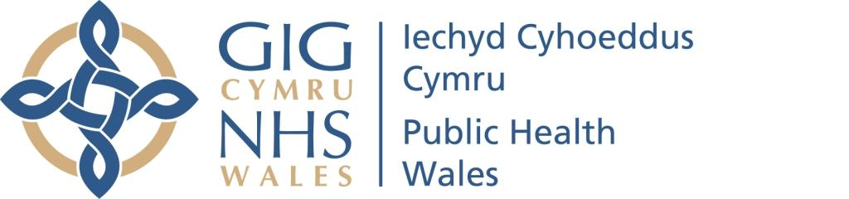

NATIONAL SAFEGUARDING TEAM (NHS WALES)

NHS WALES NOTIFICATION PATHWAY FOR LOOKED AFTER CHILDREN (LAC)

Author: LAC Steering Group (sub group to NHS Wales Safeguarding Network)
Date: September 2016 | Version: Final
Publication/ Distribution:
- NHS Safeguarding Network
- Public Health Wales (Intranet)
- LAC Health Teams across Wales
Review Date: December 2017
Purpose and Summary of Document:
Children and young people who are looked after continue to be the most socially excluded groups in society. Health Boards have a statutory responsibility to ensure the health needs of Looked After Children are met. Looked After Children experience a greater number of moves than children in the general population. Moves may involve changing Health Board areas, resulting in appointments being changed, missed, delayed or cancelled. Slow and unreliable transfer of the child’s records and health information is another factor which may contribute to poorly co-ordinated health care.
The NHS Wales Notification Pathway for Looked After Children provides standards of good practice for Health Boards and NHS Trusts working with children who are currently Looked After by the local authority.
The pathway has been produced in collaboration with all Health Boards across Wales. It aims to facilitate a safe and effective notification process to ensure that systems are in place to enable health information and health records to accompany each child or young person. There should be swift communication and transfer of all health information prior to a move or within ten days of the placement.
The NHS Wales Notification Pathway for Looked After Children will ensure that children and young people who are looked after have their health information shared promptly and appropriately with relevant persons in the area where they reside and that continuity of health care provision will be maintained and monitored.

CONTENTS

Page
1. | INTRODUCTION AND PURPOSE OF THE PATHWAY | 4
2. | AIM | 5
3. | OBJECTIVES | 5
4. | MINIMUM REQUIREMENTS | 5
5. | INFORMATION SHARING | 6
6. | REFERENCES and ACKNOWLEDGEMENTS | 7
 | Appendix 1 – Flowcharts for Placements and Notifications | 8
 | Appendix 2 – The Care Planning, Placement and Case Review (Wales) Regulations 2015: Health Care Needs Notification Form | 12

1. INTRODUCTION AND PURPOSE OF THE PATHWAY
Children and young people who are looked after continue to be the most socially excluded groups in society. Evidence shows that they share many of the same health risks and problems of their peers, but often to a greater degree and in part due to the impact of poverty, poor parenting, chaotic lifestyles and abuse or neglect before they enter the care system. Looked After Children experience a greater number of moves than children in the general population. Moving between different foster carers, homes or units can mean that health problems get overlooked. Moves may involve changing Health Board areas, resulting in appointments being changed, missed, delayed or cancelled. Slow and unreliable transfer of the child’s records and health information is another factor that may contribute to poorly co-ordinated health care.
The NHS Wales Notification Pathway for Looked After Children provides standards of good practice for Health Boards and NHS Trusts working with children who are currently Looked After by the local authority.
The pathway has been produced in collaboration with all Health Boards across Wales. It was developed by Looked After Children Health Professionals following wide consultation with colleagues in Health, Social Care and Welsh Government. It aims to facilitate a safe and effective notification process to ensure that systems are in place to enable health information and health records to accompany each child or young person. There should be swift communication and transfer of all health information prior to a move or within ten days of the placement.
The NHS Wales Notification Pathway for Looked After Children will ensure that children and young people who are looked after have their health information shared promptly and appropriately with relevant persons in the area where they reside and that continuity of health care provision will be maintained and monitored.
Health professionals must be provided with the information about each looked after child to ensure that the child receives the right services, in the right place, at the right time
Local authorities notify NHS Wales when children become looked after including those who are placed for adoption or when there is a change of circumstances, for example change of legal status, special guardianship, adoption order granted and arrangements for care leavers. Co-operation and co-production with partner agencies, whereby practitioners work together as equal partners, should underpin this process to improve well-being, the quality of care provided and support for looked after children.

2. AIM
To ensure that children and young people who are looked after have their health information shared promptly and appropriately with relevant persons in the area where they reside and that continuity of health care provision will be maintained and monitored.

3. OBJECTIVES
3.1 LAC Health Services within NHS Wales are notified of all placements of children or young people who are looked after including pre-adoption.
3.2 LAC Health Services within NHS Wales are notified when children or young people change placement, have a change of legal status, have an adoption order granted or leave care.
3.3 The child’s health record and most recent health assessment should follow each child or young person to their area of residence whilst being looked after by the local authority.
3.4 NHS Wales will share information relating to the child and young person’s general practitioner, dentist and lead health professionals involved with the child or young person to ensure continuity of care.

4. MINIMUM REQUIREMENTS
4.1 In accordance with the Social Services and Well-being (Wales) Act 2014 the responsible local authority must provide written notification to the NHS organisation providing health services and the child’s registered general practitioner prior to the child being placed, but if not possible no later than 5 working days of a child becoming looked after. The main contact for all local authorities regarding notifications of placements will be the LAC Health Service within the Health Boards and Clinical Commissioning Groups.
4.2 The LAC Health Service within the Health Board from the area of origin will be responsible for forwarding the notification and all relevant information to the key health professionals within their organisation.
4.3 LAC Health Services within the Health Boards will be responsible for ensuring the Social Worker is updated with details of all health professionals involved with the child or young person at the new placement.
4.4 Children / young people being placed out of Health Boards:
- With the exception of emergency placements, arrangements to secure appropriate health services for the child of young person should be made before they are placed.
- In addition to the routine transfer of records form completed by the Health Visitor or School Nurse, the LAC Health Service will be responsible for completing the health care needs form which will be sent to the receiving area Health Board highlighting the responsibilities of the placing area and the requests for health input in the host area.
4.5 Children / young people transferred in to Health Board area from within Wales:
The placing authority retains responsibility for the child or young person and should follow a similar notification pathway or procedure:
- It is best practice that upon receipt of a notification of a new transfer, the LAC Health Service will make contact with the child’s placement. The aim is to ensure that all the information is available and will ensure that the child’s immediate health needs are addressed.
- The LAC Health Service will ensure that the child health system and relevant patient administration systems are updated.
4.6 The Statutory Review process will ensure that health assessments are completed as requested and that individual health care plans for the looked after child or young person are implemented and reviewed.
4.7 Children / young people transferred from outside Wales:
The placing authority retains responsibility for the child or young person and should follow a similar notification pathway or procedure. If any health professionals identify looked after children, pre-adoption placements or care leavers in their area they should inform the LAC Health Service within their organisation as soon as possible.

5. INFORMATION SHARING
5.1 While it is acknowledged that practitioners need to be sure that their actions comply with all legal and professional obligations, fear that sharing genuine concerns is prevented by law is misplaced. The Data Protection Act 1998 promotes lawful and proportionate information sharing, while protecting the right of the individual to have their information fairly processed.
5.2 When sharing information with third parties, all agencies must take account of the principles set out in the Wales Accord on the Sharing of Personal Information (WASPI), and ensures that all notifications contain only the amount of information it is necessary to share.

6. REFERENCES
Social Services and Well-being (Wales) Act 2014. Part 6 – Code of Practice (Looked After and Accommodated Children)
The Care Planning, Placement and Case Review (Wales) Regulations 2015
Looked After Children Health Exchange (LACHE) 2012. Supporting and Promoting the Health Needs of Looked After Children in Wales, A Practice Guide
Department for Education and Department of Health (2015) Promoting the Health and Well-Being of Looked After Children, London: DfE and DH (Issued in England but has good practice relevance for Wales)
Welsh Assembly Government (2007). Towards a Stable Life and Brighter Future (Now replaced by SSWB(W)A but has good practice relevance)

ACKNOWLEDGEMENTS
The LAC Steering Group has representation from all Health Boards across Wales.

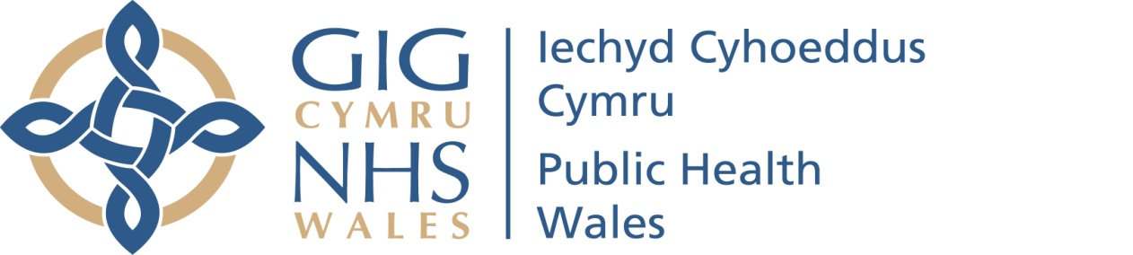
APPENDIX 1

FLOWCHARTS for PLACEMENTS
and NOTIFICATIONS

a) Flowchart for notification once In Area Placement agreed
b) Flowchart for agreeing Out of Area Placement
c) Flowchart for notification once Out of Area Placement agreed

It will be for the individual Local Authorities and Health Boards to determine who/what job title, within their agencies fulfil the stated roles

Key to abbreviations:
LA Local Authority
HB Health Board
LAC Looked After Children
SW Social Worker
OOAP Out of Area Placement
ADM Agency Decision Maker
PHW Public Health Wales

a) Flowchart for notification once In Area Placement agreed

Placement approved by ADM

IN THE CASE OF AN EMERGENCY PLACEMENT THE SAME PATHWAY
IS TO BE FOLLOWED AS SOON AS POSSIBLE

LA (e.g., SW/LAC admin) notifies
HB (e.g. LAC Health Team) via email/fax/letter
(within 5 working days)

HB (e.g. LAC Health Team) checks demographics (NHS number, DOB, GP) informs relevant health professionals of change in circumstances, e.g. Child Health Dept/LAC Nurse/LAC Health Team/Head of Safeguarding Children

SW ensures registration with GP and dentist and informs placing HB (LAC admin/Team) of details.

SW obtains (and makes available) consent for statutory Health Assessments

SW requests statutory Health Assessments via LAC Health Team (who will assist in making arrangements)

b) Flowchart for agreeing Out of Area Placement

Placing LA (e.g.: senior SW Manager) informs placing HB (e.g.: LAC nurse/LAC admin) that OOAP being considered

Key health professional collates health information. Links with HB member of multi-agency Placement Panel

- Multi-agency Placement Panel meets
- Child/YP health needs discussed
- Financial considerations agreed

In area placement considered
OOAP identified

Placing SW contacts/visits proposed placement to ensure suitable to meet Child/YP needs and liaises with HB member of the multi-agency Placement Panel

Contact details of nominated LAC leads in host area obtained

If placement suitable

OOAP approved by ADM

c) Flowchart for notification once Out of Area Placement agreed

OOAP approved by ADM

IN THE CASE OF AN EMERGENCY PLACEMENT THE SAME PATHWAY
IS TO BE FOLLOWED AS SOON AS POSSIBLE

Placing LA (e.g. SW/LAC admin) notifies
Placing HB (e.g. LAC Health Team) via email/fax/letter
(within 5 working days)

Placing HB (e.g. LAC Health Team) checks demographics (NHS number, DOB, GP) informs host Child Health Dept/LAC Nurse/LAC Health Team/Medical Adviser in Adoption*/Head of Safeguarding Children in writing. (List available on PHW Intranet)

Placing LAC Nurse/Team (health professional) completes Health Needs Form (template). Health Needs Form sent to host LAC Team. Child Health records to be transferred to host authority following local protocols

Placing SW ensures registration with GP and dentist and informs placing HB (LAC admin/Team) of details.

Placing SW obtains (and makes available) consent for statutory Health Assessments

Placing SW requests statutory Health Assessments via placing LAC Health Team (who will assist in making arrangements)

*In adoption placements, the Medical Adviser will facilitate transfer of health information/ request review directly with the Medical Adviser in the host area

APPENDIX 2

THE CARE PLANNING, PLACEMENT AND CASE REVIEW (WALES) REGULATIONS 2015
HEALTH CARE NEEDS NOTIFICATION FORM

LOOKED AFTER CHILD / YOUNG PERSON’S DETAILS
Name of Child/Young Person:
(also known as)
Date of Birth:
Gender (please tick): | Male | Female
NHS Number:
Carer’s Name:
Placement Address:

Post Code:
Telephone Number:
Is this Placement:  (please tick) | Foster Carer  Connected Foster Carer  Children’s Home  Parent & Baby Placement  Other: | Placement with parents  Residential School  Pre-Adoption Placement  Secure Children’s Home  Young Offenders Institution
Date of commencement of Placement:
Was this an emergency Placement? (please tick) |  |  | Yes No
Is the placement address to be withheld from the parent(s)? |  |  | Yes | No | Not known

CONTACT DETAILS OF KEY STAFF FROM PLACING HEALTH BOARD/LOCAL AUTHORITY
Health Board/Trust of Origin
(Commissioning)
LAC Nurse/LAC Team of Origin:
Local Authority Children’s Services of Origin: | Social Worker Name: | Tel No:
Local Authority Children’s Services of Origin: | Address:
Local Authority Education Department of Origin:

REASON FOR THE PLACEMENT (please tick)
Becomes Looked After  Pre-Adoption placement | Change of Placement  Other – please specify

CHILD / YOUNG PERSON’S LEGAL STATUS (please tick)
Accommodated  Full Care Order | Interim Care Order  Other – please specify
Is the child on Child Protection Register? | Yes | No | Not known
Is the child in touch with Youth Offending Service? | Yes | No | Not known
Date placement is due to end?
(if applicable/known)

Current GP Name & Address:

Proposed GP Name & Address:

Current Dentist Name & Address:

Current School / College:

Proposed School / College:

CHILD / YOUNG PERSON’S HEALTH INFORMATION
Does the child have any known diagnoses?

What existing health care services or treatments does the child receive?
Details of Health Professionals involved:

Any additional information regarding this child:

HOLISTIC HEALTH ASSESSMENT
Date of the last Health Assessment:
A copy of the child’s Health Assessment (please tick): | has been sent | Or is attached
When is the next Health Assessment due?
Who is going to carry out the Health Assessment?

A COPY OF THIS HEALTH CARE NEEDS NOTIFICATION FORM HAS BEEN SENT TO:
Host Health Board / Trust LAC Nurse / LAC Team:
Details:

PLEASE FORWARD TO APPROPRIATE HEALTH TEAM WITH RESPONSIBILITY FOR LAC
Name of Health Professional completing this form:

Signature: | Date:
Contact Details: | Tel No:

THE COMMUNITY RECORD WILL BE TRANSFERRED TO YOUR
CHILD HEALTH DEPARTMENT WITHIN YOUR HEALTH BOARD

