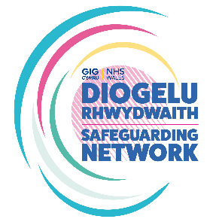
The All-Wales Female Genital Mutilation Pregnancy Pathway Audit Tool
Name of Professional conducting Audit:
Role/Designation:
Division/Department:
Timeframe of Audit
Start Date: |  | End Date:
Record Type (eg paper/electronic):
Record Reference Number/Code:

FGM Pregnancy Pathway
- Was the pregnant woman asked about FGM at booking? | Yes / No [delete as appropriate]
- If FGM has occurred was the pregnant woman referred to an Obstetrician? | Yes / No
- Was de-infibulation offered? | Yes / No / Not applicable
- Was a referral to FGM support services offered and made (eg BAWSO)? | Offered? - Yes / No  Made? – Yes / No / Declined
- Is there clear documentation that a conversation has occurred around FGM legislation in the UK? | Yes / No
- Was the DOH (2017) risk assessment completed for any female children or wider family members?  FGM Professional Guidance Forms (publishing.service.gov.uk) | Yes / No
- Were at risk Safeguarding Reports submitted?  If so, for whom? | Yes / No  Adult  Child  Unborn
- Is there evidence of a clear plan of care? | Yes / No
- Has the FGM Pathway been fully completed? | Yes / No / Partially
- Was the adult informed that FGM information will be shared with GP and other relevant professionals? | Yes / No
- Is there evidence that the Safeguarding Midwife/ Designated Safeguarding Lead and/or the Corporate Safeguarding Team have been informed of FGM disclosure? | Yes / No

Auditor’s comments:

