Man sy’n llesol i adferiad
Recovery Friendly Space

Recovery friendly spaces are here to support a positive experience when getting back out in the community. This may include spaces of safe seated areas supported by understanding and kindness. | Mae mannau sy’n llesol i adferiad yma i gynnig profiad cadarnhaol wrth fynd allan i’r gymuned unwaith eto. Gall hyn gynnwys mannau gydag ardaloedd diogel i eistedd sy’n cael eu cynnal gan ddealltwriaeth a charedigrwydd.
Shops and business will display the following signs when: | Bydd siopau a busnesau yn arddangos yr arwyddion canlynol pan:
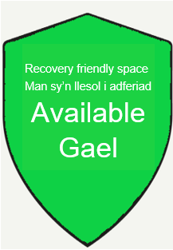  Fydd mannau sy’n llesol i adferiad ar gael Recovery friendly spaces are available | 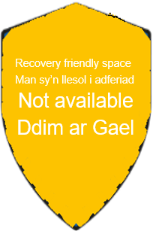  Na fydd mannau sy’n llesol i adferiad ar gael  Recovery friendly spaces are not available
Initiative activities / Gweithgareddau menter
Extra Cleaning Measures - Mesurau glanhau ychwanegol

List of business and shops Rhestr o fusnesau a siopao

Iceland
Display materials to support social distancing
Monday’s are their quietest times
Little Rose Café
Display materials to support social distancing
Safe Resting Areas
Priority tables and services
Post Office
Display materials to support social distancing
Best Wishes Card Shop
Display materials to support social distancing
Considering priority times
Safe Resting Areas
Mad Images Hair & Beauty
Display materials to support social distancing
Priority times for people
Kalan Café Takeout
Display materials to support social distancing
Howells Menswear
Display materials to support social distancing
A T Davies Newsagents
Display materials to support social distancing
Safe Resting Areas
ABC Domestics
Display materials to support social distancing
Safe Resting Areas
Lloyds Chemist
Display materials to support social distancing
Sheppards Chemist
Display materials to support social distancing
Hair By Sian 46 Oxford Street
Display materials to support social distancing
Priority times for people
Safe Resting Areas
Pet Shop 42 Oxford Street
Display materials to support social distancing
CJ Barber 36 Oxford Street
Display materials to support social distancing
Priority times for people
Safe Resting Areas
Butchers 34 Oxford Street
Display materials to support social distancing
Safe Resting Areas
Friary 30 Oxford Street
Display materials to support social distancing
Fruit shop & Butcher 23 Oxford
Display materials to support social distancing
Safe Resting Areas
Hair Culture
Display materials to support social distancing
Mountain Ash Embroidery 18 Oxford Street
Display materials to support social distancing
Priority times for people
Safe Resting Areas
Bazzare 17 Oxford Street
Display materials to support social distancing
Priority times for people
Safe Resting Areas

