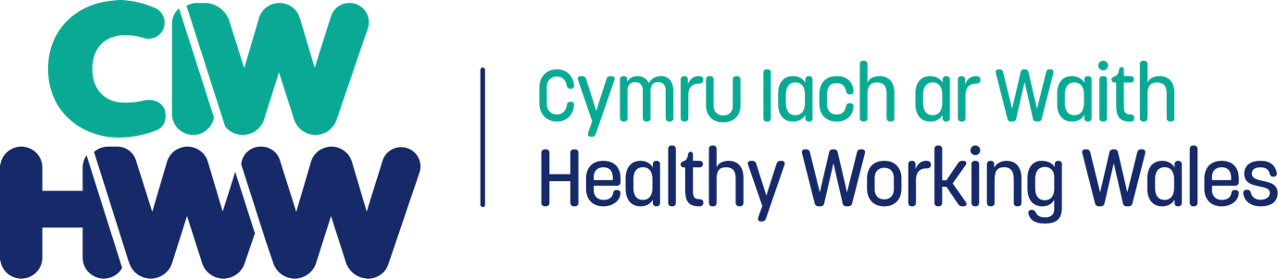

Healthy Working Wales –

A Guide for Corporate Health Standard Enhanced Status Checks

August 2022
Introduction

This guide is intended to help you to prepare for your forthcoming Enhanced Status Check (ESC) assessment. It outlines the process and what you can expect, as well as giving answers to the most frequently asked questions.

If you have any further questions, please contact Healthy Working Wales (HWW) at WorkplaceHealth@wales.nhs.uk who will be able to help you.

Very best of luck for your Enhanced Status Check!

The Enhanced Status Check process

Step 1
You will receive an email from Healthy Working Wales inviting you to have an ESC to extend your CHS award by a period of 12 months.

Step 2
Once HWW receive confirmation from you that you would like to proceed, your HWW Adviser will be in contact with you to:
a) talk you through the process, and
b) go through the documentation that you will need to complete, including the detail required.

Step 3
You will be required to complete a template in advance of your ESC. The purpose of the template is to capture a summary of the progress your organisation has made since your last CHS Assessment / Status Check.
In addition to the completed template, you are also required to submit 3-5 key pieces of evidence that demonstrate your ‘planned approach to wellbeing’. Examples include:
- An action plan (*essential*). NB This action plan does not necessarily need to be your CHS Action Plan, however it must be a planning document that demonstrates your organisation’s planned approach.
- Health and Wellbeing Strategy / Policy
- Calendar of events
- Monitoring and Evaluation e.g. surveys and feedback
- Minutes of meetings / Board reports
- Other

Step 4
You are required to return the completed template to HWW, along with your evidence, and a timetable for the ESC (please see suggested timetable on page 5). Please return your completed ESC template to the HWW email account – workplacehealth@wales.nhs.uk

Step 5
Once your HWW Adviser is satisfied that your organisation is ready for the ESC and that the relevant ESC template and supporting evidence has been received, you will be asked to provide your availability / dates for your ESC to take place.
An assessor from Emma George Consulting will then be assigned to your organisation. Details of your Assessor will be shared with you in advance of the ESC.

Step 6
Your ESC meeting is held via an online video meeting, which you are required to host. Please allow up to 1.5 hours for this meeting.

Step 7
Following your successful ESC meeting, you will receive a brief feedback report from your assessor, along with an electronic certificate from HWW that confirms the extension of your award for a period of 12 months.
Example Timetable for an Enhanced Status Check
The timetable below sets out the necessary components of an ESC, the order that these should take place, and suggested timings for each of these components. The timings may be adapted to suit your organisation.

10.00 am | Meet with CHS lead and key representatives of the health and wellbeing group (e.g. Health & Safety Lead, Occupational Health Lead, Mental Health First Aider Lead/Champion, Digital Communications Lead), may also include member of senior management team, employee not on working group.
11.00 am | Presentation/ discussion on the healthy lifestyle topic that you have chosen
11.20 pm | Reconvene working group to give high level feedback and confirmation of award extension
11.30 pm | Close

Frequently Asked Questions

Q1) How many members of our working group should attend the ESC meeting?
We suggest a maximum of 5 people in this meeting so that everyone on the call can have the opportunity to contribute.

Q2) What do I need to prepare in advance of the ESC?
You are required to complete the template that you are sent, and to return this along with your key pieces of supporting evidence, and a timetable for the ESC to HWW – workplacehealth@wales.nhs.uk

Q3) How is the ESC meeting conducted?
The meeting is held in a ‘question and answer’ format, with the assessor using your completed template and key pieces of evidence as the basis for any further questions and discussions. The aim is for the experience to be positive and developmental in nature.

Q4) How long will the ESC take?
You should allow up to 1.5 hours for the ESC meeting.

Q5) How can I best prepare for the ESC?
In advance of the ESC, it would be useful to give some thought about the following:
- How health and wellbeing has changed within your organisation since your last assessment, and particularly since the Covid pandemic
- How health and wellbeing is planned and organised in your organisation
- How you engage staff with the health and wellbeing agenda / activities
- The ways that data is collected and used to inform strategy, goals and objectives
- Future aspirations for employee health and wellbeing
- How mental and emotional health and wellbeing is promoted.

Q6) What will I receive following the ESC?
Following your ESC you will receive a summary feedback report from your assessor. The report will capture the strengths of your organisation’s approach to health and wellbeing, as well as any suggestions for further development.
You will also receive an electronic certificate from HWW that extends your current award for a period of 12 months (from the date of the ESC).

