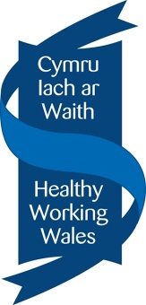

Status Check: Organisation Summary

Introduction
The five questions below are intended to help us understand and give a bit more context to your organisation, prior to our conversation together.
Don’t worry if you are struggling to answer any of the questions fully, we can have a chat about these during the status check meeting.
Please send the completed form to:
Healthyworkingwales@emmageorgeconsulting.co.uk
at least 5 working days prior to the status check meeting.
We look forward to talking with you.

Name of Organisation:
Contact name:
Role in organisation:
Contact number:
Contact email address:

Q1. Please briefly describe the current operational status of your organisation e.g. is it fully operational? Have you had to furlough employees? Have you had to suspend any social projects / volunteering opportunities etc? Implementation of new travel plans?
(Approximately 300-500 words)
Q2. What has been the impact on your organisation’s approach to sustainability in the areas covered by the Platinum award?
(Approximately 200-300 words per area)
Transport
Procurement

Facilities Management

Capital build

Employment and skills

Community Engagement

Q3. How have you continued to support and develop the case study project from your Platinum award assessment?
(Approximately 300-500 words)
Q4. How have the development points from your last assessment been addressed?
(Approximately 300-500 words)
Q5. Going forward, what would you consider to be the top three challenges for your organisation in terms of its approach to sustainability?
(Approximately 300-500 words)
1.
2.
3.
Q6. What are your greatest achievements during the pandemic? Is there anything that you are particularly proud of?

Thank you
Diolch yn Fawr

