

Patient zone

**Simple Wound Care** *for the ANTT Practice Framework see:* www.**antt**.org

**using Standard-ANTT** (Improvise the work surface for the Community setting)

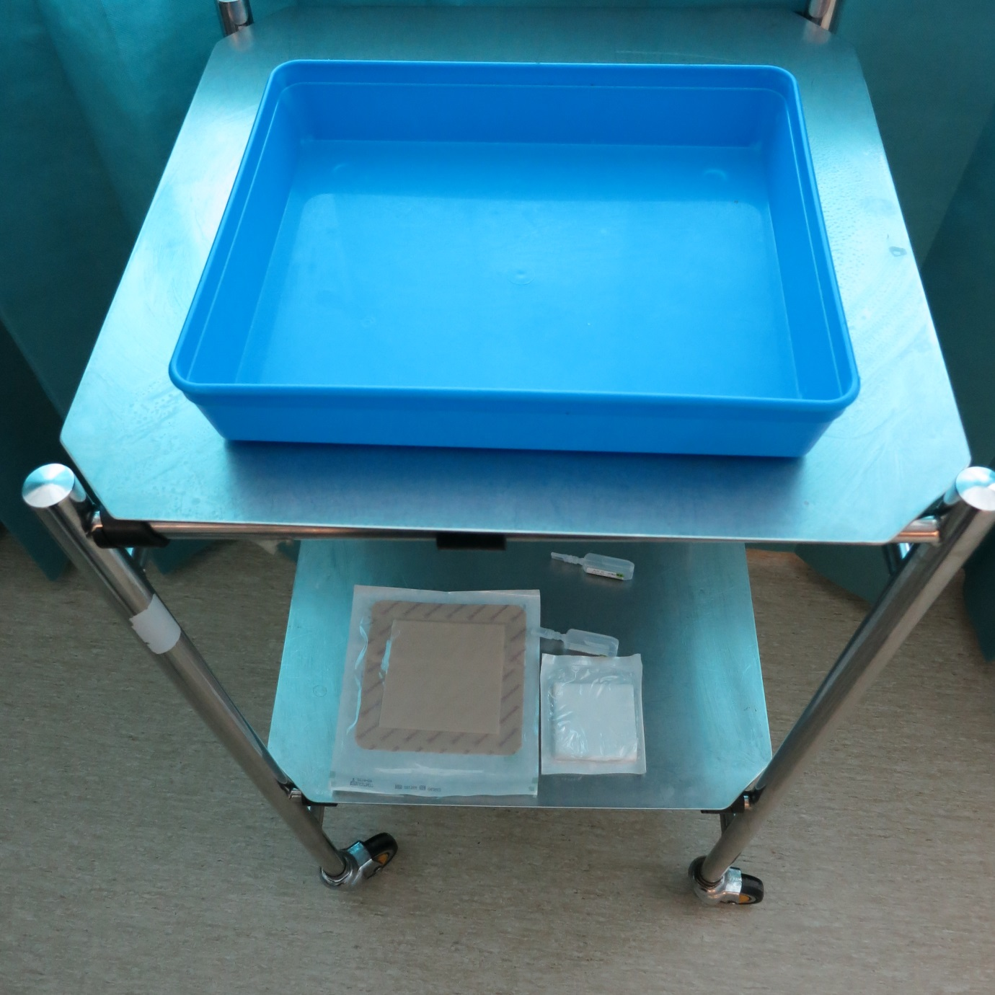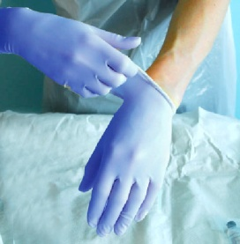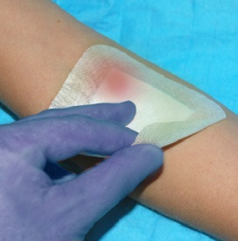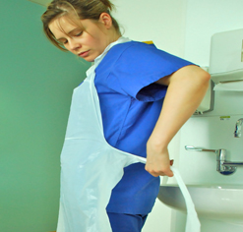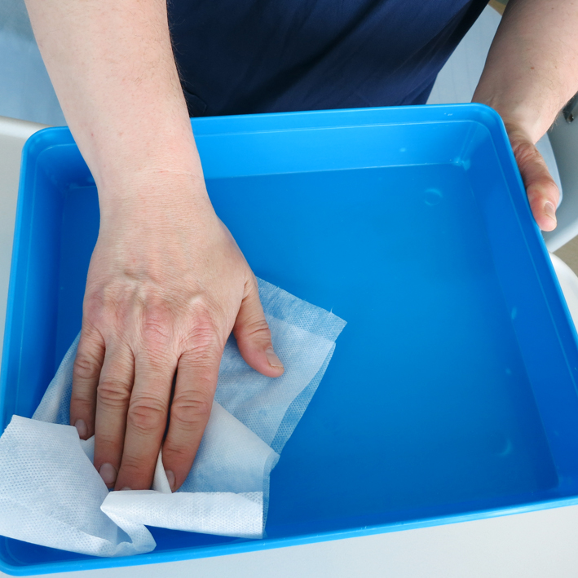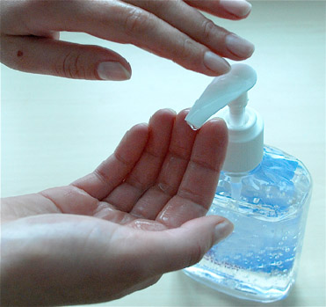

**6**

**3**

**5**

**4**

**2**

**1**

Preparation zone

**Apply apron & clean hands**

**Gather supplies**

**& place on bottom shelf of trolley**

**Clean trolley & tray according to local policy creating a Main General Aseptic Field**

**Remove dressing using non-touch technique (NTT)**

**Apply non-sterilized gloves**

**Clean hands with alcohol hand rub or soap & water**

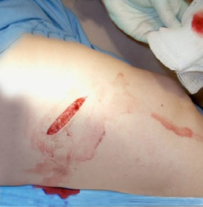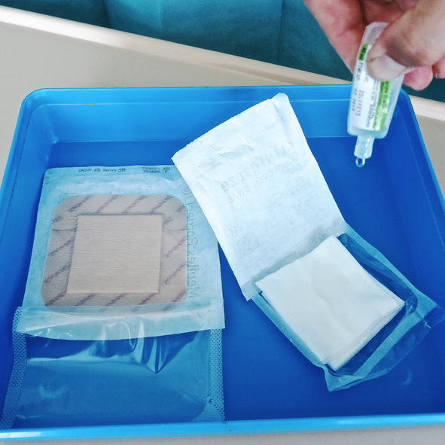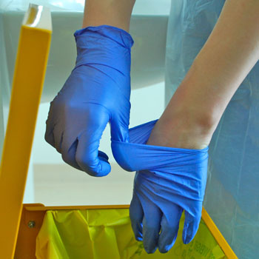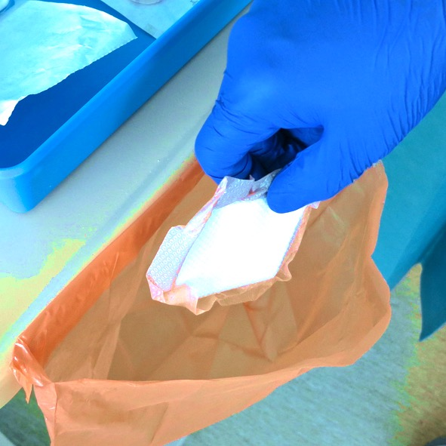

**12**

**9**

**8**

**7**

**10**

**11**

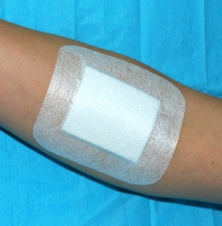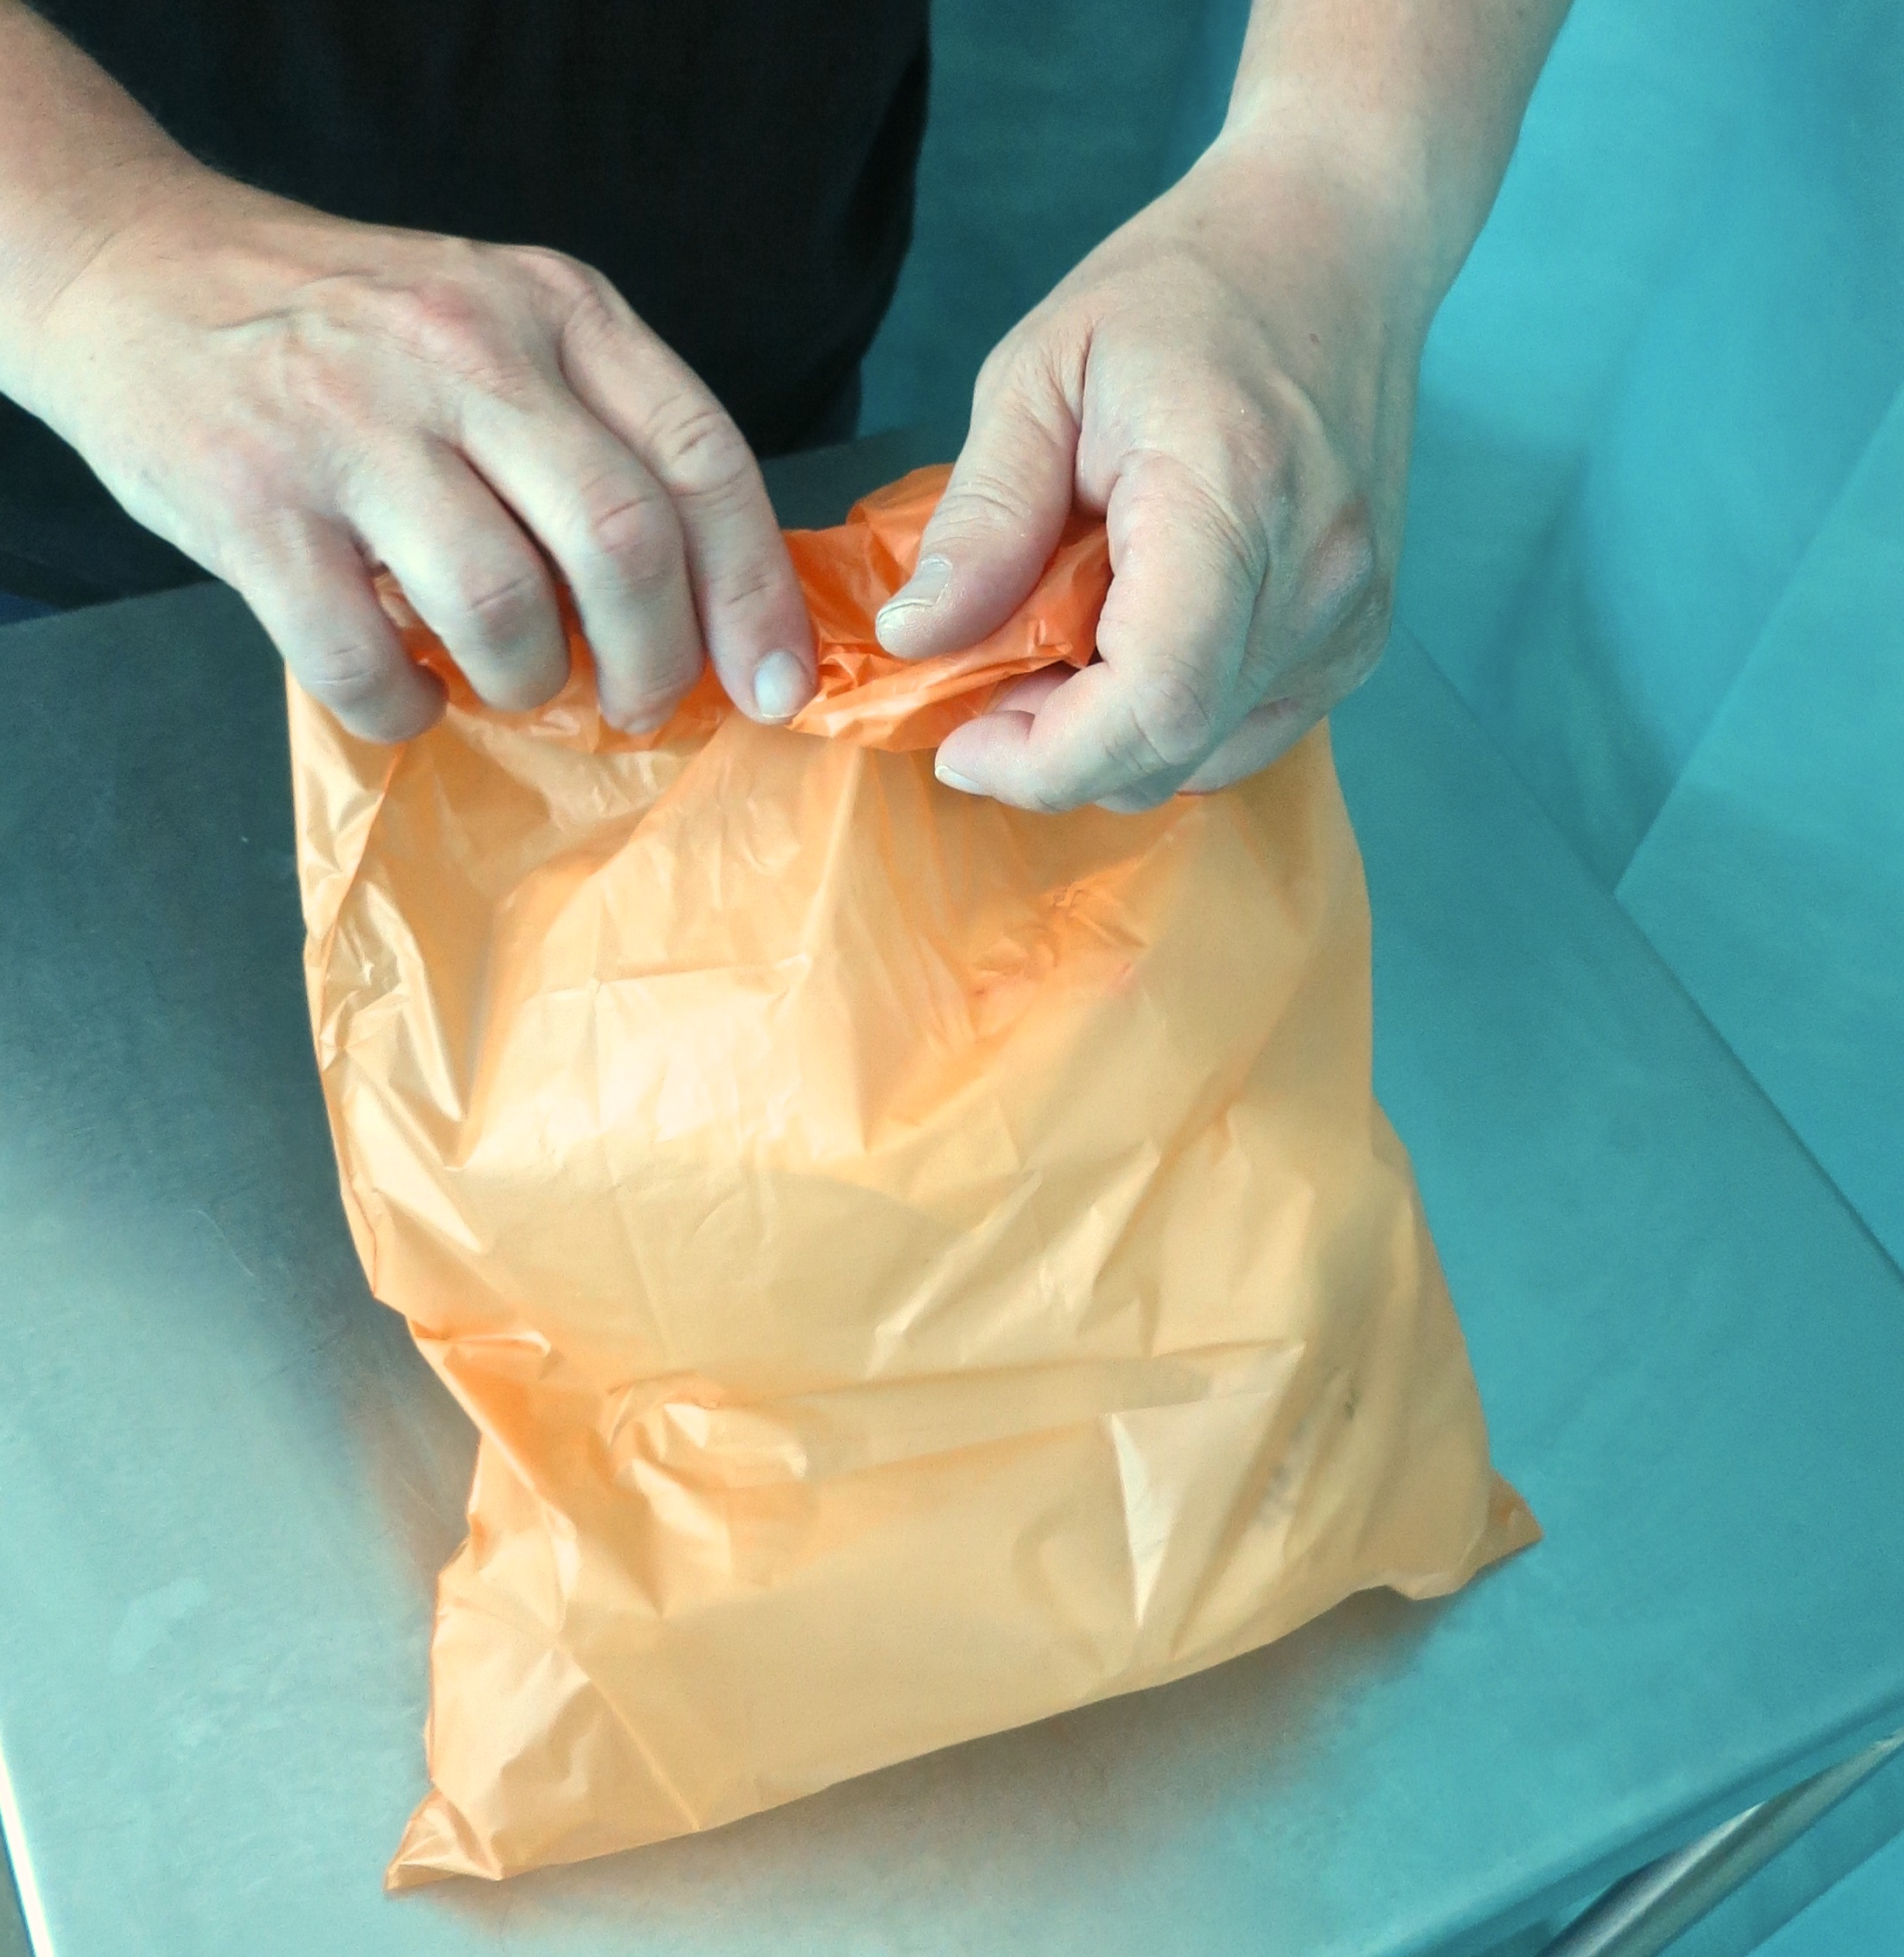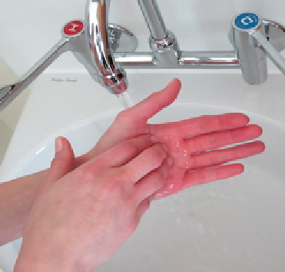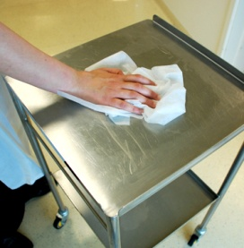

**Clean hands**

**with alcohol hand**

**rub or soap & water**

**Clean tray**

**& trolley according**

**to local policy**

**Clean hands**

**with alcohol hand rub or soap & water**

**Clean hands**

**with alcohol hand rub or soap & water**

**Dispose of equipment waste & gloves then apron & immediately…**

**Open supplies**

**Protect within Micro Critical Aseptic Fields & NTT – on a General Aseptic Field**

**Clean wound using NTT**

**Dress wound using NTT**

**Dispose of gloves**

**Dispose of dressing**

**Apply non-sterilized gloves & assemble equipment using NTT**

**1718**

**15**

Decontamination Zone

**Your Hospital Logo Here**

**13**

**14**

**16**

ANTT® © 2017 v1.1