

Patient zone

**Complex Wound Care** *for the ANTT Practice Framework see:* www.**antt**.org

**using Surgical-ANTT** (Improvise the work surface for the Community setting)

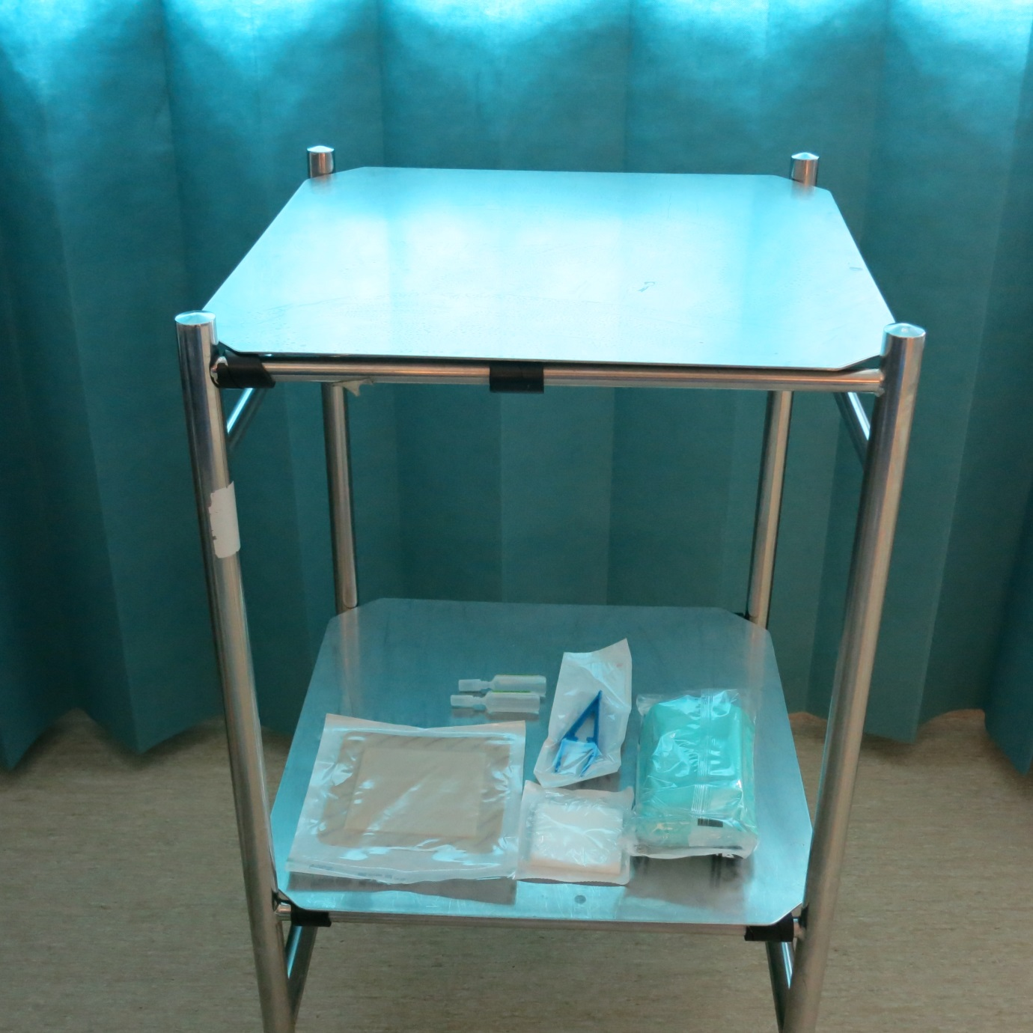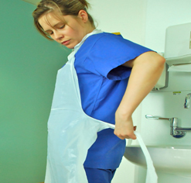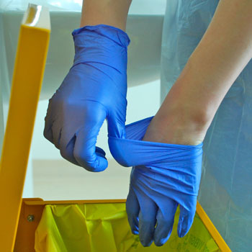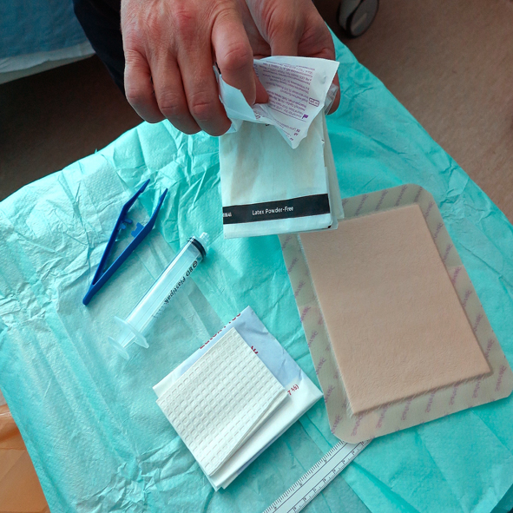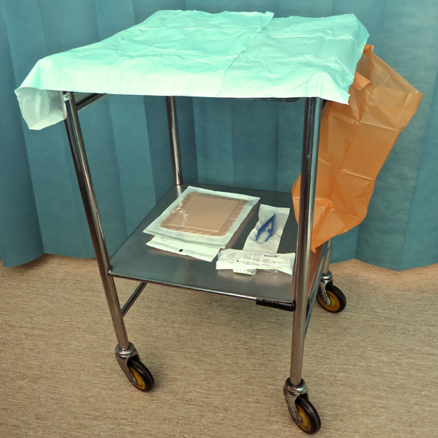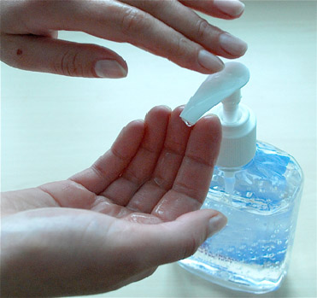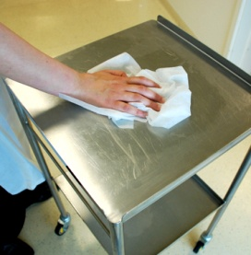

Preparation zone

**4**

**10**

**Dispose of gloves**

**3**

**6**

**5**

**Open equipment**

**using NTT**

**2**

**1**

**Clean trolley**

**according to local policy**

**Apply apron**

**& clean hands**

**Open Critical Aseptic Field (sterilized drape)**

**using NTT**

**Gather dressing**

**pack & equipment &**

**place on bottom shelf**

**Clean hands**

**with alcohol hand rub or soap & water**

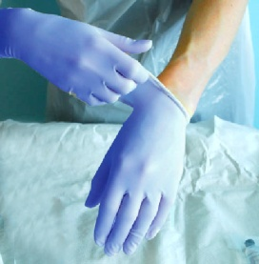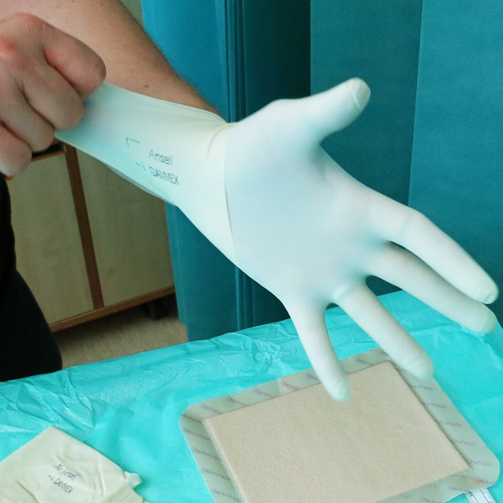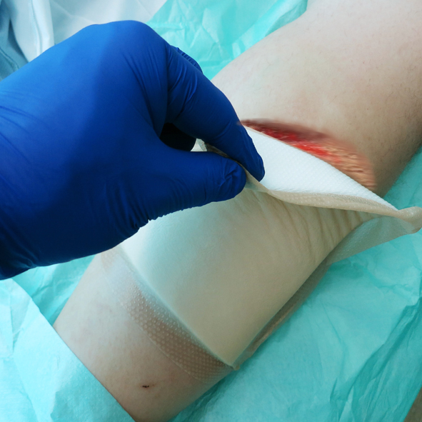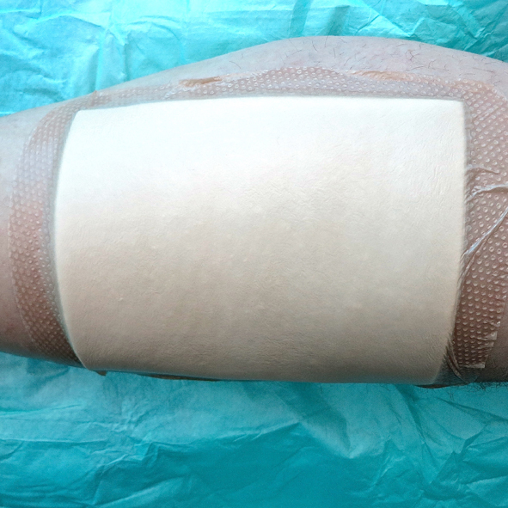

**9**

**11**

**8**

**12**

**7**

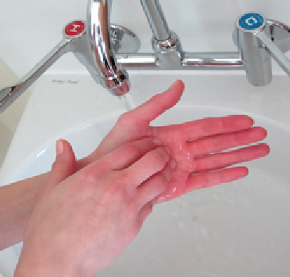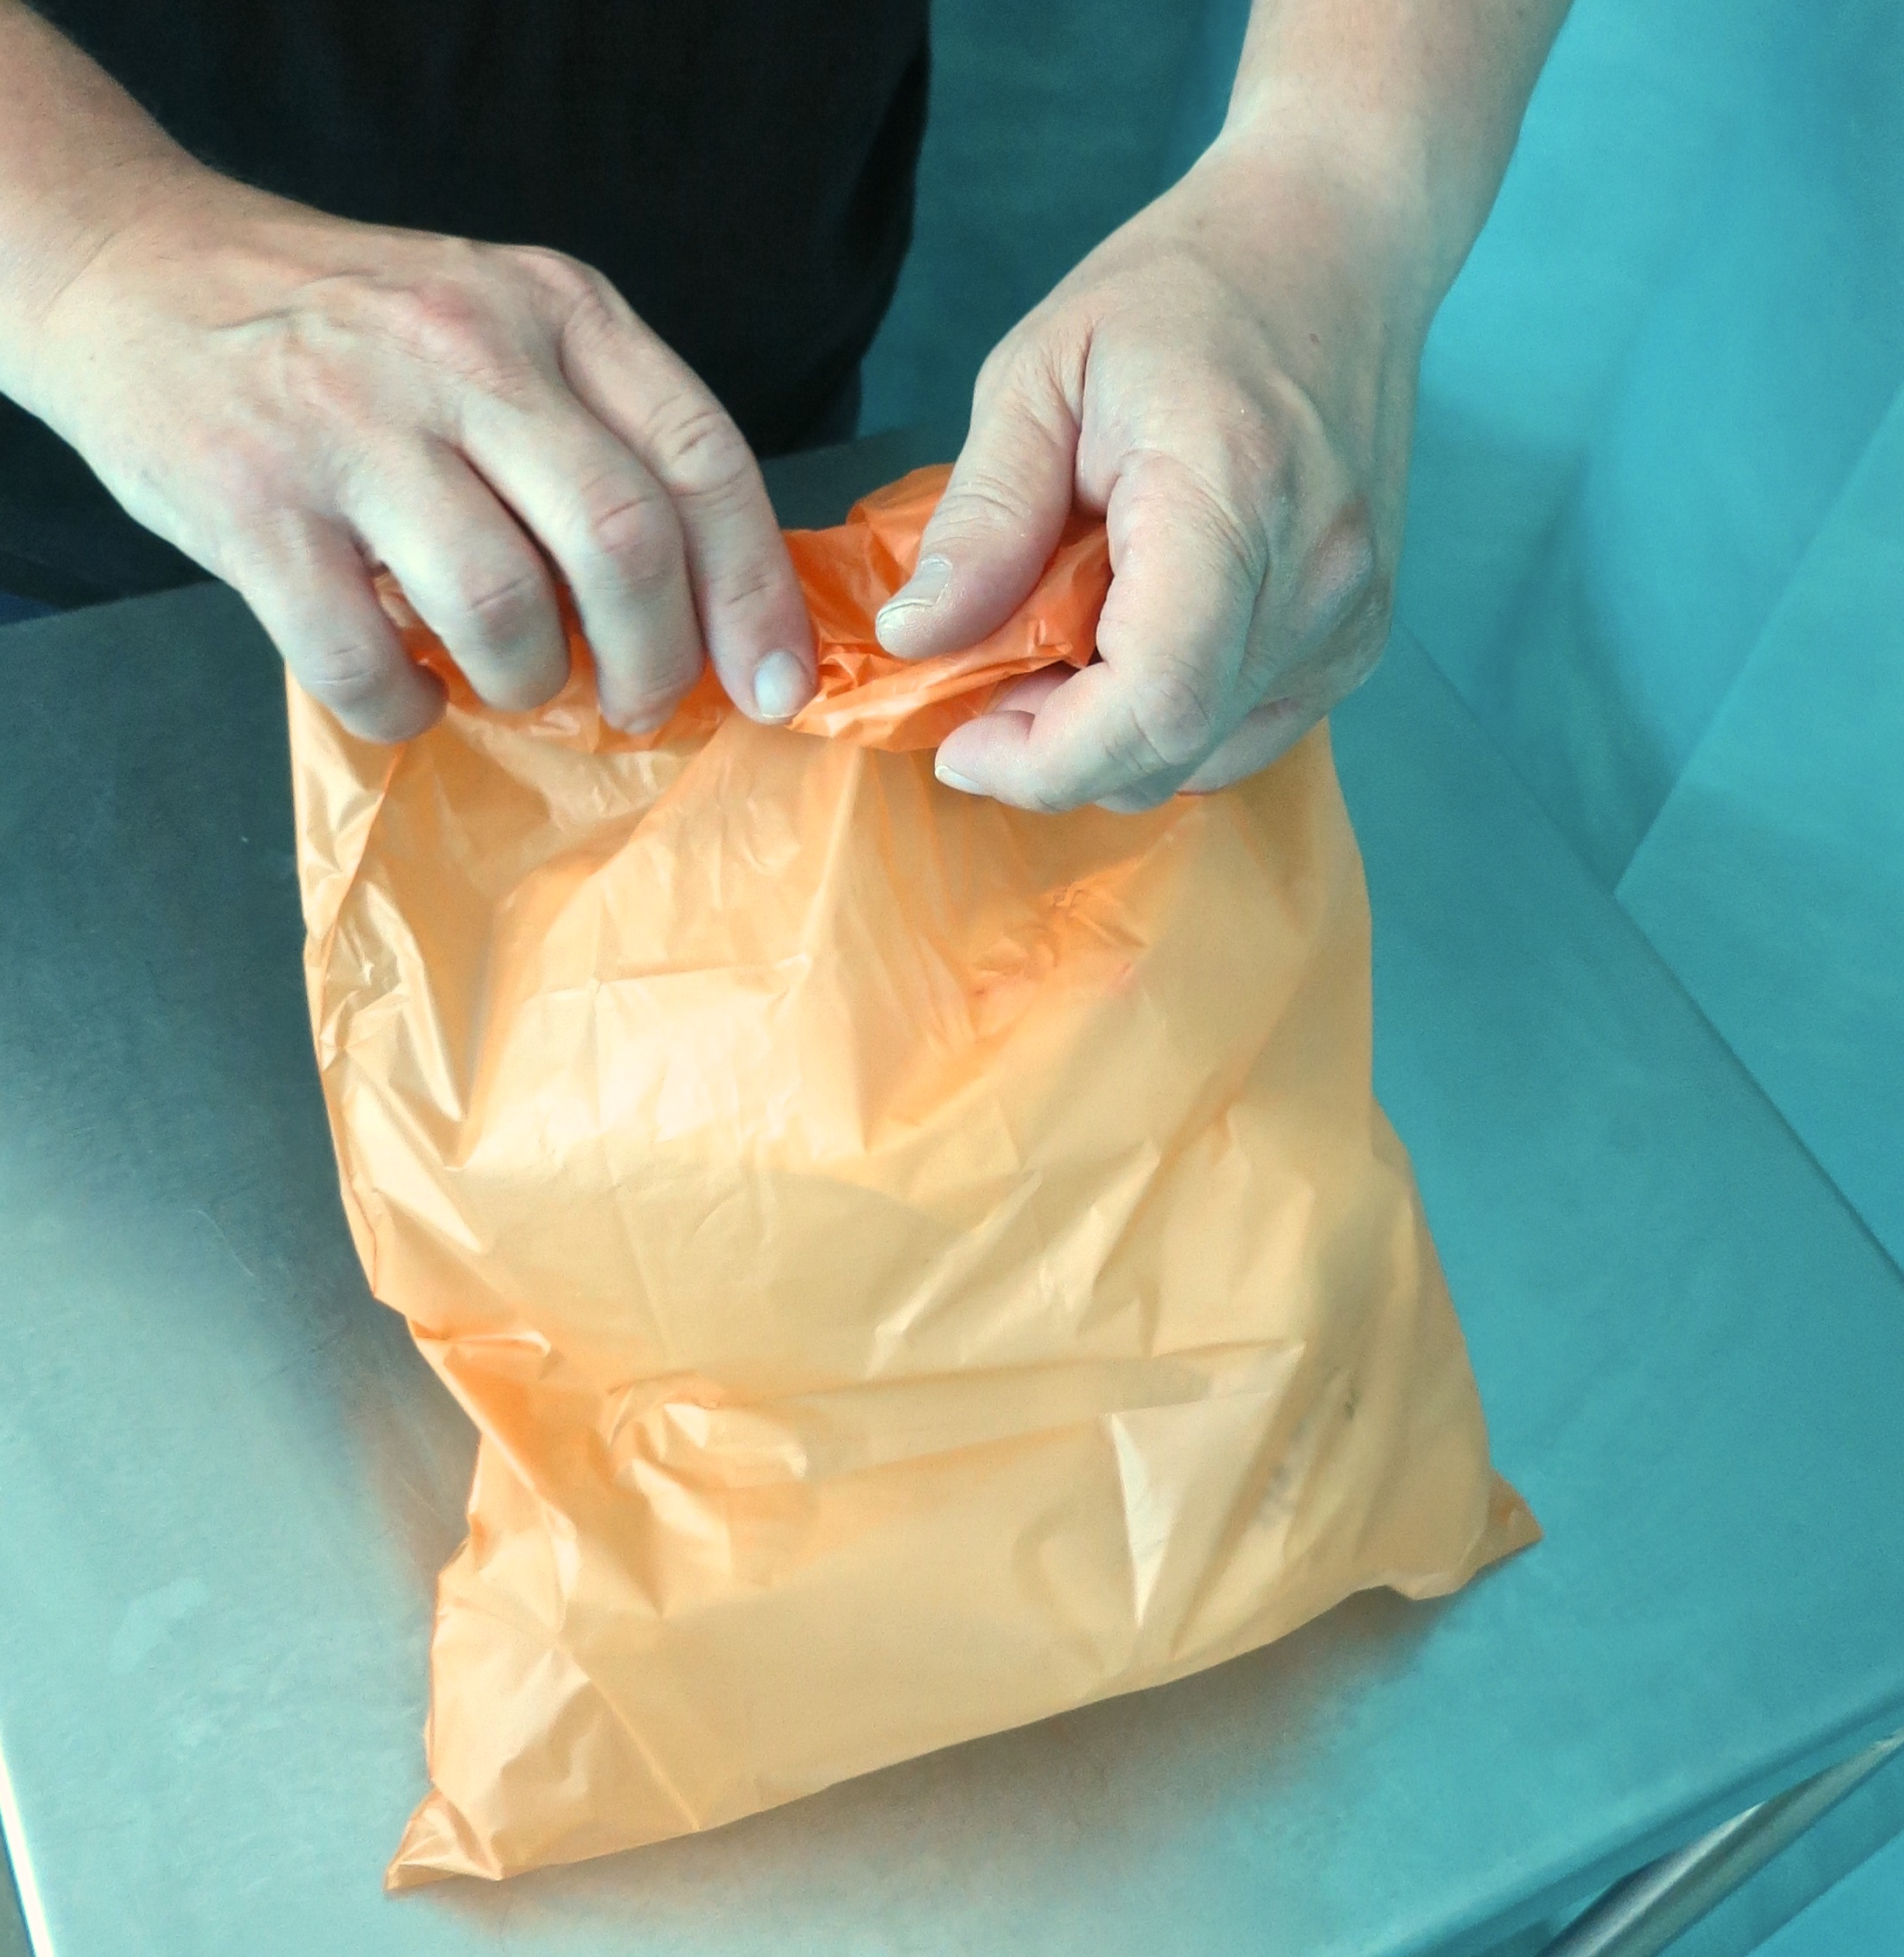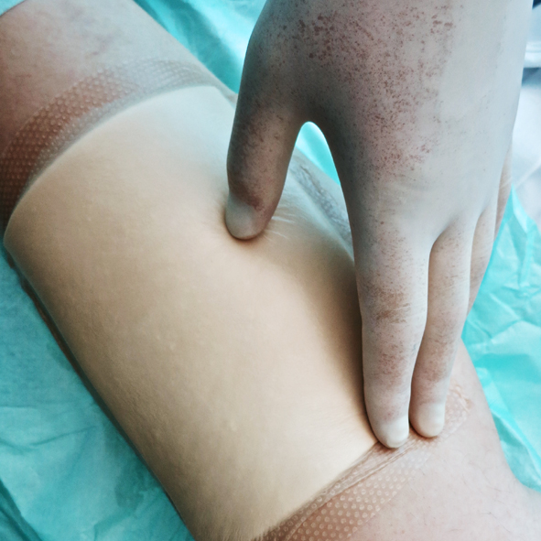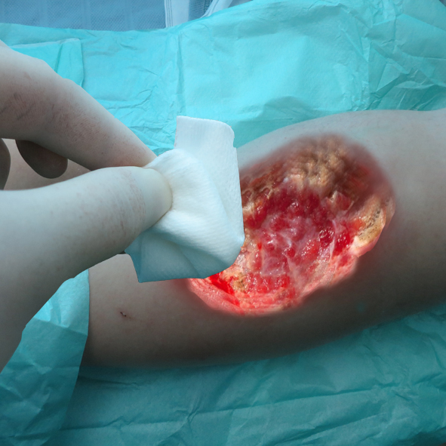

Decontamination zone

**Clean hands**

**with alcohol hand rub or soap & water**

**Clean trolley according to**

**local policy**

**17**

**18**

**Dispose of equipment, waste, gloves & apron, then …**

**13**

**14**

**15**

**16**

**Clean hands**

**with alcohol hand**

**rub or soap & water**

**Clean hands with alcohol hand rub or soap & water**

**Apply non-sterilized gloves**

**Place sterilized drape under the wound**

**Apply sterilized gloves**

**Clean wound**

**using NTT**

**Dress wound**

**using NTT**

**Remove dressing**

**using NTT & dispose**

**of dressing in waste bag**

**Your Hospital Logo Here**

ANTT® © 2017 v2.0