

**Community Peripheral Venepuncture**

(Using Standard-ANTT)

*for the ANTT Practice Framework see:* www.**antt**.org

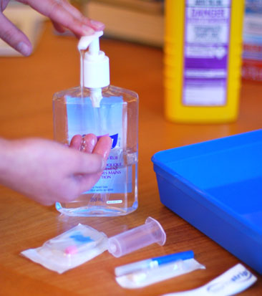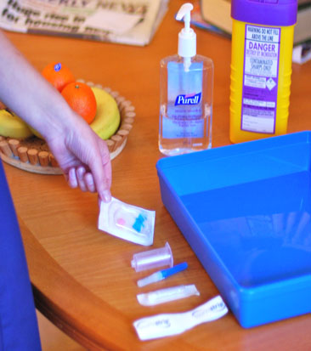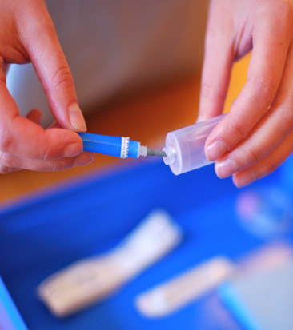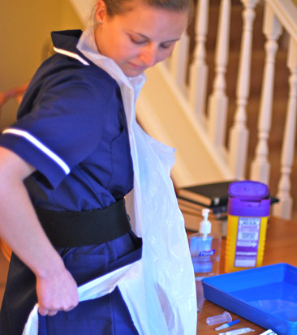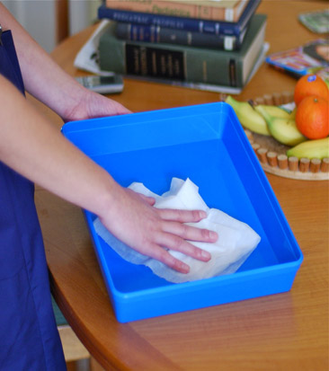

**3**

**4**

**5**

**1**

**2**

**Type your Hospital or Community name here**

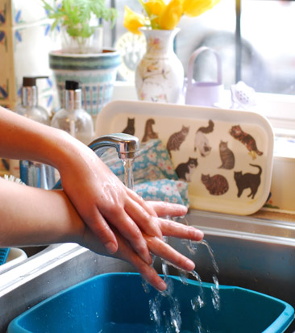

**Prepare Equipment**

**protecting Key-Parts with non-touch technique (NTT) & Micro Critical**

**Aseptic Fields (Caps & Covers)**

**Clean hands**

**with soap & water or**

**alcohol hand rub**

**Gather equipment**

**and place around tray**

**Apply disposable**

**apron**

**Clean tray according**

**to local policy – creating**

**a General Aseptic Field; whilst it dries . . . .**

**When entering the patient’s home clean hands**

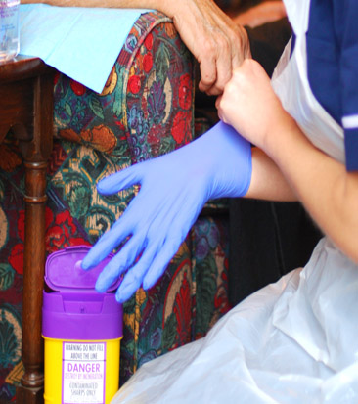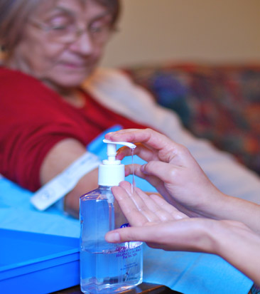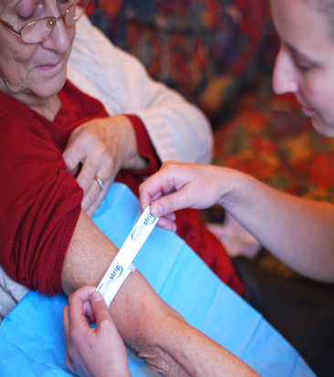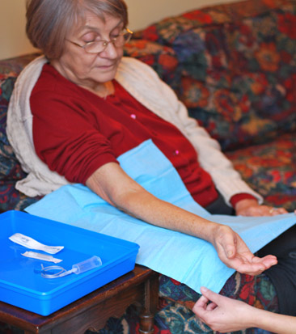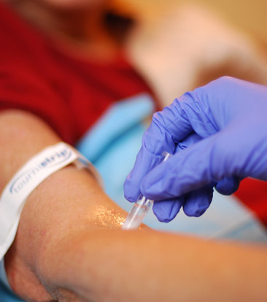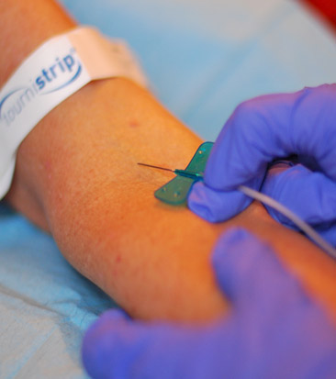

**7**

**100**

**6**

**9**

**8**

**11**

**7**

**if attempt to**

**draw blood is unsuccessful**

**return**

**to step**

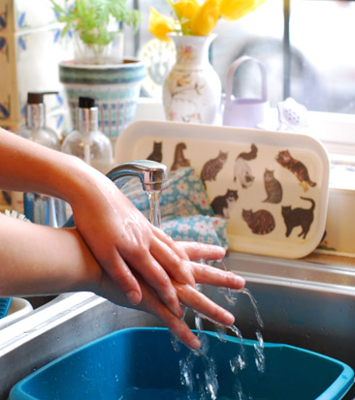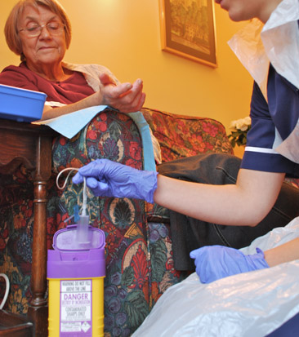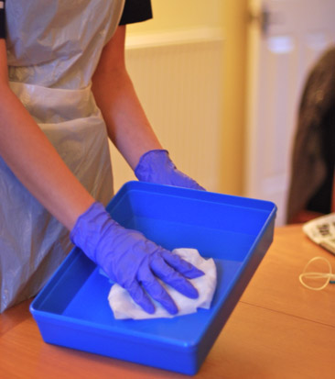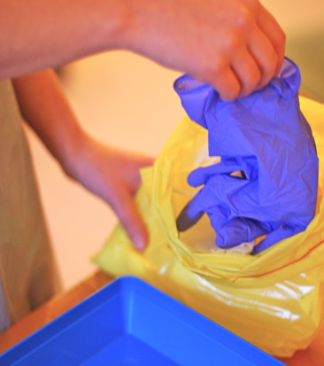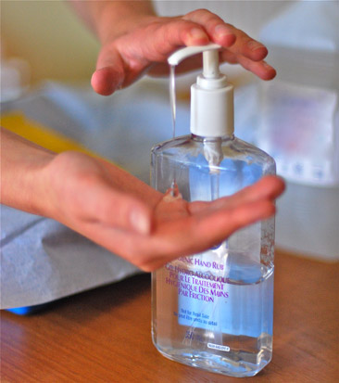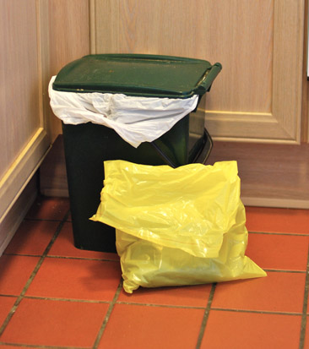

**Apply non-sterilized gloves. Or sterilized gloves if the Key-Key-site must be touched.**

**Re-apply tourniequet**

**Dispose of gloves,**

**then apron and**

**immediately…**

**When leaving the patient’s home**

**clean hands**

**13**

**14**

**12**

**16**

**15**

**Dispose of sharps**

**and equipment**

**Clean tray**

**according to local**

**policy**

**Clean hands**

**with alcohol hand**

**rub or soap & water**

**Dispose of waste**

**bag according to**

**local policy**

**Place sterilized**

**drape under the**

**patients’ arm**

**arm**

**Apply disposable**

**tourniquet & palpate**

**vein. Release tourniquet**

**Clean hands**

**with soap & water or**

**alcohol hand rub**

**Access patient’s vein**

**protecting Key-Parts &**

**Key-Sites using NTT**

**Clean skin with a 2% chlorhexidine/70%**

**alcohol applicator using a**

**cross hatch method for**

**30 sec. Allow to dry**

ANTT® © 2016 v1.1

**Your Hospital Logo Here**