

**Community peripheral & central IV therapy**

(Using Standard-ANTT) **(***Using a plastic tray for a General Aseptic Field)*

*for the ANTT Practice Framework see:* www.**antt**.org

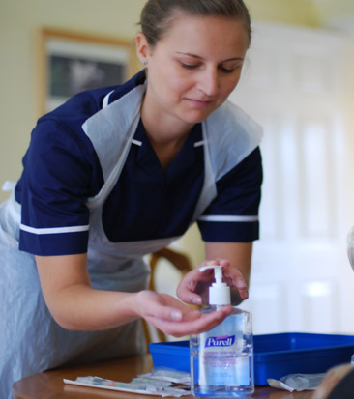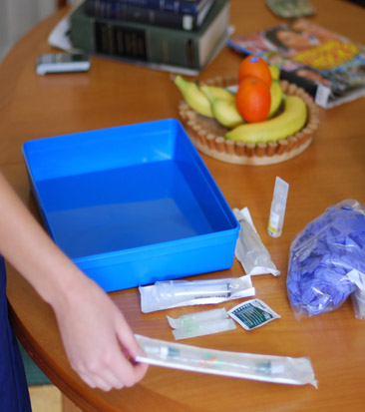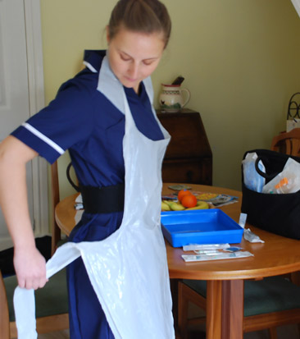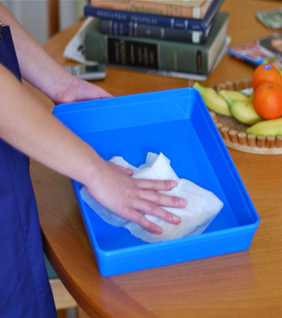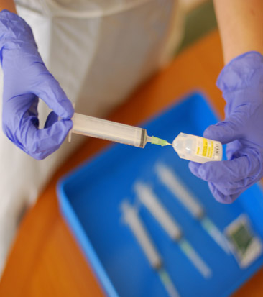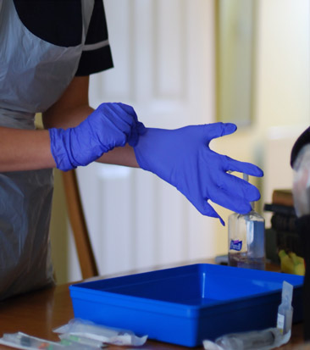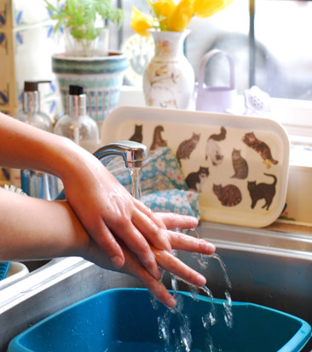

**5**

**4**

**3**

**2**

**1**

**6**

**Prepare Equipment protecting Key-Parts with**

**non-touch technique (NTT)**

**& Micro Critical Aseptic**

**Fields (Caps & Covers)**

**Apply non-sterilized gloves. Or sterilized gloves if Key-Parts / Key-Sites must be touched**

**Apply disposable apron**

**Clean tray according**

**to local policy – creating**

**a General Aseptic Field;**

**whilst it dries . . .**

**Gather equipment**

**& place around tray**

**Clean hands**

**with alcohol hand**

**rub or soap & water**

**When entering the patient’s home clean hands**

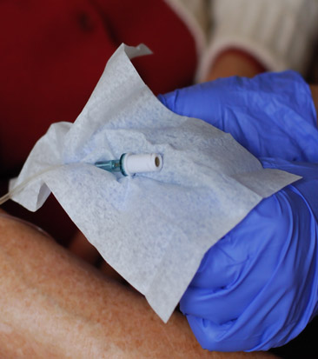

**Scrub the IV Hub**

**- Using NTT, use a 2%**

**Chlorhexidine / 70% alcohol wipe**

**- Scrub the port tip for total of**

**15 seconds using different areas**

**of the wipe**

**- Then wipe away from the tip**

**- Allow to dry before use**

**7**

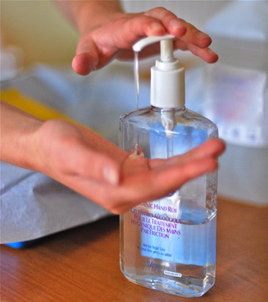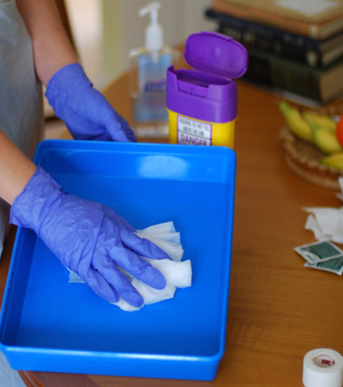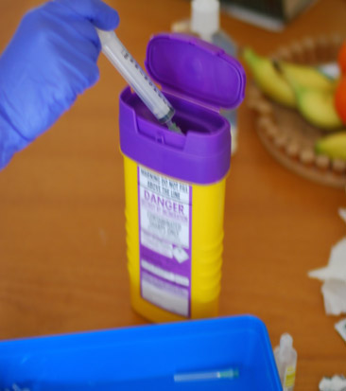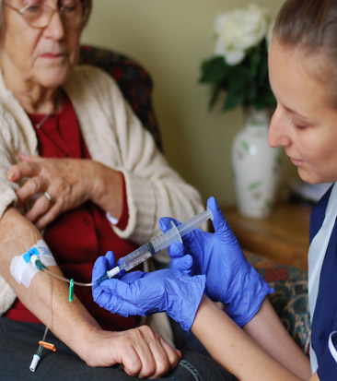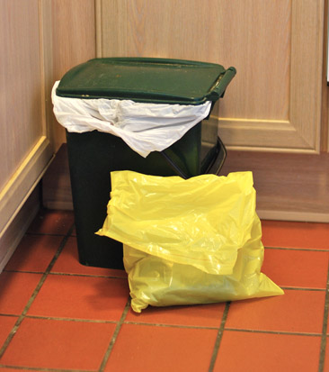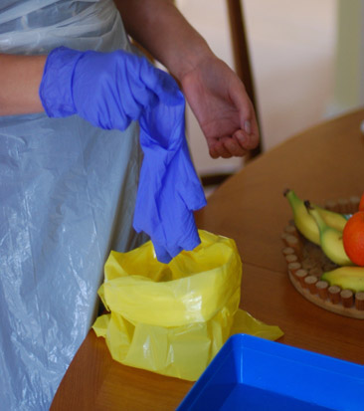

ANTT® © 2016 v1.0

**Your Hospital Logo**

**6a**

**6b**

**if, your gloves have been contaminated, clean your hands & re-glove**

**Proceed to the patient and…**

**if your gloves have not been contaminated**

**Dispose of sharps and equipment**

**Clean tray**

**according to local**

**policy**

**Clean hands**

**with soap & water or**

**alcohol hand rub**

**When leaving the patient’s home**

**clean hands**

**11**

**11**

**10**

**Dispose of waste**

**bag according to**

**local policy**

**16**

**9**

**8**

**Dispose of gloves,**

**then apron and**

**immediately …**

**Administer drugs**

**using NTT**