

*for the ANTT Practice Framework see:* www.**antt**.org

**Community peripheral & central IV therapy**

(Using Standard-ANTT) (Using a single use pack for a General Aseptic Field)

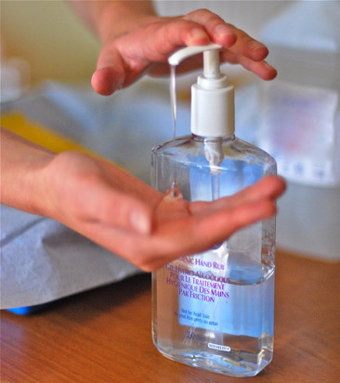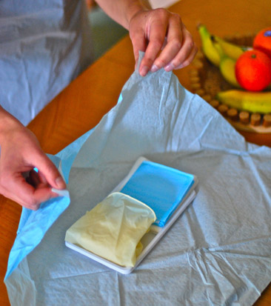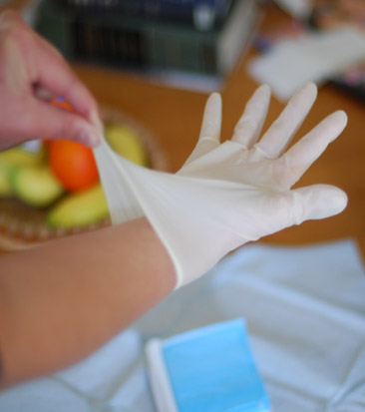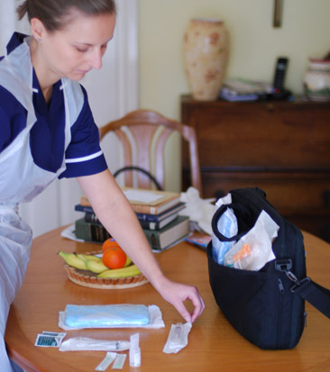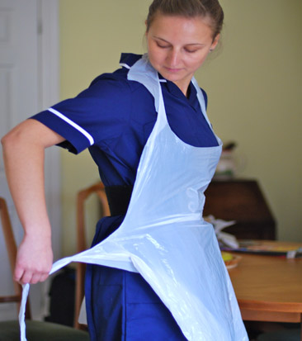

**6**

**1**

**2**

**3**

**4**

**5**

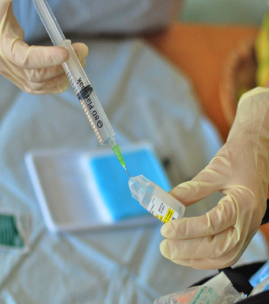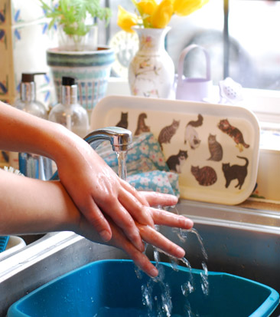

**When entering the patient’s home clean hands**

**Prepare Equipment**

**P rotecting Key-Parts with**

**NTT & Micro Critical Aseptic Fields (Caps & Covers)**

**Open pack**

**Manage as a General Aseptic Field using non-touch technique (NTT)**

**Apply disposable apron**

**Clean hands**

**with alcohol hand**

**rub or soap & water**

**Gather equipment**

**& place around the pack**

**Apply non-sterilized gloves. Or sterilized gloves if Key-Parts / Key- Sites must be touched**

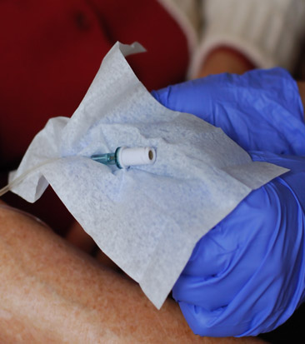

**7**

**Scrub the IV Hub**

**- Using NTT, use a 2%**

**Chlorhexidine / 70% alcohol wipe**

**- Scrub the port tip for total of**

**15 seconds using different areas**

**of the wipe**

**- Then wipe away from the tip**

**- Allow to dry before use**

**Proceed to the patient and…**

**if your gloves have not been contaminated**

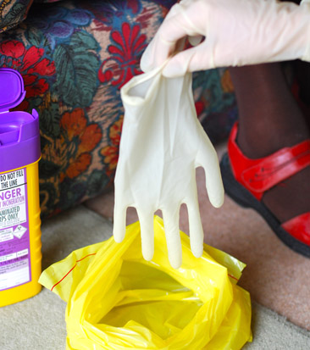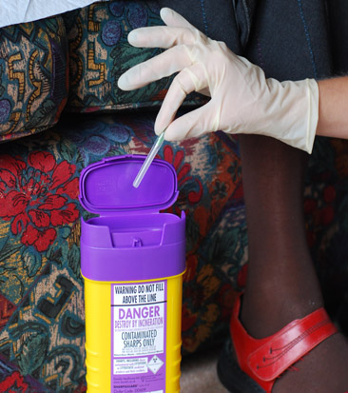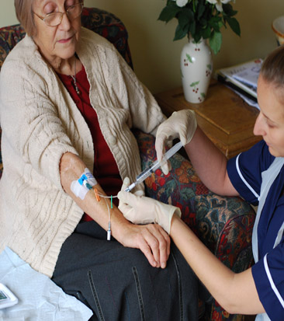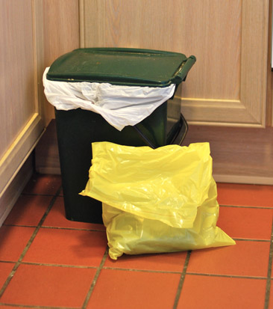

ANTT® © 2016 v1.0

**Your Hospital Logo Here**

**6a**

**6b**

**if, your gloves have been contaminated, clean your hands & re-glove**

**Clean hands**

**with soap & water or**

**alcohol hand rub**

**Dispose of waste**

**bag according to**

**local policy**

**Dispose of gloves,**

**then apron and immediately …**

**Dispose of sharps**

**and equipment**

**11**

**10**

**9**

**8**

**12**

**Administer drugs**

**using NTT**

**When leaving the patient’s home**

**clean hands**