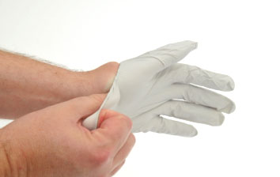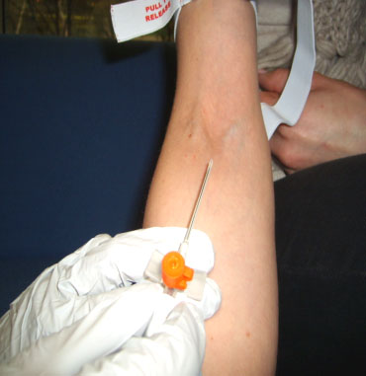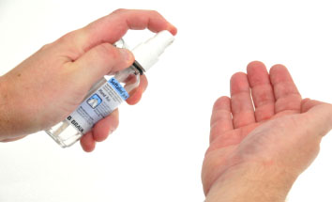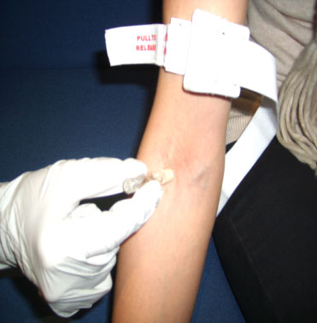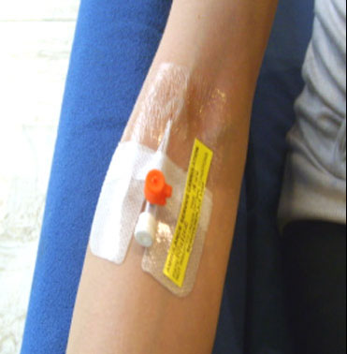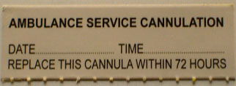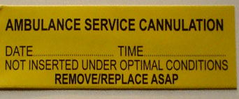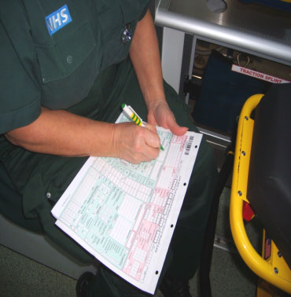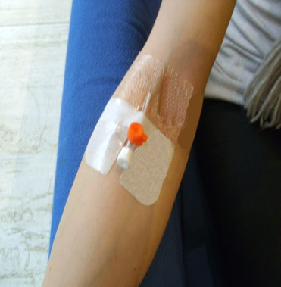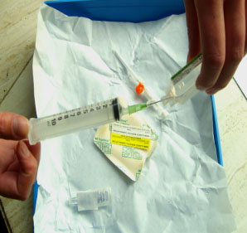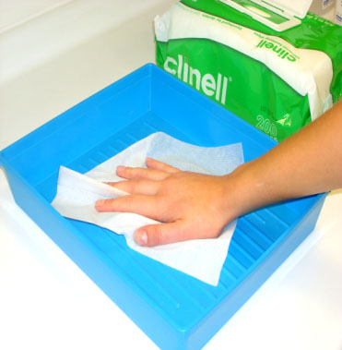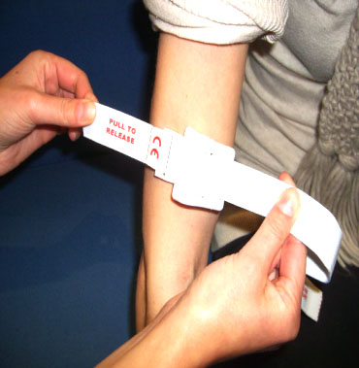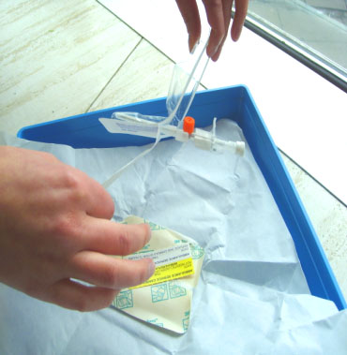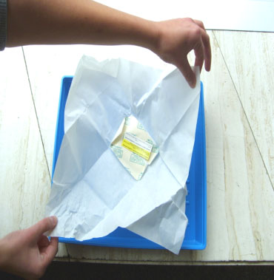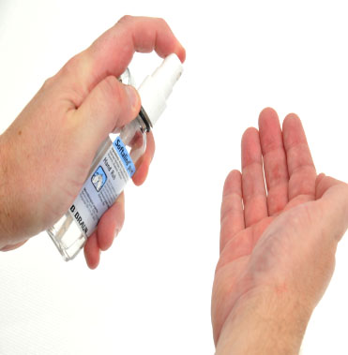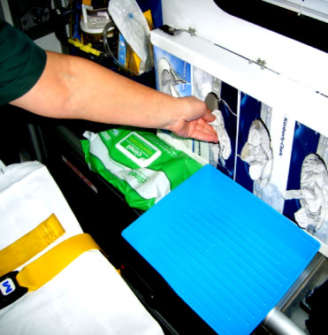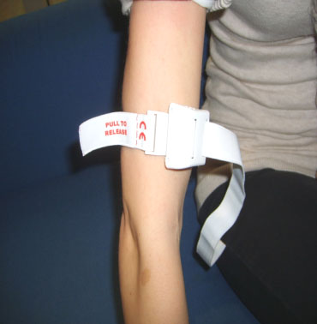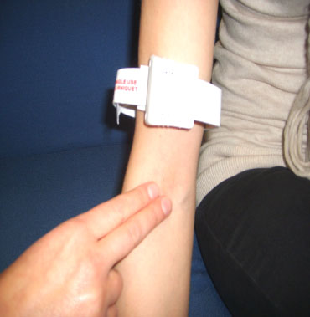

**10**

**Insert cannula to IHCD guidelines ensuring insertion site**

**is not touched & Safe disposal of sharp; remove tourniquet, flush**

**with N/S**

**13**

**16**

**Apply a white ‘replace**

**in 72 hrs’ label**

**and record date & time**

**Record the date, time** **and type of insertion on the**

**Patient Report Form**

**Clean skin with a 2% chlorhexidine / 70%alcohol applicator using a cross hatch method for 30 sec. Allow to dry**

**11**

**17**

**15**

**Remove gloves, & decontaminate hands**

**If any of the previous**

**steps could not be performed,** **e.g. for**

**life-threatening or environmental conditions, use a**

**yellow ‘*not optimal’* label. Advise the**

**receiving hospital to replace the cannula as soon as possible**

**18**

**Secure cannula**

**with semi-permeable, transparent dressing**

**using NTT**

**14**

**Prepare Equipment protecting Key-Parts with**

**non-touch technique (NTT)**

**& Micro Critical Aseptic**

**Fields (Caps & Covers)**

**6**

**Prepare 10ml N/S flush**. **Return syringe to packet & place on the field. Add unopened skin prep**

ANTTANTT® © 2016 – v1.0

**Allow skin to dry**

**Do not re-palpate the vein.**

**Re-clean the skin if**

**re-palaption is unavoidable**

**Decontaminate hands** **& apply non-sterile gloves**

**Palpate the vein**

**Open an IV pack creating a General Aseptic Field**

**Gather all equipment to hand**

**Ambulance Peripheral Cannulation Guideline** *for the ANTT Practice Framework see:* www.**antt**.org

(Using Standard-ANTT)

**Your Hospital Logo Here**

**9**

*Preparation Zone*

*Procedure (patients’) Zone*

*Post Procedure Zone*

**Decontaminate hands**

**Apply disposable tourniquet**

**If using a tray clean with universal sanitising wipe; allow tray to dry**

**1**

**7**

**3**

**4**

**5**

**2**

**8**

**12**