Welsh Healthcare Associated Infection Programme (WHAIP)

Public Health Wales

Caesarean Section

Surgical Site

Wound Care and Management

Training Booklet

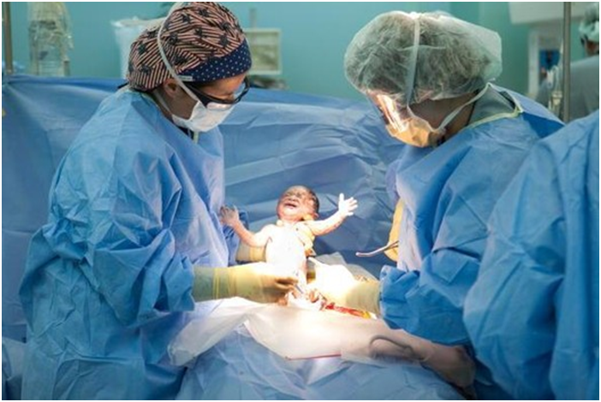

2015
Acknowledgements

We would like to thank Liz Waters (Consultant Nurse – Infection Prevention and Control in Aneurin Bevan) for her input into the training package.
We would also like to thank the Caesarean Section Steering Group and the Health Boards in Wales for their contributions to this package.
This booklet was produced by Alice Stonham and Dr Wendy Harrison on behalf of the Welsh Healthcare Associated Infection Programme (WHAIP).
Contents page

1. Introduction 4
2. Surgical site infection (SSI): 5
2.1 What are SSIs? 5
2.2 What is the worry with them? 5
2.3 Types of SSI 5
3 Caesarean Section Wound Care pathway 7
3.1 What is the Wound Care Pathway? 7
3.2 Details on the suggested interventions in the three phases of the pathway 7
3.1.1 Pre-operative phase 7
3.1.2 Intra-operative phase 8
3.1.3 Post-operative phase 9
4 Wound infection 11
4.1 How does a wound become infected? 11
4.2 How can a wound infection be recognised? 11
4.3 Suspected infection 11
4.4 Surgical site microbiology 12
5 Wound Swab 13
5.1 Aseptic swab procedure 13
5.2 Hand hygiene 14
6 WHAIP C-Section SSI surveillance 15
6.1 What is the purpose of the surveillance? 15
6.2 How is the surveillance undertaken? 15
6.3 Who is responsible for the surveillance? 15
6.4 Data management 16
7 Summary 17
8 References 18
Appendix A – WHAIP Diagnostic Tool 20
Appendix B – Wound Care Pathway 23
Appendix C - 5 Moments for Hand Hygiene (WHO, 2006) 24
Appendix D – WHAIP Example SSI surveillance forms 25

- Introduction

This booklet provides information in conjunction with the training presentation on wound care management of caesarean section wounds. References are given throughout the booklet with full details at the end. These are useful as ideas for further reading.

The Welsh Healthcare Associated Infection Programme (WHAIP) is part of the Public Health Wales Health Protection division. WHAIP were instructed by the Welsh Government to develop and support the implementation of surveillance following c-section procedures undertaken in NHS hospitals in Wales, which was a mandatory process from January 2006. Surgical Site Infection (SSI) is an important area for surveillance and remains a complication of surgery where human and financial costs are high. This booklet provides information and guidance on how to minimise infection and how to determine an infection post c-section surgery.

- Surgical site infection (SSI):
This section provides an introduction to surgical site infection (SSI) after a c-section.
  - What are SSIs?
SSIs occur in a wound after an invasive surgical procedure¹. The infection typically occurs within 30 days of the operative procedure² and there are different types of infections, depending on where the infection occurs (section 2.3).

  - What is the worry with them?
There are a number of concerns associated with SSIs, some are listed below:
- They are mostly preventable infections¹.
- These infections cause excess morbidity and mortality³.
- SSIs can double cost of treatment, as the patient’s length of stay in hospital is increased³. In a study of an English hospital, the average additional cost of a c-section SSI was £3,716. The average c-section (with no infection) had a mean cost of £3,572 compared to a c-section that became infected, which had a mean cost of £7,467⁴.
- Serious patient consequences can result from SSIs. Consequences include pain, suffering, and on some occasions they require additional surgical interventions⁵.
- SSIs are the second most common infection following a c-section, in a group of patients that are generally considered to be fit, young and well females. The most common infection is a urinary tract infection⁶.
It is important to recognise that SSIs can range from a relatively trivial wound discharge with no other complications, to a life-threatening condition. Other clinical outcomes of SSI include poor scars that are cosmetically unacceptable, persistent pain and itching, restriction of movement, particularly when over joints, and a significant impact on emotional wellbeing.

  - Types of SSI
There are three different types of surgical site infection – superficial, deep and organ/space.
The Centres for Disease Control and Prevention (CDC) use the following definitions²¹:
- Superficial: involves only skin or subcutaneous tissue of the incision
- Deep: involves only deep soft tissues (eg fascia and muscle layers) of the incision
- Organ/space: involves any part of the body, deeper than the fascial or muscle layers, that is opened or manipulated during the operative procedure
These infections must occur within 30 days of surgery. The CDC definitions have been incorporated into a diagnostic tool by WHAIP (appendix A).

Figure 1 is an illustration of the different types of SSI.
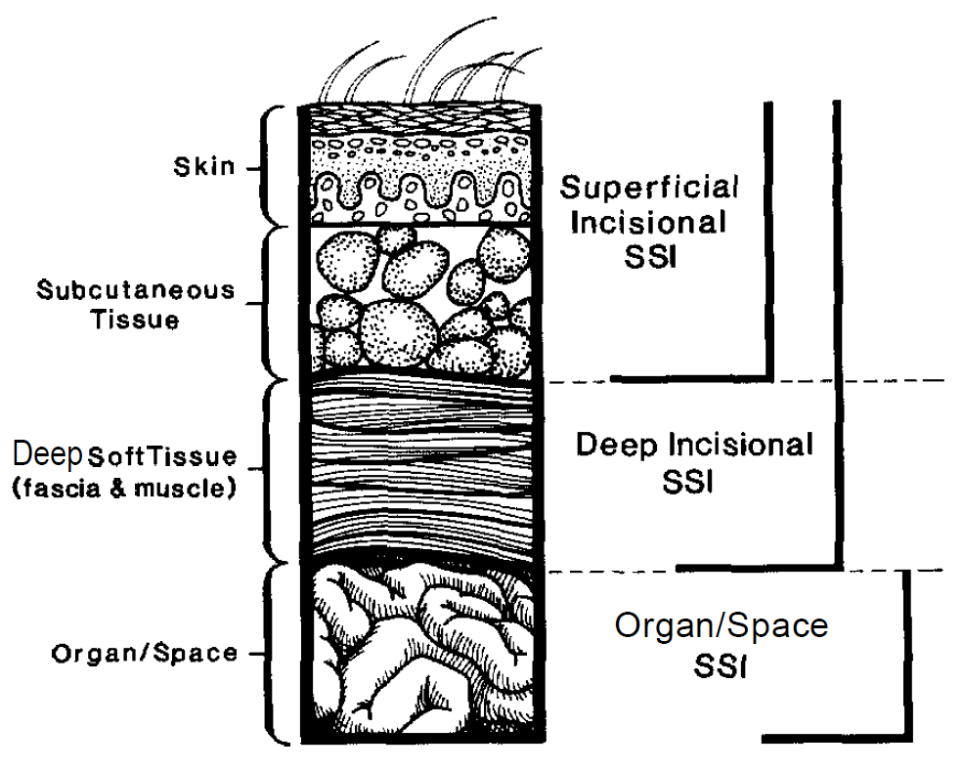
Figure 1. Classifications of the types of SSI⁷

In Welsh c-section SSI data collected for 2014, there were 7401 procedures that were captured and a total of 366 surgical site infections, both inpatient and post-discharge. 286 (78.1%) were recorded as superficial, 50 (13.7%) as deep, 3 (0.8%) as organ/space and 27 (7.4%) had no SSI type recorded. As the Welsh data indicates, superficial infections are the most common whilst organ/space infections are incredibly rare.

- Caesarean Section Wound Care pathway

3.1 What is the Wound Care Pathway?

In order to reduce the risk of infection to an absolute minimum, the following pathway should be adopted for those mothers undergoing an elective c-section in line with the National Institute for Health and Clinical Excellence (NICE) Guidance^{1,8}. The NICE guidelines outline three phases of the care process into preoperative, intra-operative and post-operative action. The care pathway has also been grouped into these three phases. The care pathway can be utilised as a standalone document or incorporated into any c-section pathway already in use.

A full copy of the pathway can be found in appendix B. In this section, the pathway has been broken down into the three phases.

3.2 Details on the suggested interventions in the three phases of the pathway

3.1.1 Pre-operative phase

 | Signature |  | Date Discussed
Gestation 32-34 weeks
1) Mother receives a local wound care leaflet? |  |  | / /
2) Optional: Mother is screened for MRSA using local guidelines?
(Universal screening in Wales has not been adopted. However, if screened and mother is found positive, decolonise using local protocol prior to surgery)
7 days prior to planned section
3) NO further removal of pubic hair – check on day of surgery. |  |  | / /
4) Daily showers/baths using soap (paying attention to axillae, groins, perineum and skin folds) – check on day of surgery. |  |  | / /
Day of surgery
5) Bath/Shower preoperatively using soap, paying attention to axillae, groins, perineum and skin folds. |  |  | / /
Screening and decolonisation
There is evidence to suggest that there is a reduction in MRSA infections when MRSA screening is carried out, but please note that Wales has not adopted universal screening.
If the mother is screened and found positive, ensure decolonisation takes place before surgery.
Hair removal
No routine hair removal should be undertaken pre-operatively, so as to reduce the risk of SSI. More specifically, there should be no hair removal 7 days prior to surgery, ensure this is discussed with the patient (and this can form an audit trail).
If hair removal is required before surgery, use electric clippers with a single-use head. Do not use razors, as they increase the risk of SSI⁹ due to micro-abrasions that razors can cause, potentially leading to the multiplication of microorganisms at the surgical site²². NICE guidelines state that where hair removal is required, to ensure that it is undertaken as close to the time of surgery as possible (therefore clipping on the day of surgery may be preferable)¹.
Pre-operative showering
When skin is incised, micro-organisms that colonise the surface of the skin may contaminate the exposed tissues and subsequently proliferate, leading to an infection. Therefore, a decreased risk of an SSI may occur if an intervention is put in place to reduce the number of microorganisms on the skin surrounding the incision. Microorganisms on the skin are often acquired by touch, and easily removed (by washing with soap). NICE guidelines advise patients to shower or have a bath (or to help patients to shower, bath or bed bath) using soap, either the day before, or on the day of, surgery¹. Ensure that patients know to pay particular attention to axillae, groins, perineum and skin folds as this is where microorganisms may accumulate.

The pathway advises that, in addition to the pre-operative showering, patients wash on a daily basis from 7 days prior to surgery.

3.1.2 Intra-operative phase

The interventions in the intra-operative stage are part of the surgical list and covered by the World Health Organisation (WHO) checklist.

 | Yes | No |  | n/a
1) Remove hair if required – using clippers with a disposable head (not by shaving). Time as close to the operating procedure as possible.
2) Administer antibiotics within 60 minutes prior to incision. Only repeat if there is excessive blood loss or prolonged operation.
3) Patient skin is prepared with povidone iodine or 2% chlorhexidine gluconate and allowed to air dry.
4) Maintain body temperature above 36°C in the peri-operative period.
5) Maintain a glucose level of < 11mmol/l in diabetic patients.
Hair removal
If hair removal is required, use electric clippers with a single-use head. Do not use razors, as they increase the risk of SSI⁹. NICE guidelines state that where hair removal is required, ensure it is undertaken as close to the time of surgery as possible¹ (see section 3.1.1).
Antibiotic prophylaxis
It is advised that for c-sections, prophylactic antibiotics are given before skin incision. This reduces the risk of maternal infection, more than prophylactic antibiotics that are given after skin incision and no effect on the baby has been demonstrated⁸.
Use antibiotic guidelines to determine which are the appropriate antibiotics and ensure that they are administered within 60 minutes prior to incision¹⁰. This is also detailed in the NICE guidance¹. The All-Wales Antimicrobial Guidance Group (AWAGG) have recommended that Cefuroxime 750mg and Metronidazole 500mg should be offered prior to incision or for penicillin allergic patients Clindamycin 600mg and Gentamicin 1.5mg/kg. This has been agreed by the All Wales Medicine Strategy Group.
Skin preparation
Skin preparation is crucial so that the transient and residential flora on the skin is removed. Skin should be prepared at the surgical site immediately before incision, using an antiseptic (either aqueous or alcohol-based) – povidone-iodine or chlorhexidine are most suitable. It is important that they are allowed to air dry, and there is no specific time for this process, it is entirely dependent on the amount and load used¹¹.
Normothermia
Maintain the patient’s body temperature above 36°C in the peri-operative period.
Further advice on this topic can be found under NICE guidance¹ – Inadvertent Peri-Operative Hypothermia Guideline (2008) – which includes advice such as the warming of IV fluids.
Glucose control
Complications arising from SSI are an additional risk for diabetic patients, therefore the Department of Health High Impact Intervention¹¹ recommends that a glucose level of <11mmol/l should be maintained in diabetic patients.
Do not give insulin routinely to patients who do not have diabetes to optimise blood glucose post-operatively as a means of reducing the risk of SSI.
3.1.3 Post-operative phase

 |  | Yes | No
1) Cover wound with an interactive dressing at the end of surgery.
2) Advise mother on post-operative wound care:
a) Don’t touch the wound unless necessary
b) Ensure that hands are regularly washed, particularly before and after using the toilet
c) If infection is suspected, contact local maternity unit (not GP)
3) Remove standard, interactive dressing 48 hours* after the procedure. Alternatively if non-standardised dressing (eg. PICO, leukomed T+) consult manufacturer’s guidance.
4) Assess wound for signs of infection.
- If the wound is clean and dry no further dressing is required and the patient may shower (or if using a transparent waterproof dressing, the patient may shower when they feel ready to).
- If the wound is displaying signs of infection (such as redness, in addition to swelling or pus) a wound swab must be taken aseptically and a fresh dressing applied daily. All assessments should be documented in the patient’s record.
5) Aseptic, non-touch techniques must be used when the wound is being redressed◊.
6) Complete WHAIP SSI surveillance form | a) on discharge from hospital
 | b) Up to 30 days post operatively
NB Throughout the period of care hands must be decontaminated before and after each episode of patient contact using the correct hand hygiene technique.
Surgical dressing
NICE guidelines^{1,11} recommend that the surgical incision is covered with an appropriate interactive dressing at the end of the operation.
*C-section NICE guidelines recommend that the dressing should be removed 24 hours after the c-section⁸. Local guidelines are more likely to state that this is 48hrs after the operation and this is recommended for the all Wales care pathway. Ensure that the dressing manufacturer’s guidelines are adhered to for non-standard dressings such as PICO.
◊ See ANTT training for Wales - http://howis.wales.nhs.uk/sitesplus/888/page/64404
If the mother has a waterproof dressing, she may shower as soon as she feels up to it. Alternatively, when the wound is clean and dry (and no further dressing is required), she may shower.
Hand hygiene
NICE guidelines recommend using an aseptic non-touch technique for changing or removing surgical wound dressings. This is a procedure that is discussed in more detail in section 5.2.
Advise the mother that the wound should not be touched, as this increases the risk of infection. As before, ensure that the patient knows to wash her hands before and after using the toilet.
ANTT is a comprehensive Practice Framework for aseptic technique used for all invasive procedures from major surgery to maintenance of invasive devices, with the Association for Safe Aseptic Practice and in conjunction with Public Health Wales and NHS Wales, please see the ANTT website (http://howis.wales.nhs.uk/sitesplus/888/page/64404).
Infection
The next section of the booklet contains information on how to identify a possible infection and what actions should be taken.
C-Section SSI surveillance
Public Health WHAIP surveillance and its importance are discussed in further detail in section 6.

- Wound infection

  - How does a wound become infected?

SSIs occur as a result of contamination of the wound site. Skin acts as a natural, physical barrier that prevents contamination, but when broken and a wound created, that natural protection is lost and bacteria may enter. Micro-organisms can gain access via a number of sources including from the skin before surgery, surgical instruments and from the environment during surgery, as well as during the provision of care post surgery (NICE, 2008).

It is important to understand the difference between ‘infection’ and ‘colonisation’ of the wound:

Infection
“The presence of multiplying bacteria that overwhelms the patient’s immune system” ¹²

Colonisation
“The presence of bacteria within the wound but with no patient immune response” ¹³

VS.

There will be active signs of disease
There will be no signs or symptoms of infection

It is also important to take into account the patient’s overall condition and the significance of taking and receiving results from surgical site samples.

  - How can a wound infection be recognised?
The ‘classic’ signs of infection are pus and cellulitis¹⁴. Cellulitis is an infection of the deeper layers of the skin and the underlying tissue¹⁵.
Two of the most accurate signs and symptoms of wound infection are increasing pain and wound breakdown¹⁶.

The SSI diagnostic tool (appendix A) has been developed as an aid to be utilised with determining the type of SSI.

  - Suspected infection

If an infection is suspected, take a wound swab, using the aseptic procedure in section 5.1.

Ensure that the mother knows to attend a maternity unit as opposed to visiting the GP surgery if she suspects an infection. However, if this is not possible or part of your local Health Board’s practice, ensure that the mother visits the GP to have her wound examined. Discourage community midwives phoning the GP for antibiotics as the GP cannot assess the wound in this situation.

Below are a number of characteristics that you would expect to be associated with different types of infections:

A healthy wound will often have some redness and be moist.
Superficial infections
Purulent discharge should be easily recognisable however people can get confused between this and ‘yellow’ lymph drainage, which can also occur naturally following surgery and serous fluid which is clearer.
Redness (that is not due to inflammation around the points of suture penetration) that will spread from the wound site and cellulitis.
Deep infections
Deep infections will have similar characteristics to superficial infections but often will also have delayed healing (which could be in the form of a gap in the wound). Wounds may have an abnormal smell and might also have increased redness. Patients with deep infections may be re-admitted for further diagnosis.
Organ/space infections
These are usually diagnosed by a surgeon or doctor when examining or re-operating on the patient.
An example of an organ/space infection after a c-section is endometritis but other infections found within the ovaries, uterus or pelvic cavity could also be included.

Wounds should be documented fully within the patient’s notes in order to capture any changes that may occur.

  - Surgical site microbiology

Micro-organisms within wound exudates are indicative but not diagnostic.

Common organisms that are found to cause SSIs:
- Staphylococcus aureus
- Coagulase-negative staphylococci
- Gram negative bacilli
- Anaerobes
- Group B streptococci

There is debate over the significance of bacteria found within surgical sites. The dose of contaminating organism will vary, depending on the patient and whether there are any foreign materials present.

It is important to consider the following questions when taking a culture from a surgical site:
- Why are you sampling?
- When are you sampling?
- What are you sampling?
- How are you sampling?

Clear labelling of the sample and correct completion of the form is crucial so that the laboratory can carry out the most appropriate tests and find the relevant organisms. Interpreting results presented by the lab is also important in deciding if an SSI is present and needs treatment. Local labs and microbiologists can be very helpful in these situations. An SSI must be documented as the date it is thought to have occurred and samples are sent, not when sample results are known. The correct procedure for taking a swab is covered in the next section of the booklet.
- Wound Swab

5.1 Aseptic swab procedure

Below is the procedure for taking an aseptic wound swab. The information has been taken from the Royal Marsden Hospital Manual of Clinical Nursing Procedures (9th edition), procedure guideline 10.22, swab sampling: wound¹⁷.
Pre-procedure
Explain the procedure to the patient
Wash hands with soap or decontaminate with alcohol hand rub, put on apron and gloves.
Remove current dressing if applicable
Re-wash/decontaminate hands

Procedure
Roll swab in ‘zig-zag’ motion over the entire wound surface
Use enough pressure to obtain fluid* from wound tissue but avoid exudates and touching wound margin
If wound dry, moisten the tip of the swab with 0.9% sodium chloride
If pus present, aspirate using sterile syringe and decant into specimen pot

Post-procedure
Carefully place swab into transport tube, ensuring fully immersed in transport medium
Redress the wound, if applicable
Remove gloves and apron and discard the clinical waste. Re-wash and decontaminate hands
Complete microbiology request form
Arrange prompt delivery to microbiology labs

*Expressed tissue fluids are likely to contain the true infective organisms and less likely to contain surface contaminants. Local practice often advocates cleaning with saline prior to taking the swab to minimise collection of the surface contaminants.

To take a wound swab, the key points to remember are:
- Take swab from wound tissue fluid (if required, clean wound with saline to remove dry exudate or other surface contaminants)
- Ensure sterile swab is used
- Use a sterile container to collect and transport the specimen
- Following hand hygiene protocols before and after (section 5.2)

5.2 Hand hygiene
The WHO has developed a 5 point process – 5 Moments for Hand Hygiene – that defines the key moments for hand hygiene, overcoming misleading language and complicated descriptions¹⁸. It aligns with the evidence base concerning the spread of health care associated infections (HAI), and is interwoven with the natural workflow of care. It is designed to be easy to learn, logical and applicable in a wide range of settings. These are suggested actions that are aimed at helping to protect the patient, yourself and the health-care environment from any harmful germs:
1) Before patient contact - clean your hands before touching a patient when approaching him/her (examples: shaking hands, helping a patient to move around, clinical examination)
2) Before an aseptic task - Clean your hands immediately before any aseptic task (examples: oral/dental care, secretion aspiration, wound dressing, catheter insertion, preparation of food, medications)
3) After body fluid exposure risk - Clean your hands immediately after an exposure risk to body fluids and after glove removal (examples: oral/dental care, secretion aspiration, drawing and manipulating blood, clearing up urine, faeces, handling waste)
4) After patient contact - Clean your hands after touching a patient and her/his immediate surroundings, when leaving the patient’s side (examples: shaking hands, helping a patient to move around, clinical examination)
5) After contact with patient surroundings - Clean your hands after touching any object or furniture in the patient’s immediate surroundings, when leaving - even if the patient has not been touched (examples: changing bed linen, perfusion speed adjustment)

The importance of hand hygiene should also be communicated to the mother. The patient should ensure that hand washing takes place before and after using the toilet, and that she does not touch the wound.
ANTT is a comprehensive Practice Framework for aseptic technique used for all invasive procedures from major surgery to maintenance of invasive devices, with the Association for Safe Aseptic Practice and in conjunction with Public Health Wales and NHS Wales, please see the ANTT website (http://howis.wales.nhs.uk/sitesplus/888/page/64404).

- WHAIP C-Section SSI surveillance

The definition of surveillance is the ‘ongoing systematic collection, analysis and interpretation of health data’¹⁹. The surveillance scheme for following SSIs in c-sections was made mandatory in Wales in January 2006, and uses internationally recognised definitions. Therefore, Welsh data can be compared with and incorporated into other international databases. It should also be noted that the potential to improve infection rates by carrying out surveillance has been demonstrated²⁰.

6.1 What is the purpose of the surveillance?
The aim of the SSI surveillance programme for c-sections is to:
- Collect surveillance data on SSI following c-section surgery to permit estimation of the magnitude of post operative c-section SSI risks in hospitalised patients
- Analyse and report c-section SSI surveillance data and describe trends in infection rates
- Provide timely feedback of c-section SSI rates to assist surgical units in minimising the occurrence of SSI
- Contribute to an increased understanding of the risk factors for SSI associated with c-section procedures

Health Boards are able to obtain an insight into their local infection rates through participation in the surveillance scheme and use this as a basis for further investigations.

6.2 How is the surveillance undertaken?
C-section SSI surveillance has two aspects to it:
- In-patient
- Post-discharge
This double aspect monitoring enables recognition of an SSI, were it to happen during any part of a patient’s journey.

It is undertaken through the filling in of a surveillance form (pink forms) which is done in the theatre/ward and post-operatively, up to 30 days after procedure. In-patient forms are usually completed by theatre staff and hospital midwives and post-discharge forms by community midwives. Appendix D shows an example inpatient and post-discharge form, which is currently under review (2015). It is important to note that there is a unique serial number that identifies that specific procedure and forms should therefore not be photocopied.

The forms are read by an optical mark reader package at WHAIP, so forms should be filled in following these instructions:
- Use a dark ink pen or biro
- Place a cross in the appropriate box
- Correct errors by completely filling the box where the incorrect response is
- Be thorough in completion
- Write clearly
- Write within the boxes, without writing onto the box lines.
DO NOT use light pens, leave gaps or photocopy forms (due to the unique serialisation of forms).

6.3 Who is responsible for the surveillance?
Surveillance primarily involves clinical staff at each hospital or Health Board and includes infection prevention and control teams as support. It is overseen by WHAIP (Public Health Wales) who act as a point of contact for queries.

The local SSI surveillance group should include representation of some or all of the following:
- Surgeons (from relevant disciplines)
- Midwives
- Theatre staff
- Ward Nurses
- Surveillance Nurses
- Clinical Nurse Specialists
- Infection Control Nurses
- Community staff
- Infection Control Doctors/Microbiologists
- Managers
- Clinical Effectiveness teams
- Clinical Audit staff
- IT staff
- Clerical and Secretarial staff

6.4 Data management

Data must be anonymised before being sent to WHAIP, which is achieved by removing the front page of the surveillance form. WHAIP centrally manage the surveillance data that is collected by each hospital. It is then imported into a c-section database which is held centrally and managed by WHAIP, but each hospital has access. WHAIP also perform quality checks of completed forms and data entry and analysis. Locally, forms should be collected and collated and data quality checks should be undertaken as well as infection rates monitored.

WHAIP also feedback to surgical, midwifery and infection control teams on infection rates on a quarterly basis and through an annual report. Reports should also be cascaded to local staff involved in the surveillance and within local audit meetings. WHAIP also provide feedback to Welsh Government on surveillance compliance and infection rates.

- Summary

Key points to remember from this training booklet (and the training presentation).

- Know the Wound Care Pathway and follow it

- Ensure that good communication with the mother is established and maintained

- Follow hand hygiene and asepsis techniques

- Complete Public Health Wales surveillance (the inpatient and post-discharge pink forms) for all patients undergoing a c-section

- References

- National Institute for Health and Clinical Excellence (NICE). 2008. Surgical site infection prevention and treatment of surgical site infection. CG74. Avaliable: https://www.nice.org.uk/guidance/cg74 [Accessed 05/01/2015]
- Horan, T.C., Andrus, M., & Dudeck, M.A. 2008. CDC/NHSN surveillance definition of health care-associated infection and criteria for specific types of infections in the acute care setting. American Journal of Infection Control, 36, (5) 309-332
- Plowman, R., Graves, N., Griffin, M.A., Roberts, J.A., Swan, A.V., Cookson, B., Taylor, L. 1999. The Socio-economic burden of hospital acquired infection. Public Health Laboratory Service, London.
- Jenks, P.J., Laurent, M., McQuarry, S., & Watkins, R. 2014. Clinical and economic burden of surgical site infection (SSI) and predicted financial consequences of elimination of SSI from an English hospital. Journal of Hospital Infection, 86, (1) 24-33
- Coello, R., Charlett, A., Wilson, J., Ward, V., Pearson, A., & Borriello, P. 2005. Adverse impact of surgical site infections in English hospitals. Journal of Hospital Infection, 60, (2) 93-103
- Sykes, P.K., Brodribb, R.K., McLaws, M.L., & McGregor, A. 2005. When continuous surgical site infection surveillance is interrupted: The Royal Hobart Hospital experience. American Journal of Infection Control, 33, (7) 422-427
- Horan, T.C., Gaynes, R.P., Martone, W.J., Jarvis, W.R., & Emori, T.G. 1992. CDC Definitions of Nosocomial Surgical Site Infections, 1992: A Modification of CDC Definitions of Surgical Wound Infections. Infection Control & Hospital Epidemiology, 13, (10) 606-608
- National Institute for Health and Clinical Excellence (NICE). 2011. Caesarean section. https://www.nice.org.uk/guidance/cg132/chapter/1-guidance#/procedural-aspects-of-cs [Accessed 06/01/2015]
- Tanner, J., Norrie, P., & Melen, K. 2011. Preoperative hair removal to reduce surgical site infection. Cochrane Database Syst Review. Issue 11.
- James, M. & Martinez, E.A. 2008. Antibiotics and perioperative infections. Best Practice & Research Clinical Anaesthesiology, 22, (3) 571-584
- Health Protection Agency (HPA). 2011. High Impact Intervention (care bundle to prevent surgical site infection). Avaliable: http://webarchive.nationalarchives.gov.uk/20120118164404/hcai.dh.gov.uk/files/2011/03/2011-03-14-HII-Prevent-Surgical-Site-infection-FINAL.pdf [Accessed 23/02/2015]
- Kingsley, A. 2001. A proactive approach to wound infection. Nursing standard, 15, (30) 50-58 in: Patel, S. 2007. Understanding wound infection and colonisation. Wound Essentials, 2, 132-142
- Ayton, M. 1984. Wound care: wounds that won't heal. Nursing times, 81, (46) in: Patel, S. 2007. Understanding wound infection and colonisation. Wound Essentials, 2, 132-142
- Scanlon, E. 2005. Wound infection and colonisation. Nursing standard, 19, (24) 57-67
- NHS. 2014. Cellulitis. Available: http://www.nhs.uk/conditions/Cellulitis/Pages/Introduction.aspx [Accessed 08/05/2015]
- Gardner, S.E., Frantz, R.A., & Doebbeling, B.N. 2001. The validity of the clinical signs and symptoms used to identify localized chronic wound infection. Wound Repair and Regeneration, 9, (3) 178-186
- Dougherty, L., & Lister, S. (Eds.). 2015. Royal Marsden Hospital Manual of Clinical Nursing Procedures (9th edition).
- World Health Organisation. (2006). Five moments for hand hygiene. Avaliable: http://www.who.int/gpsc/tools/Five_moments/en/ [Accessed 15/12/2014].
- Centres for Disease Control and Prevention (CDC). 1988. Guidelines for Evaluating Surveillance Systems. Available: http://www.cdc.gov/mmwr/preview/mmwrhtml/00001769.htm [Accessed 24/02/2015]
- Haley, R.W., Culver, D.H., White, J.W., Morgan, W.M., Emori, T.G., Munn, V.P., & Hooton, T.M. 1985. The efficacy of infection surveillance and control programs in preventing nosocomial infections in US hospitals. American journal of epidemiology, 121, (2) 182-205
- Centres for Disease Control and Prevention (CDC). 2015. Surgical Site Infection (SSI) Event. Available: http://www.cdc.gov/nhsn/PDFs/pscManual/9pscSSIcurrent.pdf [Accessed 06/11/2015]
- Health Protection Scotland. 2012. Targeted literature review: What are the key infection prevention and control recommendations to inform a surgical site infection (SSI) prevention quality improvement tool? Available: http://www.documents.hps.scot.nhs.uk/hai/infection-control/evidence-for-care-bundles/literature-reviews/ssi-review.pdf [Accessed 06/11/2015]

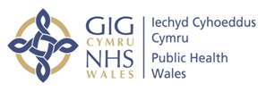
Appendix A – WHAIP Diagnostic Tool

From:
- CDC (2014) Surgical Site Infection (SSI) Event. Available: http://www.cdc.gov/nhsn/PDFs/pscManual/9pscSSIcurrent.pdf
- PHE (2013) Protocol for the surveillance of surgical site infections. Available: https://www.gov.uk/government/uploads/system/uploads/attachment_data/file/364412/Protocol_for_surveillance_of_surgical_site_infection_June_2013.pdf
Superficial surgical site infection
An infection that occurs within 30 days of surgery and involves only the skin or subcutaneous tissue of the incision and meets at least one of the criteria below

Criterion 2
The superficial incision yields organisms from the culture of aseptically aspirated fluid or tissue, or from a swab and pus cells are present
Criterion 1
Purulent drainage from the superficial incision

Criterion 3
The superficial incision is deliberately opened by a surgeon to manage the infection, with a positive culture or a culture is not taken
AND at least one of the following signs or symptoms:
- Pain/tenderness
- Localised swelling
- Redness
- Heat

Criterion 4
The surgeon or a trained healthcare worker diagnoses a superficial incisional infection.
If one or more criteria are answered with ‘yes’ this is a Superficial SSI
Deep surgical site infection
An infection that occurs within 30 days of surgery and involves deep soft tissues (i.e. fascial and muscle layers) of the incision and meets at least one of the criteria below

Criterion 2
The deep incision yields organisms from the culture of aseptically aspirated fluid or tissue, or from a swab and pus cells are present
Criterion 3
Diagnosis of a deep incisional surgical site infection by a surgeon or trained healthcare worker
Criterion 4
An abscess or other evidence of infection involving the deep incision that is found by direct examination during re-operation or by histopathological or radiological examination
Criterion 1
Purulent drainage from the deep incision but not from the organ space component of the surgical site

Criterion 5
Deep incision that spontaneously dehisces (opens up) or is deliberately opened up by a surgeon when the patient has at least one of the following signs or symptoms (unless the incision is culture negative):
- Fever (>38°C)
- Localised pain or tenderness

If one or more criteria are answered with ‘yes’, this is a Deep SSI
From:
- CDC (2014) Surgical Site Infection (SSI) Event. Available: http://www.cdc.gov/nhsn/PDFs/pscManual/9pscSSIcurrent.pdf
- PHE (2013) Protocol for the surveillance of surgical site infections. Available: https://www.gov.uk/government/uploads/system/uploads/attachment_data/file/364412/Protocol_for_surveillance_of_surgical_site_infection_June_2013.pdf
Organ space surgical site infection
An infection that occurs within 30 days of surgery and involves any part of the anatomy (i.e. organ/space) other than the incision that has been opened/manipulated during the surgical procedure and meets at least one of the criteria below

Criterion 2

The organ/space yields organisms from the culture of aseptically aspirated fluid or tissue, or from a swab and pus cells are present
Criterion 3

Diagnosis of an organ/space infection by a surgeon or trained health worker
Criterion 4

An abscess or other evidence of infection involving the organ/space that is found by direct examination during re-operation or by histopathological or radiological examination
Criterion 1

Purulent drainage from a drain that is placed through a stab wound into the organ/space

If one or more criteria are answered with ‘yes’, this is an Organ/Space SSI
From:
- CDC (2014) Surgical Site Infection (SSI) Event. Available: http://www.cdc.gov/nhsn/PDFs/pscManual/9pscSSIcurrent.pdf
- PHE (2013) Protocol for the surveillance of surgical site infections. Available: https://www.gov.uk/government/uploads/system/uploads/attachment_data/file/364412/Protocol_for_surveillance_of_surgical_site_infection_June_2013.pdf
Appendix B – Wound Care Pathway
Below is a full version of the Wound Care Pathway, to be used across Wales.
PRE-OPERATIVE PHASE
 | Signature |  | Date Discussed
Gestation 32-34 weeks
1) Mother receives a local wound care leaflet? |  |  | / /
2) Optional: Mother is screened for MRSA using local guidelines?
(Universal screening in Wales has not been adopted. However, if screened and mother is found positive, decolonise using local protocol prior to surgery)
7 days prior to planned section
3) NO further removal of pubic hair – check on day of surgery. |  |  | / /
4) Daily showers/baths using soap (paying attention to axillae, groins, perineum and skin folds) – check on day of surgery. |  |  | / /
Day of surgery
5) Bath/Shower preoperatively using soap, paying attention to axillae, groins, perineum and skin folds. |  |  | / /
INTRA-OPERATIVE PHASE
 | Yes | No |  | n/a
1) Remove hair if required – using clippers with a disposable head (not by shaving). Time as close to the operating procedure as possible.
2) Administer antibiotics within 60 minutes prior to incision. Only repeat if there is excessive blood loss or prolonged operation.
3) Patient skin is prepared with povidone iodine or 2% chlorhexidine gluconate and allowed to air dry.
4) Maintain body temperature above 36°C in the peri-operative period.
5) Maintain a glucose level of < 11mmol/l in diabetic patients.
POST-OPERATIVE PHASE
 |  | Yes | No
1) Cover wound with an interactive dressing at the end of surgery.
2) Advise mother on post-operative wound care:
a) Don’t touch the wound unless necessary
b) Ensure that hands are regularly washed, particularly before and after using the toilet
c) If infection is suspected, contact local maternity unit (not GP)
3) Remove standard, interactive dressing 48 hours* after the procedure. Alternatively if non-standardised dressing (eg. PICO, leukomed T+) consult manufacturer’s guidance.
4) Assess wound for signs of infection.
- If the wound is clean and dry no further dressing is required and the patient may shower (or if using a transparent waterproof dressing, the patient may shower when they feel ready to).
- If the wound is displaying signs of infection (such as redness, in addition to swelling or pus) a wound swab must be taken aseptically and a fresh dressing applied daily. All assessments should be documented in the patient’s record.
5) Aseptic, non-touch techniques must be used when the wound is being redressed◊.
6) Complete WHAIP SSI surveillance form | a) on discharge from hospital
 | b) Up to 30 days post operatively
NB Throughout the period of care hands must be decontaminated before and after each episode of patient contact using the correct hand hygiene technique.

*C Section NICE guidelines recommend that the dressing should be removed 24 hours after the c section⁸. Local guidelines are more likely to state that this is 48hrs after the operation and this is recommended for the all Wales care pathway. Ensure that the dressing manufacturer’s guidelines are adhered to for non-standard dressings such as PICO.
◊See ANTT training for Wales - http://howis.wales.nhs.uk/sitesplus/888/page/64404
Appendix C - 5 Moments for Hand Hygiene (WHO, 2006)

Section 5.2 provides a full explanation of the WHO’s 5 moments.

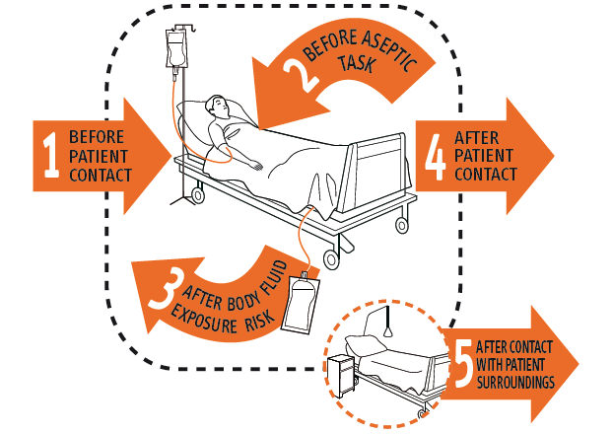

Appendix D – WHAIP Example SSI surveillance forms
Below is an example SSI surveillance form (2008) as referred to in section 6.2. 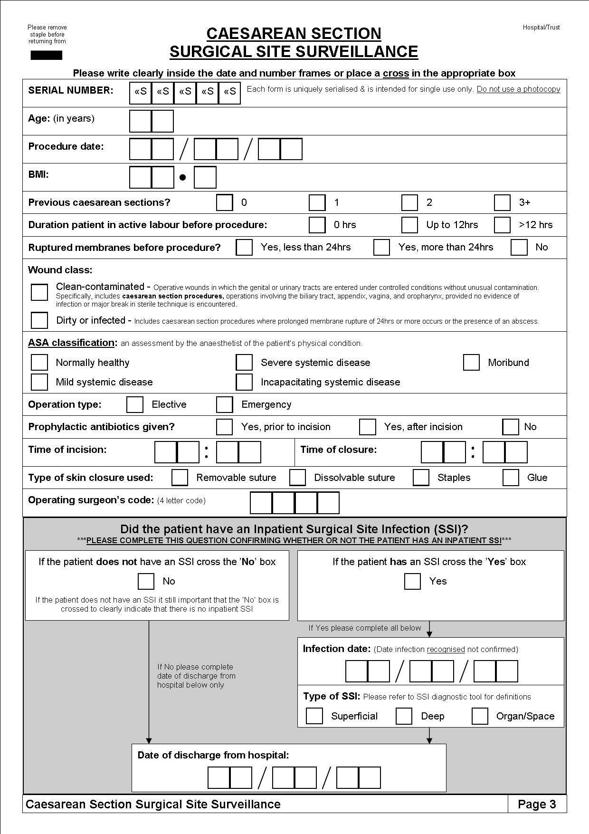
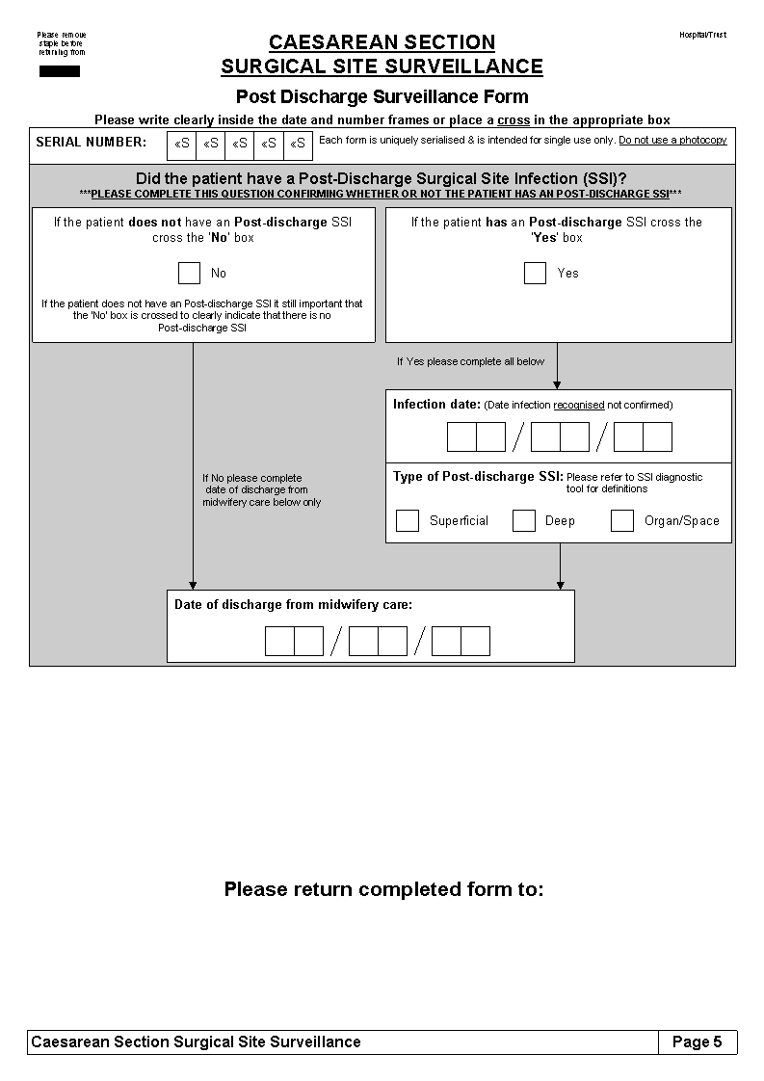

Data from 1st January 2014 to 31st December 2014
See Appendix C for WHO 5 moments diagram

