

**PROTOCOL:**

**Caesarean Section**

**Surgical Site Infection**

**Surveillance**



**4TH Edition**

**January 2016**

**Published by the Welsh Healthcare Associated**

Welsh Healthcare Associated Infection Programme (WHAIP)

National Public Health Service (NPHS) 2nd DRAFT Edition July 2007





**Infection Programme (WHAIP)**

**Contact details for Public Health Wales (WHAIP)**

**General contact:**

**Telephone:** 029 2040 2473

**Fax:** 029 2040 2506

*Lead for SSI programme:* Dr Wendy Harrison

[Wendy.harrison2@wales.nhs.uk](mailto:Wendy.harrison2@wales.nhs.uk)

*Information Analyst:* Miss Alice Neden

[Alice.Neden@Wales.nhs.uk](mailto:Alice.Neden@Wales.nhs.uk)

**SUMMARY: HOW TO CARRY OUT THE CAESAREAN SECTION**

**SSI SURVEILLANCE**

* Data is captured using paper questionnaires (forms)
* Details on how to obtain these forms and their completion is detailed in this protocol
* Data is collected for all patients undergoing caesarean section surgery in Wales (includes elective and emergency procedures)
* To ensure infection data associated with the procedures is recorded on the form patients must be followed up post discharge from hospital in the community. We recommend that community midwives are best placed to carry out the community aspect of this surveillance
* We recommend that community midwives are trained so that they have a clear understanding of the criteria required to define an infection using surveillance definitions

**TABLE OF CONTENTS**

|  |  |  |
| --- | --- | --- |
|  |  | **Page** |
| **SECTION 1** | **INTRODUCTION AND PRINCIPLES** | **5** |
|  | 1.1 Introduction | **6** |
|  | 1.1a Definition of surveillance | **6** |
|  | 1.1b Background to SSI surveillance | **6** |
|  |  |  |
| **SECTION 2** | **SETTING UP SURVEILLANCE** | **8** |
|  | 2.1 The role of the WHAIP team, Public Health Wales | **9** |
|  | 2.2 Who should be involved? | **9** |
|  | 2.3 Surveillance flow | **9** |
|  | 2.4 Data capture method | **10** |
|  | 2.5 Data confidentiality | **10** |
|  |  |  |
| **SECTION 3** | **DATA COLLECTION AND ANALYSIS** | **12** |
|  | 3.1 Data collection | **13** |
|  | 3.1a Data collection method | **13** |
|  | 3.1b Inclusion criteria | **13** |
|  | 3.1c Identification of study population | **14** |
|  | 3.1d Monitoring patients for SSI | **15** |
|  | 3.1e Data definitions | **16** |
|  | 3.2 Data analysis and reporting | **16** |
|  |  |  |
| **SECTION 4** | **APPENDIX** | **18** |

**SECTION 1**

**INTRODUCTION AND PRINCIPLES**

**1 INTRODUCTION AND PRINCIPLES**

**1.1 Introduction**

* The purpose of this protocol is to provide information, definitions and instructions for national and local surveillance of surgical site infections (SSI) following caesarean section procedures in Wales
* For national surveillance, a standardised methodology, including use of a common set of definitions, is required. Definitions provided in this protocol allow comparisons of surveillance information collected in Wales with those collected across the Pan Celtic countries and England (other European countries)
* Surveillance is a multidisciplinary activity and local ownership is crucial. This protocol is intended for use by midwives, nurses, surgeons, infection control and all other personnel who are involved in surgical site surveillance (in particular for caesarean section) in Wales

**1.1a Definition of Surveillance**

Surveillance is the ongoing systematic collection, analysis, and interpretation of health data essential to the planning, implementation, and evaluation of public health practice, closely integrated with the timely dissemination of these data to those who need to know. The final link of the surveillance chain is the application of these data to prevention and control (Centers for Disease Control and Prevention (CDC), 1988).

Effective surveillance requires careful planning that is based on a clear understanding of its purpose, and awareness by those involved of the benefits and objectives of identified programmes.

***The objectives of surgical site infection (SSI) surveillance are to:***

* Monitor the incidence of infection
* Provide early warning and investigation of problems and subsequent planning and intervention to control
* Monitor trends over time
* Examine the impact of interventions using quality improvement methodology
* Gain information on the quality of care and service improvement
* Prioritise the allocation of resources

**1.1b Background to SSI surveillance**

During the 1990s surveillance of healthcare associated infections (HCAI) became a key part of the activity undertaken by infection control practitioners to evaluate the burden of HCAI in their hospitals and instigate changes in practice. Surveillance of surgical site infections collects information on infections directly related to the provision of healthcare and is an area in which changes in practice could potentially rapidly improve infection rates.

The caesarean section surgical site infection (SSI) surveillance scheme was mandated by the Welsh Government in 2006 (WHC (2005) 093). The surveillance was set-up and continues to be managed by the Welsh Healthcare Associated Infection Programme (WHAIP). The surveillance scheme is paper-based with the required information completed by staff within the hospital for the inpatient form and community staff for the post-discharge (up to 30 days after the procedure).

SSIs are an important area for surveillance as it has been recognised that they are one of the important complications of surgery and both human and financial costs are high (Plowman *et al*., 1999). Further, the potential to improve infection rates by carrying out surveillance has been demonstrated (Haley *et al*., 1985). Indicators such as SSI rates after surgery are one way of assessing the quality and effectiveness of care (Gaynes and Solomon 1996).

**REFERENCES**

Centers for Disease Control (1988) CDC surveillance update Atlanta: CDC

Plowman R, Graves N, Griffin M, Roberts JA, Swan AV, Cookson B and Taylor L. (1999) *The Socio-economic Burden of Hospital Acquired Infection Public Health* Laboratory Service, London.

Haley RW, Culver DH, White JW, Morgan M, Emori TG, Munn VP and Hooton TM. (1985) The efficacy of infection surveillance and control programmes in preventing nosocomial infections in US Hospitals. *American Journal of Hospital Epidemiology* 121(2): 182-205.

Gaynes R.P. and Solomon S. (1996) Improving Hospital-Acquired Infection Rates: The CDC Experience *Journal on Quality Improvement* 22 (7): 457-467.

**SECTION 2**

**SETTING UP SURVEILLANCE**

**2 SETTING UP SURVEILLANCE**

**2.1 The role of the WHAIP team, Public Health Wales**

* To facilitate and coordinate the implementation of caesarean section SSI surveillance within Health Boards
* To prepare national protocols for data collection
* Support Health Boards in data analysis, data interpretation, quality improvement methodology and feedback of data

**2.2 Who should be involved?**

The local SSI surveillance group should include representation of some or all of the following:

|  |  |
| --- | --- |
| Surgeons | Microbiologists |
| Theatre staff | Infection control |
| Ward nurses | Outpatient staff |
| IT staff | Community staff/midwives |
| Midwives | Clerical/secretarial staff |

* 1. **Surveillance flow**



**Figure 2.1 Simple flows for setting up surveillance**

* 1. **Data capture method**

The following schematic diagram shows the data capture method and process for the c section surveillance in Wales. Data capture is via questionnaires completed both inpatient and post discharge in the community. To obtain the questionnaires please contact WHAIP using the contacts on page 2 of this protocol.

**PUBLIC HEALTH WALES**

Inculsion in ECDC (TESSy) database

Data file

produced

Questionnaires scanned

Questionnaire distribution

Import into Welsh database

All Wales

reports

Accessed via Public Health Data Library (PHDL)

Questionnaires

returned via post

Surgical teams,

Midwives (hospital and community), infection control, microbiologists

Directorates

Questionnaire completion

(at booking, ward, theatre)

Hospital / HB reports

Removal of patient

identifiers from

questionnaires by

surveillance

coordinator

**HOSPITAL**

**Figure 2.2 Schematic diagram of c section SSI surveillance data capture in Wales**

* 1. **Data confidentiality**

*The information obtained is collected with a guarantee that it will:*

* Be held in the strictest confidence
* Be used only for the purposes stated
* Not otherwise be disclosed or released without the consent of the clinical unit concerned

**Data may, however, be published in an anonymised format for research purposes.**

*Both Health Boards and the WHAIP team at Public Health Wales should note the following points to ensure confidentiality:*

* No patient named details should be sent to Public Health Wales
* Forms being posted should be double enveloped, with the addressee details also on the inner envelope

Data sent to the WHAIP team at Public Health Wales must be anonymised prior to being sent. This includes removing the front page of the surveillance form, which details patient information (this page must be retained by the local surveillance co-ordinator). In this way no individual will be identifiable within any report resulting from the analysis of the data.

If a hospital decides to record data on which surgeon(s) perform a procedure, these data should be coded to ensure anonymity.

Where information is supplied to Public Health Wales as part of national surveillance activity, obtaining specific consent to pass the information to Public Health Wales should be addressed as part of the Health Boards’ process for informing patients about the use of data. Patient information leaflets about data collection systems should now be available within Health Boards in accordance with the Data Protection Act 1998.

**SECTION 3**

**DATA COLLECTION AND ANALYSIS**

**3.1 Data collection**

**3.1a Data collection method**

* Data is collected via a paper questionnaire (referred to as the pink forms).
* Forms have unique identifiers via a serial number that are printed by WHAIP. It is therefore important that forms are not photocopied as this could lead to duplicate records being produced i.e. identical serial number used for more than one patient.
* Information completed on the forms is scanned using an Optical Mark reader. This allows for data files to be produced and loaded into the c section database for validation and analysis.

To ensure the accuracy and effectiveness of scanning please follow these instructions when completing the forms:

* Use a dark ink pen or biro
* Place a cross in the appropriate box
* Correct errors by completely filling the box where the incorrect response is
* Be thorough in completion
* Write clearly
* Write within the boxes, without writing onto the box lines

*Please do not:*

* Use light pens i.e. green
* Use a tick
* Leave gaps

**3.1b Inclusion criteria**

All patients undergoing a c section procedure should be included in the surveillance. The following OPCS codes are used for inclusion:

* Lower uterine segment caesarean delivery (elective R17.2 and

non elective R18.2)

* Elective upper uterine segment caesarean delivery (elective

R17.1 and non elective R18.1)

The denominator for the SSI surveillance programme is the number of procedures, not the number of patients.

If patients undergo re-intervention at the same site within 30 days of the original surgery, the surveillance form relating to the initial operation should be completed, if still being utilised, and a new one commenced for the new episode of surgery.

**3.1c Identification of study population**

* A method must be in place to ensure that all patients who have had the specified operations are included in the surveillance, for example checks against theatre lists. Theatre and ward staff should be fully aware of which groups of surgical patients are under surveillance and reminded of this at regular intervals.

**3.1d Monitoring patients for SSI**

* All patients in the study population should have surgical site wound checks (direct observations of the wound) during their post-operative inpatient stay and up to and including day 30 post operatively (through post discharge surveillance in the community by the community midwife)
* Medical and nursing records, information from clinical personnel and positive microbiology cultures can be used as sources for potential identification of surgical site infections by the data collector(s)
* Date (of onset) and type of SSI must be recorded on the surveillance form
* There should be an agreed process identified locally to carry out the surveillance. This may include checking monthly on patients that have undergone a c section and ensuring a pink form is completed for them. Ensure that the community midwife knows to follow up the patient and document whether an SSI develops or not in the notes and on the pink form.
* It is essential that if no infection is noted that this is completed on the form.
* If an infection (SSI) is noted it is important to continue to follow-up the patient so that the date of discharge (from hospital / midwifery care) can be obtained. If an SSI is detected during the hospital stay and recorded there is no need for a post discharge form to be completed.
* An example SSI surveillance form for c section procedures is available in the appendix.

**Table 3.1 Core dataset captured by the surveillance**

|  |  |
| --- | --- |
| **Question** | **Responses** |
| **IN PATIENT SURVEILLANCE** |  |
| Serial number (individual for each patient) |  |
| Age (in years) | Number |
| Procedure date | Date |
| BMI | Number to one decimal place |
| Previous Caesarean sections | Zero  One  Two  Three or more |
| Duration in active labour before procedure | 0 hrs  Up to12 hrs  >12 hrs |
| Ruptured membranes before procedure | Yes – for less than 24hrs  Yes – for more than 24 hrs  No |
| Wound class | Clean-Contaminated  Dirty or infected |
| ASA classification | Normally healthy  Mild systemic disease  Severe systemic disease  Incapacitating systemic disease  Moribund patient |
| Operation type | • Elective  • Emergency |
| Prophylactic antibiotics given? | • Yes, prior to incision  • Yes, after incision  • No |
| Operating surgeon’s code | • 4 letter code |
| Type of skin closure used | • Removable suture  • Dissolvable suture  • Staples  • Glue |
| Time of incision | • 24 hour clock |
| Time of closure | • 24 hour clock |
| Surgical site infection (SSI)? | • No/ Yes |
| Infection date (date infection recognised **not** confirmed) | • Date |
| Type of SSI | • Superficial  • Deep  • Organ/Space |
| Date of discharge from hospital | Date |
| **POST DISCHARGE SURVEILLANCE** |  |
| Post-discharge surgical site infection (SSI)? | Yes/No |
| Infection date (date infection recognised **not** confirmed) | Date |
| Type of SSI | Superficial  Deep  Organ/Space |
| Patient re-admitted due to an SSI? | Yes/No |
| Date of discharge from midwifery care | Date |

**3.1e Data definitions**

All data items included in the above table are to be completed on the pink paper surveillance form. All fields are essential and must be completed. From the above table the wound class, ASA classification and SSI type have definition to ensure the correct response is chosen. In particular SSIs are categorised as superficial, deep or organ / space. To determine the SSI type WHAIP have developed a diagnostic tool which makes it easier to determine what criteria are required to meet the various definitions of infection. Details of this tool and definitions around wound class, ASA classification and SSI can be found in the appendix.

**3.2 Data analysis and reporting**

* The WHAIP team at Public Health Wales will manage the data centrally. The questionnaire forms filled in at the hospitals will be returned to Public Health Wales (fortnightly – monthly) depending on the number of operations carried out. The forms will be scanned and the data files produced will be imported into the central c section SSI database
* Auditing of the data provided by health boards will occur comparing data provided in the WHAIP database to that included in the patient’s notes. This will ensure quality of the data being reported both nationally and locally

*National reporting:*

* Annual reports will be published on the WHAIP website for all Wales data only. Reports will include caveats were applicable
* In addition to reporting at an all Wales level, annual reports with also be produced at a health board level. These will be distributed at the same time as the Wales report

*Local reporting:*

* Feedback to individual hospitals will occur on a quarterly basis in the form of a report (or on an ad-hoc basis if required). Visits from WHAIP will also occur if necessary or on request
* If staffs wish to access their data at any time they can do so via the Public Health Wales Data Library (PHDL). This can be found on the intranet. There is a list of pre-defined report that include SSI rate tables and trend rates, SSI rates by risk factors and also compliance with the surveillance. To utilise this facility staff must be registered by WHAIP. To do this please contact WHAIP using contact details included at the start of this protocol
* Hospitals have the opportunity to analyse their own data locally (via data exports) or can ask WHAIP to support them in other analyses not covered by the reports available. We also provide training and information on methodology for reducing infection (i.e. quality improvement methodology)
* The aim is to provide a national programme of work with local focus and ownership. The emphasis will be to understand at a hospital level: infection rates, services provided and current practice / interventions in place. For WHAIP to then work with individual hospitals to reduce infection (if necessary)
* It is essential that locally, feedback to all staff involved in the surveillance takes place. This may be by dissemination of the report, print outs from the PHDL on compliance and rates (on walls or circulated) or such feedback at audit meetings

**SECTION 4**

**APPENDIX**

**APPENDIX**

**Data definitions for wound class, ASA classification and SSI defintions**

***Wound class***

This is an assessment of the likelihood and degree of contamination of a surgical wound at the time of the operation.

*Clean contaminated*

Specific to c sections – Operative wounds in which the genital or urinary tracts are entered under controlled conditions without unusual contamination. Specifically, includes c section procedures, operations involving the biliary tract, appendix, vagina and oropharynx, provided no evidence of infection or major break in sterile technique is encountered.

*Dirty or infected*

Specific to c sections – Includes c section procedures where prolonged membrane rupture of 24hrs or more occurs or the presence of an abscess.

***ASA classification***

This is an assessment by the anaesthesiologist of the patient's preoperative physical condition using the American Society of Anaesthesiologists' (ASA) Classification of Physical Status schema:

Normally healthy patient

Patient with mild systemic disease

Patient with severe systemic disease that is not incapacitating

Patient with an incapacitating systemic disease that is a constant threat to life

Moribund patient who is not expected to survive for 24 hours with or without operation

**Definition of SSIs**

The case definitions utilised are obtained from the ECDC protocol (HELICS Surveillance of Surgical Site Infections – version 9.1, September 2004)

***Superficial infection:***

Involves only skin and subcutaneous tissue of the incision **and** the patient has at least one of the following:

1. purulent drainage from the superficial incision
2. organisms isolated from an aseptically obtained culture of fluid or tissue from the superficial incision
3. at least one of the following signs or symptoms of infection: pain or tenderness, localised swelling, redness, or heat, and superficial incision is deliberately opened by surgeon, and is culture-positive or not cultured. A culture-negative finding does not meet this criterion
4. diagnosis of superficial incisional SSI by the surgeon or trained healthcare worker

The following are not reported as superficial incisional SSI

* stitch abscess (minimal inflammation and discharge confined to the points of suture penetration)
* infected burn wound
* if the incisional site infection involves or extends into the fascial and muscle layers, report as a deep incisional SSI

Classify infection that involves both superficial and deep incision sites as deep incisional SSI.

***Deep infection***

Involves deep soft tissues (e.g. fascial and muscle layers) of the incision **and** the patient has at least one of the following:

1. purulent discharge from the deep incision but not from the organ/space component of the surgical site
2. a deep incision spontaneously dehisces or is deliberately opened by a surgeon and is culture-positive or not cultured when the patient has at least one of the following signs or symptoms: fever (>38°C), or localised pain or tenderness. A culture-negative finding does not meet this criterion
3. an abscess or other evidence of infection involving the deep incision is found on direct examination, during re-operation, or by histopathological or radiological examination
4. diagnosis of a deep incisional SSI by a surgeon or trained healthcare worker

Classify infection that involves both superficial and deep incision sites as deep incisional SSI.

***Organ / space infection***

An organ/space SSI involves any part of the body, excluding the skin incision, fascia, or muscle layers that is opened or manipulated during the operative procedure.

An organ/space SSI must meet the following criterion:

Infection involves any part of the body, excluding the skin incision, fascia, or muscle layers, that is opened or manipulated during the operative procedure **and** the patient has at least one of the following:

1. purulent drainage from a drain that is placed through a stab wound into the organ/space
2. organisms isolated from an aseptically obtained culture of fluid or tissue in the organ/space
3. an abscess or other evidence of infection involving the organ/space that is found on direct examination, during re-operation, or by histopathological or radiological examination
4. diagnosis of an organ/space SSI by a surgeon or trained healthcare worker

Occasionally an organ/space infection drains through the incision. Such an infection generally does not involve re-operation and is considered a complication of the incision. Therefore, classify as a **deep SSI**.

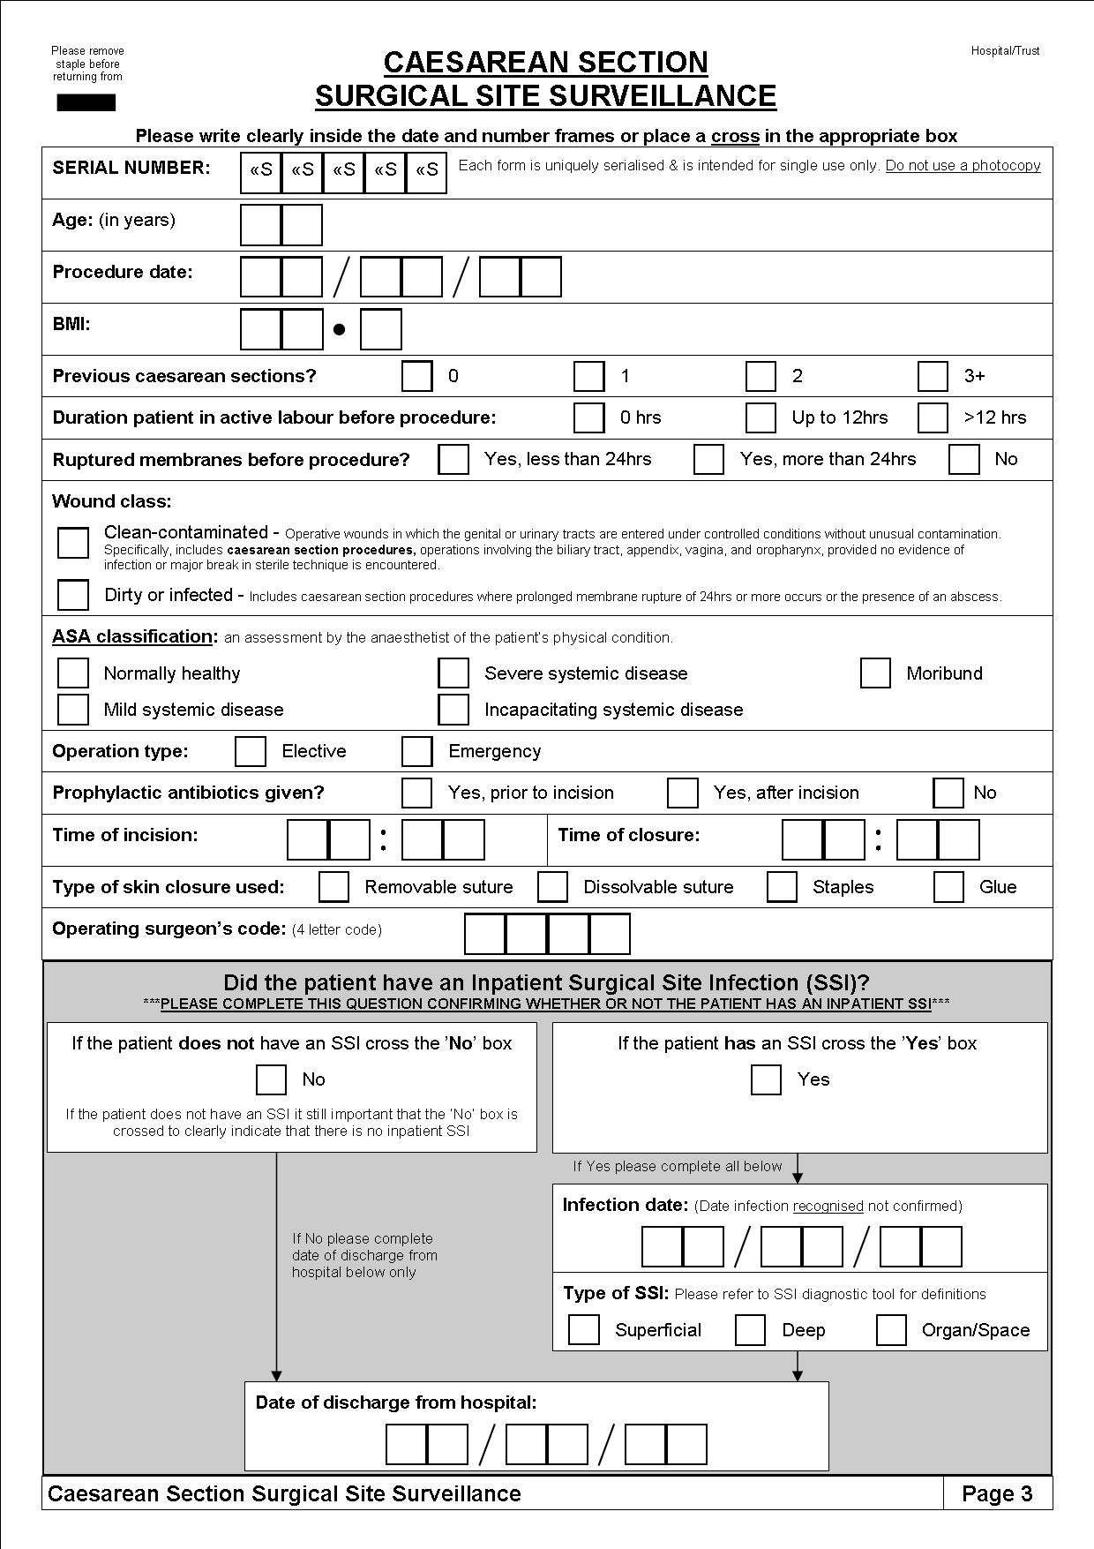

**Example questionnaire (pink form) for inpatient and post-discharge surveillance (2008)**

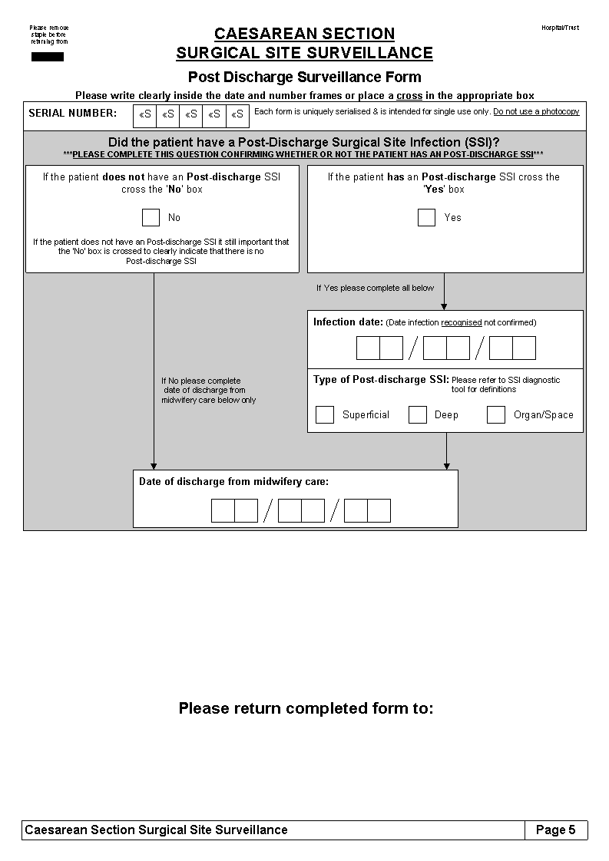

Superficial surgical site infection

An infection that occurs within 30 days of surgery and involves only the skin or subcutaneous tissue of the incision **and** meets at least one of the criteria below

**Criterion 2**

The superficial incision yields organisms from the culture of aseptically aspirated fluid or tissue, or from a swab **and** pus cells are present

**Criterion 1**

Purulent drainage from the superficial incision

**Criterion 3**

The superficial incision is deliberately opened by a surgeon to manage the infection, unless the incision is culture negative

**AND** at least one of the following signs or symptoms:

* Pain/tenderness
* Localised swelling
* Redness
* Heat

**Criterion 4**

The surgeon or a trained healthcare worker diagnoses a superficial incisional infection.

If one or more criteria are answered with ‘yes’ this is a **Superficial SSI**

References:

CDC (2014) Surgical Site Infection (SSI) Event. Available: <http://www.cdc.gov/nhsn/PDFs/pscManual/9pscSSIcurrent.pdf>

PHE (2013) Protocol for the surveillance of surgical site infections. Available: <https://www.gov.uk/government/uploads/system/uploads/attachment_data/file/364412/Protocol_for_surveillance_of_surgical_site_infection_June_2013.pdf>

Deep surgical site infection

An infection that occurs within 30 days of surgery **and** involves deep soft tissues (i.e. fascial and muscle layers) of the incision **and** meets at least one of the criteria below

**Criterion 2**

The deep incision yields organisms from the culture of aseptically aspirated fluid or tissue, or from a swab **and** pus cells are present

**Criterion 3**

Diagnosis of a deep incisional surgical site infection by a surgeon or trained healthcare worker

**Criterion 4**

An abscess or other evidence of infection involving the deep incision that is found by direct examination during re-operation or by histopathological or radiological examination

**Criterion 1**

Purulent drainage from the deep incision but not from the organ space component of the surgical site

**Criterion 5**

Deep incision that spontaneously dehisces (opens up) or is deliberately opened up by a surgeon when the patient has at least one of the following signs or symptoms (unless the incision is culture negative):

* Fever (>38°C)
* Localised pain or tenderness

If one or more criteria are answered with ‘yes’, this is a **Deep SSI**

References:

CDC (2014) Surgical Site Infection (SSI) Event. Available: <http://www.cdc.gov/nhsn/PDFs/pscManual/9pscSSIcurrent.pdf>

PHE (2013) Protocol for the surveillance of surgical site infections. Available: <https://www.gov.uk/government/uploads/system/uploads/attachment_data/file/364412/Protocol_for_surveillance_of_surgical_site_infection_June_2013.pdf>

Organ space surgical site infection

An infection that occurs within 30 days of surgery **and** involves any part of the anatomy (i.e. organ/space) other than the incision that has been opened/manipulated during the surgical procedure **and** meets at least one of the criteria below

**Criterion 2**

The organ/space yields organisms from the culture of aseptically aspirated fluid or tissue, or from a swab **and** pus cells are present

**Criterion 3**

Diagnosis of an organ/space infection by a surgeon or trained health worker

**Criterion 4**

An abscess or other evidence of infection involving the organ/space that is found by direct examination during re-operation or by histopathological or radiological examination

**Criterion 1**

Purulent drainage from a drain that is placed through a stab wound into the organ/space

If one or more criteria are answered with ‘yes’, this is an **Organ/Space SSI**

**45: Carmarthenshire Hip & Knee**

**Serial Number: «Missing merge field»**

**Page Number: 1**

References:

CDC (2014) Surgical Site Infection (SSI) Event. Available: <http://www.cdc.gov/nhsn/PDFs/pscManual/9pscSSIcurrent.pdf>

PHE (2013) Protocol for the surveillance of surgical site infections. Available: <https://www.gov.uk/government/uploads/system/uploads/attachment_data/file/364412/Protocol_for_surveillance_of_surgical_site_infection_June_2013.pdf>