

Accessible Communication and Information Standards for People with Sensory Loss

Online Survey of General Practices in Wales

1. Background
The Centre for Equality and Human Rights (CEHR) has been working with Welsh Government, NHS Wales and Sensory Loss organisations to ensure communication and information is accessible to people with sensory loss whenever they need healthcare.
Following on from the “All Wales Standards for Communication and Information for People with Sensory Loss” which were published in December 2013, a new Accessible Information Standard (the Standard) has been introduced. The Accessible Information Standard requires general practices to capture, record, transfer and flag the different information and communication needs of patients with sensory loss.
The term ‘people with sensory loss’ refers to people who are Deaf and use British Sign Language (BSL), people who are deafened or have hearing loss, people who are blind or partially sighted and people who are deafblind: those who have a combination of sight and hearing loss.
There are over 600,000 people in Wales with sensory loss. Sensory loss affects people of all ages and a significant number will be older people.
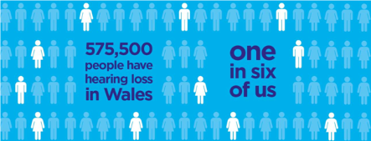
http://www.wales.nhs.uk/sitesplus/888/news/45288

100,000
people in Wales are blind or partially sighted

The Accessible Information Standard is a tool, an enabler, to help health professionals meet their legal duty under the Equality Act 2010 to make reasonable adjustments for disabled people. Health Boards and NHS Trusts have a responsibility to ensure that communication and information is accessible to people with sensory loss. The Standard also ensures that there is consistency in how the different communication and information needs of people with sensory loss are recorded in GP information systems across Wales.

2. Survey Aims and Objectives

Between 19 April 2018 and 14 June 2018, the CEHR ran an online survey aimed at staff working in general practices. The aim of the survey was to gather the views of staff to:
- understand their views on what works well,
- understand what could help to improve the experience of patients with sensory loss, and
- to understand what, if any, barriers exist to achieving this.

Completion of the survey was entirely voluntary and anyone completing the survey was able to leave any questions they would prefer not to answer, blank.

The survey was hosted on the website of the Centre for Equality and Human Rights, and links were provided to GPOne and Primary Care One. A flyer was sent out to practice managers in every general practice across all seven health boards. Other key stakeholders were aksed to share the survey and encourage practices to complete it. The survey took approximately 10 minutes to complete. 91 survey questionnaires were completed across the seven health boards.

3. Survey Analysis and Findings

The questionnaire was broken up into four sections. The infographics below illustrate the key findings of the survey. A full copy of the questionnaire is available at Appendix A.

PART 1: ABOUT YOU

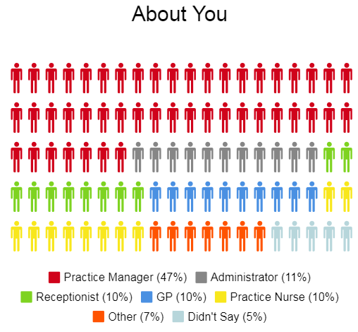

Almost half of survey respondents (47%) were practice managers.

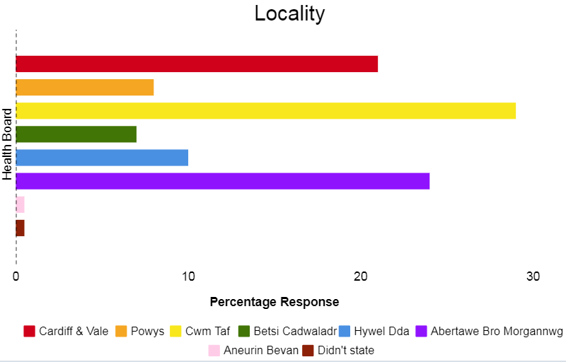
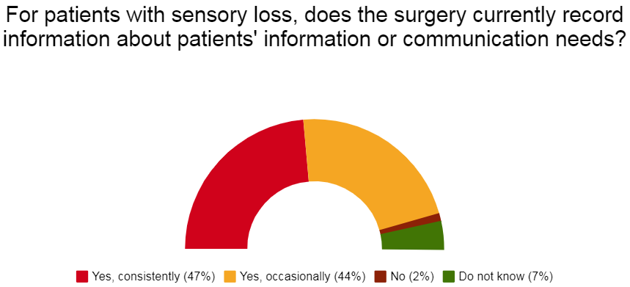
PART 2: IDENTIFYING AND RECORDING PATIENTS’ INFORMATION AND COMMUNICATION NEEDS

Almost half of the respondents surveyed (47%) currently record information about their patients’ communication and information needs. The majority record this information in their IT system.

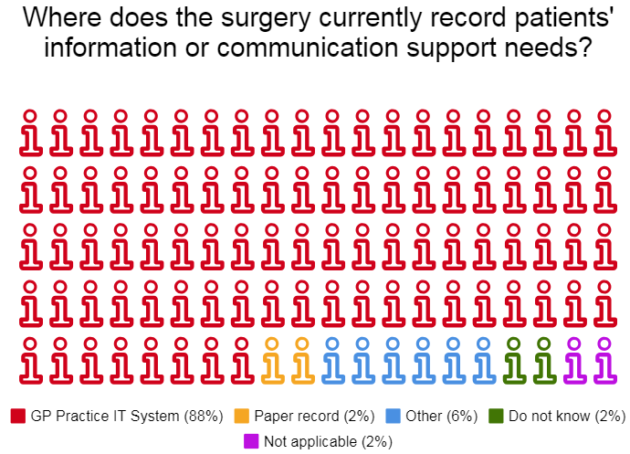
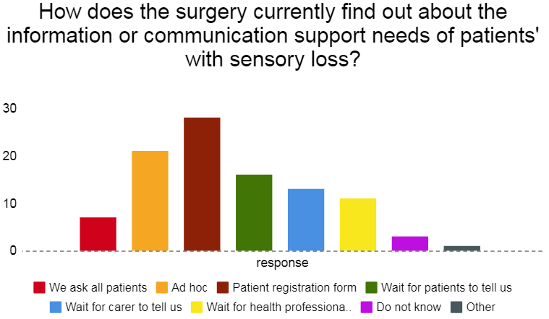
A small number of respondents (8%) ask all patients for this information. Just under a third rely on patient registration forms for this information.

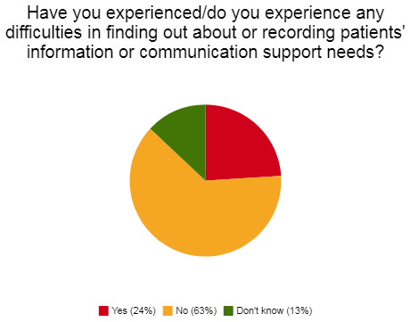

The majority of survey respondents (63%) reported no difficulty in finding out about patients’ communication and information needs.

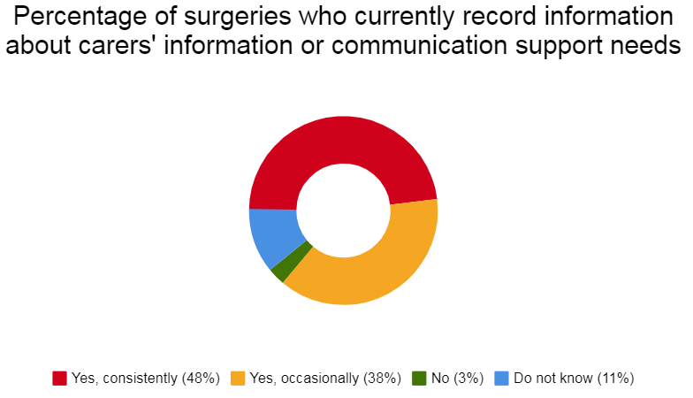

Almost half (47%) of respondents currently capture information about the communication and information needs of carers. The majority record this information in the patient’s record.
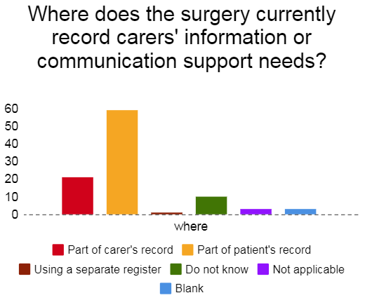
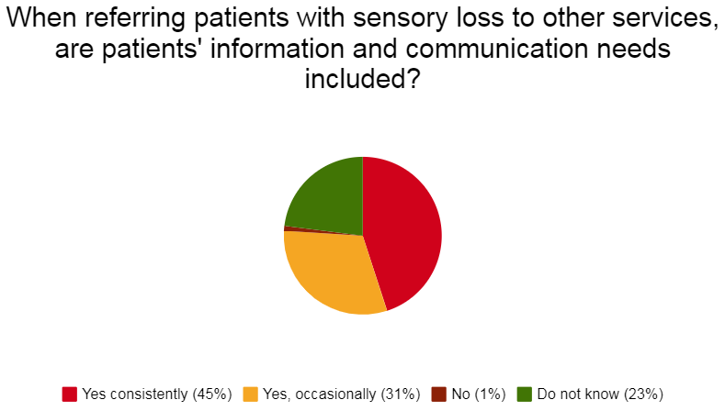

Almost half of the respondents (45%) share information about patients’ communication and information needs when making referrals to other services.

PART 3: MEETING PATIENTS’ INFORMATION AND COMMUNICATION SUPPORT NEEDS

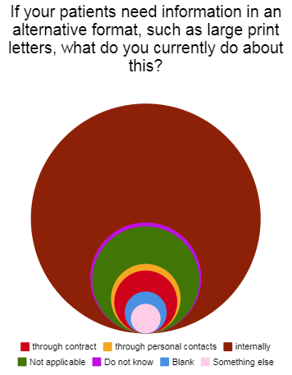

If patients need information in an alternative format, the majority of practices (60%) provide the information or support internally/in-house. A third of the respondents reported feeling unclear about where to get information and support to meet patients’ different communication and information needs.

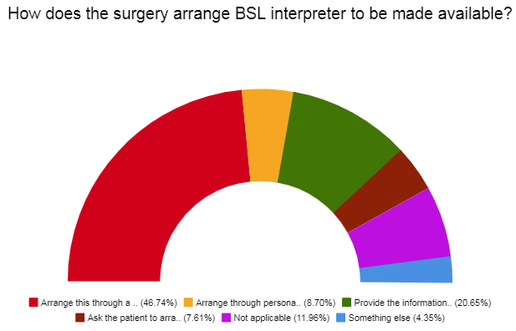
Almost half of the general practices surveyed arrange BSL interpreters through a contract or agreement with one or more suppliers. A small number (7%) ask the patient to arrange this.

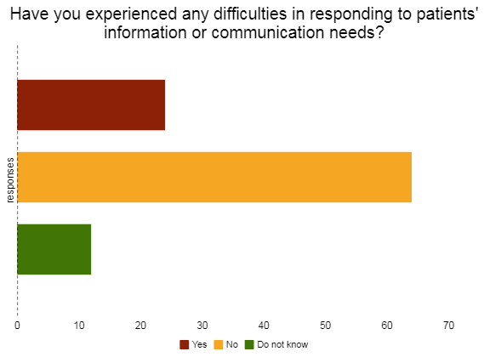

The majority of general practices reported no difficulties in responding to patients’ information or communication needs.

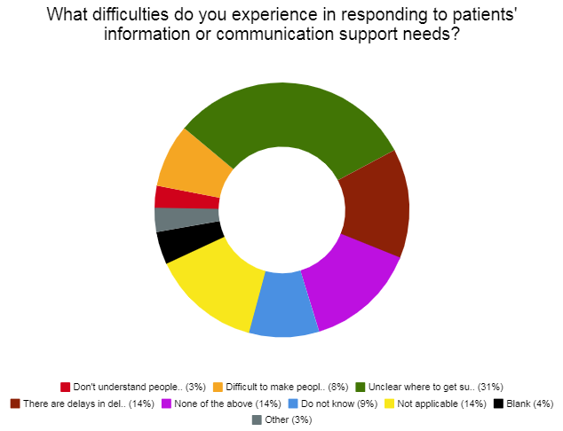

Please refer to Appendix A, Question 15 for full description

PART 4: AWARENESS OF THE ALL WALES STANDARDS FOR ACCESSIBLE COMMUNICATION

Almost half (45%) of practices are aware of the All Wales Standards for Accessible Communication and Information. Of those who responded positively, 26% agreed that the Standards have helped to improve access to healthcare for people with sensory loss.

Disappointingly, the majority of practices (75%) had not heard of the ‘It Makes Sense’ campaign and 70% had not heard of the key messages for staff of ‘Find out; Ask and Offer’.

Disappointingly again, the majority of practices (84%) had not completed the NHS Wales e-learning module on sensory loss.

4. Conclusion

- This is the first survey to understand the level of awareness within general practices of the different communication and information needs of patients with sensory loss. It reflects a shapshot of current awareness and practice across a relatively small number of general practices. Most have responded positively and whilst this is encouraging, this does not generally reflect the experience of patients who encounter communication and information barriers when they need to see their general practitioner or a member of the practice team. The Accessible Health Standard was introduced in October 2018. This requires general practices to capture, record, share and alert the different communication and information needs of patients with sensory loss. Resources have been developed to support the effective implementation of the new standard and can be downloaded at http://www.equalityhumanrights.wales.nhs.uk/resources

5. Recommendations

As part of the implementation of the new Standard, it is recommended that:

- An annual survey is undertaken to measure progress on a wider scale and to ensure that we continue to understand the experience of patients with sensory loss when they need to access their general practice;

- the e-learning module on sensory loss awareness is promoted via GP One and through health boards’ primary care teams and cluster groups

- General practices are supported and signposted to organisations who can provide information in different formats.

January 2019/CEHR

Appendix A

Primary Care Survey: Identifying and Meeting Patients Information and Communication Needs

PART 1: ABOUT YOU

- What is your job role?
- Practice Manager
- Administrator
- Receptionist
- GP
- Practice Nurse
- Other, please specify:
- Didn’t say

- Locality
- Cardiff and Vale
- Powys
- Cwm Taf
- Betsi Cadwaladr
- Hywel Dda
- Abertawe Bro Morgannwg
- Aneurin Bevin
- Didn’t state

- Surgery (optional)

PART 2: IDENTIFYING AND RECORDING PATIENTS’ INFORMATION AND COMMUNICATION NEEDS

- For patients with sensory loss, does the surgery currently record information about patients’ information or communication support needs?
- Yes, consistently / as a routine
- Yes, occasionally / ad hoc
- No
- Do not know

- Where does the surgery currently record patients’ information or communication support needs? Please tick all that apply
- GP practice IT system
please name:
Emis:
Vision:
Other:

Paper record
- Other system / record, please explain
Blank – 4
Other system – 1

- Do not know
- Not applicable (we do not record their needs)

- How does the surgery currently find out about the information or communication support needs of patients’ with sensory loss. Please tick all that apply
- We ask all patients
- Ad hoc, we ask patients when it appears
they might have sensory loss
- Patient registration form
- We wait for patients to tell us
- We wait for a carer to tell us
- We wait for a health professional to tell us
- Do not know
- Other, please specify:

- Have you experienced /do you experience any difficulties in finding out about or recording patients’ information or communication support needs?
- Yes
- No
- Don’t know

- What difficulties do you experience in finding out about or recording patients’ information or communication support needs? Please tick all that apply
- I am/staff are uncomfortable in asking people about their needs
- I am/staff are too busy to ask people about their needs
- No system for recording this information
- No system for acting upon this information
- Not considered to be relevant
- Do not know/Didn’t respond
- Not applicable (we do not experience difficulties)
- Other difficulty/difficulties, please explain:

- Does the surgery currently record information about carers’ information or communication support needs?
- Yes, consistently / as a routine
- Yes, occasionally / ad hoc
- No
- Do not know

- Where does the surgery currently record carers’ information or communication support needs?
- As part of the carer’s record
- As part of the patient’s / cared-for-person’s record
- Using a separate register / record
- Do not know/Didn’t respond
- Not applicable (we do not record carers’ needs)
- Somewhere else, please specify:

- When referring patients’ with sensory loss to other services, are patients’ information and communication support needs included?
- Yes, consistently / as a routine
- Yes, occasionally / ad hoc
- No
- Do not know

PART 3: MEETING PATIENTS’ INFORMATION AND COMMUNICATION SUPPORT NEEDS

- If your patients’ need information in an alternative format, such as a large print letters, what do you currently do about this? Please tick all that apply.
- Arrange this through a contract or agreement with one or more suppliers

- Arrange through personal contacts with one or more suppliers / individuals

- Provide the information or support internally / in-house
- Ask the patient to arrange it themselves
- Nothing
- Not applicable (have never been asked for this)
- Do not know/Didn’t respond 16%
- Something else, please explain 1%

- If your patients’ need communication support, such as a British Sign Language Interpreter, what do you currently do about this? Please tick all that apply.
- Arrange this through a contract or agreement with one or more suppliers

- Arrange through personal contacts with one or more suppliers / individuals

- Provide the information or support internally / in-house
- Ask the patient to arrange it themselves
- Nothing
- Not applicable (have never been asked for support)
- Something else, please explain:
- Do not know

- Have you experienced / do you experience any difficulties in responding to patients’ information or communication support needs?
- Yes
- No
- Do not know

- What difficulties do you experience in responding to patients’, information or communication support needs? Please tick all that apply.
- I / staff don’t understand what to do about people’s needs
- It is difficult to make colleagues / other services aware of needs
- It is unclear where / who to get information / support from
- There are delays in delivery / difficulties in meeting requests
- None of the above
- Do not know
- Not applicable (we do not experience difficulties)
- Blank
- Other difficulty / difficulties, please explain:

- Please add any comments or explanation about the difficulties your GP surgery experiences in recording and / or responding to patients’ information or communication support needs here.

- We are keen to learn about good practice in recording and responding to people’s information and communication support needs. If something you do is working well, please tell us about it here.

PART 4: AWARENESS OF THE ALL WALES STANDARDS FOR ACCESSIBLE COMMUNICATION
- Do you know about the All Wales Standards for Accessible Communication?
- Yes
- No
- Not sure

- If yes, do you think the standards have helped to improve access to NHS Wales Services for people with sensory loss since their launch in 2013?
- Yes
- No
- Not sure
- Not applicable
- Didn’t respond

- Have you heard of the “It Makes Sense” campaign?
- Yes
- No
- Not sure/didn’t respond
- If yes, how did you hear about the “It Makes Sense Campaign”?
- Support organisation or charity
- “It Makes Sense” Campaign film
- “It Makes Sense” newsletter
- Posters
- NHS website
- Word of mouth
- Training session
- Other, please specify (didn’t specify)
- Didn’t respond

- Have you heard of the “It Makes Sense” campaign key messages for NHS Wales staff of Find Out, Ask, Offer.
- Yes
- No
- Not sure/Didn’t respond

23. Have you completed the NHS Wales E-Learning Module on Sensory Loss Awareness
- Yes
- No
- Not sure/Didn’t respond

