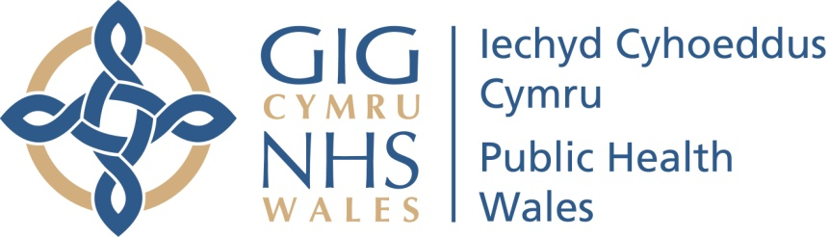

The Pre-release Access to Official Statistics (Wales) Order 2009
Declaration as to persons granted pre-release access to official statistics
Child Measurement Programme for Wales, 2017/18 school year
Published 7th March 2019, 9.30 a.m.
Pre-release access to this release of official statistics was granted for a period of five working days prior to the date of publication, to those people in the positions / organisations listed below:
Public Health Wales
- Jyoti Atri – Director of Health and Wellbeing
- Julie Bishop – Director of Health Improvement
- Lucy O’Loughlin – Consultant in Public Health – ‘Every Child’ lead
- Daniel Owens – Communications Officer
NHS Wales Health Boards
- Leslie Jones, Consultant in Public Health – Betsy Cadwaladr University Health Board
- Suzanne Wood, Consultant in Public Health Medicine – Cardiff and Vale University Health Board
- Sandra Husbands, Executive Director of Public Health – Abertawe Bro Morgannwg University Health Board
- Michael Thomas, Consultant in Public Health Medicine – Hywel Dda University Health Board
Welsh Government
- Cabinet Secretary for Health and Social Service
- Chief Medical Officer
- Sarah Rowles, Healthy and Active branch, Public Health Division
- Rebekah Tune – Communications
- Neil Surman – Deputy Director Public Health

