

SUBSTANCE MISUSE PROGRAMME

Harm Reduction Database Wales: Prevention and detection of infectious disease amongst people accessing substance misuse services
Annual Report 2019-20

About Public Health Wales

Public Health Wales exists to protect and improve health and wellbeing and reduce health inequalities for people in Wales. We work locally, nationally and internationally, with our partners and communities.
The Substance Misuse Programme works to address both the current and emerging public health threats in Wales and in line with the overarching strategic objective to ‘reduce health inequalities, and prevent or reduce communicable and non-communicable disease, wider harms and premature death related to drugs and alcohol use and related risk behaviours’.

Substance Misuse Programme
Public Health Wales
Number 2 Capital Quarter
Tyndall Street
Cardiff
CF10 4BZ

Tel: 02920104496

www.publichealthwales.org/substancemisuse

Acknowledgements: Public Health Wales would like to thank all those that contributed to the Harm Reduction Database Wales, including service users, staff and all provider organisations including specialist substance misuse services, Criminal Justice services including OIS and specialist clinical treatment service providers.

Published: Drew Turner and Josie Smith, Substance Misuse Programme, Health Protection Division, Public Health Wales, 2020.

Contents
Glossary of key abbreviations 4
1 Forward 5
2 Executive Summary 6
2.1 Key findings and trends 6
2.2 Recommendations 8
3 Preventing infections amongst people who inject drugs through effective needle and syringe programmes 10
3.1 Location and type of NSPs across Wales 10
3.2 NSP activity overview 11
3.3 Geographic comparisons of individuals accessing NSP services across Wales 14
3.4 NSP clients - Profile of unique individuals accessing services 17
3.5 Comparisons of clients attending Specialist NSP services vs Community Pharmacy services 24
4 Blood Borne Virus screening, diagnosis and treatment 27
4.1 BBV screening in community settings in Wales 28
4.2 BBV screening overview 28
4.3 Demographics and risk factor characteristics of all individuals receiving BBV screening 30
4.4 Diagnosis and treatment 32
4.5 Hepatitis C treatment 37
5 Data Quality 40
5.1 Needle and Syringe Programme module 40
5.2 Blood Borne Virus module 40
6 Appendices 41
6.1 Appendix A - What is the Harm Reduction Database? 41
6.2 Appendix B - Definitions and notes on data interpretation 43

Glossary of key abbreviations

Anti-HCV | Hepatitis C virus antibody
Anti-HIV | Human Immunodeficiency Virus antibody
BBV | Blood Borne Virus
BCU | Betsi Cadwaladr University Health Board
CTM | Cwm Taf Morgannwg
DBST | Dried Blood Spot Test
DAA | Direct acting antivirals
EASR | European Age Standardised Rate
HBV | Hepatitis B virus
HBsAg | Hepatitis B virus surface antigen
HCV | Hepatitis C virus
HDS | High dead space
HIV | Human Immunodeficiency Virus
HRD | Harm Reduction Database Wales
IPED | Image and Performance Enhancing Drug
LDS | Low dead space
LIMS | Laboratory Information Management System
MSM | Men who have sex with men
NSP | Needle and Syringe Programme
OST | Opioid substitution therapy
PCR | Polymerase chain reaction
POCT | Point of Care Test
PWID | People who inject drugs
RNA | Ribonucleic acid
SCRA | Synthetic Cannabinoid Receptor Agonist
SMS | Substance misuse service
UAM | Unlinked Anonymous Monitoring Survey
WHO | World Health Organisation
WNDSM | Welsh National Database for Substance Misuse

Forward
This report was written in the shadow of the COVID-19 pandemic. Since March 2020 restrictions on freedom of movement and the requirement for social distancing has resulted in new challenges for harm reduction services. We are also working in the backdrop of increasing harms due to substance misuse. Drug misuse deaths are at the highest recorded levels with 208 drug deaths recorded in 2018. Hospital admissions relating to illicit drugs have increased by 17 per cent over the last 5 years.
Increased focus over the last few years has been on upscaling screening and treatment for Hepatitis C, alongside new screening and treatment opportunities, leading to better engagement, diagnosis and treatment outcomes. However, activity to prevent new infections though the provision of clean and sterile injecting equipment requires has static, and in some areas declined. Optimal needle and syringe provision remains a critical element in reducing the health burden of blood borne virus and bacterial infections and requires a fresh focus and resource.
In 2019-20, we report a reduction in the number of individuals accessing NSP services in Wales, especially younger people. It is important to continue to consider the needs of the population who use online needle and syringe provision rather than traditional NSP services, alongside continued efforts to reach new populations who currently choose not to attend NSP services. Whilst there has been a reduction in needle and syringe activity due to the pandemic, many services have remained open and active, expanding their outreach programmes in these difficult times. We have heard many examples of innovation as a consequence of COVID-19 which should be noted, evaluated and further developed.
In addition, it is important that NSP services continue to help address other harms caused by substance misuse. This includes ensuring all NSP and substance misuse service clients reporting opioid use have ready access to take home Naloxone in order to reduce preventable deaths due to opioids in Wales. Over the next year, the harm reduction database NSP module will be developed to incorporate the provision of self-care wound packs, with an associated training package for service users and providers. The ACT (Ask, Check, Treat) project will support people who inject drugs to prevent, identify and manage injecting site infections to reduce escalation to severe bacterial infections that may result in the requirement for more invasive health care interventions.
The COVID-19 pandemic came after a record year for blood borne virus screening in Wales. 2019-20 is the third full year since the implementation of the Harm Reduction Database BBV module. Over this time, around 7,000 individuals have been tested for blood borne viruses including hepatitis C, within substance misuse services. Levels of screening indicate a 134 per cent increase since 2017-18, over which time a total of 1,197 people across Wales have been identified as antibody reactive for hepatitis C, enabling them to be referred for further testing and treatment to clear the virus.
Public Health Wales would like to thank all service users and frontline staff who have contributed to the provision of substance use and harm reduction services and to the Harm Reduction Database so that timely evidence of progress and trends is available in Wales.

Executive Summary

Key findings and trends

Needle and Syringe Programmes
- Coverage of NSP remains sub-optimal and as such requires substantial upscaling in order to prevent blood borne virus transmission and bacterial infections. It is estimated that amongst PWID injecting opioids and/or stimulants, coverage (clean injecting equipment for every injecting event) in Wales is around 27 per cent. Individuals who accessed specialist sites were, on average, being issued with almost double the number of syringes over the year compared to those accessing pharmacy NSP
- Approximately one third of NSP interactions (33 per cent) occurred in specialist NSP services with the remaining two thirds (67 per cent) occurring in community pharmacy.
- Data quality within NSPs varied by geographic area and service type, with injecting risk factor completion ranging from 19 to 87 per cent, indicating substantial variability in the quality of injecting-related disease prevention service provision.
- There has been a decrease in NSP activity including the number of regular clients attending, interactions in NSP services and syringes provided compared to the previous year, dropping by 8 per cent, 4 percent and 4 percent respectively. There was a substantial reduction in activity in NSP services in the month of March compared to previous years due to the impact of the COVID-19 pandemic.
- Use and injecting of stimulant substances in the NSP dataset is considered to be substantially underreported given the level of self-report use of stimulants, particularly cocaine and crack cocaine, in other surveys, and datasets and assessment data.
- For the first year, opioids were the largest substance group recorded. The proportion of individuals accessing NSP and reporting IPED use has reduced in each of the last 3 years.
- Amongst people who inject drugs (PWID) opioids and where data recorded:
- Self-reported indirect sharing of injecting equipment (e.g. sharing of spoons, filters, water) was reported by 32 per cent and direct sharing (needles and syringes) by 26 per cent
- The proportion of new initiates reporting opioid injecting (individuals injecting for less than 36 months) has declined over the last 5 years from 11 per cent to 6 per cent
- Self-reported higher risk injecting sites (e.g. groin) has increased from 19 per cent in 2015-16 to 20 per cent in 2019-20
- Amongst PWID injecting stimulants and where data recorded:
- Self-reported indirect sharing of injecting equipment (e.g. sharing of spoons, filters, water) was reported by 36 per cent and direct sharing (needles and syringes) by 30 per cent in 2019-20, an increase of 8 percentage points over the last 5 years
- The proportion of new initiates reporting stimulant injecting (individuals injecting for less than 36 months) has declined over the last 5 years from 12.5 per cent to 4 per cent.
- Self-reported higher risk injecting sites (e.g. groin) has increased steadily, rising form 14 per cent in 2015-16 to 20 per cent in 2019-20

- Amongst PWID injecting Image and Performance Enhancing Drugs (IPEDs):
- Those reporting IPED injecting consistently represent the youngest PWID cohort, however, recent years have seen a substantial decline in younger IPED users accessing NSP services
- The proportion of new initiates reporting IPED use and attending services (individuals injecting for less than 36 months) has declined substantially over the last 5 years, from 36 per cent to 15 per cent
- The proportion of individuals only attending pharmacy sites has increased over the last 5 years, with 64 per cent attending pharmacy only in 2015-16 to 67 per cent in 2019-20

Blood Borne Virus screening
- Between 1 April 2017 and 31 March 2020, a total of 8,734 BBV tests were completed by substance misuse and community services involving 7,048 individuals. Over 50 per cent of individuals (n=3,773) were screened in 2019-20.
- Amongst those tested in 2019-20:
  - HIV antibodies, and Hepatitis B Surface Antigen was detected in less than 1 per cent of individuals
  - Across Wales Hepatitis C antibodies (anti-HCV) were detected in 17 per cent of individuals, with rates varying between health boards.
  - Amongst high risk groups, including current PWID, prevalence rates across Wales ranged from 54 per cent in Swansea Bay Health Board to 11 per cent in Powys Teaching Health Board
  - The incidence rate of anti-HCV amongst recent initiates (those injecting 36 months or less) was 21 per 100 person years. Amongst other individuals testing anti-HCV negative in 2018-19 and anti-HCV reactive in 2019-20, the incidence rate was 6 per 100 person years.
  - Of those who tested reactive for anti-HCV, 72 per cent of individuals were recorded as having received a confirmatory PCR test to establish current infection
    - There remain 401 anti-HCV reactive individuals in Wales have not had a confirmatory PCR recorded on the Harm Reduction Database.
- Rates of anti-HCV were highest amongst individuals reporting having injected opioids in the last 12 months (38 per cent), injected drugs whilst in prison (47 per cent), and injecting drugs daily (38 per cent). Rates were lowest amongst under 25 years old (2 per cent) and those who had injected IPEDs in last 12 months (none detected)
- 255 individuals were referred into HCV clinical specialist services by SMS in Wales, 55 per cent (n=140) following reactive anti-HCV test and 45 per cent (n=115) following an HCV confirmatory PCR/RNA test

Recommendations
- To address current sub-optimal coverage (sterile injecting equipment for every injecting event) across Wales, Welsh Government, Public Health Wales, Health Board area NSP pharmacy leads and Community Pharmacy Wales work to agree and implement a national specification for pharmacy provision of needle and syringe programmes.

- Public Health Wales, in collaboration with people with lived experience, undertake a mixed method community needs assessment research project, updating that published in 2006 Needs Assessment of harm reduction services. Research objectives include evidencing the facilitators and barriers to access and engagement with NSP and other harm reduction and treatment services including uptake of testing and treatment for blood borne viruses.

- Develop the Harm Reduction Database Wales – Needle and Syringe Programme Module to streamline and improve data quality, reporting and incorporation of the ACT project for the provision of self-care wound pack to reduce injecting related bacterial infections. Associated training on prevention, identification and treatment of bacterial infections to be implemented across Wales

- Substance Misuse and allied services, with the support of Welsh Government and Public Health Wales, re-establish routine opt-out blood borne virus testing, referral and treatment across Wales, paused as a consequence of COVID-19 pandemic in March 2020.

- Central collation and evaluation of new and innovative methods of delivery of harm reduction services, initiated as a consequence of COVID-19 pandemic, for consideration of expansion and embedding across Wales for effective and cost-effective service developments.

Preventing infections amongst people who inject drugs through effective needle and syringe programmes
Needle and Syringe Programme (NSP) services provide sterile injecting equipment and related paraphernalia, including foil as an alternative to injecting, as well as harm reduction information, advice and referral to specialist treatment services. As such they represent a vital service in the prevention of infections related to injecting, specifically blood borne viruses: hepatitis B, hepatitis C and HIV; as well as bacterial infections including Staphylococcus aureus and Invasive Group A streptococci, often related to unsterile injection practices. NSPs are the first line service to prevent infections by ensuring the use of sterile injecting equipment at every injecting event in line with best practice guidance.,

Location and type of NSPs across Wales
Currently in Wales Needle and Syringe Programmes operate within 57 specialist statutory/ voluntary organisation sites and 217 community pharmacies. In 2019-20, 43 specialist sites and 186 pharmacies recorded at least one interaction. Figure 1 shows the geographical location of NSP sites across Wales.
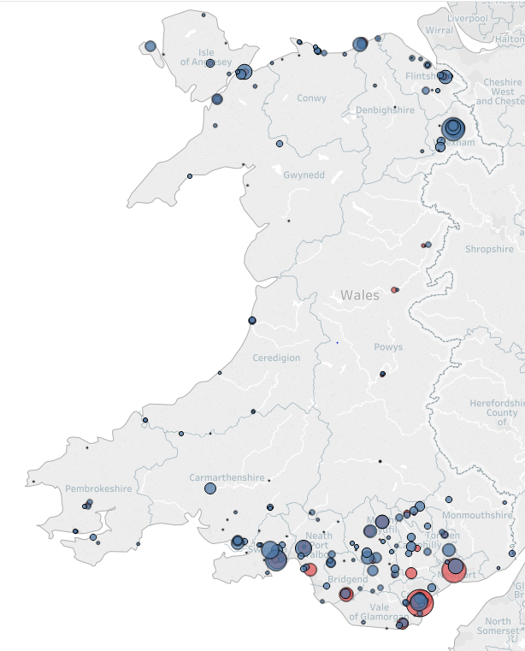
Figure 1 – Geographical location of NSP sites in Wales by site type and number of individuals attending 2019-20
In total, 142,190 interactions occurred across all NSP sites in 2019-20, a reduction of 4 per cent compared to the previous year. This decrease can largely be accounted for by reduction in interactions in March 2020 were there were 3,204 fewer interactions compared to the same period the previous year. This is likely as a result of disruption to services due to the COVID-19 pandemic.
Approximately one third of interactions (33 per cent) occurred in specialist NSP services whilst the remaining two thirds (67 per cent) occurred within community pharmacy settings (see Table 1).
Geographical variation in site coverage and concentration of specialist NSP services between health boards reflects differences in rurality between health board regions. For example, in Cardiff and the Vale University Health Board (UHB), 69 per cent of all interactions occurred within specialist services. In comparison, 92 per cent of NSP interactions in Betsi Cadwaladr UHB occurred within community pharmacy NSP services.
Further analysis of Health Board and Local Authority level activity is available in Section 3.3 - Geographic comparisons of individuals accessing NSP services across Wales.
Table 1 - NSP Interactions by Health Board 2019-20

NSP activity overview
The 2019-20 financial year represents the sixth year of the collection of NSP activity data across all services (community pharmacy and specialist substance misuse services) in Wales.
Table 2 - Summary of NSP activity, by year 2014-15 to 2019-20
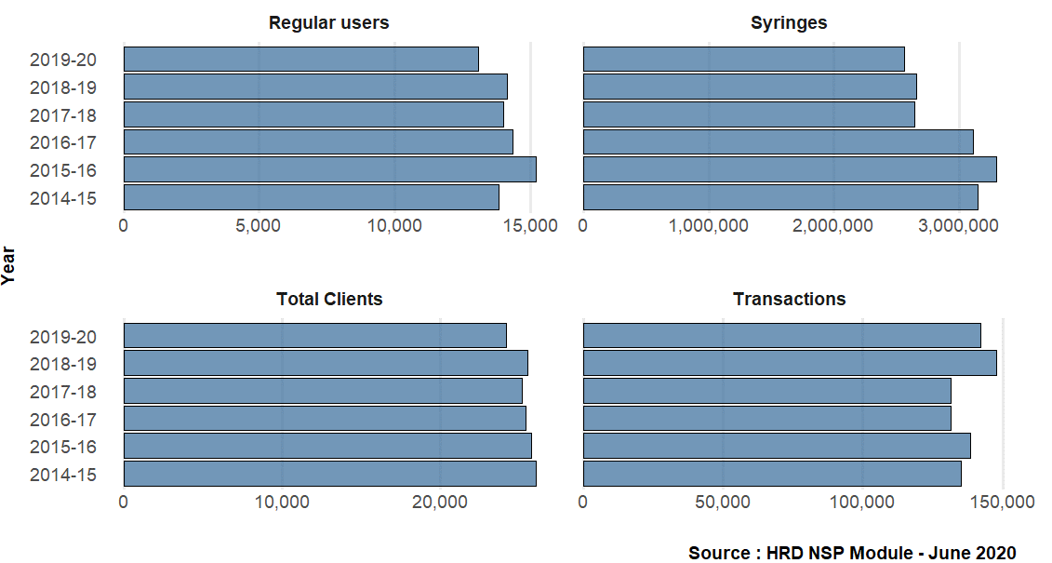
Figure 2 - Summary of NSP activity, by year 2014-15 to 2019-20
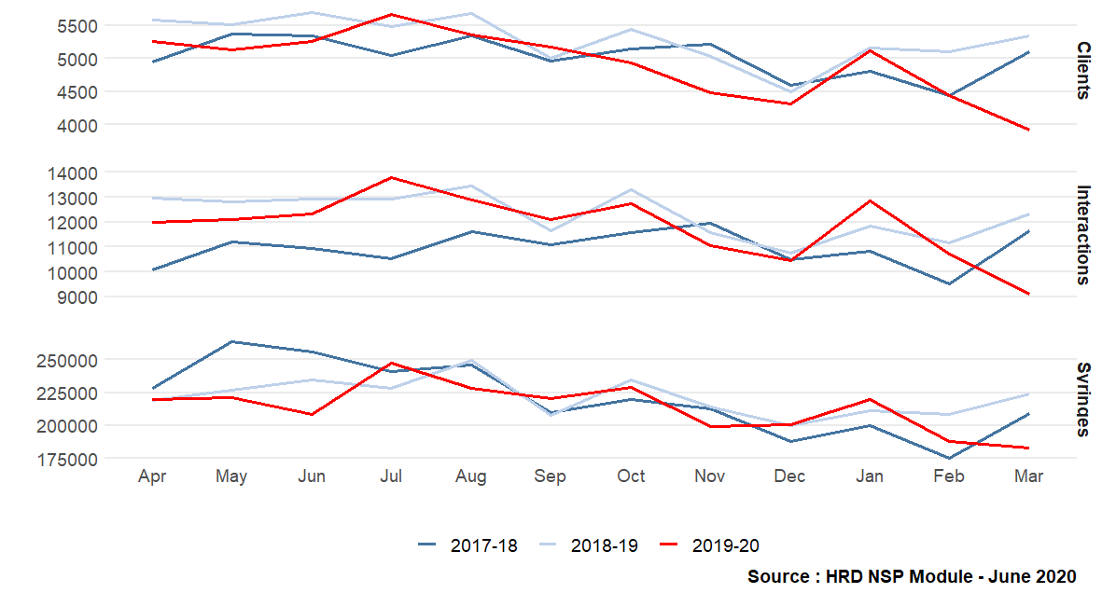
Figure 3 - Summary of NSP activity in Wales, by month 2017-18 to 2019-20

Table 3 – NSP activity summary by Health board, 2019-20
N.B. As individual PWID may report use of more than one substance type, proportions by substance type will not add up to 100 per cent

Syringes dispensed
There were 2,564,798 syringes dispensed in Welsh NSP services in 2019-20. This represents a decrease of 4 percent compared to the previous year and the lowest number of syringes provided since the introduction of pharmacy services in 2014-15. One explanation could be the disruption to services as a result of the COVID-19 pandemic from late February.
In November 2019, production of the Nevershare syringes was stopped abruptly, and a small reduction in the number of syringes dispensed by services was observed compared to previous years. However, the number of syringes then increased to normal levels by December. Further work is required to establish the significance of any impact caused by the change in equipment on service uptake and injecting practices.
Prior to implementation of the national procurement project in 2017-18, the quantity of injecting equipment was slightly higher due to provision of fixed multipacks of injecting equipment. Subsequently, and due to a change to provision of single injecting kits alongside pick and mix, overall quantity of injecting equipment issued decreased, with the difference representing a decrease in wastage of unwanted and unused equipment. Before COVID-19 lockdown in March 2020, levels of provision of injecting equipment had remained stable from 2017-18.
Coverage rates
It is a principle of NSP services in Wales, supported by UK-wide guidance, to provide PWID with sufficient sterile injecting equipment for every injecting event. The term ‘coverage rate’ refers to the proportion of injecting events where sterile injecting equipment is used.
Whilst the HRD records both frequency of injecting reported by each individuals attending NSP, alongside the equipment provided at every interaction, the undertaking of robust coverage analysis remains challenging due to the complex nature of injecting practices across PWID subgroups.
A crude estimate has been calculated by reviewing the median number of syringes provided to PWID injecting opioids and/or stimulants and reporting injecting daily. Assuming that each individual PWID only injects once per day, it would be expected that they would collect 365 syringes per year. The median number of syringes provided to this group was 100 per person in 2019-20. This approximates a coverage rate of 27 per cent. Coverage of NSP remains sub-optimal and as such requires substantial upscaling in order to prevent blood borne virus transmission and bacterial infections.

Foil dispensed
In line with best practice, all individuals who are injecting or at risk of initiation to injecting are encouraged to consider alternative methods of consumption, for example, the use of foil for heroin smoking instead of injecting. As such, foil for smoking is available in specialist NSP services. As shown in Table 4, uptake of foil has increased amongst regular opioid NSP clients over the last 5 years.
The proportion of individuals using opioids and collecting foil varies by health board from 48 per cent in Swansea Bay to 36 per cent in BCU Health Board.
Table 4 - Number and proportion of individuals reporting opioid use collecting foil for smoking, by year

Table 5 - Number and proportion of individuals reporting opioid use collecting foil for smoking, by Health Board

Geographic comparisons of individuals accessing NSP services across Wales
In 2019-20 the European Age Standardised Rate (EASR) of individuals attending NSP services across Wales was 706.8 individuals per 100,000 population (see Table 6). Geographical comparisons between health boards and local authorities highlights variation in individuals attending NSP services.
- At Health Board level, BCU Health Board had the highest rate of regular clients attending NSP services (1021.7 individuals per 100,000 population), and Powys Teaching Health Board the lowest (334.6 individuals per 100,000 population).
- At Local Authority level, Wrexham had the highest rate (2011.6 individuals per 100,000 population), which was nearly three times higher than the Welsh rate of regular clients attending services. The lowest rates were recorded in Monmouthshire (337 individuals per 100,000 population) and Powys (334.6 individuals per 100,000 population).
- Opioids: Rates of PWID reporting use of opioids were highest in the health board region of BCU (652.4 per 100,000 population) and local authority of Wrexham (1260.3 individuals per 100,000 population), and lowest in Powys Teaching Health Board (193.0 individuals per 100,000 population) and Caerphilly local authority area (1590 individuals per 100,000 population).
- Stimulants: Rates of PWID reporting use of stimulants were highest in Cwm Taf Morgannwg (CTM) Health Board (227.5 individuals per 100,000 population) and the local authority of Merthyr Tydfil (345.3 individuals per 100,000 population), nearly three times higher than the overall Welsh rate (111.9 individuals per 100,000 population). Rates were lowest in Powys Teaching Health Board (55.3 individuals per 100,000 population) and Caerphilly Local Authority area (44.6 per 100,000 population).
- IPEDs: Individuals reporting use of IPEDs were highest in CTM Health Board (509.2 per 100,000 population) and Wrexham Local Authority (1,023.2 individuals per 100,000 population), and lowest in Powys Teaching Health Board (143.6 individuals per 100,000 population) and Monmouthshire Local Authority (109.2 individuals per 100,000 population).

Table 6 - Number of individuals regularly accessing NSP per EASR 100,000 population (15-64 years) by local authority, 2019-20

NSP clients - Profile of unique individuals accessing services
In 2019-20, a total of 24,196 unique individuals accessed NSP services (see Table 7). This number has been gradually decreasing over the last 5 years. Of these individuals, 54.8 per cent (n = 13,091) were defined as regular NSP service users (for definition see section 6.2.2 - Regular NSP service users). This represents an 8 per cent reduction in the number of regular clients compared to the previous year. The reported reduction, at least in part, is a result of disruption to services due to the COVID-19 epidemic in March.

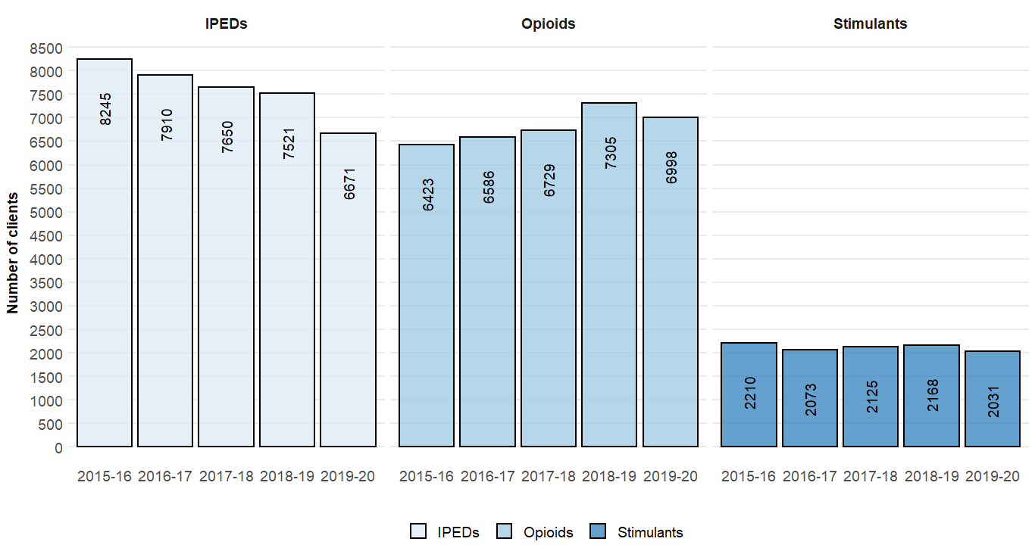
Figure 4 - Number of individuals regularly accessing needle and syringe programmes by substance group and year 2015-16 to 2019-20.
Table 7 - Proportion of regular individuals accessing NSP in Wales by substance group and year (2014-15 to 2019-20)
For the first year on record, Opioids was the largest substance group of reported use, representing 54 per cent (n=6,998) of all individuals regularly attending NSP. The proportion of individuals reporting opioid use has increased by 11 per cent compared to 2014-15.
In 2019-20, Image and Performance Enhancing Drugs (IPEDs) was reported amongst 51 per cent (n=6,671) of all individuals regularly attending NSP. The proportion of clients accessing NSP services for IPEDs has reduced for the third consecutive year. Early review of the data for the first quarter of 2020-21 suggests that this proportion dropped substantially again since March 2020 and the COVID-19 lockdown period.
The smallest substance group reported were stimulants, reported by 2,031 individuals. There has been little change in the proportion of individuals who reported use / injecting of stimulants over the 5 years, which has increased marginally to 16 per cent. This is highly likely to be a data quality issue with secondary substances injected poorly reported in a number of NSP services – see section 3.4.2.
As indicated by the proportions of PWID within each of the substance categories above, an individual may use one or more type of substance. The profile of poly-drug type use reported by those regularly attending NSP services, and were recorded, in 2019-20 is shown in Figure 5.

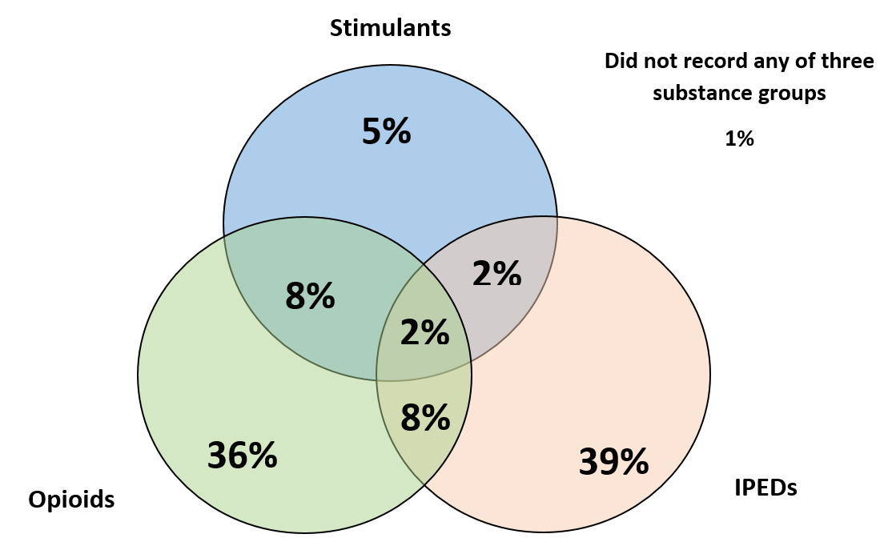
Figure 5 - Venn diagram detailing the profile of self-reported substance group use by individuals regularly accessing NSPs in 2019-20

Profile of PWID reporting use of opioids
In 2019-20, 54 per cent (n = 6,998) of all individuals regularly accessing NSP reported using an opioid, an increase of 2 percentage points from the previous year. Table 8 compares demographics and injecting characteristics of individual PWID reporting opioid use by year from 2015-16 to 2019-20.
Table 8 - Demographics and injecting characteristics of individuals reporting opioid use by year, 2015-16 to 2019-20
Demographics:
- Median age and range, proportion of individuals aged 50+ years, and length of injecting career have both increased since 2015-16 (see Table 8). This trend is accompanied by a decline in the proportion of individuals aged under 25 years, and new injecting initiates (injecting less than 36 months). This data is consistent with an older cohort of PWID using opioids as shown in Figure 6.
- Sex distribution has remained relatively consistent over the last 4 years, with females representing between 18 to 19 per cent of unique individuals accessing NSP services.
- Unemployment was reported amongst 78 per cent (n=2,861) of individuals.
- Proportion of individuals reporting sex working remains consistent at < 5 per cent, however, this is believed to be underreported.
- The proportion of clients reporting no fixed abode (NFA) has increased year on year, from 22 per cent in 2015-16 to 24 per cent in 2019-20. Non-secure housing (e.g. hostel, friend’s home) was reported by a further 15 per cent of individuals. Being homeless or unstably housed often results in higher risk and non-sterile injecting practices due lack of access to washing facilities, clean surfaces for preparation and injecting in public places.

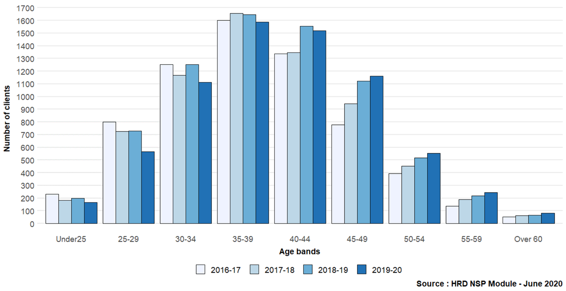
Figure 6 - Number of regular NSP individuals who reported using an opioid, by age quintile and year 2016-17 to 2019-20

Injecting risk behaviour and trends:
- The proportion of new initiates reporting opioid injecting (individuals injecting for less than 36 months) and accessing NSPs has declined over the last 5 years from 11 per cent to 6 per cent
- Median length of injecting career has increased over the last 5 years, from 10 years to 12 years
- Self-reported higher risk injecting sites (e.g. groin) has increased steadily, rising from 17 per cent in 2016-17 to 20 per cent in 2019-20. Injecting using higher risk sites can lead to serious health complications, including severe bacterial and blood stream infections and pseudoaneurysms which could result in limb amputation or death
- The proportion of individuals reporting injecting in the arm or leg has remained consistent since 2014-15 at 88 per cent of individuals
- Self-reports of re-use of injecting paraphernalia has remained relatively consistent over recent years with nearly half of all individuals (49 per cent) reported re-use of paraphernalia in 2019-20
- Self-reported indirect sharing of injecting equipment (e.g. sharing of spoons, filters, water) was reported by 32 per cent and direct sharing (needles and syringes) by 26 per cent
- The annual median number of NSP interactions with individuals in 2019-20 was 5 interactions (range: 2 – 398 interactions) providing a median of 60 syringes per year (range: 0 – 15,188 syringes). Whilst the median number of interactions has remained consistent, the median number of syringes issued has decreased by 17 per cent since 2017-18 when single injection kits were introduced.

Profile of PWID reporting use of stimulants
In 2019-20, 15 per cent (2,031) of all individuals regularly accessing NSPs reported using a stimulant, the smallest of the three substance groups. The stimulant group includes substances such as amphetamine, cocaine and crack cocaine. Table 9 compares demographics and injecting characteristics of PWID reporting stimulant use by year from 2015-16 to 2019-20.
Table 9 - Demographics and injecting characteristics of individuals reporting stimulant use by year, 2015-16 to 2019-20
Demographics:
- The age distribution of PWID reporting stimulant injecting and attending NSP services is indicative of an older cohort with the median age increasing from 37 to 40 in the last 5 years with a corresponding decrease from 6.2 per cent to 2.2 per cent in the proportion of PWID aged under 25 years
- Sex distribution has remained relatively stable over the last 4 years, with females representing between 17.5 to 19 per cent of PWID using stimulants in 2019-20
- Unemployment was reported amongst 80 per cent (n= 996) of individuals
- Less than 5 per cent reported being engaged in sex work in 2019-20, consistent with previous years but likely to be underreported
- Non-secure housing (e.g. hostel, friend’s home) or having no fixed abode (NFA) was reported by 36 per cent of individuals
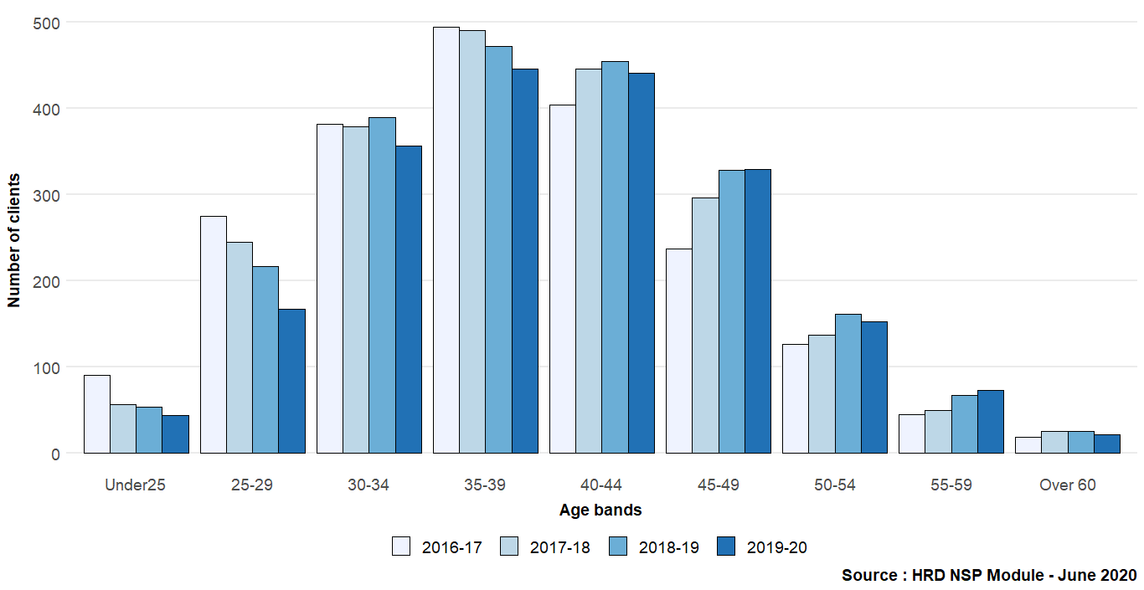
Figure 7 - Number of regular NSP individuals who reported using a stimulant, by age group and year 2018-17 to 2019-20
Injecting risk behaviour and trends:
- Median length of injecting career of those reporting stimulant use has increased over the last 5 years, and was typically longer than those using opioids
- The proportion of new initiates (individuals injecting for less than 36 months) has declined substantially over the last 5 years from 13 to 4 per cent
- Use of higher risk injecting sites (e.g. groin) amongst those using stimulants has increased consistently, rising from 14 per cent in 2015-16 to 20 per cent in 2019-20
- Self-reports of re-use of injecting paraphernalia has remained relatively stable but high over the last 5 years at between 47 to 48 per cent
- Self-reported indirect sharing of injecting equipment (e.g. sharing of spoons, filters and/or water) was reported by 27.6 per cent and direct sharing (needles and syringes) by 36 per cent in 2019-20, an increase of 7 percentage points over the last 5 years.
- In 2019-20 the annual median number of interactions for those using stimulants was 6 (range 2 – 395 interactions) with a median of 83 syringes (range 0 – 6,244 syringes) being issued. Syringe distribution was greatest amongst those using stimulants compared to any other injecting subgroup, with approximately 45 per cent and 117 per cent more syringes being provided compared to those using opioids and IPEDs respectively. This is consistent with higher frequency of stimulant injection.

Individuals using Image and Performance Enhancing Drugs (IPEDs)
In 2019-20, 51 per cent (6,671) individuals reported injecting IPEDs. Table 10 compares demographics and injecting characteristics of individuals reporting IPED use by year from 2015-16 to 2019-20.
Table 10 - Demographics and injecting characteristics of individuals reporting Image and Performance Enhancing Drug (IPED) use by year

- Age Distribution - Those reporting IPED injecting consistently represent the youngest PWID cohort, however, recent years have seen a substantial decline in younger IPED users accessing NSP services (see Figure 8 & Table 10). The proportion of new initiates (individuals injecting for less than 36 months) has declined by 22 per cent in the last 5 years from 37 per cent to 15 per cent. It is suspected, although no empirical evidence is yet available, that new initiates and younger PWID using IPEDs may preferentially be accessing injecting equipment online and/or via private suppliers. This has been referenced within online communities and user forums citing reasons including convenience, to maximise privacy, and to avoid stigma and judgment.
- Sex distribution has remained relatively stable over the last 4 years, with females accounting for 4 to 5 per cent of those injecting IPEDs and accessing NSP services
- Unemployment was reported amongst 29 per cent of individuals
- Secure housing status was reported by the majority of individuals reporting IPED use, with non-secure housing (e.g. hostel, friend’s home) or having no fixed abode (NFA) being reported by only 9 per cent of individuals
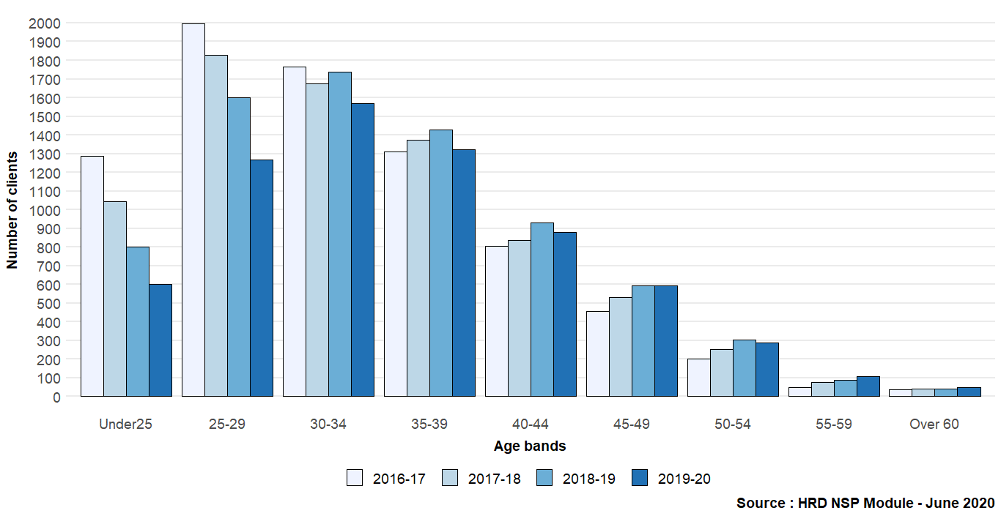
Figure 8 - Number of regular NSP individuals who reported using an IPED, by age group and year 2016-17 to 2019-20
Injecting risk behaviour and trends:
- Whilst the median length of injecting career amongst individuals using IPEDs is lower than all other injecting subgroups, this has increased over the last 5 years, from 4 years in 2015-16 to 8 years in 2019-20
- Intramuscular injection remains the most common method of injecting IPEDs, reported by 93 per cent of individuals. The proportion of individuals reporting subcutaneous injection remains stable at 21 per cent
- Reports of both ever sharing and re-use of injecting paraphernalia remains far lower in individuals using IPEDs than other injecting subgroups. However, analysis would indicate marginal increases across both categories over the last 5 years
- The annual median of NSP interactions with individuals using IPEDs was lower than other injecting subgroups at 2 interactions (range 1-295 interactions) recorded in 2019-20
- The proportion of individuals only attending pharmacy sites has increased over the last 5 years, from 64 per cent in 2015-16 to 67 per cent in 2019-20

Comparisons of clients attending Specialist NSP services vs Community Pharmacy services
In 2019-20, 47 per cent of individuals reporting opioids, 47 per cent stimulants and 67 per cent IPEDs only accessed NSP though community based pharmacies. These percentages vary, with more rural areas such as BCU and HDUHB recording a higher proportion of individuals only accessing pharmacies compared to more urban areas (see Table 11). For this analysis, two distinct categories are considered – those reporting either or both opioid and stimulant injecting are classified within the ‘Psychoactive Substances’ category, and those injecting IPEDs under the ‘IPED’ category.
PWID reporting psychoactive substance use:
- There is little difference between median age and age distributions of those accessing pharmacy sites compared with specialist services (see Table 11)
- A higher proportion of female clients accessed specialist services compared to community pharmacy
- Client interactions were highest within specialist NSP services compared to pharmacies. Individuals who accessed specialist sites were, on average, being issued with almost double the number of syringes over the year
- A higher proportion of clients who attend specialist services reported living in non-secure housing (e.g. hostel, friend’s home) or having no fixed abode (NFA) and were unemployed. This could be partially down to a lack of data collection in pharmacy NSP services.

PWID reporting IPED use:
- Clients attending pharmacy-based NSP services were typically younger than those accessing specialist sites. A higher proportion of individuals were under the age of 25 and the median age was marginally lower (see Table 11).
- New registrations of individuals using IPEDs was greatest within pharmacy-based services compared to specialist service NSPs.
- Median number of client interactions was comparable between the two site types. However, clients attending specialist services collected over double the number of syringes than those attending pharmacies.
- There is little difference between median age and age distributions of those accessing pharmacy sites compared with specialist services (see Table 11).

Table 11 - Demographics and characteristics of individuals attending specialist and pharmacy NSP services, by substance type

Blood Borne Virus screening, diagnosis and treatment
The development of new generation hepatitis C (HCV) treatments and their increased availability in Wales means that highly effective and shorter duration treatment is now possible for all affected. Whilst hepatitis B (HBV) and HIV remain chronic infections, effective treatment is in place to manage these. Such significant advances in treatment have prompted WHO to publish a global health sector strategy on viral hepatitis which sets out to eliminate HBV and HCV as significant public health threats by 2030. Welsh Government have since committed to achieving WHO targets as outlined by Welsh Health Circular (WHC/2017/048).
In 2017 the Harm Reduction Database Wales (HRD): Blood Borne Virus module was implemented in all substance misuse services (SMS), Tiers 1-3, as well as selected enhanced service Community Pharmacy providers across Wales to support ongoing surveillance of BBV infections and treatment amongst individuals accessing these services (see 6.1.2 - HRD: Blood Borne Virus (BBV) module).
Over the last year, two core developments have been in embedded within substance misuse services. These include:
- Introduction of confirmatory PCR screening on Dried Blood Spot Testing (DBST) samples, thereby increasing the opportunity for confirmatory screening across settings where venepuncture screening is not possible
- Targeted screening undertaken by Public Health Wales Microbiology Laboratory Service using Point of Care Test (POCT) oral swab screening providing opportunity for the undertaking of rapid HCV antibody (anti-HCV) testing and dissemination of results in 20 minutes
- The introduction of a Key Performance Indicator (KPI) for screening within substance misuse services. Progress to achieving the KPI targets are calculated using data from both the Harm Reduction Database and the Welsh National Database for Substance Misuse and reported by Welsh Government. The KPI is defined as:

KPI - Testing for blood borne viruses (hepatitis B, hepatitis C and HIV)
All clients who are in contact with substance misuse services to be routinely tested on site, or tested by a third party if not available on site, for blood borne virus infection (hepatitis B, hepatitis C and HIV) on at least an annual basis.

Eligible: Clients who were assessed as not having been tested for blood borne virus infection in the previous 12 months, or who are not currently on treatment for blood borne virus infection.

BBV screening in community settings in Wales
During the 2019-20 reporting period blood borne virus screening was available from within 90 community service sites Wales wide. These included specialist substance misuse services (including NSPs), enhanced service community pharmacy NSPs, homelessness services and hostels. In 2019-20, 82 sites recorded one or more BBV tests on the HRD. Figure 9 shows the geographical location of services offering BBV screening across Wales.
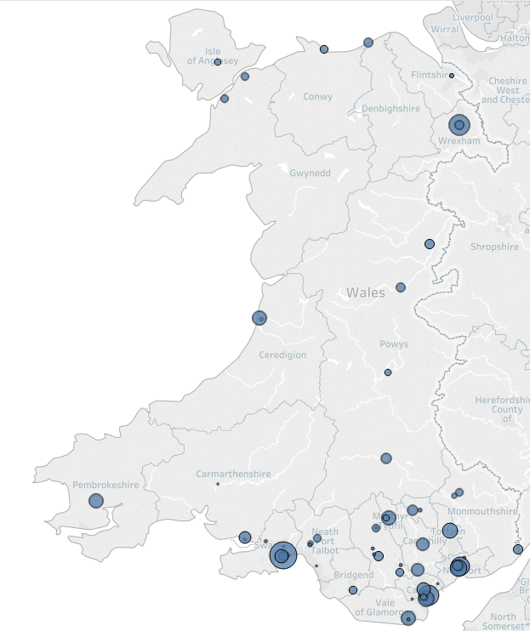
Figure 9 - Geographical location of community services in Wales providing BBV screening by number of unique clients attending in 2019-20

BBV screening overview
Following implementation of the HRD: Blood Borne Virus module, between 1 April 2017 and 31 March 2020, a total of 8,734 BBV tests with valid results, were completed by Substance Misuse and community services involving 7,048 individuals.
During the 2019-20 reporting period:
- 3,773 unique individuals were screened for at least one blood borne virus (HBV, HCV, HIV), an increase of 31 per cent on the previous year
- Four of the health boards reported an increase in BBV screening, however, decreases in screening were recorded in both CTM and BCU health boards, (see Table 12)
- The highest levels of screening were recorded in Aneurin Bevan Health Board and the largest proportional increase in testing has been observed in Swansea Bay (see Table 13)
- A total of 636 individuals were offered and declined testing, with two thirds (68 per cent) of these recorded in CTM and Aneurin Bevan University Health Board areas
- Hepatitis C was the most commonly screened for blood borne virus, with 97 per cent of all individuals screened

Table 12 - Number of individuals receiving a blood borne virus test by virus type, health board, and year
Table 13 - Number of individuals offered blood borne virus screening, by health board 2019-20
- Whilst nationally the most common sample collection method was Dried Blood Spot Test (DBST), accounting for 74 per cent of all tests undertaken, regional variances occurred between health board regions (see Figure 10)
- During this period 234 POCT – Oral Swab samples (HCV only) were collected by Public Health Wales Microbiology Laboratory Service in targeted settings and recorded on the Harm Reduction Database. There were less than 15 samples where a POCT sample was not accompanied by DBST samples. As such, POCT samples have not been included in testing and demographic breakdowns
- Venepuncture remains the ‘gold standard’ test for blood borne viruses, but is not always possible or available within the range of community settings currently providing screening
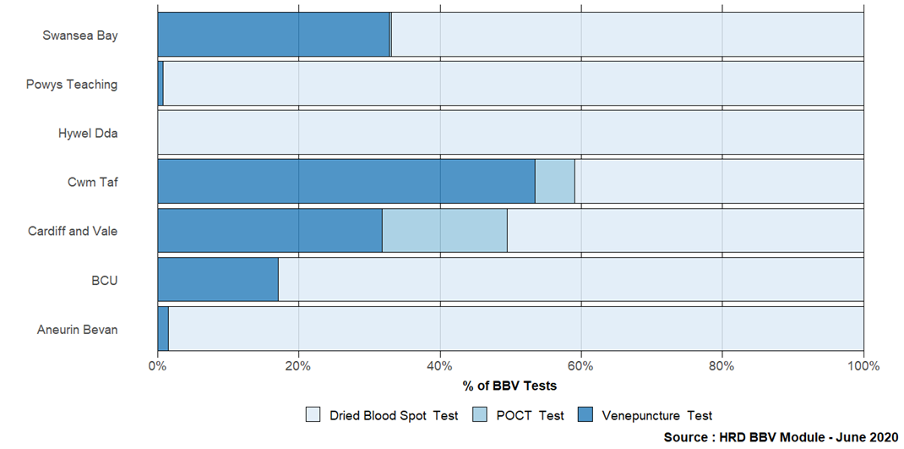
Figure 10 - Proportion of BBV sample collection methods used, by Health Board, 2019-20

BBV screening coverage within Substance Misuse Services
Whilst the increase in screening and diagnosis is positive, coverage amongst individuals accessing substance misuse or harm reduction services remains low. Data from the Welsh National Database for Substance Misuse (WNDSM) records 18,435 individuals assessed by specialist substance misuse services during 2018-19, of which 8,747 were assessed for problematic drug use, and 9,633 for problematic alcohol use. In addition, as indicated earlier in this report (see 3.2 - NSP activity overview), there were 13,091 unique PWIDs regularly attending NSP services during the same reporting period as screening was undertaken, a proportion of whom will not be in contact with substance misuse treatment services. The introduction of the KPI in April 2019 (see 4 - Blood Borne Virus screening, diagnosis and treatment) aims to facilitate the continued upscale of BBV screening across Wales, so that all individuals at risk of BBV infection are routinely tested, and where required, provided with treatment.

Demographics and risk factor characteristics of all individuals receiving BBV screening
The HRD: BBV Module enables the recording of demographics and risk factor characteristics. In order to support ongoing upscale and roll out of BBV screening within non-clinical settings and amongst those not engaged in substance misuse treatment services, these questions are non-mandated. As such a table of data completeness related to this can be found in Section 5 - Data Quality.
Demographic and risk factor characteristics for all individuals where data was collected is summarised in Table 18.

Demographics
- Median age of individuals receiving screening remains consistent with the previous year at 39 years (range 14-82). The most common age group was 40-44 year olds (see Figure 9)
- The median age of females offered screening was slightly younger than that of males (37 years compared to 39 years). The most common age group for females was 30-34 years
- Sex distribution has remained stable over the last 3 years with between 29 and 32 percent of those tested reported as female, as shown in figure 11

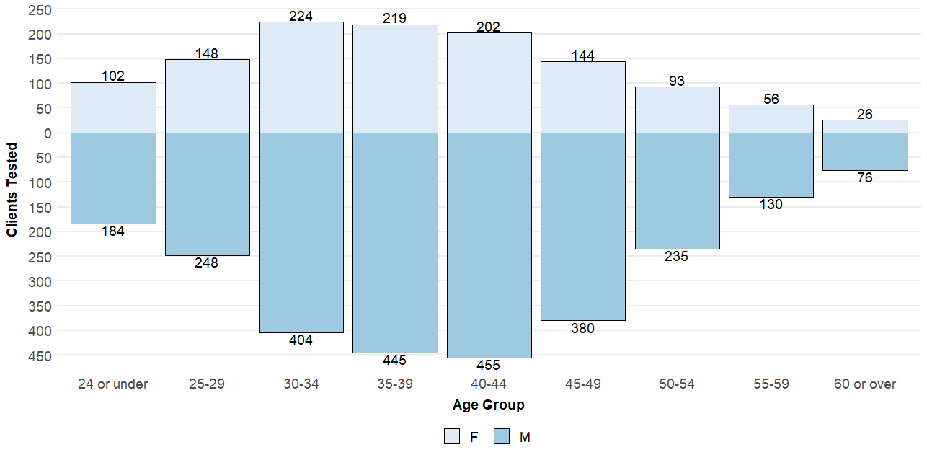
Figure 11 - Age and gender profile of individuals receiving BBV screening across Wales, 2019-20
- Unemployment was reported amongst 61 per cent (n=1,395) of individuals
- Sex working (i.e. receiving money, goods, or drugs in exchange for sex) was reported by 5 per cent of individuals.
- Non-secure housing (e.g. hostel, friend’s home) or having no fixed abode (NFA) was reported by 23 per cent (n=506) of individuals. Having NFA often results in higher risk and non-sterile injecting practices.
- There has been an increase in the proportion of individuals where data on housing and homelessness data was not collected/reported. In 2019-20, 1,520 did not have an employment status and 1,572 did not have a housing status, representing 40.3 per cent and 41.7 per cent respectively.

Risk Factors – for summary see Table 18
- One or more risk factors were identified and recorded for 97 per cent (n=3669) of individuals screened during 2019-20, median number of risk factors was 3 (range: 0-8)
- The most common risk recorded in 2019-20 was “Ever used drugs” reported for 89 per cent of individuals (n=2,390 / 2,687)
- Ever injecting drugs was reported by 46 per cent of individuals (n = 1,213 / 2,612)
- Having ever been in prison was reported by 38 per cent of individuals (n = 951 / 2504)
- Having been assaulted involving blood to blood contact or human bite reported by 15 per cent of individuals (n = 470 / 2381)

Diagnosis and treatment

Human Immunodeficiency Virus (HIV)
A total of 3,678 individuals were screened for HIV within SMS in 2019-20, an increase of 35 per cent on the previous year. Where results were available and recorded on the HRD (n=3,305), only 1 individual was identified as positive for HIV antibodies, indicative of infection, and was referred immediately into specialist clinical treatment.
Whilst HIV infections amongst PWID remain uncommon, there have been a total of 41 new HIV diagnoses in Wales with injecting drug use reported as a risk factor for infection since 2003. Importantly, half of these cases have been recorded since 2014. Clusters of newly diagnosed HIV infections amongst PWID have been reported in recent years in Wales and more dramatically in Greater Glasgow and Clyde, Scotland with 165 new diagnoses of HIV.
In order to prevent and diagnose early, those individuals at risk of HIV infection and co-infection with HCV, it is essential that front line services continue to develop an integrated approach to multiple risk behaviours including substance misuse and sexual health risk taking behaviour. This approach is reflected in the Harm Reduction Database screening section and further training on substance misuse and sexual health is available at: https://www.smash-ed.org/

Hepatitis B (HBV)
For the period 2019-20, a total of 3,671 individuals were screened for hepatitis B (HBV) within SMS in Wales, an increase of 32 per cent on the previous year. Where results were available and recorded on HRD (n=3,357), less than one per cent of individuals tested positive for hepatitis B surface antigen (HBsAg) indicating current HBV infection. The proportion of HBV infections identified within this client group is comparable with previous enhanced surveillance systems utilised within SMS in Wales and UAM surveys conducted across England and Wales.

Hepatitis C (HCV)
For the period 2017 - 2020, a total of 6,872 individuals were screened for hepatitis C (HCV) within SMS in Wales.
In 2019-20:
- 3,761 individuals were screened for HCV (including anti-body and PCR), an increase of 32 per cent on the previous year
- A total of 4,293 anti-HCV, and 1,429 HCV PCR/RNA tests were conducted.
- Valid results were recorded for the majority of tests performed (see Table 14). Since the introduction of confirmatory PCR screening on DBST samples, there has been an increase in the proportion of individual’s receiving a confirmatory test. However, there has also been an increase in tests returning as “insufficient sample”. It is important that all DBST samples spots are covered in order to maximise the likelihood of a successful test.
Table 14 - Hepatitis C screening outcomes by health board, and type of test, 2019-20
Table 15 - Hepatitis C screening outcomes by health board, and type of test, 2017-20

Hepatitis C antibodies
Over 2019-20, a total of 3,315 individuals were screened for hepatitis C antibodies (anti-HCV) in Wales, of which overall 17 per cent of tests were reactive (see Table 16). Whilst these rates are comparable with the previous single year reporting period and historic enhanced surveillance systems utilised within SMS in Wales, testing coverage is expected to increase within SMS and amongst populations not in contact with SMS, which should impact on overall prevalence.
Comparison across health boards indicates variation in the proportion of anti-HCV reactivity, with Swansea Bay recording the highest rates amongst those tested and Powys Teaching recording the lowest.
Table 16 - Proportion of all individuals screened for hepatitis C antibodies testing reactive by health board, for all years 2017-20 and 2019-20
Rates of anti-HCV reactivity varied between demographic and risk factor characteristics recorded at time of screening (see Table 18). Amongst these, anti-HCV reactivity appeared highest amongst:
- Individuals reporting having injected heroin and stimulants in last 12 months
- Having injected drugs whilst in prison
- Injecting drugs daily.
Individuals under 25 years old, who had injected IPEDs in last 12 months, and Men Who Have Sex with Men (MSM) had the lowest rates of anti-HCV.
Further analysis of individuals at ongoing risk of HCV infection and transmission also indicates regional variation in anti-HCV reactivity amongst individuals recorded as having injected psychoactive (opioid and/or stimulant) drugs within 12 months prior to screening (see Table 17). Rates varied from 50 per cent reactivity in Swansea Bay to 10 per cent in Powys Teaching Health Board.

Table 17 - Proportion of current and recent ex-PWID (injected in last 12 months) injecting psychoactive drugs, screened for hepatitis C antibodies and testing reactive by health board, for all years 2017-20 and 2019-20

HCV anti-reactive tests not yet confirmatory tested
Of those individuals tested reactive for anti-HCV, 28 per cent were recorded as not yet having received a confirmatory PCR test in order to establish current infection, a decrease from around 50 per cent the previous year. This increase is likely to be a result of the introduction of PCR testing though DBST samples. However, there remain 401 anti-HCV reactive individuals across Wales who have not had a confirmatory PCR recorded on the Harm Reduction Database.

Table 18 - Proportion of individuals receiving BBV screening alongside proportion of individuals that tested reactive for anti-HCV by demographics and risk factor characteristics, 2019-20
    - Hepatitis C confirmed cases
Between 1 April 2019 and 31 March 2020, 1,154 individuals received a confirmatory PCR test in the community for HCV, of which, 222 individuals (19.2 per cent) were identified as having a confirmed chronic infection and requiring treatment. These included:
- 159 individuals identified following a reactive anti-HCV test during the reporting period
- 47 individuals who were identified as reactive anti-HCV since April 2017 but prior to 1 April 2019.
- 16 individuals identified following direct confirmatory PCR (i.e. anti-HCV reactivity was identified prior to implementation of the HRD)
Table 19 - Year of first anti-HCV reactive test result for individuals with a positive confirmatory PCR test for HCV, by health board, 2019-20

Repeat screening and incidence/new cases
During 2019-20, only 285 individuals were repeat tested for anti-HCV via DBST, following a previous anti-HCV negative result in the previous year. Of these, 17 returned an antibody positive result providing an incidence rate of 6 per 100 person years. The KPI states that all at-risk individuals should be tested on at least an annual basis. It is important that all individuals accessing services are screen regularly for blood borne virus so that new infections can be identified and treated quickly to limit further transmission. Furthermore, increased data will allow for analysis on different risk populations.

Hepatitis C treatment

Individuals referred to clinical specialist services
According to data recorded on the HRD, over the period 2019-20 a total of 255 individuals were referred into HCV clinical specialist services by SMS and associated services in Wales (see Table 20). Of which:
- 31 per cent (n=79) were referred following a reactive anti-HCV test
- 68 per cent (n=173) were referred following a positive confirmatory PCR/RNA test
The HRD: BBV module automatically generates a referral to HCV clinical specialist treatment services once the test result has been given to the client, thereby eliminating loss to follow-up.

Table 20 - Number of individuals screened for hepatitis C within SMS in Wales and referred into clinical specialist services, by type of test and health board, 2019-20
In addition to the HCV screening process, the HRD also enables the recording of referral outcomes and treatment milestones by clinical specialist services following referral. This feature has been designed to support joint working partnerships between SMS and Clinical Nurse Specialists/Teams post-referral and to support engagement with individuals during treatment.
For individuals referred into clinical specialist services by SMS, an initial referral outcome was recorded for 65 per cent of individuals (see Table 21). Since 2017, of all those referred to treatment, no outcome data is available for 182 referrals (see Table 22).
Table 21 - Initial outcomes following referral of individuals tested for hepatitis C into hepatitis C clinical specialist services in 2019-20
Table 22 - Initial outcomes following referral of individuals tested for hepatitis C into clinical specialist services, 2017-20

Individuals commencing hepatitis C treatment
Since 2017, only 93 individuals had been recorded on the Harm Reduction Database as having commenced HCV treatment following referral from SMS and associated services across Wales (see Table 23). Of these, 54 were recorded as successful completing treatment. This figure does not accurately reflect the level of treatment provision following referral for HCV treatment from SMS services.
According to treatment commencement data held centrally by the Lead Consultant for Blood Borne Virus Action, matching analysis would indicate that 302 individuals, who have a positive PCR test recorded on the HRD in the last three years, had started a HCV treatment program. Further analysis is required to confirm this and future development and streamlining of the HRD with external data sources is ongoing.

Table 23 - Treatment outcomes for individuals referred and accepted into clinical specialist services 2017-20

Data Quality

Needle and Syringe Programme module
Table 24 provides the proportion of missing demographic and injecting characteristic data across all seven Health Boards / APBs for those individuals accessing NSP services during the period 1 April 2019 – 31 March 2020.
Table 24 - Proportion of incomplete demographic and injecting characteristic data items for individuals accessing NSP services, by health board, 2019-20

Blood Borne Virus module
Table 25 provides the data completion rates across all seven Health Boards / APBs for key data fields for those individuals tested during the period 1 April 2019 – 31 March 2020. For all other data items the HRD has been configured to impose mandatory data recording prior to the completion of subsequent sections of the database.
As Wales moves forward towards the elimination of Hepatitis B and C, the ability to identify testing coverage within high risk populations will become a crucial factor in maximising both testing and treatment. Therefore it is important that full risk assessments are completed for each individual requiring screening were practically possible.

Table 25 - Proportion of individuals receiving BBV screening 'not asked' a risk factor question, by risk factor and health board, 2019-20

Appendices

Appendix A - What is the Harm Reduction Database?
In 2010 the Substance Misuse Programme, Public Health Wales implemented the national Harm Reduction Database Wales (HRD), funded by Welsh Government. The HRD is a web-based modular tool for the recording of demographic, substance use, risk and outcome data on a range of interventions, including:
- Needle and Syringe Programmes (NSPs)
- Take-home Naloxone (THN)
- Long Acting and Reversible Contraception (LARC)
- Blood Borne Viruses (BBV)
- Fatal and Non-Fatal Drug Poisoning Reviews
The HRD represents the sole system in Wales for evidencing the nature and scale of these community interventions amongst those with substance misuse issues and complements the data derived from the Welsh National Database for Substance Misuse (WNDSM) for substance misuse treatment services.

HRD: Needle and Syringe Programmes (NSP) module

About
The HRD provides a solution in which NSP staff can record client interactions in line with national guidelines for individuals live at point of contact. Since implementation, the data has been used to improve the quality of services, to reduce harm and to better understand the nature and scale of injecting drug use in Wales.

Data captured
In order to preserve NSP Service anonymity, no named patient information is used throughout this module. Unique client activity is monitored utilising unique reference codes provided at the point of client registration. Data collected for individuals via the NSP module includes:
- Demographics
- Historical and current substance use
- Health and risk behaviours, including sharing and reuse of injecting equipment
- Onward referral to specialist health and social care providers
- Interactions and activity, including injecting equipment provided and harm reduction information and advice issued

HRD: Blood Borne Virus (BBV) module

About
The HRD BBV module was developed to better support the collection, recording and management of data in Wales relating to BBV screening and Hepatitis B vaccination. Funded by Welsh Government, this module complements the Welsh Government’s Substance Misuse Delivery Plan objective for introduction of opt-out screening within all substance misuse services and commitments to elimination targets of Hepatitis C by 2030. In addition to offering a live surveillance system that provides detailed data on the nature and scale of BBV infections in Wales, the HRD also enables frontline clinicians to tailor client-centred BBV interventions and harm reduction information and advice.

Data captured
This development supports the recording of information relating to:
- Client details
- Demographics
- Assessment of risk behaviours, including substance use, sexual activity etc.
- Screening, results, and vaccination history, including type of BBV test, date, outcome
- Onward referral to specialist BBV, sexual health and clinical treatment providers
- Treatment milestones, including date treatment commenced and completed, type of treatment, outcome

Appendix B - Definitions and notes on data interpretation

Health Boards and Local Authorities
- When referring to a local authority or a health board, an individual was included in every geographical region where they had at least one NSP interaction. This was to ensure that individuals were all allocated using a single methodology.
- Individuals accessing NSP services solely though mobile NSP units in Betsi Cadwaladr University Health Board area (BCUHB) were assigned to Wrexham (East), Denbighshire (Central) and Gwynedd (West). Consequently, the numbers of unique individuals injecting drugs in Anglesey, Conwy and Flintshire may be underreported.

Regular NSP service users
A regular NSP service user is defined as an individual who has attended NSP services on at least two occasions within a given financial year or reported IPED injecting and attending an NSP service at least once in the current and once in the previous financial year.
Non-regular individuals have been excluded when presenting key demographics. Records with only one interaction in a given period for non-IPED users may be indicative of individuals using different unique identifier details when presenting for injecting equipment or mistakes in data entry. As such, and to ensure as robust analysis as is possible, these records have been excluded from the main analysis and details for this sub-group are presented in Table 28.

Table 28 - Demographics and injecting characteristics of non-regular clients attending NSPs in Wales 2019-20

Substance groups
This report looks at three substance groups.
IPED individuals – Individuals who have reported using/injecting image and performance enhancing drugs, for example, steroids, human growth hormone and peptides.
Opioid individuals – Individuals who have reported using/injecting opioids, for example, heroin and methadone.
Stimulant individuals – Individuals who have reported using/injecting stimulants, for example, amphetamine, cocaine powder and crack cocaine

Table 29 - Harm reduction database drug classifications

NSP Interactions not transactions
Whilst in previous years the term ‘transaction’ has been used to describe the provision of injection related equipment within NSP services, we have moved to use the term ‘interaction’. This has been done to better describe what should occur when an individual attends NSP services to access sterile injecting equipment. During the interaction, a discussion and provision of sterile injecting equipment that is suitable for their needs in terms of the type of drug(s) being injected, the route of injection and the frequency of injecting, should be ensured, including assessment of equipment for secondary distribution to reduce potential direct and indirect sharing of injecting equipment by others. In addition, provision of tailored and well evidenced harm reduction information and advice, and signposting to relevant services as required should be undertaken and recorded.

Welsh Government. 2011. Substance Misuse Treatment Framework (SMTF) Service Framework for Needle and Syringe Programmes in Wales. Available at: https://gov.wales/substance-misuse-needle-and-syringe-programmes
National Institute for Health and Clinical Excellence. 2014. Needle and Syringe Programmes. Public Health Guidance PH52. Available at: https://www.nice.org.uk/guidance/PH52
Welsh Government Statistical First Release SFR108/2018. Community pharmacy services in Wales, 2017-18. Available at: https://statswales.gov.wales/Catalogue/Health-and-Social-Care/NHS-Primary-and-Community-Activity/Community-Pharmacies/enhancedservices-by-localhealthboard-year
Mobile Sites operate across BCU and have been plotted in the county were they are assigned by the BCU Harm Reduction Services.
Regular clients refers to individual PWID who have accessed NSP services on two or more occasions in the year. See section 5.2
Welsh Government. Substance Misuse Treatment Framework (SMTF) Service Framework for Needle and Syringe Programmes in Wales. 2011
NICE. Needle and syringe programmes. NICE public health guidance 52. London: NICE; 2014, http://www.nice.org.uk/Guidance/PH52
Office for national Statistics (ONS): Implementing the 2013 European Standard Population: the impact of selected upper age limits on mortality statistics. https://webarchive.nationalarchives.gov.uk/20160106020035/http://www.ons.gov.uk/ons/guide-method/user-guidance/health-and-life-events/revised-european-standard-population-2013--2013-esp-/index.html
Welsh Service users living close to the border with England may attend English NSP services and therefore may not fully be represented in the Welsh data.
Indicative of secondary distribution – collecting NSP equipment for self and another person(s)
A full list of substances in all groups can be found in 6.2 - Appendix B - Definitions and notes on data interpretation
Indicative of secondary distribution – collecting NSP equipment for self and another person(s)
Image and performance enhancing drugs. A full list of substances in all groups can be found in 6.2 - Appendix B - Definitions and notes on data interpretation
World Health Organisation (2016). Combating hepatitis B and C to reach elimination by 2030. http://www.who.int/hepatitis/publications/hep-elimination-by-2030-brief/en/
Welsh Government (2017). Attaining the WHO targets for eliminating hepatitis (B and C) as a significant threat to public health. http://www.wales.nhs.uk/sitesplus/888/news/46429
Includes HIV, hepatitis B, and hepatitis C
Mobile Sites operate across BCU. They have been plotted in the county were they have been assigned.
Including; homelessness services, community pharmacy services, sex worker support projects
Not reported for 1520 individuals
Public Health England. HIV Annual data tables. 2018. Available at: https://www.gov.uk/government/statistics/hiv-annual-data-tables
NHS Glasgow and greater Clyde. HIV infections in people who inject drugs - update 2019. Available at: https://www.nhsggc.org.uk/your-health/public-health/public-health-protection-unit-phpu/bloodborne-virus/hiv/hiv-infections-in-people-who-inject-drugs-update-2019/#
Public Health Wales (2017), Enhanced surveillance of blood borne viruses in drug users in Wales: Annual report 2016. https://www.wales.nhs.uk/sites3/page.cfm?orgid=457&pid=62269
Public Health England (2018), Unlinked anonymous HIV and viral hepatitis monitoring among PWID 2018 report. https://www.gov.uk/government/statistics/people-who-inject-drugs-hiv-and-viral-hepatitis-monitoring
Where valid results were recorded on the HRD
Public Health Wales (2017), Enhanced surveillance of blood borne viruses in drug users in Wales: Annual report 2016. https://www.wales.nhs.uk/sites3/page.cfm?orgid=457&pid=62269
Welsh Government (2011), Substance Misuse Treatment Framework (SMTF) Service Framework for Needle and Syringe Programmes in Wales. http://gov.wales/docs/dsjlg/publications/commsafety/110628needleen.pdf
Welsh Government (2016), Substance Misuse Delivery Plan 2016 – 2018. http://gov.wales/topics/people-and-communities/communities/safety/substancemisuse/publications/dplan/?lang=en
Welsh Government (2017), Welsh Health Circular (WHC/2017/048), Attaining the WHO targets for eliminating hepatitis (B and C) as a significant threat to public health. http://cardiffandvaleapb.org/download/media-resources/WHC-2017-048-Attaining-the-WHO-targets-for-eliminating-hepatitis-B-and-C-as-a-significant-threat-to-public-health.pdf

