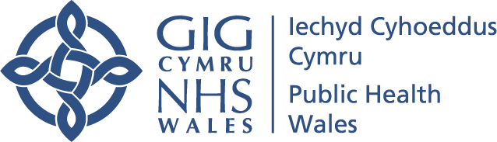

Novel Coronavirus FAQs
Version 3 – Published 28 February 2020

1) What are the symptoms of Novel Coronavirus?
Novel Coronavirus causes symptoms similar to other respiratory viruses such as the flu. These may include:
- Cough
- Shortness of breath
- Fever

2) How can you be infected with Novel Coronavirus?
Like the common cold, the Novel Coronavirus infection usually occurs through close contact with a person who has the infection.
Close contact means being less than 2 metres away from a person with the virus for more than 15 minutes.
A person can also be infected by touching contaminated surfaces if they do not wash their hands.

3) How can I help prevent the spread of Novel Coronavirus?
There is currently no vaccine to prevent Novel Coronavirus. The best way to prevent infection is to avoid being exposed to the virus through good hygiene.
There are general principles you can follow to help prevent the spread of respiratory viruses such as Novel Coronavirus. These include:
- Washing your hands often with soap and water for at least 20 seconds. Use an alcohol-based hand sanitiser that contains at least 60% alcohol if soap and water are not available
- Avoid touching your eyes, nose and mouth with unwashed hands
- Avoid close contact with people who are unwell
- If you feel unwell, stay at home and do not attend work or school
- Cover your cough or sneeze with a tissue then throw the tissue in the bin, and then wash your hands immediately
- Clean and disinfect frequently touched objects and surfaces in the home and work environment

4) What is the risk to the general public?
The risk to the general public is low, unless you have recently returned from a country or region on this list, or have been in close contact with an individual with confirmed Novel Coronavirus.

5) Can I catch Novel Coronavirus from post/packages received from China?
The virus does not survive well outside the body and so it is highly unlikely that Novel Coronavirus can be spread through post or packages.

6) Can I get Novel Coronavirus from food/takeaways?
It is highly unlikely that Novel Coronavirus can be spread through food as the virus does not survive on surfaces or in food.
It is, however, good hygiene practice to always wash your hands or use hand sanitiser before you eat.

7) Do I need to wear a face mask?
It is not necessary to wear a face mask if you are well.

8) There is someone in my child’s school/university who has just returned from China or one of the other specified areas, what should I do?
If a confirmed case occurs in an educational setting the local Health Protection Team will provide you with advice and will work with the head teacher, principal and or management team of that setting. Outside those that are defined as close contacts, the rest of the school does not need to take any precautions or make any changes to their own activities attending educational establishments or work as usual, unless they become unwell. If they become unwell they will be assessed as a suspected case depending on their symptoms.
This advice applies to teaching staff and children in the rest of the class who are not in a close friendship group or children undertaking small group work. The decision as to whether pupils, students and staff fall into this contact group or the closer contact group will be made between the Health Protection Team, the educational setting and (if they are old enough) the student.
Advice should be given as follows:
- If they become unwell with cough, fever or shortness of breath they will be asked to self-isolate and should seek medical advice from NHS Direct Wales on 0845 46 47 or phone 111 if available in your area (Hywel Dda, Powys, Aneurin Bevan and Swansea Bay)
- If they are unwell at any time within the 14 days of contact and they are tested and are positive for COVID-19 they will become a confirmed case and will be treated as such.

9) Can I attend mass gatherings?
Unless you have recently returned from a country or region on this list, or have been in close contact with an individual with confirmed Novel Coronavirus, you can attend mass gatherings.
Any individuals who have been instructed to self-isolate have received guidance, which includes advice not to attend public events.

The latest information and travel advice is available from:
- Department of Health and Social Care and Public Health England (PHE)
- Foreign and Commonwealth Office (FCO)
- The Welsh Government

