

Housing Warmth and Health and Well-being in Wales case study:
About your data loggers

Mae’r ddogfen hon ar gael yn Gymraeg / This document is available in Welsh
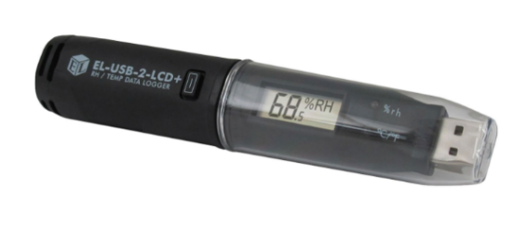
What do they look like?
The loggers are black with a small screen. They have a small internal battery and will record temperature and humidity data at regular intervals (e.g. every hour).

What do they do?
The data loggers will take temperature and humidity readings while they are in your home; they do not collect any other information or data. The graph is an example of the data the research team will receive after we collect the data loggers from you and download the data.
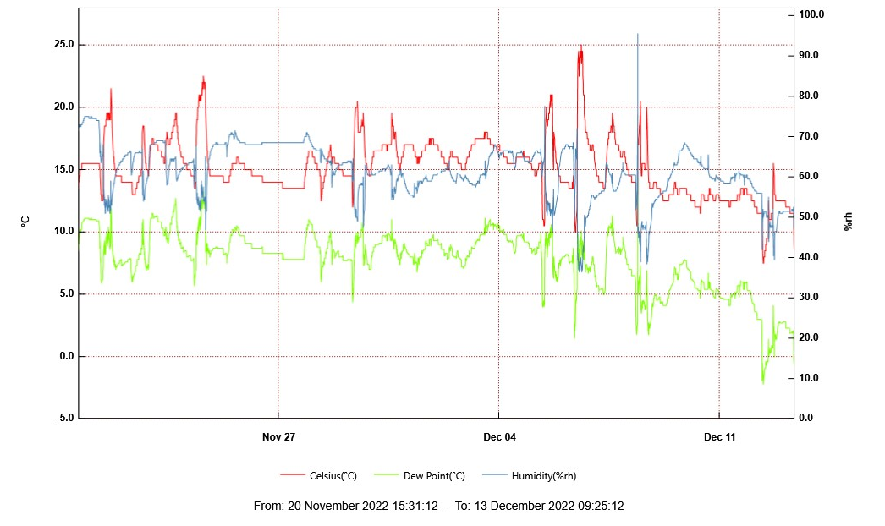
Where will they go?
We are asking you to have two data loggers placed in your home in the areas that you spend most of your time; one in your main living space and one in your bedroom (the room where you sleep). The data loggers need to be placed in a dry location, away from direct sources of heat and cold such as a window, door, or radiator. Examples of ideal locations are on a shelf or on top of a wardrobe. An M.E.L researcher, working on behalf of Public Health Wales and Bangor University, who delivers the loggers to you will discuss this with you and position the data loggers for you.

You do not need to do anything, and the data loggers should be left in their location until M.E.L Research contact you. If you need to move the data loggers to clean (e.g. dust) or they are accidently moved out of position, please do not worry. We do ask if you could please put them back in their original location as soon as you can. Please try to ensure that children do not play with the data loggers and that they are handled only when really needed.

How long will I have them?
We are asking you to keep the data loggers in your home for 4-6 weeks. At the end of this period, M.E.L Research will contact you to ask you to package the two data loggers using the pre-paid packaging and will offer to arrange for a courier to collect them.
Thank you for your time and help with this project.

