


Housing Warmth and Health and Well-being in Wales case study: Debrief leaflet

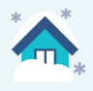
Thank you for participating in our Housing Warmth and Health and Well-being in Wales case study. With the rise in the cost of living and in particular the cost of energy causing worry for many people this winter, the Public Health Wales research team have compiled a list of financial, housing and health services and schemes that you may be interested in.

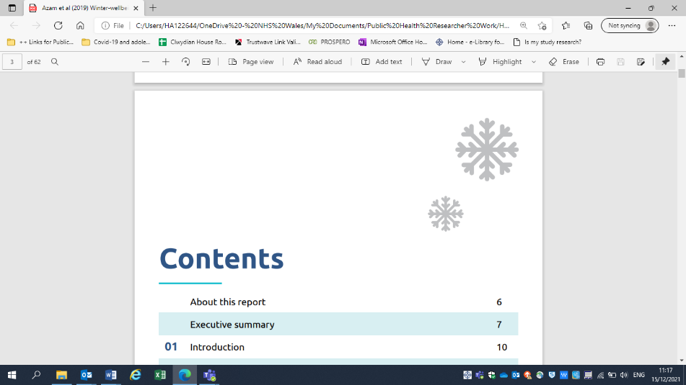
Public Health Wales hope that you have found this experience interesting and if you have any questions or concerns you can contact M.E.L Research:
Telephone: 0800 073 0348
E-mail: phw.survey@melresearch.co.uk

If you would like to make a complaint or raise concerns about any aspect of this research independent from the research team, please contact
Email: Complaints.publichealthwales@wales.nhs.uk

Contact details for the Public Health Wales research team:
Email: PHW.Warmth@wales.nhs.uk

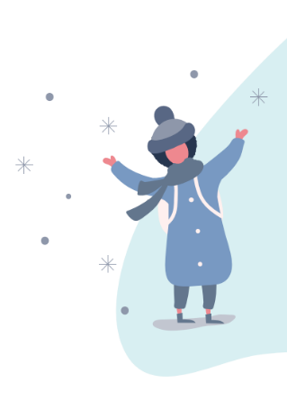

Mae’r daflen hon ar gael yn Gymraeg / This leaflet is available in Welsh

Financial and housing services | What they do
Advicelink Cymru - 0800 702 2020  (9am-5pm Mon-Fri) | 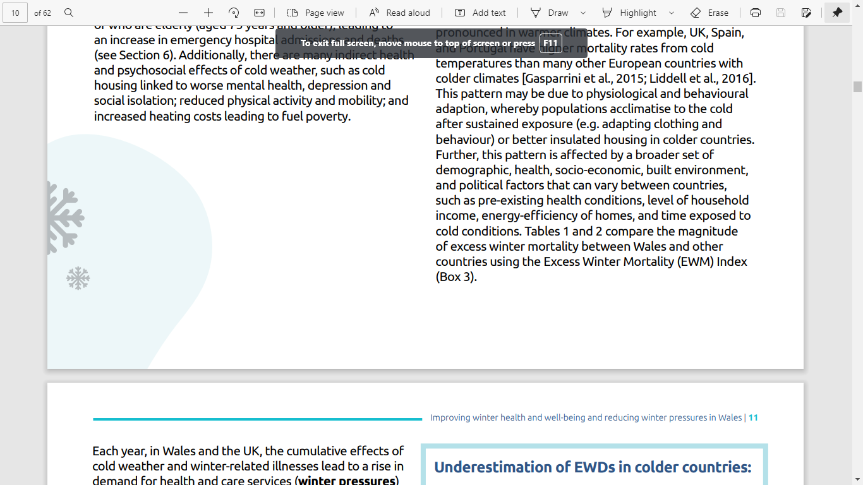  A Citizen’s Advice service that offers free and confidential advice on a range of subjects such as welfare benefits, debt, employment, education, housing and discrimination. As seen on the Welsh Government ‘Claim What’s Yours’ campaign.
Citizen’s Advice – Either visit your local CAB office or call 0800 702 2020  www.citizensadvice.org.uk/wales/ | Free, independent, confidential and impartial advice on any issue. They have specialist advisers who provide guidance on more complex issues such as money problems, benefit queries and energy inquiries.
National Energy Action (NEA) – For Warm and Safe Homes Advice call 0800 304 7159  www.nea.org.uk | A charity providing free support service and advice to householders in England and Wales on their energy bills and keeping warm and safe in their home. They can also help with benefits advice and income maximisation.
Nest – 0808 808 2244  (9am-6pm Mon-Fri or request a call back)  www.nest.gov.wales/en/ | The Nest scheme offers a range of free, impartial advice and, if eligible, a package of free home energy efficiency improvements such as a new boiler, central heating or insulation. This can lower energy bills and benefit health and well-being.
StepChange – 0800 138 1111  www.stepchange.org | Provides free, expert debt advice either online or via the phone. Households can speak to them about their debts and they will take a look at their financial situation and advise people on what they can do next.
Turn2us – 0808 802 2000  www.turn2us.org.uk | A national charity which tackles financial insecurity. It offers services to calculate what benefits households may be entitled to and runs a helpline to give support and information to people who don't have access to the internet or find it hard to go online.
Warm Wales – 01656 747 622 Email:  information@warmwales.org.uk  www.warmwales.org.uk | A charity providing homes with affordable warmth to alleviate fuel poverty. They can provide gas connection grants to help qualifying households connect to the gas network and The Healthy Homes Healthy People project – which provides financial and energy advice for vulnerable households in North and South Wales.
Health and well-being services | What they do
Dewis Cymru  www.dewis.wales | Provides information on a range of organisations and services (private and public) available locally and nationally.
NHS Direct Wales – 111  www.nhsdirect.wales.nhs.uk | Health advice 24 hours a day, 365 days a year.
MIND – 0300 123 3393 (9am-6pm Mon-Fri)  Email: info@mind.org.uk  www.mind.org.uk  Post: Mind Infoline, PO Box 75225, London, E15 9FS | Support and counselling services. Ask them about mental health problems, where to get help near you, treatment options and advocacy services.
Samaritans – 08457 90 90 90 (24 hours)  https://www.samaritans.org/?nation=wales | Provides confidential, non-judgmental emotional support for people experiencing feelings of distress or despair, including those that could lead to suicide.
C.A.L.L. Helpline (Community Advice and Listening Line) – 0800 132 737 (24 hours) or Text HELP and your question to 81066. www.callhelpline.org.uk | Offer confidential, emotional support and information / literature on Mental Health and related matters to the people of Wales.

