



How to update your signature in Outlook

- Go to the Sharepoint page and click the ‘Email Signature’ tab:
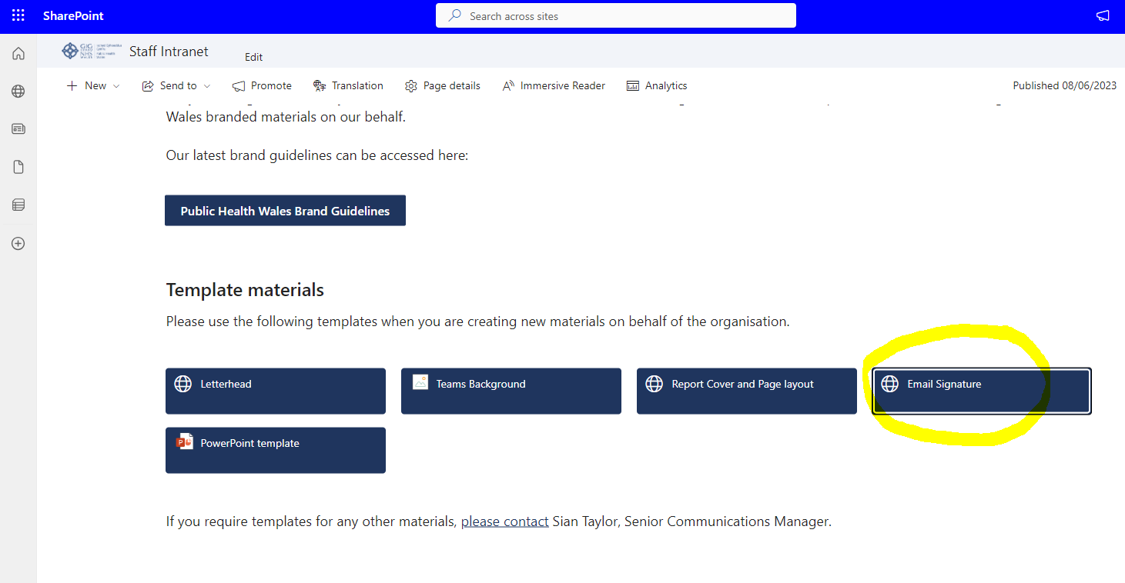

- A downloads bar will drop down. Click ‘Open file’:

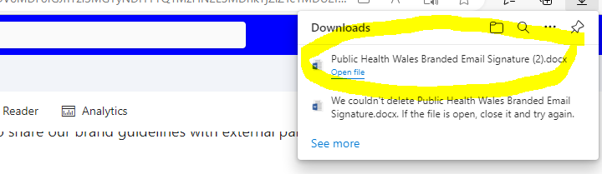

- Once you have opened the Powerpoint file, edit the signature with your details:
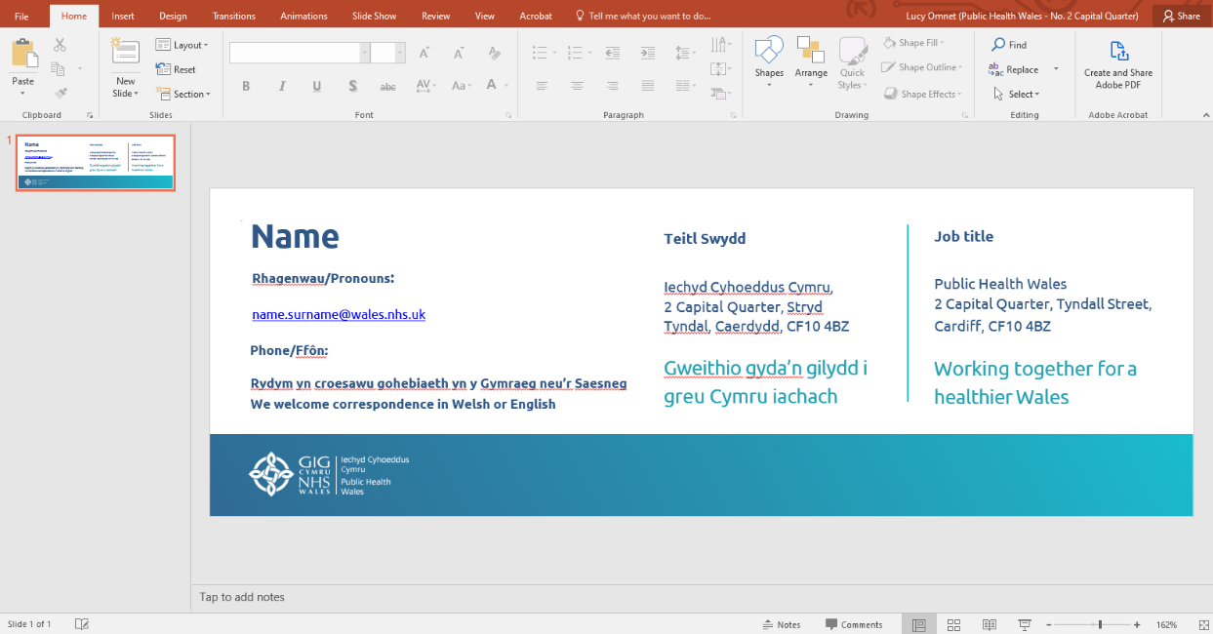

- Once you have filled out the signature press Ctrl A on your keyboard to select all of the contents. Then press Ctrl C to copy:
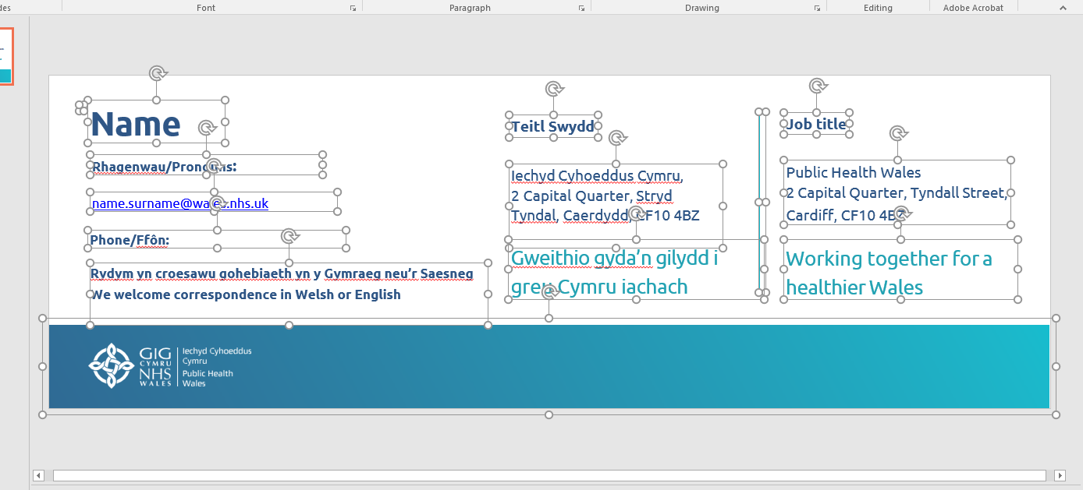

- Go to Outlook and create a new email. Under the ‘Message tab’ click ‘signature’

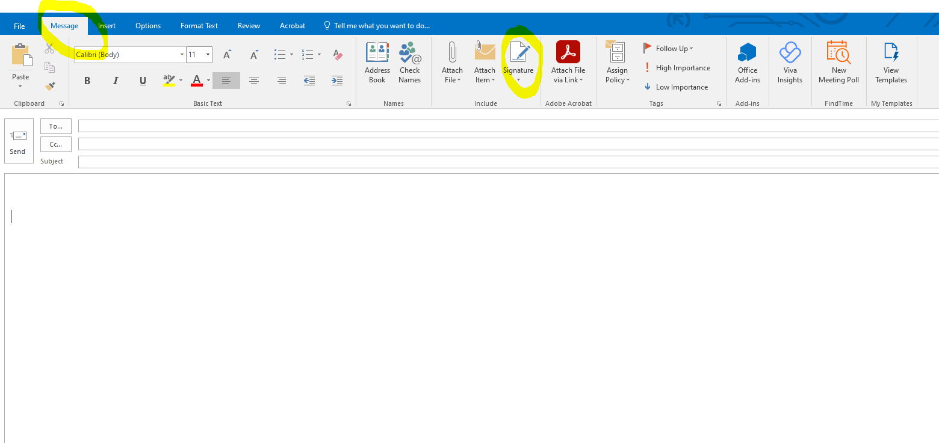

- Name your new signature and then right click on the mouse. Under ‘paste options’ click the ‘a clipboard’ icon as shown below:
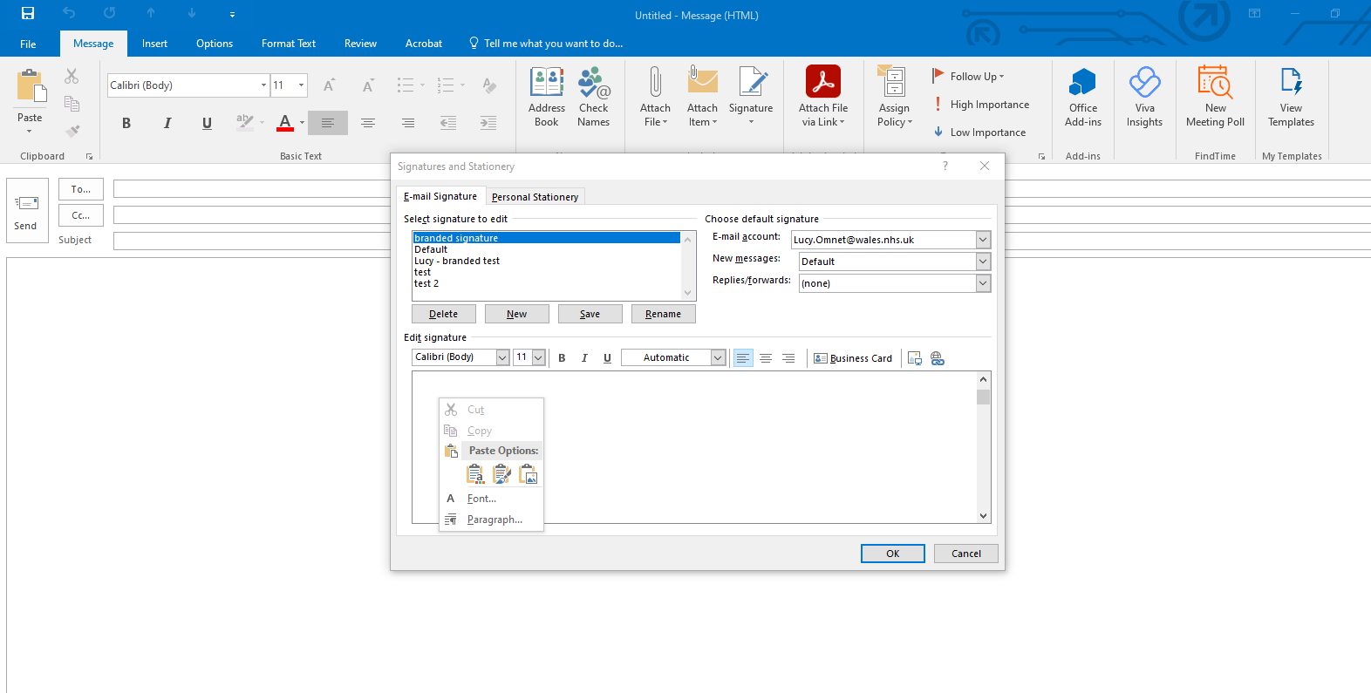

- Click OK and your signature should be useable.

