Neonatal myocarditis incident, Wales, 2022-23

Background
Enteroviruses can cause severe clinical syndromes in neonates, including neonatal sepsis, meningo-encephalitis, and respiratory infection. Myocarditis is a rare but recognised complication of neonatal enterovirus infection, usually associated with Coxsackie B viruses.

Non-polio enteroviruses are common infections, often showing seasonal patterns of transmission. The characterisation of the syndromes caused by these viruses is incomplete as testing protocols and surveillance varies across countries and regions, and typing of enteroviruses is not universal.

In Wales, enterovirus testing, typing and surveillance has been undertaken since 2016, with publications on associated neurological syndromes and seasonal waves of EV D-68[1], [2].

Incident
In late 2022, clinicians in Cardiff and southwest England noted a number of cases of severe neonatal disease associated with enterovirus. The understanding that this constituted a cluster was enabled through clinical networks, and eight cases admitted to paediatric intensive care units from September to December 2022 were described in a publication[3]. These cases were aged 9 to 16 days at presentation, with most resident in South Wales (5/8) and all with positive enterovirus PCR (respiratory, stool, blood, CSF, skin, pericardial fluid samples). Two Coxsackieviruses were identified in the cases where typing was available – B3 and B4.

This cluster constituted a higher than expected incidence of this rare infectious presentation, with the authors estimating an incidence density of 38.5 per 100,000 person years based on the hospital catchment areas. However, no single virus was responsible, with Coxsackie B3 and B4 being identified from the 6/8 cases for which typing was available.

Further cases were identified and numbers monitored by the Wales Specialist Virology Centre in Public Health Wales, and reported to the Communicable Disease Surveillance Centre. Due to the ongoing concerns, Public Health Wales reported 10 cases between June 2022 and April 2023 via a Disease Outbreak Notification through the IHR national focal point in UKHSA, and incident management meetings were held in Wales (26/4/2023) and UKHSA (28/4/2023) [4].

METHODS
A briefing note was sent to clinicians in Wales with guidance on reporting severe enterovirus cases, including testing and typing (this was also done in England), in April 2023.
CDSC identified cases of hospitalised enterovirus via laboratory surveillance. The virology team, working with clinicians, provided further clinical and epidemiological details via a structured form.

Case definitions
Cases of NEM were defined as neonates (aged < 28 days) with a positive EV sample, with clinical or post-mortem diagnosis of myocarditis. These cases were reported by clinicians to public health authorities via case reporting forms, encouraged through communications to clinical and microbiology networks.
Cases of severe enterovirus were defined as neonates with a positive enterovirus sample from June 2022 to June 2024, with evidence of a severe presentation or hospital admission.

Background enterovirus epidemiology
We reviewed testing and case data for enterovirus in children aged <1 year and neonates (<28 days). Annual testing trends for both groups were summarised from 2012 to June 2024. Monthly testing trends were summarised from 2019 to June 2024. Cases data were reviewed for the period covering 1 July 2022 to the latest available data (June 2024).

Wales national laboratory system data (Datastore) were extracted for enterovirus tests and positive results for any sample types in each of the age group (age <1year and neonates), where sample location was a hospital. For the number of tests (by year and by month), proportion of positive tests (by year and by month) and number of positive tests (by age at sample date), data were de-duplicated at episode level. This means children may appear more than once per episode of illness. For number of children confirmed with enterovirus, data were de-deduplicated to person-level.

To understand the background frequency of this syndrome, we searched the Patient Episode Database for Wales for Infants aged 0–90 days with a discharge diagnosis of acute myocarditis ICD-10 I40 or unspecified myocarditis I514 or myocarditis in viral disease classified elsewhere I411, by month of year and age group. The age of the infant was calculated as age at admission date.

Responses to the IHR notification and WHO disease outbreak report were collated by the IHRNFP and shared with PHW.

Further methods are described in the Eurosurveillance paper from 2023, including those used for investigations elsewhere in the UK[5].

Virology
In Wales (population ca 3 million, ca 28,000 annual births), positive samples from patients with symptoms consistent with EV infection and/or respiratory symptoms are tested by a specific EV assay with typing of positives (enabling differentiation of enterovirus and rhinovirus).

Surveillance for EV has been active in Wales since 2015, with a pause over the pandemic . Data are collected on all EV tests performed (positive and negative). Between 2015 and 2019, as part of a pilot programme, EV typing was attempted on all EV-positive samples. An increase in EV detections in infants aged < 90 days was noted in 2018/2019, associated with peaks in CVB3 and CVB4 , in line with trends observed in England – see figure under results of historical enterovirus testing.

RESULTS

Descriptive epidemiology of cases

Overview – all severe EV cases
From 27/06/2022 to 03/06/2023 there were 53 neonates testing positive for Enterovirus. Of those 53, 2 (3.8%) resulted in death.
There were 52 (98.1 %) hospital admissions. The median length of stay is 5 days (range 1-200). There were 10 (18.9 %) critical care admissions. The median length of stay in critical care is 15 days (range 4-72).
  - Summary by disease category
Non Mutually Exclusive Disease Category | Number of Cases
Myocarditis | 11
Meningitis/Encephalitis | 21
Sepsis | 23

Disease category is cleaned from both final diagnosis and clinical conditions at presentation. In the table cases are counted in all categories that they were identified as.

Epi curve: Weekly cases Myocarditis vs Non-Myocarditis
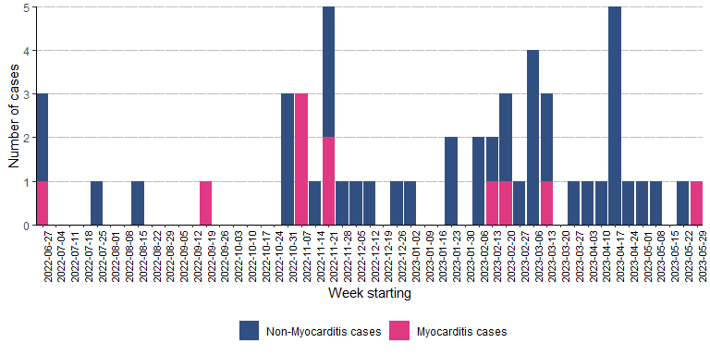

Myocarditis cases
There were 11 reported cases of enterovirus myocarditis. Only one further case was reported after the first IMT (report from May 2023).
The cases were very young (median age at first positive test 9 days) and nearly all in the southern part of Wales (map redacted). There was a marked gradient by deprivation quintile of case residence, with higher numbers in the less deprived areas, although absolute case numbers were small so this may not have been statistically significant.

  - Age breakdown for Myocarditis cases
For Myocarditis cases, median age at first positive test is 9 days (range 4 - 19)
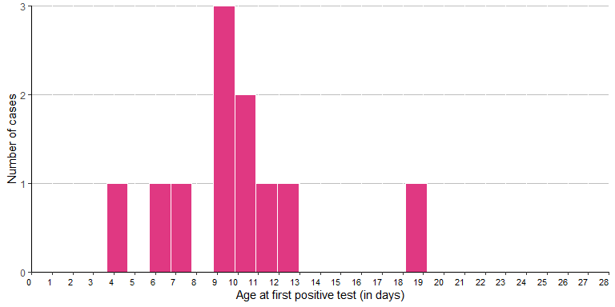
  - Gender breakdown for Myocarditis cases
Gender | Cases (n) | (%)
Female | 6 | 54.5
Male | 5 | 45.5
Total | 11 | 100.0

  - Age gender pyramid: Myocarditis cases
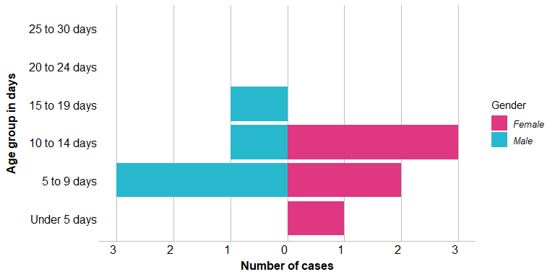

Most cases lived in the southeastern part of Wales.

  - Breakdown by Local Health Board of residence for Myocarditis cases
Local Health Board of Residence | Number of cases | (%)
Aneurin Bevan UHB | 3 | 27.3
Cardiff and Vale UHB | 3 | 27.3
Cwm Taf Morgannwg UHB | 3 | 27.3
Hywel Dda UHB | 1 | 9.1
Powys THB | 1 | 9.1
Total | 11 | 100.0

Virology
  - Summary by typing
Type | Number of Cases | (%)
CV-A9 | 1 | 1.9
CV-B3 | 3 | 5.7
CV-B4 | 4 | 7.5
E-9 | 3 | 5.7
Unknown | 42 | 79.2
Total | 53 | 100.0
Four distinct enteroviruses were detected in severe cases. Of the myocarditis cases, all were Coxsackie B virus B3 or B4.

Results: Background enterovirus surveillance data
  - Historical Enterovirus typing and hospital data

  - Hospital episode data

International Health Regulations response
The IHR national focal point confirmed to Public Health Wales that no other countries had reported similar increases in myocarditis associate with enterovirus.

ISARIC
ISARIC used case reports of severe enterovirus infections to recruit to a study aiming to describe the clinical and epidemiological characteristics of the cases in health boards across Wales. To date recruitment has been slow and the team are still gathering data. The final findings are likely to be published in a peer-reviewed journal.

DISCUSSION
We identified 11 cases of neonatal myocarditis associated with enterovirus, with the last report from May 2023. These occurred against a background of further severe enterovirus cases, noting that circulation varies between years. There was no evidence of a resurgence of cases after this period (June 2022 to May 2023). Although there was some evidence of clustering of cases in time and place, this increase was not seen in other parts of the UK, nor in Europe or worldwide. Different types of enterovirus were involved so there was not a clear single source of infection.

We did not identify any evidence through phylogenetic analysis that NEM cases in this cluster were genetically different from CVB3/CVB4 viruses circulating in the UK, although the analysis was limited to partial VP1 sequencing of available samples (those sent to the reference laboratory). High seasonal EV activity in 2022/23 may relate to reduced exposure over the COVID lockdown period, perhaps increasing susceptibility and/or severity in neonates of unexposed mothers.

The reasons for this cluster remain uncertain.
It is now recognised that the transmission of a number of common pathogens, particularly respiratory infections, was interrupted due to the social distancing measures used during the COVID-19 pandemic period in 2020-22. Seasonality in infections can be complex and is not well-understood, but a combination of age-specific population immunity, coupled with seasonal factors such as the environment and mixing patterns, is likely to account for the usual seasonal circulation of respiratory viruses[6].

Changes in population immunity due to interruption of circulation of common infections have led to unseasonal, larger or unusual infection manifestations in the period following 2021/22. Examples include scarlet fever, whooping cough, and hepatitis of unknown origin associated with adenovirus infection. This may be part of the reason for the timing of this cluster[7].

As initial reporting was clinician driven, this may have heightened awareness in a regional network and identified cases that were not diagnosed elsewhere – that is, an increased sensitivity for detection. Wales has a strong history of enterovirus surveillance and virology, and this coupled with clinical network connections may have contributed to the detection of these cases.

RECOMMENDATIONS
The incident management team agreed the following recommendations:
- Continue vigilance for severe outcomes of enterovirus infection
- Complete ISARIC research to characterise severe EV cases
- Continue surveillance and typing of enterovirus in Wales.

REFERENCES

[1] S. Cottrell, C. Moore, M. Perry, E. Hilvers, C. Williams, and A. G. Shankar, “Prospective enterovirus D68 (EV-D68) surveillance from September 2015 to November 2018 indicates a current wave of activity in wales,” Eurosurveillance, vol. 23, no. 46, Nov. 2018, doi: 10.2807/1560-7917.ES.2018.23.46.1800578.
[2] C. J. Williams et al., “Cluster of atypical adult Guillain-Barré syndrome temporally associated with neurological illness due to EV-D68 in children, South Wales, United Kingdom, October 2015 to January 2016,” Eurosurveillance, vol. 21, no. 4, pp. 26–32, Jan. 2016, doi: 10.2807/1560-7917.ES.2016.21.4.30119.
[3] K. F. Ng et al., “Remember the heart: Neonatal myocarditis,” 2023. doi: 10.1136/archdischild-2023-325316.
[4] World Health Organization, “WHO | Disease Outbreak News (DONs),” Who. 17 May 2023 Myocarditis (acute infective) – United Kingdom. Available at: https://www.who.int/emergencies/disease-outbreak-news/item/2023-DON465 .
[5] A. Singanayagam et al., “Increased reports of severe myocarditis associated with enterovirus infection in neonates, United Kingdom, 27 June 2022 to 26 April 2023,” Eurosurveillance, vol. 28, no. 39, Sep. 2023, doi: 10.2807/1560-7917.ES.2023.28.39.2300313.
[6] M. Lipsitch and C. Cile Viboud, “Influenza seasonality: Lifting the fog.” [Online]. Available: https://www.pnas.org
[7] S. Mandal et al., “Paediatric acute hepatitis of unknown aetiology: a national investigation and adenoviraemia case-control study in the UK,” Lancet Child Adolesc Health, vol. 7, no. 11, pp. 786–796, Nov. 2023, doi: 10.1016/S2352-4642(23)00215-8.

